

DEPARTMENT OF COMPUTER & SOFTWARE ENGINEERING
COLLEGE OF E&ME, NUST, RAWALPINDI

CS-272 Artificial Intelligence

LAB MANUAL – 01

Course Instructor: Dr. Arslan Shaukat

Lab Instructor: Engr. Eman Fatima

Student Name: _______________________________________________

Degree/ Syndicate: ____________________________________________

LAB # 01: Object Oriented Design Practices in Python

Lab Objective:
The primary objective of this lab is to enable students to gain familiarity with the Python Integrated Development and Learning Environment (IDLE) and to understand the conventional coding practices followed in Python programming. The lab further aims to introduce students to object-oriented design practices, focusing on the use of classes, objects, and modular programming principles. Students will also learn to apply object-oriented constructs for developing hierarchical data structures, thereby enhancing their ability to model real-world problems effectively in Python.

Hardware/Software Tools:
- Hardware: Desktop/Computer
- Software Tool: Python IDLE

Lab Description:
Object-oriented design practices in Python form the foundation for developing structured, modular, and reusable programs. Python provides powerful object-oriented features such as classes, objects, inheritance, and polymorphism, which allow programmers to model real-world entities and their relationships effectively. Learning these concepts helps students understand how to design and implement hierarchical data structures, making programs more efficient and easier to maintain. This lab introduces students to Python’s IDLE environment, conventional coding practices, and the systematic application of object-oriented principles. Through hands-on exercises, students will practice creating classes, defining attributes and methods, and applying inheritance to build structured solutions. By working with object-oriented constructs, they will develop essential programming skills that support scalability, reusability, and clarity in software development.

Overview of Python Programming:
Python is a high-level, general-purpose, and portable programming language widely used for scripting, web development, and compute-intensive tasks. It automatically compiles source code to byte code, eliminating the need for a separate compilation step, and can be extended with C/C++ for improved performance. Python offers rich built-in data structures such as lists, dictionaries, and strings, along with powerful control structures like if-else and for loops. Its modular organization into functions, classes, modules, and packages promotes reusability and maintainability, as seen in its extensive standard library. Being dynamically typed, Python determines variable types at runtime and enforces indentation for block structure, following the convention of four spaces. Python’s interactive prompt, along with tools like IPython and IDLE, provides an excellent environment for experimentation, debugging, and learning. Simple operations, from printing “Hello, World!” to performing mathematical computations, demonstrate Python’s simplicity, readability, and efficiency, making it a preferred choice for beginners and professionals alike.

- Operators in Python: Operators are special symbols that perform operations on variables and values, such as arithmetic (+, -, *), comparison (==, >, <), logical (and, or, not), and assignment (=, +=).

Command | Name | Example | Output
+ | Addition | 4+5 | 9
- | Subtraction | 8-5 | 3
* | Multiplication | 4*5 | 20
/ | Division | 19/3 | 6
% | Remainder | 19%3 | 5
** | Exponent | 2**4

- Operator Precedence in Python: Operator precedence defines the order in which operators are evaluated in an expression. For example, multiplication and division have higher precedence than addition and subtraction, like standard mathematics.

Operators | Descriptions
() | Parentheses
>> << | Right and Left Bitwise Shift

- Comments in Python: Comments are non-executable lines used to explain code and improve readability. In Python, single-line comments begin with #, while multi-line comments can be written using triple quotes (''' or """).
- Variables: In python, variables are used to store data values that can be accessed and manipulated throughout a program. A variable acts as a container for information. You can assign different types of data to variables, such as numbers, texts etc. Variables in Python don't need to be declared with a specific type (like in some other programming languages such as int, string, float etc). Python automatically understands the type based on the value assigned. Variables can be used in calculations, comparisons, or simply to store and retrieve data in a program.
- Variable names should be meaningful.
- Variable should start with a letter or underscore (_) and cannot contain spaces or special characters ($, !, @ etc).

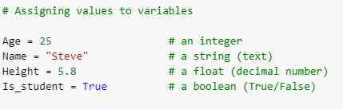
- Strings: In Python, strings are sequences of characters enclosed in quotes. They can include letters, numbers, symbols, and even spaces. Strings are one of the most used data types for storing text.
- Creating Strings
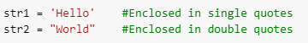
- String Concatenation
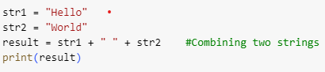
- Accessing Characters
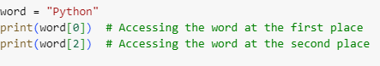
- String Slicing
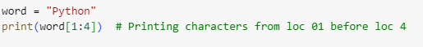
- String Length
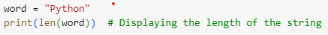
- Boolean Operators in Python: Boolean operators return either TRUE or FALSE.
Expression | Function
< | less than
<= | less than or equal to
> | greater than
>= | greater than or equal to
!= | not equal to
<> | not equal to (alternate)
== | equal to

- Conditional Statements: In Python, conditional statements are used to perform different actions based on certain conditions. They allow the program to make decisions and execute specific blocks of code only when certain conditions are met.
- If Statement
Executes a block of code if the condition is True.
- Else Statement
Executes a block of code if the if condition is False.
- Elif Statement
Stands for else if and allows for multiple conditions to be checked.
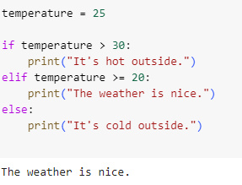
- User-defined Inputs: User-defined input allows a program to take values directly from the user at runtime instead of using pre-defined values in the code. In Python, this is done using the built-in input() function, which reads input as a string from the keyboard. If numerical input is required, the string can be converted into other data types using functions like int() and float().
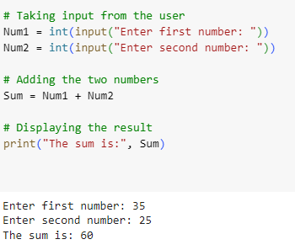
- Loops in Python: In Python, a for loop is used to iterate over a sequence (like a list or range) and execute a block of code multiple times, once for each item in the sequence. The basic structure of a for loop is simple and easy to understand. Let’s understand its basic structure:
for variable in sequence/range

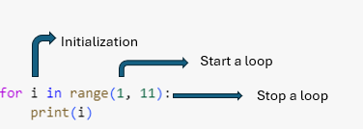
Example No. 01:
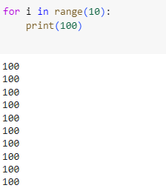
Example No. 02:
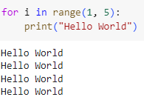
A while loop in Python is used to repeat a block of code as long as a certain condition is true. It keeps running the code inside the loop until the condition becomes false.
- The condition is checked before every iteration.
- If the condition is false at the start, the loop will not execute.
- The loop can run infinitely if the condition never becomes false unless there is a break statement to exit the loop.
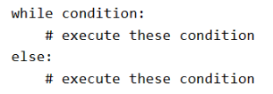

Example No. 01:

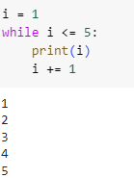

- Functions in Python: Functions in Python are reusable blocks of code that perform a specific task. They help in organizing code, reducing repetition, and improving readability. Functions can take inputs (parameters), perform operations, and return outputs using the return statement.

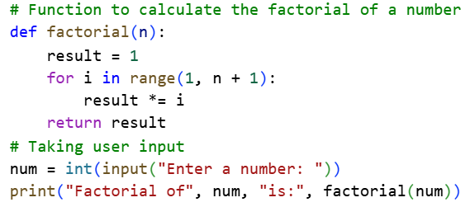
- Lists: A list is a versatile data structure in Python that stores an ordered collection of items. Each item in a list has a position (index), starting from zero. Lists can hold values of different types and allow modification, such as adding new elements, removing existing ones, or updating values. They are written as comma-separated items enclosed in square brackets [ ].
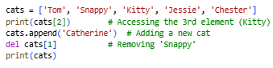
- Compound Datatypes in Python: Compound datatypes allow grouping together different types of values into a single variable. The most common compound datatype in Python is the list, which can contain a mix of strings, numbers, and even other lists. These datatypes support powerful operations such as slicing, concatenation, repetition, and element modification.
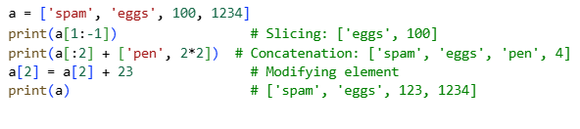
- Functions of Lists: The append(x) method adds a single item to the end of a list, while extend(L) appends all items from another list. The insert(i, x) method allows inserting an element at a specific position, whereas remove(x) deletes the first occurrence of a specified value. With pop([i]), elements can be removed by index, or the last item can be removed if no index is specified. The count(x) method returns how many times a value appears in the list, while sort() arranges elements in ascending order, and reverse() flips the order of items in place. These functions make lists highly flexible and powerful for data handling in Python.
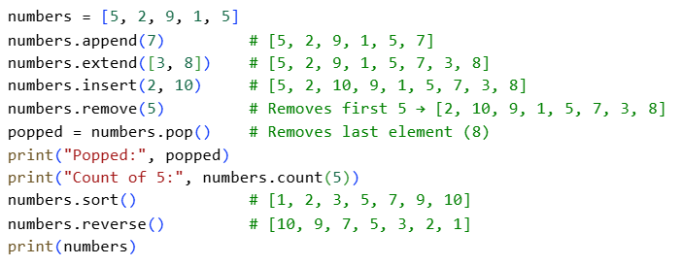
- Tuples: Tuples are immutable sequences in Python, which makes them ideal for storing fixed collections of items such as coordinates, configuration settings, or database records. Although their values cannot be changed after creation, tuples support operations like indexing, slicing, concatenation, repetition, and membership testing. Useful functions include len() to determine size, max()/min() for comparisons, and count(x) or index(x) for analyzing occurrences of elements.
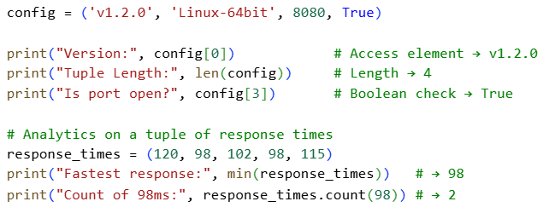
- Dictionaries: Dictionaries are mutable key–value collections that provide fast access to data through unique keys, making them essential for structured data such as records, mappings, or JSON-like objects. They allow adding, updating, and removing items dynamically. Common functions include keys() to retrieve all keys, values() to retrieve values, and items() for complete key–value pairs. Methods like get() ensure safe retrieval, update() modifies or merges data, while pop() and clear() handle deletion. Dictionaries are extensively used in applications like databases, APIs, and data analytics.
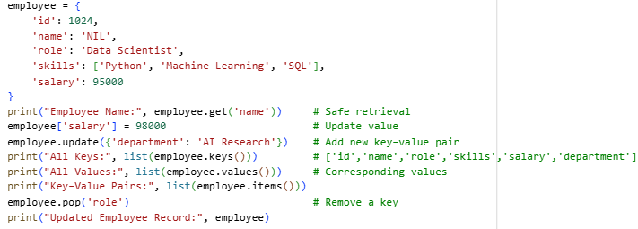
Object Oriented Programming in Python:
- Classes: Classes are the fundamental building blocks of object-oriented programming (OOP) in Python. They group variables (attributes) and methods (functions) related to a single entity, allowing code reusability and modularity. Objects are instances of classes, and they provide access to the attributes and behaviors defined in the class.
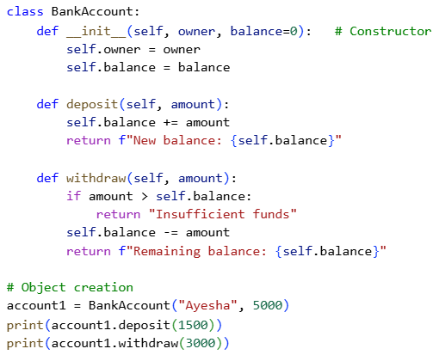
- Inheritance: Inheritance allows one class (child) to acquire the properties and methods of another class (parent). This promotes reusability and extendibility of code. Python supports single, multiple, and multilevel inheritance. Additionally, methods can be overridden in the child class to change their behavior.
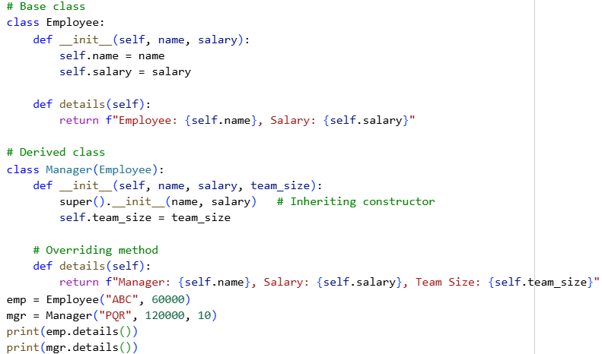
- Modules: A module is a Python file containing functions, classes, and variables that can be reused in other programs by importing it. Using modules improves code organization, reduces redundancy, and makes projects easier to maintain.
- File: Utitlities.py
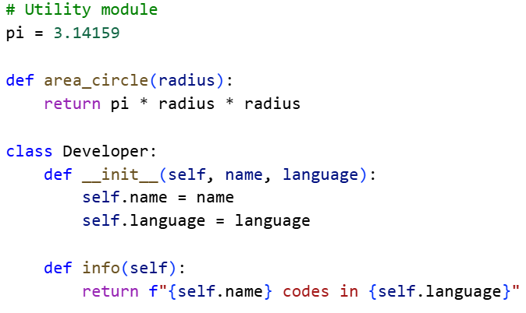

- File: main.py
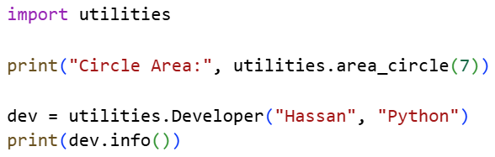
- Trees: Python does not have a built-in tree structure, but trees can be implemented using classes. A tree is a hierarchical data structure consisting of nodes, where each node has data and references to child nodes. They are widely used in search algorithms, compilers, and hierarchical data representation.
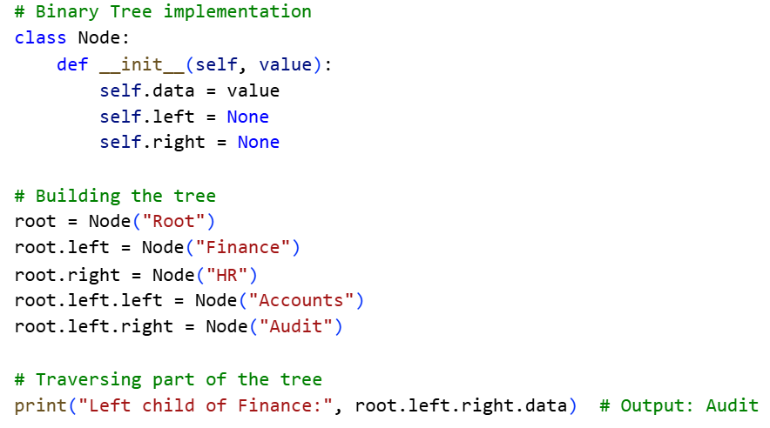

Lab Tasks:
- Write a program that takes a sentence from the user and checks whether it is a palindrome (ignoring spaces, punctuation, and case).
Example: “Was it a car or a cat I saw” → Palindrome.

- Write a program that checks if a given number is an Armstrong number. An Armstrong number is a number that is equal to the sum of its digits, each raised to the power of the number of digits.

- Write a program that generates a random verification code consisting of letters, digits, and special characters. The user should enter the number of codes to generate and their length. Each code must include at least one uppercase letter, one digit, and one special character. Display all the generated codes.

- Write a program to create a class Vector with attributes x and y to represent coordinates. Include methods magnitude() to compute the vector’s length and direction() to calculate its angle with the x-axis. Take input for the vector from the user in the main program, create an object of the class, and display its magnitude and direction.

- Create a Binary Search Tree (BST) and insert a series of integers into it. Write a program to search for the node 25 in the BST (as covered in your Data Structures and Algorithms course). You can hard-code the values or take them as input from the user. Also, state the time complexity of the search operation in Big-O notation.

