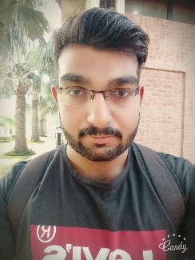

E: ZaheerAhmad@cuilahore.edu.pk

Comsats University | Associate Prof

Comsats University | Assistant Prof

**TradeUp.Biz** (<https://demo.tradeup.biz/>)

Full Stack Developer - Team Leader

TradeUp.Biz is a business management system. It contains many modules. I developed many core features such as report generation and data-base creation ana many more.

**Slyvar - HR Management System**

(<http://slyvarerp.s3-website.eu-west-3.amazonaws.com/>

**Projects**

ABDUR REHMANKHALID

CONTACT INFO

Phone

+923481483324

Email

Abdur.r.khalid@gmail.com

Web

<https://abdurrkhalid.github.io/>

EDUCATION

COMSATS University| Lahore

BS in Computer Science

2016-2020

Intermediate

F.C College | Lahore

2013-2015

EXPERTISES

ReactJS

Git

MongoDB

SQL

TypeScript

Node.JS

AngularJS (6+)

Mr. Asif Shahzad

P: Comsats University | Assistant Prof

E: asif.shahzad@cuilahore.edu.pk

Mr. Zaheer Ahmed

REFERENCES

WORK EXPERENCES

Back-End Developer

Saifmo | Sep 2020 - Dec 2020

Developed the completed Back-End of a HR Management System and Implemented the Business Logic by the Means of Back-End API creation.

Created the Data Models for various Business Entities.

Implemented the Business Logic by Implementing Services.

Front-End Developer

NextByte Solutions | July 2020 - Sept 2020

Developed the interactive Front-Ends for the various kind of projects including Resturant Management Systems and Gym Management Systems using AngularJS and ReactJS.

Consumed the Back-End APIS using Different APIs.

Implemented State-Management using NGRX and Redux.

II am a full stack developer. I love to build applications using JavaScript Frameworks such as AngularJS, ReactJS for Front-End and Node.JS for Back-End. I am a very enthusiastic person in terms of learning new technologies. I have experience of building Enterprise level applications. I am a highly committed person. I love learning new things.

FULL STACK DEVELOPER