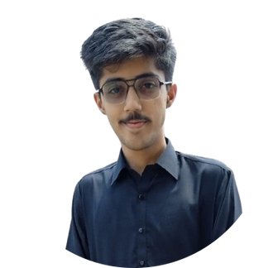



About Me
Motivated beginner in front end web development, with a foundation in HTML, CSS, JavaScript, and React JS. Focused on building responsive, user-friendly websites and eager to grow through hands-on experience
Contact
+92 334 1936722
rafaynadir885@gmail.com
- no: 73/1, Street no 5, Dhamial Road, Bakramandi, Rawalpindi, Punjab, Pakistan

Skills
- HTML, CSS & Java script
- React JS
- Time & Team Management

Languages
- English
- Urdu

Abdur Rafay Nadir

Frontend Web Developer

 Education

(2023 - Cont)
National University of Modern Languages, Rawalpindi
BS Computer Science CGPA: 3.99


Experience

Personal Projects:
QR Code Generator Website:
Designed and developed a responsive QR Code generating website that generates the custom QR Code for any text or URL, along with the feature of downloading that QR Code.

To-Do List Website:
Built a notes keeping or to-do list website, where users can add their tasks or important notes, having features of editing it and deleting it, using React JS and React Bootstrap.

NewsApp Website:
Designed a NewsApp Website using React JS (through news API), that gives latest news from the field of sports. User have the choice to select the category (i.e, cricket, football) and can get latest updates about that sport.

Other Projects:
Text Utility Website
Simple Calculator
Clothing Brand Website

