Final Year Project

RAAAH
Intelligent Crowd Management and Smart Tourism Platform
for Northern Pakistan
Software Requirements Specification (SRS)
FYP Team
Ammar Ahmad 23P-3071
Abdur Rafay Baig 23F-3046
Faiza Ali 23F-0739
Supervised by
Dr. Muhammad Usama
Department of Computer Science
National University of Computer and Emerging Sciences
Chiniot-Faisalabad, Pakistan
2026
Anti-Plagiarism Declaration
This is to declare that the above publication produced under the:
Title: RAAAH - Intelligent Crowd Management and Smart Tourism Platform for Northern Pakistan
is the sole contribution of the author(s) and no part hereof has been reproduced on as it is basis (cut and paste) which can be considered as Plagiarism. All referenced parts have been used to argue the idea and have been cited properly. We will be responsible and liable for any consequence if violation of this declaration is determined.
Date: ______________________
Student 1
Name: M Ammar Ahmad
Signature: ___________________
Student 2
Name: Abdur Rafay Baig
Signature: ___________________
Student 3
Name: Faiza Ali
Signature: ___________________

Table of Contents
1. Introduction 1
2. Vision Document 2
2.1 Problem Statement 2
2.2 Business Opportunity 2
2.3 Objectives 2
2.4 Scope 3
2.5 Constraints 3
2.6 Stakeholder and User Descriptions 3
2.6.1 Market Demographics 3
2.6.2 Stakeholder Summary 4
2.6.3 User Environment 4
2.6.4 Stakeholder Profiles 4
2.6.4.1 Supervisor 4
2.6.4.2 Development Team 5
2.6.4.3 Tourist 5
2.6.4.4 Community Safety Observer 6
2.6.4.5 Administrator 6
2.6.4.6 Tourism Authority 6
3. System Requirements Specification 7
3.1 System Features 7
3.2 Functional Requirements 7
3.2.1 Tourist Registration and Profile 8
3.2.2 Destination Discovery and Information 8
3.2.3 Crowd Monitoring 8
3.2.4 Tourist Visit History 9
3.2.5 AI-Based Alternative Destination Recommendation 10
3.2.6 Safety and Disaster Risk Alert System 10
3.2.7 Community-Based Hazard Reporting 11
3.2.8 Tourist Safety Notification 11
3.2.9 Cultural and Responsible Tourism Information 11
3.2.10 Admin / Tourism Authority Dashboard 12
3.3 Non-Functional Requirements 12
3.3.1 User-Friendly Interface 12
3.3.2 Performance 12
3.3.3 Data Security 12
3.3.4 Privacy 12
3.3.5 Reliability 12
3.3.6 Compatibility 12
3.3.7 Scalability 13
3.3.8 Maintainability 13
4. High-Level System / Architecture Diagram 14
5. Use Case Diagram 15
6. High-Level Use Cases 16
6.1 Register Account 16
6.2 Login 16
6.3 Manage Profile and Preferences 16
6.4 Explore Destinations 17
6.5 Save Destination 17
6.6 Check In at Destination 17
6.7 Check Out of Destination 18
6.8 View Visit History 18
6.9 Get Alternative Destination Recommendations 18
6.10 Submit Hazard Report 18
6.11 Review Hazard Report 19
6.12 Update Destination Risk Status 19
6.13 Receive Safety Notification 19
6.14 View Cultural and Responsible Tourism Information 20
6.15 Manage Destinations 20
6.16 Manage Users 20
6.17 View Analytics Dashboard 21
7. Expanded Use Cases 22
7.1 Register Account 22
7.2 Login 23
7.3 Manage Profile and Preferences 24
7.4 Explore Destinations 25
7.5 Save Destination 26
7.6 Check In at Destination 27
7.7 Check Out of Destination 28
7.8 View Visit History 28
7.9 Get Alternative Destination Recommendations 29
7.10 Submit Hazard Report 30
7.11 Review Hazard Report 31
7.12 Update Destination Risk Status 32
7.13 Receive Safety Notification 32
7.14 View Cultural and Responsible Tourism Information 33
7.15 Manage Destinations 34
7.16 Manage Users 35
7.17 View Analytics Dashboard 35
8. Activity / Swimlane Diagrams 37
8.1 Register Account 37
8.2 Login 38
8.3 Manage Profile and Preferences 39
8.4 Explore Destinations 40
8.5 Save Destination 41
8.6 Check In at Destination 42
8.7 Check Out of Destination 43
8.8 View Visit History 44
8.9 Get Alternative Destination Recommendations 45
8.10 Submit Hazard Report 46
8.11 Review Hazard Report 47
8.12 Update Destination Risk Status 48
8.13 Receive Safety Notification 49
8.14 View Cultural and Responsible Tourism Information 50
8.15 Manage Destinations 51
8.16 Manage Users 52
8.17 View Analytics Dashboard 53
9. System Sequence Diagrams 54
9.1 Register Account 54
9.2 Login 55
9.3 Manage Profile and Preferences 56
9.4 Explore Destinations 57
9.5 Save Destination 58
9.6 Check In at Destination 59
9.7 Check Out of Destination 60
9.8 View Visit History 61
9.9 Get Alternative Destination Recommendations 62
9.10 Submit Hazard Report 63
9.11 Review Hazard Report 64
9.12 Update Destination Risk Status 65
9.13 Receive Safety Notification 66
9.14 View Cultural and Responsible Tourism Information 67
9.15 Manage Destinations 68
9.16 Manage Users 69
9.17 View Analytics Dashboard 70
10. Component Diagram 71
11. Package Diagram 72
12. Data Flow Diagrams 73
12.1 DFD Level 0 73
12.2 DFD Level 1 74
12.3 DFD Level 2 75
12.3.1 Crowd Monitoring 75
12.3.2 Alternative Destination Recommendation 76
12.3.3 Hazard Reporting and Safety Notification 77
13. Entity Relationship Diagram 78
14. Deployment Diagram 79
15. Domain Model 80
References 81

List of Tables
Table 1: Problem Statement 2
Table 2: Stakeholder Summary 4
Table 3: Supervisor 4
Table 4: Development Team 5
Table 5: Tourist 5
Table 6: Community Safety Observer 6
Table 7: Administrator 6
Table 8: Tourism Authority 6
Table 9: Functional Requirements: Tourist Registration and Profile 8
Table 10: Functional Requirements: Destination Discovery and Information 8
Table 11: Crowd Level Classification 9
Table 12: Functional Requirements: Crowd Monitoring 9
Table 13: Functional Requirements: Tourist Visit History 9
Table 14: Functional Requirements: AI-Based Alternative Destination Recommendation 10
Table 15: Functional Requirements: Safety and Disaster Risk Alert System 10
Table 16: Functional Requirements: Community-Based Hazard Reporting 11
Table 17: Functional Requirements: Tourist Safety Notification 11
Table 18: Functional Requirements: Cultural and Responsible Tourism Information 11
Table 19: Functional Requirements: Admin / Tourism Authority Dashboard 12
Table 20: Actors 15
Table 21: High-Level Use Case: Register Account 16
Table 22: High-Level Use Case: Login 16
Table 23: High-Level Use Case: Manage Profile and Preferences 16
Table 24: High-Level Use Case: Explore Destinations 17
Table 25: High-Level Use Case: Save Destination 17
Table 26: High-Level Use Case: Check In at Destination 17
Table 27: High-Level Use Case: Check Out of Destination 18
Table 28: High-Level Use Case: View Visit History 18
Table 29: High-Level Use Case: Get Alternative Destination Recommendations 18
Table 30: High-Level Use Case: Submit Hazard Report 18
Table 31: High-Level Use Case: Review Hazard Report 19
Table 32: High-Level Use Case: Update Destination Risk Status 19
Table 33: High-Level Use Case: Receive Safety Notification 19
Table 34: High-Level Use Case: View Cultural and Responsible Tourism Information 20
Table 35: High-Level Use Case: Manage Destinations 20
Table 36: High-Level Use Case: Manage Users 20
Table 37: High-Level Use Case: View Analytics Dashboard 21
Table 38: Expanded Use Case: Register Account 22
Table 39: Expanded Use Case: Login 23
Table 40: Expanded Use Case: Manage Profile and Preferences 24
Table 41: Expanded Use Case: Explore Destinations 25
Table 42: Expanded Use Case: Save Destination 26
Table 43: Expanded Use Case: Check In at Destination 27
Table 44: Expanded Use Case: Check Out of Destination 28
Table 45: Expanded Use Case: View Visit History 28
Table 46: Expanded Use Case: Get Alternative Destination Recommendations 29
Table 47: Expanded Use Case: Submit Hazard Report 30
Table 48: Expanded Use Case: Review Hazard Report 31
Table 49: Expanded Use Case: Update Destination Risk Status 32
Table 50: Expanded Use Case: Receive Safety Notification 32
Table 51: Expanded Use Case: View Cultural and Responsible Tourism Information 33
Table 52: Expanded Use Case: Manage Destinations 34
Table 53: Expanded Use Case: Manage Users 35
Table 54: Expanded Use Case: View Analytics Dashboard 35

List of Figures
Figure 1: High-Level System / Architecture Diagram 14
Figure 2: Use Case Diagram 15
Figure 3: Activity Diagram: Register Account 37
Figure 4: Activity Diagram: Login 38
Figure 5: Activity Diagram: Manage Profile and Preferences 39
Figure 6: Activity Diagram: Explore Destinations 40
Figure 7: Activity Diagram: Save Destination 41
Figure 8: Activity Diagram: Check In at Destination 42
Figure 9: Activity Diagram: Check Out of Destination 43
Figure 10: Activity Diagram: View Visit History 44
Figure 11: Activity Diagram: Get Alternative Destination Recommendations 45
Figure 12: Activity Diagram: Submit Hazard Report 46
Figure 13: Activity Diagram: Review Hazard Report 47
Figure 14: Activity Diagram: Update Destination Risk Status 48
Figure 15: Activity Diagram: Receive Safety Notification 49
Figure 16: Activity Diagram: View Cultural and Responsible Tourism Information 50
Figure 17: Activity Diagram: Manage Destinations 51
Figure 18: Activity Diagram: Manage Users 52
Figure 19: Activity Diagram: View Analytics Dashboard 53
Figure 20: System Sequence Diagram: Register Account 54
Figure 21: System Sequence Diagram: Login 55
Figure 22: System Sequence Diagram: Manage Profile and Preferences 56
Figure 23: System Sequence Diagram: Explore Destinations 57
Figure 24: System Sequence Diagram: Save Destination 58
Figure 25: System Sequence Diagram: Check In at Destination 59
Figure 26: System Sequence Diagram: Check Out of Destination 60
Figure 27: System Sequence Diagram: View Visit History 61
Figure 28: System Sequence Diagram: Get Alternative Destination Recommendations 62
Figure 29: System Sequence Diagram: Submit Hazard Report 63
Figure 30: System Sequence Diagram: Review Hazard Report 64
Figure 31: System Sequence Diagram: Update Destination Risk Status 65
Figure 32: System Sequence Diagram: Receive Safety Notification 66
Figure 33: System Sequence Diagram: View Cultural and Responsible Tourism Information 67
Figure 34: System Sequence Diagram: Manage Destinations 68
Figure 35: System Sequence Diagram: Manage Users 69
Figure 36: System Sequence Diagram: View Analytics Dashboard 70
Figure 37: Component Diagram 71
Figure 38: Package Diagram 72
Figure 39: DFD Level 0 73
Figure 40: DFD Level 1 74
Figure 41: DFD Level 2: Crowd Monitoring 75
Figure 42: DFD Level 2: Alternative Destination Recommendation 76
Figure 43: DFD Level 2: Hazard Reporting and Safety Notification 77
Figure 44: Entity Relationship Diagram (ERD) 78
Figure 45: Deployment Diagram 79
Figure 46: Domain Model 80

1. Introduction
RAAAH is an intelligent tourism platform designed to address the lack of real-time information available to tourists visiting Northern Pakistan, particularly the Gilgit-Baltistan region. The platform integrates crowd monitoring, disaster-aware safety alerts and AI-based alternative destination recommendations into a single web application. Tourists can check crowd levels and safety conditions at their selected destination before departing. If a destination is overcrowded or affected by a hazard such as a flash flood or landslide, RAAAH alerts the tourist and recommends safer and less crowded alternatives based on personal preferences, distance and current conditions.
The platform also provides tourism authorities and administrators with a dashboard to monitor crowd distribution, review community safety reports and support data-driven tourism management. RAAAH does not impose restrictions on tourists; it gives them the information and alternatives they need to make their own informed decisions.

2. Vision Document

2.1 Problem Statement

Category | Description
The Problem | Tourists lack a reliable pre-travel view of crowd levels, weather conditions, road or hazard warnings and nearby alternatives.  Visitors concentrate on a small number of popular destinations, which increases congestion and environmental pressure.  When a destination becomes crowded or unsafe, tourists have no easy way to find a suitable alternative.
Affects | Tourists visiting Northern Pakistan.  Local communities and infrastructure at popular destinations.  Tourism and disaster management authorities.
Impact | Overcrowding and excessive pressure on roads, accommodation and fragile mountain environments.  Avoidable safety risks from flash floods, landslides, rockfalls, glacier-related hazards and extreme weather. The Murree tragedy of January 2022, in which 23 people died, shows the result of a sudden tourist influx combined with bad weather and no crowd or road information.  Authorities lack aggregated data for crowd and safety planning.
Solution | A web-based platform that estimates crowd levels, shows weather and safety status of destinations, collects verified community hazard reports, alerts affected tourists, recommends safer and less crowded alternatives through an AI-based engine, and gives authorities an analytics dashboard.

Table 1: Problem Statement

2.2 Business Opportunity
Tourism to Northern Pakistan grows every year, yet there is no single platform that combines crowd, weather, safety and alternative destination information for tourists of the region. Map and weather applications cover only parts of this need, and disaster advisories are general rather than destination-specific. RAAAH fills this gap. It can be offered to tourism departments and disaster management authorities as a decision-support tool, it helps promote lesser-known destinations by distributing visitors more evenly, and the same model can later be extended to other tourist regions of Pakistan.

2.3 Objectives
The objectives of RAAAH are to:
- Provide estimated current crowd awareness for supported destinations.
- Detect and classify overcrowding into Low, Moderate, High and Critical levels.
- Recommend safer and less crowded alternative destinations using crowd, distance, accommodation, safety and preference factors.
- Provide weather and destination-specific hazard information before travel.
- Provide administrators and tourism authorities with aggregated analytics for tourism management.
- Protect user privacy by aggregating consent-based location signals and avoiding public exposure of individual locations.

2.4 Scope
RAAAH is a web application for tourists and tourism authorities, covering registered destinations of Northern Pakistan with an initial focus on Gilgit-Baltistan. The scope of the project includes:
- Destination discovery with information on attractions, culture, weather, crowd levels, safety status and accessibility.
- Crowd estimation using location-based check-ins and active visitor data.
- AI-based alternative destination recommendations based on crowd levels, distance, safety, weather and user preferences.
- A safety module providing destination-specific risk status, hazard information and tourist notifications.
- Community-based hazard reporting with the validation workflow Unverified, Under Review, Verified and Resolved.
- An admin and tourism authority dashboard with aggregated analytics and role-based access.

2.5 Constraints
- Crowd estimates depend on the number of tourists who use the platform and check in, so they are estimates and not exact counts.
- Many destinations in the northern areas have weak or unstable internet connectivity.
- Check-in requires browser location permission, and location accuracy depends on the user's device.
- Weather, maps and notifications depend on external APIs (OpenWeatherMap, Google Maps and Firebase) and their usage limits.
- Public safety information depends on timely review of hazard reports by administrators.

2.6 Stakeholder and User Descriptions

2.6.1 Market Demographics
The target market is domestic and international tourists who visit Northern Pakistan, including families, student groups, solo travellers and adventure groups who use smartphones to plan their trips. The secondary market includes tourism departments and disaster management authorities of the region that need aggregated information for crowd and safety management.

2.6.2 Stakeholder Summary

Name | Description | Responsibility
Supervisor | Faculty member who guides the project. | Provides direction, reviews requirements and design, and monitors progress.
Development Team | Students who develop RAAAH. | Specify requirements, design, implement, test and document the system.
Tourist | Registered user planning or making a trip. | Views destination conditions, checks in, receives recommendations and safety alerts.
Community Safety Observer | Verified user who reports hazards from the ground. | Submits hazard reports for administrator review.
Administrator | Authorized operator of the platform. | Manages destinations, users and content, reviews hazard reports and updates risk status.
Tourism Authority | Official of a tourism or disaster management department. | Monitors aggregated crowd and safety analytics for planning.

Table 2: Stakeholder Summary

2.6.3 User Environment
RAAAH is accessed through modern web browsers (Chrome, Edge, Firefox and Safari) on smartphones, laptops and desktops. Tourists mostly use it on mobile phones while planning a trip and while travelling, where the internet connection may be slow. Administrators and tourism authority officials mainly use it on desktop computers. No special hardware is required.

2.6.4 Stakeholder Profiles

2.6.4.1 Supervisor

Representatives | Dr. Muhammad Usama
Description | Supervises the development of the project.
Type | Internal, technical stakeholder
Responsibility | 1. Gives direction to the development team.  2. Reviews and approves the SRS and design artifacts.  3. Ensures the project is completed within the given time.  4. Tracks progress of the committed features.
Success Criteria | Completion of the features committed in this document.
Involvement | Requirement reviewer and progress reviewer.
Comments / Issues | None

Table 3: Supervisor

2.6.4.2 Development Team

Representatives | Ammar Ahmad, Abdur Rafay Baig, Faiza Ali
Description | Responsible for the development of the project.
Type | Internal, technical stakeholder
Responsibility | 1. Specify requirements.  2. Design, develop and test the system.  3. Prepare project documentation.
Success Criteria | Successful development of the committed features.
Involvement | Research, development and documentation of the project.
Comments / Issues | None

Table 4: Development Team

2.6.4.3 Tourist

Representatives | Tourists visiting Northern Pakistan
Description | Primary end users who discover destinations and plan trips using the platform.
Type | External stakeholder
Responsibility | 1. Register and maintain travel preferences.  2. Check crowd and safety conditions before travel.  3. Check in and check out at destinations.  4. Consider recommended alternatives and safety alerts.
Success Criteria | Tourist gets reliable destination conditions and suitable alternatives before travelling.
Involvement | High
Comments / Issues | Crowd estimation depends on tourists checking in.

Table 5: Tourist

2.6.4.4 Community Safety Observer

Representatives | Verified local residents, guides or field workers
Description | Submit ground-level hazard observations.
Type | External stakeholder
Responsibility | Submit accurate hazard reports with location and description.
Success Criteria | Hazards are reported in time and verified by the administrator.
Involvement | Medium
Comments / Issues | Reports affect public information only after verification.

Table 6: Community Safety Observer

2.6.4.5 Administrator

Representatives | Authorized platform administrator
Description | Manages platform data and validates safety information.
Type | Internal stakeholder
Responsibility | 1. Manage destinations and their capacity thresholds.  2. Manage users and verify Community Safety Observers.  3. Review hazard reports and update destination risk status.  4. Manage cultural and responsible tourism content.
Success Criteria | Destination and safety information remains accurate and up to date.
Involvement | High
Comments / Issues | None

Table 7: Administrator

2.6.4.6 Tourism Authority

Representatives | Tourism and disaster management officials
Description | Use aggregated analytics for tourism management.
Type | External stakeholder
Responsibility | Monitor crowd distribution, safety reports and recommendation trends.
Success Criteria | Analytics support data-driven crowd and safety decisions.
Involvement | Medium
Comments / Issues | Access is limited to aggregated data.

Table 8: Tourism Authority

3. System Requirements Specification

3.1 System Features
RAAAH offers the following features:
- Tourist Registration and Profile: Tourists create an account, receive a unique Tourist ID and store travel preferences, saved destinations and visit history.
- Destination Discovery and Information: Tourists explore registered destinations, each with description, location, attractions, culture, crowd level, safety status, weather and accessibility information.
- Crowd Monitoring: The system estimates visitor levels from location-based check-ins and classifies them as Low, Moderate, High or Critical.
- Tourist Visit History: Completed visits are recorded and used by the recommendation engine for personalization.
- AI-Based Alternative Destination Recommendation: The engine analyzes preferences, history, crowd, safety, weather and distance to recommend suitable alternatives.
- Safety and Disaster Risk Alert System: Each destination carries a risk status of Low Risk, Elevated Risk or High Risk with hazard information.
- Community-Based Hazard Reporting: Verified Community Safety Observers submit hazard reports that are validated before they influence public information.
- Tourist Safety Notification: Tourists are alerted when a verified hazard affects a destination, along with safer alternatives.
- Cultural and Responsible Tourism Information: Information on local traditions, etiquette, history, food and environmental guidelines.
- Admin / Tourism Authority Dashboard: A role-based dashboard with aggregated analytics on tourists, crowd levels, safety reports and recommendation trends.

3.2 Functional Requirements
The system must fulfil the following functional requirements:

3.2.1 Tourist Registration and Profile

ID | Requirement
FR-01.01 | The system shall allow a tourist to create an account using basic personal information.
FR-01.02 | The system shall generate a unique Tourist ID for each registered tourist.
FR-01.03 | The system shall allow users to log in and log out, and shall provide features according to the user's role (Tourist, Community Safety Observer, Administrator or Tourism Authority).
FR-01.04 | The system shall allow tourists to set and update travel preferences such as nature, historical sites, adventure, culture and photography.
FR-01.05 | The system shall allow tourists to view and update their profile information.
FR-01.06 | The system shall maintain the tourist's saved destinations and visit history in the profile.
FR-01.07 | The system shall ask for the tourist's consent before using location information.

Table 9: Functional Requirements: Tourist Registration and Profile

3.2.2 Destination Discovery and Information

ID | Requirement
FR-02.01 | The system shall allow tourists to search and browse registered destinations of Northern Pakistan.
FR-02.02 | The system shall display destination locations on a map using the Google Maps API.
FR-02.03 | The system shall provide a dedicated page for each destination showing its name, description and geographic location.
FR-02.04 | The destination page shall show main attractions, activities and cultural or historical background.
FR-02.05 | The destination page shall show the current crowd level and safety or risk status.
FR-02.06 | The destination page shall show current weather conditions using the OpenWeatherMap API, and road and accessibility information.
FR-02.07 | The system shall allow tourists to save destinations to their profile.

Table 10: Functional Requirements: Destination Discovery and Information

3.2.3 Crowd Monitoring
Each destination has a configurable capacity threshold. The active visitor count is classified as follows:
Crowd Level | Condition
Low | Visitor count is within the normal capacity range.
Moderate | Visitor count is approaching the configured capacity.
High | Visitor count has reached the configured threshold.
Critical | Visitor count has exceeded the configured capacity limit.

Table 11: Crowd Level Classification

ID | Requirement
FR-03.01 | The system shall allow a tourist to check in at a destination using location, only when the tourist is within the destination area.
FR-03.02 | The system shall allow a tourist to check out of a destination, and shall close a check-in automatically after a configured time.
FR-03.03 | The system shall allow the administrator to configure a capacity threshold for each destination.
FR-03.04 | The system shall estimate the active visitor count of each destination from active check-ins.
FR-03.05 | The system shall classify the crowd level of each destination as Low, Moderate, High or Critical.
FR-03.06 | The system shall display the crowd level on destination pages without exposing any individual tourist's location.
FR-03.07 | The system shall provide the crowd level of each destination to the AI Recommendation Engine.

Table 12: Functional Requirements: Crowd Monitoring

3.2.4 Tourist Visit History

ID | Requirement
FR-04.01 | The system shall record a completed visit when a tourist checks out of a destination.
FR-04.02 | The system shall allow tourists to view their visit history.
FR-04.03 | The system shall provide the visit history to the AI Recommendation Engine. Previously visited destinations shall not be excluded, but new and suitable alternatives shall be given higher priority.
Table 13: Functional Requirements: Tourist Visit History

3.2.5 AI-Based Alternative Destination Recommendation

ID | Requirement
FR-05.01 | When a tourist selects a destination, the system shall analyze its current conditions against the tourist's preferences.
FR-05.02 | If the selected destination is crowded, unsafe, inaccessible or affected by unfavourable weather, the system shall recommend suitable alternative destinations.
FR-05.03 | The recommendation engine shall consider tourist preferences, visit history, crowd level, safety and risk status, weather, distance and accessibility, accommodation availability and destination characteristics.
FR-05.04 | The system shall score and rank candidate destinations and display personalized recommendations to the tourist.
FR-05.05 | The engine shall initially use a content-based or hybrid approach, with provision for ML-based personalization as data accumulates.
FR-05.06 | The system shall allow the tourist to continue with the originally selected destination.

Table 14: Functional Requirements: AI-Based Alternative Destination Recommendation

3.2.6 Safety and Disaster Risk Alert System

ID | Requirement
FR-06.01 | The system shall maintain a risk status of Low Risk, Elevated Risk or High Risk for each destination.
FR-06.02 | The system shall support the hazard types flash flood, landslide, rockfall, glacier-related hazard, road blockage and extreme weather.
FR-06.03 | The system shall display destination-specific hazard and weather information before travel.
FR-06.04 | The system shall allow the administrator to update the risk status of a destination based on verified hazards and current conditions.

Table 15: Functional Requirements: Safety and Disaster Risk Alert System

3.2.7 Community-Based Hazard Reporting

ID | Requirement
FR-07.01 | The system shall allow verified Community Safety Observers to submit hazard reports with hazard type, location and description.
FR-07.02 | The system shall assign the status Unverified to every new report.
FR-07.03 | The system shall allow the administrator to move a report through the statuses Under Review, Verified and Resolved.
FR-07.04 | The system shall use a report to update public safety information only after it is Verified.

Table 16: Functional Requirements: Community-Based Hazard Reporting

3.2.8 Tourist Safety Notification

ID | Requirement
FR-08.01 | The system shall alert tourists when a verified hazard affects a destination they have selected, saved or checked in to.
FR-08.02 | The system shall deliver alerts as push notifications through Firebase Cloud Messaging and display them inside the application.
FR-08.03 | When a destination becomes unsafe, the system shall recalculate recommendations and include safer alternatives with the alert.

Table 17: Functional Requirements: Tourist Safety Notification

3.2.9 Cultural and Responsible Tourism Information

ID | Requirement
FR-09.01 | The system shall provide information on local traditions and customs, cultural etiquette, historical background, and local food and practices.
FR-09.02 | The system shall provide environmental guidelines and appropriate tourist behaviour for destinations.
FR-09.03 | The system shall allow the administrator to manage this content.

Table 18: Functional Requirements: Cultural and Responsible Tourism Information

3.2.10 Admin / Tourism Authority Dashboard

ID | Requirement
FR-10.01 | The system shall allow dashboard access only to authorized users through role-based access control.
FR-10.02 | The dashboard shall show total registered tourists, current crowd levels and tourist distribution.
FR-10.03 | The dashboard shall show active safety reports and recommendation trends.
FR-10.04 | The system shall allow the administrator to add and update destinations, including their location and capacity threshold.
FR-10.05 | The system shall allow the administrator to manage users and verify Community Safety Observers.
FR-10.06 | The dashboard shall show aggregated data only.

Table 19: Functional Requirements: Admin / Tourism Authority Dashboard

3.3 Non-Functional Requirements

3.3.1 User-Friendly Interface
The system must provide a simple and responsive interface that works on both mobile and desktop screens, so that tourists can reach crowd, safety and weather information with minimal navigation.

3.3.2 Performance
The system must respond promptly to user actions. Typical requests should complete within 3 seconds under normal load, and crowd levels must be refreshed soon after check-ins change.

3.3.3 Data Security
The system must store passwords in hashed form, use HTTPS, and enforce role-based access on the server for every request.

3.3.4 Privacy
Location must be used only with the tourist’s consent, and public pages and dashboards must show only aggregated data, never the location of an individual tourist.

3.3.5 Reliability
The system must remain available during operation without data loss. If an external service such as the weather API is unavailable, the last available data must be shown with its update time.

3.3.6 Compatibility
The system must work on modern web browsers (Chrome, Edge, Firefox and Safari) on desktop and mobile devices.

3.3.7 Scalability
The system must support growth in users and destinations. Frequently accessed data such as crowd levels and destination status must be cached using Redis.

3.3.8 Maintainability
The system must follow a modular design with separate frontend, backend and AI recommendation components, so that the recommendation model can be updated or retrained independently.

4. High-Level System / Architecture Diagram
RAAAH consists of a React.js / Next.js web client, a Node.js and Express.js REST API, a Python-based AI recommendation engine, a PostgreSQL database with PostGIS and a Redis cache, along with the external services Google Maps API, OpenWeatherMap API and Firebase Cloud Messaging.
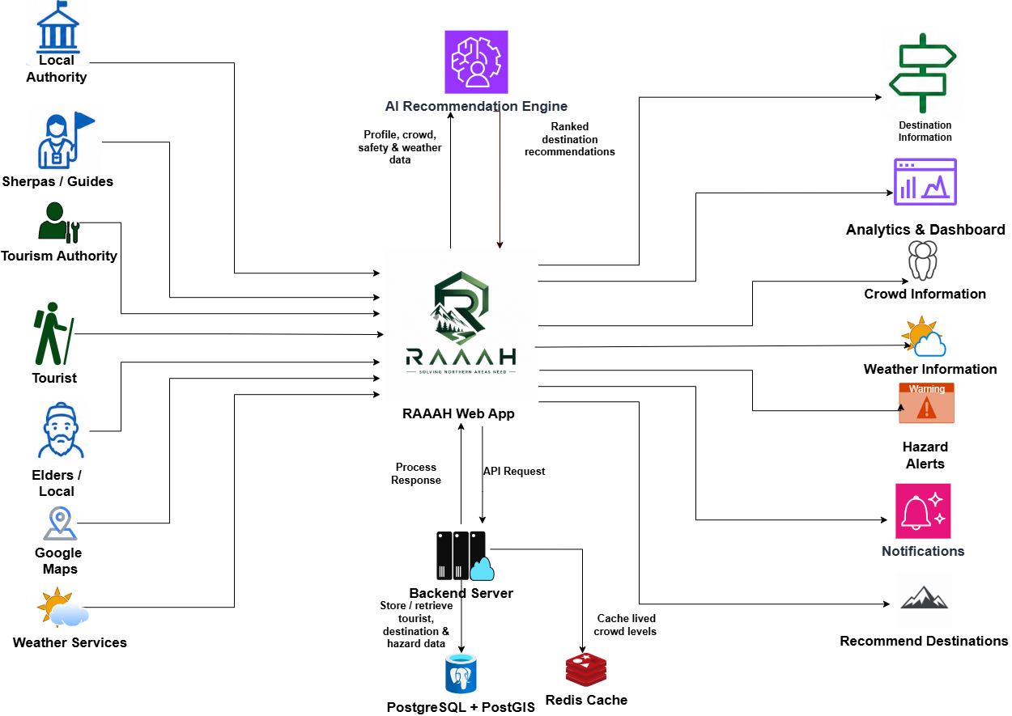
Figure 1: High-Level System / Architecture Diagram

5. Use Case Diagram

Actor | Description
Tourist | Registered user who explores destinations, checks in, receives recommendations and safety alerts.
Community Safety Observer | Verified tourist who submits hazard reports. Can also perform all Tourist use cases.
Administrator | Manages destinations, users, hazard reports and risk status.
Tourism Authority | Views aggregated analytics on the dashboard.
Table 20: Actors
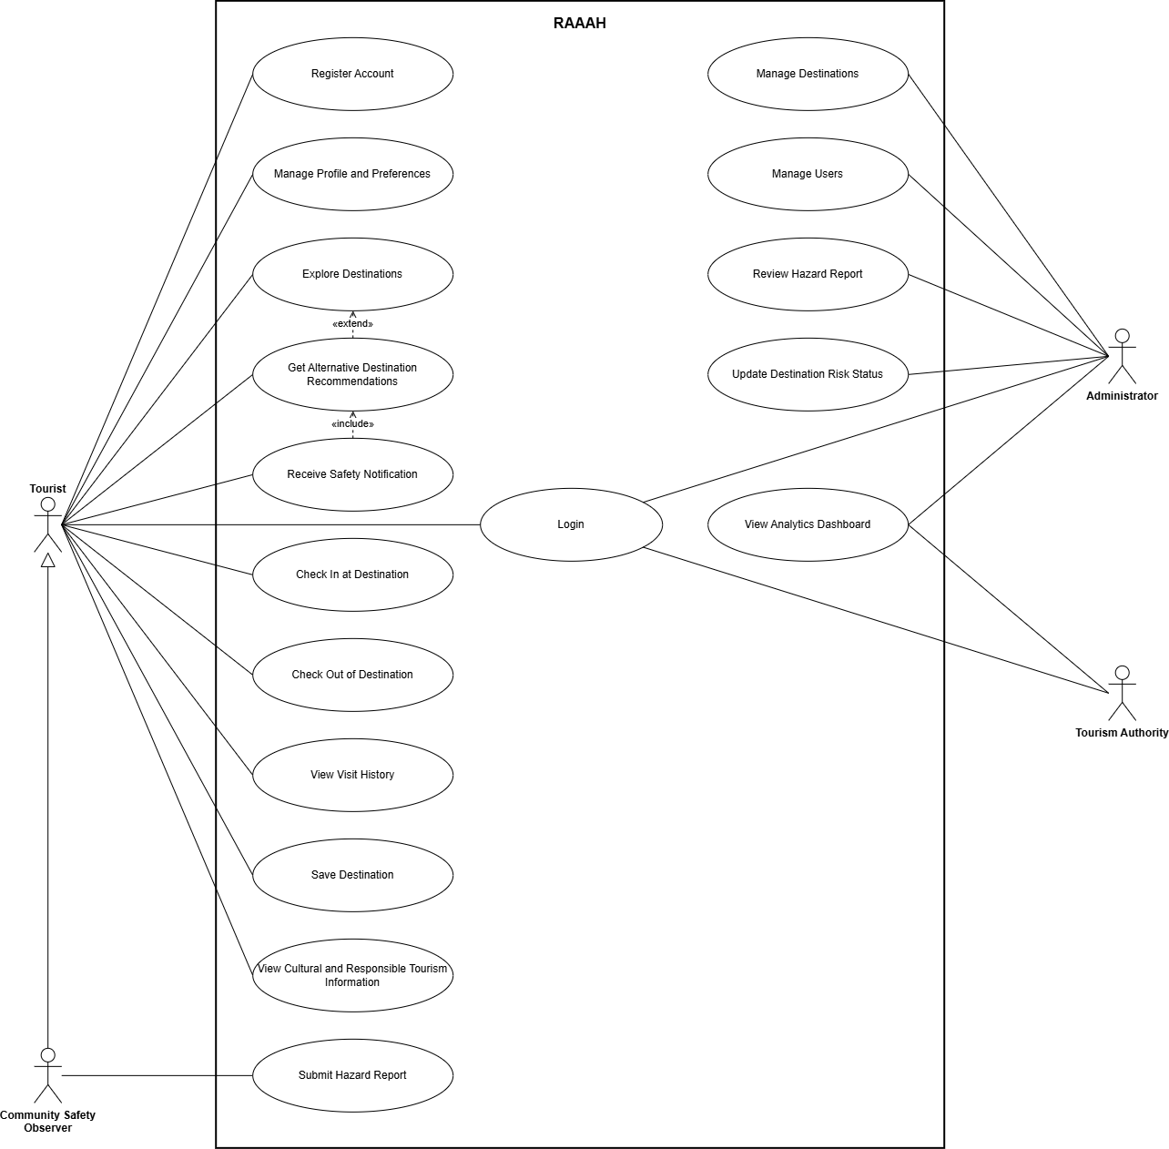
Figure 2: Use Case Diagram

6. High-Level Use Cases

6.1 Register Account

Use Case ID | UC-01
Use Case Name | Register Account
Actor(s) | Tourist
Type | Primary
Description | A new tourist creates an account and receives a unique Tourist ID.

Table 21: High-Level Use Case: Register Account

6.2 Login

Use Case ID | UC-02
Use Case Name | Login
Actor(s) | Tourist, Community Safety Observer, Administrator, Tourism Authority
Type | Primary
Description | A registered user logs in to access the features of the assigned role, and logs out when finished.

Table 22: High-Level Use Case: Login

6.3 Manage Profile and Preferences

Use Case ID | UC-03
Use Case Name | Manage Profile and Preferences
Actor(s) | Tourist
Type | Primary
Description | Tourist views and updates profile information, travel preferences and location consent.

Table 23: High-Level Use Case: Manage Profile and Preferences

6.4 Explore Destinations

Use Case ID | UC-04
Use Case Name | Explore Destinations
Actor(s) | Tourist
Type | Primary
Description | Tourist searches destinations and views the information page of a destination, including crowd level, safety status, weather and accessibility.

Table 24: High-Level Use Case: Explore Destinations

6.5 Save Destination

Use Case ID | UC-05
Use Case Name | Save Destination
Actor(s) | Tourist
Type | Primary
Description | Tourist saves a destination to the profile to plan a visit and receive alerts about it.

Table 25: High-Level Use Case: Save Destination

6.6 Check In at Destination

Use Case ID | UC-06
Use Case Name | Check In at Destination
Actor(s) | Tourist
Type | Primary
Description | Tourist checks in at a destination using location. The check-in is used to estimate the crowd level.

Table 26: High-Level Use Case: Check In at Destination

6.7 Check Out of Destination

Use Case ID | UC-07
Use Case Name | Check Out of Destination
Actor(s) | Tourist
Type | Primary
Description | Tourist checks out of a destination. The visit is added to the visit history and the crowd level is updated.

Table 27: High-Level Use Case: Check Out of Destination

6.8 View Visit History

Use Case ID | UC-08
Use Case Name | View Visit History
Actor(s) | Tourist
Type | Secondary
Description | Tourist views the record of completed destination visits.

Table 28: High-Level Use Case: View Visit History

6.9 Get Alternative Destination Recommendations

Use Case ID | UC-09
Use Case Name | Get Alternative Destination Recommendations
Actor(s) | Tourist
Type | Primary
Description | System recommends safer and less crowded destinations that match the tourist’s preferences.

Table 29: High-Level Use Case: Get Alternative Destination Recommendations

6.10 Submit Hazard Report

Use Case ID | UC-10
Use Case Name | Submit Hazard Report
Actor(s) | Community Safety Observer
Type | Primary
Description | A verified observer reports a hazard observed at or near a destination.

Table 30: High-Level Use Case: Submit Hazard Report

6.11 Review Hazard Report

Use Case ID | UC-11
Use Case Name | Review Hazard Report
Actor(s) | Administrator
Type | Primary
Description | Administrator reviews a hazard report and moves it through the validation workflow.

Table 31: High-Level Use Case: Review Hazard Report

6.12 Update Destination Risk Status

Use Case ID | UC-12
Use Case Name | Update Destination Risk Status
Actor(s) | Administrator
Type | Primary
Description | Administrator updates the risk status of a destination to Low Risk, Elevated Risk or High Risk.

Table 32: High-Level Use Case: Update Destination Risk Status

6.13 Receive Safety Notification

Use Case ID | UC-13
Use Case Name | Receive Safety Notification
Actor(s) | Tourist
Type | Primary
Description | Tourist receives an alert when a verified hazard affects a selected, saved or checked-in destination, along with safer alternatives.

Table 33: High-Level Use Case: Receive Safety Notification

6.14 View Cultural and Responsible Tourism Information

Use Case ID | UC-14
Use Case Name | View Cultural and Responsible Tourism Information
Actor(s) | Tourist
Type | Secondary
Description | Tourist views local culture, etiquette and environmental guidelines.

Table 34: High-Level Use Case: View Cultural and Responsible Tourism Information

6.15 Manage Destinations

Use Case ID | UC-15
Use Case Name | Manage Destinations
Actor(s) | Administrator
Type | Primary
Description | Administrator adds and updates destinations, including location, capacity threshold and destination information.

Table 35: High-Level Use Case: Manage Destinations

6.16 Manage Users

Use Case ID | UC-16
Use Case Name | Manage Users
Actor(s) | Administrator
Type | Primary
Description | Administrator manages user accounts and verifies Community Safety Observers.

Table 36: High-Level Use Case: Manage Users

6.17 View Analytics Dashboard

Use Case ID | UC-17
Use Case Name | View Analytics Dashboard
Actor(s) | Administrator, Tourism Authority
Type | Primary
Description | Authorized user views aggregated analytics on tourists, crowd levels, safety reports and recommendation trends.

Table 37: High-Level Use Case: View Analytics Dashboard

7. Expanded Use Cases

7.1 Register Account

Use Case ID | UC-01
Use Case Name | Register Account
Actor(s) | Tourist
Type | Primary
Description | A new tourist creates an account and receives a unique Tourist ID.
Trigger | Tourist selects the Register option.
Pre-condition | The tourist does not already have an account.
Post-condition | The account is created and a unique Tourist ID is generated.
Normal Flow | 1. Tourist selects Register.  2. System displays the registration form.  3. Tourist enters basic personal information and travel preferences and submits the form.  4. System validates the information.  5. System creates the account and generates a unique Tourist ID.  6. System displays a confirmation message.
Alternative Flow | 4a. Email is already registered: system shows an error and asks the tourist to log in.  4b. Required information is missing or invalid: system highlights the fields to be corrected.

Table 38: Expanded Use Case: Register Account

7.2 Login

Use Case ID | UC-02
Use Case Name | Login
Actor(s) | Tourist, Community Safety Observer, Administrator, Tourism Authority
Type | Primary
Description | A registered user logs in to access the features of the assigned role, and logs out when finished.
Trigger | User selects the Login option.
Pre-condition | The user has a registered account.
Post-condition | The user is logged in and the interface of the assigned role is displayed.
Normal Flow | 1. User selects Login.  2. System displays the login form.  3. User enters email and password.  4. System verifies the credentials and identifies the user’s role.  5. System displays the home page or dashboard according to the role.
Alternative Flow | 4a. Invalid credentials: system shows an error and asks the user to try again.

Table 39: Expanded Use Case: Login

7.3 Manage Profile and Preferences

Use Case ID | UC-03
Use Case Name | Manage Profile and Preferences
Actor(s) | Tourist
Type | Primary
Description | Tourist views and updates profile information, travel preferences and location consent.
Trigger | Tourist opens the Profile page.
Pre-condition | Tourist is logged in.
Post-condition | Updated profile and preferences are saved and used for recommendations.
Normal Flow | 1. Tourist opens the Profile page.  2. System displays profile information, preferences and location consent.  3. Tourist updates the required information.  4. System validates and saves the changes.  5. System displays a confirmation message.
Alternative Flow | 4a. Invalid information entered: system shows an error and keeps the previous values.

Table 40: Expanded Use Case: Manage Profile and Preferences

7.4 Explore Destinations

Use Case ID | UC-04
Use Case Name | Explore Destinations
Actor(s) | Tourist
Type | Primary
Description | Tourist searches destinations and views the information page of a destination, including crowd level, safety status, weather and accessibility.
Trigger | Tourist opens the Destinations page or searches for a destination.
Pre-condition | 1. Tourist is logged in.  2. Destinations are registered in the system.
Post-condition | Destination information is displayed to the tourist.
Normal Flow | 1. Tourist opens the Destinations page.  2. System displays registered destinations on a list and a map.  3. Tourist searches for or selects a destination.  4. System retrieves destination details, current crowd level and risk status.  5. System retrieves current weather from the OpenWeatherMap API.  6. System displays the destination page.
Alternative Flow | 3a. No destination matches the search: system shows a ‘No destinations found’ message.  5a. Weather service is unavailable: system shows the last available weather with its update time.  6a. Destination is crowded or unsafe: system shows a warning and offers alternative recommendations.

Table 41: Expanded Use Case: Explore Destinations

7.5 Save Destination

Use Case ID | UC-05
Use Case Name | Save Destination
Actor(s) | Tourist
Type | Primary
Description | Tourist saves a destination to the profile to plan a visit and receive alerts about it.
Trigger | Tourist selects Save on a destination page.
Pre-condition | Tourist is logged in.
Post-condition | The destination is added to the tourist’s saved destinations.
Normal Flow | 1. Tourist opens a destination page.  2. Tourist selects Save.  3. System adds the destination to the tourist’s saved destinations.  4. System displays a confirmation message.
Alternative Flow | 3a. Destination is already saved: system informs the tourist and offers to remove it.

Table 42: Expanded Use Case: Save Destination

7.6 Check In at Destination

Use Case ID | UC-06
Use Case Name | Check In at Destination
Actor(s) | Tourist
Type | Primary
Description | Tourist checks in at a destination using location. The check-in is used to estimate the crowd level.
Trigger | Tourist selects Check In on the destination page.
Pre-condition | Tourist is logged in and has given location consent.
Post-condition | The check-in is recorded and the crowd level of the destination is updated.
Normal Flow | 1. Tourist selects Check In.  2. System requests the tourist’s current location.  3. System verifies that the tourist is within the destination area.  4. System records the check-in.  5. System updates the active visitor count and crowd level of the destination.  6. System displays a confirmation message.
Alternative Flow | 2a. Location permission is denied: system informs the tourist that check-in requires location.  3a. Tourist is outside the destination area: system rejects the check-in.

Table 43: Expanded Use Case: Check In at Destination

7.7 Check Out of Destination

Use Case ID | UC-07
Use Case Name | Check Out of Destination
Actor(s) | Tourist
Type | Primary
Description | Tourist checks out of a destination. The visit is added to the visit history and the crowd level is updated.
Trigger | Tourist selects Check Out.
Pre-condition | Tourist has an active check-in.
Post-condition | The check-in is closed, the visit is recorded in visit history and the crowd level is updated.
Normal Flow | 1. Tourist selects Check Out.  2. System closes the active check-in.  3. System records the visit in the tourist’s visit history.  4. System updates the crowd level of the destination.  5. System displays a confirmation message.
Alternative Flow | 1a. Tourist does not check out: system closes the check-in automatically after the configured time and records the visit.

Table 44: Expanded Use Case: Check Out of Destination

7.8 View Visit History

Use Case ID | UC-08
Use Case Name | View Visit History
Actor(s) | Tourist
Type | Secondary
Description | Tourist views the record of completed destination visits.
Trigger | Tourist opens the Visit History page.
Pre-condition | Tourist is logged in.
Post-condition | Visit history is displayed.
Normal Flow | 1. Tourist opens the Visit History page.  2. System retrieves the tourist’s completed visits.  3. System displays the visits with destination and date.
Alternative Flow | 2a. No visits recorded: system displays ‘No visits yet’.

Table 45: Expanded Use Case: View Visit History

7.9 Get Alternative Destination Recommendations

Use Case ID | UC-09
Use Case Name | Get Alternative Destination Recommendations
Actor(s) | Tourist
Type | Primary
Description | System recommends safer and less crowded destinations that match the tourist’s preferences.
Trigger | Tourist selects a destination that is crowded, unsafe or affected by weather, or requests recommendations.
Pre-condition | 1. Tourist is logged in.  2. Crowd, safety and weather data of destinations are available.
Post-condition | Personalized alternative destinations are displayed to the tourist.
Normal Flow | 1. Tourist selects a destination or requests recommendations.  2. System collects the tourist’s preferences, visit history and location.  3. System collects current crowd, safety, weather and accessibility data of destinations.  4. AI Recommendation Engine analyzes the data and scores the candidate destinations.  5. AI Recommendation Engine ranks the destinations.  6. System displays the personalized recommendations.  7. Tourist selects a recommended destination and the system displays its details.
Alternative Flow | 6a. No suitable alternative is found: system informs the tourist and shows the safety information of the selected destination.  7a. Tourist continues with the original destination: system displays the selected destination.

Table 46: Expanded Use Case: Get Alternative Destination Recommendations

7.10 Submit Hazard Report

Use Case ID | UC-10
Use Case Name | Submit Hazard Report
Actor(s) | Community Safety Observer
Type | Primary
Description | A verified observer reports a hazard observed at or near a destination.
Trigger | Observer selects Report Hazard.
Pre-condition | Observer is logged in and verified as a Community Safety Observer.
Post-condition | The report is saved with status Unverified and is available for administrator review.
Normal Flow | 1. Observer selects Report Hazard.  2. System displays the hazard report form.  3. Observer selects the hazard type, sets the location and enters a description.  4. Observer submits the report.  5. System validates and saves the report with status Unverified.  6. System displays a confirmation message.
Alternative Flow | 5a. Required information is missing: system asks the observer to complete the form.

Table 47: Expanded Use Case: Submit Hazard Report

7.11 Review Hazard Report

Use Case ID | UC-11
Use Case Name | Review Hazard Report
Actor(s) | Administrator
Type | Primary
Description | Administrator reviews a hazard report and moves it through the validation workflow.
Trigger | A new hazard report is available for review.
Pre-condition | 1. Administrator is logged in.  2. An Unverified report exists.
Post-condition | The report status is updated. A Verified report updates public safety information and triggers tourist notifications.
Normal Flow | 1. Administrator opens the hazard reports list.  2. System displays the reports with their status.  3. Administrator selects a report and marks it Under Review.  4. Administrator verifies the report and marks it Verified.  5. System updates the safety information of the affected destination and notifies affected tourists.  6. Administrator marks the report Resolved when the hazard is cleared.
Alternative Flow | 4a. Report is not valid: administrator rejects the report and it does not appear publicly.

Table 48: Expanded Use Case: Review Hazard Report

7.12 Update Destination Risk Status
Use Case ID | UC-12
Use Case Name | Update Destination Risk Status
Actor(s) | Administrator
Type | Primary
Description | Administrator updates the risk status of a destination to Low Risk, Elevated Risk or High Risk.
Trigger | A hazard is verified or resolved, or conditions at a destination change.
Pre-condition | Administrator is logged in.
Post-condition | The new risk status is shown on the destination page and used by the recommendation engine.
Normal Flow | 1. Administrator opens the destination in the dashboard.  2. System displays the current risk status and active hazards.  3. Administrator selects the new risk status.  4. System saves and displays the updated risk status.  5. If the risk is raised, system notifies affected tourists.
Alternative Flow | 4a. Update fails: system shows an error and keeps the previous status.

Table 49: Expanded Use Case: Update Destination Risk Status

7.13 Receive Safety Notification
Use Case ID | UC-13
Use Case Name | Receive Safety Notification
Actor(s) | Tourist
Type | Primary
Description | Tourist receives an alert when a verified hazard affects a selected, saved or checked-in destination, along with safer alternatives.
Trigger | A hazard report is verified or the risk status of a destination is raised.
Pre-condition | The tourist has selected, saved or checked in to the affected destination.
Post-condition | The tourist receives the alert and alternative recommendations.
Normal Flow | 1. System identifies tourists affected by the hazard.  2. AI Recommendation Engine re-evaluates suitable alternatives.  3. System sends the alert through Firebase Cloud Messaging.  4. Tourist opens the alert.  5. System displays hazard details and safer alternatives.
Alternative Flow | 3a. Push notification cannot be delivered: the alert is shown inside the application when the tourist next opens it.
Table 50: Expanded Use Case: Receive Safety Notification

7.14 View Cultural and Responsible Tourism Information

Use Case ID | UC-14
Use Case Name | View Cultural and Responsible Tourism Information
Actor(s) | Tourist
Type | Secondary
Description | Tourist views local culture, etiquette and environmental guidelines.
Trigger | Tourist opens the Culture section.
Pre-condition | Content is available in the system.
Post-condition | Cultural and responsible tourism information is displayed.
Normal Flow | 1. Tourist opens the Culture section.  2. System retrieves the cultural and responsible tourism information.  3. System displays traditions, etiquette, history, local food and environmental guidelines.
Alternative Flow | 2a. No content is available: system displays an appropriate message.

Table 51: Expanded Use Case: View Cultural and Responsible Tourism Information

7.15 Manage Destinations
Use Case ID | UC-15
Use Case Name | Manage Destinations
Actor(s) | Administrator
Type | Primary
Description | Administrator adds and updates destinations, including location, capacity threshold and destination information.
Trigger | Administrator opens destination management.
Pre-condition | Administrator is logged in.
Post-condition | Destination information is saved and available to tourists.
Normal Flow | 1. Administrator opens destination management.  2. System displays the list of destinations.  3. Administrator adds a new destination or selects one to update.  4. Administrator enters the destination information, location and capacity threshold.  5. System validates and saves the destination.  6. System displays a confirmation message.
Alternative Flow | 5a. Invalid or missing information: system highlights the fields to be corrected.
Table 52: Expanded Use Case: Manage Destinations

7.16 Manage Users
Use Case ID | UC-16
Use Case Name | Manage Users
Actor(s) | Administrator
Type | Primary
Description | Administrator manages user accounts and verifies Community Safety Observers.
Trigger | Administrator opens user management.
Pre-condition | Administrator is logged in.
Post-condition | User account or role is updated.
Normal Flow | 1. Administrator opens user management.  2. System displays the list of users.  3. Administrator selects a user.  4. Administrator updates the user's status or verifies the user as a Community Safety Observer.  5. System saves the change and displays a confirmation message.
Alternative Flow | 3a. User is not found: system displays an appropriate message.

Table 53: Expanded Use Case: Manage Users

7.17 View Analytics Dashboard
Use Case ID | UC-17
Use Case Name | View Analytics Dashboard
Actor(s) | Administrator, Tourism Authority
Type | Primary
Description | Authorized user views aggregated analytics on tourists, crowd levels, safety reports and recommendation trends.
Trigger | Authorized user opens the dashboard.
Pre-condition | User is logged in as Administrator or Tourism Authority.
Post-condition | Aggregated analytics are displayed.
Normal Flow | 1. User opens the dashboard.  2. System verifies the user's role.  3. System retrieves aggregated data.  4. System displays total registered tourists, crowd levels, tourist distribution, active safety reports and recommendation trends.
Alternative Flow | 2a. User is not authorized: system denies access.  3a. No data is available: system displays an appropriate message.
Table 54: Expanded Use Case: View Analytics Dashboard

8. Activity / Swimlane Diagrams

8.1 Register Account
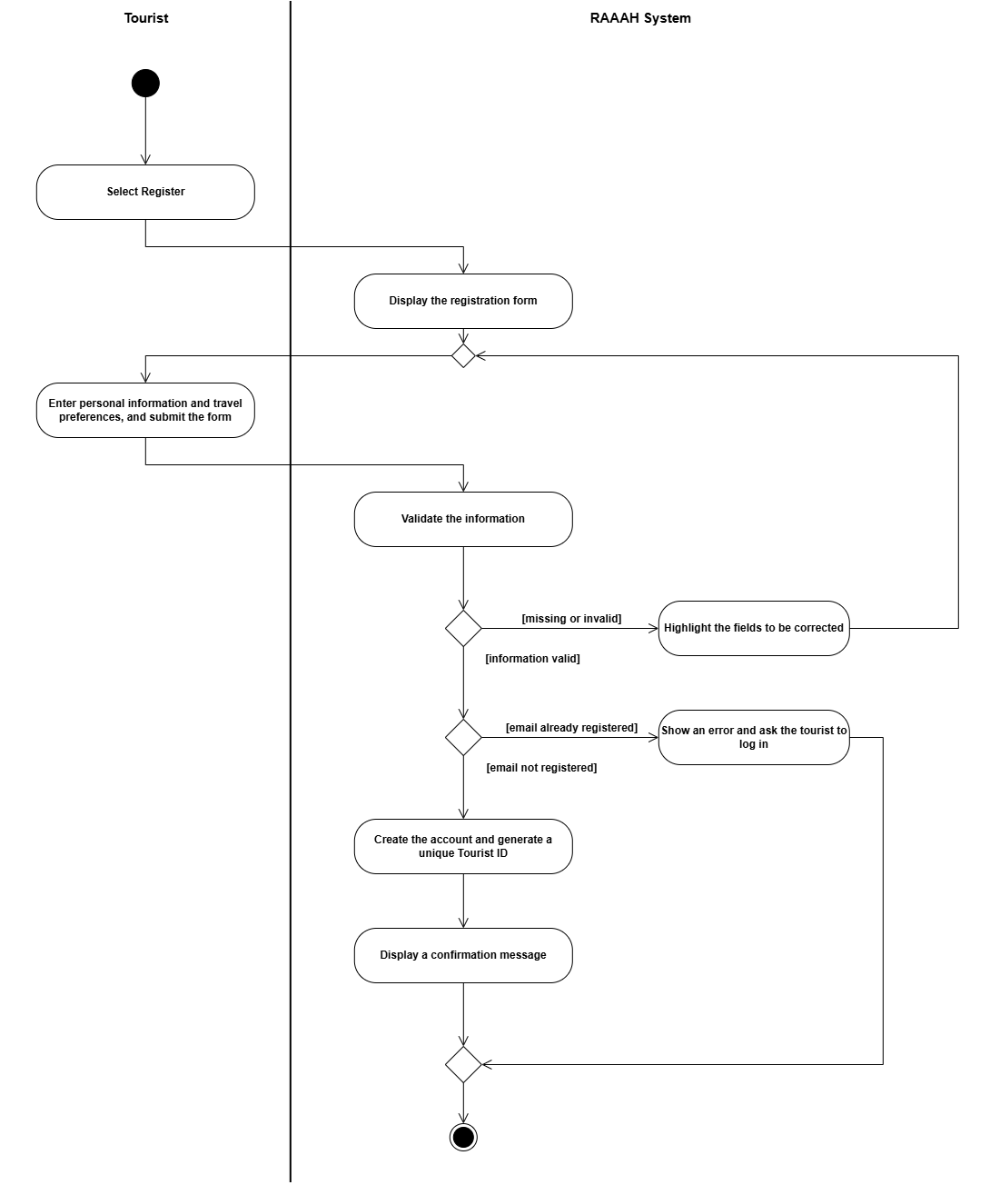

Figure 3: Activity Diagram: Register Account

8.2 Login
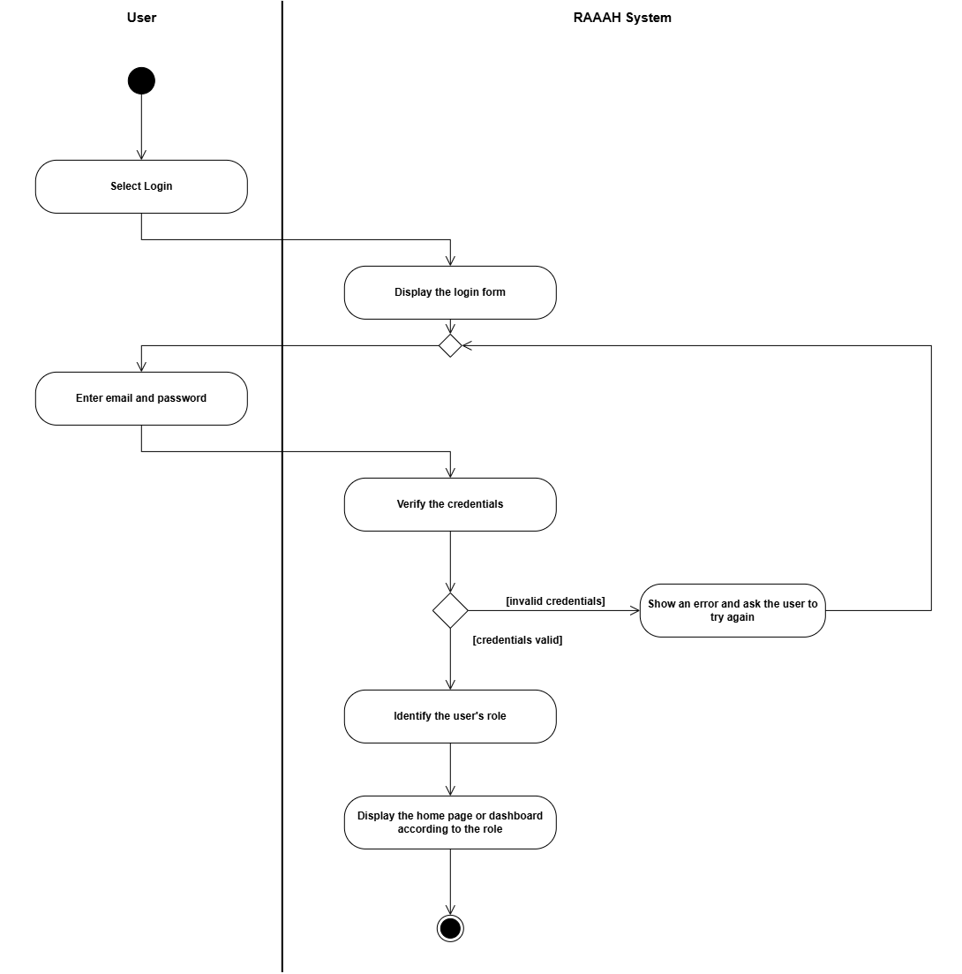
Figure 4: Activity Diagram: Login

8.3 Manage Profile and Preferences
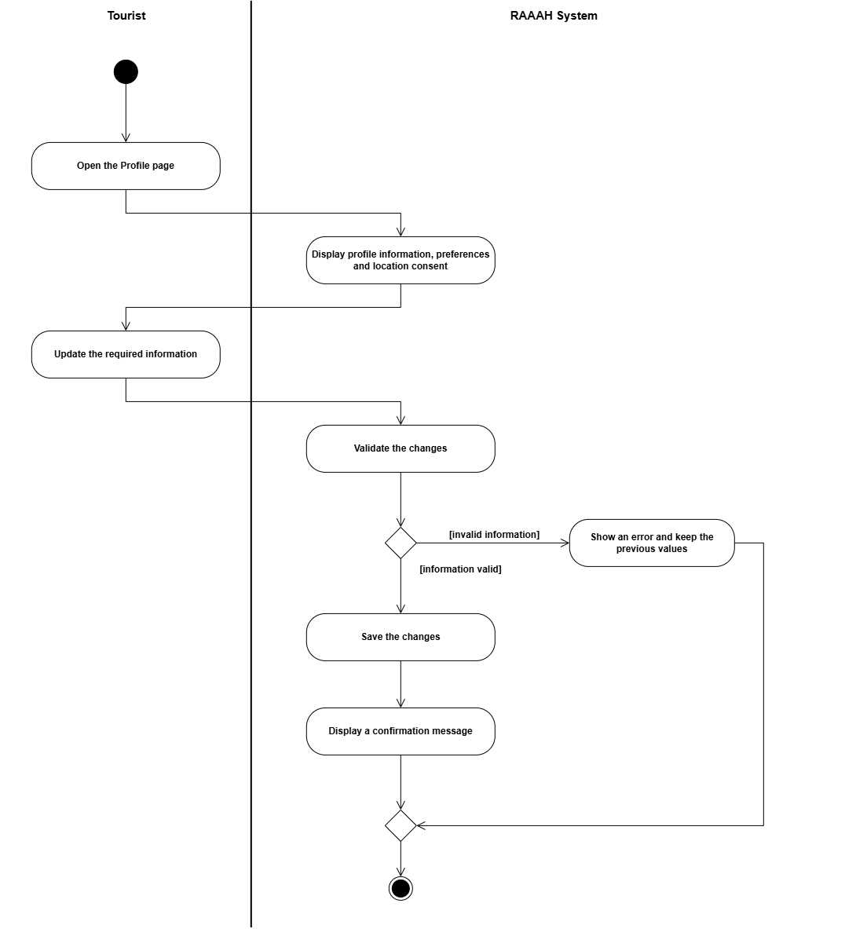
Figure 5: Activity Diagram: Manage Profile and Preferences

8.4 Explore Destinations
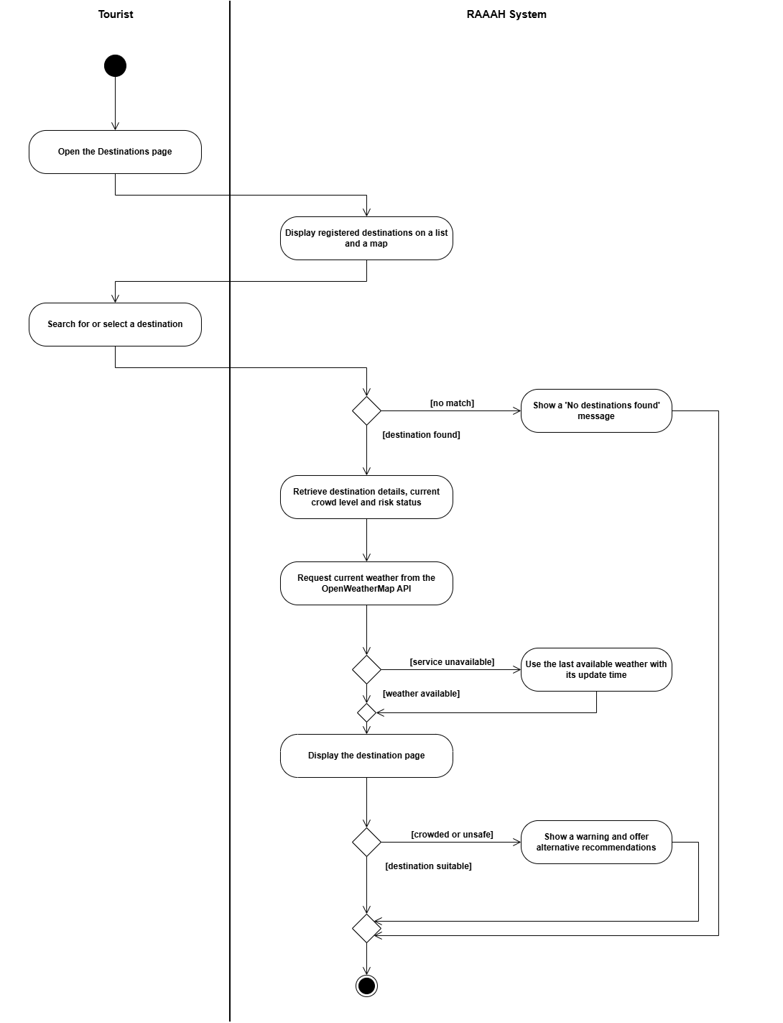
Figure 6: Activity Diagram: Explore Destinations

8.5 Save Destination
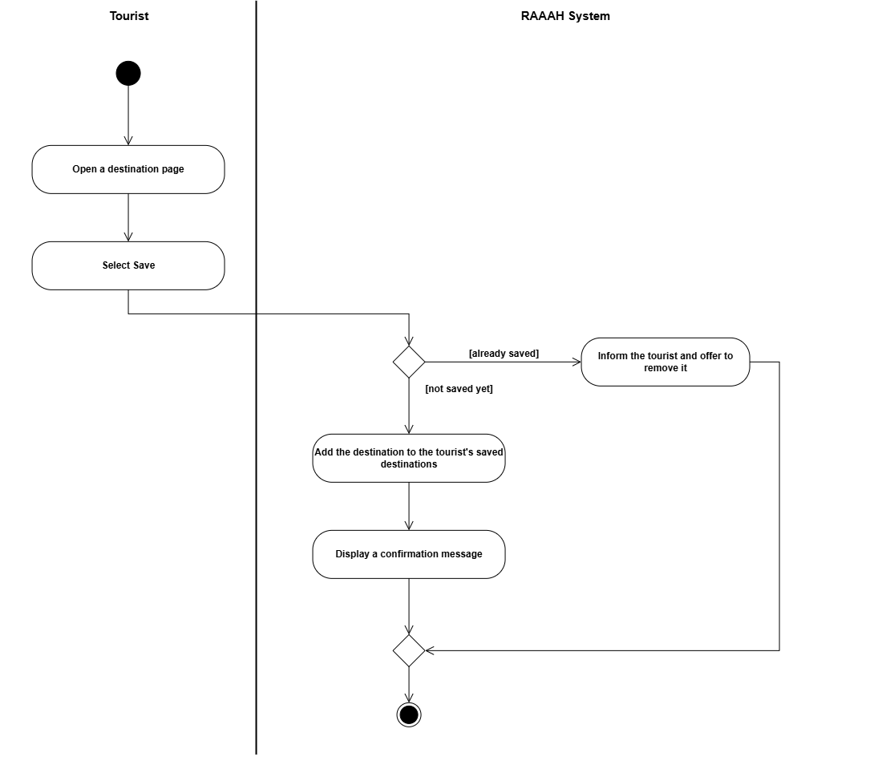
Figure 7: Activity Diagram: Save Destination

8.6 Check In at Destination
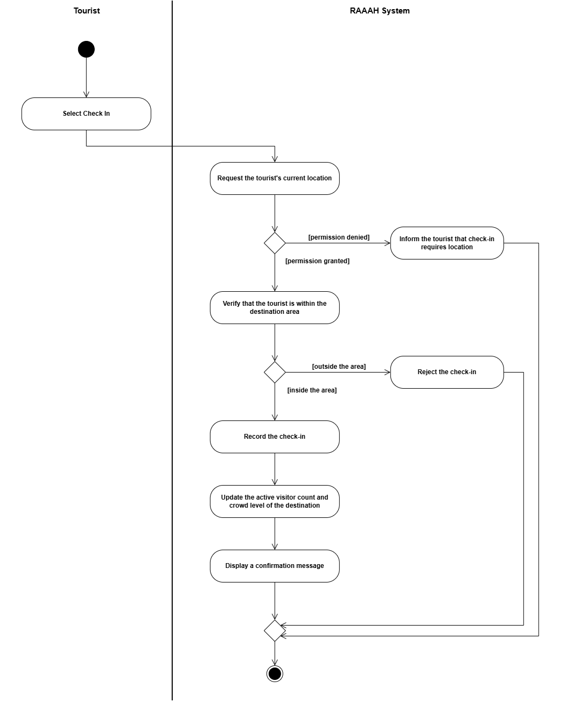
Figure 8: Activity Diagram: Check In at Destination

8.7 Check Out of Destination
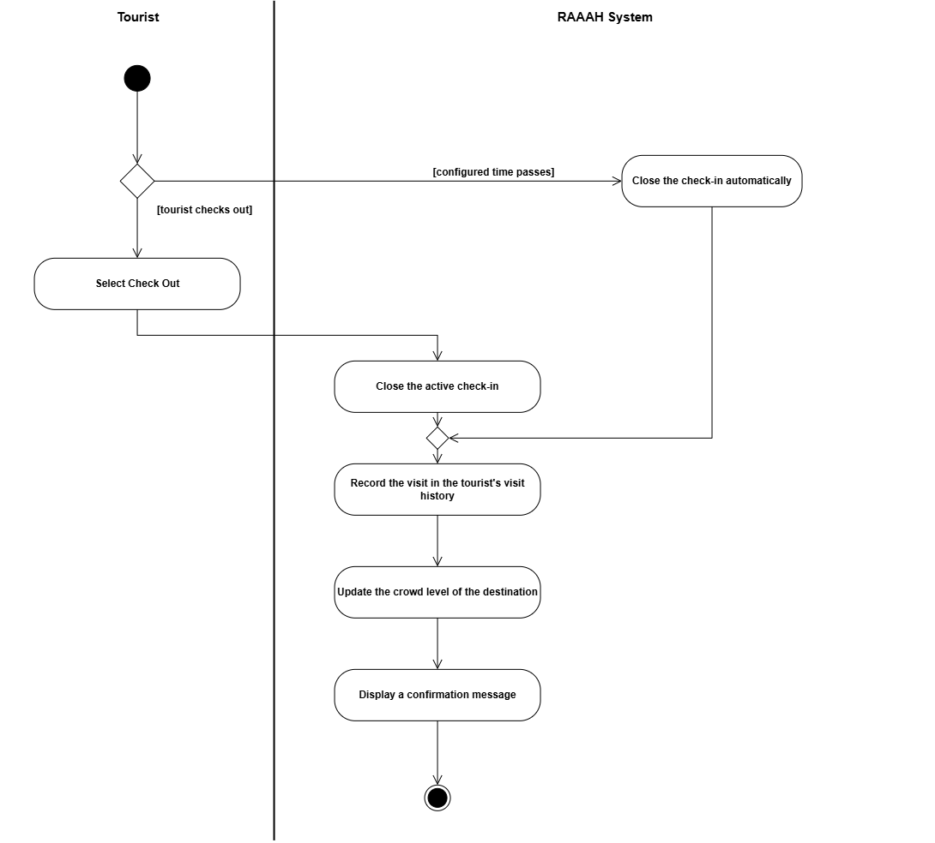
Figure 9: Activity Diagram: Check Out of Destination

8.8 View Visit History
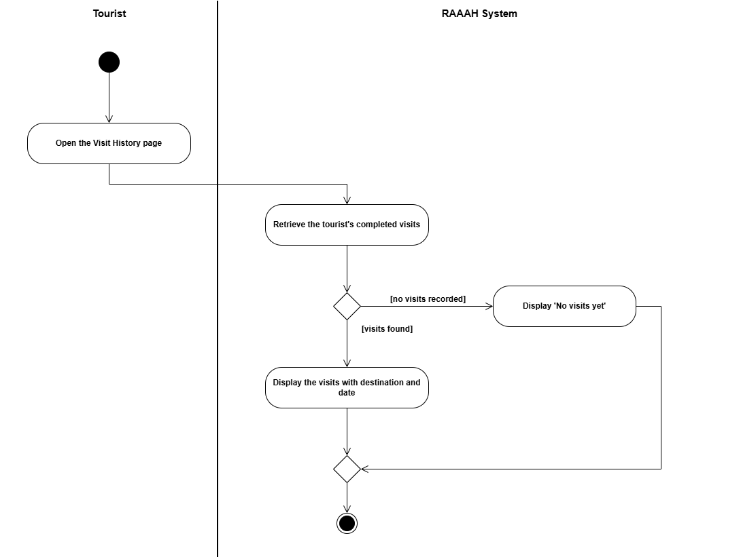

Figure 10: Activity Diagram: View Visit History

8.9 Get Alternative Destination Recommendations
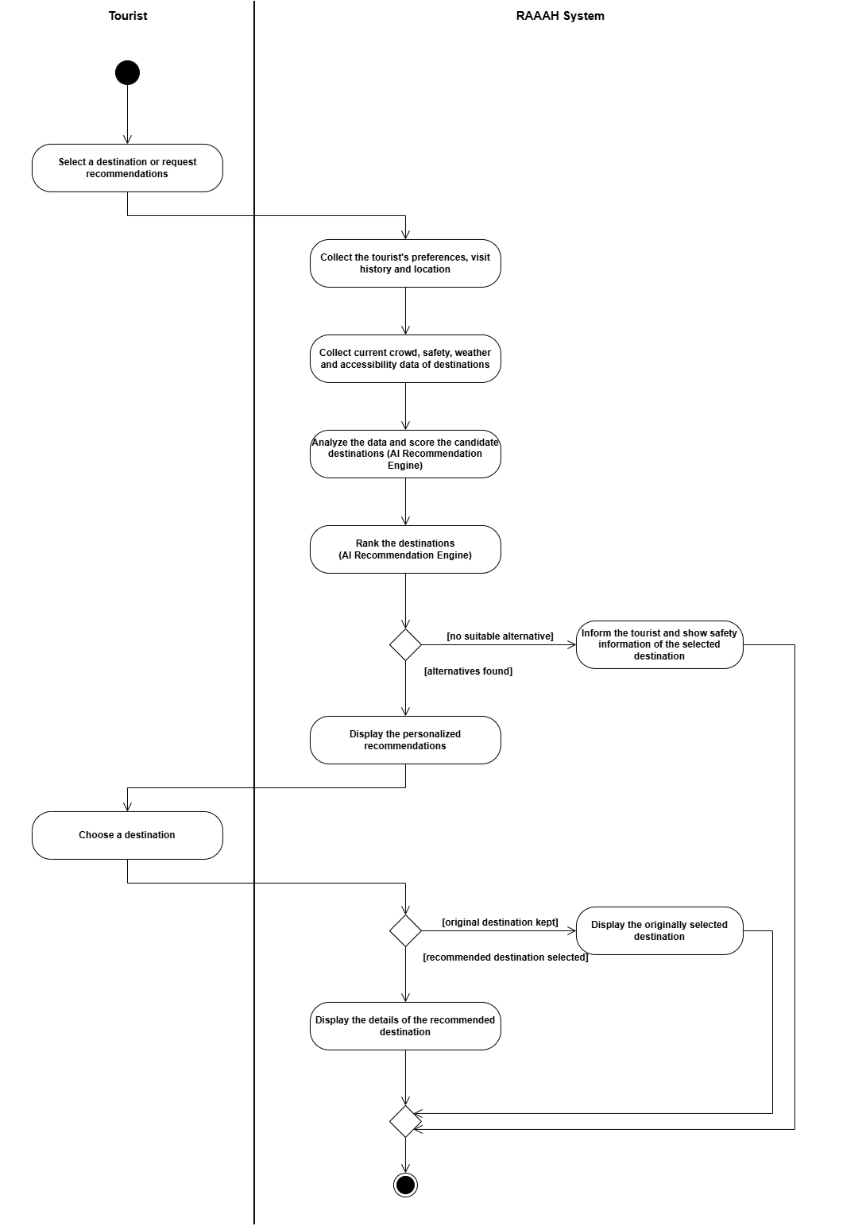 Figure 11: Activity Diagram: Get Alternative Destination Recommendations

8.10 Submit Hazard Report
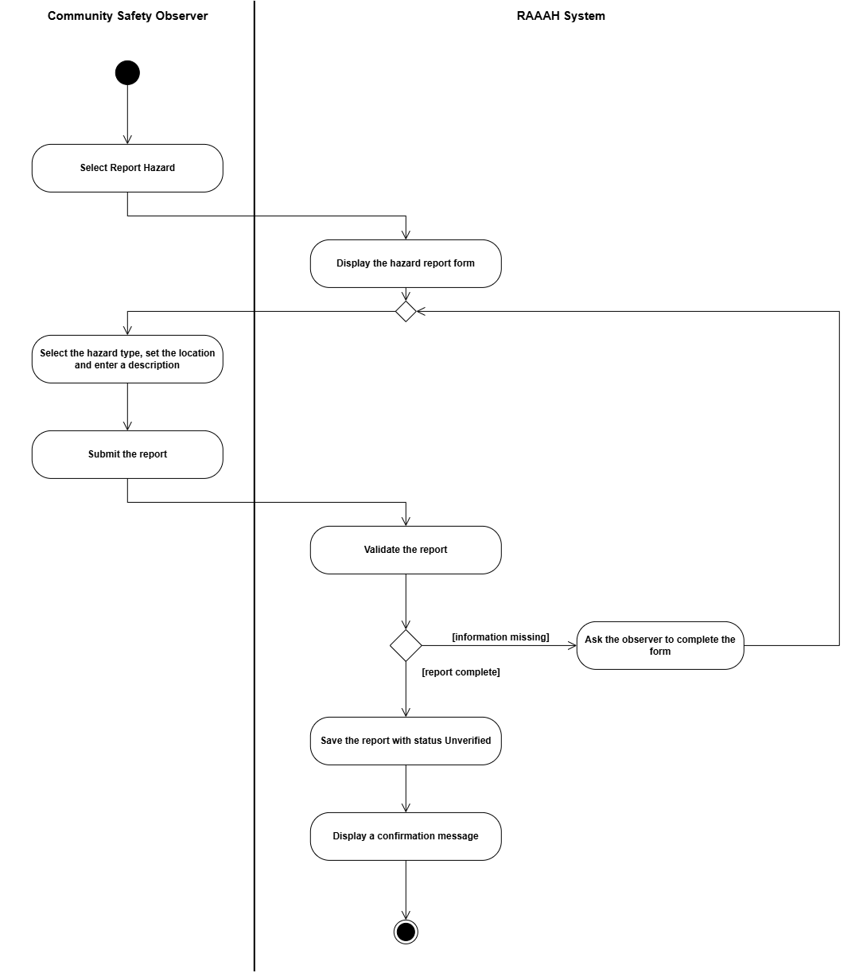
Figure 12: Activity Diagram: Submit Hazard Report

8.11 Review Hazard Report
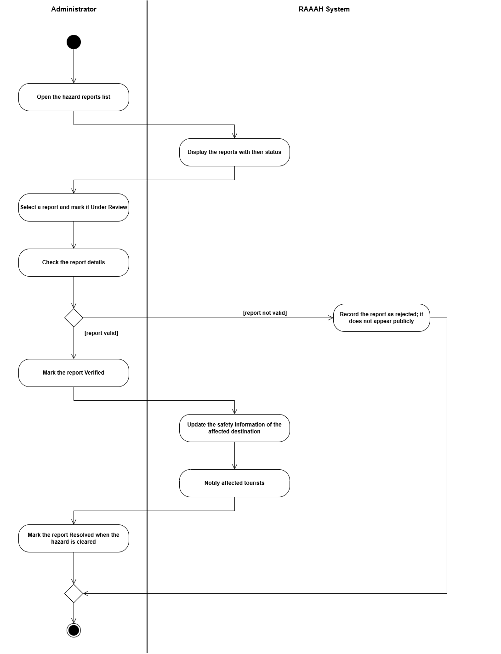
Figure 13: Activity Diagram: Review Hazard Report

8.12 Update Destination Risk Status
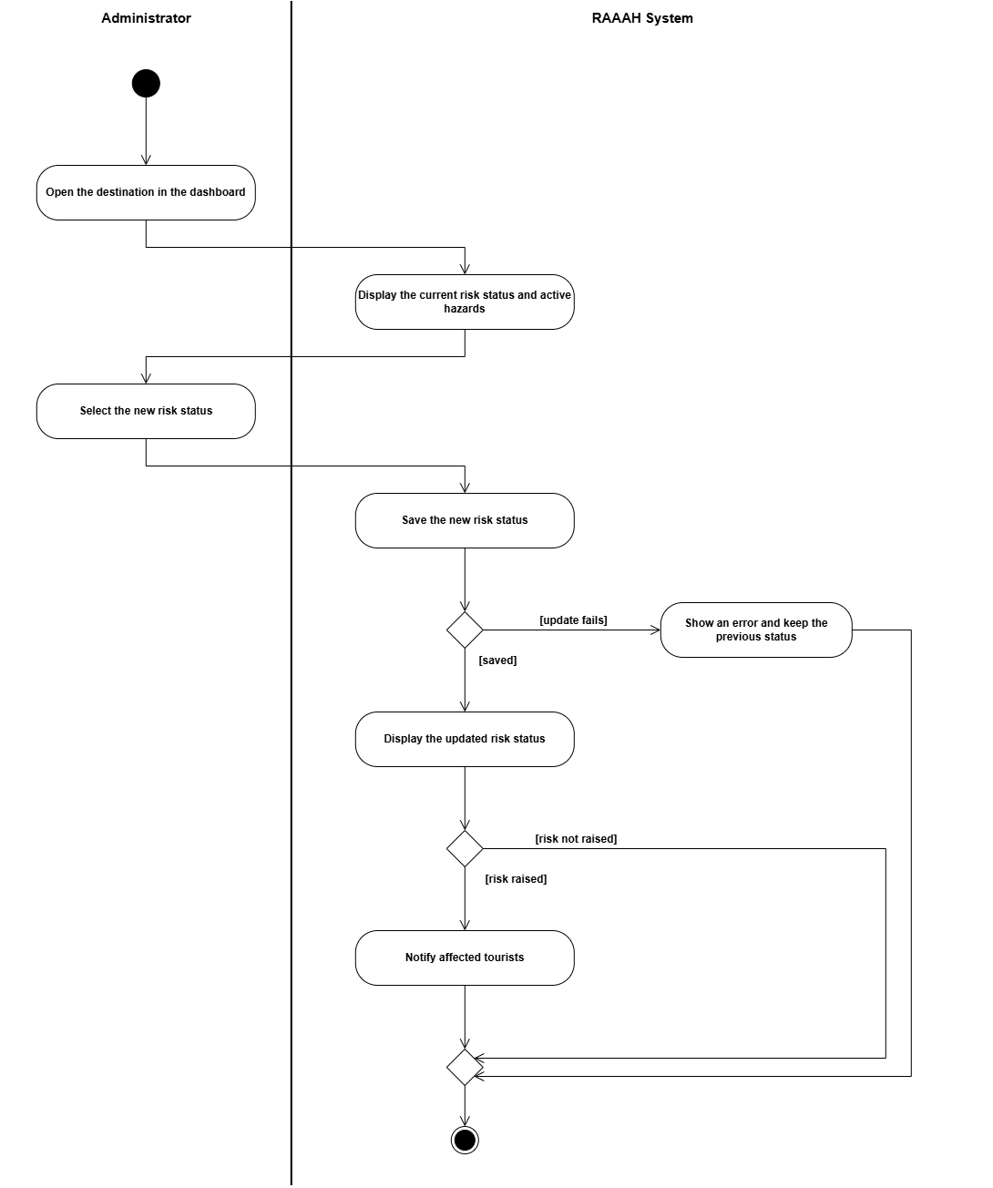
Figure 14: Activity Diagram: Update Destination Risk Status

8.13 Receive Safety Notification
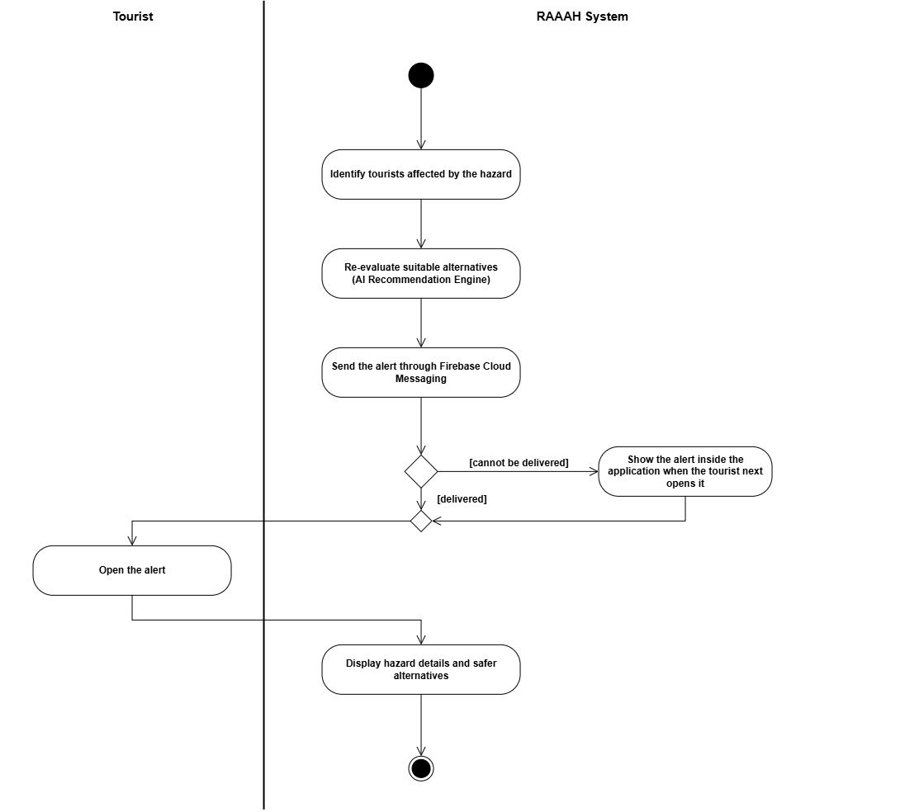
Figure 15: Activity Diagram: Receive Safety Notification

8.14 View Cultural and Responsible Tourism Information
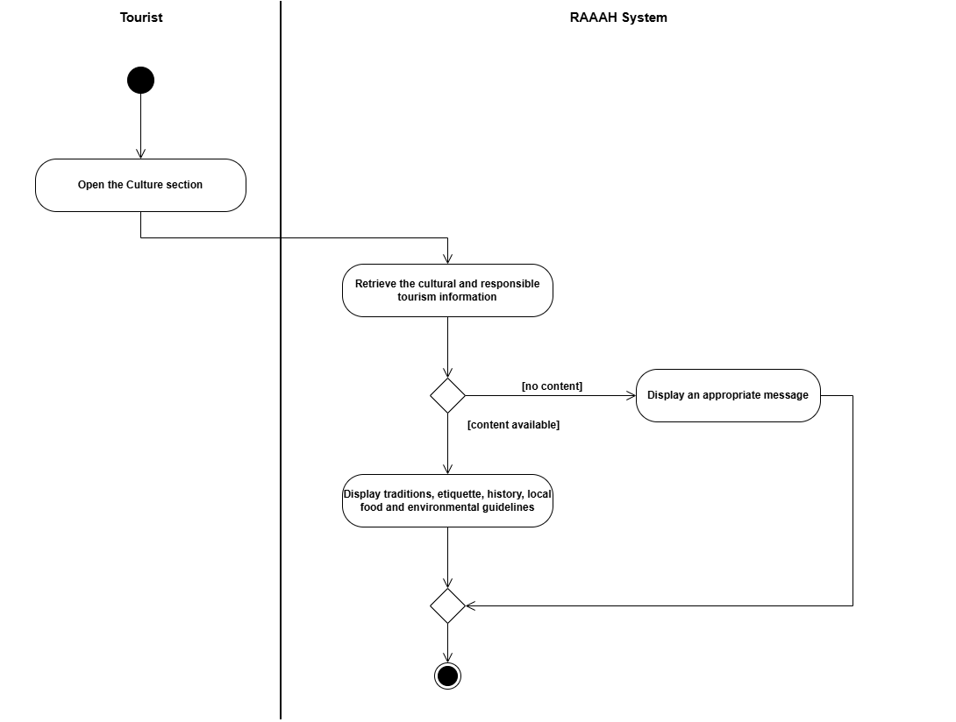
Figure 16: Activity Diagram: View Cultural and Responsible Tourism Information

8.15 Manage Destinations
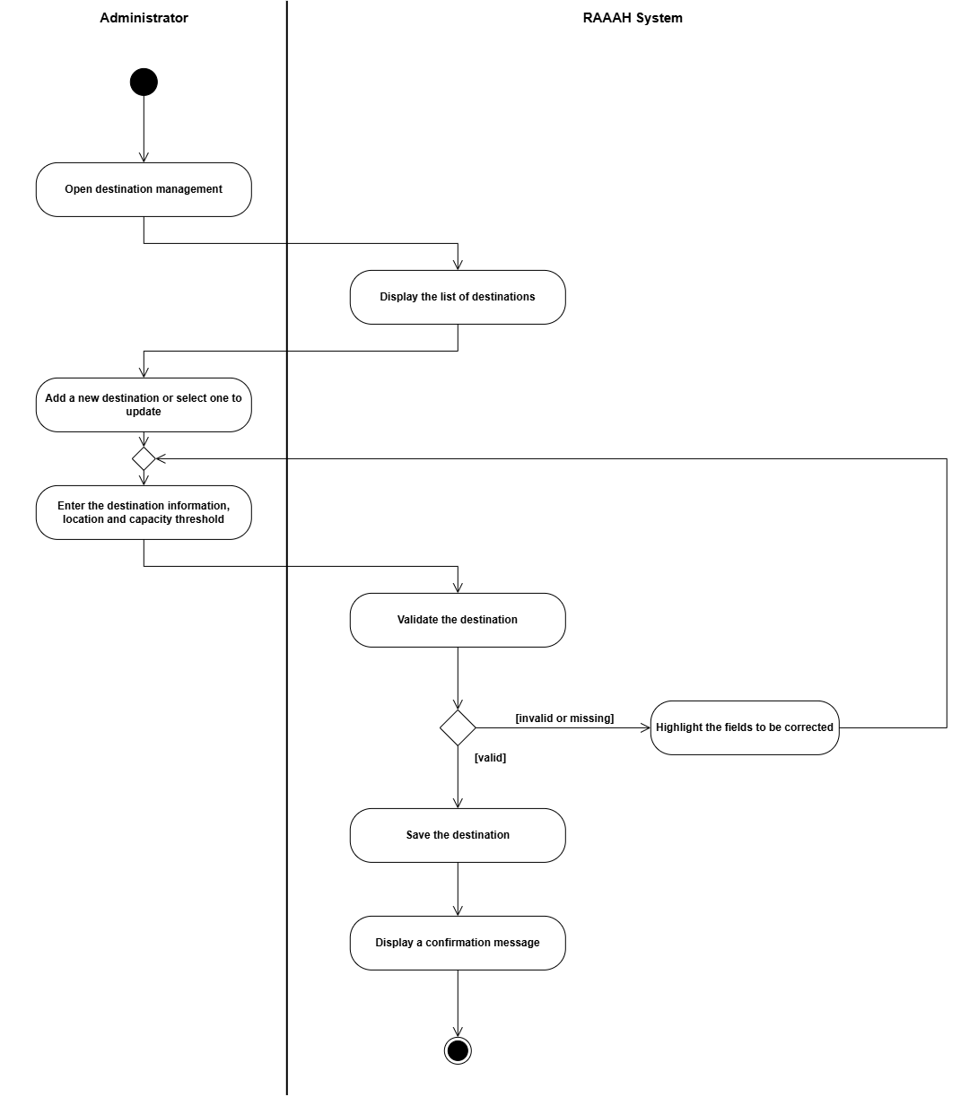
Figure 17: Activity Diagram: Manage Destinations

8.16 Manage Users
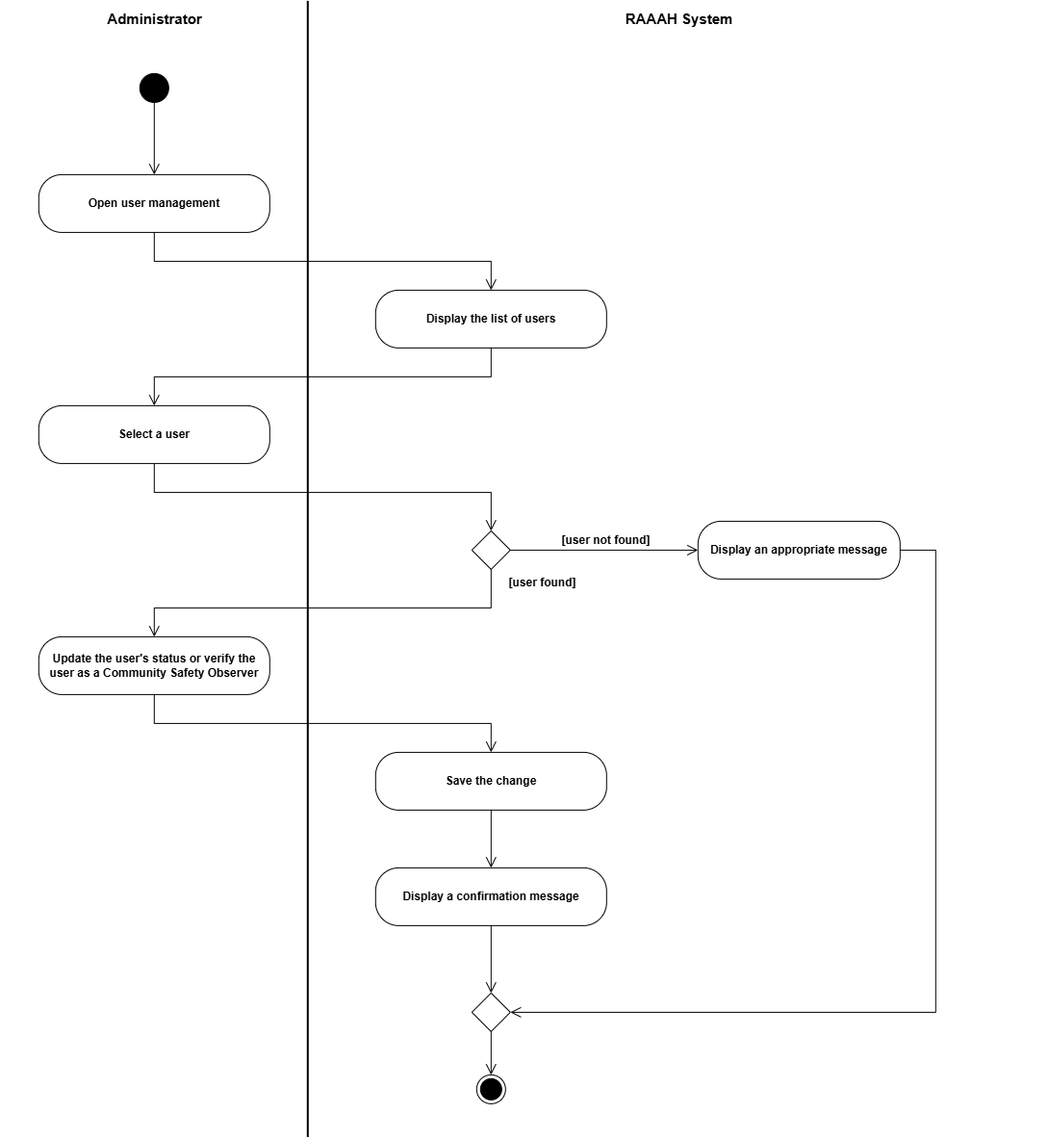
Figure 18: Activity Diagram: Manage Users

8.17 View Analytics Dashboard
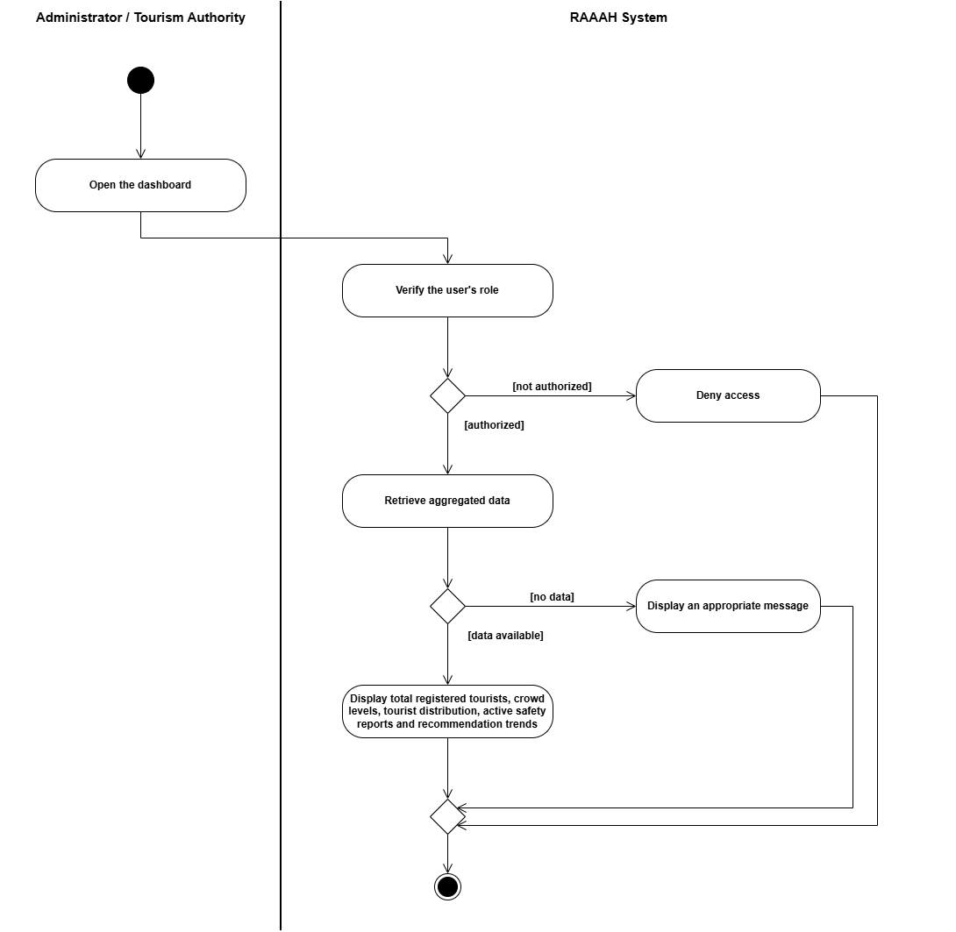
Figure 19: Activity Diagram: View Analytics Dashboard

9. System Sequence Diagrams

9.1 Register Account
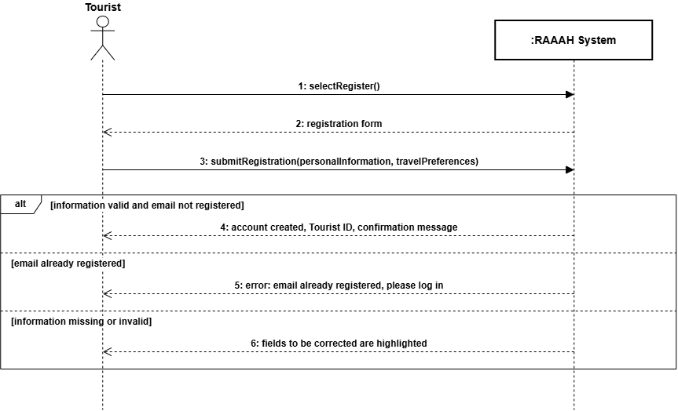Figure 20: System Sequence Diagram: Register Account

9.2 Login
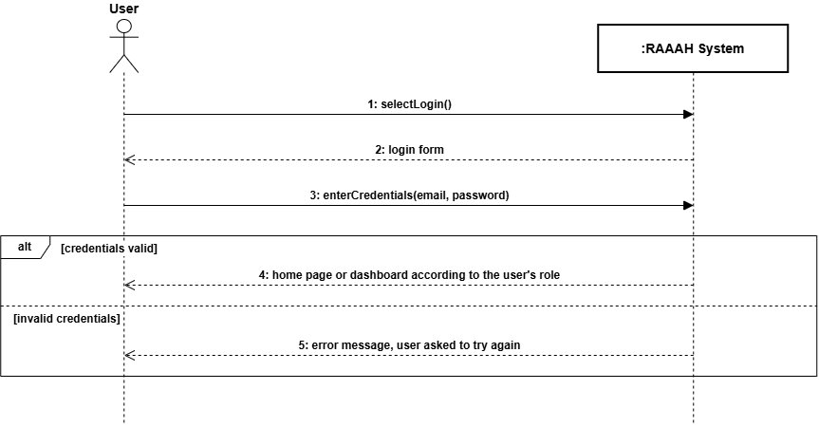Figure 21: System Sequence Diagram: Login

9.3 Manage Profile and Preferences
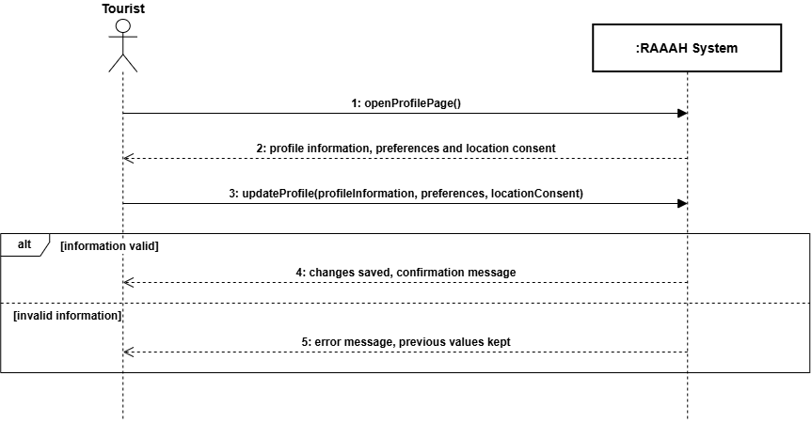Figure 22: System Sequence Diagram: Manage Profile and Preferences

9.4 Explore Destinations
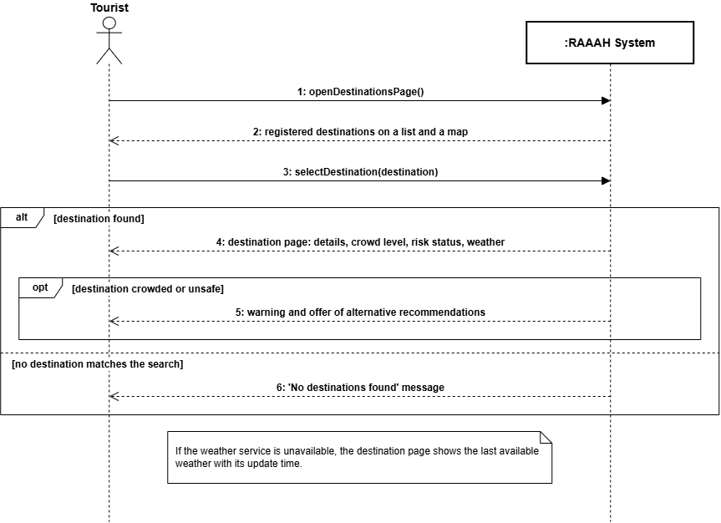Figure 23: System Sequence Diagram: Explore Destinations

9.5 Save Destination
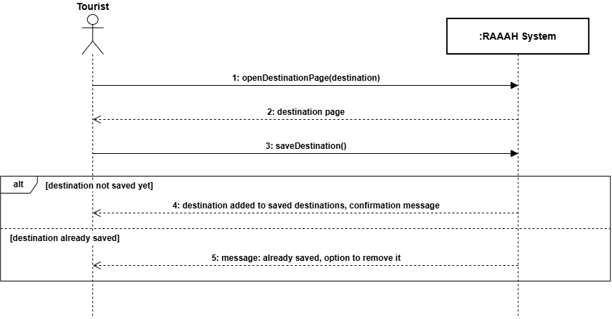Figure 24: System Sequence Diagram: Save Destination

9.6 Check In at Destination
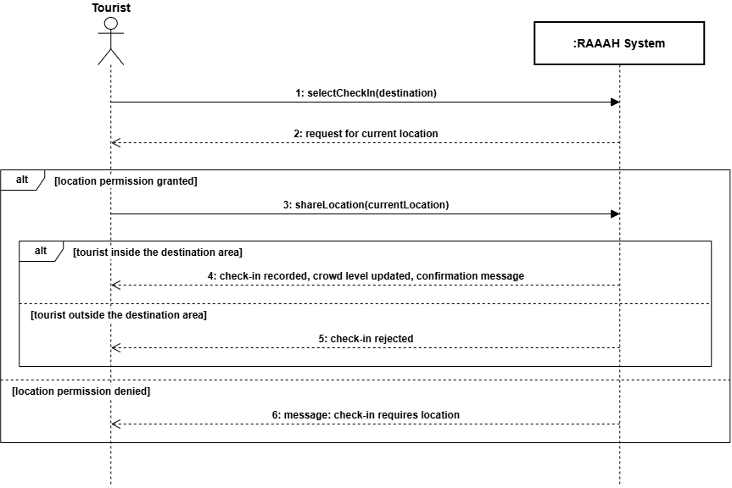Figure 25: System Sequence Diagram: Check In at Destination

9.7 Check Out of Destination
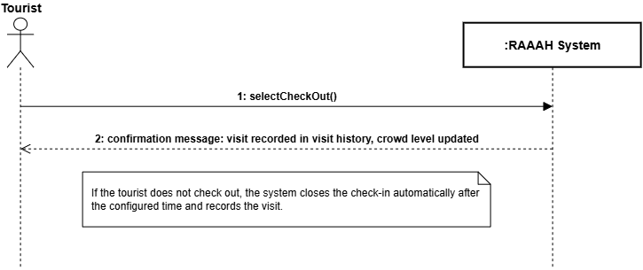
Figure 26: System Sequence Diagram: Check Out of Destination

9.8 View Visit History
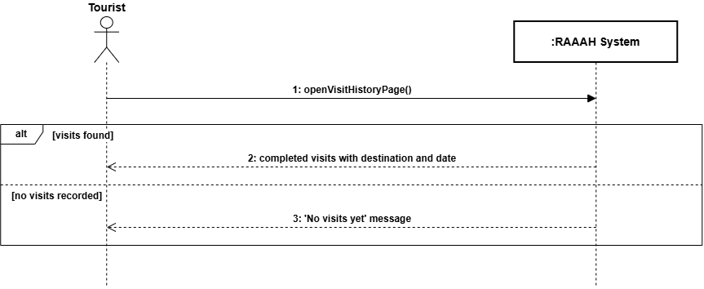Figure 27: System Sequence Diagram: View Visit History

9.9 Get Alternative Destination Recommendations
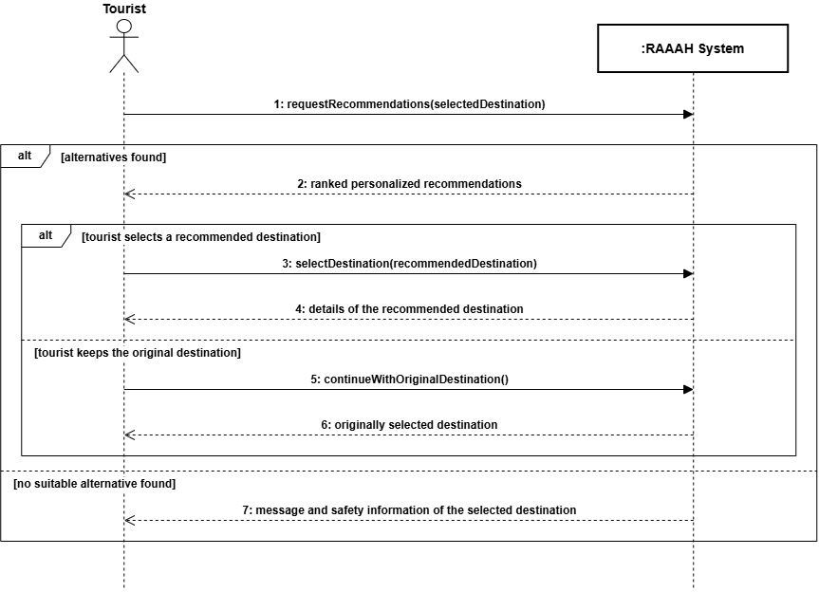Figure 28: System Sequence Diagram: Get Alternative Destination Recommendations

9.10 Submit Hazard Report
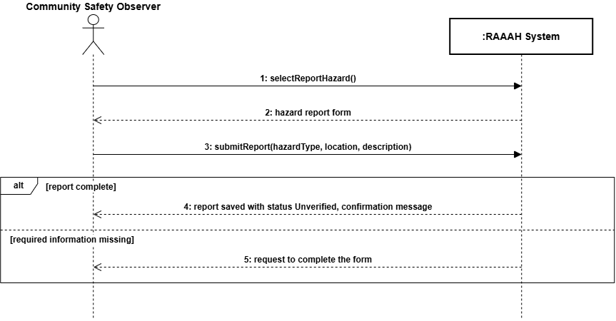Figure 29: System Sequence Diagram: Submit Hazard Report

9.11 Review Hazard Report
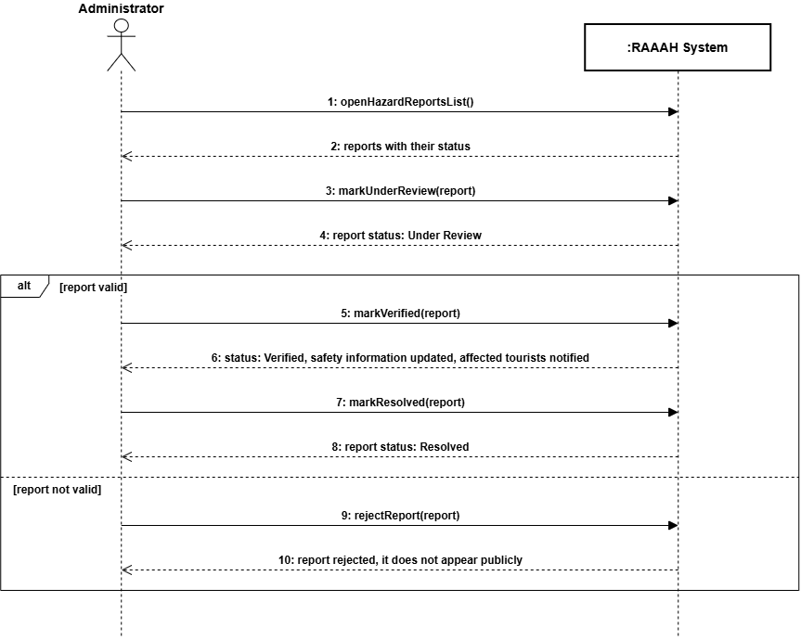
Figure 30: System Sequence Diagram: Review Hazard Report

9.12 Update Destination Risk Status
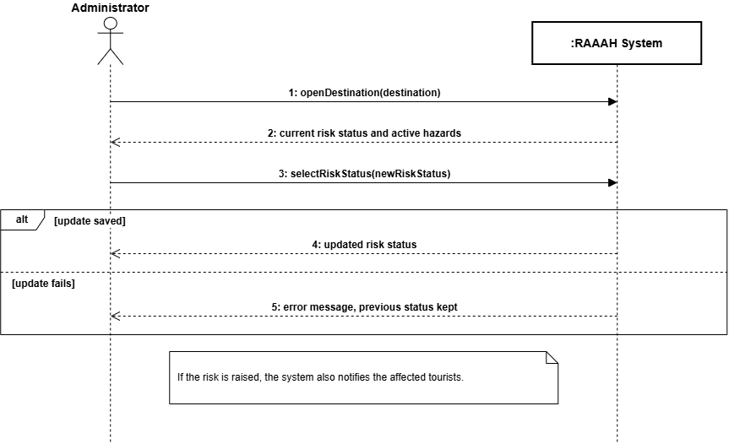
Figure 31: System Sequence Diagram: Update Destination Risk Status

9.13 Receive Safety Notification
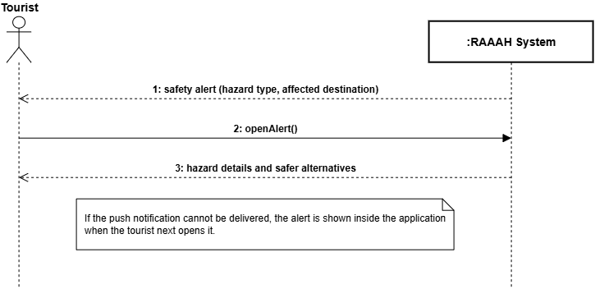Figure 32: System Sequence Diagram: Receive Safety Notification

9.14 View Cultural and Responsible Tourism Information
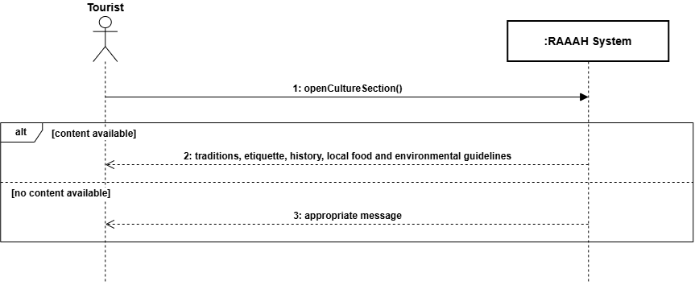
Figure 33: System Sequence Diagram: View Cultural and Responsible Tourism Information

9.15 Manage Destinations
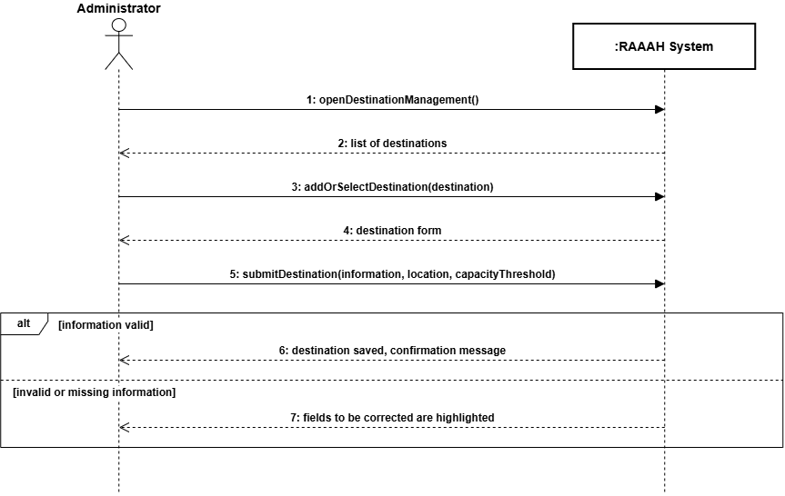Figure 34: System Sequence Diagram: Manage Destinations

9.16 Manage Users
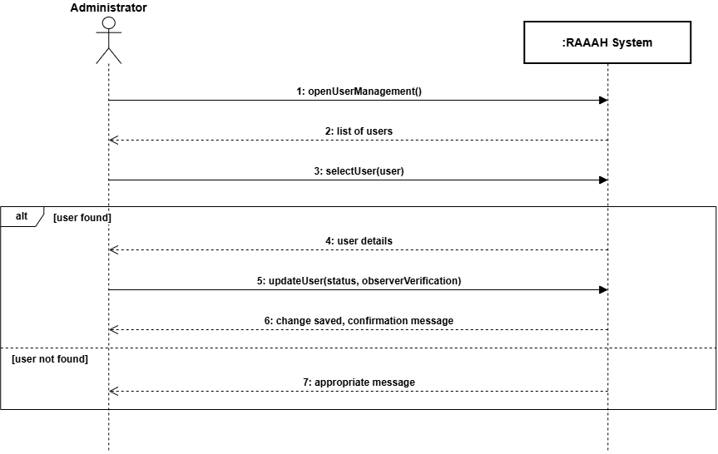Figure 35: System Sequence Diagram: Manage Users

9.17 View Analytics Dashboard
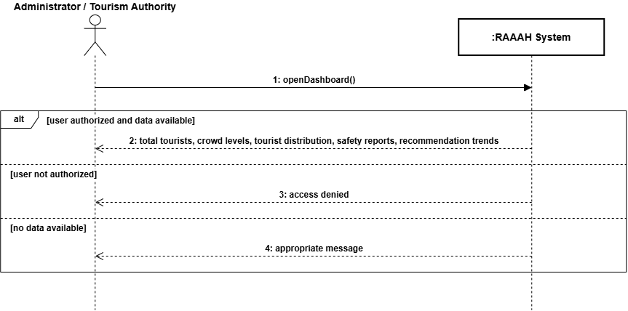Figure 36: System Sequence Diagram: View Analytics Dashboard

10. Component Diagram
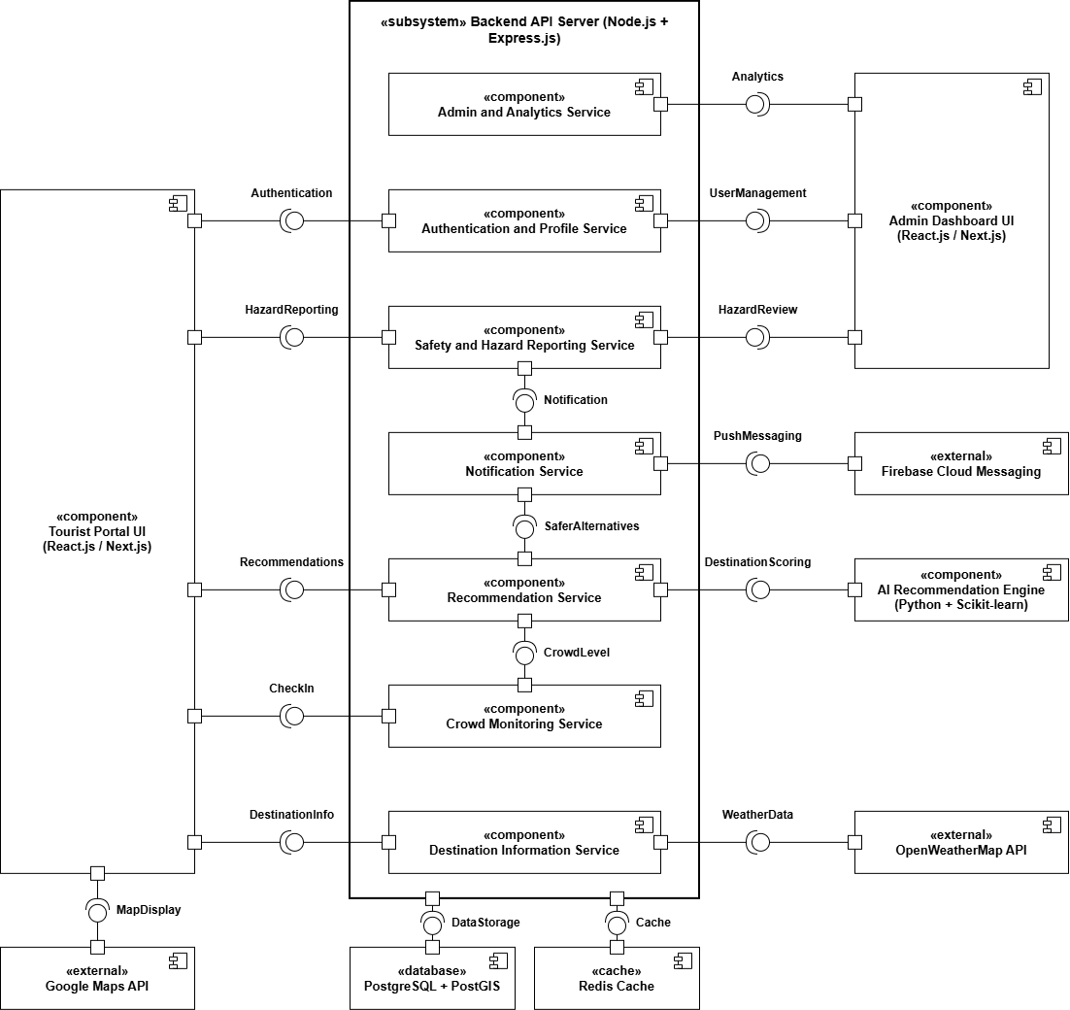
Figure 37: Component Diagram

11. Package Diagram
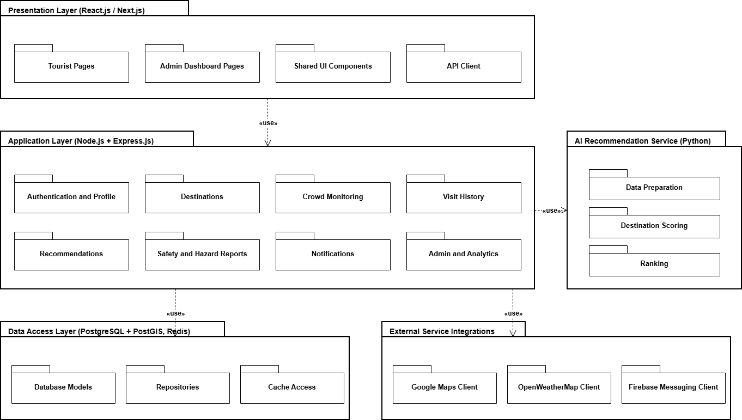
Figure 38: Package Diagram

12. Data Flow Diagrams

12.1 DFD Level 0
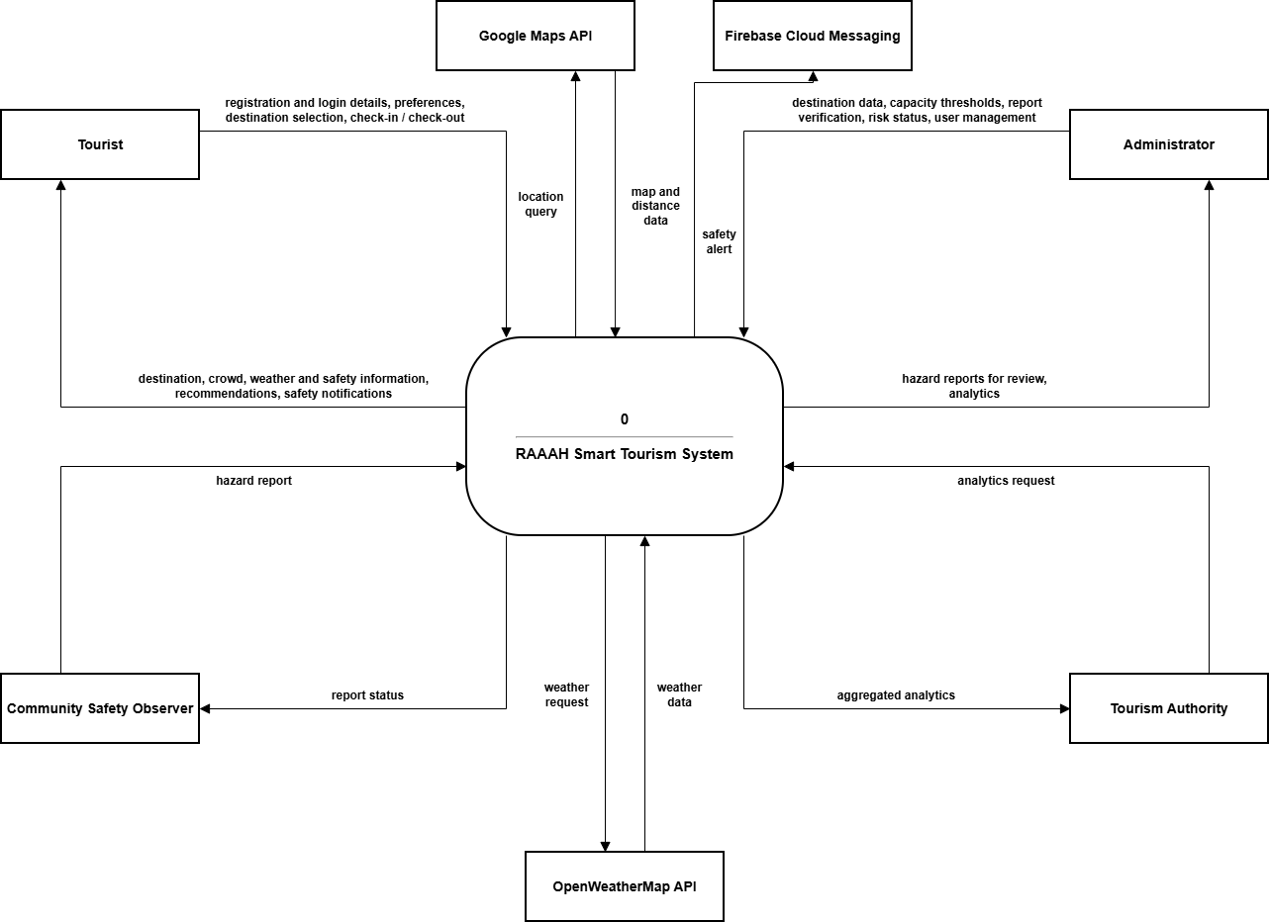
Figure 39: DFD Level 0

12.2 DFD Level 1
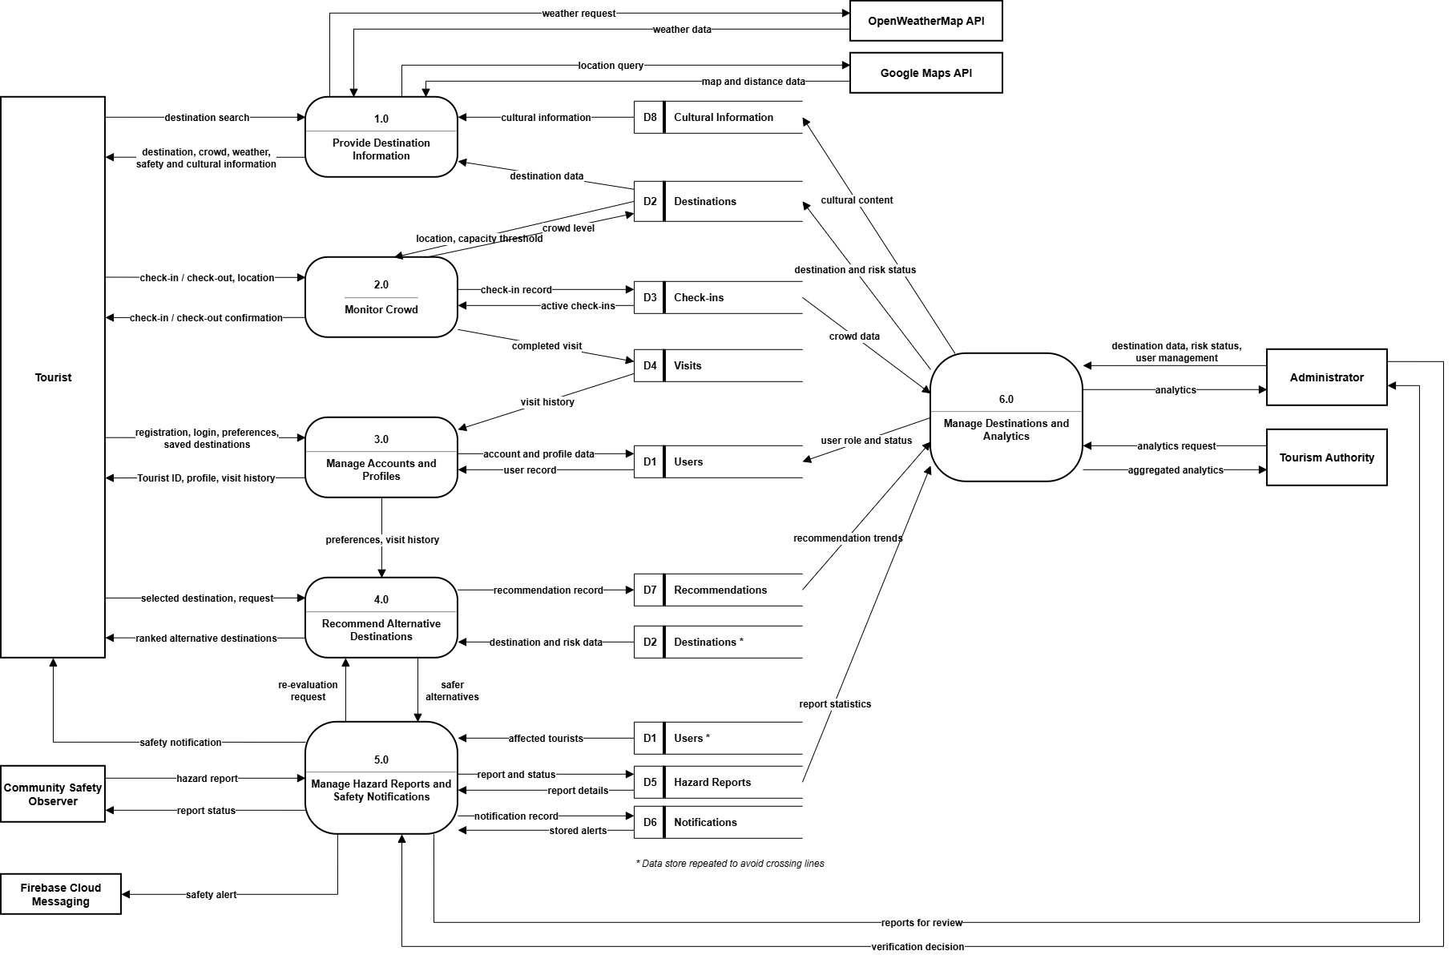
Figure 40: DFD Level 1

12.3 DFD Level 2

12.3.1 Crowd Monitoring
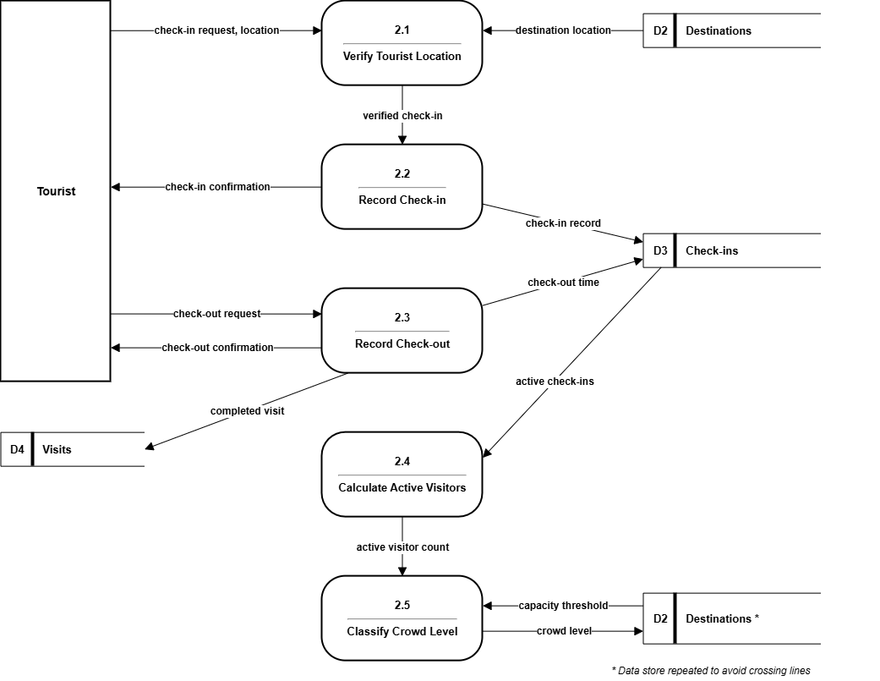
Figure 41: DFD Level 2: Crowd Monitoring

12.3.2 Alternative Destination Recommendation
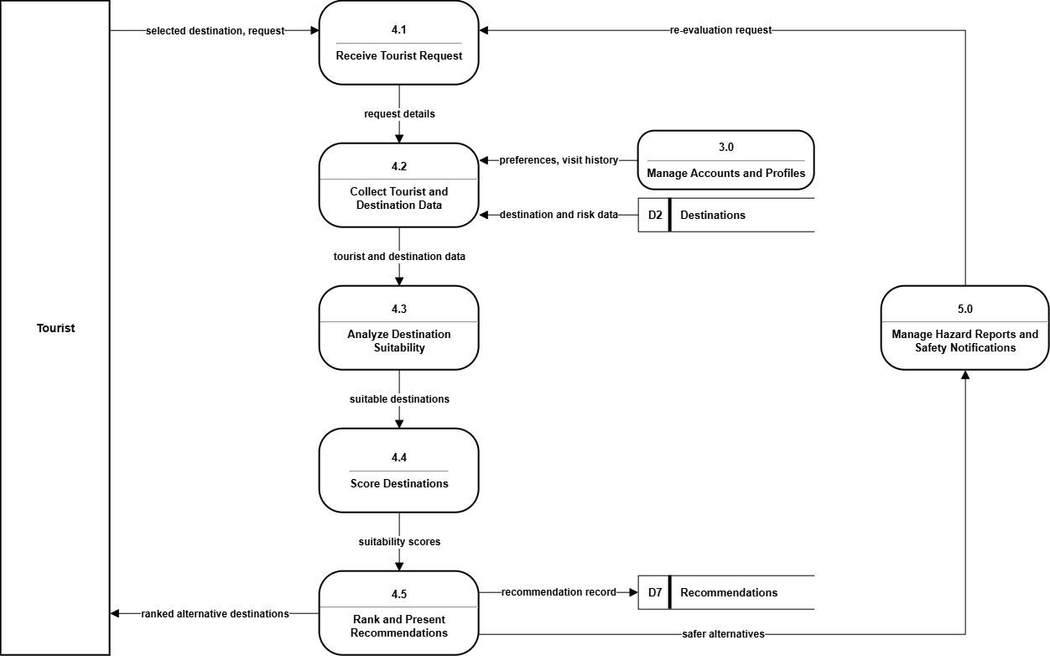
Figure 42: DFD Level 2: Alternative Destination Recommendation

12.3.3 Hazard Reporting and Safety Notification
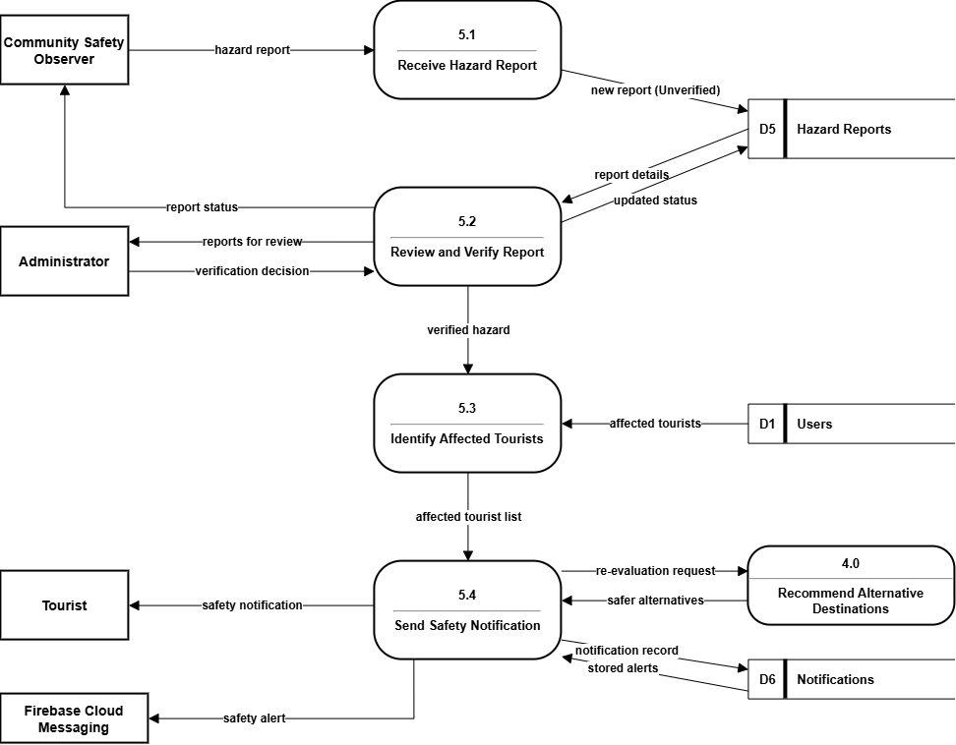
Figure 43: DFD Level 2: Hazard Reporting and Safety Notification

13. Entity Relationship Diagram
RAAAH uses PostgreSQL, a relational database, with the PostGIS extension for location data. The entity relationship diagram below shows the database design of the system.
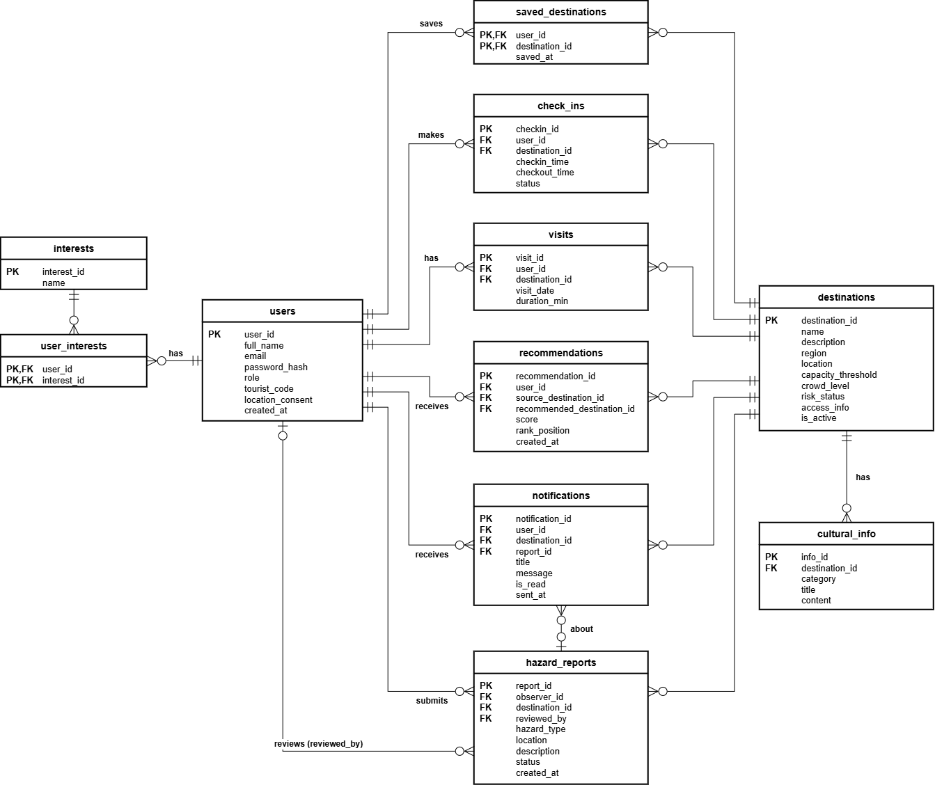
Figure 44: Entity Relationship Diagram (ERD)

14. Deployment Diagram
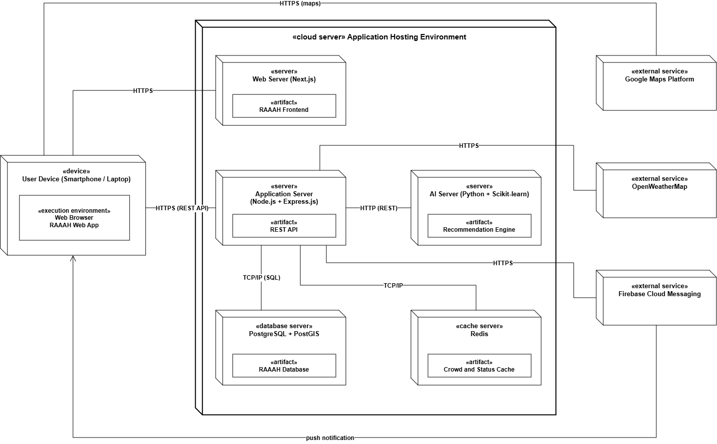
Figure 45: Deployment Diagram

15. Domain Model
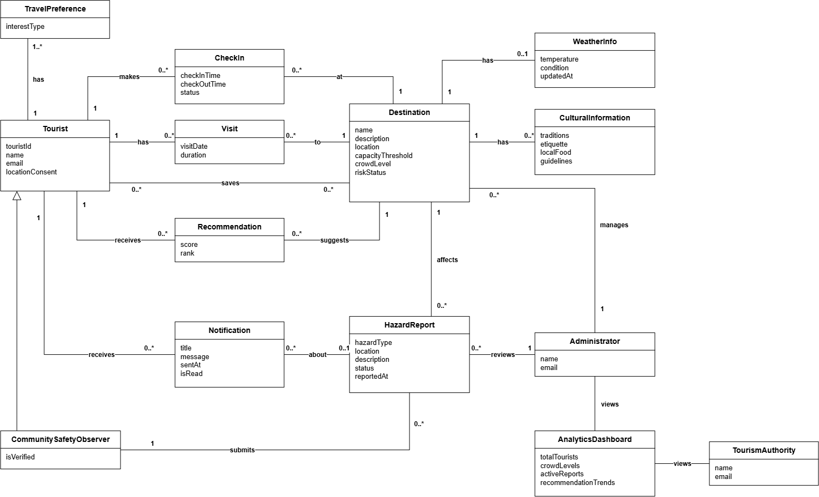
Figure 46: Domain Model

References
[1] C. Larman, Applying UML and Patterns: An Introduction to Object-Oriented Analysis and Design and Iterative Development, 3rd ed. Upper Saddle River, NJ, USA: Prentice Hall, 2004.
[2] NDMA Pakistan - National Disaster Management Authority. Available: https://www.ndma.gov.pk
[3] GBDMA - Gilgit-Baltistan Disaster Management Authority. Available: https://gbdma.gob.pk
[4] Pakistan Tourism Development Corporation (PTDC). Available: https://www.tourism.gov.pk
[5] A. Riaz et al., "Flash Flood Risk Assessment in Gilgit-Baltistan, Pakistan," Natural Hazards Journal, 2022.
[6] OpenWeatherMap API Documentation. Available: https://openweathermap.org/api
[7] Google Maps Platform Documentation. Available: https://developers.google.com/maps
[8] Firebase Cloud Messaging Documentation. Available: https://firebase.google.com/docs/cloud-messaging
[9] Express.js Documentation. Available: https://expressjs.com
[10] Scikit-learn: Machine Learning in Python. Available: https://scikit-learn.org
[11] PostgreSQL Documentation. Available: https://www.postgresql.org/docs

