API Testing Using APIDOG – Assignment Report
Student ID: 23F-3046, 23P-3071, 23F-3025
Course: Software Quality Engineering

1. Introduction
This assignment explains API testing using Postman.
The goal was to choose any free public API and test five HTTP methods:
- GET
- POST
- PUT
- DELETE

2. Member 1 Selected API
API Used: https://dummyjson.com/products

2.1 Get Request — Fetch All Products

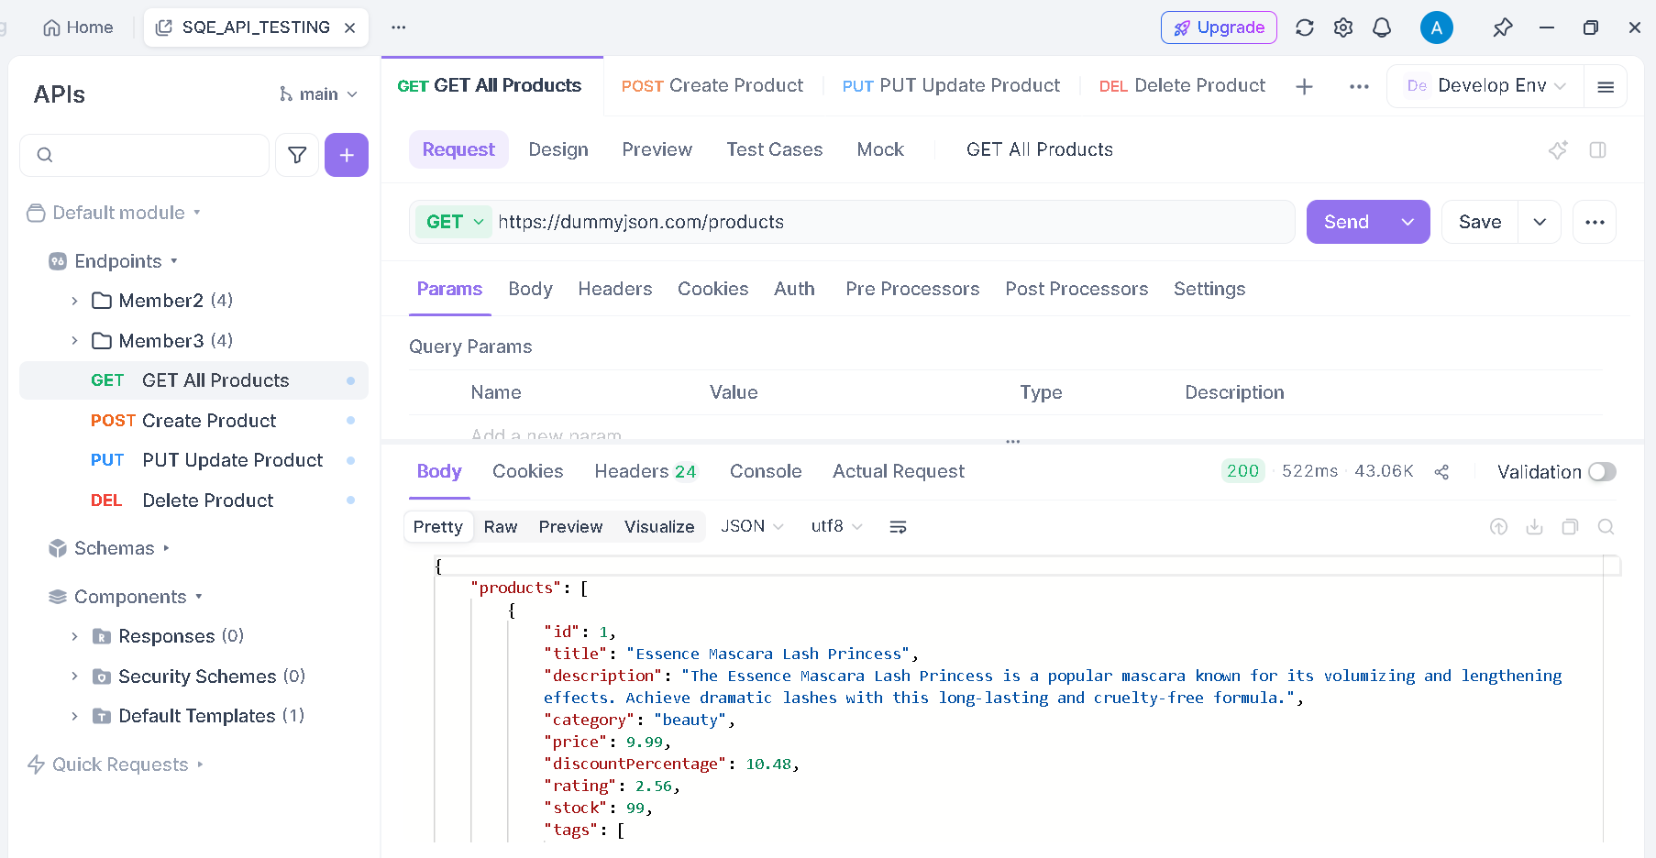

2.2 Post Request — Create a New Product

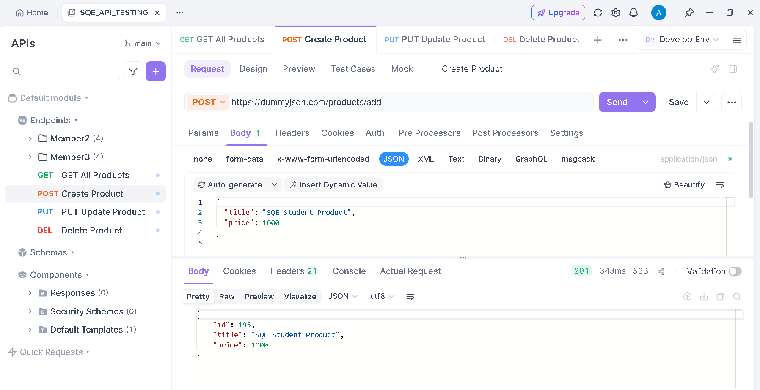

2.3 Put Request — Fully Update Product #1

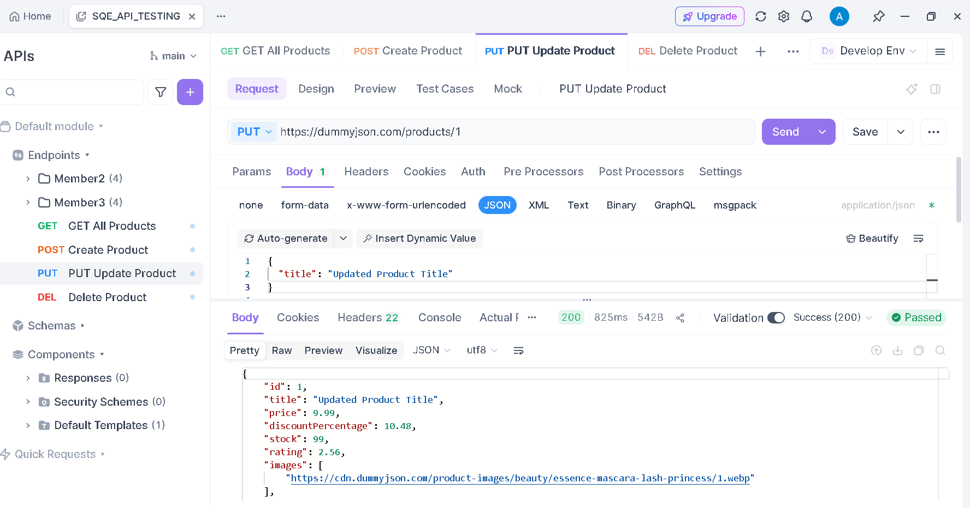

2.4 Delete Request — Delete Product #1

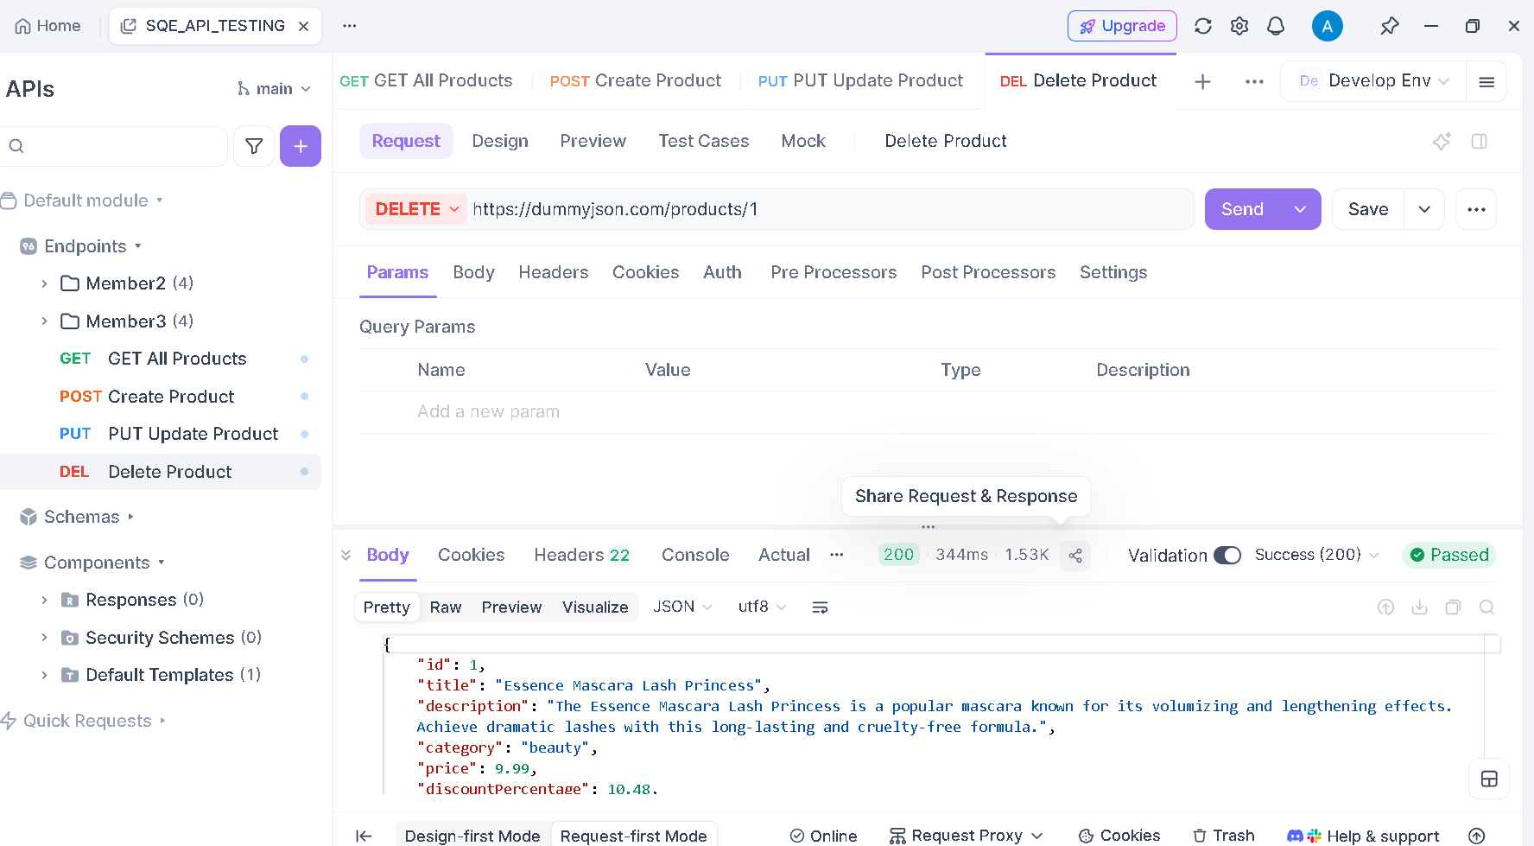

3. Member 2 Selected API
API Used: https://jsonplaceholder.com
This API provides fake product data and supports full CRUD operations.

3.1 Get Request — Fetch All Products

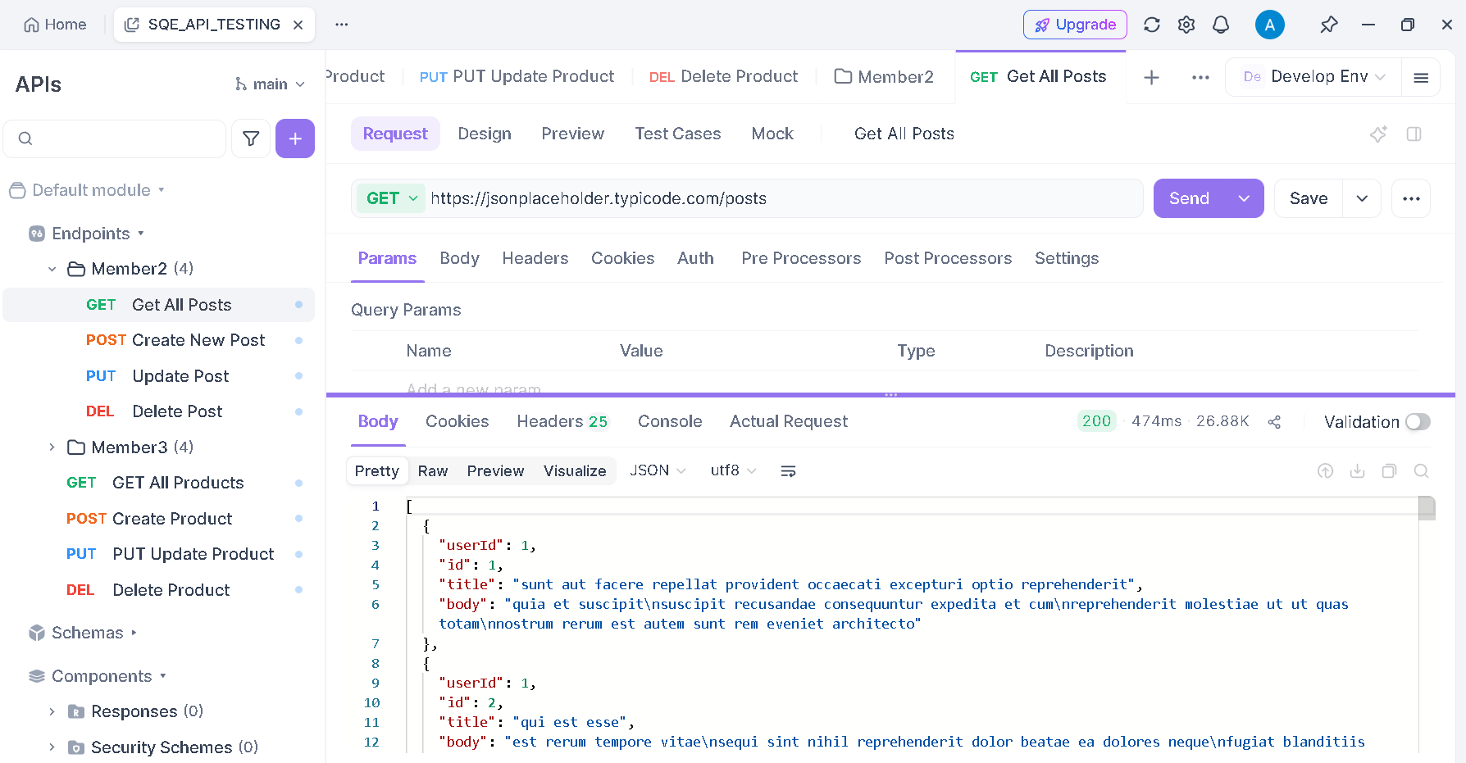

3.2 Post Request — Create a New Product

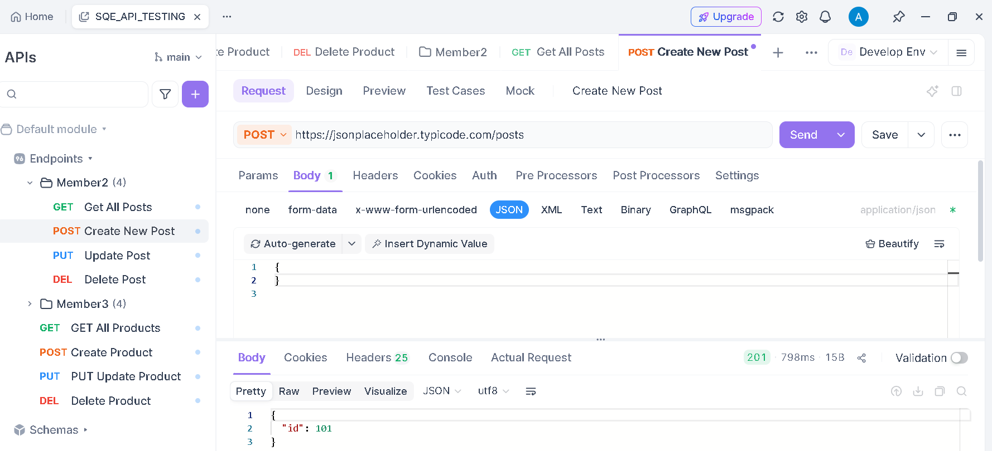

3.3 Put Request — Fully Update Product #1

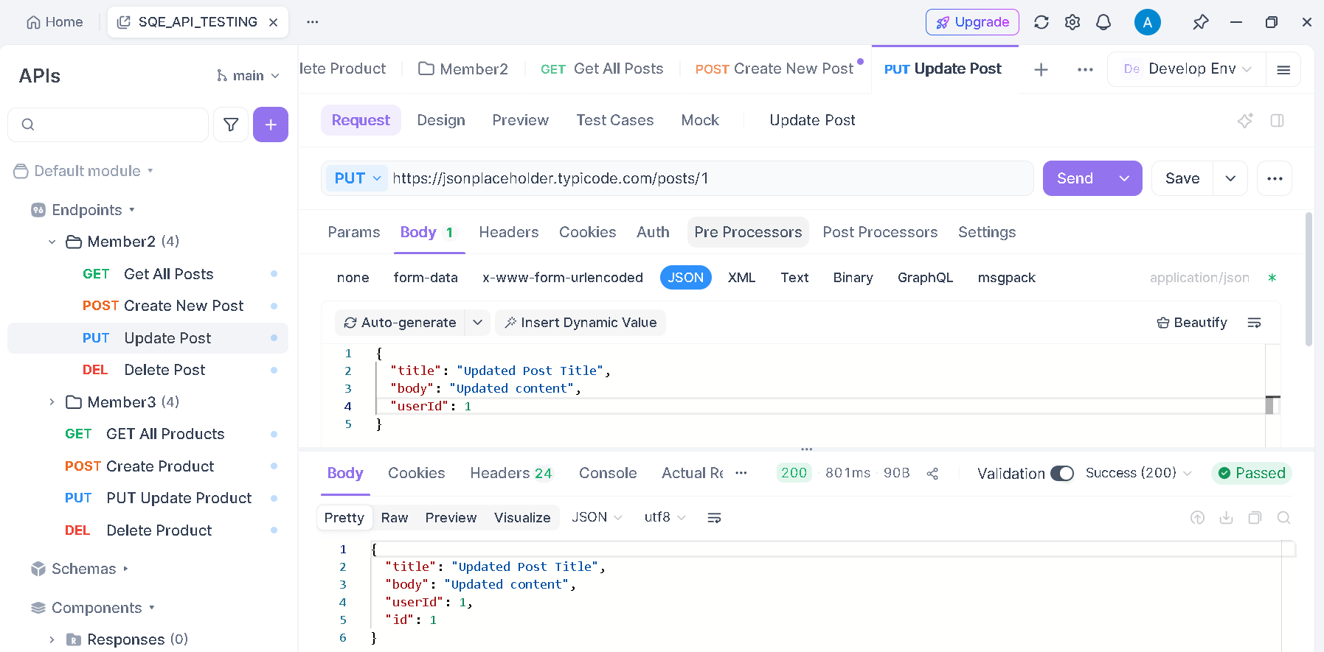

3.4 Delete Request — Delete Product #1

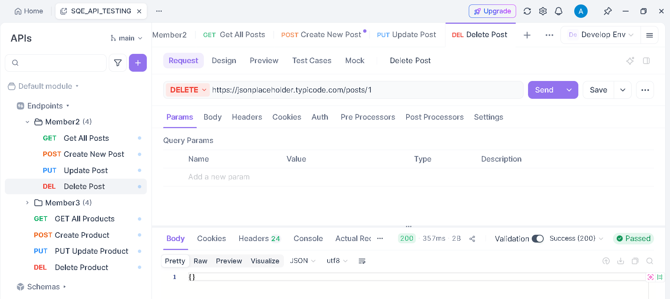

4. Member 3 Selected API
API Used: https://fakestoreapi.com
This API provides fake product data and supports full CRUD operations.

4.1 Get Request — Fetch All Products

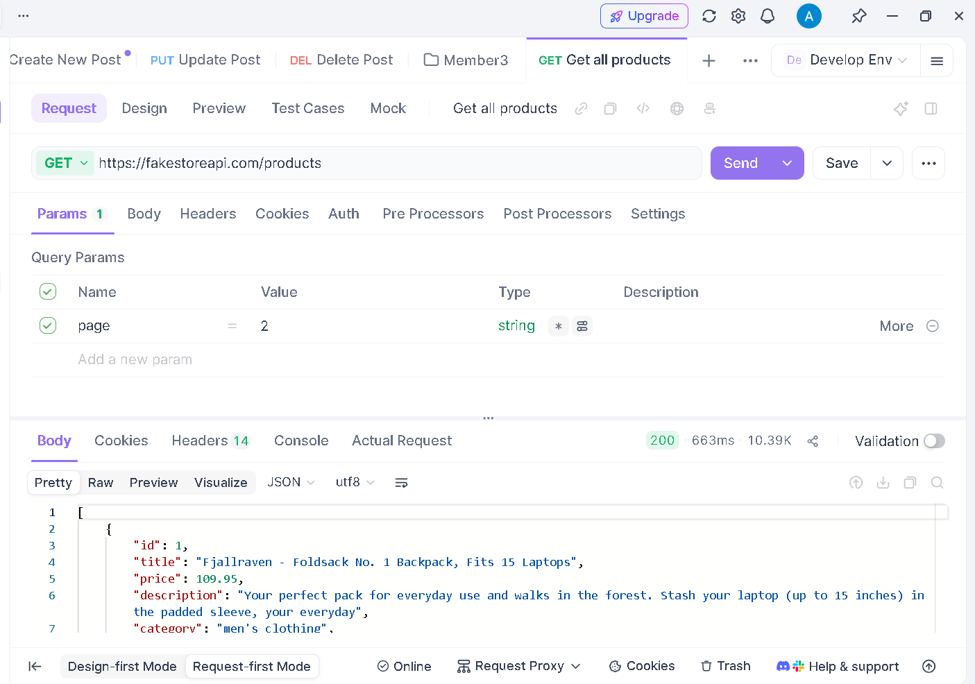

4.2 Post Request — Create a New Product

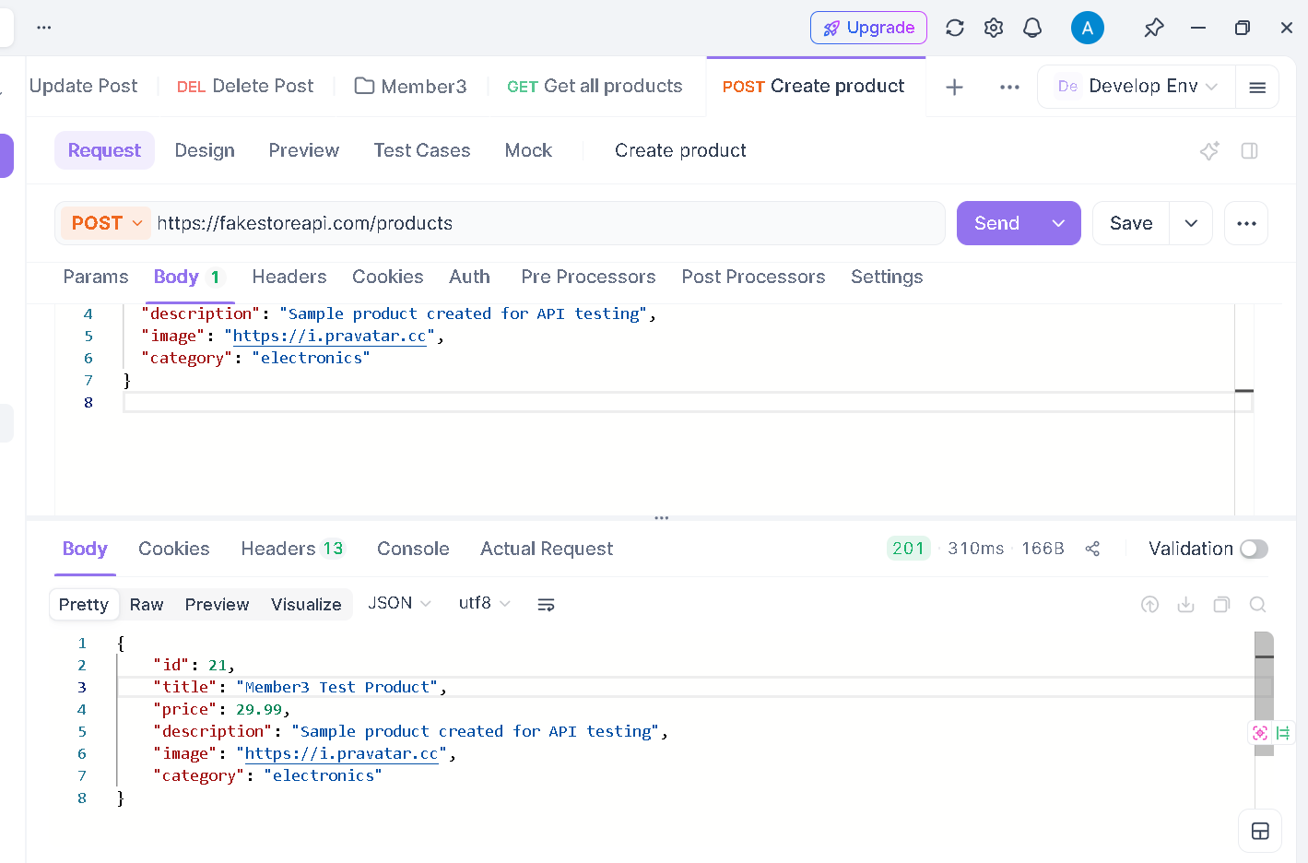

4.3 Put Request — Fully Update Product #1

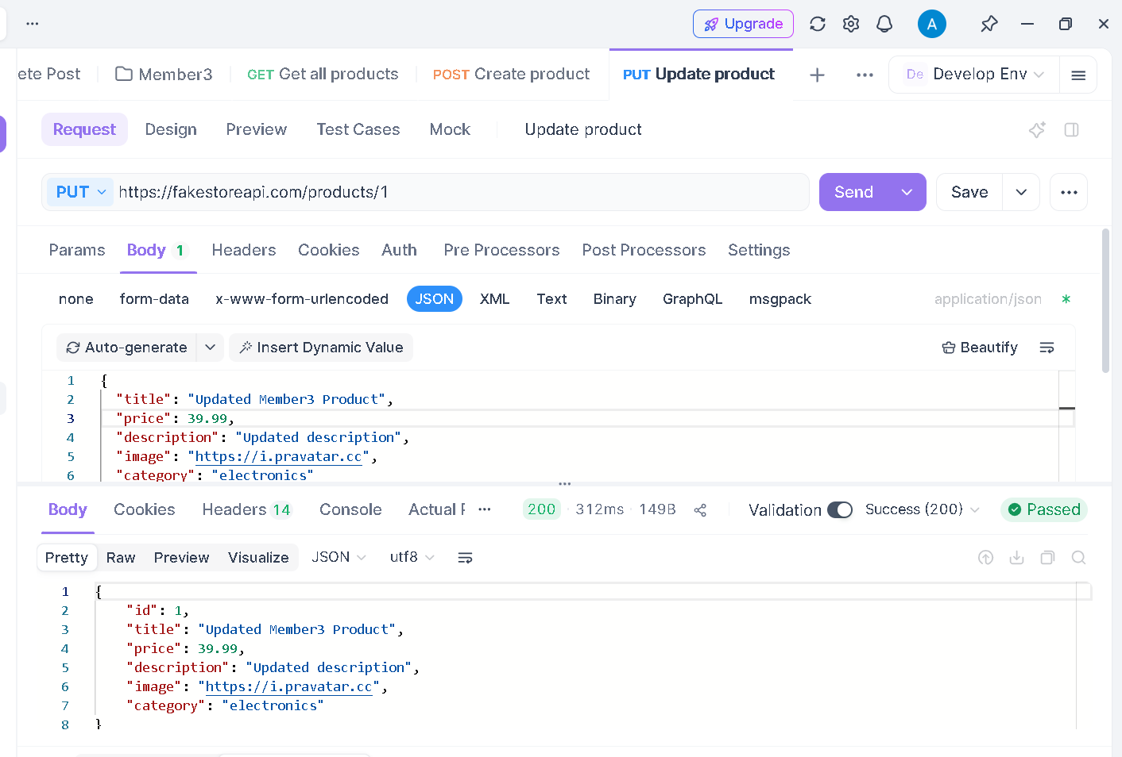

4.4 Delete Request — Delete Product #1

