1 – Test Cases for DummyJSON API

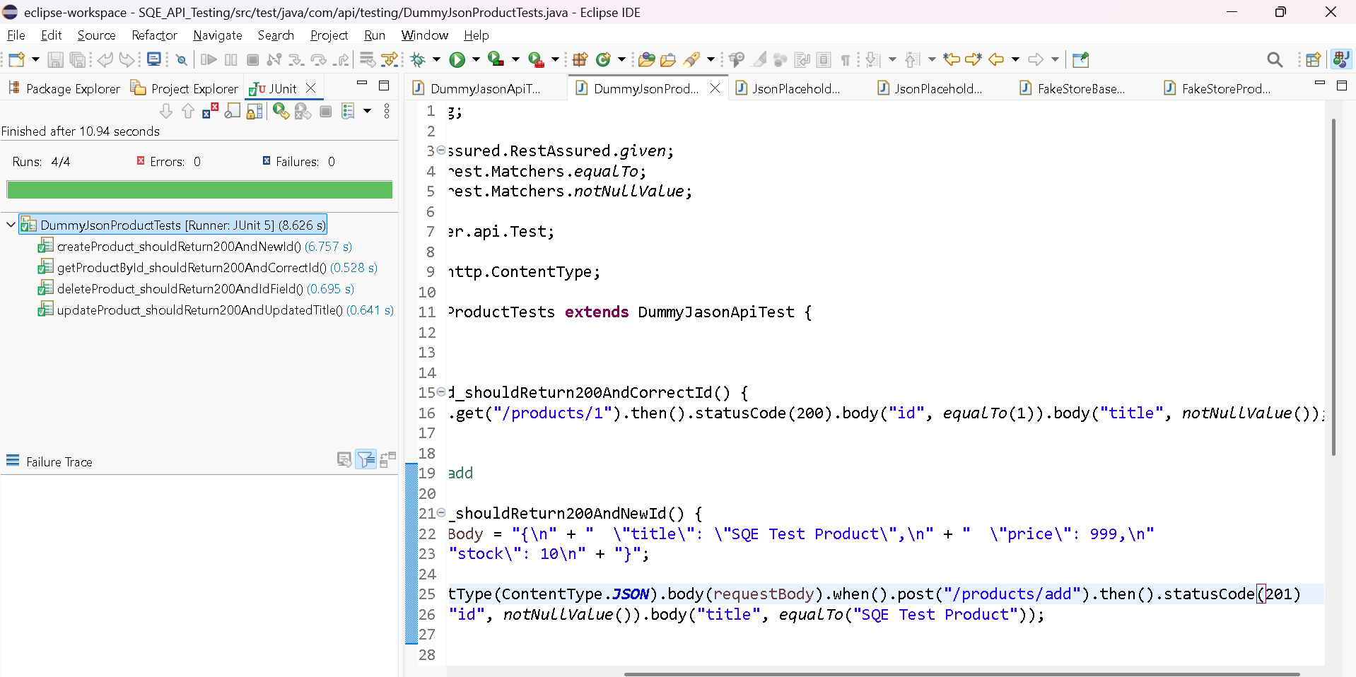

2– Test Cases for JasonPlaceHolderAPI

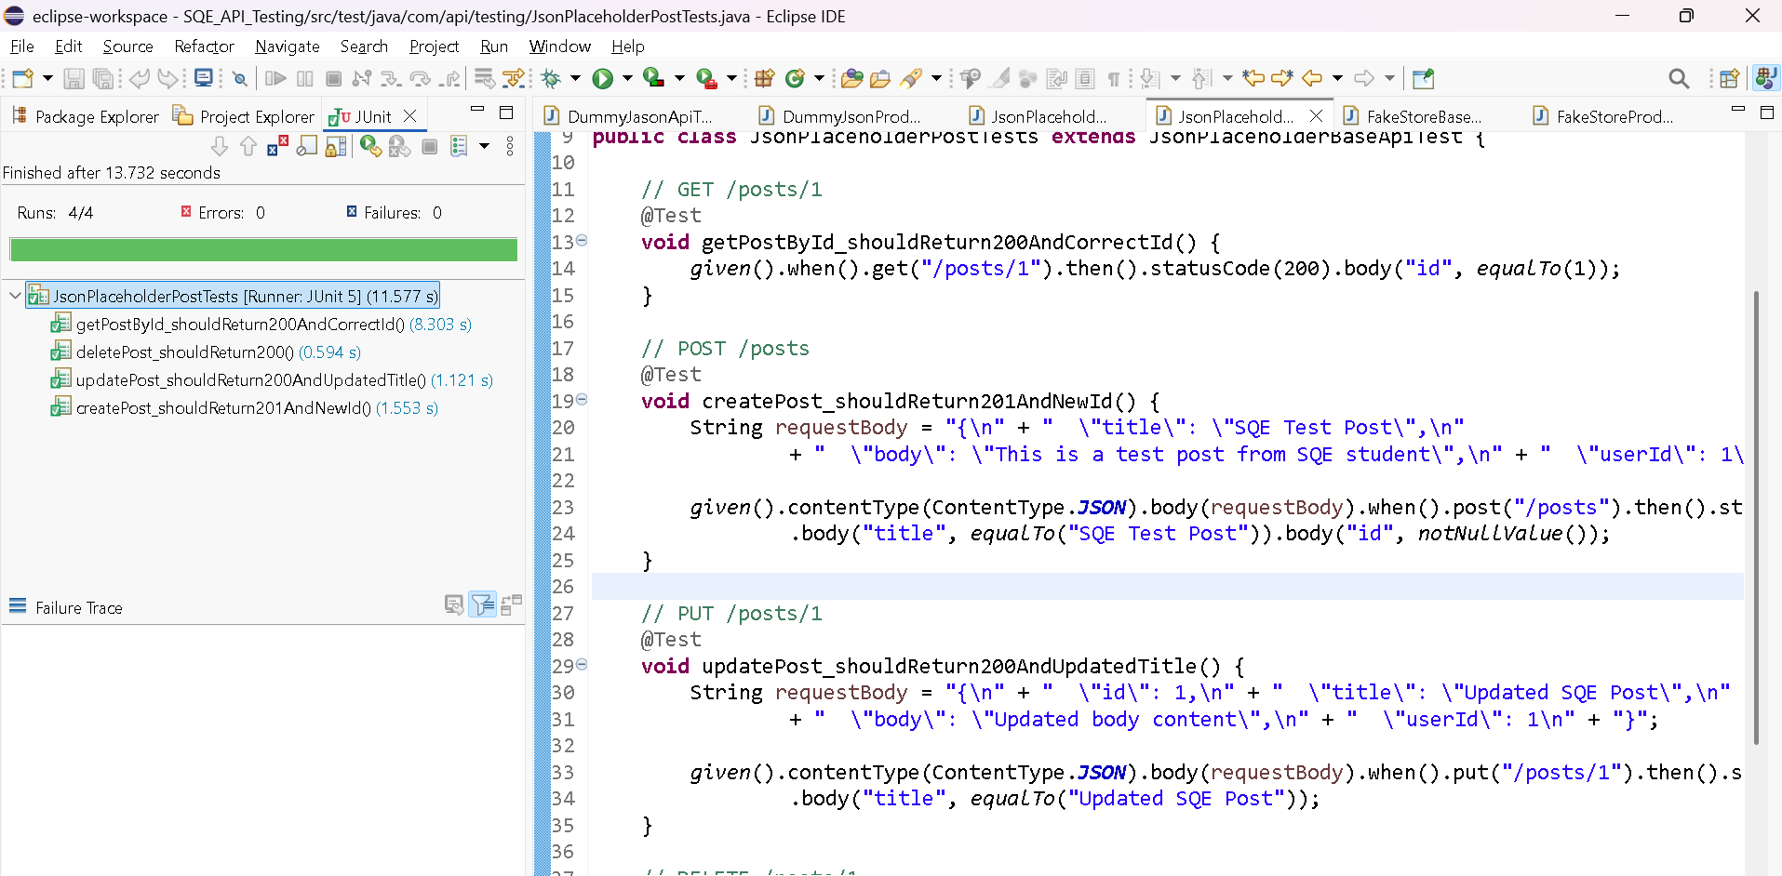

3– Test Cases for FakeAPIStoreProducts

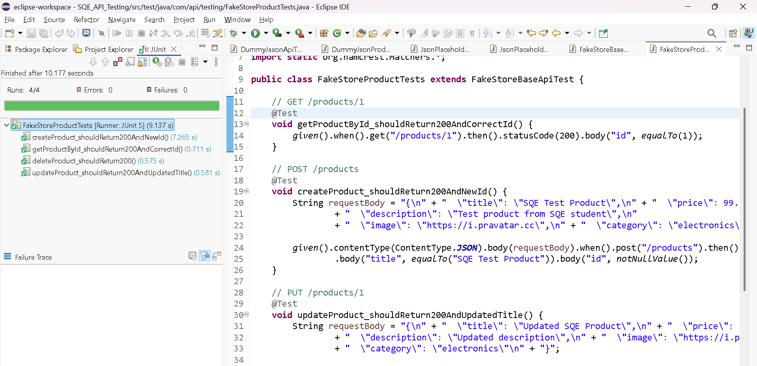
2 –PERFORMANCE TEST ON J-METER
