

**Mawlana Bhashani Science And Technology University**

**Lab-Report**

Report No : 09

Course Code : ICT-3110

Course Title : Operating System Lab.

Date of Performance :

Date of Submission : 25/09/2020

**Submitted By: Submitted To:**

Name:Md Abdur Rahim Nazrul Islam

ID:IT-18024 Assistant Professor

3rd Year 1st Semester Dept. of ICT

Session : 2017-18 MBSTU

Dept. of ICT

MBSTU

**Experiment No : 09**

**Experiment Name :** Implementation of Priority Scheduling Algorithm.

**Priority Scheduling** is a method of scheduling processes that is based on priority. In this algorithm, the scheduler selects the tasks to work as per the priority.

The processes with higher priority should be carried out first, whereas jobs with equal priorities are carried out on a round-robin or FCFS basis. Priority depends

upon memory requirements, time

Priority Scheduling Algorithm:

→ Processes with same priority are execute on first come first served (FCFS) basis.

→ Priority scheduling is a non-preemptive algorithm and one of most common scheduling algorithm in batch systems.

→ Each process is assigned a priority process with highest priority is to be execute first and so on.

Algorithm:

**Step 1:** Start the process

**Step 2:** Accept the number of processes in the ready Queue

**Step 3:** For each process in the ready Q, assign the process id and accept the CPU burst time

**Step 4:** Sort the ready queue according to the priority number.

**Step 5:** Set the waiting of the first process as ‗0 and its burst time as its turnaround time

**Step 6:** Arrange the processes based on process priority

**Step 7:** for each process in the Ready Q calculate

a) Waiting time(n)= waiting time (n-1) + Burst time (n-1)

b) Turnaround time (n)= waiting time(n)+Burst time(n)

**Step 8:** Calculate

c) Average waiting time = Total waiting Time / Number of process

d) Average Turnaround time = Total Turnaround Time / Number of process Print the results in an order

**Step 9:** Stop the process.

**Code Implementation :**

#include<stdio.h>

int main()

{

int bt[20],p[20],wt[20],tat[20],pr[20],i,j,n,total=0,pos,temp,avg_wt,avg_tat;

printf("Enter Total Number of Process:");

scanf("%d",&n);

printf("\nEnter Burst Time and Priority\n");

for(i=0;i<n;i++)

{

printf("\nP[%d]\n",i+1);

printf("Burst Time:");

scanf("%d",&bt[i]);

printf("Priority:");

scanf("%d",&pr[i]);

p[i]=i+1;

}

for(i=0;i<n;i++)

{

pos=i;

for(j=i+1;j<n;j++)

{

if(pr[j]<pr[pos])

pos=j;

}

temp=pr[i];

pr[i]=pr[pos];

pr[pos]=temp;

temp=bt[i];

bt[i]=bt[pos];

bt[pos]=temp;

temp=p[i];

p[i]=p[pos];

p[pos]=temp;

}

wt[0]=0;

for(i=1;i<n;i++)

{

wt[i]=0;

for(j=0;j<i;j++)

wt[i]+=bt[j];

total+=wt[i];

}

avg_wt=total/n;

total=0;

printf("\nProcess\t Burst Time \tWaiting Time\tTurnaround Time");

for(i=0;i<n;i++)

{

tat[i]=bt[i]+wt[i];

total+=tat[i];

printf("\nP[%d]\t\t %d\t\t %d\t\t\t%d",p[i],bt[i],wt[i],tat[i]);

}

avg_tat=total/n;

printf("\n\nAverage Waiting Time=%d",avg_wt);

printf("\nAverage Turnaround Time=%d\n",avg_tat);

return 0;

}

**Output :**

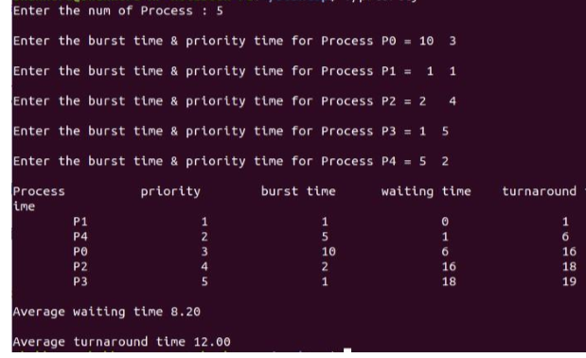

**Discussion :**

This lab helps to learn priority algorithm. Using this algorithm we can find waiting time and turnaround time that depend the priority.