This is our job board website, currently its build with Vue Js, Larval, PHP, and Its working for employer login & register, buy a package for Job Posts, also I need to add on same packages Resume Packages with my own decisions, its time to change every months,

Packages I will change my self on every month,

**<https://dump.w2jobs.us/>**

|  |  |  |
| --- | --- | --- |
| **Admin:**  dump.w2jobs.us/login  U: support@w2jobs.net  P: YochiIsBack789 | **Employer:**  dump.w2jobs.us/login  U: jobs@w2jobs.net  P: YochiIsBack789 | **Candidate:**  dump.w2jobs.us/login  U: robert@yopmail.com  P: YochiIsBack789 |

1. On Employer page add New page "Resume Search", Like hiring.monster.om, (Filters required on sidebar, 1. Search by job time, skills, categories, 2. Search by location is there, 3. Add search by Visa Status* 4. Search by Miles )

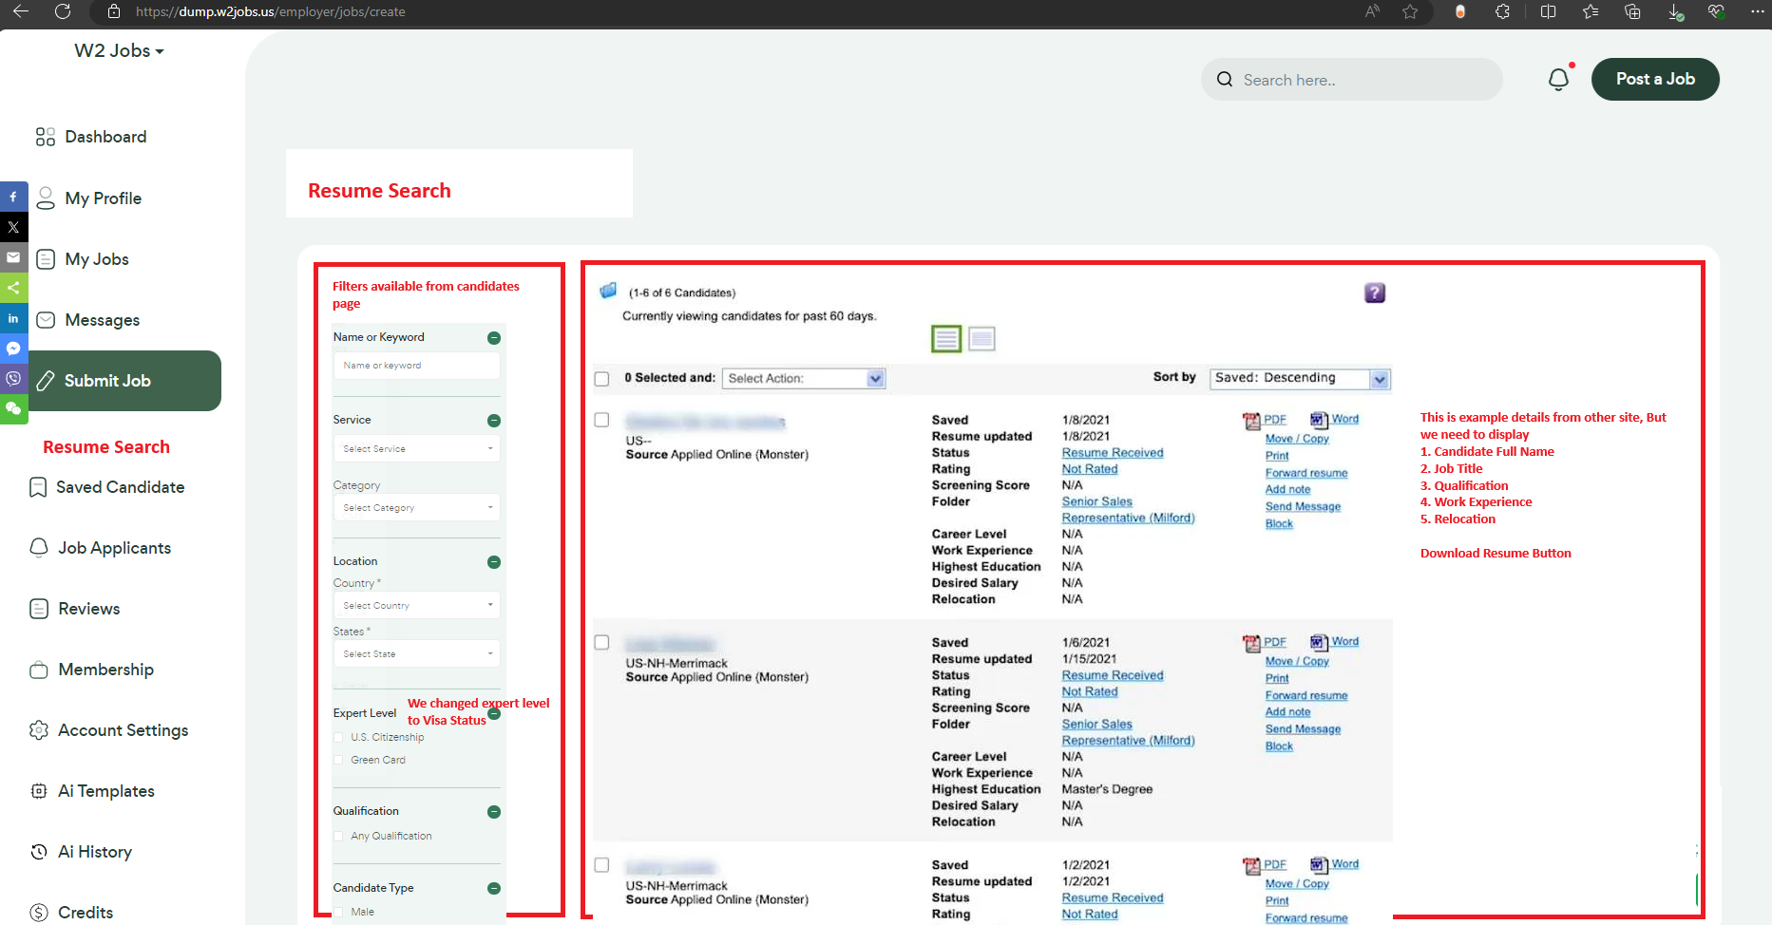

1. When employer purchased package, then resumes will display otherwise no need to display.

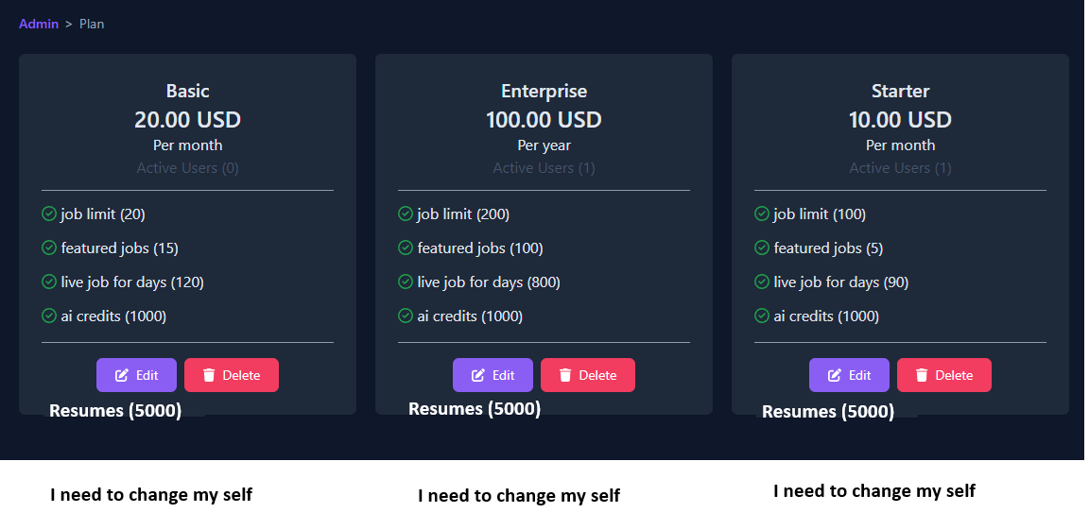

1. When employer select to view & down the resume (When view & downloaded resume, it will deducted from his package, he can only download remaining resumes)

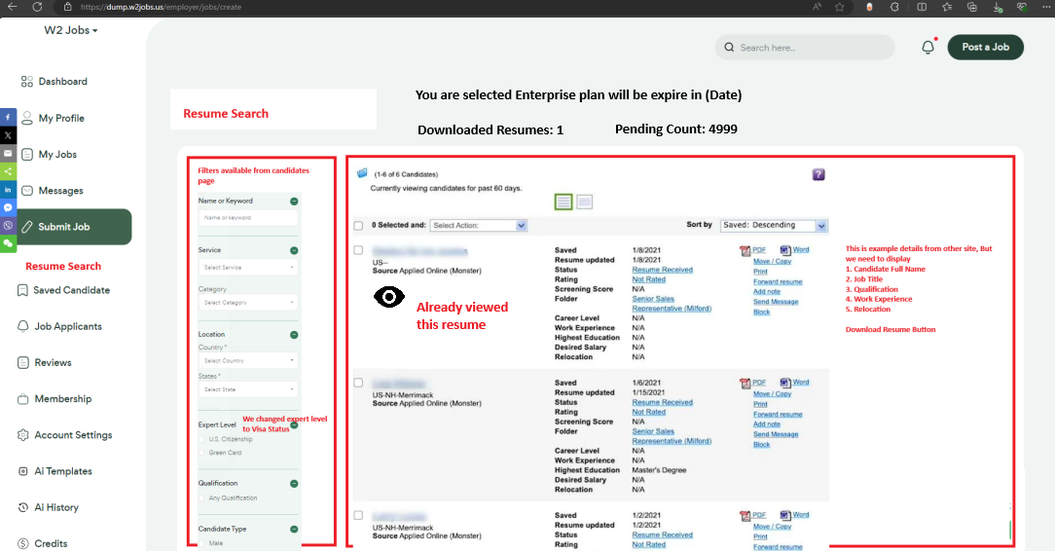

1. Bulk Resume uploading on admin side (Admin side uploaded each resume, should be show on employer page )

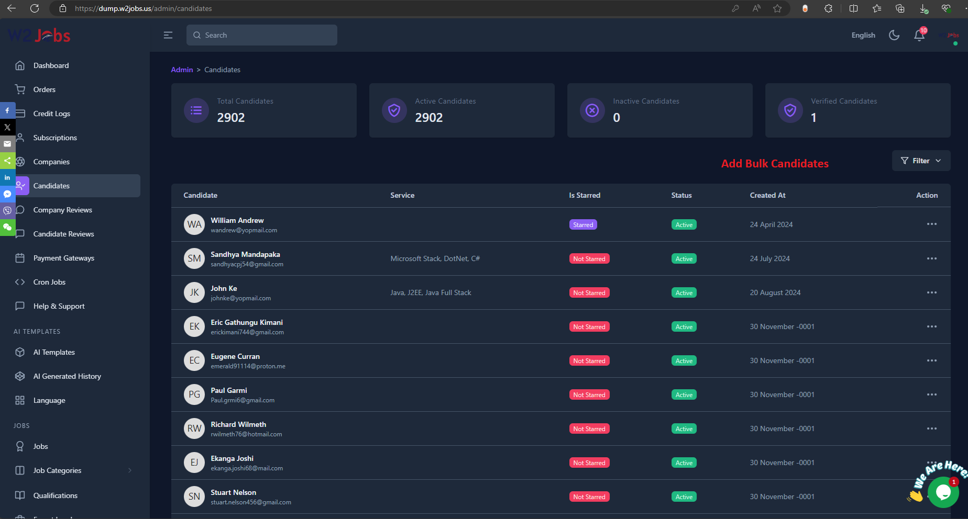

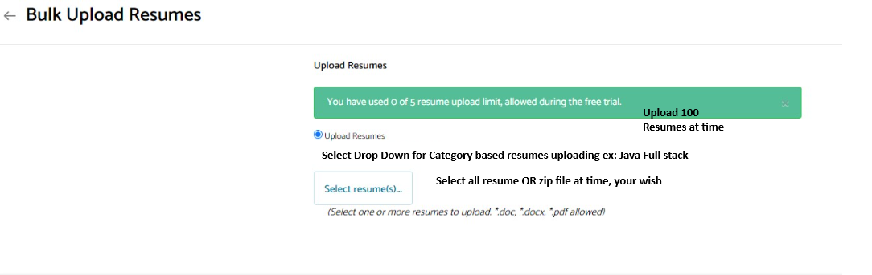

1. Later on we need to reduce the candidate resume uploading options like Indeed (When upload the resume automatically define the summery, experience one by one, skills, and Name, Email, Phone and Address based)

Please suggest me if any chance to reduce this sections and need all details single resume uploading like indeed or linkedin.com

<https://dump.w2jobs.us/user/resume>

**Note: Once you done this project, I will give you another 3 sites to make the changes**