Multi-Objective UAV
Strategy Engine Using
Genetic Algorithms
UNIVERSITY ARTIFICIAL INTELLIGENCE ASSIGNMENT · TECHNICAL REPORT
Institution and course | Student details
Bahria University, Lahore Campus  Department of Computer Science  Artificial Intelligence | BSCS 5 | Assignment 2 | Mian Abd ur Rahman Qayyum  Roll No: 03-134242-039
1. Introduction and problem formulation
Disaster response requires a UAV fleet to survey important areas while conserving energy and avoiding hazardous or prohibited terrain. This project implements a reproducible, locally executable simulation and a hand-written Genetic Algorithm (GA). A strategy jointly chooses deployment sites, waypoint trajectories, segment speeds, sensor activation and discrete sensor power.
The mission maximizes priority-weighted unique coverage and expected target detection, while minimizing fleet energy, completion time and hazard exposure. Geometry and sensor decisions combine discrete, binary and continuous variables. Nonlinear sensing and shared coverage make strategies interdependent; a GA can explore these combinations without requiring gradients. The result is a weighted compromise, rather than a proof of global optimality or a Pareto front.
Environment and physical assumptions
The 50 × 50 grid uses environment seed 2026. Each cell stores traversability, priority (1, 3 or 5), hazard intensity in [0, 1], target probability, sampled target presence and coverage. Circular priority zones, rectangular buildings and no-fly zones, and smooth hazard regions define the terrain. 28 simulated targets are sampled without replacement from a priority-biased probability map. Optimization uses this prior; target locations provide a separate expected-detections diagnostic. A* uses four-neighbour movement and hazard-weighted edges.
UAV specification | Configured value
Fleet / waypoints | 3 UAVs / 4 encoded segments per UAV
Range / battery | 90 cells / 65 model energy units per UAV
Speed / sensing | 0.8–3 cells/s; base radius 2.6 cells
Power levels / sensor draw | [0.5, 1.0, 1.5]; 0.22 × power energy units/s
Missions are one-way surveys from externally supplied deployment sites; launch logistics and return-to-base are excluded. A cell is one abstract distance unit. Energy is a transparent surrogate model, not a calibrated hardware battery specification. All hard constraints are verified for the expanded grid route, not just its encoded waypoints.

2. Methodology and mathematical model
Hybrid chromosome. Each fleet chromosome contains one UAVPlan per vehicle: {start: (x,y), waypoints: [(x,y)]×K, speeds: [v]×K, sensors: [0/1]×K, sensor_power: [p]×K}. Segment j begins at deployment (j=0) or the previous waypoint. Speeds, sensing and power stay linked to segments during crossover. Deep copies preserve parent independence. Each waypoint pair is expanded with cached A*, whose edge cost is 1 + 1.8(h_{a} + h_{b})/2.
Normalized multi-objective fitness
F = 0.35 C + 0.25 D − 0.15 E_{n} − 0.10 T_{n} − 0.15 R_{n} − P
Let S be traversable cells, q_{c} their priorities, π_{c} the normalized target prior, h_{c} hazard intensity, and b_{c} indicate at least one active sensor footprint. Then C = Σ q_{c}b_{c} / Σ q_{c}, with both sums over S. Reobserving a cell never adds new unique coverage. D = Σ π_{c}[1 − exp(−z_{c})], where z accumulates exposure from every active visit.
A visit to arrival cell a at speed v and power p has duration Δt = 1/v and radius r = r₀√p. For each traversable cell c within r, add 0.65 p Δt exp(−d(a,c)² / (2r²))(1 − 0.4h_{c}) to z_{c}. This independent-exposure model saturates detection probability as observations accumulate. Inactive or zero-length segments produce no observations. The sampled-target diagnostic sums these probabilities at actual target cells.
For UAV i, E_{i} = Σ L_{j}(0.26 + 0.045v_{j}² + 0.22s_{j}p_{j}/v_{j}) and T_{i} = Σ L_{j}/v_{j}; L is the number of A* grid edges and s is the sensor state. R_{i} = Σ h_{a}/v_{j} over arrival cells along the route. Thus higher speeds reduce time but increase propulsion expenditure and reduce sensing dwell. Hazards affect route selection, risk and sensing quality.
For N identical UAVs with battery B, range L_{max} and minimum speed v_{min}, E_{n} = Σ E_{i}/(NB), T_{n} = max T_{i}/(L_{max}/v_{min}), and R_{n} = Σ R_{i}/(NL_{max}/v_{min}). All five objectives lie in [0,1] for feasible solutions. Fixed physical bounds avoid generation-dependent normalization. Coverage and detection receive 60% of weight to prioritize service; the remaining 40% controls resource and exposure costs. Weights express a policy preference and are not empirically learned.
Evolutionary operators and hard constraints
Tournament selection (size 3) chooses parents from a population of 60. Crossover probability is 0.85; segment swapping and arithmetic waypoint recombination are selected equally. Per-gene mutation probability is 0.15: local spatial moves, occasional waypoint replacement, speed perturbation, sensor toggle, power changes and deployment moves. The best 2 survive; about 5% random immigrants replenish diversity, rising to 15% if mean normalized gene standard deviation falls below 0.06. Elitism preserves quality; immigrants supply exploration.
Repair projects coordinates into traversable cells within the deployment component, clamps speeds, snaps powers and shortens segments until battery/range limits hold. It replans truncated endpoints and checks the resulting A* route again. The evaluator independently checks structure, connectivity, bounds and resources. Feasible P=0; an invalid chromosome receives F=−1−V, where V is its violation count, and is never shown as a valid final mission. Workflow: initialize → repair/evaluate → select → crossover/mutate → repair/evaluate → elite survivor selection; terminate at the generation/budget limit or optional stagnation.

3. Results and experiments
The main run used optimizer seed 42, 100 generations and 5,860 fitness evaluations per optimizer. Initial GA best fitness was 0.04270; final fitness was 0.21513. Random search used identical terrain, priors, initialization distribution, repair and fitness, with an independent RNG stream. Elites are not re-evaluated; every generated candidate evaluation counts.
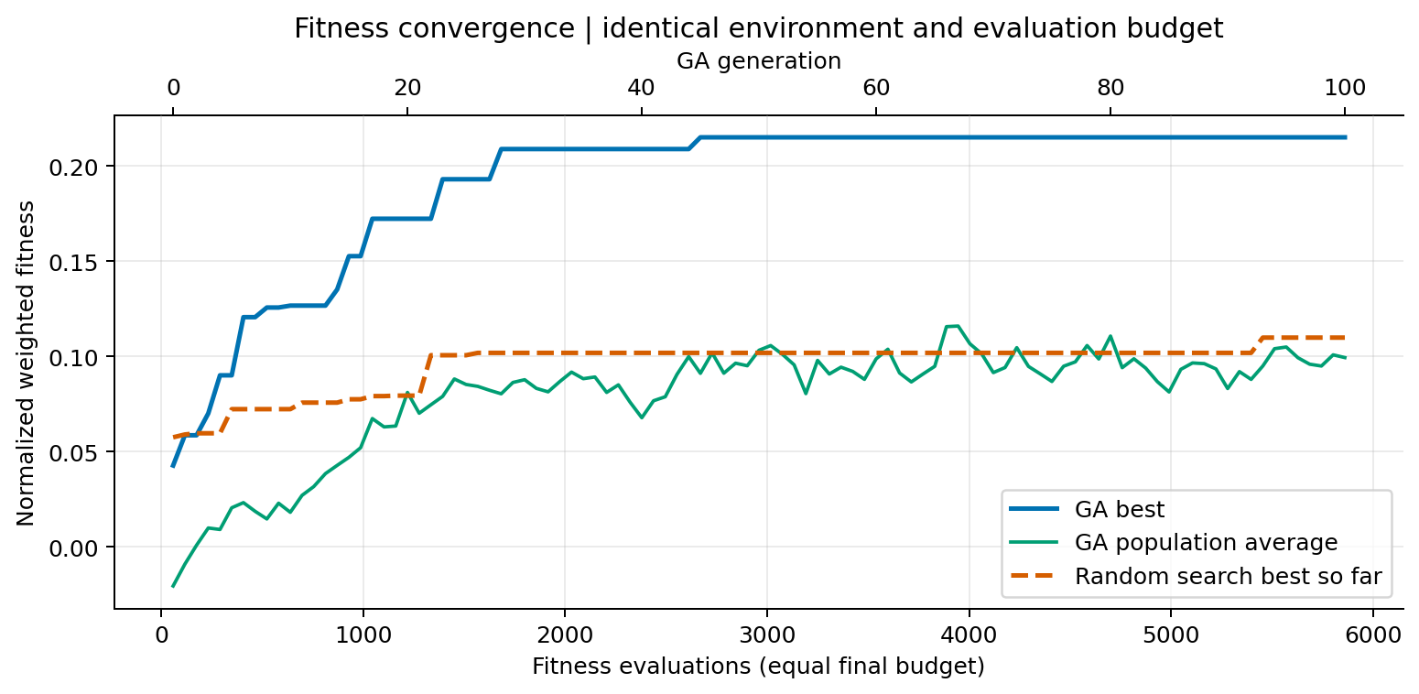
Figure 1. Recorded fitness traces, aligned by cumulative evaluator calls; top axis shows GA generation.
Main run metric | GA | Random search
Best fitness | 0.21513 | 0.10990
Weighted coverage / detection | 66.9% / 53.1% | 43.4% / 32.1%
Energy / fleet completion time | 117.81 / 54.00 s | 87.09 / 52.60 s
Hazard exposure / valid evaluations | 29.45 / 5,860 | 19.08 / 5,860
Compute time (seconds) | 43.25 | 36.57
Sensitivity and independent repeats
All 12 sensitivity configurations used 600 evaluations each and seeds 42, 43, 44 (36 runs). One factor varies at a time. Equal evaluations, rather than equal generations, prevent larger populations receiving extra search effort; partial final generations retain previous survivors to keep population size fixed. The table gives mean final fitness. CSV files also record runtime, diversity, feasible fraction and evaluations to 90% of each run’s observed gain.
Varied parameter | Values → mean final fitness
Population | 20 → 0.1558; 40 → 0.1401; 60 → 0.1406; 100 → 0.1185
Mutation | 0.05 → 0.1519; 0.1 → 0.1518; 0.15 → 0.1406; 0.3 → 0.1100
Tournament | 2 → 0.1116; 3 → 0.1406; 5 → 0.1610; 7 → 0.1742
Separate repeated comparison (3 seeds; 1,800 evaluations each): GA fitness 0.1846 ± 0.0212, random search 0.0958 ± 0.0067 (sample SD). These exploratory repeats describe variation across optimizer seeds on one fixed terrain; they do not establish statistical significance or generalization.
Sensitivity plots include all three factors with error bars, convergence effort, diversity, feasibility and computational cost. Route-cache reuse differs between optimizers. Wall times were recorded on a shared host with some concurrent jobs; they are illustrative, not isolated hardware benchmarks. Equal evaluator budgets are not equal CPU budgets.

4. Discussion, limitations and conclusion
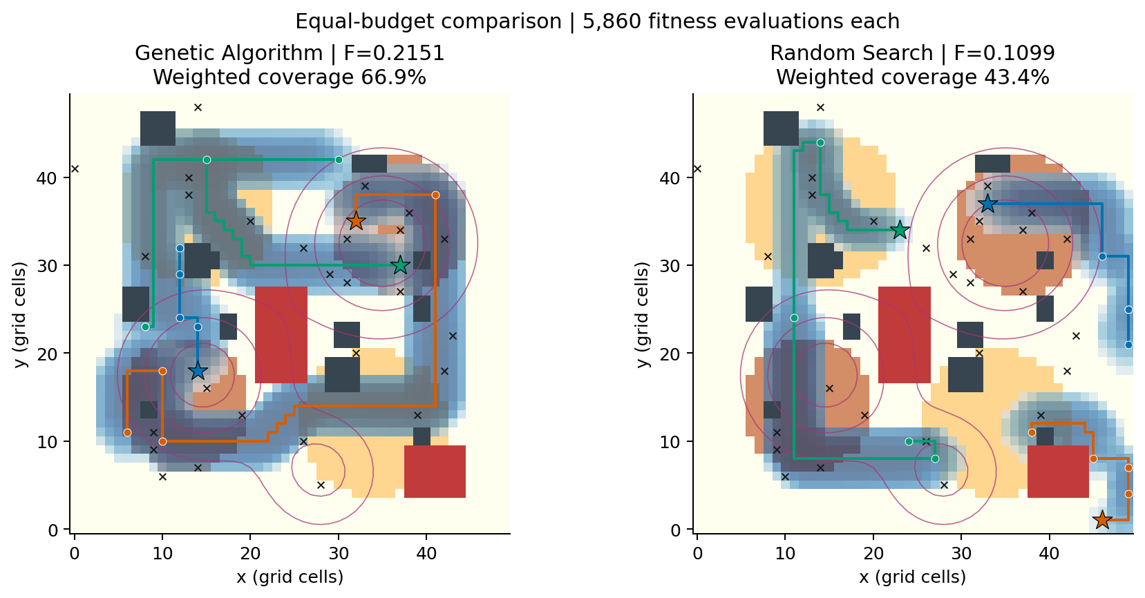
Figure 2. Final independently feasible routes and sensing footprints. Red: no-fly; charcoal: buildings; purple contours: hazards; stars: deployments.
Evolved strategy. The main GA changes fitness by +0.17242 from its initial population and finishes +0.10523 relative to equal-budget random search. Weighted coverage is 66.9% versus 43.4%; detection is 53.1% versus 32.1%. The solution combines deployment and path placement with sensor settings; its performance is measured from expanded routes rather than hardcoded waypoints. The sampled-target expected-detection diagnostic is 16.72 of 28 targets. This is an expectation, not an integer count of realized Bernoulli detections.
Trade-offs. Fleet energy totals 117.81 model units, completion time is the slowest vehicle’s 54.00 s, and integrated hazard exposure is 29.45 hazard-seconds. Broad active-sensor footprints improve unique coverage, while overlapping observations improve detection but earn no extra coverage. Faster travel reduces time and exposure, at a propulsion and sensing-dwell cost. A* detours avoid severe hazards when their edge-cost benefit justifies extra distance.
Hyperparameters. Best observed means in the individual sweeps were population=20 (mean F=0.1558); mutation=0.05 (mean F=0.1519); tournament=7 (mean F=0.1742). These are separate one-factor experiments, not a jointly optimized setting. Population comparisons trade exploration against number of generations under the same budget. The convergence statistic is relative to each run’s final gain, so a weaker solution can appear to converge sooner. Three seeds give limited precision.
Strengths and practical limits. The implementation provides deterministic tests, exact accounting of fitness calls, explicit feasibility and auditable JSON/CSV/NPZ artifacts. The world is static during a mission; footprint sensing assumes no building occlusion and independent exposures. UAV collision avoidance, weather evolution, communication, acceleration, altitude, turning radius and return-to-base are outside this model. Resource repair can create stationary suffixes and bias search toward feasible prefixes. All repeated experiments reuse one environment; runtime depends on hardware and route-cache reuse.
Future work and conclusion. Evaluate several terrain seeds, calibrate energy and sensor models, add time-dependent hazards, reserve energy for return, and enforce inter-UAV separation. A Pareto-based evolutionary method could expose policy trade-offs instead of fixing weights. Within the declared surrogate model, the delivered engine executes a real evolutionary search, compares it with an equal-budget baseline and produces feasible, reproducible mission artifacts.
Reproducibility: python main.py; python main.py --experiments; python generate_report.py; python -m pytest -v. Executed with Python 3.14.4, NumPy 2.3.5. All figures and tables in this report are generated from saved measurements.

