EF101-P11 Computer Hardware Inventory and Maintenance System: Project Report
Course: EF-101 Fall 2026 · Project: EF101-P11 Computer Hardware Inventory and Maintenance System · Group: Irteza Raza (EE-26129), Abdur Rauf (EE-26138), Hassan Majid (EE-26125) · Submission: Monday, 9 November 2026
Updated for project version 21 (reviewed on 12 Nov 2026: the test suite (test_app.py) has 292 automated checks in total, and schema.sql matches the shipped inventory.db).

1. Problem and objectives
An organization with dozens of computers loses track of what it owns, where each machine is, whether it is under warranty and how often it breaks. This system stores that information in one database and turns it into decisions: what to repair, replace or budget for.
Who would use it. A school computer lab or a small IT office that looks after a few rooms of PCs. The technician records each machine once, logs faults as they happen, and the manager reads the dashboard to decide what to repair, replace or budget for. A spreadsheet is not enough here because it has no relationship between a machine and its fault history, no validation (a typo in a RAM size or an IP address is accepted silently), and no record of what was done to a machine over time.
Objectives:
- Record each computer's hardware specs, location, warranty and operating status.
- Track a fault from the moment it is reported: its category, description, actions, technician and one running Updated Cost, then write it to the history as a single entry when the PC is Operational again.
- Keep the history of closed faults for every machine, and let users correct typos in any record.
- Search, filter and sort the inventory by CPU family, RAM, storage type, location, status and warranty.
- Show a dashboard: total, operational, faulty, out of warranty and needing attention, hardware-distribution charts, and the most frequently failing asset and fault category.
- Export inventory and maintenance data as CSV (opens in Excel) or as printable reports, and keep timestamped backups of the database.

2. Architecture
Everything runs on one computer: the browser sends a request, Flask runs a query on the SQLite file, and the result comes back as a page or a CSV download. The app needs no Internet connection to work.
- Browser (client): the user fills forms and clicks filters; pages are HTML from Jinja templates, styled by one plain CSS file (light and dark theme). Charts are CSS bars computed on the server, so no JavaScript chart library is used.
- Flask app (app.py): routes receive the request, validate input and call the database layer. It contains no SQL.
- Database layer (queries.py, db.py): every SQL statement lives in queries.py; db.py opens the SQLite file with foreign keys switched on.
- SQLite database (inventory.db): one file holding four tables: locations, assets, fault_steps and maintenance.
- Dashboard / Export: SQL aggregates feed the dashboard; /export/assets.csv and /export/maintenance.csv stream CSV files.
- QR labels and scanner (bonus): qr_labels.py builds the spec text of each asset’s label, draws it as a QR code (SVG, segno package) and decides which asset a scanned text means through /api/scan-lookup. /labels prints the label sheet and /scan reads a label with the camera, a photo or a typed code.
What happens on Save: the browser POSTs the form, Flask validates it, a parameterised INSERT or UPDATE runs, the change is committed to inventory.db, and the browser is redirected to the asset page. If the form is invalid it is shown again with messages and nothing is saved. Launching the app never deletes data: a first launch creates an empty database with six places, and python seed.py (or the reset-demo-data launcher, which asks for YES and saves a backup first) replaces it with demo data.
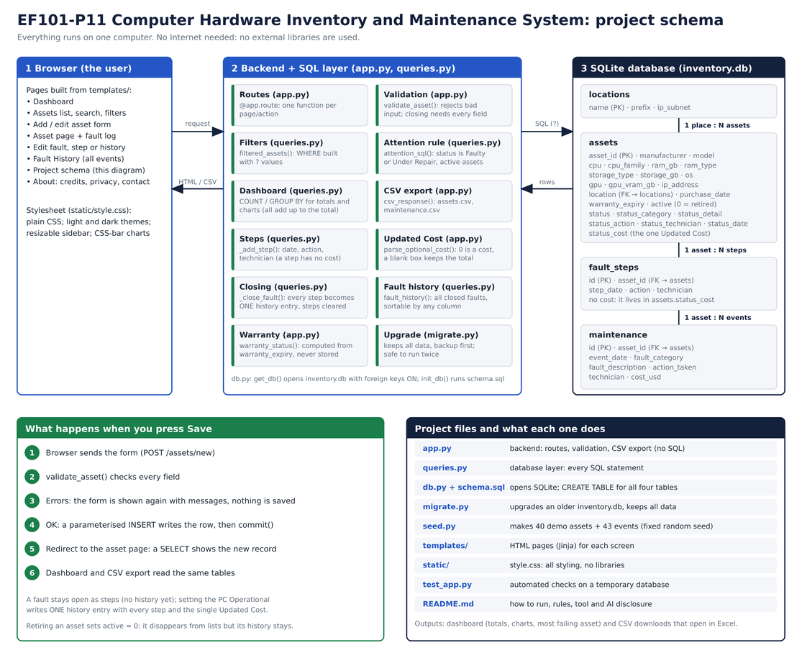
Figure 1. Project schema: layers, the four tables and the Save flow (docs/project-schema.png).
Local-only protections. The server listens on 127.0.0.1 only and answers only requests addressed to 127.0.0.1 or localhost (this blocks DNS rebinding) unless the INVENTORY_ALLOWED_HOSTS setting adds other names. It refuses form posts that come from another website (cross-site request forgery), limits each text box to 500 characters, and sends a Content-Security-Policy so the browser loads nothing from outside the app. Debug mode is off. No font, script or image comes from the Internet, which is why the Privacy page can truthfully say the app makes no outbound requests.

3. Technology choices
Component | Choice | Why
Language | Python | Readable; one language for server, seed script, upgrade script and tests
Web framework | Flask (3.x) | Small enough that every route can be traced from button to SQL query
Database | SQLite via built-in sqlite3 | One file, no server to install, supports relationships and constraints
Data access | Raw SQL with ? placeholders, all in queries.py | Easy to explain; prevents SQL injection; keeps app.py free of SQL
Pages | Jinja templates + plain CSS | Server-rendered forms; no front-end framework or build step
Charts | CSS bars from SQL counts | Works offline; every chart is computed from the same query as the totals
Export | Python csv module | CSV opens in Excel
Tests | Flask test client in test_app.py | Repeatable evidence (290 checks) on a temporary database
Launchers | start.*, reset-demo-data.*, scripts/ | Two-click start on Windows, macOS and Linux: finds Python, creates venv/, installs Flask and segno
Upgrades | migrate.py | Upgrades an older inventory.db without losing data; keeps a backup; safe to run twice
QR codes (bonus) | segno (Python, server) and jsQR (JavaScript, browser) | segno draws the codes as SVG; jsQR reads them from the camera or a photo. jsQR is one bundled file, so nothing is loaded from the Internet

Rationale: Streamlit was rejected because it hides the request, route and SQL path that the course asks us to explain; a spreadsheet-only approach was rejected for the reasons in section 1 (no relationships, validation or history).

4. Data design
Four tables. One place has many assets (assets.location references locations.name). One asset has many steps while a fault is open (fault_steps.asset_id) and many history entries once faults are closed (maintenance.asset_id). All three references are enforced with PRAGMA foreign_keys = ON.
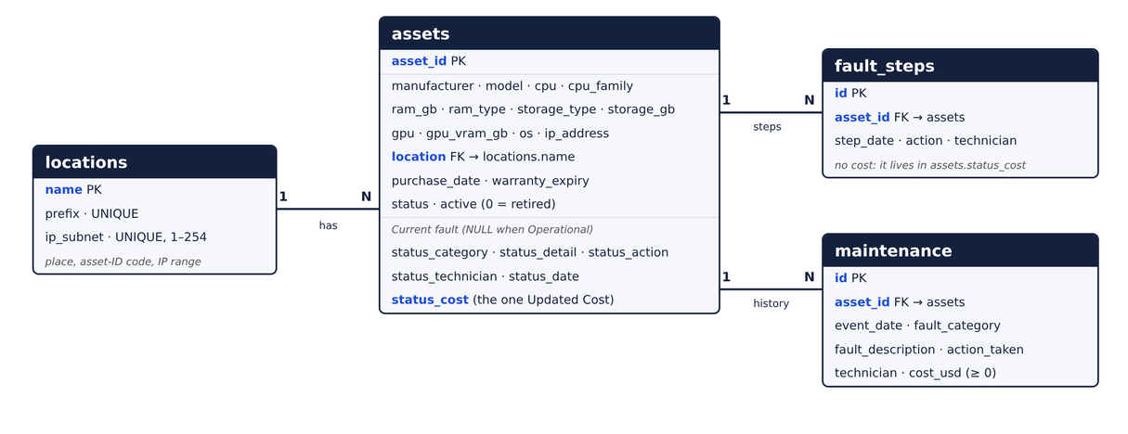
Figure 2. Entity-relationship diagram (keys and relationships; full columns in the tables below).
locations
Field | Type | Purpose
Name | TEXT, primary key | Shown in the drop-down, e.g. Lab 1
Prefix | TEXT, unique | Start of automatic asset IDs, e.g. L1 gives L1-PC-001
ip_subnet | INTEGER, unique, 1–254 | x in the place's IP range 192.168.x.n

assets
Field | Type | Purpose
asset_id | TEXT, primary key | Permanent identity, e.g. L1-PC-041; generated from the place or typed by the user
manufacturer, model | TEXT, required | Make and model
cpu, cpu_family | TEXT, required | Full CPU name; family used for filtering
ram_gb | INTEGER, > 0 | Memory (working space for running programs)
ram_type | TEXT: DDR1 to DDR5, required | Recorded per machine because some CPUs accept DDR4 or DDR5
storage_type | TEXT: SSD, HDD, NVMe, Hybrid | Drive technology
storage_gb | INTEGER, > 0 | Permanent storage capacity
gpu, gpu_vram_gb | TEXT optional; INTEGER > 0 or NULL | Blank GPU means integrated graphics; the VRAM field only appears for a dedicated GPU
OS | TEXT, required | Operating system
ip_address | TEXT, optional | Suggested from the ID on the form, changeable (192.168.x.n); blank = Not Assigned; unique inside a place
location | TEXT, foreign key to locations | Room or department
purchase_date, warranty_expiry | TEXT (ISO date); expiry >= purchase | Warranty status is computed from the expiry date
Status | TEXT: Operational, Faulty, Under Repair | Current condition
status_category, status_detail, status_action, status_technician, status_date | TEXT | The current (open) fault; all NULL when Operational
status_cost | REAL, >= 0 or NULL | The single Updated Cost of the open fault
Active | INTEGER, default 1, only 0 or 1 | 0 = retired, kept for history

fault_steps
Field | Type | Purpose
Id | INTEGER, auto-increment key | Step number
asset_id | TEXT, foreign key | Which asset has the open fault
step_date, action, technician | TEXT | What was done, when and by whom; a step has no cost of its own

maintenance
Field | Type | Purpose
Id | INTEGER, auto-increment key | Event number
asset_id | TEXT, foreign key | Which asset
event_date | TEXT (ISO date) | When the fault was closed
fault_category | TEXT | Fixed drop-down; used for the most-common-fault result
fault_description, action_taken, technician | TEXT | What broke, what was done (every step listed), who did it
cost_usd | REAL, >= 0, default 0 | Final Updated Cost in US dollars

Design decisions:
- Retire, don't delete: active = 0 hides the asset but keeps its history for failure analysis.
- Warranty status is computed (Active, Expiring soon, Expired) from warranty_expiry, so it never goes stale.
- Asset ID vs IP address: the ID identifies the machine for its whole life; the IP can change, is optional, is suggested from the ID and the place's range, and can repeat between places but never inside one.
- Open fault vs history: while a PC is Faulty or Under Repair its fault lives on the asset row and in fault_steps; nothing is written to maintenance until the PC is set to Operational, so the history only holds finished faults.
- One cost per fault: the Updated Cost is a single number on the asset, not a sum of steps, so correcting it never creates an audit step.
- Constraints in the database (CHECK, NOT NULL, UNIQUE, primary and foreign keys) back up the validation in the app; the tests confirm the database itself refuses a duplicate IP in a place. Dates are stored as ISO text (YYYY-MM-DD), so comparing the text is the same as comparing the dates; the check warranty_expiry >= purchase_date relies on this, and the app converts any typed date format to ISO before saving. The active column accepts only 0 or 1.
The full schema.sql is in Appendix A.

5. Main code segments
Route | Method | What it does
/dashboard (and / redirects here) | GET | Totals, charts, most failing asset and fault category, needs-attention list
/assets | GET | List with search, filters and column sorting
/assets/new | GET, POST | Add an asset (with optional current fault)
/api/next-asset-id | GET | Next free ID for the chosen place, e.g. L1-PC-041
/api/suggested-ip | GET | IP suggested for the form from the place and the Asset ID
/api/reset-demo | POST | Saves a backup, then replaces the data with demo data (sidebar button Reset to demo data)
/assets/<id> | GET | Asset details, current fault, steps and maintenance history
/assets/<id>/edit | GET, POST | Edit an asset (ID cannot change); status changes open or close a fault
/assets/<id>/retire, /reactivate | POST | Set active to 0 or 1
/assets/<id>/maintenance | POST | Log form: add a step to an open fault, or close it
/assets/<id>/fault/edit, /steps/<id>/edit|delete | GET, POST | Correct the current fault or its steps
/maintenance, /maintenance/<id>/edit|delete | GET, POST | Fault History page (sortable); correct or delete a history entry
/export/assets.csv, /export/maintenance.csv | GET | CSV download
/report/assets, /report/maintenance | GET | Printable asset inventory and maintenance reports (standalone print CSS)
/api/backup | POST | Save timestamped database backup to backups/ without resetting
/a/<id>, /api/scan-lookup | GET | Short address of an asset (opens it, case ignored; also understood on older labels); what a scanned text means (JSON)
/scan | GET | Scanner page: camera, photo upload or typed code; opens the asset
/labels, /assets/<id>/label, /qr/<id>.svg | GET | Printable label sheet (follows the list filters), one label, and the QR image as SVG
/about/credits, privacy, contact, schema | GET | Information pages; the schema page shows the project diagram

Filters and sorting build the SQL WHERE and ORDER BY clauses from the query string; values always go in as ? parameters, and an unknown sort column is ignored, so input never reaches the SQL text.
Validation (server-side): required fields; RAM and storage positive whole numbers; RAM type DDR1–DDR5; valid IP and no duplicate IP inside a place; valid dates (stored as YYYY-MM-DD); purchase date not in the future; warranty not before purchase; duplicate asset ID rejected (upper and lower case count as the same); asset ID only letters, digits, - . _ (at most 40 characters); cost a finite number from 0 to 1,000,000,000; each text box at most 500 characters; location name at most 40 characters.
Export safety. A CSV cell that starts with = + - or @ gets a leading apostrophe so Excel cannot run it as a formula, and each file starts with a UTF-8 byte-order mark so accented text opens correctly.
Needs-attention rule (active assets only): status is Faulty or Under Repair, and nothing else. Past faults are listed separately in the Fault History page. The rule is one function, attention_sql() in queries.py.
Fault life-cycle. Setting a PC to Faulty or Under Repair opens a fault (category, description, actions to be taken, technician, date, Updated Cost). Each save with a new action adds a step. Under Repair requires a technician. Setting the PC to Operational closes the fault: every fault field and the date are required, and ONE history entry is written whose Action taken lists every step with its date. The steps are then cleared.
Updated Cost. A typed 0 is a real cost of 0; a blank box keeps the current total. The final history entry records the Updated Cost.
Asset IDs and IPs. An ID is generated from the place code unless the user types one. The Add/Edit form suggests an IP (192.168.range.last two ID digits) that the user can keep, replace with a custom IP, or leave blank (Not Assigned). The same IP may be used in different places but not twice in one; a repeated IP is refused on save.
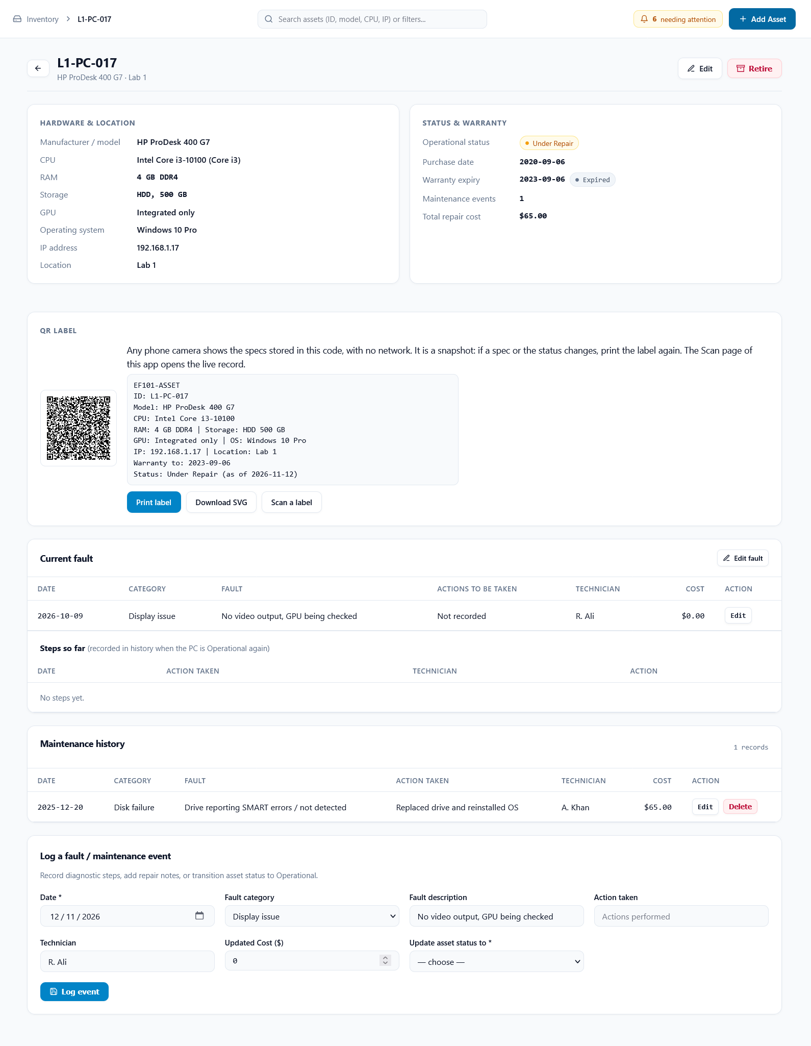
Figure 3. Asset page for L1-PC-017 (Under Repair), version 21 (demo data): hardware and warranty, the current fault with its Updated Cost, the steps so far (none recorded yet), the closed-fault history, the QR label card, and the form for logging a fault or maintenance event.
Major Asset Editing Error: Problem found in version 1 and how it was fixed. The only serious error we met during testing was that editing an existing asset crashed with the message "UndefinedError: 'sqlite3.Row object' has no attribute 'get'", while adding an asset worked. Cause: the edit page loads the asset with a SELECT, which returns a sqlite3.Row, and the shared form template asset_form.html reads each value with a.get(...), which a Row does not have. The Add page passes a plain dictionary, and so does the edit page after a failed validation, so only opening the edit page for an existing asset failed. Fix: the edit route now converts the Row to a dictionary before showing the form and turns empty (NULL) values into blank text, which also stops fields such as GPU from showing the word "None". A regression test now opens the edit page of every asset and checks that no input shows "None". Everything found after that was small glitches and improvements that did not stop the app from being used.
QR labels and scanner (bonus, versions 20 and 21). Every asset has a QR code that holds a short block of plain text: the asset ID, model, CPU, RAM, storage, GPU, operating system, IP address, location, warranty expiry and the status with an “as of” date (fault details and costs are never put on a label). Any phone camera shows this text with no network, which matters because the app runs only on the computer it is installed on. The text is a snapshot made on the day the label is printed, so a label is printed again after a spec or status change; the asset page is always current. The asset page shows the code with Print label and Download SVG, and /labels prints a sheet of labels for the assets the list currently shows. The Scan page reads a label in the browser (camera, uploaded photo or typed code; a USB barcode scanner types into the same box), asks the app which asset the text means through /api/scan-lookup, and opens the live record. The spec block, an older link, EF101-ASSET:<ID> or a bare ID are all understood, and upper or lower case is ignored. The code uses error-correction level Q with a 4-module quiet zone and each field is cut to 60 characters so that it stays easy to scan; every generated label decodes back to its text (checked on the 40 demo assets). No database change was needed: the text is built from the existing assets table when a label is shown.
Printable reports and backup (version 21). Version 21 adds standalone printable reports for the asset list and the fault history (/report/assets and /report/maintenance). They have their own minimal styling and @media print rules that hide the controls on print. A Backup data button in the sidebar (/api/backup) saves a timestamped copy of the database to a backups/ directory without wiping any data, and the demo reset (/api/reset-demo) now saves a backup before it resets the data.
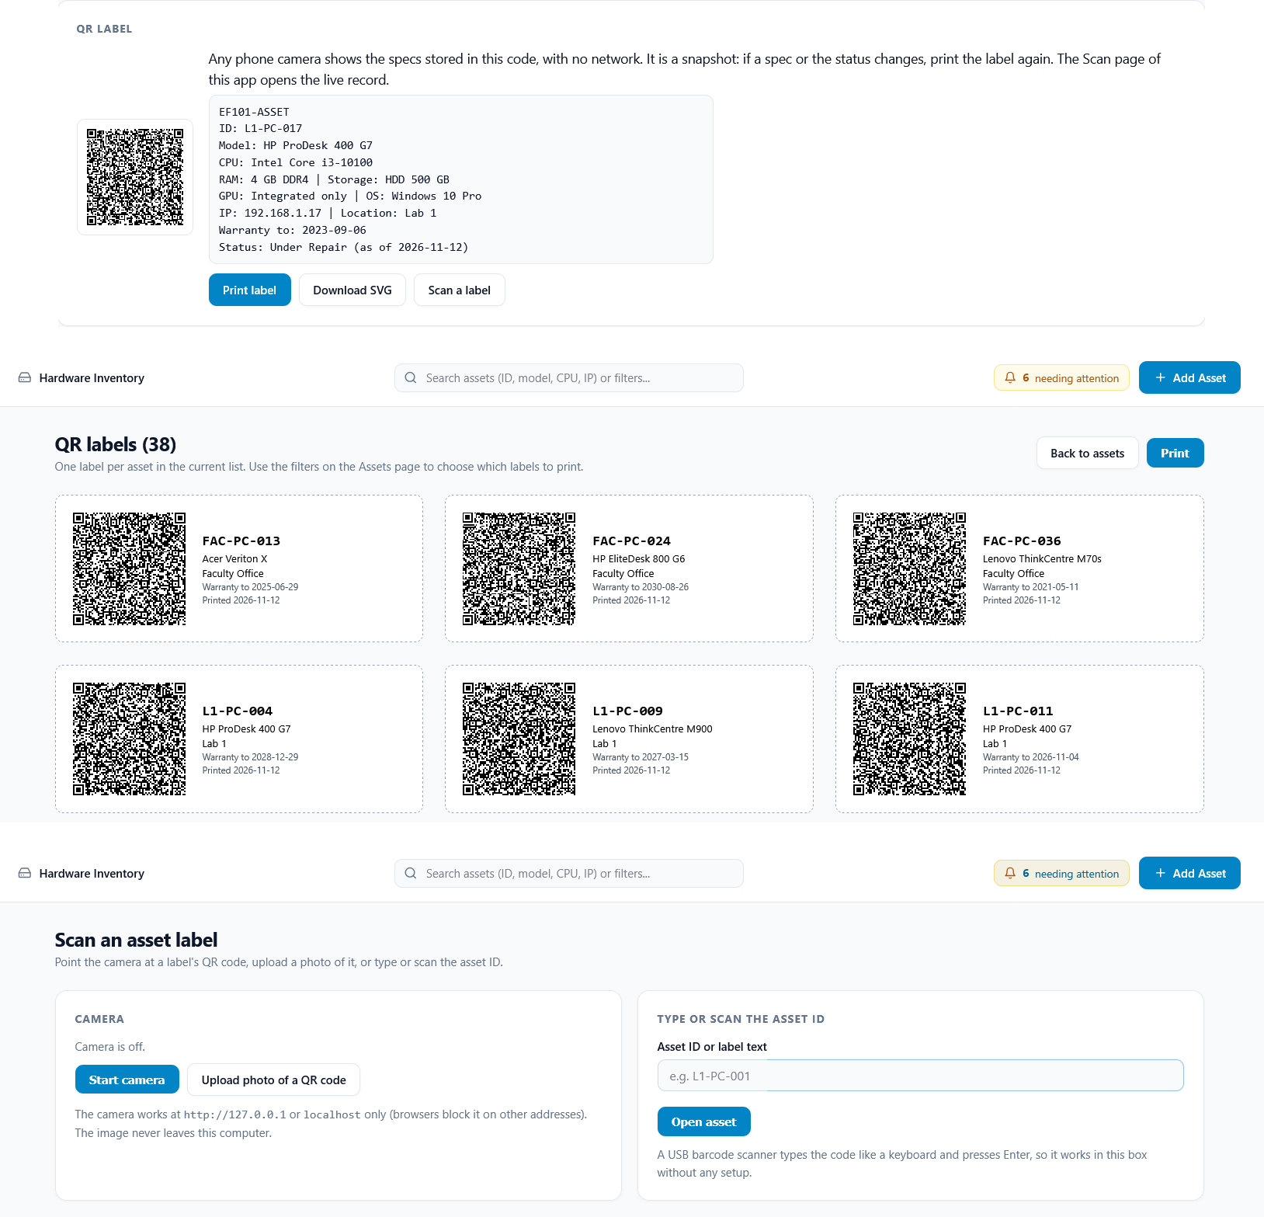
Figure 4. QR bonus feature (version 21). Top: the QR label card on the asset page. Middle: the printable label sheet, first two rows shown (it follows the list’s filters). Bottom: the Scan page with the camera off, showing the photo upload and typed-ID options.

6. Testing
Area | What is checked | Example
Add and validate | Valid form saves; bad input is rejected and nothing is saved | Blank manufacturer, RAM = 0 or text, bad IP, future purchase date, warranty before purchase, duplicate asset ID
Edit, retire, reactivate | Values update; retired assets leave the list but keep history | Retired asset hidden, shown with ?show=retired
Fault life-cycle | Open fault, steps, closing writes ONE entry | Closing combines every step into one entry; saving twice adds no step; Under Repair needs a technician
Updated Cost | 0 is saved, blank keeps the total, a cost alone adds no step | Closing with cost 0 gives a history entry of exactly 0
IP rules | Per-place uniqueness in the app and in the database | Same IP in the same place rejected; database refuses a duplicate; same IP in another place allowed
Search, filters, sorting | Row counts match SQL; sorting is safe | sort=DROP TABLE is ignored; q=' OR 1=1 -- does not crash
Dashboard and export | Charts add up to the total; CSV rows match the data | List count = dashboard total; attention list = its card
Places and IDs | New place gets the next range; IDs come from the place | Lab 4 gets range 7; the form suggests 192.168.7.1 for L4-PC-001
Upgrade and launch | migrate.py keeps data; launching keeps data | migrate.py is safe to run twice; busy port is skipped
Errors | Unknown asset or URL | 404 page, no crash
Security and robustness | Odd input and cross-site requests are refused; nothing is saved | Cost nan or 1e999, asset ID with a space or slash, date typed as 10/01/2025 (saved as 2025-01-10), POST from another site (403), wrong Host header (400), CSV cell =1+1 (exported as '=1+1)
QR labels and scanning | Scanned text is mapped to the right asset; routes, label sheet and QR image behave; odd input is escaped | Spec block (also pasted as one line), older link, EF101-ASSET:ID and bare ID all open the asset; unknown code gives 404 and is shown escaped; label text format and limits (status word only, fields cut to 60 characters); label sheet = list filter; every generated code decodes back to its text; app still works without segno
Printable reports and backup | Reports open with their tables and filters; a backup writes a file to backups/; the demo reset saves one first | /report/assets?location=Lab 1 shows the filter; POST /api/backup names the new file in its message

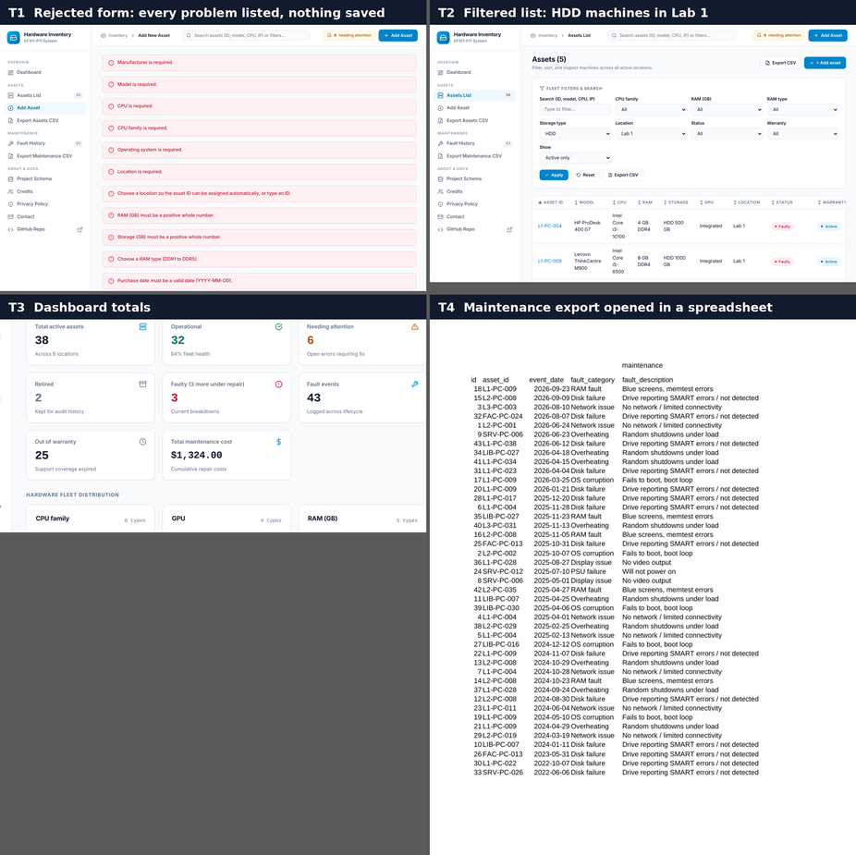
Figures T1–T4. Manual evidence from the demo database: T1 a rejected Add form (nothing is saved); T2 the filtered list; T3 the dashboard totals; T4 the exported maintenance CSV opened in a spreadsheet (LibreOffice Calc).

7. Results
Figures below come from the shipped inventory.db (demo data, not real assets) on 12 Nov 2026. Warranty-based numbers depend on the date; the out-of-warranty count of 25 applies on 12 Nov 2026.
- Dataset: 40 assets (38 active, 2 retired) in 6 places and 43 maintenance events, total repair cost $1,324.
- Status (active assets): 32 operational, 3 faulty, 3 under repair.
- Out of warranty: 25 of 38 active assets (13 in warranty).
- Needing attention: 6 of 38, the three faulty and three under-repair assets (rule in section 5).
- Hardware mix: RAM 4 GB × 7, 8 GB × 10, 16 GB × 12, 32 GB × 5, 64 GB × 4; storage NVMe × 17, HDD × 13, SSD × 8; CPU family Core i5 × 10, Core i3 × 9, Core i7 × 8, Ryzen 7 × 5, Ryzen 9 × 4, Ryzen 5 × 2; 25 machines use integrated graphics.
- Assets per place: Lab 1 and Library 10 each, Lab 2 7, Lab 3 5, Faculty Office and Server Room 3 each.
- Most frequently failing asset: L1-PC-009 with 6 events, then L2-PC-008 (5) and L1-PC-004 (4).
- Most common fault category: Disk failure, 14 of 43 events, ahead of Overheating (9), Network issue (7), RAM fault (5) and OS corruption (5).
Interpretation. HDD machines are 15 of the 40 assets but account for 27 of the 43 events and 11 of the 14 disk failures, and the three most frequently failing assets are all HDD machines. This suggests replacing the remaining HDDs with SSDs is the most effective way to cut repairs. The data is synthetic (generated by seed.py with a deliberate bias towards HDD failures), so these numbers illustrate the method and are not real findings.
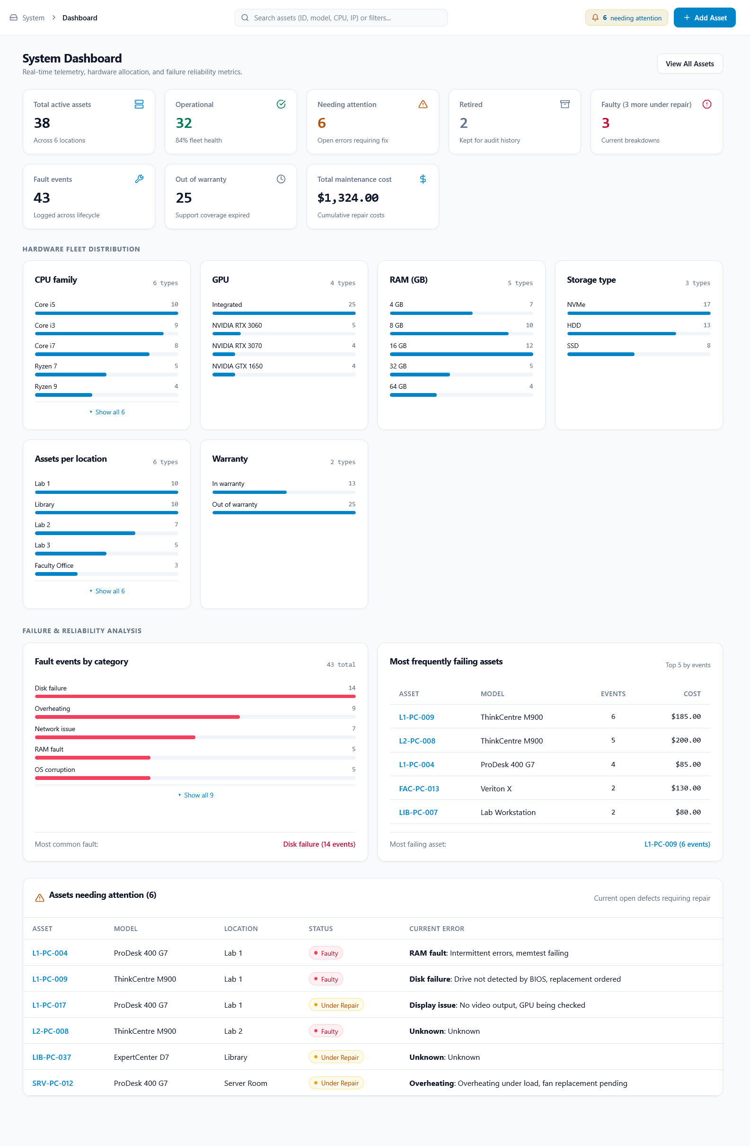
Figure 5. The dashboard on 12 Nov 2026 (version 21): totals, hardware-distribution charts (CPU family, GPU, RAM, storage, place, warranty), fault events by category and the most frequently failing assets.

8. Limitations and future work
Limitations:
- No login or user roles, so anyone who can open the app can change data.
- Data entry is manual; specs are not read from the machines.
- SQLite suits one site and few simultaneous users; many concurrent writers would need a server database.
- Costs are in one currency (US dollars) and there is a single technician name field, not a list of staff.
- The demo dataset is synthetic, so the failure statistics illustrate the method and are not real findings.
- A QR label is a snapshot of the specs and status on the day it was printed; after a change it must be printed again (the “as of” date on the label shows its age). The app itself answers only on this computer, so a phone reads the specs from the code but cannot open the live record. The browser camera works only at 127.0.0.1 or localhost.
Done in version 20: QR asset labels with a scanner page. Done in version 21: printable asset and maintenance reports, in-app backup without resetting, and automatic reset backups to backups/. Future work (only after the mandatory parts): automatic spec import, warranty reminders, a depreciation dashboard, a spare-parts inventory.

9. Contributions
Member | Main area | Contribution | Report sections
Irteza Raza  (EE-26129) | Database: schema.sql, db.py, queries.py, seed.py, inventory.db | Built schema.sql, db.py, queries.py, seed.py, inventory.db using Claude  Fixed IP address, Current Fault Editing, Maintenance History Management, Fault History Table using Claude  Added GPU VRAM Field, Delete and Edit buttons in Maintenance History using Claude. Built the v19 interface from Hassan Majid's ideas using Claude. | 4, 7, 8
Abdur Rauf  (EE-26138) | Backend: app.py, qr_labels.py, test_app.py, migrate.py, launcher scripts, README | Built app.py, test_app.py, migrate.py, launcher scripts, README, Interface using Claude  Fixed Major Asset Editing Error mentioned in Section 5, Cost logic, Dates, Asset IDs, RAM types, Dashboard sorting, Assets Editing page tweaks, Unused Code using Claude  Added Theme, Sidebar, Credits, Privacy Policy, Contact, Fault history, Current fault field using Claude. Built the v19 interface from Hassan Majid's ideas using Claude.  Added the v20 QR labels, label sheet, scanner page and short-link routes (qr_labels.py, static/scan.js), and v21 printable reports (/report/assets, /report/maintenance) and the backups/ system using Claude. | 1, 5, 6, 7, 8
Hassan Majid  (EE-26125) | Frontend design (ideas); final report | Proposed the interface design ideas: theme, sidebar, sidebar sections and assets list sorting. Ideas only, no code; Irteza Raza and Abdur Rauf built them in v19. | 1, 2, 3, 7, 8
Abdur Rauf owns migrate.py, the launcher scripts and the README, which were added after the original split. Shared: cross-review of each other's code, testing and rehearsal for the viva. Hassan Majid proposed the interface ideas (theme, sidebar, sidebar sections, assets list sorting) without writing code; Irteza Raza and Abdur Rauf built them in version 19. Hassan Majid answers the frontend viva questions. Version 20 (QR labels and scanner, move to new repo) and Version 21 (printable reports, in-app backup, backups/ directory) were built by Abdur Rauf with Claude.
For all changes, fixes and tweaks for version 20 and later (from 12 Nov 2026), check changelogs directory in the GitHub Repository.
[https://github.com/AbdurRauf-01/ef101-fall2026-p11/tree/main/changelogs]
For all changes, fixes and tweaks for version 19 (9 Nov 2026), check changelogs directory in the GitHub Repository.
[https://github.com/irtazaraza7184/ef101-p11/tree/main/changelogs]
For all changes, fixes and tweaks before version for version 18 and before, check changelogs directory in the GitHub Repository.
[https://github.com/AbdurRauf-01/ef101-p11/tree/main/changelogs]

10. Tool and AI disclosure
Software: Python, Flask, segno (QR codes), SQLite (built-in sqlite3), Jinja templates and plain CSS. In the browser, jsQR (Apache-2.0, one file bundled with the app) reads QR codes; no font, script or file is loaded from the Internet at run time.
AI: Claude (Anthropic) was used to draft the application code, the demo-data script, the test script and report skeleton. Later versions of the project (up to version 21) were improved and fixed using several Claude accounts. Version 19 (9 Nov 2026), built by Irteza Raza and Abdur Rauf with Claude from the interface ideas proposed by Hassan Majid, changed the interface styling, sidebar counts and the Credits, Privacy, Contact and Schema text, and added the IP suggestion and two helper routes (listed in CHANGELOG.md). A final review on 12 Nov 2026 (also with Claude) found and fixed further errors. The screenshots in Figures 3 to 5 were captured from the running app (version 21, demo database) on 12 Nov 2026 and cropped for this report.

Appendix A: schema.sql
-- EF101-P11 Computer Hardware Inventory and Maintenance System: database schema (SQLite)
-- locations (1) -- (N) assets (1) -- (N) maintenance
-- assets (1) -- (N) fault_steps: the work done while a fault is open (one history entry is written when it closes)
-- The cost of an open fault is ONE number: assets.status_cost (Updated Cost). Steps carry no cost.
-- Running this file wipes and recreates all tables.

DROP TABLE IF EXISTS fault_steps;
DROP TABLE IF EXISTS maintenance;
DROP TABLE IF EXISTS assets;
DROP TABLE IF EXISTS locations;

CREATE TABLE locations (
name TEXT PRIMARY KEY, -- shown in the drop-down, e.g. Lab 1
prefix TEXT NOT NULL UNIQUE, -- start of automatic asset IDs, e.g. L1 -> L1-PC-001
ip_subnet INTEGER NOT NULL UNIQUE -- x in the place's IP range 192.168.x.n (1..254)
CHECK (ip_subnet BETWEEN 1 AND 254)
);

CREATE TABLE assets (
asset_id TEXT PRIMARY KEY, -- permanent identity, e.g. L1-PC-001
manufacturer TEXT NOT NULL,
model TEXT NOT NULL,
cpu TEXT NOT NULL, -- full model, e.g. Intel Core i5-12400
cpu_family TEXT NOT NULL, -- grouping used for filtering, e.g. Core i5
ram_gb INTEGER NOT NULL CHECK (ram_gb > 0),
ram_type TEXT NOT NULL CHECK (ram_type IN ('DDR1','DDR2','DDR3','DDR4','DDR5')),
storage_type TEXT NOT NULL CHECK (storage_type IN ('SSD','HDD','NVMe','Hybrid')),
storage_gb INTEGER NOT NULL CHECK (storage_gb > 0),
gpu TEXT, -- NULL / empty = integrated only
gpu_vram_gb INTEGER CHECK (gpu_vram_gb IS NULL OR gpu_vram_gb > 0),
os TEXT NOT NULL,
ip_address TEXT, -- 192.168.x.n; unique inside a place
location TEXT NOT NULL REFERENCES locations(name),
purchase_date TEXT NOT NULL, -- ISO date YYYY-MM-DD
warranty_expiry TEXT NOT NULL, -- warranty status is COMPUTED from this
status TEXT NOT NULL DEFAULT 'Operational'
CHECK (status IN ('Operational','Faulty','Under Repair')),
-- Current fault: filled while status is Faulty / Under Repair, all NULL when Operational
status_category TEXT, -- fault category, 'Unknown' if not given
status_detail TEXT, -- fault description ('' = not given)
status_action TEXT, -- actions to be taken ('' = not decided)
status_technician TEXT, -- technician ('' = not assigned yet)
status_date TEXT, -- date the fault was recorded (ISO)
status_cost REAL CHECK (status_cost IS NULL OR status_cost >= 0), -- updated cost of the open fault
active INTEGER NOT NULL DEFAULT 1 CHECK (active IN (0,1)), -- 0 = retired (kept for history)
CHECK ((status = 'Operational' AND status_category IS NULL AND status_detail IS NULL
AND status_action IS NULL AND status_technician IS NULL AND status_date IS NULL
AND status_cost IS NULL)
OR (status <> 'Operational' AND status_category IS NOT NULL AND status_detail IS NOT NULL
AND status_action IS NOT NULL AND status_technician IS NOT NULL AND status_date IS NOT NULL)),
CHECK (warranty_expiry >= purchase_date),
UNIQUE (location, ip_address) -- no two PCs in one place share an IP
);

CREATE TABLE maintenance (
id INTEGER PRIMARY KEY AUTOINCREMENT,
asset_id TEXT NOT NULL REFERENCES assets(asset_id),
event_date TEXT NOT NULL,
fault_category TEXT NOT NULL, -- one of the fault category drop-down options
fault_description TEXT NOT NULL, -- may be '' when not given
action_taken TEXT NOT NULL, -- may be '' when not given
technician TEXT NOT NULL, -- may be '' when not given
cost_usd REAL NOT NULL DEFAULT 0 CHECK (cost_usd >= 0) -- US dollars
);

CREATE INDEX idx_maint_asset ON maintenance(asset_id);

-- Steps of an open fault (Faulty / Under Repair). They are not history yet: when the PC is Operational
-- again, all steps are combined into the Action taken of ONE maintenance entry and this table is emptied.
-- A step has no cost: the cost of the open fault is the single Updated Cost in assets.status_cost.
CREATE TABLE fault_steps (
id INTEGER PRIMARY KEY AUTOINCREMENT,
asset_id TEXT NOT NULL REFERENCES assets(asset_id),
step_date TEXT NOT NULL, -- ISO date of the step
action TEXT NOT NULL, -- what was done
technician TEXT NOT NULL -- who did it ('' = not recorded)
);

CREATE INDEX idx_steps_asset ON fault_steps(asset_id);

