Cloudflare R2 and CDN Management
GML Admin Portal – Developer Implementation Specification
SmarterASP + Cloudflare R2 + Cloudflare CDN
Prepared for Grade My Labs (GML)
Version 1.0 | 1 August 2026
Implementation authority
The written requirements in this document are mandatory. The included UI images are conceptual mockups; if a label or value in a mockup conflicts with the written specification, the written specification takes precedence.

Document Map
This specification defines the storage structure, admin-portal layout, backend services, advertisement logic, database records, API behavior, security controls, and acceptance criteria required for implementation.
- 1. Scope and mandatory outcomes
- 2. Target architecture
- 3. Cloudflare R2 object-key structure
- 4. SmarterASP environment variables
- 5. Admin menu and shared page layout
- 6. GML Diagrams tab
- 7. GML Exam Engine tab
- 8. Advertisements tab
- 9. Advertisement probability and rotation logic
- 10. Backend API requirements
- 11. Database requirements
- 12. R2 and CDN operation flows
- 13. Security, validation, audit, and errors
- 14. Developer acceptance criteria
- Appendix A. UI mockups

1. Scope and Mandatory Outcomes
The GML Admin Portal hosted on SmarterASP must provide a controlled interface for managing Cloudflare R2 objects and Cloudflare CDN cache behavior. The backend must use credentials stored in SmarterASP environment variables and must never expose those credentials to the browser or desktop applications.
- Manage application files. Administrators can upload, list, replace, delete, and copy CDN URLs for files belonging to GML Diagrams and GML Exam Engine.
- Manage 20 fixed advertisement slots. Administrators can upload or replace advertisement images, configure probability values, and assign each advertisement to one or more applications.
- Preserve permanent URLs. Replacing a file must use the same R2 object key; therefore, the CDN URL remains unchanged.
- Refresh cached content. Every successful replacement must purge the exact CDN URL so clients receive the updated object.
- Protect credentials. All R2 and Cloudflare API credentials remain server-side and are loaded only from environment variables.
Core invariant
Same logical file = same R2 object key = same CDN URL. A Replace operation changes the object content, not the object key.

2. Target Architecture
GML Admin Portal on SmarterASP
|
+-- R2 S3-compatible API
| +-- Upload or replace objects
| +-- List objects by prefix
| +-- Read metadata
| +-- Delete objects
|
+-- Cloudflare API
+-- Purge exact CDN URLs
Cloudflare R2 Bucket
+-- Custom CDN domain, for example https://cdn.grademylabs.com

The R2 bucket must be connected once to a Cloudflare custom domain. After that connection exists, an R2 object becomes available through the CDN by combining the configured CDN base URL with the object key. The application does not need a separate “publish to CDN” operation for every upload.
Required operation order
For a replacement: upload the new object, verify the result, purge the exact CDN URL, then return success. Never purge first.

3. Cloudflare R2 Object-Key Structure
Cloudflare R2 uses flat object storage. The portal may display folder-style navigation, but the implementation must use object-key prefixes. The mandatory root prefix is GML-SmarterASP.
GML-SmarterASP/
|-- GML-Diagrams/
|-- GML-Exam-Engine/
`-- Advertisements/

3.1 GML Diagrams prefix
GML-SmarterASP/GML-Diagrams/

Examples of stable files that may be stored under this prefix:
- GML-Diagrams-Setup.msi
- GML-Diagrams-Release-Notes.pdf
- GML-Diagrams-Version.json
- GML-Diagrams-Checksum.txt
Example stable CDN URL:
https://cdn.grademylabs.com/GML-SmarterASP/GML-Diagrams/GML-Diagrams-Setup.msi

3.2 GML Exam Engine prefix
GML-SmarterASP/GML-Exam-Engine/

Examples of stable files that may be stored under this prefix:
- GML-Exam-Engine-Setup.msi
- GML-Exam-Engine-Release-Notes.pdf
- GML-Exam-Engine-Version.json
- GML-Exam-Engine-Checksum.txt
Example stable CDN URL:
https://cdn.grademylabs.com/GML-SmarterASP/GML-Exam-Engine/GML-Exam-Engine-Setup.msi

3.3 Advertisements prefix
The Advertisements prefix contains exactly 20 fixed logical slots. Each slot has an immutable object key and permanent CDN URL.
GML-SmarterASP/Advertisements/Advertisement-01.webp
GML-SmarterASP/Advertisements/Advertisement-02.webp
...
GML-SmarterASP/Advertisements/Advertisement-20.webp

Advertisement slot rule
The administrator may replace the image stored in a slot, but may not rename, delete, or change the object key of the slot.

4. SmarterASP Environment Variables
The backend must read all Cloudflare and R2 configuration from SmarterASP environment variables. Secret values must not be stored in appsettings.json, source control, database tables, JavaScript, HTML, browser local storage, or logs.
Variable | Purpose | Secret
CLOUDFLARE_R2_ACCOUNT_ID | Cloudflare account identifier | No
CLOUDFLARE_R2_ACCESS_KEY_ID | R2 S3 API access key | Yes
CLOUDFLARE_R2_SECRET_ACCESS_KEY | R2 S3 API secret key | Yes
CLOUDFLARE_R2_BUCKET_NAME | R2 bucket name | No
CLOUDFLARE_R2_ENDPOINT | S3-compatible endpoint | No
CLOUDFLARE_R2_REGION | Use auto unless the SDK requires a value | No
CLOUDFLARE_CDN_BASE_URL | Public custom CDN domain | No
CLOUDFLARE_ZONE_ID | Cloudflare zone identifier | No
CLOUDFLARE_CACHE_PURGE_TOKEN | API token limited to cache purge | Yes
CLOUDFLARE_R2_ROOT_PREFIX | Must be GML-SmarterASP | No

CLOUDFLARE_R2_ROOT_PREFIX=GML-SmarterASP
CLOUDFLARE_CDN_BASE_URL=https://cdn.grademylabs.com
CLOUDFLARE_R2_ENDPOINT=https://<ACCOUNT-ID>.r2.cloudflarestorage.com

- Validate all mandatory variables during application startup or when the Cloudflare service is first used.
- Return a sanitized configuration error when a variable is missing; never echo secret values.
- Use a dedicated SmarterASP application pool where possible so unrelated sites cannot access the same process-level variables.
- The View Settings action may show only non-secret values: bucket name, root prefix, CDN domain, and connection status.

5. Admin Menu and Shared Page Layout
Add Cloudflare Management under the existing Global Settings area in the left-hand admin navigation.
Dashboard
`-- Global Settings
`-- Cloudflare Management
|-- GML Diagrams
|-- GML Exam Engine
`-- Advertisements

Cloudflare Management should open as one page with three top tabs. The tabs keep the existing admin theme, spacing, typography, and action-button style.

5.1 Shared header and connection panel
- Page title: Cloudflare Management.
- Description: Manage files and advertisements stored in Cloudflare R2 and delivered through CDN.
- Top-right Test Connection button.
- Tabs: GML Diagrams, GML Exam Engine, Advertisements.
- Connection panel showing Connected/Disconnected, bucket, root prefix, CDN domain, and last checked time.
- View Settings button showing only non-secret configuration.

5.2 Test Connection behavior
1. Confirm that all required environment variables are present.
2. Authenticate to R2 and verify access to the configured bucket.
3. Verify that the root prefix can be listed.
4. Validate that the cache-purge token can access the configured zone.
5. Return a clear success or sanitized failure message and update Last Checked.
Authorization
Create a backend permission such as ManageCloudflareStorage. Enforce it on every page action and API endpoint; hiding a menu item is not sufficient.

6. GML Diagrams Tab
This tab lists only objects whose key starts with GML-SmarterASP/GML-Diagrams/. It must never display Exam Engine or Advertisement objects.
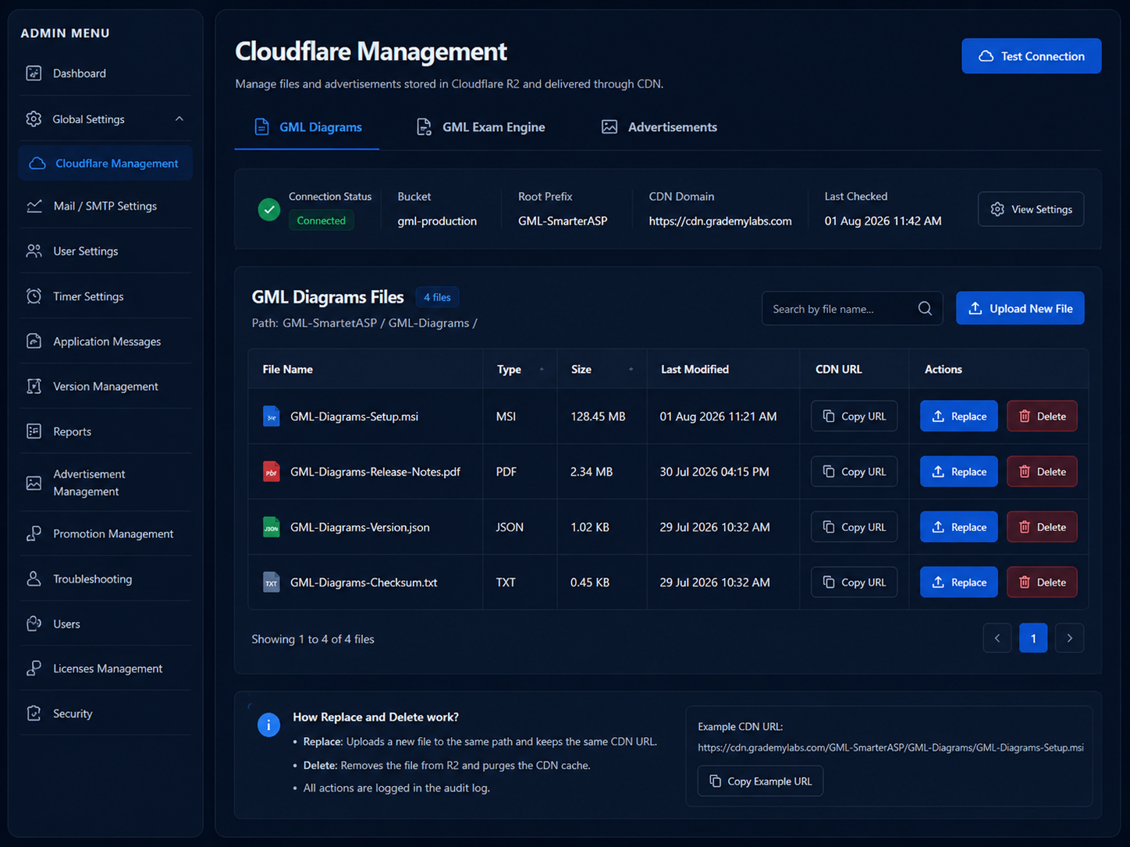
Figure 1. Proposed GML Diagrams file-management layout.

6.1 Required controls and columns
Column | Behavior
File name | Object file name without the prefix
Type | MSI, PDF, JSON, ZIP, TXT, and other approved types
Size | Human-readable object size
Last modified | R2 last-modified timestamp
CDN URL | Copy URL action; the secret bucket endpoint is never shown
Actions | Replace and Delete

- Search by file name.
- Upload New File button for creating a new object in this prefix.
- Pagination for large lists.
- Optional sorting by file name, type, size, and modified date.

6.2 Replace action
1. Select the existing object and show its current file name and CDN URL.
2. Allow the administrator to select a replacement file.
3. Do not allow the object key to be edited during Replace.
4. Validate extension, MIME type, size, and content.
5. Upload to the same R2 object key.
6. Verify the resulting object metadata or ETag.
7. Purge the exact CDN URL.
8. Refresh the table and write an audit record.

6.3 Delete action
1. Display a destructive confirmation with file name and CDN URL.
2. Check whether the file is referenced by an active release or website record.
3. Delete the R2 object after confirmation.
4. Purge the exact CDN URL so stale content is not served.
5. Update related records and write an audit entry.

7. GML Exam Engine Tab
This tab follows the same layout and behavior as GML Diagrams, but it lists only objects under GML-SmarterASP/GML-Exam-Engine/.
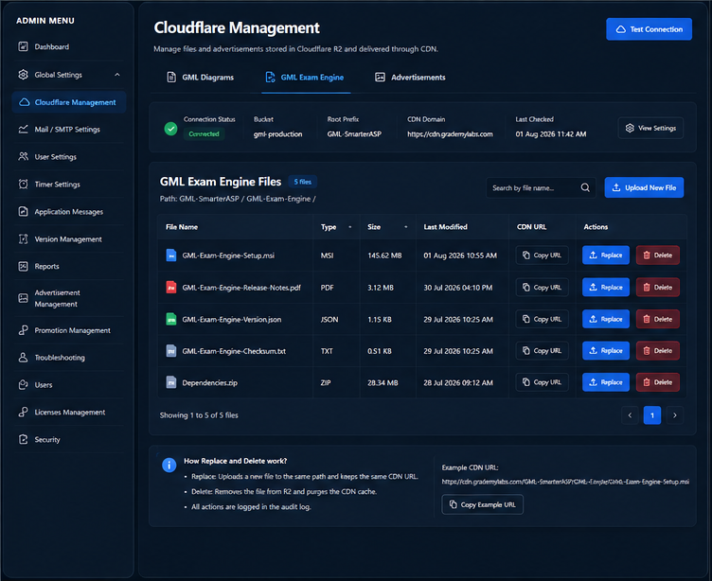
Figure 2. Proposed GML Exam Engine file-management layout.
- Upload New File creates an object only under the Exam Engine prefix.
- Replace uploads to the same object key and keeps the same CDN URL.
- Delete removes the object and purges its exact CDN URL.
- Copy URL returns the custom-domain CDN URL, not the R2 API endpoint.
- All validation, authorization, pagination, and audit rules are identical to GML Diagrams.

8. Advertisements Tab
This tab displays exactly 20 fixed advertisement slots. It is not a general file browser. The only file action is Upload for an empty slot or Replace for an uploaded slot. There is no Delete action.
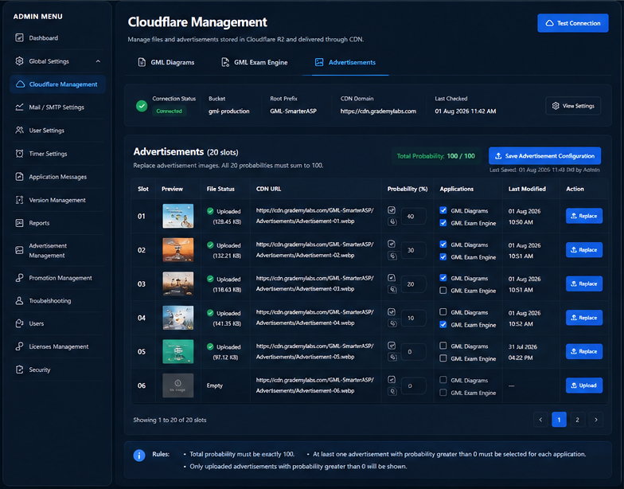
Figure 3. Proposed Advertisements management layout.

8.1 Required row layout
Column | Required behavior
Slot | Fixed number from 01 through 20
Preview | Thumbnail or Empty placeholder
File status | Uploaded or Empty, with size when available
CDN URL | Permanent URL and Copy URL action
Probability (%) | Integer input from 0 through 100
Applications | Checklist loaded from the applications table
Last modified | Last successful image replacement time
Action | Upload for empty slot; Replace after first upload

8.2 Fixed-slot behavior
- Seed 20 slot records in the database during migration or initialization.
- Map slot 01 to Advertisement-01.webp, slot 02 to Advertisement-02.webp, and so on.
- ObjectKey and SlotNumber are immutable.
- The local upload file name does not determine the R2 object key.
- Replacing an image must preserve probability values and application assignments.
- After replacement, purge the exact CDN URL and refresh the preview using a cache-busting query parameter only in the admin UI if necessary.

8.3 Probability input validation
- Each value is an integer between 0 and 100.
- The total across all 20 slots must equal exactly 100 before the configuration can be saved.
- Display a live Total Probability indicator, for example 100 / 100.
- When one slot is set to 100, automatically set all other slots to 0.
- A slot with probability 0 is never selected by a desktop application.
- An empty slot is never selected even if its probability is greater than 0; saving should warn or block until the inconsistency is corrected.

8.4 Application checklist
The checklist must be populated dynamically from the applications/products table. At minimum, the current applications are GML Diagrams and GML Exam Engine.
- An advertisement is eligible only for applications whose checkbox is selected.
- A single advertisement may be assigned to one application, both current applications, future applications, or none.
- An advertisement assigned to no applications is never returned by the desktop API.
- Save all 20 probabilities and all application assignments in one database transaction.

9. Advertisement Probability and Rotation Logic
The requested 50/50 behavior requires deterministic weighted rotation rather than independent random selection. Implement Smooth Weighted Round Robin or an equivalent deterministic weighted scheduler.

9.1 Eligibility filtering
Before choosing an advertisement, filter the 20 slots using all of the following conditions:
- The slot has an uploaded object.
- Probability is greater than 0.
- The requesting application is selected for the slot.
If the eligible probability values do not total 100 after application filtering, treat them as relative weights and normalize them for selection. Do not create a “no advertisement” gap simply because some globally weighted advertisements are assigned to other applications.

9.2 Required examples
Configuration | Expected behavior
100 / 0 / ... | Advertisement 01 is returned every time.
50 / 50 | Advertisement 01, then 02, then 01, then 02; use slot number as the tie-breaker for the first selection.
30 / 70 | Over ten selections, approximately three are slot 01 and seven are slot 02, distributed through the sequence.

9.3 Rotation state
Persist rotation state separately for each device and application so that one application or device does not change another one’s sequence.
Rotation key = DeviceIdentifier + ApplicationId
Examples:
DEVICE-123 + GML Diagrams
DEVICE-123 + GML Exam Engine
DEVICE-456 + GML Diagrams

- Use the lowest slot number as the deterministic tie-breaker for a new state.
- Increment an Advertisement Configuration Version whenever probabilities or application assignments change.
- Reset or reinitialize rotation state when the configuration version changes.
- The API returns exactly one advertisement per request.

10. Backend API Requirements
Exact route naming may follow the project’s conventions, but the following capabilities and security boundaries are mandatory.
Method | Endpoint | Purpose
GET | /api/admin/cloudflare/status | Connection and non-secret configuration status
GET | /api/admin/cloudflare/gml-diagrams/files | List Diagrams objects by prefix
POST | /api/admin/cloudflare/gml-diagrams/files | Upload a new Diagrams object
PUT | /api/admin/cloudflare/gml-diagrams/files/replace | Replace an existing Diagrams object
DELETE | /api/admin/cloudflare/gml-diagrams/files | Delete a Diagrams object
GET | /api/admin/cloudflare/gml-exam-engine/files | List Exam Engine objects by prefix
POST | /api/admin/cloudflare/gml-exam-engine/files | Upload a new Exam Engine object
PUT | /api/admin/cloudflare/gml-exam-engine/files/replace | Replace an existing Exam Engine object
DELETE | /api/admin/cloudflare/gml-exam-engine/files | Delete an Exam Engine object
GET | /api/admin/cloudflare/advertisements | Return all 20 slot records
POST | /api/admin/cloudflare/advertisements/{slot}/replace | Upload or replace a fixed advertisement slot
PUT | /api/admin/cloudflare/advertisements/configuration | Atomically save weights and assignments
POST | /api/admin/cloudflare/purge | Retry exact-URL purge without re-uploading
GET | /api/desktop/advertisements/next | Return the next eligible advertisement

10.1 Desktop advertisement response
{
"success": true,
"advertisementId": 2,
"advertisementSlot": "Advertisement-02",
"cdnUrl": "https://cdn.grademylabs.com/GML-SmarterASP/Advertisements/Advertisement-02.webp",
"contentType": "image/webp",
"configurationVersion": 14
}

The desktop endpoint must authenticate or validate the product key and device according to the existing desktop API rules. It must not return R2 credentials, internal bucket endpoints, unrelated advertisements, or the full advertisement list.

10.2 Object-key safety
- The backend determines the allowed prefix from the endpoint or category; the browser cannot supply an arbitrary bucket or unrestricted prefix.
- Reject path traversal, control characters, absolute URLs, and keys outside the allowed prefix.
- For Replace, use the stored existing key rather than accepting a new key from the client.

11. Database Requirements
Table | Purpose
AdvertisementSlots | 20 immutable slot records, probability, object metadata, upload status
AdvertisementApplications | Many-to-many mapping between slots and applications
AdvertisementConfiguration | Configuration version, total probability, updater, timestamp
AdvertisementRotationState | Per-device, per-application weighted rotation state
CloudStorageAuditLog | Upload, replace, delete, purge, and configuration audit records

11.1 AdvertisementSlots fields
Field | Requirement
Id | Primary key
SlotNumber | Unique integer 1–20
DisplayName | Advertisement 01–20
ObjectKey | Unique immutable R2 key
Probability | Integer 0–100
IsUploaded | Whether the R2 object exists
ContentType / FileSize / ETag | Current R2 metadata
LastReplacedAt / LastReplacedBy | Replacement audit fields
UpdatedAt | Last configuration update

11.2 AdvertisementApplications fields
- AdvertisementSlotId
- ApplicationId
- IsEnabled
- Unique constraint on AdvertisementSlotId + ApplicationId

11.3 AdvertisementRotationState fields
- DeviceIdentifier
- ApplicationId
- Current scheduler state or per-slot current weights
- ConfigurationVersion
- UpdatedAt
- Unique constraint on DeviceIdentifier + ApplicationId

11.4 CloudStorageAuditLog fields
- AdministratorId or system actor
- Operation: Upload, Replace, Delete, Purge, RetryPurge, ConfigurationUpdate
- Category: GML Diagrams, GML Exam Engine, Advertisement
- ObjectKey and CDN URL
- OldETag and NewETag where available
- Success, PartialSuccess, or Failure
- Sanitized message and timestamp

12. R2 and CDN Operation Flows

12.1 Upload a new application file
1. Authorize the administrator.
2. Validate file metadata and determine the allowed prefix.
3. Ensure the target object key does not already exist unless replacement was explicitly selected.
4. Upload to R2 and verify metadata.
5. Construct the CDN URL from CDN base URL + object key.
6. Write an audit record and return the file details.

12.2 Replace an existing file or advertisement
1. Load the existing object key from trusted server-side data.
2. Validate the replacement file.
3. Upload to the same object key.
4. Verify object metadata or ETag.
5. Purge the exact CDN URL.
6. Update metadata, preview, and audit log.
Partial failure handling
If R2 replacement succeeds but CDN purge fails, return Partial Success. Do not automatically roll back the object. Show Retry CDN Refresh and record the failure without exposing secrets.

12.3 Delete an application file
1. Authorize and confirm the destructive operation.
2. Check active references and warn if the object is in use.
3. Delete the R2 object.
4. Purge the exact CDN URL.
5. Update database references and audit log.

12.4 Cache purge request
POST /client/v4/zones/{zone_id}/purge_cache
Authorization: Bearer {CLOUDFLARE_CACHE_PURGE_TOKEN}
Content-Type: application/json
{
"files": [
"https://cdn.grademylabs.com/GML-SmarterASP/Advertisements/Advertisement-04.webp"
]
}

Normal operations must purge only the affected URL. Do not use Purge Everything for routine upload, replacement, or deletion.

13. Security, Validation, Audit, and Errors

13.1 Security controls
- Use least-privilege R2 credentials restricted to the intended bucket and object read/write operations.
- Use a separate Cloudflare token restricted to Zone Cache Purge for the required zone.
- Never send secrets to the browser, desktop clients, logs, telemetry, exception details, or audit records.
- Protect admin endpoints against CSRF where cookie authentication is used.
- Use server-side authorization for every operation.
- Rate-limit or debounce repeated purge and connection-test requests.

13.2 File validation
Area | Validation
Application files | Configurable allowed extensions, MIME validation, maximum size, safe file names, and optional checksum
Advertisements | Allow webp/png/jpg/jpeg; validate actual image content, dimensions, aspect ratio, and maximum size
All uploads | Reject empty or corrupted files, unsafe keys, and mismatched content types

13.3 User-facing error states
- Missing configuration: identify the missing variable name only if it is non-secret; never display its value.
- R2 unavailable: preserve the page and allow retry.
- Upload rejected: show the specific validation reason.
- Purge failed after upload: show Partial Success and Retry CDN Refresh.
- Probability total not 100: disable Save and show the current total.
- No eligible advertisement for an application: show a configuration warning; the desktop API must return no advertisement safely rather than fail.

13.4 Transaction boundaries
- Save all 20 probabilities and application mappings in one database transaction.
- Increment configuration version only after a successful transaction.
- Do not claim full success until the required R2 operation completes.
- Treat CDN purge as a separately reportable step so partial success is visible and retryable.

14. Developer Acceptance Criteria
☐ 1. Cloudflare and R2 credentials are loaded only from SmarterASP environment variables.
☐ 2. No secret is exposed in HTML, JavaScript, API responses, logs, audit records, or desktop responses.
☐ 3. The admin menu contains Global Settings > Cloudflare Management with the three required tabs.
☐ 4. GML Diagrams lists only objects under its required prefix.
☐ 5. GML Exam Engine lists only objects under its required prefix.
☐ 6. Application-file Replace keeps the same object key and CDN URL.
☐ 7. Application-file Delete removes the object and purges the exact CDN URL.
☐ 8. Advertisements displays exactly 20 fixed slots.
☐ 9. Advertisement object keys are immutable and slots cannot be deleted.
☐ 10. An empty advertisement slot shows Upload; an occupied slot shows Replace only.
☐ 11. Replacing an advertisement keeps the same CDN URL and does not change its probability or assignments.
☐ 12. Each advertisement has a probability input from 0 to 100.
☐ 13. The total across all 20 probability values must equal exactly 100.
☐ 14. Setting one slot to 100 automatically sets all remaining slots to 0.
☐ 15. Each advertisement has a dynamic application checklist.
☐ 16. Desktop applications receive only uploaded advertisements assigned to that application with probability greater than 0.
☐ 17. A 50/50 configuration alternates deterministically, beginning with the lower slot number.
☐ 18. Unequal weights are distributed using deterministic weighted rotation.
☐ 19. Rotation state is independent per device and application.
☐ 20. Probability and application changes increment a configuration version and reset relevant rotation state.
☐ 21. Every upload, replace, delete, purge, retry, and configuration change is audited.
☐ 22. A failed CDN purge after a successful upload is reported as Partial Success and can be retried without another upload.
☐ 23. Test Connection verifies R2 access and cache-purge access without revealing credentials.
☐ 24. The UI follows the existing admin portal’s dark theme and responsive behavior.

Appendix A. UI Mockups
Mockup note
These images show the desired information architecture and visual direction. Exact text, paths, validation, and behavior must follow the written specification.

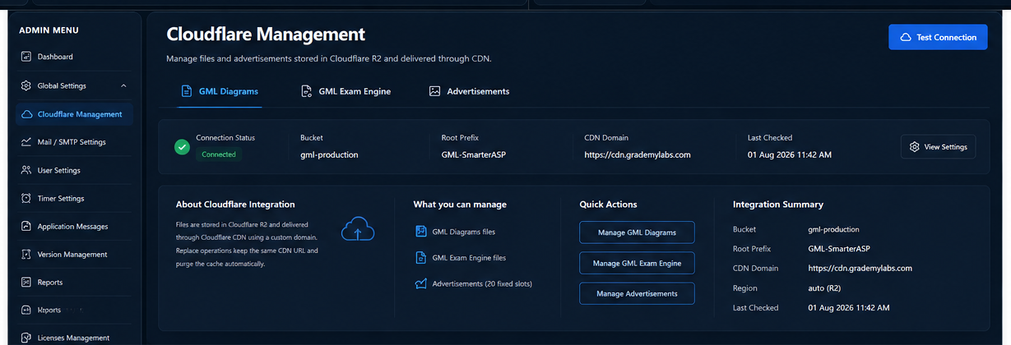
Figure 4. Cloudflare Management overview and quick actions.
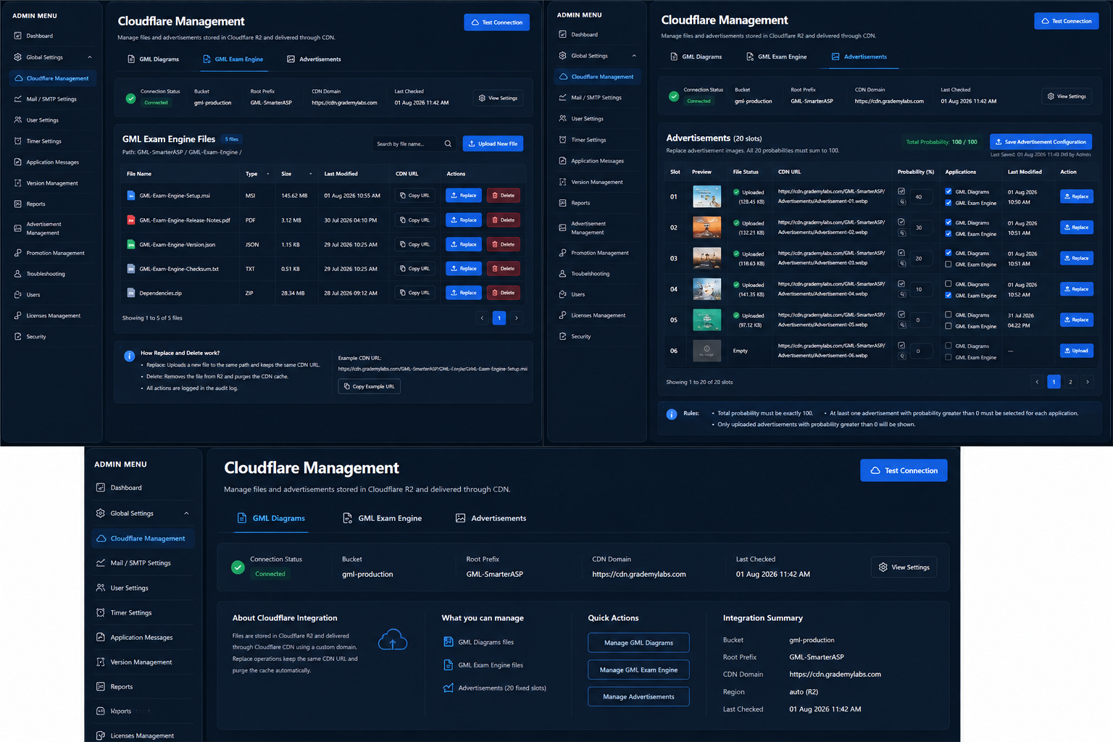
Figure 5. Combined design board showing GML Exam Engine, Advertisements, and overview layouts.

Implementation Summary
Permanent asset rule:
Same logical file -> same R2 object key -> same CDN URL
Replacement flow:
Validate -> upload to same key -> verify -> purge exact URL -> audit
Advertisement selection flow:
Filter by uploaded + probability > 0 + application assignment
-> normalize eligible weights
-> deterministic weighted rotation per device and application
-> return one CDN URL

