GML

Pricing, Subscriptions, Trials, User Profile, and Admin Pricing Management
  - Consolidated developer implementation requirements for GML Diagrams, GML Exam Engine, the user portal, and admin pricing configuration
━━━━━━━━━━━━━━━━━━━━━━━━━━━━━━━━━━━━━━━━
Document purpose | Implementation specification for website, admin portal, licensing backend, payment integration, and desktop entitlement validation
Products in scope | GML Diagrams and GML Exam Engine
Prepared for | GML development team
Status | Implementation requirements
Date | 1 August 2026
Be Curious to Learn

Contents
1. Purpose, scope, and core implementation rules
2. Product-specific licensing architecture
3. GML Diagrams plans, prices, and entitlement levels
4. Trials, upgrades, downgrades, and product-key preservation
5. Public Pricing page
6. My Account page redesign
7. Subscriptions page layout and user flows
8. GML Exam Engine BETA access
9. Instructor and Enterprise processes
10. Billing, notifications, security, and audit logging
11. Recommended database model
12. Recommended APIs
13. Acceptance criteria
14. Admin Pricing Management
Appendix A. Visual references and proposed layouts
Document convention
The word “subscription” refers to a plan for one specific GML product. A user can hold different plans for different GML products at the same time.

1. Purpose, Scope, and Core Implementation Rules
This document consolidates the requirements for the GML public Pricing page, the My Account page, the Subscriptions experience, trials, upgrades, downgrades, product keys, Instructor access, Enterprise contact requests, and GML Exam Engine BETA access.

1.1 Products in scope
- GML Diagrams: Plan-based licensing with Free, Basic, Professional, Instructor, and Enterprise categories.
- GML Exam Engine: Initially managed through a BETA request and approval process, with a separate product key and one-year BETA validity.

1.2 Mandatory rules
- Licenses and subscriptions must be product-specific. A plan for GML Diagrams must not grant access to GML Exam Engine.
- A product key identifies the user license for one product. It must not be tied to a single plan category.
- The same product key must be retained during upgrades, downgrades, renewals, billing-cycle changes, trial activation, trial expiry, and trial conversion to paid access.
- A new product key is generated only when the user first obtains access to a product, or when an administrator explicitly replaces a compromised or revoked key.
- Feature access must be based on explicit entitlements returned by the backend, not only on the plan name.
- No frontend-only check is sufficient for plan, trial, or license enforcement. The backend must validate every restricted operation.
- Existing diagrams, application settings, cloud connections, and credentials must not be deleted because of an upgrade, downgrade, trial expiry, or billing-cycle change.
- GML subscription charges do not include AWS, Microsoft Azure, Google Cloud, or Marketplace vendor charges.
Cloud-cost disclaimer
The GML subscription enables features inside GML Diagrams. Infrastructure, data transfer, Marketplace, vendor licensing, public IP, gateway, firewall, load balancer, and other cloud-provider charges are billed separately by the relevant provider.

2. Product-Specific Licensing Architecture

2.1 Required ownership model
User
├─ GML Diagrams Product License
│ ├─ Persistent Product Key
│ ├─ Current Base Plan
│ ├─ Active Trial, if any
│ ├─ Effective Entitlements
│ └─ Device Registrations
│
└─ GML Exam Engine Product License
├─ Separate Product Key
├─ BETA Access Status
├─ Expiry Date
└─ Device Registrations

The user account itself must not contain one global subscription field that controls every product. The backend must resolve the selected product first and then resolve its plan, license status, trial, product key, and entitlements.

2.2 Account status versus product status
Status type | Purpose | Examples
Account status | Controls whether the user account can authenticate and access the portal. | Active, Pending Verification, Suspended, Inactive, Locked
Product-license status | Controls a specific product key. | Active, Inactive, Expired, Suspended, Revoked, Pending Activation
Subscription status | Controls a product plan and billing state. | Active, Pending Payment, Expired, Cancelled, Scheduled for Downgrade
BETA request status | Controls access-request workflow. | Not Requested, Pending, Approved, Rejected, Expired

UI clarification
The green badge at the top-right of the current My Account page must be labeled “Account Status: Active” so users do not confuse it with a product subscription or license state.

3. GML Diagrams Plans, Prices, and Entitlement Levels

3.1 Plan names and prices
Plan | Monthly price | Yearly price | Acquisition method | Primary audience
Free | USD 0 | USD 0 | Self-service activation | Learners and users of basic cloud objects
Basic | USD 1 | USD 10 | Self-service purchase | Users requiring cloud-native paid resource types
Professional | USD 2 | USD 20 | Self-service purchase | Engineers requiring Marketplace and advanced features
Instructor | Contact Us | Contact Us | Admin assignment only | Verified instructors and trainers
Enterprise | Contact Us | Contact Us | Sales/admin process | Organizations, universities, and managed teams

The yearly Basic price is USD 10 instead of USD 12, and the yearly Professional price is USD 20 instead of USD 24. The pricing interface should communicate this as two months free when paying yearly.

3.2 Free plan
- Create, edit, and delete supported basic AWS, Azure, and GCP networking objects.
- Examples include VPCs or virtual networks, subnets, route tables, basic security controls, and other objects classified by GML as Basic Resources.
- Higher-level objects may be visible in a diagram but must be read-only when they are outside the Free entitlements.
- The user can activate the Free plan without a payment method.
- After activation, the backend generates the user’s first persistent GML Diagrams product key.

3.3 Basic plan
- Includes all Free features.
- Enables supported cloud-native resource types that commonly generate provider charges.
- Examples include NAT gateways, transit gateways, VPN gateways or connections, load balancers, private endpoints, public IP resources, managed cloud firewalls, Azure Virtual WAN components, GCP Cloud NAT, and similar native services.
- Does not include third-party Marketplace appliances.
- Eligible Basic users can request one automatic one-month Professional trial.

3.4 Professional plan
- Includes all Basic features.
- Enables supported AWS Marketplace, Azure Marketplace, and Google Cloud Marketplace resources.
- Supports BYOL and PAYG models where the relevant provider and vendor permit them.
- May include Fortinet FortiGate, Palo Alto VM-Series, Cisco virtual appliances, Check Point CloudGuard, F5 BIG-IP, and future supported products.
- Allows commercial use and advanced multi-cloud design or deployment functionality.

3.5 Instructor and Enterprise
- Instructor: Displayed as Contact Us. It is not directly purchasable and cannot be automatically activated. A GML administrator manually assigns Professional-level technical access when the instructor qualifies under the student-referral program.
- Enterprise: Displayed as Contact Us or Contact Sales. It adds organization-level capabilities such as centralized administration, SSO, RBAC, shared templates, approval workflows, audit logs, custom limits, and support.

3.6 Feature comparison
Capability | Free | Basic | Professional | Instructor | Enterprise
Basic cloud resources | Yes | Yes | Yes | Yes | Yes
Create/edit/delete basic objects | Yes | Yes | Yes | Yes | Yes
Cloud-native paid resource types | No | Yes | Yes | Yes | Yes
Marketplace resources | View only | No | Yes | Yes | Yes
Marketplace deployment | No | No | Yes | Admin controlled | Yes
Simulation mode | Limited | Yes | Yes | Yes | Yes
Commercial use | Limited | Yes | Yes | Educational use | Yes
Classroom/referral features | No | No | No | Yes | Optional
Team, SSO, governance | No | No | Limited | Limited | Yes
Purchase method | Self-service | Self-service | Self-service | Contact Us | Contact Sales

Entitlement implementation
Do not hardcode rules such as “if plan is Professional, enable Marketplace.” Return explicit entitlements such as basic_resources, premium_cloud_resources, marketplace_resources, simulation_mode, live_deployment, commercial_use, and classroom_management.

4. Trials, Upgrades, Downgrades, and Product-Key Preservation

4.1 Automatic trial paths
Base plan | Automatic trial | Duration | Automatic uses
Free | Basic | One calendar month | One time per user and product
Basic | Professional | One calendar month | One time per user and product

- A user with no subscription must first activate Free or purchase a paid plan. A trial must always have a base plan to return to.
- No payment card is required for an automatic trial.
- A trial must not automatically convert into a paid subscription.
- Cancelling a trial early still counts as using the one automatic trial.
- Changing the product key, billing cycle, email-display data, or base plan must not reset trial usage.
- After the one automatic trial has been used, the user can submit an Additional Trial Request. Only an administrator can approve and assign extra trial time.

4.2 Trial activation and expiry
1. Validate that the authenticated user owns the product license and has the correct eligible base plan.
2. Verify that the relevant one-time trial has not already been consumed and that no conflicting trial is active.
3. Preserve the existing product key and base subscription.
4. Set the effective plan and entitlements to the trial plan for one calendar month.
5. Store exact start and end timestamps and mark the automatic trial as used.
6. At expiry, remove only the trial entitlements and restore the base plan.
7. Keep diagrams and settings. Unsupported objects become read-only. Do not delete real cloud resources.

4.3 Upgrades
Current plan | Available upgrade paths
No subscription | Free, Basic, Professional, Instructor Contact Us, Enterprise Contact Sales
Free | Basic, Professional, Enterprise
Basic | Professional, Enterprise
Professional | Enterprise
Instructor | Paid Professional commercial use or Enterprise

- A user may upgrade directly without buying every intermediate plan.
- Paid upgrades should use payment-provider proration when supported.
- After payment confirmation, update the plan and entitlements immediately without reinstalling the desktop application.
- Preserve the same account, product key, device registrations, diagrams, credentials, cloud connections, and settings.

4.4 Downgrades
- Allow Professional to Basic or Free, and Basic to Free.
- A downgrade should normally take effect at the end of the current paid billing period.
- Keep the same product key.
- Do not delete diagrams or actual cloud resources.
- Resources outside the lower plan remain visible but become read-only.
- Show a clear warning that existing cloud resources may continue generating provider charges.

4.5 Persistent product-key rule
Mandatory product-key behavior
A product key identifies the user’s license for one GML product. Subscription plan, billing cycle, trial status, entitlements, limits, and expiry dates can change without changing the product key.

Action | Product-key result
Free to Basic | Same key
Basic to Professional | Same key
Professional to Basic or Free | Same key
Start or end trial | Same key
Convert trial to paid | Same key
Monthly to yearly | Same key
Renew subscription | Same key
Admin assigns Instructor/Professional entitlement | Same key if one already exists
First access to a new product | Generate a new key for that product
Admin security replacement | New key permitted

Before upgrade
Product: GML Diagrams
Product key: GMLD-ABCD-EFGH-IJKL
Plan: Basic
After upgrade
Product: GML Diagrams
Product key: GMLD-ABCD-EFGH-IJKL
Plan: Professional

5. Public Pricing Page

5.1 Navigation and URL
- Add Pricing as a top-level item in the main navigation.
- Recommended URL: /pricing.
- Support direct product selection through a query parameter, such as /pricing?product=diagrams and /pricing?product=exam-engine.
- Use the same dark navy, cyan, rounded-card, and subtle-glow visual language as the current website.
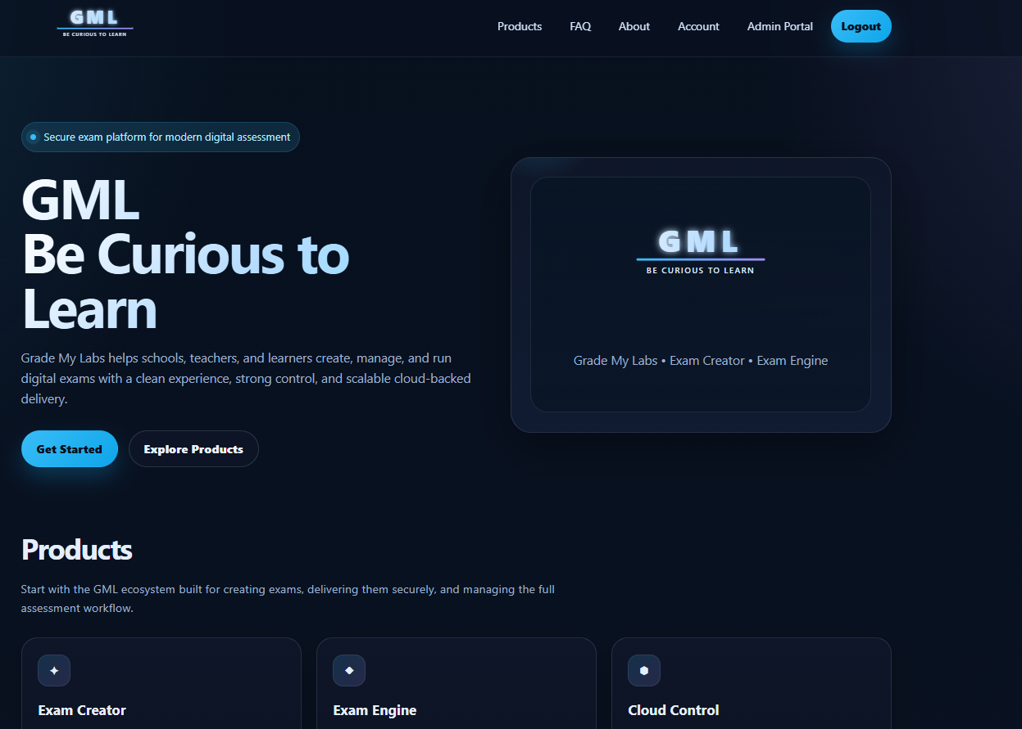
Figure 1. Current GML public home page used as the visual-style reference.

5.2 Product-first page structure
The Pricing page must be product-first. The user first selects GML Diagrams or GML Exam Engine, and then sees the plans or access model for that product. Do not present one global Free/Basic/Professional plan selector that appears to apply to every GML product.
Pricing
├─ Product selector
│ ├─ GML Diagrams
│ └─ GML Exam Engine
└─ Selected product pricing or access options

5.3 GML Diagrams pricing cards
- First row: Free, Basic, and Professional.
- Second row: Instructor and Enterprise.
- Highlight Professional as Recommended.
- Add a Monthly / Yearly selector. Yearly should show “Save 2 Months.”
- Free button: Get Started or Current Plan.
- Basic button: Choose Basic, Upgrade, Current Plan, or Try Basic Free for 1 Month, depending on state.
- Professional button: Choose Professional, Upgrade, Current Plan, or Try Professional Free for 1 Month, depending on state.
- Instructor button: Contact Us only.
- Enterprise button: Contact Sales only.
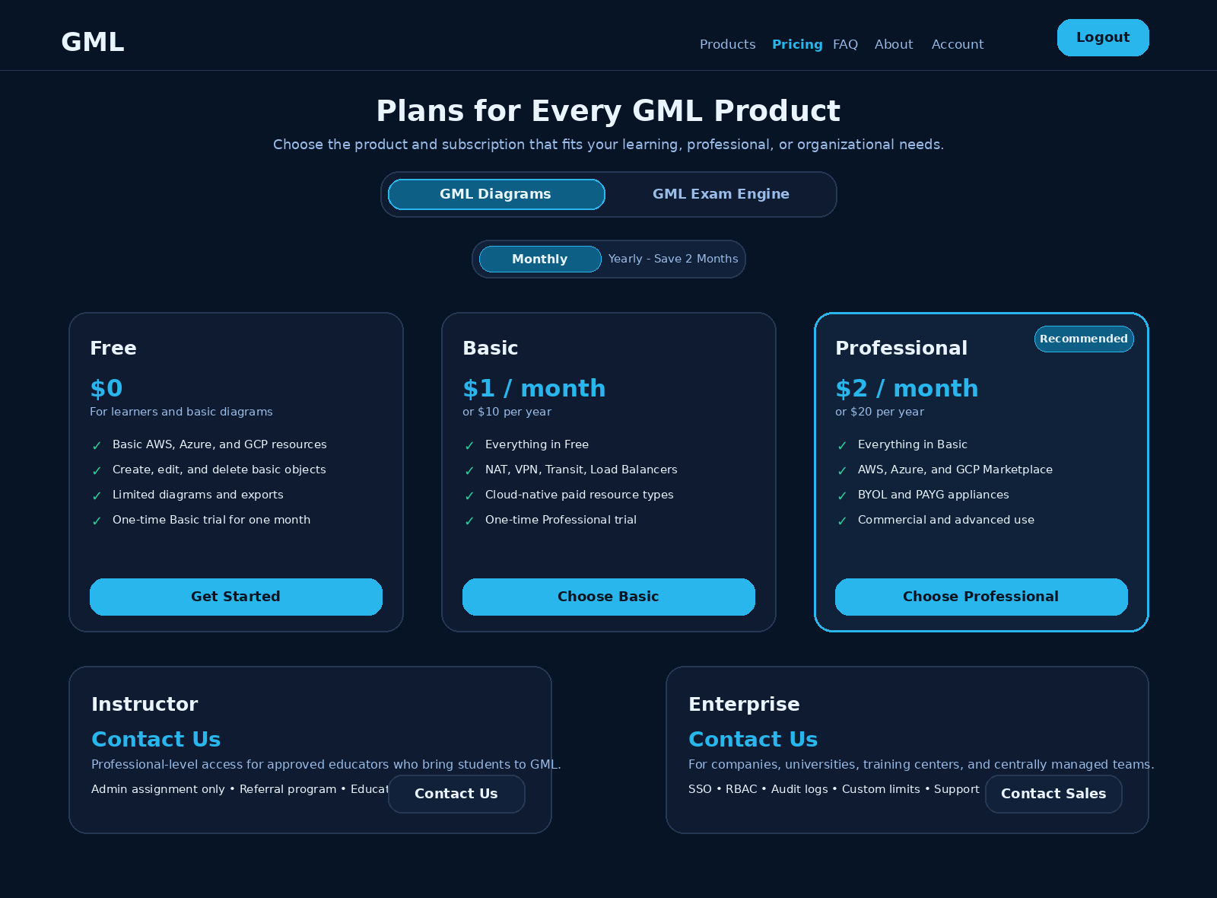
Figure 2. Proposed GML Pricing page layout using the existing website design language.

5.4 GML Exam Engine pricing section
- Initially display “GML Exam Engine BETA - Free During BETA.”
- The primary action is Request BETA Access, Sign In to Request Access, Request Pending, or Go to Downloads, based on user state.
- Provide a separate “Exam Engine for Organizations - Contact Us” card for institutional or future commercial access.
- The page must be backend-driven so commercial Exam Engine plans can be added later without redesigning the page.

5.5 Dynamic action labels
User/product state | Primary action
Not authenticated | Sign In to Continue
Current plan | Current Plan
Eligible paid plan | Choose Plan or Upgrade
Eligible automatic trial | Start Free Trial
Automatic trial already used | Request Additional Trial
Instructor | Contact Us
Enterprise | Contact Sales
Exam Engine BETA not requested | Request BETA Access
BETA request pending | Request Pending
BETA approved | Go to Downloads

6. My Account Page Redesign

6.1 Current layout
The current My Account page contains Profile Details, BETA Applications, and Change Password. The visual design is suitable and should be retained, but the navigation and content must be expanded and reorganized.
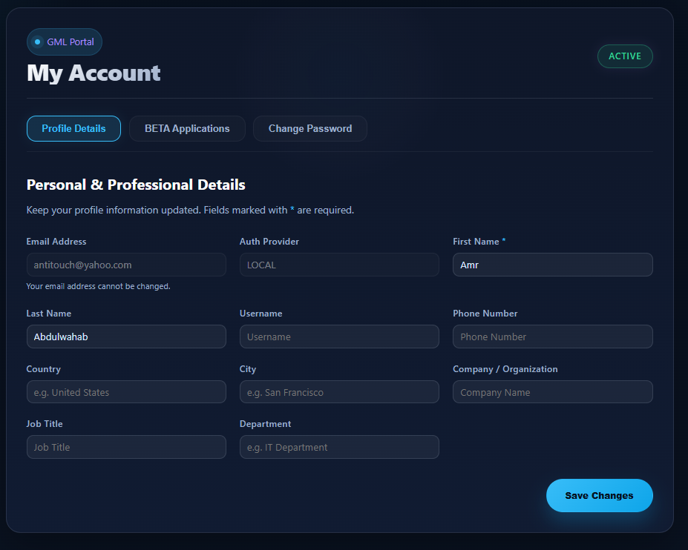
Figure 3. Current Profile Details tab.
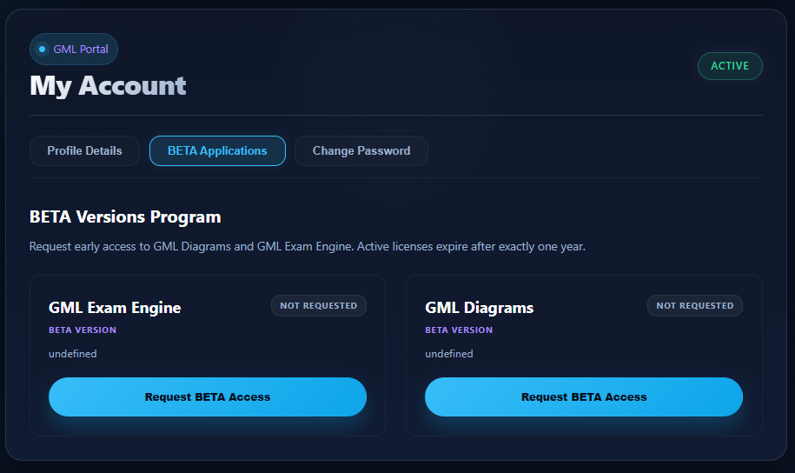
Figure 4. Current BETA Applications tab. The “undefined” text must be removed.
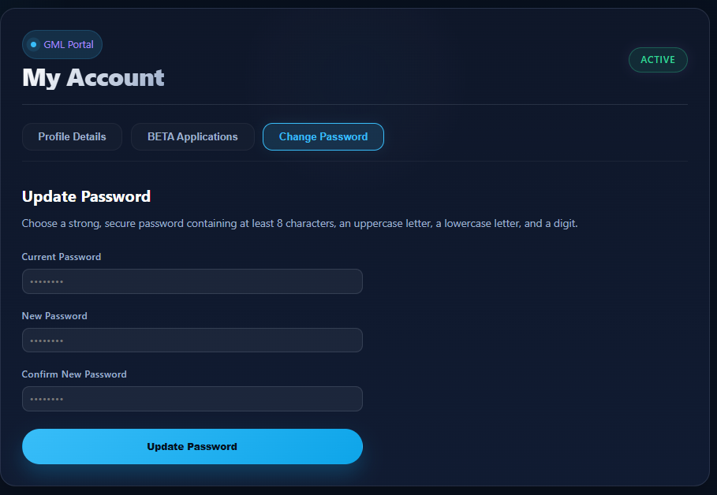
Figure 5. Current Change Password tab.

6.2 Recommended simplified tabs
Tab | Purpose
Profile Details | Personal and professional account information.
Subscriptions | All applications, plans, trials, product keys, BETA requests, downloads, and plan changes.
Security | Change password and, in a later phase, session management.

Rename BETA Applications to Subscriptions. Rename Change Password to Security and place the existing password form inside the Security tab.

6.3 Profile Details requirements
- First Name is mandatory.
- Email Address is visible but read-only.
- Auth Provider is read-only.
- Other current fields can remain optional unless a separate business rule requires them.
- Display server-side validation messages and a clear success notification after saving.
- Do not show empty API values as undefined or null.

6.4 Security requirements
- Retain Current Password, New Password, and Confirm New Password.
- Require at least eight characters, one uppercase letter, one lowercase letter, and one digit.
- Add show/hide controls and live requirement indicators where practical.
- Optionally add “Sign out of other sessions” and a session list in a later phase.

7. Subscriptions Page Layout and User Flows

7.1 Page purpose
Subscriptions is the central product-management area. It lists available GML applications and allows the user to select one. The selected product then displays its current license, plan, product key, trial status, plan options, billing information, downloads, and history.

7.2 Recommended desktop layout
- Page title and explanatory text.
- Selectable product cards at the top.
- One detailed panel for the selected product.
- Available plan cards under the current-subscription panel.
- Trial panel shown only when relevant.
- Collapsible Subscription History section.
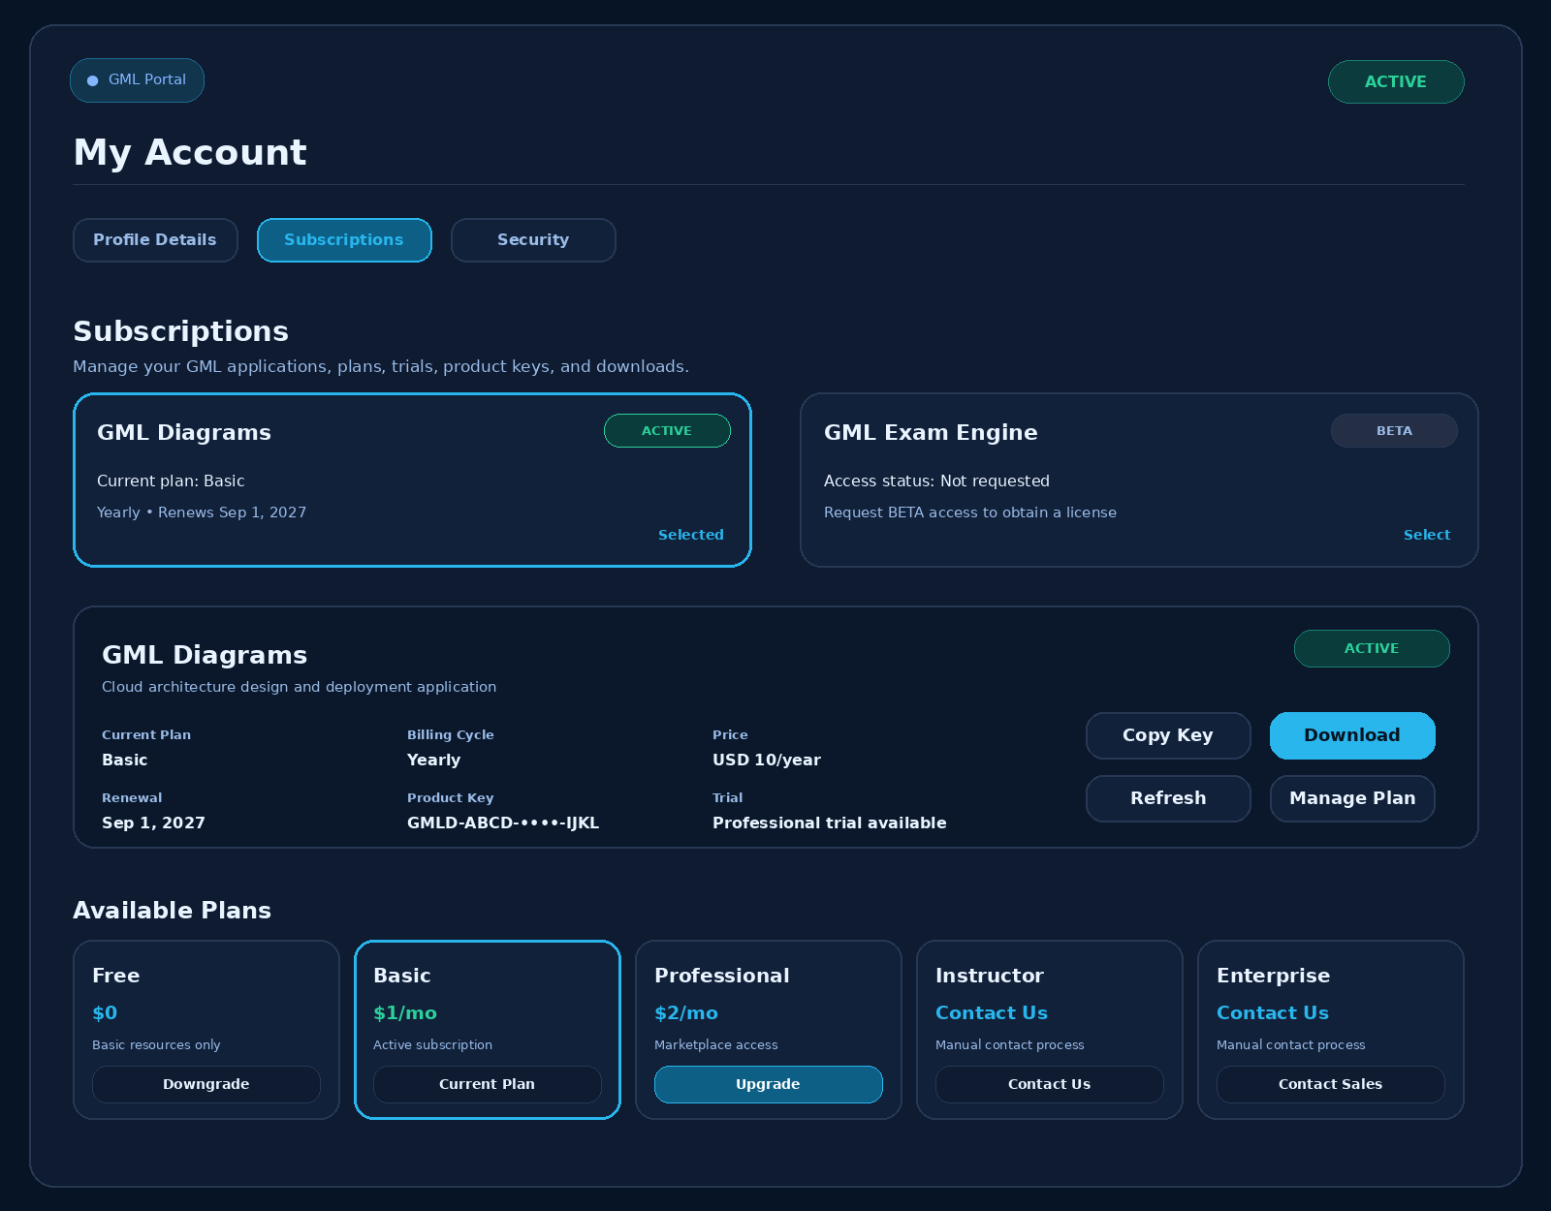
Figure 6. Proposed Subscriptions tab with product selector, selected-product details, and plan cards.

7.3 Product selector cards
Display GML Diagrams, GML Exam Engine, and future GML applications as backend-driven cards. The selected card should use a cyan border, stronger contrast, and a Selected indicator. The whole card should be clickable.
Card field | Example
Product name | GML Diagrams
Program or current plan | Basic
Status | Active
Billing/expiry summary | Yearly - Renews 1 Sep 2027
Trial summary | Professional trial available
Primary action | Select or View Subscription

7.4 Selected-product panel
Field | Required behavior
Product name and description | Always visible.
Current plan/program | Free, Basic, Professional, Instructor, Enterprise, BETA, or No Subscription.
License/subscription status | Product-specific state, separate from account status.
Billing cycle and price | Visible for paid self-service plans.
Start, renewal, or expiry date | Use the date relevant to the selected product.
Product key | Mask by default; provide Show and Copy actions.
Registered devices | Show current count and allowed maximum when applicable.
Last validation | Show the last successful desktop license validation.

7.5 No-subscription state and first subscription
Important state distinction
Do not silently treat “no subscription” as Free. Free becomes active only after the user explicitly activates it and a product-license record is created.

When a user selects GML Diagrams and has no subscription, show the following options:
Plan | Price | Action
Free | USD 0 | Activate Free
Basic | USD 1/month or USD 10/year | Subscribe to Basic
Professional | USD 2/month or USD 20/year | Subscribe to Professional
Instructor | Contact Us | Open Instructor form
Enterprise | Contact Us | Open Enterprise contact form

1. For Free, show confirmation, create the product license, generate the first GML Diagrams key, assign Free entitlements, and enable download/use.
2. For Basic or Professional, collect billing cycle, complete payment, create the product license after payment confirmation, generate the first key, and assign the selected plan.
3. For Instructor or Enterprise, create only a contact/application request. Do not activate a subscription automatically.

7.6 Trial controls
Current state | Display
Free and Basic trial unused | Try Basic Free for One Month
Basic and Professional trial unused | Try Professional Free for One Month
Trial active | Trial name, exact end date, days remaining, Keep This Plan
Automatic trial already used | Trial Already Used and Request Additional Trial
No subscription | Activate Free or purchase a plan first

7.7 Plan-change dialogs
- Upgrade dialog: Current plan, target plan, monthly/yearly choice, proration, amount due, renewal date, added features, and confirmation.
- Downgrade dialog: Current plan, target plan, effective date, removed features, read-only impact, cloud-cost warning, and confirmation.
- Success message: Explicitly confirm that the existing product key remains valid.

7.8 Subscription history
Date | Action | Previous | New | Status
1 Sep 2026 | Subscription created | - | Basic | Completed
1 Nov 2026 | Trial started | Basic | Professional Trial | Active
1 Dec 2026 | Trial expired | Professional Trial | Basic | Completed

7.9 Mobile behavior
- Stack product cards vertically.
- Use vertical plan cards or a horizontal scroll area.
- Stack primary and secondary actions.
- Keep one dominant cyan primary action per section.
- Make wide tables horizontally scrollable in the web interface.

8. GML Exam Engine BETA Access
GML Exam Engine remains a separate product and initially uses a BETA access-request model. Its subscription card appears on the Subscriptions page beside GML Diagrams.

8.1 States and actions
State | Displayed message/action
Not Requested | Request BETA Access
Pending | Request Pending; button disabled
Approved | Show key, activation date, expiry date, version, and Download
Rejected | Show reason when available and Contact Support
Expired | Request Renewal
Suspended | Contact Support

8.2 Approval behavior
1. User submits the BETA request from Subscriptions.
2. Administrator approves or rejects the request.
3. On approval, create the Exam Engine product-license record and generate a separate Exam Engine product key.
4. Set the BETA key validity to exactly one year.
5. Enable Download and display the key and expiry date.
6. Do not affect the user’s GML Diagrams key or subscription.

8.3 Undefined-value fix
The current BETA cards display “undefined.” The frontend must never render raw undefined, null, or empty object values. The developer must correct the API mapping and use a fallback such as “Early-access BETA version” when an optional description is unavailable.

9. Instructor and Enterprise Processes

9.1 Instructor - Contact Us only
- The Instructor option must display Contact Us and must not have Buy Now or automatic activation.
- The user submits institution, course, role, expected students, dates, country, intended use, and optional evidence.
- The request enters Pending Review and is handled manually by a GML administrator.
- The administrator can approve, reject, request information, assign, renew, suspend, expire, or revoke access.
- The assigned technical level is Professional, but educational-use restrictions and referral conditions may apply.

9.2 Student-referral rule
Eligible students in each 3-month period | Current specified benefit
Fewer than 5 | No automatic complimentary license; administrator review
5 students | Administrator may assign Professional access
10 students | Administrator may assign Professional access

Configurable threshold note
The current requirement assigns Professional access at both the 5-student and 10-student thresholds. Store both thresholds as configurable rules. The administrator can later differentiate duration, classroom limits, credits, or another benefit without changing code.

9.3 Eligible student definition
- Registers using the instructor referral code or link.
- Verifies the email address.
- Is not a duplicate, test, fraudulent, or already-counted account.
- Meets the configurable minimum activity requirement, such as first login, first diagram, or assigned exercise completion.

9.4 Instructor dashboard
- Instructor request and approval status.
- Referral code and referral link.
- Current three-month evaluation period.
- Registered, eligible, and ineligible student counts.
- Current assigned plan and expiry date.
- Students needed to reach the next configured threshold.

9.5 Enterprise contact flow
- Display Contact Sales.
- Collect organization, contact, user count, instructor/student count, cloud-account requirements, Marketplace needs, SSO, governance, support, and notes.
- Submitting the form creates a sales request only. An Enterprise subscription is assigned after the commercial process.

10. Billing, Notifications, Security, and Audit Logging

10.1 Billing
- Show billing controls only for paid self-service subscriptions.
- Display billing cycle, price, next billing date, automatic renewal, payment status, payment method summary, and invoices.
- Provide Change Billing Cycle, Update Payment Method, View/Download Invoice, Cancel Renewal, Upgrade, and Downgrade.
- Do not show payment-card management for Free, admin-assigned Instructor access, or manual Enterprise agreements unless supported by the contract.
- The payment provider is the source of truth for proration, tax, discounts, refunds, invoices, and payment status.

10.2 Notifications
Event | Notification requirement
Subscription purchase or upgrade | Email and in-app confirmation
Payment failure | Immediate email and in-app warning
Trial activation | Confirmation with exact end date
Trial expiry | 7 days, 3 days, 1 day, and at expiry
Instructor request | Submission and decision notifications
BETA request | Submission, approval, rejection, and expiry reminders
License nearing expiry | Configurable reminder schedule

10.3 Security
- Require authentication for every My Account and subscription endpoint.
- Prevent access to another user’s profile, product key, invoices, or requests.
- Use server-side authorization, CSRF protection, secure cookies, and rate limiting.
- Mask product keys in the UI and avoid exposing cloud credentials on the profile page.
- Validate payment webhooks and make plan changes idempotent.
- Do not trust plan names, prices, target plans, trial eligibility, or dates submitted by the frontend.

10.4 Audit logging
- First product-license creation and key generation.
- Upgrade, downgrade, renewal, cancellation, and billing-cycle change.
- Trial activation, expiry, conversion, extension, and admin assignment.
- Instructor approval, renewal, suspension, and revocation.
- BETA request approval or rejection.
- Product-key replacement and device-registration changes.
- Administrator identity, timestamp, reason, previous values, and new values.

11. Recommended Database Model

11.1 Core product and plan tables
products
--------
id
code
name
description
program_type # subscription, beta, contact_only
is_active
display_order
subscription_plans
------------------
id
product_id
code # free, basic, professional, instructor, enterprise
name
monthly_price
yearly_price
currency
purchase_method # self_service, admin_only, contact_sales
is_public
is_active
display_order
plan_entitlements
-----------------
id
plan_id
entitlement_code
entitlement_value
resource_limit
is_enabled

11.2 Persistent product licenses
product_licenses
----------------
id
user_id
product_id
product_key
status
maximum_devices
created_at
updated_at
user_product_subscriptions
--------------------------
id
product_license_id
plan_id
status
billing_cycle
start_date
end_date
next_renewal_date
automatic_renewal
payment_provider
payment_subscription_id
previous_plan_id
scheduled_plan_id
assigned_by_admin_id
assignment_reason
created_at
updated_at

The product_key belongs in product_licenses, not in each plan or subscription record. This is what preserves it across plan changes.

11.3 Trial tables
subscription_trials
-------------------
id
product_license_id
base_plan_id
trial_plan_id
trial_type # automatic, admin_assigned, admin_extension
status
start_date
end_date
automatic_trial_used
approved_by_admin_id
converted_to_paid
converted_subscription_id
created_at
updated_at
trial_requests
--------------
id
user_id
product_id
current_plan_id
requested_trial_plan_id
reason
testing_activities
requested_duration_days
status
reviewed_by_admin_id
reviewed_at
administrator_notes
approved_trial_id
created_at
updated_at

11.4 Instructor and referral tables
instructor_applications
-----------------------
id
user_id
institution_name
job_title
course_name
expected_students
course_start_date
course_end_date
country
usage_description
supporting_document
status
reviewed_by
reviewed_at
administrator_notes
created_at
updated_at
instructor_referral_periods
---------------------------
id
instructor_user_id
period_start
period_end
registered_students
eligible_students
minimum_required_students
higher_threshold_students
assigned_plan_id
license_start_date
license_end_date
review_status
reviewed_by
reviewed_at
administrator_notes
created_at
updated_at
student_referrals
-----------------
id
instructor_user_id
student_user_id
referral_code
registered_at
email_verified
minimum_activity_completed
is_eligible
ineligibility_reason
evaluation_period_id
created_at
updated_at

11.5 BETA request table
beta_access_requests
--------------------
id
user_id
product_id
status
requested_at
reviewed_by
reviewed_at
rejection_reason
product_license_id
created_at
updated_at

12. Recommended APIs

12.1 User-facing endpoints
GET /api/profile
PUT /api/profile
GET /api/products
GET /api/products/{productId}/subscription
GET /api/products/{productId}/plans
POST /api/products/{productId}/activate-free
POST /api/products/{productId}/subscription/change-plan
POST /api/products/{productId}/subscription/cancel-renewal
POST /api/products/{productId}/subscription/change-billing-cycle
GET /api/products/{productId}/trial-eligibility
POST /api/products/{productId}/trials/start
POST /api/products/{productId}/trials/request-additional
POST /api/products/{productId}/trials/convert-to-paid
POST /api/products/{productId}/license/refresh
GET /api/products/{productId}/subscription/history
POST /api/products/{productId}/beta-request
GET /api/instructor/application
POST /api/instructor/application
GET /api/instructor/dashboard
POST /api/enterprise/contact
GET /api/invoices

12.2 Administrative endpoints
GET /api/admin/instructor-applications
POST /api/admin/instructor-applications/{id}/approve
POST /api/admin/instructor-applications/{id}/reject
GET /api/admin/instructors/{userId}/referrals
POST /api/admin/users/{userId}/assign-plan
POST /api/admin/users/{userId}/renew-plan
POST /api/admin/users/{userId}/suspend-plan
POST /api/admin/users/{userId}/revoke-plan
GET /api/admin/trial-requests
POST /api/admin/trial-requests/{id}/approve
POST /api/admin/trial-requests/{id}/reject
POST /api/admin/users/{userId}/assign-trial
POST /api/admin/trials/{trialId}/extend
POST /api/admin/trials/{trialId}/end
GET /api/admin/beta-requests
POST /api/admin/beta-requests/{id}/approve
POST /api/admin/beta-requests/{id}/reject
POST /api/admin/product-licenses/{id}/replace-key

12.3 Example license-validation response
{
"product": "gml_diagrams",
"product_key": "GMLD-ABCD-EFGH-IJKL",
"license_status": "active",
"base_plan": "basic",
"effective_plan": "professional",
"trial_active": true,
"trial_end_date": "2026-09-10T14:00:00Z",
"entitlements": {
"basic_resources": true,
"premium_cloud_resources": true,
"marketplace_resources": true,
"simulation_mode": true,
"live_deployment": true,
"commercial_use": true
}
}

12.4 Change-plan response requirement
{
"success": true,
"product": "gml_diagrams",
"product_key": "GMLD-ABCD-EFGH-IJKL",
"previous_plan": "basic",
"current_plan": "professional",
"product_key_changed": false
}

13. Acceptance Criteria
1. Pricing is available as a public top-level page and supports product selection.
2. GML Diagrams shows Free, Basic, Professional, Instructor, and Enterprise with the approved prices and contact methods.
3. GML Exam Engine is shown separately and can use the BETA access model.
4. My Account uses Profile Details, Subscriptions, and Security tabs.
5. The top account badge clearly states Account Status.
6. Subscriptions lists all applications as selectable cards and shows details for the selected product.
7. A user with no GML Diagrams subscription can activate Free, purchase Basic or Professional directly, or contact GML for Instructor or Enterprise.
8. The first access to a product creates one product key; future plan changes preserve it.
9. Free users can use one Basic trial for one calendar month.
10. Basic users can use one Professional trial for one calendar month.
11. Extra trial periods require administrator approval.
12. Trials do not require payment details and do not auto-convert to paid access.
13. Trial expiry returns the user to the base plan and does not delete diagrams or cloud resources.
14. Upgrades and downgrades preserve the same product key, device registrations, diagrams, settings, credentials, and cloud connections.
15. Downgraded unsupported resources become read-only.
16. Instructor and Enterprise display Contact Us/Contact Sales rather than a direct purchase button.
17. Instructor access is assigned manually and referral thresholds are configurable.
18. GML Exam Engine approval creates a separate one-year BETA key.
19. No UI screen renders undefined, null, or raw missing values.
20. Feature access uses backend entitlements and server-side authorization.
21. All plan, trial, key, approval, billing, and admin changes are audit logged.
22. The desktop application can refresh the existing key and receive new entitlements without reinstallation.

14. Admin Pricing Management
Add a new administration area that allows authorized GML administrators to manage product-specific prices, plan visibility, purchase methods, plan features, trial rules, Instructor rules, publication status, and complete pricing history. The page must use the same dark navy, cyan, rounded-card design language as the existing GML Admin Portal.

14.1 Navigation Placement and Page Objective
Recommended navigation
Admin Portal → Global Settings → Pricing Management
- The page is an administrative configuration page. It must not be exposed to normal portal users.
- Pricing must be managed separately for each product, including GML Diagrams, GML Exam Engine, and future GML products.
- Changes for one product must never alter the plans or subscriptions of another product.
- The page must read and write backend pricing configuration rather than relying on values hardcoded in the frontend.

14.2 Recommended Page Header and Product-Level Settings
Display the page title Pricing Management and the description: “Configure product plans, prices, billing cycles, trials, and visibility.”
Control | Required behavior
Product | Select GML Diagrams, GML Exam Engine, or another configured product.
Currency | Select the product’s default billing currency, initially USD.
Tax Mode | Select Tax Inclusive or Tax Exclusive according to the payment-provider configuration.
View Pricing | Open the public Pricing page for the selected product in a new tab.
Save Settings | Save product-level settings without publishing plan-level draft changes.

14.3 Internal Tab Structure
Tab | Purpose
Plans & Prices | Create and edit plans, prices, public visibility, purchase methods, status, and display order.
Features & Entitlements | Control user-facing feature text and backend entitlement codes for every plan.
Trial Rules | Configure automatic one-time trials and administrator-approved additional trials.
Instructor Rules | Configure Instructor contact, referral, evaluation, and manual-assignment rules.
Price History | Display every price or plan change with its administrator, effective date, and affected subscriptions.

14.4 Plans & Prices Tab
The default tab must display a plan table for the selected product and an Add Plan button. The initial GML Diagrams configuration must be:
Plan | Monthly | Yearly | Purchase method | Public | Initial status
Free | USD 0 | USD 0 | Automatic Free Activation | Yes | Active
Basic | USD 1 | USD 10 | Online Payment | Yes | Active
Professional | USD 2 | USD 20 | Online Payment | Yes | Active
Instructor | Contact Us | Contact Us | Admin Assignment Only | Yes | Active
Enterprise | Contact Us | Contact Us | Contact Sales | Yes | Active
Required plan-table columns:
- Plan name.
- Monthly price.
- Yearly price.
- Currency.
- Purchase method.
- Trial availability.
- Public pricing-page visibility.
- Plan status: Draft, Active, Inactive, or Archived.
- Display order.
- Actions: Edit, Duplicate, Disable, and View History.

14.5 Edit Plan Drawer or Modal
Selecting Edit must open a right-side drawer or modal. The plan code must become read-only after subscriptions exist so it can continue to serve as a stable API and entitlement identifier.
Field | Requirement
Plan Name | Editable public display name.
Plan Code | Stable identifier such as free, basic, professional, instructor, or enterprise.
Monthly Price | Numeric value for plans sold monthly. Prevent negative values.
Yearly Price | Numeric value for plans sold yearly. Prevent negative values.
Currency | Required for every numeric price.
Purchase Method | Select the permitted acquisition workflow.
Payment Provider Product ID | Identifier used by the configured payment provider.
Monthly Price ID | Provider-side identifier for monthly billing.
Yearly Price ID | Provider-side identifier for annual billing.
Badge | Optional badge such as Recommended, Best Value, or None.
Short Description | User-facing summary displayed on the Pricing page.
Display on Pricing Page | Controls public visibility.
Allow New Subscriptions | Controls whether new customers may purchase or activate the plan.
Allow Upgrades | Controls whether eligible lower plans can upgrade to this plan.
Allow Downgrades | Controls whether users may move from this plan to a lower plan.
Supported purchase methods:
- Automatic Free Activation.
- Online Payment.
- Contact Us.
- Contact Sales.
- Admin Assignment Only.
- Unavailable.

14.6 Features & Entitlements Tab
The administrator must be able to manage both the text shown to customers and the machine-readable entitlements returned to the desktop application.
Feature | Public display value | Example entitlement code
Basic cloud resources | Included | basic_resources
Premium cloud resources | Included or Not Included | premium_resources
Marketplace resources | Included, View Only, or Not Included | marketplace_resources
Commercial use | Included or Restricted | commercial_use
Classroom management | Included or Not Included | classroom_management
- Add, edit, remove, and reorder feature rows.
- Mark a feature as Included, Limited, View Only, Controlled, or Not Included.
- Prevent deletion of an entitlement code that is referenced by active licenses unless a controlled migration is performed.
- Make the license-validation API use the entitlement values rather than the public plan description.

14.7 Trial Rules Tab
Rule | Initial configuration
Free to Basic | Enabled; one calendar month; one automatic use per user; no payment card; no automatic conversion.
Basic to Professional | Enabled; one calendar month; one automatic use per user; no payment card; no automatic conversion.
Additional trials | Enabled only through a user request followed by administrator approval.
Default additional duration | Administrator-configurable.
Product-key behavior | Use the existing product key throughout activation, expiry, extension, or paid conversion.
- Allow an administrator to change duration, automatic-use count, availability, and source/target plans.
- Do not reset an already-used automatic trial when the user changes billing cycle, renews, upgrades, or downgrades.
- Keep full trial history even if a trial is cancelled, converted, extended, or ended early.

14.8 Instructor Rules Tab
Setting | Initial value
Pricing-page display | Contact Us
Direct purchase | Disabled
Automatic assignment | Disabled
Manual admin assignment | Enabled
Evaluation period | 3 months
Minimum eligible students | 5
Higher threshold | 10
Assigned technical level | Professional
Because the currently defined five-student and ten-student thresholds both result in Professional access, the page must include an optional configurable benefit for the higher threshold. Examples include a longer license duration, a larger classroom limit, more student seats, or additional live-deployment credits. The higher-threshold benefit may remain disabled until the business rule is finalized.

14.9 Existing-Customer Price Impact
Before a price is published, the administrator must explicitly select how the new price affects subscriptions.
Option | Behavior
New subscriptions only | Safest default. Existing customers keep their current contracted price.
Existing subscriptions at next renewal | Apply the new price when each affected subscription renews.
All subscriptions immediately | High-risk administrative migration requiring additional confirmation and authorization.
Mandatory default
Always preselect “New subscriptions only.” Never silently change the price charged to existing customers.

14.10 Draft, Preview, Scheduling, and Publishing
- Support Draft, Scheduled, and Published states.
- Provide Save Draft, Preview Pricing Page, Publish Now, Schedule Publication, and Discard Changes actions.
- Only Published values may appear on the public Pricing page or be used for new checkout sessions.
- A scheduled publication must store the intended effective date and the administrator who scheduled it.
- Before publishing, display a confirmation showing the product, plan, old price, new price, affected-subscription scope, and effective date.
- Publishing must be transactional: either all selected pricing changes become active together or none do.

14.11 Price History and Audit Trail
Recorded value | Requirement
Administrator | User who created, edited, scheduled, published, or reverted the change.
Date and time | Store in UTC and display in the administrator’s configured timezone.
Product and plan | Identify the exact affected product and plan.
Previous value | Persist the old price or configuration value.
New value | Persist the replacement value.
Reason | Administrator-entered reason for the change.
Effective date | Immediate or scheduled publication date.
Customer impact | Record whether existing subscriptions were affected.

14.12 Roles and Permissions
Administrative role | Recommended access
Super Administrator | Full pricing, entitlement, trial, publishing, and history control.
Billing Administrator | Edit prices, payment identifiers, price-impact rules, and publish changes.
Product Administrator | Edit plans, descriptions, visibility, features, and entitlements; publishing may require approval.
Support Administrator | Read-only access.
Instructor Administrator | Edit Instructor rules and review assignments only.

14.13 Validation and Safety Rules
- Reject negative prices.
- Require a currency whenever a numeric price is configured.
- Prevent duplicate plan codes for the same product.
- Prevent publication of an online-payment plan without valid payment-provider product and price identifiers.
- Prevent Instructor and Enterprise from becoming directly purchasable unless an authorized administrator intentionally changes their acquisition model.
- Do not delete a plan that has subscription history or active subscriptions. Inactivate or archive it instead.
- Do not permit plan-code changes after licenses or subscriptions reference that code.
- Do not expose draft or scheduled prices through normal customer APIs before their effective date.
- Validate every update server-side and record it in the audit log.

14.14 Recommended Administrative APIs
Method | Endpoint | Purpose
GET | /api/admin/pricing/products | List products available for pricing configuration.
GET | /api/admin/pricing/products/{productId}/plans | List plans and current prices for one product.
POST | /api/admin/pricing/products/{productId}/plans | Create a plan.
PUT | /api/admin/pricing/plans/{planId} | Update plan details and draft pricing.
POST | /api/admin/pricing/plans/{planId}/publish | Publish a plan or price change.
POST | /api/admin/pricing/plans/{planId}/schedule | Schedule publication.
POST | /api/admin/pricing/plans/{planId}/disable | Stop new subscriptions without deleting history.
GET | /api/admin/pricing/plans/{planId}/history | Retrieve plan and price history.
GET | /api/admin/pricing/trial-rules | Retrieve trial configuration.
PUT | /api/admin/pricing/trial-rules | Update trial configuration.
GET | /api/admin/pricing/instructor-rules | Retrieve Instructor-program configuration.
PUT | /api/admin/pricing/instructor-rules | Update Instructor-program configuration.

14.15 Pricing Management Acceptance Criteria
- An authorized administrator can select a product and view only that product’s plans.
- The initial GML Diagrams prices display as Free USD 0, Basic USD 1 monthly or USD 10 yearly, Professional USD 2 monthly or USD 20 yearly, Instructor Contact Us, and Enterprise Contact Us.
- The administrator can edit prices, descriptions, purchase methods, public visibility, display order, and status.
- The administrator can configure features and machine-readable entitlements separately.
- The administrator can configure the Free-to-Basic and Basic-to-Professional one-month trials.
- The administrator can configure Instructor referral thresholds and optional higher-threshold benefits.
- The default price-impact scope is New subscriptions only.
- Draft changes do not appear publicly until they are published.
- The administrator can preview, publish immediately, or schedule publication.
- Every change is visible in Price History with administrator, previous value, new value, reason, effective date, and customer impact.
- Unauthorized roles cannot edit or publish pricing.
- Existing product keys remain unchanged when users later upgrade, downgrade, renew, change billing cycles, or use trials.

Appendix A. Visual References and Proposed Layouts
The following images are included to give the developer a direct visual reference for the existing website and the recommended new pages. The proposed mockups are conceptual and should be implemented responsively using the project’s existing UI components.

A1. Current GML website home page and visual language.

A2. Current Profile Details page.

A3. Current BETA Applications page to be renamed Subscriptions.

A4. Current Change Password page to be moved into Security.

A5. Proposed public Pricing page mockup.

A6. Proposed Subscriptions page mockup.

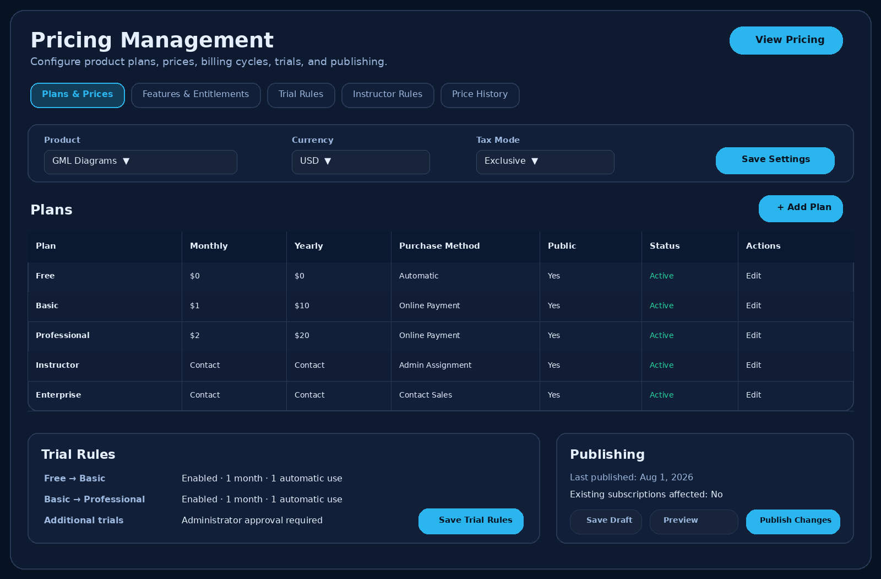
A7. Proposed Admin Pricing Management page mockup.

Appendix B. Developer Delivery Checklist
- Database migrations and seed data for products, plans, prices, and entitlements.
- Public Pricing page and product selector.
- My Account navigation update and Subscriptions tab.
- No-subscription activation and first-key generation.
- Upgrade, downgrade, renewal, and billing-cycle flows with key preservation.
- Automatic and admin-assigned trial workflows.
- Instructor and Enterprise contact workflows.
- Exam Engine BETA request, approval, one-year key, and download access.
- Admin portal screens for plan assignment, trials, Instructor review, referrals, and BETA requests.
- Payment provider integration and validated webhooks.
- Desktop license-validation and Refresh License support.
- Email/in-app notifications, audit logs, authorization tests, and acceptance tests.
- Admin Pricing Management tabs, product selector, edit-plan workflow, entitlements, trials, and Instructor rules.
- Draft, preview, scheduling, publishing, existing-customer price scope, and Price History audit trail.
- Payment-provider identifier validation, pricing permissions, and server-side publication safeguards.

