
The Superior University

📝 Operating Systems Lab – Project Documentation Template

📌 Project Title
Image Processing Scheduler – SJF Non-Preemptive Algorithm

👥 Group Members
- Muhammad Abdur Rehman (023)

📂 GitHub Repository
GitHub Repository Link:
https://github.com/AbdurRehman1299/OS-Project.git

🔧 Scheduling Algorithm Implemented
SJF (Shortest-Job First) Non-Preemptive Algorithm

📄 Project Description
- What problem your project solves:
The project schedules the processing of multiple images based on their arrival and burst times using the Shortest-Job First (SJF) Non-Preemptive scheduling algorithm. It aims to minimize the average turnaround and waiting times, improving overall system efficiency in image processing.
- What inputs are required (arrival time, burst time, time quantum):
Number of images, for each image: Image ID, Arrival Time, and Burst Time.
- What outputs are generated:
A table display for each image: Image ID, Arrival Time, Burst Time, Completion Time, Turnaround Time (Completion – Arrival), Waiting Time (Turnaround – Burst), Average Turnaround Time, and Average Waiting Time
- How the algorithm is implemented:
  - Inputs are stored in a list of dictionaries.
  - Images are first sorted by arrival time.
  - The algorithm then:
    - Selects all images that have arrived and are not yet completed.
    - Among them, picks the one with shortest burst time.
    - Processes it, updating current_time, completion_time, turnaround_time, and waiting_time.
    - Repeats until all images are processed.
  - Finally, results are printed in a formatted table.

📸 Output Screenshots
Inputs:
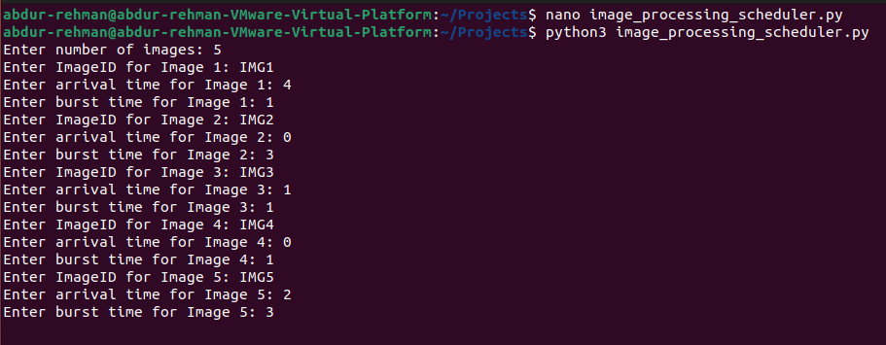
Output:
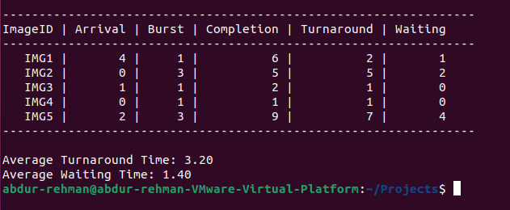

🧠 Code Structure & Explanation
- Functions or classes used:
No functions or classes are defined in this project. The entire logic is implemented in a procedural style, with code blocks executing in sequence from top to bottom.
- Core logic of the scheduling algorithm:
  - Input Phase: Takes the number of images, Collects Image ID, Arrival Time, and Burst Time for each image, and stores them as dictionaries in a list.
  - Sorting Phase: Sorts images by arrival time to simulate real-time image processing.
  - Scheduling Loop:
    - Selects all images that have arrived and are not yet completed.
    - From these, select the one with the shortest burst time.
    - Updates: current_time, completion_time, turnaround_time, waiting_time, and marks the image as completed.
    - If no image is available at the current time, it increments time by 1 unit.
    - Repeats until all images are processed.
  - Output Phase: Sorts images back by Image ID, prints a formatted table with all metrices, calculates and prints average Turnaround Time and Waiting Time.

- Any external libraries (e.g., matplotlib, tabulate) used for output formatting or visualization:
No external libraries are used. All output is printed using basic Python print() and formatted strings.

📊 Performance Metrics
Metric | Value
Average Waiting Time | 3.20
Average Turnaround Time | 1.40

🛠️ Challenges Faced
- Incorrect Waiting Time and Turnaround Time Calculation.
- Handling Idle Time Between Image Arrivals
- Sorting Logic and Display and Issues

