WEDER STRATEGIES
Full Stack Developer Internship, Technical Exercise
System Design Document
Offline Field Issue Tracker
Prepared by: Abdurehman Kero
Document version: 1.0
Date: 30 September 2026
Status: Final draft for submission
Technology stack: React, Node.js, Express, PostgreSQL
Table of Contents
1. Introduction 3
1.1 Purpose 3
1.2 Scope and design goals 3
1.3 Technology choices 3
2. System Architecture 3
2.1 Overview 3
2.2 Main design idea: local first 4
2.3 Project structure 4
3. Database Design 4
3.1 Table: reports 4
3.2 Table: report_history 5
4. API Design 5
4.1 Endpoints 5
4.2 Response codes and error format 5
5. Client Design 6
5.1 Screens and components 6
5.2 Local database (IndexedDB) 6
5.3 Knowing if the app is online 6
6. Offline Storage and Synchronization Design 6
6.1 Sync states of a report 6
6.2 The sync procedure 6
6.3 Why duplicates cannot happen 7
6.4 Interrupted synchronization 7
6.5 Conflicts 7
7. Status Workflow Design 7
8. Validation and Error Handling 8
9. History Design 8
10. Security and Data Safety 8
11. Testing Design 8
11.1 Testing priorities 8
11.2 Test environment 9
12. Deployment, Setup and Seed Data 9
13. Design Trade-offs and Future Improvements 9

1. Introduction

1.1 Purpose
This document explains how the Offline Field Issue Tracker will be built so that it meets the Software Requirements Specification (SRS). It describes the architecture, the database, the API, the screens, the offline storage and synchronization method, the status workflow, the testing plan and the important design decisions. Requirement numbers such as FR-20 refer to the SRS.

1.2 Scope and design goals
The design covers the React client, the Express API and the PostgreSQL database. I set four goals and used them to settle every choice that follows. First, data safety: a submitted report must never be lost. Second, repeat safety: retrying must never create duplicates. Third, simple rules: the workflow and permissions must fit on one page. Fourth, a size that fits six hours of work, with nothing half finished.

1.3 Technology choices
Part | Choice | Reason
Client | React with Vite | Required stack. Vite starts fast and builds a static app that a service worker can cache.
Local storage | IndexedDB through the small idb library | Holds structured data and survives restarts. localStorage is too small and cannot store many records safely.
Server | Node.js 20 with Express | Required stack. Simple routing and middleware.
Database | PostgreSQL with the pg library | Required stack. Has unique constraints, transactions and UUID support.
Validation | Zod schemas | One readable schema per request, with clear error messages.
Server tests | Jest with Supertest | Tests the real HTTP routes against a test database.
Client tests | Vitest with fake-indexeddb | Tests sync logic without a browser.

2. System Architecture

2.1 Overview
The system has three layers. The browser holds the screens and its own local database, so it can work alone. The Express API holds the business rules and is the only part that talks to PostgreSQL. PostgreSQL holds the permanent data. The browser never writes to the server database directly and always goes through the API.
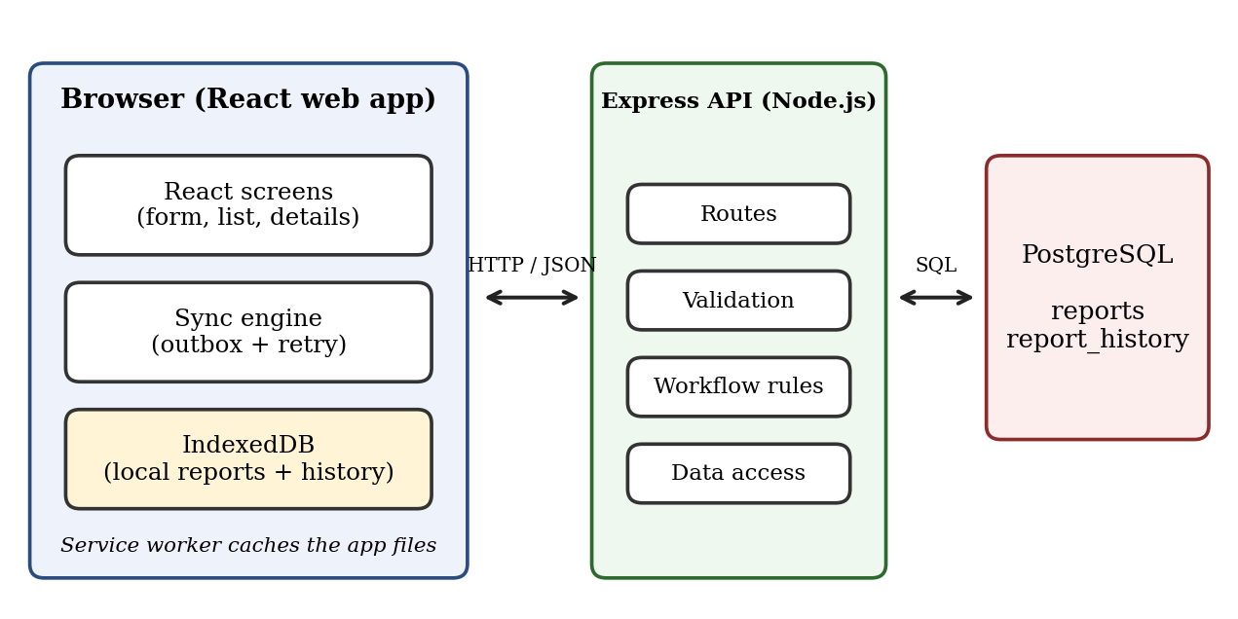
Figure 1: System architecture

2.2 Main design idea: local first
The screen always reads from and writes to IndexedDB, never straight to the network. A separate sync engine moves data between IndexedDB and the server. Because of this, the screens behave the same online and offline, and the only difference is how quickly the sync engine can finish its work. This idea is often called the outbox pattern: a submitted report waits in an outbox until the server confirms it.

2.3 Project structure
Folder | Contents
/client/src/pages | ReportList, ReportForm, ReportDetails, SyncPanel.
/client/src/db | IndexedDB setup and functions to save, read and update reports and history.
/client/src/sync | The sync engine, retry timing and error classification.
/client/src/shared | Category lists, status rules and validation shared with the forms.
/server/src/routes | Express routes, one file per resource.
/server/src/services | Business logic: create report, change status, edit report, write history.
/server/src/workflow.js | The one file that defines valid transitions and who may use them.
/server/src/db | Connection pool, migration SQL and seed script.
/server/tests, /client/tests | Automated tests.
/docs | SRS, this design document, QA checklist.

3. Database Design

3.1 Table: reports
Column | Type | Notes
id | UUID, primary key | Generated by the server.
client_id | UUID, NOT NULL, UNIQUE | Created on the device. The unique rule is what makes a retry safe.
category | TEXT, NOT NULL | CHECK against the six allowed values.
description | TEXT, NOT NULL | CHECK length between 10 and 1000.
location_text | TEXT, NOT NULL | Place description.
latitude, longitude | NUMERIC, NULL | CHECK for valid ranges.
priority | TEXT, NOT NULL | CHECK Low, Medium, High, Critical.
status | TEXT, NOT NULL | CHECK against the statuses the server can store.
reporter_name, assigned_to | TEXT | Reporter is required. Assignee is set on assignment.
reported_at | TIMESTAMPTZ, NOT NULL | Time from the device.
received_at | TIMESTAMPTZ, NOT NULL | Server time, default now().
updated_at | TIMESTAMPTZ, NOT NULL | Changes with every update.
version | INTEGER, NOT NULL | Default 1. Used for conflict detection.
possible_duplicate_of | UUID, NULL | Refers to reports(id).

3.2 Table: report_history
Column | Type | Notes
id | BIGSERIAL, primary key | Increasing number, so order is always clear.
report_id | UUID, NOT NULL | Foreign key to reports(id).
event_type | TEXT, NOT NULL | CREATED, SUBMITTED, SYNC_FAILED, SYNCED, STATUS_CHANGED, DETAILS_EDITED, DUPLICATE_FLAGGED.
from_value, to_value | TEXT, NULL | Old and new value, for example two statuses.
note | TEXT, NULL | Reason, error message or attempt details.
actor_role | TEXT, NOT NULL | field_worker, coordinator or system.
source | TEXT, NOT NULL | client (happened on the device) or server.
occurred_at | TIMESTAMPTZ, NOT NULL | Real time of the event. For client events it is the device time.

Indexes are placed on reports(status), reports(priority), reports(reported_at DESC) and report_history(report_id, id). The history table has no update or delete code in the application, and there is no DELETE endpoint for reports, which keeps the audit trail complete.

4. API Design

4.1 Endpoints
All requests and responses use JSON. The role is sent in the X-Role header with the value field_worker or coordinator.
Method and path | Role | Purpose
GET /api/health | any | Used by the client to test if the server is really reachable.
POST /api/reports | field worker | Create a submitted report from the outbox. Idempotent by client_id.
GET /api/reports | any | List reports. Query: status, priority, category, page, limit.
GET /api/reports/:id | any | One report with its possible duplicate.
PATCH /api/reports/:id | coordinator | Edit category, priority, description or location. Needs the version.
POST /api/reports/:id/status | coordinator | Change status. Body: toStatus, note, assignedTo, version.
GET /api/reports/:id/history | any | Full history, oldest first.

4.2 Response codes and error format
Code | Meaning | Client reaction
201 | Report created. | Mark Synced.
200 | Report with this client_id already exists. The existing record is returned. | Mark Synced (this is a successful retry).
400 | Validation error, with a list of field messages. | Mark Failed and show messages.
403 | Role is not allowed to do this. | Show message.
404 | Report not found. | Show message.
409 | Version conflict: someone changed the report first. | Reload the latest data and ask the user to try again.
422 | Invalid status transition. | Show the message. Data is unchanged.
5xx, timeout, no network | Server or connection problem. | Keep Pending and retry later.

Every error uses the same body shape: an error object with a code, a message and an optional details list. This lets the client treat all errors the same way.

5. Client Design

5.1 Screens and components
- ReportList: merges local and cached server reports, shows badges for status, priority and sync state, and has the filters.
- ReportForm: create or edit a Draft. Validates on blur and on save. Buttons: Save draft, Submit, Use my location.
- ReportDetails: all fields, the history timeline, and for a coordinator the allowed action buttons.
- SyncPanel: number of pending and failed reports, last sync time, the Sync now button.
- Header: online indicator and the role switch.

5.2 Local database (IndexedDB)
Store | Key | Holds
reports | id (the client ID) | All fields, plus syncStatus, syncError, attempts, nextAttemptAt, serverId, serverVersion.
history | auto number, index on reportId | Events that happened on the device, with a flag sent = true or false.
settings | name | Selected role, last sync time.

When a report arrives from the server, it is stored in the same reports store with syncStatus set to Synced. If a local record exists with the same ID, the server fields replace it, because after a successful sync the server copy is the truth.

5.3 Knowing if the app is online
The browser online event only says that a network exists, not that my server is reachable. So the app treats the indicator as a hint and uses a real call to /api/health, and every sync request doubles as a connection test. A failed call simply keeps the report Pending.

6. Offline Storage and Synchronization Design

6.1 Sync states of a report
State | Meaning | Next state
Local only | Draft on the device. Never sent. | Pending (when submitted).
Pending | Submitted, waiting for the server. | Syncing.
Syncing | A request is in progress. | Synced, Pending (temporary error) or Failed.
Synced | The server confirmed the report. | Stays Synced. Later changes come from the server.
Failed | Five attempts failed or the server rejected the data. Kept on the device. | Pending (user pressed Retry).

6.2 The sync procedure
The sync engine runs as a single loop, so two syncs can never run at the same time. The steps are:
- Take all reports in state Pending whose next attempt time has passed, oldest first.
- For the first one, set state Syncing and save it to IndexedDB.
- Send POST /api/reports with the report fields and its unsent local history events.
- If the answer is 201 or 200: save serverId, version and status, mark the history events as sent, set state Synced.
- If the answer is 400: set state Failed, save the server message, and add a SYNC_FAILED event.
- If there is a network error, timeout or 5xx: add a SYNC_FAILED event, increase the attempts counter, and set the next attempt time to 5 s, 15 s, 60 s, 2 min and 5 min in order. After the fifth failure the state becomes Failed, otherwise it goes back to Pending.
- Continue with the next report. When the list is empty, download the latest server reports into the cache.
The loop starts when the app opens, when the online event fires, right after a submit, every 30 seconds while pending reports exist, and when the user presses Sync now or Retry.

6.3 Why duplicates cannot happen
The hard guarantee is on the server, not the client. The client ID column has a UNIQUE constraint. The create service runs INSERT ... ON CONFLICT (client_id) DO NOTHING inside a transaction and then reads the row by client ID. If the insert created a row, the answer is 201. If the row already existed, the answer is 200 with the stored record. The first version always wins, so a repeated or delayed request cannot overwrite a record that a coordinator may have already changed.

6.4 Interrupted synchronization
Three cases matter. If the request fails before it reaches the server, the report stays Pending and is retried. If the server saved the report but the answer was lost, the retry gets 200 and everything becomes consistent. If the browser closes during a sync, the report is left in Syncing, so on startup every Syncing report is set back to Pending. This is safe because of the rule in Section 6.3.

6.5 Conflicts
A new report cannot conflict with anything on the server. After it is on the server, only coordinators change it, and they work online. Each PATCH or status request must contain the version number the user saw. The service runs UPDATE ... WHERE id = $1 AND version = $2. If no row is updated, the API returns 409 and the screen reloads the latest data. No change is lost silently, and no one overwrites someone else by accident.

7. Status Workflow Design
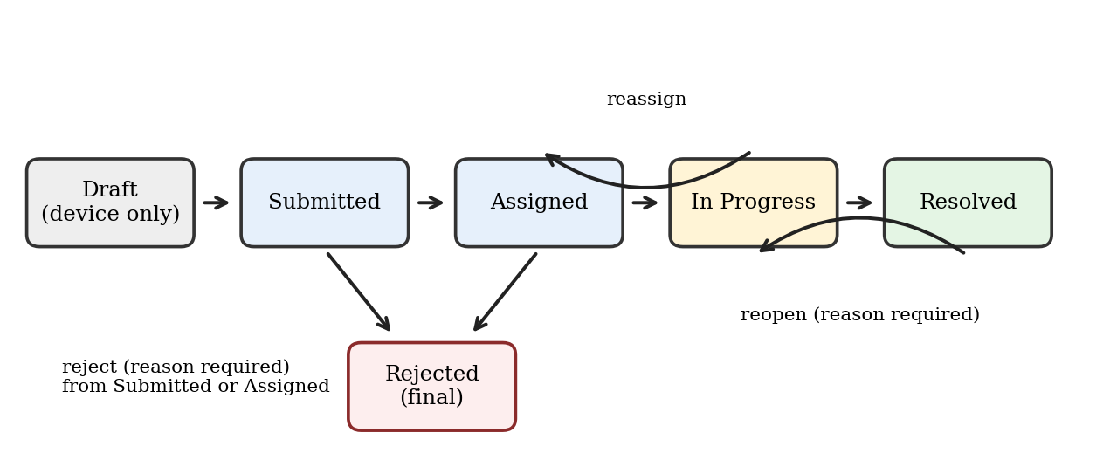
Figure 2: Status workflow
The rules are stored as a plain object in one file, for example Submitted: [Assigned, Rejected]. Each entry also lists the role that may use it and whether a note or an assignee is required. The same function, canTransition(from, to, role, payload), is used by the API to decide, and by the client to choose which buttons to show. An invalid request gets a 422 answer with a message such as Cannot change from Submitted to Resolved. The status change and its history entry are written in one database transaction, so a report can never change without a record.
Submit (Draft to Submitted) is done on the device. The server then receives a report whose status is already Submitted and rejects any other starting status.

8. Validation and Error Handling
- Two layers: the client validates for speed and friendly messages, and the server validates again with Zod because the client cannot be trusted.
- Rules: category and priority from fixed lists, description 10 to 1000 characters, location 3 to 200 characters, latitude and longitude in range and sent together, reported time not more than 5 minutes in the future, required notes for reject, reopen and resolve.
- Server errors: one Express error handler converts every error into the standard body and hides internal details from the client. Unknown errors become a 500 and are logged.
- Client errors: a failed local save shows a visible message. A failed sync is shown on the report itself and in the history, never only in the console.

9. History Design
History is written at the moment something happens. Client events (CREATED, SUBMITTED, SYNC_FAILED) are saved in IndexedDB and travel with the report at sync time, so the server history also shows the offline failures. Server events (SYNCED, STATUS_CHANGED, DETAILS_EDITED, DUPLICATE_FLAGGED) are written by the service inside the same transaction as the change. The details page loads the list ordered by id. The history table is append-only.

10. Security and Data Safety
- Parameterized queries everywhere, so SQL injection is prevented. React escapes text, which prevents script injection in descriptions.
- CORS allows only the client address from the environment file. The helmet package adds safe headers.
- Settings such as the database URL are read from a .env file that is ignored by Git. A .env.example file shows the needed names.
- Roles are simulated and are not real security. The header check only demonstrates the permission rules. Real login would replace it.
- No hard deletes on the server. Local Drafts are deleted only after confirmation. The app requests persistent storage so the browser is less likely to clear the data.

11. Testing Design

11.1 Testing priorities
I spend the limited time where a failure would hurt most: losing or duplicating data, breaking the workflow, and breaking the rules for editing. Screen layout is tested last and mostly by hand.
Priority | What is tested | Tool
1 | Idempotent create: same client ID twice gives one row and answers 201 then 200. | Jest, Supertest
2 | Workflow: every valid transition passes, and invalid ones, wrong roles and missing notes are refused. | Jest
3 | Sync engine: success, network error keeps Pending, five failures give Failed, 400 gives Failed, Syncing resets on start. | Vitest, fake-indexeddb
4 | Version conflicts: the second update with an old version gets 409. | Jest, Supertest
5 | Validation: bad category, short description, future time, bad coordinates. | Jest
6 | History: entries exist and are ordered for create, sync, and status change. | Jest
7 | Offline persistence and UI flows. | Manual QA checklist

11.2 Test environment
Server tests use a separate PostgreSQL database named by an environment variable. Each test run applies the migration and clears the tables first. The commands are npm test in the server folder and in the client folder, with one root script that runs both.

12. Deployment, Setup and Seed Data
The project runs locally in three steps: create the database and run the migration, start the server with npm run dev, and start the client with npm run dev. A seed script adds about 12 demonstration reports in every status, including one possible duplicate, so a reviewer sees the workflow without typing data. A public deployment is optional and is not planned unless time remains.

13. Design Trade-offs and Future Improvements
Decision | Benefit | Cost
Web app instead of native | One codebase, no installation. | No background sync on some browsers.
Server wins after sync | Simple and predictable. | Local edits to synced reports are not allowed.
Coordinator online only | Avoids many conflict cases. | No offline coordinator work.
Polling timer for sync | Works in every browser. | Uses a little battery while pending.
Simulated roles | Fits the brief and stays testable. | Not secure.

With more time I would add real login, photo attachments, background sync where supported, a pull-by-date endpoint for efficient refresh, end-to-end tests with Playwright, and deployment with continuous integration.

