SOFTWARE DEVELOPMENT LIFECYCLE

PLANNING PHASE

- Requirement Gathering and Analysis
  - This is the foundation of the planning phase, where the "what" of the system is determined.
  - Elicitation: Collecting needs from stakeholders (users, clients, managers, etc.) through interviews, surveys, workshops, and observation.
  - Documentation: Formalizing the needs into a Requirements Specification Document (RSD) or Software Requirements Specification (SRS). These requirements are typically categorized:
    - Functional Requirements: What the system must do (e.g., "The system shall allow users to log in").
    - Non-functional Requirements: How the system should be (e.g., performance, security, reliability, scalability).

- Feasibility Study
  - The feasibility study assesses whether the proposed project is realistic, practical, and achievable. It answers the question: "Can we build this system?"
  - Type of Feasibility:
    - Technical: Assesses if the required technology and expertise are available and viable to build the system.
    - Economic (or Financial): Evaluates the cost-benefit analysis. Does the projected revenue/savings justify the development cost (ROI)?
    - Operational: Assesses if the proposed system will solve the business problem and be accepted by the end-users and organization.
    - Schedule: Determines if the project can be completed within the specified timeframe and deadlines.
    - Legal/Political: Checks for adherence to laws, regulations (e.g., GDPR), standards, and internal policies.

- Scope Definition and Project Goals
  - Scope Definition: Establishing the boundaries of the project—what features will be included and, equally important, what will be excluded. This prevents scope creep (the uncontrolled expansion of the project's work).
  - Goal Setting: Defining the high-level objectives that the system must achieve. These should be SMART (Specific, Measurable, Achievable, Relevant, Time-bound).
    - Example Goal: "Reduce customer support calls related to order tracking by 30% within 6 months of deployment."

- Technology Stack Selection
  - Programming Languages: Selecting appropriate languages (e.g., Python, Java, JavaScript) based on performance needs, existing team expertise, and system requirements.
  - Frameworks and Libraries: Choosing necessary frameworks (e.g., React, Spring, Django) and third-party tools.
  - Databases: Selecting the storage solution (e.g., SQL, NoSQL) that best fits the data structure and access needs.
  - Deployment Environment: Determining the hosting infrastructure (e.g., cloud platforms like AWS, Azure, on-premise servers).

- Cost Estimation and Resource Allocation
  - Effort Estimation: Using various techniques (like Function Point Analysis, COCOMO, or Delphi technique) to estimate the total person-hours required to complete the project.
  - Cost Estimation: Translating effort estimates into monetary costs, including:
    - Personnel (salaries)
    - Software/Hardware licenses
    - Infrastructure/Overhead
  - Resource Allocation: Identifying and assigning the necessary team members (developers, testers, project managers, designers) and their roles.

- Scheduling and Milestones (Project Plan)
A detailed project timeline is established, often resulting in a Project Plan Document.
  - Work Breakdown Structure (WBS): Decomposing the entire project work into smaller, manageable tasks.
  - Task Sequencing: Determining the order in which tasks must be performed, identifying dependencies.
  - Timeframe Assignment: Allocating specific time estimates to each task.
  - Milestone Identification: Defining significant checkpoints or deliverables that mark progress (e.g., "Prototype Complete," "Beta Release"). Tools like Gantt Charts or Critical Path Method (CPM) are often used here:
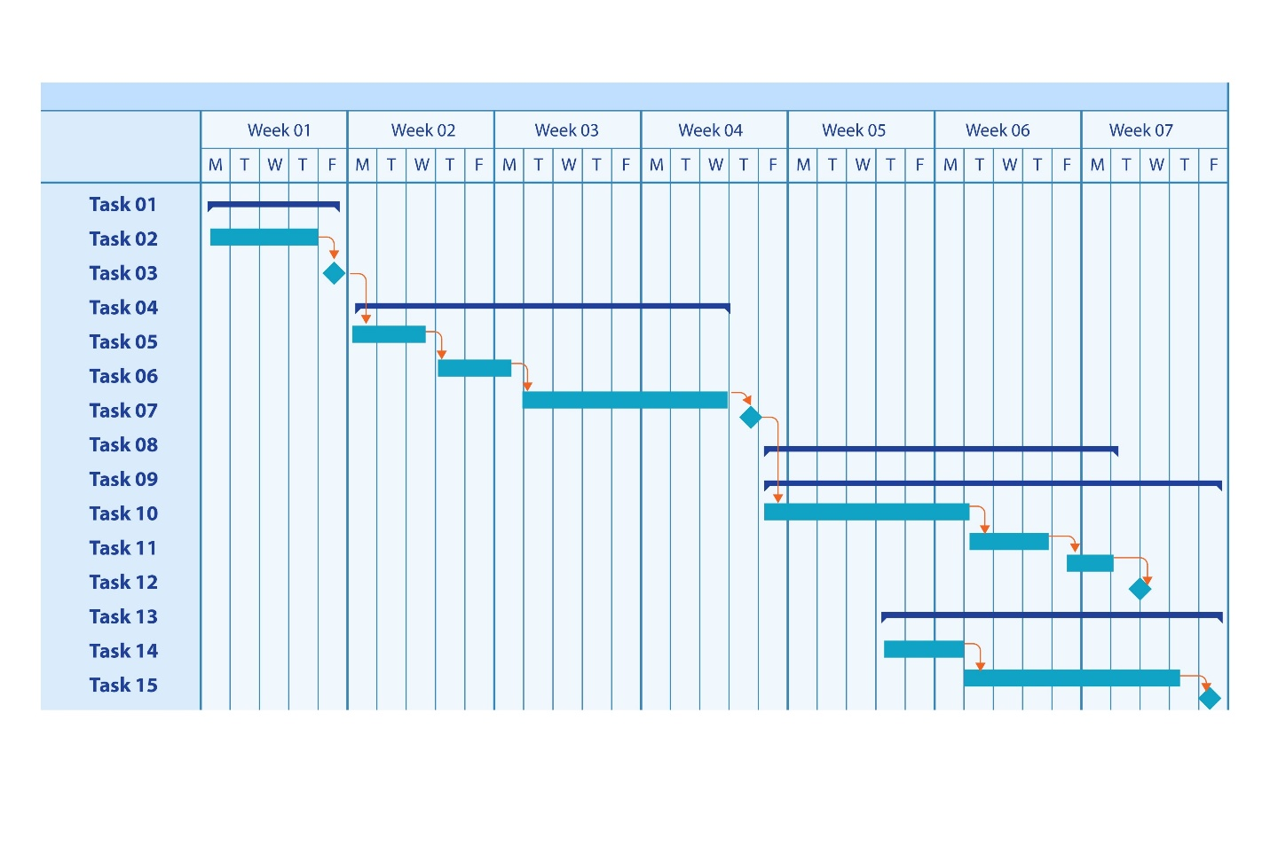

- Risk Analysis and Mitigation
Proactively identifying potential problems and planning how to manage them.
  - Identification: Brainstorming and documenting potential risks (e.g., key personnel leaving, budget cuts, technology failures, shifting requirements).
  - Assessment: Evaluating the likelihood and impact of each risk.
  - Mitigation Strategy: Developing a plan to either reduce the probability of the risk occurring or minimize its impact if it does occur (e.g., cross-training team members, having a contingency budget).

CITIZENS’ COMPLAINT AND FEEDBACK PLATFORM

- Requirement Gathering and Analysis
Elicitation:
- As a citizen, I need a mobile app by which I raise my complains for the responsible institution in the country.
- Complaint Form Module Inputs:

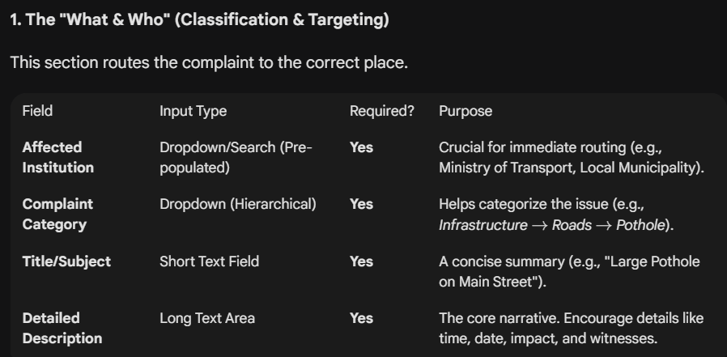

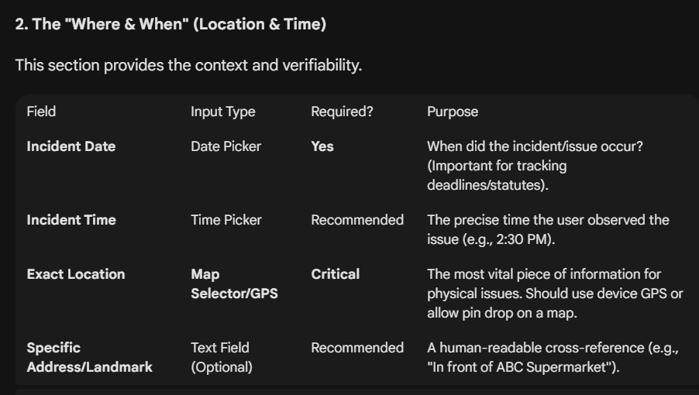

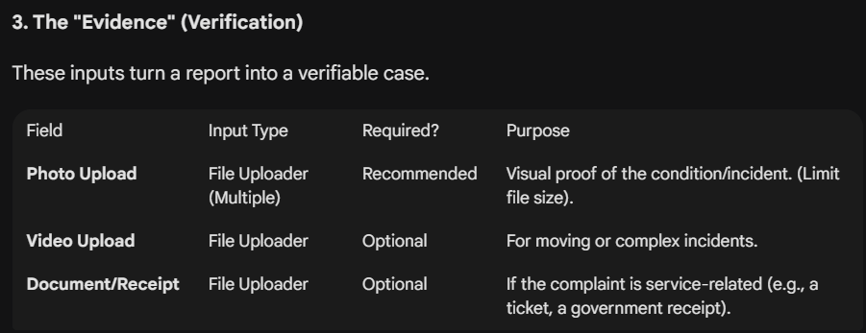

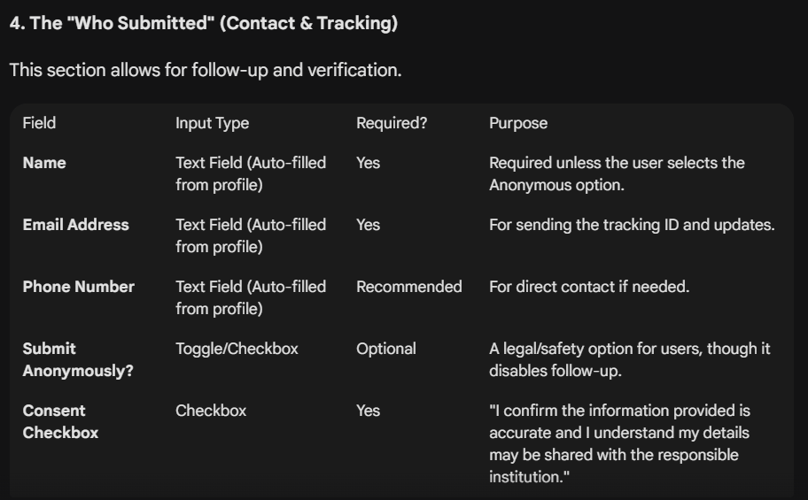

- The mobile app should include module by which NEWS and important government activities are shared.

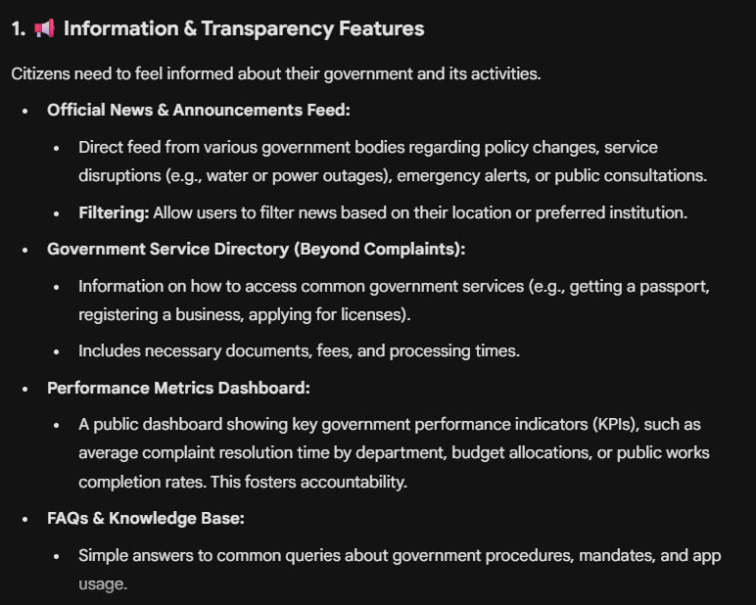

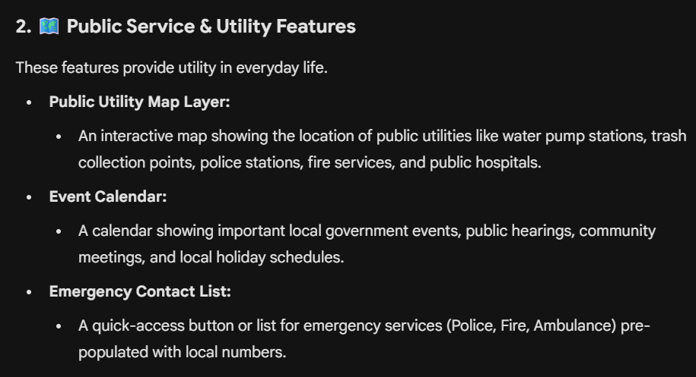

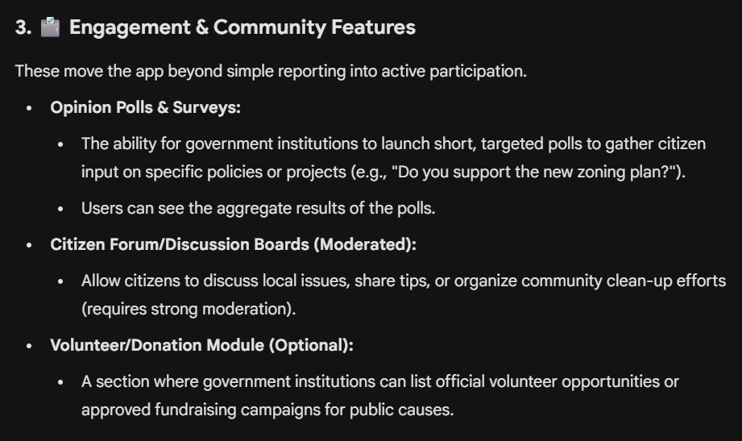

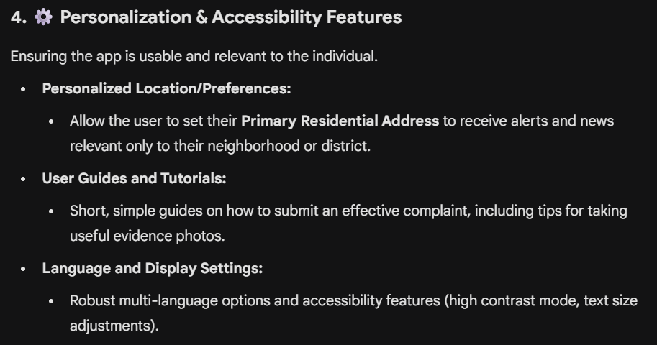

- Government institutions need a webapp by which they respond to the citizens’ compliant. Additionally, the web app should include the institutional side of the above-mentioned citizen app features.

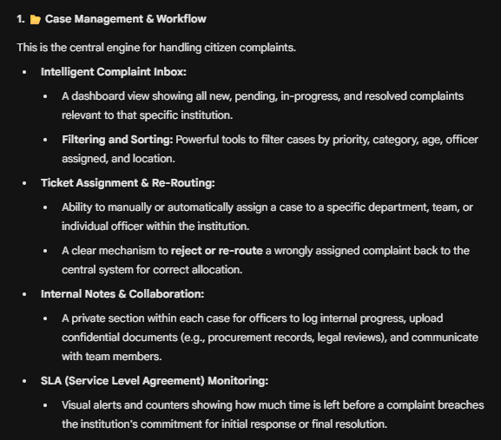

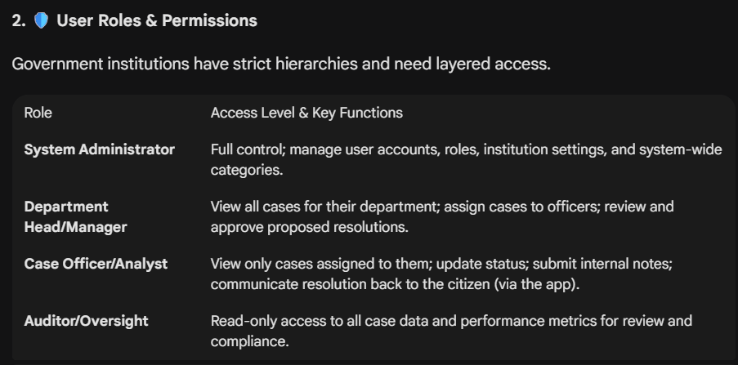

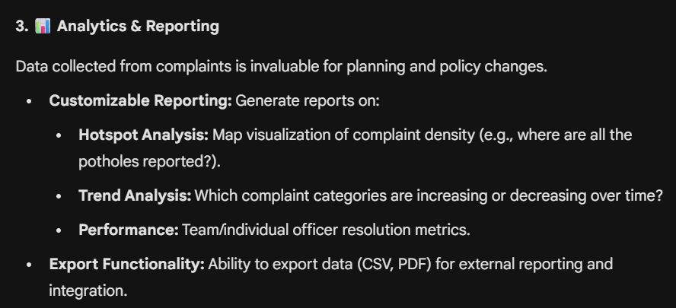

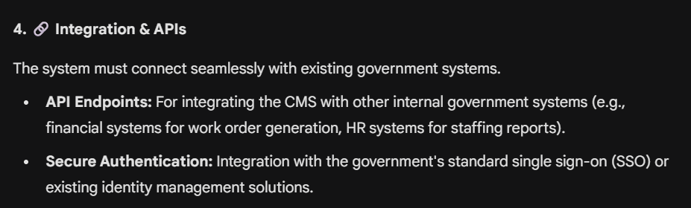

- Goals
  - Business Goal: Sell to Anti-Corruption Commission/Ombudsman for 5M ETB/year.
  - Technical Goal: Build an MVP with anonymous complaint submission, basic triage, geospatial dashboard and Amharic OCR.
  - Citizen Impact: Process 1K complaints/month, 80% resolution rate.
  - Save 20% admin time, align with Digital Ethiopia 2025.
- Market Validation
- Scope of MVP
  - Features
    - Citizen: Anonymous complaint form (text, file upload), status tracking, Amharic/English UI.
    - Government: Admin dashboard (complaint list, basic geospatial map), keyword-based triage, role-based access.
    - Integrations: Tesseract OCR, Ethio Telecom SMS, Google Maps API.
  - Exclusion (for v2): Full AI triage (BERT), voice input, Oromo/Tigrinya support.
- Resource Planning
  - Hardware: Laptop (4GB RAM min), stable internet (4G or Ethio Telecom fiber).
  - Software:
    - Free: VS Code, Git, Tesseract OCR, PostgreSQL, AWS Free Tier.
    - Paid: Domain (~500 ETB/year, e.g., ethcomplaints.et), Google Cloud Vision (~2K ETB for 10K images).
  - • Time: 2-3 months, 20h/week (total ~200h).
  - • Budget: 10K ETB (domain, hosting, APIs).

