Frustum
The camera view is what the camera sees, whereas the frustum is the specific, invisible 3D volume that defines what the camera is allowed to see.
Field of View
To be continued;

Horizontal
Query: How to calculate horizontal field of view OpenGL (to Google AI);
To calculate the horizontal field of view (hFOV) in OpenGL, you typically use the relationship between the vertical field of view (vFOV) and the window's aspect ratio. While standard OpenGL functions like gluPerspective or modern GLM library functions use vFOV as an input, hFOV can be derived using trigonometry.

The Conversion Formula
If you have the vertical field of view (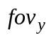) and the aspect ratio (aspect = width / height), the horizontal field of view (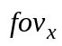) is calculated as follows:
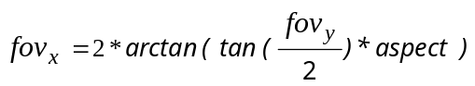
Conversely, if you want to find the required vertical FOV for a specific target horizontal FOV, use:
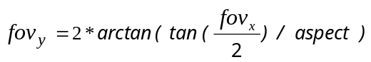
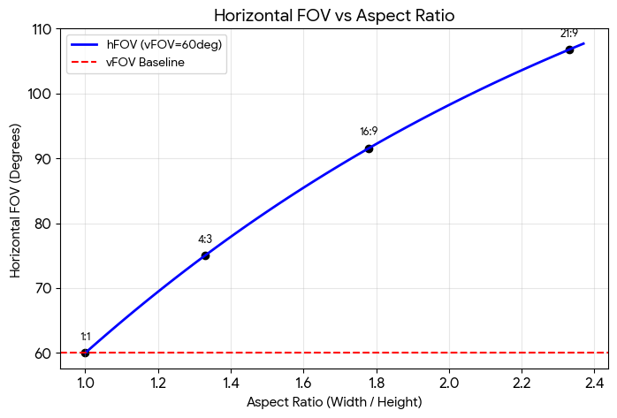
The above graph illustrates how the horizontal FOV scales relative to the vertical FOV (set at 60 degrees) across different aspect ratios (from 1:1 to 21:9 ultra-wide).

Alternative: Calculation from Focal Length
If you are simulating a physical camera, you can calculate FOV based on the sensor width and focal length:
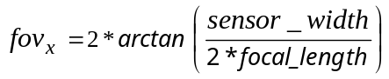

Vertical
Query: How to calculate vertical field of view in OpenGL (to Google AI);
In OpenGL, the vertical field of view (often called fovy) is typically the angle you provide directly to functions like glm::perspective or the legacy gluPerspective.
If you need to calculate it from other parameters, use the following methods based on your available data.
Calculate from Object Height and Distance
If you want a specific object of height H to fill the screen vertically when it is at a certain distance D from the camera, use basic trigonometry:
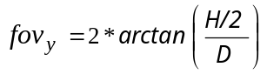
Calculate from Horizontal FOV and Aspect Ratio
If you already have the horizontal field of view FOV and want the corresponding vertical field of view for a specific screen:
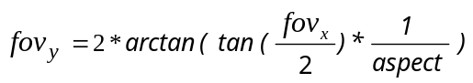

The relationship between the field of view angles and the physical viewport dimensions can be visualized through right triangles formed by the camera's eye position and the near clipping plane.
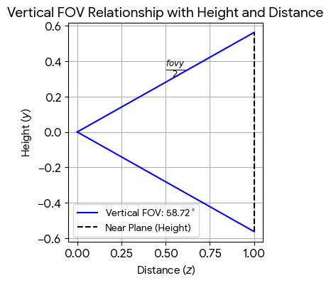
To be continued;
Projection
Query: How to manually calculate projection matrix in OpenGL;
To manually calculate an OpenGL projection matrix, you must construct a 4x4 matrix that transforms coordinates from view space to Normalized Device Coordinates (NDC) in the range [-1, 1]. OpenGL typically uses a column-major format.
Before building the matrix, define your frustum boundaries:
There are the left and right boundaries (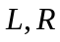), the bottom and top boundaries (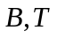), near and far clipping planes (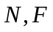) (must be positive distances from the camera).
If you are using Field of View (FOV) and Aspect Ratio (AR), you first calculate T and R:
T (top):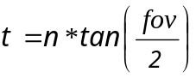; R (right): 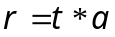; for a symmetric frustum: L = -R and B = -T.
The two primary types of projection are Perspective (simulating depth) and Orthographic (parallel projection).
These matrices assume a right-handed system in eye space (looking down -Z) and transform to a left-handed system in NDC.

Perspective Matrix
The perspective matrix projects a frustum into a cube. For a symmetric frustum, the matrix is:
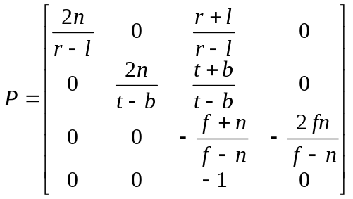;
Simplified Symmetric Form (where R = -L and T = -B):
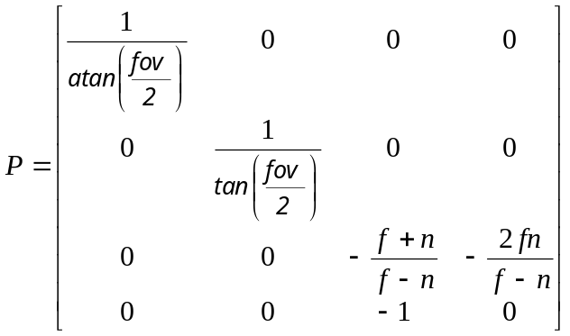;
The third row (z-axis) maps z-value to the range [-1, 1].
The fourth row (w-component) stores —z-value in the w-component for allowing the 'perspective divide' later (x/w, y/w, z/w).

OpenGL Implementation
The gluPerspective function is part of the OpenGL Utility Library (GLU) and is used to set up a perspective projection matrix. This creates a 3D effect where objects appear smaller as they move further away from the viewer, simulating real-world depth perception.

Parameter Breakdown
From the left to right:
- Filed of view vertical: The vertical viewing angle in degrees. A typical value is 45 or 60 degrees. Increasing this value makes more of the scene visible but makes individual objects appear smaller.
- Aspect: The aspect ratio, which is the width of the viewport divided by its height (W/H). This should usually match your window's aspect ratio to prevent the image from appearing stretched or squashed.
- Near Plane: The distance from the viewer to the near clipping plane. Objects closer than this distance will not be rendered. This value must always be positive.
- Far Plane: The distance from the viewer to the far clipping plane. Objects beyond this distance will not be rendered. This must also be positive.

Orthographic Matrix
The query to Google AI: what coordinates should be sent to glOrtho? In window coordinate system or in normalized device coordinates?
You should use window coordinates (or "world coordinates" representing your specific application dimensions). Do not use Normalized Device Coordinates (NDC) directly in glOrtho.
The glOrtho function is used to define an orthographic projection matrix. Its primary job is to act as a transformer—it takes your custom coordinate system and maps it into the standard NDC space, which spans from [-1.0, 1.0] on the X and Y axes.
Because glOrtho acts as this mathematical bridge, the parameters you send to it define the virtual boundaries of your camera.
The orthographic matrix is a simple linear scale and translation that maps a box-shaped volume to NDC.
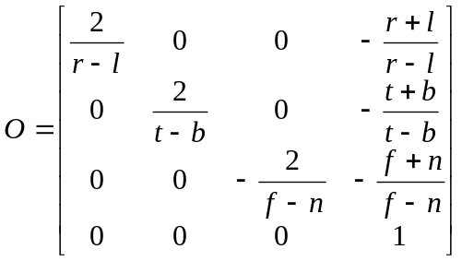;

Final Result
To calculate the projection matrix manually, use the parameters (n, f, FOV and a) to fill the 4x4 matrix P; P matrix is then multiplied by your view and model matrices in the shader: gl_Position = Projection * View * Model * vec4(position, 1.0);
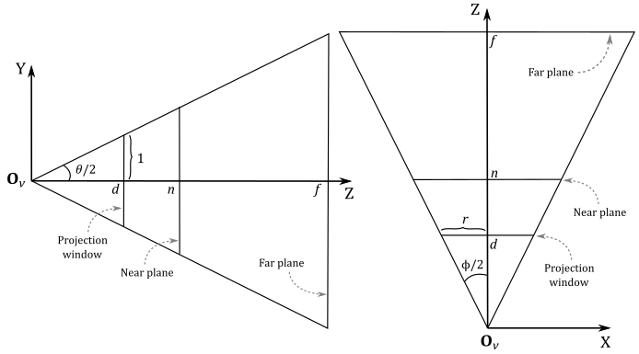
Multi-monitor System
Query: how to calculate frustum for multi-monitor system (to Google AI);
Calculating the viewing frustum for a multi-monitor system prevents the stretching and distortion caused by treating three side-by-side screens as one massive monitor. Instead of a single, highly stretched camera image, a multi-monitor setup requires an off-axis (or "skewed") frustum for each individual screen.

The Variables
- W_{total}: Total horizontal width of all your screens combined (including physical monitor bezels);
- W_{single}: Width of one individual monitor;
- D: Distance from your eyes to the center of your primary/center monitor.

Total Horizontal FOV
Because you are wrapping the FOV across three screens, you must calculate the total angle required to cover the combined width. Use this formula:
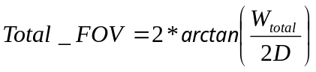
Note: Ensure your game or 3D engine is set to output degrees rather than radians;

Off-Axis Frustum Settings
Three monitors are used in this example. The following offsets should be defined:
- Left plane distance is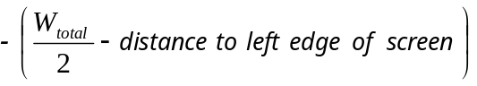;
- Right plane distance is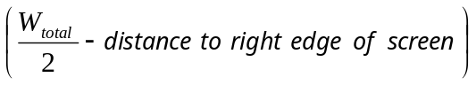;
- Top/Bottom planes have standard values based on your vertical screen height.

Adjusting for Bezels
To calculate the frustum correctly, you must account for the plastic gap between the screens. When inputting your total width (W_{total}), measure the internal bezel gaps. Many simulators feature built-in bezel correction that shifts the rendering slightly inward, making the image "teleport" behind the frames for a perfectly contiguous image.

Centered Single View Setups
Starting simply with single screen setups. All you need is the distance your eyes are from the screen and your screen size. There are plenty of online FOV calculators that can give you a number right away, but here is the formula anyways.
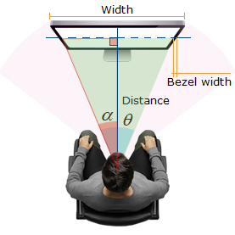 | Code:  x: screen width (without bezels)  y: distance from eyes to monitor  z: camera FOV  z = 2arctan(x/(2y))  Tip: use degree mode on your calculator;  Camera FOV is ~40 degrees.  Now if you find the FOV is too small, there are two options:  You can move closer to your display, or you can buy a bigger display.

Generic Matrix Entries
What do transformation matrix entries mean in OpenGL?
In OpenGL, a transformation matrix is a 4 × 4 grid of numbers used to translate, rotate, and scale vertices. Because OpenGL stores matrices in column-major order (as a 1D array of 16 elements), the entries map specifically to the spatial directions and positions of your 3D geometry.
The matrix acts as a set of modified axes (or basis vectors) for your object. A standard transformation matrix M is organized like this:
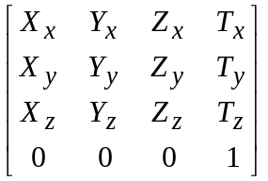

Scaling
The top-left 3 × 3 portion (entries X_{x}, Y_{y}, and Z_{z}) dictates the size of your object along each axis. [1, 2, 3, 4], where:
X_{x} [col:0;row:0] is X-axis scaling,
Y_{y} [col:1;row:1] is Y-axis scaling and Z_{z} [col:2;row:2] is Z-axis scaling.

Stretching
A stretch in the XY-plane is a linear transformation which enlarges all distances in a particular direction by a constant factor but does not affect distances in the perpendicular direction.
We only consider stretches along the x-axis and y-axis.
A stretch along the X-axis has the form x' = k*x; y' = y for some positive constant k.
Note that if k > 1, then this really is a "stretch"; if k < 1, it is technically a "compression", but we still call it a stretch. Also, if k = 1, then the transformation is an identity, i.e. it has no effect.
The matrix associated with a stretch by a factor k along the x-axis is given by: 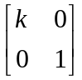
Similarly, a stretch by a factor k along the y-axis has the form x' = x; y' = k*y, so the matrix associated with this transformation is 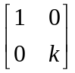

Squeezing
If the two stretches above are combined with reciprocal values, then the transformation matrix represents a squeeze mapping: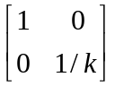.
A square with sides parallel to the axes is transformed to a rectangle that has the same area as the square. The reciprocal stretch and compression leave the area invariant.

Rotation
The off-diagonal values in the top-left 3 × 3 matrix define how the object is rotated or skewed.
For rotation by an angle θ counterclockwise (positive direction) about the origin the functional form is 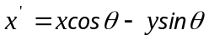and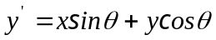. Written in matrix form, this becomes:
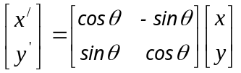
Similarly, for a rotation clockwise (negative direction) about the origin, the functional form is 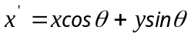and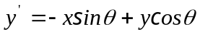. The matrix form is:
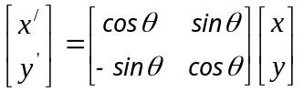
These formulae assume that the x axis points right and the y axis points up.

Shearing
For shear mapping (visually similar to slanting), there are two possibilities.
A shear parallel to the X axis has form x' = x + k*y; y' = y. Written in matrix form, this becomes:
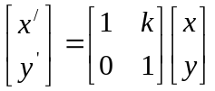
A shear parallel to the Y axis has form x' = x; y' = y + k*x. Written in matrix form, this becomes:
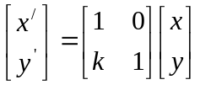

Reflection
To be continued;

The Bottom Row
The bottom row (0, 0, 0, and 1) is part of the homogeneous coordinates system.
These entries [col:0;row:3], [col:1;row:3], [col:2;row:3] are typically 0 for basic 3D translation/rotation, but are used in projection matrices to achieve perspective division (creating the illusion of depth).
And W [col:3;row:3]: this is usually 1.0 for regular objects. If it shrinks, OpenGL mathematically scales the vertex closer to the screen center.

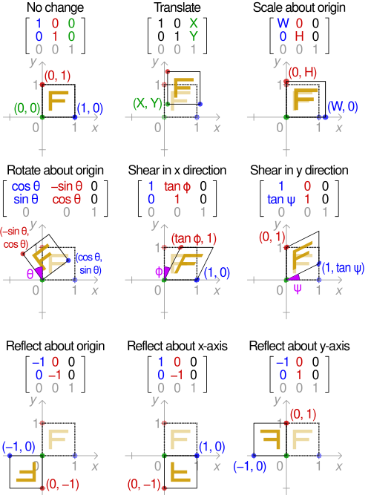

Microsoft implementation is described here;
The 2D and 3D object projection is described here;
The complete description is taken from DirectX;
Microsoft implementation is described here;
Microsoft implementation is described here and here;
A description and an example of stretching is here;
A reflection transformation is described here;

