The 4th Element of a Vector
Question: What does the graphics card do with the fourth element of a vector as the final position?
Component or Element of a Vector
Query: How to correctly say 'a component' or 'an element' of a vector? (Google AI)
In Mathematics and Physics (Formal & Applied)
Term: Component (preferred).
Usage: Refers to the projection of a vector along a specific axis.
In Computing, Data Science, and Linear Algebra (Numerical)
Term: Element (preferred) or Entry.
Usage: Refers to the individual numerical values stored within a vector structure.
In the most cases the term 'component' is preferred regardless the context, mathematics, physics or programming.
Affine and Euclidean Spaces
A vector as difference of two points: V = B - A;
The vector 'V' moves the point 'A' to point 'B' because A + V = A + B - A = B.
Put A = 0 (the origin) and the result will be V = B - 0 = B: the point 'B' and the vector that moves 0 to B are the same thing.

Affine Space
An affine space is a geometric structure that formalizes the intuitive notion of points and parallel lines, behaving like a vector space that has "forgotten" its origin.
It consists of a set of points where positions can be shifted by vectors (translations), allowing for affine combinations (like centroids) but not absolute positions or vector additions.
Definition
An affine space is a set of points A associated with a vector space V, i.e. translations or directions, and a map that lets adding vectors to points.
Intuition
It is a vector space without a fixed origin. If a point is the "zero" point cannot be identified or defined, it is an affine space.
Structure
It supports translation and the concept of parallel lines. Through any point, a unique line parallel to another line can be drawn.
Difference from Vector Spaces
Unlike vector spaces, there is no meaningful adding two points in an affine space: the sum of P+Q is not defined, but it is possible to calculate the vector difference between two points P-Q.

Properties and Components
Affine Subspaces (Flats)
These are subsets, such as lines or planes, that may not pass through the "origin" of the underlying vector space (e.g. Ax=b where b≠0).
Points as Locations
Points have no size or shape (0-dimensional), while lines are 1-dimensional, and planes are 2-dimensional.
Transformation
Rigid motions and affine transformations (like scaling, rotation, and translation) are native to affine space, making it crucial for computer graphics and kinematics.
Relation to Projective Space
An affine space is a subset of a projective space, created by removing a "hyper-plane at infinity".
Common Examples
Euclidean Space: Considered as an affine space, if there is a focus on the relative positions of points, not their distance from the origin.
A Line Not Through the Origin: In a vector space, any straight line that does not pass through the origin is an affine space, but not a vector subspace.

Affine and Projective Space
The Affine Space is a projective space in the sense that there is a construction that allows establishing an equivalence relation between Affine and Euclidean vectors, and they can be confused with each other.
All the affine vectors that projects to the origin with the same direction can be seen as the same Euclidean vector. This means that all the vectors that have the same proportions in the coordinates can be considered equivalent, mathematically:
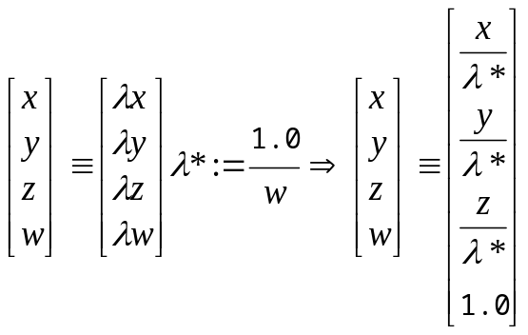
The formula means that every affine vector can be reduced to a canon version where w=1 (this value looks the most appropriate for further discussion).
That can be represented visually:
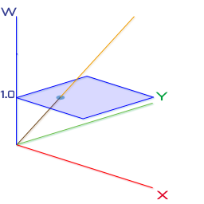
2D Euclidean in 3D Affine hence the mean of "projective" space; the Euclidean space is 2D plane (the cyan region).
There is a particular set of affine vectors that can't be put in their canonical version (with ease) the one that lies on the (hyper) plane w=0.
It can be represented visually:
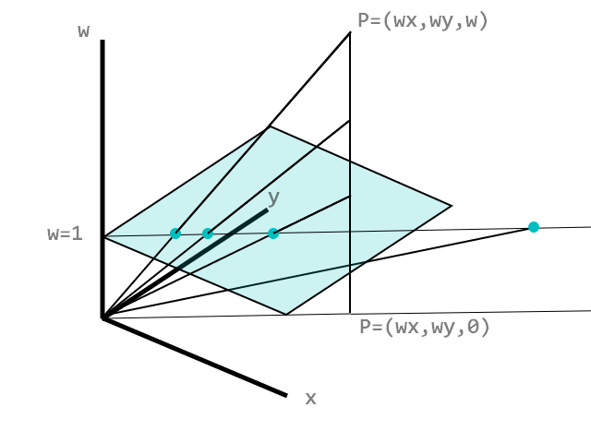
While w->0 then the projected vector into the Euclidean space goes to the infinite, but to the infinite in a particular direction.
Now is clear that adding up two vectors in the projective space can lead to problems when the sum vector is considered as a projected vector in the Euclidean space, this appends because the sum consists of the W components in the affine space and then project them to the Euclidean (hyper) plane.
This is the reason why only "points" can be added to "vectors" because a "vector" will not change the w coordinate of the "point". This is true only for "points" where W=1:
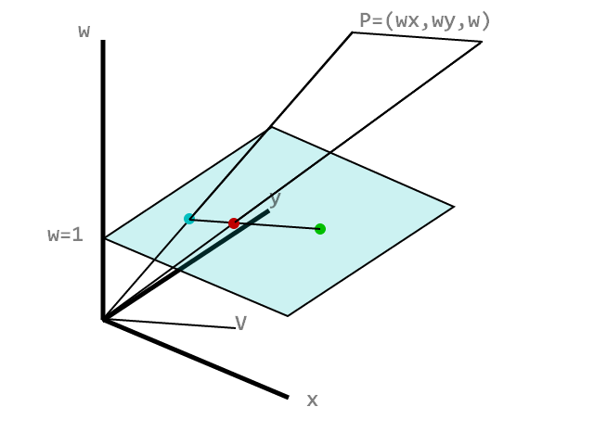
The green point is the one obtained adding the two affine vectors that represent the cyan "point" and the V "vector", but if the vector V is applied to every affine vector in a form different by the canon one, a wrong result will be obtained (the red "point").
Affine Space can't be used transparently to describe operation on Euclidean Spaces and the misuse of the term "vector" has sense under the (strict) constraint of compute sums only on canon projective vectors.
Said that, is quite reasonable to think that the GPU assumes that a Vector4 has to have w=0 or w=1, unless you really know what you are doing.

Euclidean Space
It is the fundamental, flat, geometric space of 1, 2, or is the fundamental, flat, geometric space of 1, 2, or n-dimensions where standard Euclidean geometry rules apply, such as the parallel postulate and Pythagoras' theorem.
Points are defined by n-tuple(s) of real numbers (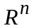), and distances are calculated using the Euclidean distance formula, remaining invariant under rotation or translation.

Key Aspects of Euclidean Space
Dimensions (n): While 2D (plane) and 3D (space) are most common, Euclidean space extends to any finite number of dimensions.
Distance Metric: The distance between points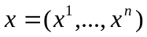, and 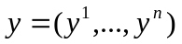 is defined by the norm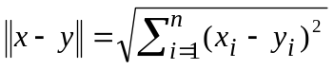, based on the Pythagorean Theorem.
Structure: It is an inner product space that allows for measuring angles, lengths, and volumes.
Flatness: Unlike curved surfaces (non-Euclidean geometry), parallel lines in Euclidean space remain equidistant and never meet.

The excerpts of explanation are taken from Game Development article;
Affine space detailed description is in en.wikipedia.org;
One of the answer from discussion on gamedev.stackexchange.com ;
Euclidean space is described in en.wikipedia.org and sciencedirect.com ;

