What Is SOLID
The query to Google AI: solid rules of software development detailed description or explanation. Created by Robert C. Martin ("Uncle Bob"), the acronym stands for:
- Single Responsibility;
- Open/Closed;
- Liskov Substitution;
- Interface Segregation;
- Dependency Inversion.
In object-oriented programming and functional programming, SOLID is a mnemonic acronym for five principles intended to make source code more understandable, flexible, and maintainable. Although the principles apply to object-oriented programming, they also form a core philosophy for methodologies such as agile software development and adaptive software development.

Single Responsibility

Definition
The single-responsibility principle states that there should never be more than one reason for a class to change. In other words, every class should have only one responsibility.

Benefit
This principle keeps components focused and makes debugging or updating a specific feature much simpler.

Explanation
Every component should do just one job. If a class handles user data and prints reports, it has two jobs. Splitting those means changes to report printing will never break user data handling.

Importance
Maintainability | When classes have a single, well-defined responsibility, they're easier to understand and modify.
Testability | It's easier to write unit tests for classes with a single focus.
Flexibility | Changes to one responsibility don't affect unrelated parts of the system.

Chain-of-Responsibility Pattern
The Chain of Responsibility pattern solves:
- Coupling the sender of a request to its receiver should be avoided;
- It should be possible that more than one receiver can handle a request.
Solution
Defining a chain of receiver objects having the responsibility, depending on run-time conditions, to either handle a request or forward it to the next receiver on the chain (if any).

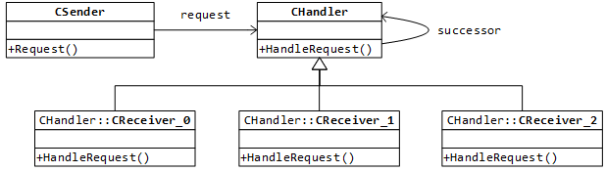
Figure #1: an example of using chain of responsibility pattern

Open–Closed

Definition
Software entities should be open for extension, but closed for modification.

Benefit
It allows adding new features or behaviors without rewriting or breaking existing working code.

Importance
Extensibility | New features can be added without modifying existing code.
Stability | Reduces the risk of introducing bugs when making changes.
Flexibility | Adapts to changing requirements more easily.

Liskov Substitution

Definition
Subtypes must be substitutable for their base types without altering program correctness.

Explanation
Derived classes should extend base class functionality without breaking it, ensuring consistent behavior across inheritance hierarchies.

Importance
Polymorphism | Enables the use of polymorphic behavior, making code more flexible and reusable.
Reliability | Ensures that subclasses adhere to the contract defined by the superclass.
Predictability | Guarantees that replacing a superclass object with a subclass object won't break the program.

Interface Segregation

Definition
This principle splits interfaces to more specific ones so that clients will only have to know about the methods that are of interest to them. Such shrunken interfaces are also called role interfaces (that may be predecessors for 'consumer-driven contract'). Clients should not be forced to depend on methods they do not use.

Explanation
This principle is intended to keep a system decoupled and thus easier to refactor, change, and redeploy.

Importance
Decoupling | It reduces dependencies between classes, making the code more modular and maintainable: when a feature changes, the small, relevant interface needs to be updated.
Flexibility | Objects mix and match only the behaviors they need. Such approach allows for more targeted implementations of interfaces.
Unused Dependences | This principle helps to avoid unnecessary dependencies: clients don't have to depend on methods they don't use.

Dependency Inversion

Definition
This principle states that one should depend upon abstractions, not concretes.

Benefit
It allows adding new features or behaviors without rewriting or breaking existing working code.

Importance
Loose coupling | It reduces dependencies between modules, making the code more flexible and easier to test.
Flexibility | It enables changes to implementations without affecting clients.
Maintainability | It decouples code modules, making components easier to swap out and test.

SOLID - Wikipedia
The single responsibility principle is described here;
Chain of responsibility pattern is described here;
ISP detailed description is here;
DIP detailed description is here;

