The Task #1
To find a distance between viewer eyes or virtual camera to a monitor by applying input values;

Input values:
W − The total width of the monitor, including the bezels and the matrix together;
Θ − Theta, the camera horizontal view angle;
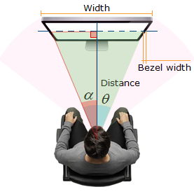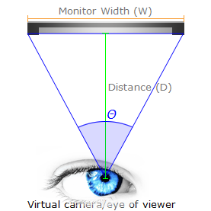
Figure #1: the diagram of input and output parameters;

Solution
The output value, i.e. a distance (D), can be found by performing the following steps:
(1) Finding a half of viewing angle: 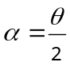 ;
(2) Using a half of monitor width as opposite side, monitor bezel is not taken into account:
w = Width / 2;

The answer:
(3) Finally, calculating adjacent side value, i.e. the distance between human eyes and monitor:
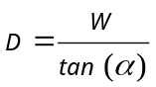, where the distance (D) value is in the same unit as monitor width (W);

Test Case
Table #1: Predefined angles of horizontal view;
Angle | Shortcut | Description
60° | Narrow | Simulates a telephoto perspective or tight focused framing.
75° | Standard / Natural | Closest to a normal human concentrated focal view without peripheral stretch.
90° | Default Gaming | Widely used as the standard default horizontal FOV in first-person video games and 3D software like D5 Render to balance immersion and distortion.
110° to 120° | Wide / Ultra-wide | Common in action cameras, security setups, and VR headsets to maximize situational awareness.
180°+ | Fisheye / Panoramic | Extreme peripheral coverage requiring specialized non-rectilinear projection.

The input values: monitor size (h x w) 102 x 76 cm, horizontal field of view is 60 degrees;
The result: 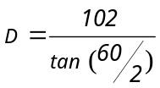 , the tangent value is 1.7320508; the distance is 58.8897 cm;
The Task #2
Determining the viewing angle (λ angle) by human eyes or by a virtual camera at the monitor matrix (without bezel) by applying input values;
Table #2: Task diagram schema and its parameters' description;
Diagram Schema | Parameter Description
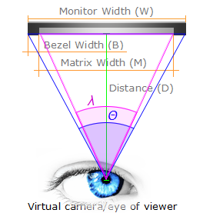  Figure #2: the diagram of input and output parameters; | Input values:  B − A bezel width of the monitor;  M − A monitor matrix width;  W − The total width of a monitor;  D − A distance between virtual camera and monitor;  Θ − Theta, the camera horizontal view angle;  Output values:  λ − an angle of view to monitor matrix, it is required to calculate;

Solution
The first step is the finding a distance between virtual camera and monitor by applying predefined horizontal angle of view and total width of a monitor:
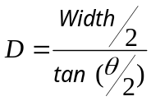, where ‘W’ is the width of monitor, Θ is the value of horizontal field of view;
The second step is finding an angle of view for monitor matrix, the answer:
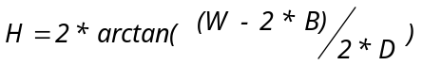, where H is horizontal field of view for bezel-less monitor, the dividend is gross monitor width minus its bezels' width, the divisor is the distance multiplication, the quotient is the result been found;

Test Case
Table #3: Predefined monitor types and its bezel width;
Monitor Type | Bezel Width, mm | Notes
Borderless / 3-sided bezel-less models | 1.5 − 3.0 | For the physical outer frame, though an active black border panel matrix sits inside.
Standard consumer monitors | 8.0 − 12.0 | The bezel width depends on the side of the monitor.
Extreme narrow bezel units | 1.7 | Total bezel-to-bezel.
Ultra-narrow commercial displays | 1.25 − 2.25 | The bezel width depends on the side of the monitor.

The input values: monitor size (h x w) 102 x 76 cm, bezel width 10 mm (standard monitor), horizontal field of view is 60 degrees (narrow view);
The 1st step is a calculating a distance between virtual camera and a monitor taking into account a total monitor width (matrix + bezels):
, the tangent value is 1.7320508; the distance is 58.8897 cm;
The 2nd step is a calculating a horizontal field of view for the monitor matrix without monitor bezels:
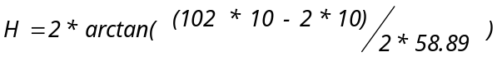;
The note: the screen width value is converted to the same measure data type as a bezel has;
Matrix width is 1,000 mm; the horizontal field of view is 1.4535 (radians) or 83.28 (degrees).
The Task #3
Defining possible intersection of a certain sphere by a ray;

Initial conditions:
The player sees objects of the virtual world through the plane of the screen and wants to hit the objects by hovering the mouse cursor over it and clicking on a pixel on the screen, the player 'shoots' a ray through this point;
The parameters of the encompassing/bounding sphere are calculated for each object;
Table #4: Task diagram schema and its parameters' description;
Diagram Schema | Parameter Description
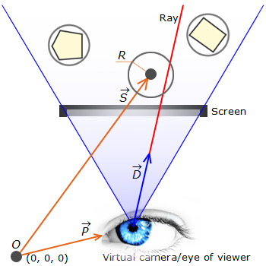 | Input values:  P − virtual camera position vector in the scene;  D − the normalized vector of direction the shot occurred;  A set of bounding spheres for all objects of the scene;  For each sphere are known:  R − the scalar value of radius;  S − the vector of the center position;  Note:  P, D and a set of bounding spheres are given by graphical engine.  Output values:  I − the vector of intersection point between a ray and a sphere, if any;

Solution
We have: camera position (P vector), ray direction (D vector), sphere center (vector S) and sphere radius (R);
The step #1: finding the vector (M) from the ray origin to the sphere center;
Vector M = {P.x - S.x, P.y - S.y, P.z - S.z};
The step #2: calculating the dot products (B, C);
B = dot(M, D) = (M.x * D.x + M.y * D.y + M.z * D.z);
C = dot(M, M) - R * R;

