Test question #2
The program for the computer of an electric car

Content
Question 3
Setting the Task 3
Defining the Basic Requirements 3
Input Data 3
Hardware Components 3
Major Components 3
Traction Battery and Inverter 3
Cooling/Heating System (thermal system) 4
Traction Electric Motor 4
Auxiliary Components 4
Control and Management Systems 4
Control System of the Main Components 4
Auxiliary Component Control System 5
Functional Specification 6
Acquiring Data 6
CAN Bus Data 6
External Internet Services and GPS 6
Discreteness of Data Requests 7
Electric Vehicle Charging Statistics 7
Data Analysis 7
Defining the Optimal Mode 8
Scenario #1 8
Scenario #2 9
Appendix 9
#1 Web Services Data Specification 9
Weather Data 9
Route Data 10
Map of Charging Stations 10
#2 Electric Vehicle Charging Statistics 11
#3 Program Initialization 11
#4 Local Data Provider 12
Data Quick Access Manager 13
Internet Service of Denormalized Data 13
Special Data Buffer (In-memory Cache) 13
Index Database 13
#5 Internal System Data Provider 13
#6 External Data Provider 14
#7 Data Analysis 15
End of Story 15
Beyond the End 15
Simple Reliable Way 16
Traffic Jams 16

Question
Suggest, in your opinion, the optimal software architecture for the on-board computer of an electric vehicle. Justify your decision.

Setting the Task
Creating optimal software architecture requires the following steps or subtasks:
- Defining the basic requirements;
- Input data, their attributes and data sources;
- Composing of a functional specification;
- Logical design;
- Justification of the decision.

Defining the Basic Requirements
The main requirements, taking into account the specifics of the operation of an electric vehicle, include the following:
- Monitoring the current state of equipment and devices;
- Visual display of information to the driver and passengers;
- Dynamic analysis of statistical data, both internal and external;
- Calculating of trends in value changes of important parameters: the charge level of the traction battery;
- Making predictions on data changes using mathematical methods;
- Issuing recommendations on optimizing the movement of an electric vehicle in order to ensure the successful completion of the proposed route.

Input Data
The input data includes:
- Voltage level in volts (V), acceptable range;
- Current amperage in amperes (A), permissible current surges when the device is turned on,
especially for resistive loads;
- Power consumption in watts (W), matching the expected values;
- Temperature range in degrees (°F or °C), acceptable range;
- Engine speed (rotations per second).

Hardware Components
The components of an equipment or device can be divided by categories of consumption or generation of electricity into main components and auxiliary or additional ones.

Major Components
The main category of hardware components includes the following:
- Traction battery (traction battery pack);
- Motor power inverter (traction inverter);
- Cooling/heating system (heating system, HVAC);
- Electric motor (induction motor).

Traction Battery and Inverter
The traction battery is the main power source of the electric motor and the level or degree of its charge is very important for the duration of the electric vehicle.
The following factors affect the battery charge duration:
- Driving mode and intensity of gear change (transmission operation);
- The length of time after the last battery charge;
- Weather conditions, especially ambient temperature;
- The temperature ranges of the battery housing or unit itself at which the battery is operating.
The inverter is necessary to convert the direct electric current of the battery into alternating current to power the induction motor of an electric vehicle.

Cooling/Heating System (thermal system)
The cooling or heating system (depending on the need) primarily serves the heating level of the traction battery, which is very important to maintain the efficiency of the electric vehicle.
Additional consumers of this system are the inverter and the motor. These components have a low priority compared to the priority of maintaining the temperature of the traction battery.

Traction Electric Motor
The traction motor is the major consumer of electricity. Depending on the model of the electric vehicle, there may be several engines (for left and right wheel traction separately, rear or front motor location or both).

Auxiliary Components
Auxiliary components or devices relate to the control of an electric vehicle (first of all), maintaining a comfortable temperature in the cabin (which is important) and providing additional options.
These components are powered by an auxiliary low-voltage system and are considered only in relation to the use of a personal computer (touch screen) installed in an electric vehicle inside.

Control and Management Systems
The basis of electric vehicle control is the serial data or message transmission protocol (frames). Based on this protocol, a network is organized for data transfer between component controllers – CAN (Controller Area Network).
This network consists of a main microcontroller unit (MCU) and a data bus, which the microcontroller controls:
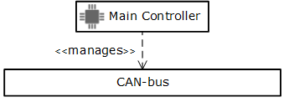
1. Basic diagram of the CAN control system
A detailed description of the system operation principles is not provided in this document.

Control System of the Main Components
The control modules of each main component are connected to the data bus.
In addition to the data bus, some components have directly connected to each other, for example, the cooling and heating system uses heat pipes. For cooling and heating, an air stream is used to heat the interior, as well as a coolant to remove heat from the engine, inverter and traction battery.
The important factor is to ensure the safety of driving an electric vehicle through a direct connection of components, for example, the engine speed control has a direct connection to the accelerator pedal or to the controls that can be located on the steering wheel.
It is also important to connect the brake pedal to the engine braking control system and the wheel brake pads.
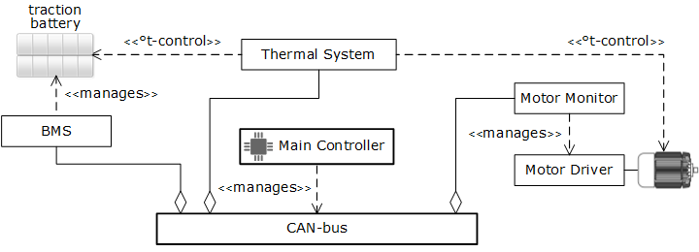
2. CAN control system of the main modules diagram
Table #1 Circuit blocks' description diagram #2
Module/Device | Description
Traction Battery | The module for connecting the traction battery to the CAN network.
BMS | Battery Management System – traction battery operation monitoring module.
Motor Driver | The engine speed control module is directly connected to the CAN network and to the controls of the electric vehicle (for instance, accelerator pedal).
Motor Monitor | The module for connecting the motor driver to the data bus of the CAN network.
Thermal System | The module controls the operation of the cooling and heating system.
As noted above, the cooling and heating system (Thermal System) plays an important role in maintaining the efficient operation of the traction battery.

Auxiliary Component Control System
Auxiliary components include:
- Front light control system;
- Rear light control system;
- Windscreen wipers and electric door glass control.
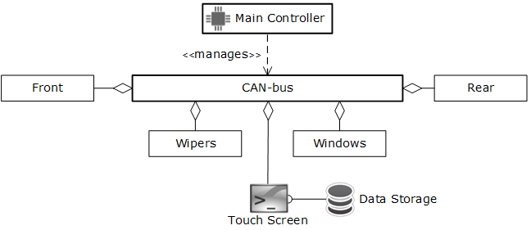
3. Control system of the CAN auxiliary modules' diagram
A brief description of the circuit elements is given in the table below:
Table #2 Description of the scheme #3 components
Module/Component | Description
Front | The control system for the headlights of the front lighting (headlight). The turn signals are also controlled by this module.
Rear | Rear lighting control system: brake light, reverse lighting, rear turn signals.
Wipers | Windscreen wipers for the front (windshield) and rear windows.
Windows | Electric motor control for lifting and lowering the windows of the cabin doors.
Touch Screen | The touch screen of the computer for displaying information about status of the modules/devices of the electric vehicle and the control system.
It should be noted that some components have related or joint behavior, for example, an emergency light is supported by both front rotary indicators (front) and rear indicators (rare).

Functional Specification
The functional specification can be decomposed into the following categories of tasks:
- Data acquisition;
- Data analysis;
- Calculating the optimal operating mode of an electric vehicle.

Acquiring Data
For data analysis, data sources would be different, starting with the system for monitoring the current state of electric vehicle modules, ending with data received from external systems or services.
- Receiving data from the internal CAN monitoring and control system;
- Receiving data from Internet services;
- Routing determination via GPS;
- Processing statistical data (or history of ones) from battery charging stations.

CAN Bus Data
The controller units of the electric vehicle devices connected to the CAN system follow a data format that guarantees command recognition by the modules. Sending and receiving commands takes place in the form of a data packet aka a frame or message.
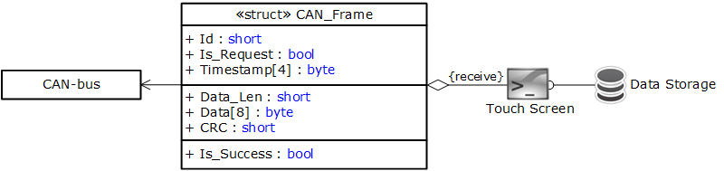
4. Diagram of data format for the CAN system message
Both the successful processing of the command and the occurrence of an error are assumed. Sending messages or frames occurs asynchronously, but it is possible to send messages periodically on a timer controlled by the main microcontroller unit of the CAN system.

External Internet Services and GPS
For getting more accurate analytical results, data from external Internet services is required. Obtaining such data is necessary to identify dependencies on factors occurring outside the electric vehicle.
Approximate list of some web services:
- Current indicators of weather conditions, as well as, predicting weather changes
in the near future (often 1-2 hours);
- Location of the electric vehicle, determination of the road profile and terrain
according to the route;
- Map of the location of the nearest charging stations.
It is worth noting that the location of the electric car and the intended route can be easily plotted using GPS, but there is a nuance: how to determine the terrain, steepness of descents and ascents. Isolines are needed. There are services that provide such information, for example openstreetmap.org.
Appendix #1 contains data structure fields or attributes that are essential for performing calculations only.

Discreteness of Data Requests
Data is requested with varying degrees of sampling over time, so, for example, there is no need to query the weather service more than once an hour.
Location, direction of travel and terrain are the most frequently requested data, but only in the case of electric vehicle movement.
The frequency of requesting data for the nearest charging stations is done only if the electric vehicle is moving and it is necessary to update the distance to the stations.
Also, the frequency of data updates for charging stations is correlated with changes in the charging level of the traction battery.

Electric Vehicle Charging Statistics
How often and the duration of charging can be found at charging stations for electric vehicles via the Internet or a Wi-Fi hotspot.
During charging, this information is available via a Bluetooth connection, but is not considered in the context of creating analytical data.
The details of the electric vehicle charging data structure are provided in the appendix #2.

Data Analysis
An example of the program architecture for data collection and its processing is given below:
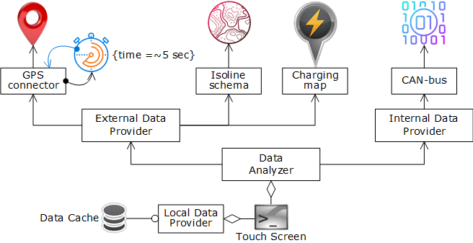
5. Block diagram of the data collection and analysis program
The architecture of the program consists of several modules according to the category of their functionality:
- Receiving data from the outside and from the internal control system;
- Placing data in the local quick access buffer;
- Data analysis in order to build possible warnings and recommendations.
Table #3 A brief description of the modules of the flowchart #5
Module | Description
Local Data Provider | The module for managing local data and the fast data access buffer (data cache). Appendix#4.
Internal Data Provider | The module for receiving and exchanging commands with the CAN system data bus. Appendix#5.
External Data Provider | Module for receiving external data from the Internet and web services, remote storage of non-normalized data (de-normalized data). Appendix#6.
Data Analizer | Data Analysis Module. Appendix#7.
Note: Block diagram No.5 can be considered as the basic one for building the architecture of the program for electric vehicles (with some simplifications).

Defining the Optimal Mode
Obtaining system data is required not only for determining the status of modules and devices of an electric vehicle at the current time, but, that is more importantly, for preventing potentially dangerous situations, for example:

Scenario #1
When descending, the speed of the electric car increases and it is necessary to lower the engine speed by reducing the degree of impact of the accelerator to a minimum, or even minor braking is necessary.
If this does not happen and there is a turn at the bottom of the descent, the system is obliged to signal the occurrence of a dangerous situation.

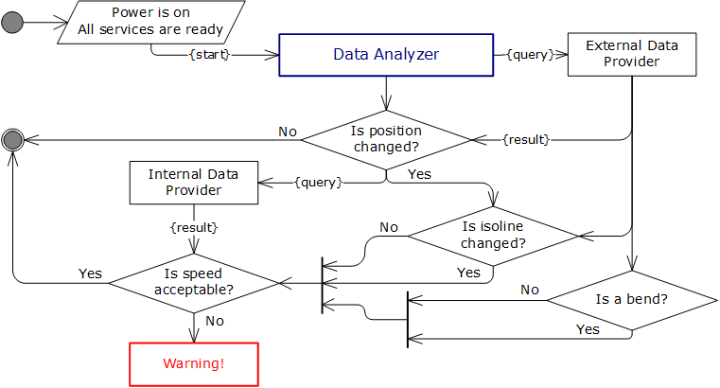

6. Flowchart for estimating the required speed of an electric vehicle (simplified version)

Scenario #2
When overcoming an ascent, if the engine speed is insufficient to ensure forward movement, the system signals that it is necessary to increase the impact of the accelerator on the engine operation mode.
If there is a turn at the point of completion of the ascent, the system is obliged to warn about a decrease in the impact on the engine by the accelerator.
The use of autopilot mode (auto-driving) is implemented in a Tesla electric car, but it is not covered in this document.

Appendix

#1 Web Services Data Specification
The header data structure is common to all web services and is shown below:
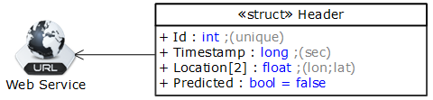
7. Web Services data header attributes' specification
Table #4 Data header attributes' description
Attribute | Description
Id | A unique identifier is assigned automatically when receiving data from a web service.
Timestamp | The timestamp of the data receipt.
Location | The location of the electric vehicle during the execution of the request.
Predicted | A flag for indicating calculated data (prediction) as opposed to real one.

Weather Data
Weather data is requested from the relevant sites, which determine the time intervals of expected or anticipated changes. The value of such an interval in most cases is 1 hour, therefore, it is not necessary to make weather requests more often than this interval, the exception may be a change in the current air temperature, which can change the value much more often.
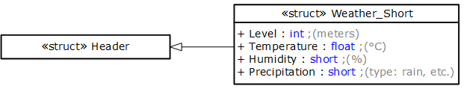
8. Weather data structure
Table #5 Weather data structure attributes’ description
Attribute | Description
Level | The values of the weather parameters depend on the altitude above sea level.
Temperature | The air temperature.
Humidity | The humidity of the air.
Precipitation | An indicator of precipitation, such as rain, snow or none.
Note: when making a request to the weather web service, the altitude above sea level is determined from the result of the last request along the route of the electric vehicle (the value of the contour line).

Route Data
Most of the data on the current location of the electric vehicle comes through the GPS service, but this does not allow determining the steepness of the possible ascents and descents that the electric vehicle will overcome.
For the above reason, it is impossible to correlate the increased or decreased power consumption of a traction battery to the terrain, that is, the ascents and descents on the highway. For solving this issue, a query is made for getting data of isolines in which the electric vehicle is moving at the current time.
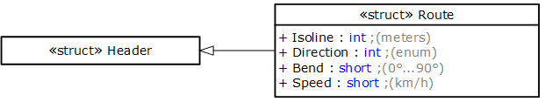
9. Route data structure schema
Table #6 Route data attributes’ description:
Attribute | Description
Isoline | The value of the altitude above sea level.
Direction | The direction of movement of the electric vehicle.  (straight | left | right | back)
Bend | The horizontal angle of rotation in degrees. A value less than 10° is not considered as a turn.
Speed | The speed of the electric vehicle.
Note: the direction of movement and turns are received from the GPS service, the value of the contour line is from a specialized web service, the speed is read from the CAN data bus.

Map of Charging Stations
The map of the nearest charging stations is updated automatically when the location of the electric vehicle changes by a certain distance: it makes no sense to make a repeat request based on the data of the charging stations when the location changes by 10 meters or less.
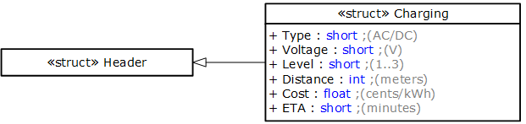
10. Data structure of the charging station attributes or properties
Table #7 Description of the attributes/properties of the charging station
Attribute/Property | Description
Type | Charging current type: alternating and/or direct current.
Voltage | The voltage of the charging current.
Level | Available charging speed: 1 – slow, 3 – fast.
Distance | The distance to the charging station from the current location of the electric vehicle.
Cost | The cost of one kilowatt per hour.
ETA | Estimation of the required charging time of the traction battery.
Note: The preliminary estimate of the battery charging time depends on the level of current battery charge: when the battery is severely discharged, the charging time increases. The available charging speed at the station is also taken into account.

#2 Electric Vehicle Charging Statistics
Statistical information of electric vehicle charging matches the set of attributes with the data structure of the search for the nearest charging stations by almost 90%. The difference is the rules for filling in some fields with data or assigning values to attributes:
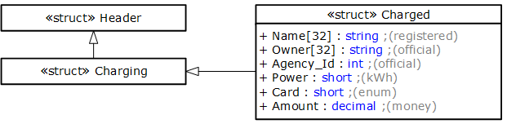
11. Charge station characteristic data structure diagram
Table #8 Charging station attributes/properties' diagram
Attribute/Property | Description
Header::Timestamp | The time when the battery starts charging.
Charging::Distance | The distance is 0 meters, since the electric car is at the station already.
Charging::ETA | The actual charging time in seconds (not predictable).
Name | The name of the charging station.
Owner | The company that owns the station.
Agency_Id | The agency's ID in the register of officially registered charging station networks.
Power | The number of kilowatts per hours for which the charge was made.
Card | The payment method.
Amount | Charging cost.
Note: information on the attributes or characteristics of charging stations is defined on the official website alt-fuel-stations.

#3 Program Initialization
Initialization of the program, or, to be more precise, data acquisition modules, is based on certain rules – sources with high priority are initialized first, then all others.
In the following block diagram of activities during the initialization process, the highest priority is to connect to the internal CAN data bus. Without connecting to this data source, the other sources are no longer important. Therefore, attempts to connect to the CAN-bus iteratively and synchronously occur several times (5 times in the diagram).
GPS and Internet connections can occur on a timer and do not affect the final process of program initialization. However, a message about the inability to connect to the service must be displayed on the computer monitor (or touch screen) in case of failure.
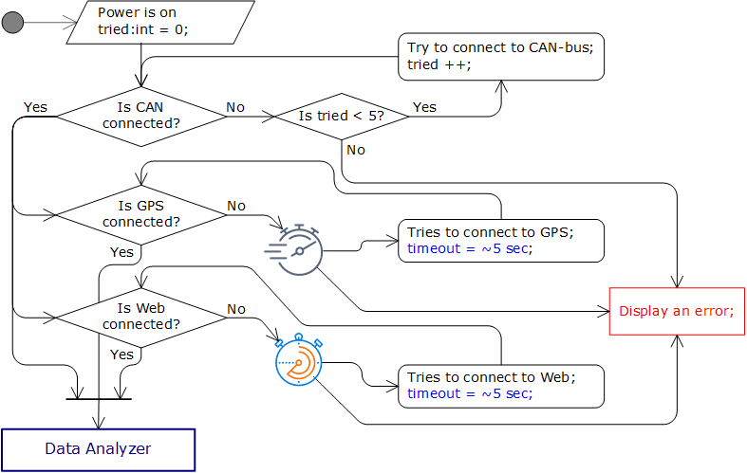
12. Diagram of the activity of the program initialization process
Note: timeout is the period of operation of the timer; the diagram shows an example of 1 time per 5 seconds.
Data Analyzer is a consumer module, in fact, the initialization result comes to two modules – Internal & External Data Providers.

#4 Local Data Provider
The local data provider is used for the following tasks:
- Receiving data from one or several Web services;
- Keeping dynamic data in a special fast access buffer (aka data cache);
- Temporary storage of data in a local relational database.
The scheme of the local data provider is shown below:
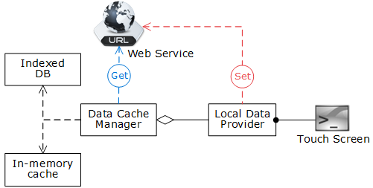
13. Block diagram of the local data provider module
Table #9 Description of the components of the block scheme #13
Component | Description
Local Data Provider | The local data provider supports the ability to receive and process data for building a model of the electric vehicle equipment state at the current time.
Data Cache Manager | The Data Quick Access Manager organizes the consolidation of an external service data with a local buffer and database.
Web Service | Internet service of a remote data server with a low level of normalization. The service is necessary for processing dynamically normalized data from the electric vehicle program.
In-memory cache | Data buffer in RAM for fast access to information (Redis).
Indexed DB | A database for temporary storage of operational information on disk. The SQLite database can be used.
Touch Screen | The operating system the program for monitoring the operation of electric vehicle devices is running under.
Note: Information about the local data provider is only informative and does not contain details of a possible implementation.

Data Quick Access Manager
Data has the following categories:
- Statistical or history data that is received or calculated by external web service in previous period of time;
- Dynamic data that is retrieved from internal CAN bus and from GPS service; this data is being gathered and processed in the current period of time;
When assessing the current situation or what is happening in real time, such data should be processed together, that is, be consolidated. For creating more accurate assessment, there are must be several data sources. Some of them are described below in this document.
The main task of the Data Quick Access Manager is to organize or coordinate the receiving data in accordance with the specifics and API of the sources.

Internet Service of Denormalized Data
The Internet service is used as a remote server for denormalized data, in other words, the data with normalization of very low level; usually it is the 2nd or event the 1st form of normalization.
The calculation and removal of data normalization, that is, the creation of redundancy of information, takes place on this service.
Redundancy of information is necessary to more accurately identify trends in data changes and predict events possible in the near future.

Special Data Buffer (In-memory Cache)
This buffer is necessary for quick access to operational information in order to process it and to build a behavior model of the electric vehicle systems at a given time.
This model serves as an informative source for offering optimal modes of using an electric vehicle, but also for creating warnings, if necessary, notifying the upcoming possible danger, and ensuring the safety of the driver and passengers.

Index Database
The computer of the electric car has available RAM from 8 (most often) to 16 gigabytes. Due to the limited amount of RAM, it is necessary to unload data from the quick access buffer into an indexed database.

#5 Internal System Data Provider
Obtaining system data is necessary for the following cases:
- Execution of requests or commands from one CAN system module to another;
- Collection of statistical data, for example, tracking battery charge level or engine speed;
- Accounting for the occurrence of command execution errors.
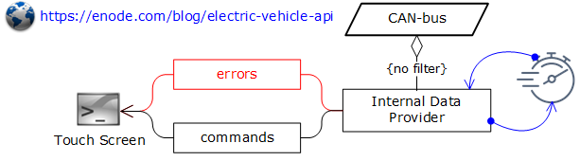
14. Block diagram of receiving data from the CAN bus
Note: The main controller of the CAN bus has its own timer for generating ping queries to the modules connected to the bus.
To receive alerts, the program or Internal Data Provider must be connected to the bus via its own module without a message filter, that is, accept all messages, but not identify them as executed.
In this context, Touch Screen designates Data Analyzer and Local Data Provider as the main consumers of data from the CAN bus.

#6 External Data Provider
Obtaining external data is necessary for the following cases:
- Identifying potentially dangerous situations;
- Monitoring the operation of electric vehicle systems to optimize their use.
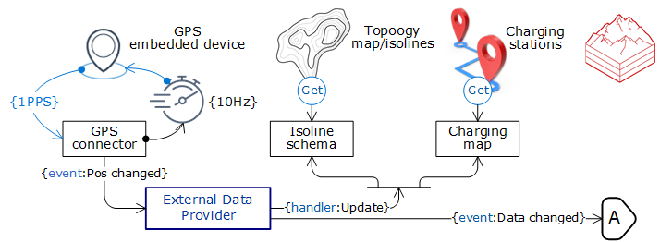
15. Block diagram of obtaining data from external data services
Table #10: Block-schema #15 components’ description
Component | Description
GPS embedded device | The device is for receiving signals from a GPS satellite.  Time synchronization occurs once per second.  (Pulse Per Second)
GPS connector | The software module for monitoring the operation of the GPS receiver. All data queries is sent asynchronously.
Topology map/isolines | A map of the topology of the area where the electric car is currently located.
Isoline schema | The module for receiving data from the terrain topology web service makes a repeated request when changing the data received from GPS.
Charging stations | A map of the nearest charging stations in the area of the current location of the electric vehicle.
Charging map | The module of receiving data from the cartographic web service makes a repeated request when changing the data received from GPS.
External Data Provider | Supports an event-dependent data model of external Internet sources.
Note: The sync pulse is necessary to monitor the time between the GPS satellite and the receiver. All asynchronous requests (10 Hz = 10 requests per second) may have minor inaccuracies in the received data, especially in cases where access to the satellite is not possible, GPS connector corrects this situation.
When changing data, the ‘External Data Provider’ module notifies the ‘Data Analyzer’ module about the need to recalculate the current state of the electric vehicle devices and modules, and movement parameters, for example, engine speed and rpm.

#7 Data Analysis
Block-schema of calculating the slope of the road is shown below.
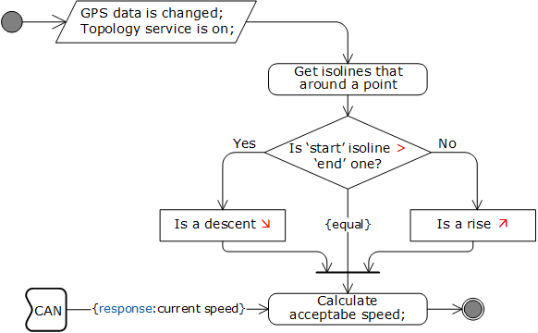
16. Calculating the estimated steepness of the descent or ascent of the road
Note: The data analyzer uses the height of the isolines surrounding the current location of the electric vehicle.

End of Story
You cannot rely on the automation and assembly quality of an electric vehicle made by the manufacturer, as this approach can often lead to problematic situations. The driver needs to make the decision himself only:

“If you want something done, do it yourself!” – The Fifth Element (1997).
This idea is very actually perfect and right, but it doesn't mean the end, the story is still going on.

Beyond the End
The sequel is complex and simple at the same time.
Main idea is to classify what things influence to a person, in this scenario: a person is just a driver of a vehicle.

Simple Reliable Way
Getting the information that may influence to the driver mood and his/her ability to classify a reason for performing a particular action that is based on physiological state. This is technical approach and can be followed by:
- Acquiring information of traffic jams or congestions;
- Taking into account holidays and weekends calendar;
- Applying the schedule of entertainment events;
- Using a historical data of recent routes;

Traffic Jams
In order to predict possible nervous excitement, it is necessary, at least, to analyze the current traffic situation on the road that a person follows in at a certain period of time.
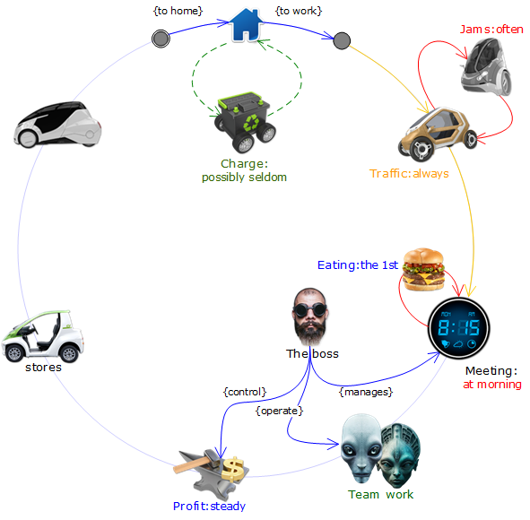

HVAC – heating ventilation and air conditioning.
The fact of using OS Linux Ubuntu by Tesla is taken into account.
The automatic driving mode may have such functionality, but it's just “maybe".
1:36:06 – The marker on the timeline of the scene in the film.

