File Guardian Project Suite Overview
(Draft Version)

Table of Content
Preface 3
Use Cases 3
Protecting Corporate Data 3
Monitoring an Access to Personal Information 3
Replacing Parental Control (must be reviewed) 3
Sharing Data 3
Accessing Data via Wi-Fi Hotspot 4
Sending Data to Web Service 4
Updating Data in a Database 5
Project Components 6
Versions 6
Basic Version 6
Full Version 6
File System Event Data Provider (core) 7
Architecture of Native Data Provider 7
File Guardian Kernel Mode Driver 7
Driver Adapter 8
OLE Data Provider 8
Connecting to Data Provider 8
FG Data Provider.NET Architecture 8
Licensing ( needs extending details) 9
TCP/IP Outgoing Connection Monitor ( needs extending details) 9
Multimedia Data Protection ( needs extending details) 9
MS Outlook Optimized Email View 9
Bitcoin Protected Data Provider ( requires reviewing and more details) 10
Appendices 11
Ground Zero (gz) 11
Appendix 1 Wi-Fi Hotspot Data Exchange Components 12
Appendix 2 Sending Data to Web Service 13
Appendix 3 Updating Data in a Database 13
Appendix 4 File Guardian Data Provider Interfaces 14
Appendix 5 File Guardian Data Provider.NET Interfaces 14
End of Story 15

Preface
Personal data protection is a very interesting topic these days: anyone, who wants to penetrate through a person’s life via electronic devices, which everyone so much loves to have. Violating an access to private data is also related to corporate business activities: a lot of software companies advertise their solution for getting all violations to be fixed.
But what is about of a simple approach?
File Guardian has such a one.
File Guardian (hereinafter, FG) project suite includes several data providers for handling an access to personal information, which is located on a user PC and/or other devices, such as multimedia ones, which can be connected to a computer for exchanging media data.
It is also possible to control incoming TCP/IP connections in order to block suspicious addresses.
A monitoring part of the data providers is not visible from a user mode and is automatically launched on operating system loading.

Use Cases
File Guardian can be used for protecting private information in different areas:
- protecting corporate information that is stored on servers;
- monitoring an access to private information on a user PC;
- using monitor capabilities instead of Microsoft Parental Control;

Protecting Corporate Data
This is the main use case, which FG is intended for. Deploying the FG package is simple enough though: a system administrator decides what computers must be monitored and what kind of information must be reported to a web or other target service.
The installation can be made via WMI service remote control. (must be reviewed)

Monitoring an Access to Personal Information
This use case is very helpful in cases when someone needs to know what happens with information located on a PC during a time when the PC stays alone without any control.

Replacing Parental Control (must be reviewed)
Microsoft parental control can be considered as a violation of personal rights that relate to accessing information that is interesting from a personal point of view.
People say “Forbidden fruit is the sweetest”.

Sharing Data
It is assumed that the monitoring system is installed by a system administrator or a user that has advanced permission rights. The system can be configured for accessing the data through devices that are accepted or specified during the installation process or by changing options later.
Moreover, for easy getting data of personal information being monitored, data providers are available for exchanging data via different ways: either locally or remotely.
The following information exchange channels are acceptable ( needs extending details):
- accessing data via Wi-Fi hotspot to mobile device such a smartphone, tablet computer;
- automatic sending data to web service;
- uploading data in a database via local network;

Accessing Data via Wi-Fi Hotspot
File Guardian monitor system can be configured to connect to Wi-Fi hotspot automatically and to share the information with mobile devices that pass authentication successfully.
A possible schema of a solution is displayed below:
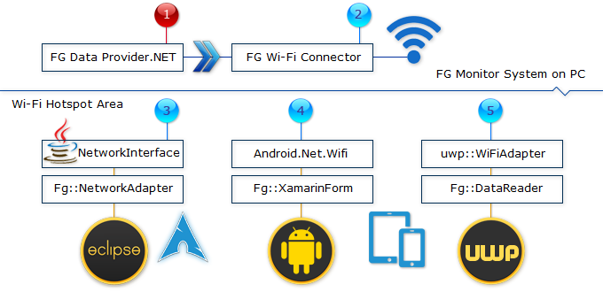
Picture #1 Wi-Fi Hotspot Access (Appendix #1)
A sharing data via Wi-Fi hotspot requires minimal sequence of installation steps:
- installing FG Data Provider unmanaged/.NET on target computer;
- configuring the provider for publishing data via Wi-Fi hotspot;
- installing required client software on devices such as Linux desktop PC, Android mobile, and Windows UWP mobile;
Using this solution allows gathering data easily via remote connection with the PC being monitored through the Wi-Fi hotspot area.

Sending Data to Web Service
File Guardian monitor software allows to send cached data that is stored in a local cache database to a web service specified. This use case includes the following steps:
- Formatting data in accordance with JSON rules; a number of events being sent can be configured for bulk upload of records to web service;
- Encryption data by key provided; an encryption can be made by MS Windows Cryptographic Provider; appropriate SDK is acceptable for downloading from official software vendor site.
- Sending encrypted data to RESTful service specified by using POST method; GET method is not applicable due to a possibly big size of the data block being sent;
- Receiving a response from the web service and logging an information in cases of failure; all errors can be viewed via operating system event journal viewer;
- Reporting failure events to one or more email addresses for interactive notification of administering and/or configuring required for fixing data upload errors.
Architecture of sending data to a web service that is compliant with RESTFul functional specification is shown below:
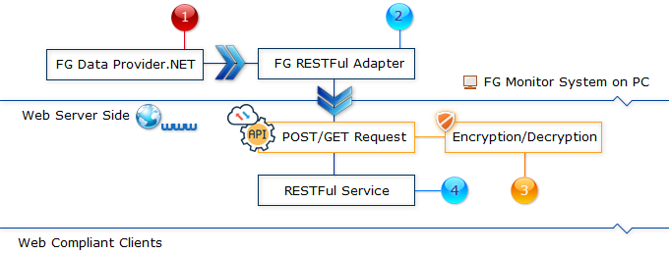
Picture #2 Sending Data of File System Events to Web Service (Appendix #2)

Updating Data in a Database
File Guardian data provider has a complete set of features that allow it to automatically send file system event data to local/remote relational databases. This can be easily achieved by using FG data cache manager functionality.
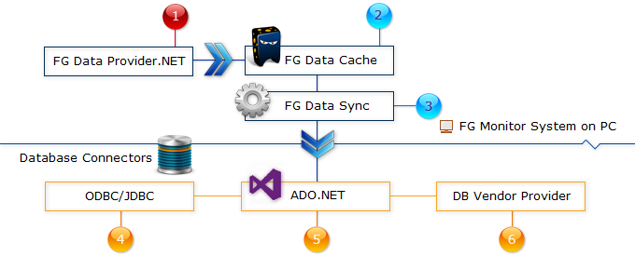
Picture #3 Updating Data of File System Events in a Database (Appendix #3)
The use case of the data synchronization is straightforward enough and can be implemented in the following steps:
- Installing FG Data Provider: it can be either native implementation or .NET compatible one;
- Configuring FG Data Cache to accept desirable volume of the data, which is being cached: all data that is exceeding the cache capacity is automatically discarded (i.e. the oldest one);
- Scheduling FG Data Sync Manager: a connection to external database can be established through standard interfaces such as ODBC and OLE DB; also the manager provides the easiest way of modifying data in a database by using standard SQL queries; .NET application can use a flexibility of Linq language extension;
- ODBC/JDBC – this is ODBC component of MS Windows operating system;
Java Database Connectivity (JDBC) is also supported by the FG Data Sync Manager module; It requires installing Java runtime on a target computer.
- ADO.NET is a set of interfaces for getting data access compatible with .NET applications;
- DB Vendor Provider is a specific data access that is provided by database vendor; in most cases, it is a standard OLE DB Provider that also can be compatible with .NET platform;
Sometimes, it is native interfaces that are acceptable from C/C++ unmanaged applications, for example, MySQL connector and OCI of Oracle Database access;
The synchronizing data of FG Data Cache with external database(s) is a powerful approach for gathering a statistic of how often and what kind of files have been accessed/changed the most time.

Project Components
Personal data protection can be divided to a set of major parts like these ones: (a) file system events; (b) network access; (c) multimedia access; (d) e-mail access optimized; (c) feeding trading data through protected channels. The following sections are a description of event data providers and components of monitoring system for aforementioned protection targets:
- Monitoring file system events;
- Monitoring outgoing TCP/IP connections;
- Providing protected access to multimedia devices;
- Adding email web view to MS Outlook;
- Bitcoin protected data provider;

Versions
There are two versions of FG Data Provider software: basic and full. The version control is required for managing license policy of the software vendor.

Basic Version
This is a version of the data provider for free use without any payment. The basic functionality allows complete monitor of file system events with applying some limits of configuration such as:
- Data cache has a limitation of specifying required data size and of locating data file;
- No automatic data synchronization module is provided, but subscribing to file system events is still acceptable;
- No task scheduler module is provided, but executing specific commands for managing FG driver state is still available;
- Sending data to a web service has limits for batch updating: it is necessary to make more queries to the service during a period of time.

Full Version
This version has all features of the software for corporate and personal use of FG Data Provider. In comparison with basic version this one has the following advanced features:
- FG Data Cache can be configured to store data block of required size in a data file located in preferable location;
Additional advanced feature is the placement of data files on local network resources and sharing the file between several instances of FG Data Provider, which are installed on separate corporate or home network computers.
- FG Task Scheduler is for automating data exchange between different targets such as uploading data to web service, updating external database and managing FG Data Cache, especially, cached data backup;
- Advanced feature of a monitoring system for handling data exchange through MS Windows clipboard is also available.

File System Event Data Provider (core)
This is a core of file system events’ monitor software. The purpose is to set up a kernel mode driver and to provide file system events’ notifications to a client software. Client software can be implemented in unmanaged C/C++ as well as in one of the managed languages and platforms such as: UWP, .NET Framework and Java.
The most important thing is that the FG driver is implemented in C language in accordance with MS Filter Manager interface specification. This requirement is mandatory due to legacy driver architecture support will be stopped soon as stated by MS Windows OS vendor.
FG native data provider package is a base for implementing .NET compatible data provider in order to make available connecting applications, which are built by one of the managed languages. Using FG Data Provider.NET makes it much easier to create a rich UI for managing file monitoring systems and a data representation for end-users.

Architecture of Native Data Provider
The data provider installation package consists of the following components:
- File Guardian kernel mode driver;
- User mode driver adapter;
- OLE Data provider module;
The brief description of aforementioned list items is below.
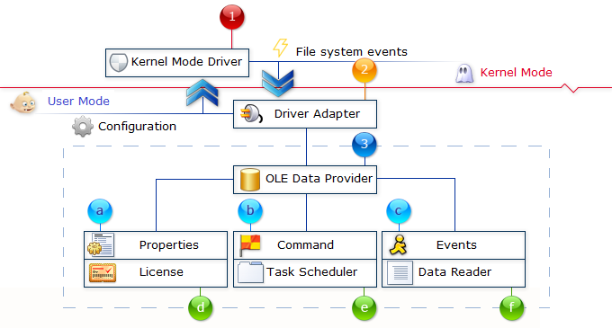
Picture #4 File Guardian Native OLE Data Provider Architecture (Appendix #4)

File Guardian Kernel Mode Driver
This is the main component of monitoring file system events in locations that can be specified. The driver provides an information of file system events in interactive mode like this:
- Creating new file;
- Changing a content of the existing one;
- Deleting the file (moving to trash bin is also monitored);
- Copying the file to different location;
- Renaming the file;
The driver does not require a specific installation process. It requires a review of license policy for allowing a trial period for using FG software without fee: connecting the driver to the licensing system via direct calling TCP/IP services in order to create HTTP(S) requests. At the same time, it is acceptable to make a driver with base functionality for use as a trial version.

Driver Adapter
This is the module for making a bridge between kernel mode and user mode spaces. It is not provided as a separate execution process, but as a part of the OLE data provider itself. The main functionality of this module is:
- Receiving events from kernel mode driver; events will be translated through special channel that allows to subscribe client modules to shared buffer between kernel and user modes;
- Sending requests to the driver for its configuring and state management; this can be made through the set of commands (customized by format) via API of kernel mode drivers’ manager;

OLE Data Provider
This module is the main component for providing services of monitoring file system events to custom software. The module is compliant to standard OLE DB Provider specification and exposes all required interfaces. Module functionality includes the following:
- Setting provider properties; the main idea of this feature is allowing to manage a set of folders and/or files that is necessary to monitor file system events that occurred over/on them;
- Executing commands; commands allow to manage a driver state, i.e. loading driver for monitoring, stopping file system monitor by unloading driver;
- Subscribing to file system event notification; file system events can be filtered by this feature and notifications will be occurred in accordance with the subscription;
- Managing license policy; license policy can be set to separate modes: (a) trial period of using data provider (default), (b) using complete set of driver features;
- Scheduling asynchronous tasks; asynchronous task(s) can be assigned for performance in accordance with time specified; a task can be, for example, a sending data to web service assigned, RESTFul service, especially;
- Converting data to appropriate format via Data Reader interface; all data, which is received from the driver, is already formatted to strings by default; but timestamps can be affected by patterns that are provided through this interface API;

Connecting to Data Provider
The installation package of File Guardian data provider contains samples of how to integrate the provider to an application that can be written in manage and manage languages such as: Visual Basic.NET, C#, Java, C++.NET, unmanaged C++.

FG Data Provider.NET Architecture
FG Data Provider.NET is a wrapper over native version of the product and is fully compatible with ADO.NET specification. FG implementation includes some extensions in modules provided such as:
- Fg::ILicense interface is for managing license information of the provider; basic version of the provider does not require a licensing;
- Fg::IScheduler interface is for automating data cache and data exchange with target services; basic version does not include this interface;
- Fg::INotification is for asynchronous notifications in cases when file system event occurs;
FG Data Provider.NET architecture is shown on the schema below:
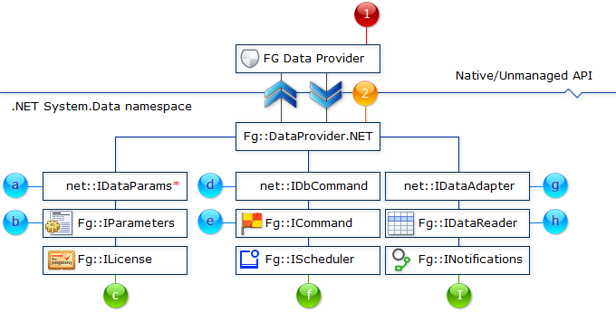
Picture #5 File Guardian .NET Data Provider Architecture
A detailed description of all components/modules of the data provider is available in Appendix #5.

Licensing ( needs extending details)
FG Data Provider requires a licensing for full version of the software only. A license can be obtained from the software vendor’s official site. The basic version does not require any licensing.

TCP/IP Outgoing Connection Monitor ( needs extending details)
This software provides a way of monitoring outgoing TCP/IP connections contrary black address lists. The lists can be updated automatically from public official sites.

Multimedia Data Protection ( needs extending details)
This is a part of data providers that allows a protected access to personal multimedia data. As a general case the following data access ways can be considered as required additional concerns for providing a protection: (a) iTunes software; (b) MS Outlook mail component;
MS Outlook Optimized Email View ( needs extending details)
Accessing web-based email services from MS Outlook are very often related to several steps of configuring an Outlook email account.
Moreover, email messages cannot be automatically assigned to a specific message folder and this makes a lot of work for the messages arrangement.
Also, such email service providers as Google require additional steps for managing security of subscribing MS Outlook as a receiver of email messages.

Bitcoin Protected Data Provider ( requires reviewing and more details)
This data provider uses OpenSSL HTTP connection to a data broker. In order to protect the data provider from an intentional substitution and/or changing its logic, the provider is digitally signed.
Also, the main feature of the provider is a restoring main operation module from encrypted resources and dynamically creating an in-process data receiver module in the memory without saving an executable on a hard drive.
Such a feature is often used by malware applications, but this can be used for data protection too.

Appendices
The appendices provide detailed technical information of software functionality implementation such as a description of interfaces.

Ground Zero (gz)
Table #0 A history of document development stages (Z-A sort order)
## | Date | Author | Change Description
 | 2019-08-31 | Tech_dog | Checking document content spelling; Fixing typos and incorrect/unclear context fragments/parts.
 | 2019-08-30 | Tech_dog | Document structure rearrangement and redesigning sections.
 | 2019-08-29 | Tech_dog | ***Do not remember***
 | 2019-08-28 | Tech_dog | Adding the following sections:  - Versions; this section is intended for describing what kind versions may be expected from software vendor;  - Licensing; FG Data Provider provides different types of licensing.
 | 2019-08-27 | Tech_dog | Adding a schema of automatic updating data in a local/remote relational database by synchronization with FG data cache.
 | 2019-08-25 | Tech_dog | Adding a schema of sharing file system event data between FG Data Provider and RESTFul web services.
 | 2019-08-22 | Tech_dog | Use cases review:  - adding personal PC data monitoring;  - taking into account MS Parental Control;
 | 2019-08-20 | Tech_dog | Creating Wi-Fi Hotspot schema is finished.
 | 2019-08-19 | Tech_dog | Reviewing an applicability of UWP C# and UWP C++ frameworks for getting FG clients on MS Windows platform completed.
 | 2019-08-18 | Tech_dog | Reviewing Xamarin framework for making a C# client for Android platform of mobile devices.
 | 2019-08-17 | Tech_dog | Reviewing Eclipse workbench for making it available as an environment for Java-based client development that is applicable for Linux operating systems.
 | 2019-07-23 | Tech_dog | The document is initially created:  - File Guardian data provider draft description;  - The provider architecture picture is added;

Appendix 1 Wi-Fi Hotspot Data Exchange Components
## | Component | Description | Required
 | FG Data Provider.NET | This is an installable component of File Guardian data provider for .NET platform. | yes
 | FG Wi-Fi Connector | The component of the data provider that allows it to connect to advertisement Wi-Fi access points for receiving configuration commands and/or transmitting data of files/folders being monitored. | yes
 | Java-based Client Device | This is a client software that is implemented by means of Java programming language. The component includes the following parts:  - javax.microedition.io.NetworkInterface – this is the base class for connecting to available Wi-Fi access points;  - Fg::NetworkAdapter – is File Guardian java package for decoding/encoding data or commands of monitoring;  - Eclipse IDE – is a development framework for rich UI application and plug-ins;  This is an interface for producing applications that run on Linux operating systems. | no
 | Android-base Client Software | This is a module for connecting to Wi-Fi hotspot(s) by means of mobile devices that support the Android operating system. This type of FG client includes the following sub-modules:  - Android.Net.Wifi – Xamarin package for getting connected to Wi-Fi hotspot;  - Fg::XamarinForm – File Guardian package for decoding/encoding monitoring file system event data; | no
 | UWP-based Client Software | This part of File Guardian client software is made for compatibility with devices that are supported by MS Windows 10 operating system. The software includes the following components/modules:  - WiFiAdapter – is a class of UWP framework package; it is required for connecting to and exchanging data with Wi-Fi network;  - Fg::DataReader – File Guardian module for retrieving data from a computer being monitored for personal data protection; | no

Appendix 2 Sending Data to Web Service
## | Component | Description | Required
 | FG Data Provider.NET | File Guardian Data provider is completely compliant with .NET specification of data provider interfaces required. | mandatory
 | FG RESTFul Adapter | FG adapter includes the following sub-modules:  - Converting data of file system events to JSON compatible format;  - Encrypting data by system service with key and algorithm specified;  - Composing HTTP POST request;  - Sending data to RESTFul service specified. | mandatory
 | Encryption/Decryption | This is a part of web service being a consumer of data provided. This component is implemented on the web service side in dependence of what kind of framework is used for service implementation. | mandatory
 | RESTFul Service | The standard web service compliant with RESTFul interface for data exchange. | mandatory

Appendix 3 Updating Data in a Database
## | Component | Description | Required
 | FG Data Provider.NET | File Guardian Data provider is completely compliant with .NET specification of data provider interfaces required. | mandatory
 | FG Data Cache | FG Data Cache consists of an integrated database SQLite and provides the following features:  - Handling data that is received from FG driver;  - Managing a data cache database file location;  - Configuring a desired volume of data being saved in the cache; | mandatory
 | FG Data Sync | This is a data synchronization manager module for exchanging data between FG Data Cache and external relational database(s).  A connection to a database is set through standard interfaces that are installed as a part of the operating system. | mandatory
 | ODBC/JDBC | This is a part of the operating system core. A connection to an external database can be established through the ODBC interface. The FG Data Sync module provides an interface for setting such a kind of connection.  JDBC drivers are also supported in cases where Java runtime is installed on a PC. | optional
 | ADO.NET | This is a part of .NET framework for accessing databases from applications being developed by means of managed languages. FG Data Sync is able to connect to managed code assembly if required. | optional
 | DB Vendor Provider | Some database vendors provide their own implementations of OLE DB providers for native and managed .NET applications. Such providers can be used as a standard OLE DB provider with special extensions for particular databases.  For example, MySQL vendors offer managed and unmanaged providers.  Such data providers must be installed on a user PC. | optional

Appendix 4 File Guardian Data Provider Interfaces
## | Interface  Name | Description | Required
 | IDBProperties | This interface is for data source objects; it is used to get/set standard properties of data provider; the interface implementation can be extended for using custom properties, such as management of folder list that is being monitored by the driver; | mandatory
 | ICommand | This interface is for synchronous command execution; it can be used as parameterized command for controlling File Guardian kernel driver work; | mandatory
 | IDBAsynchNotify | This interface is for getting notifications of changing data on kernel driver side; | mandatory
 | IDriverLicense | The interface is for supporting license policy of the data provider; | Available in full version only
 | ITaskScheduler | It is supported in the full version of the data provider, but not in the trial one. The interface supports asynchronous execution of tasks in accordance with a schedule provided. | Available in full version only
 | IDataReader | This interface is intended for getting event data in a format provided, especially, event timestamps and long paths of files being affected by file system events. | Available in full version only

Appendix 5 File Guardian Data Provider.NET Interfaces
## | Interface  Name | Description | Required
 | FG Data Provider | This is a part of data provider that is implemented in native code, especially, kernel mode driver and driver adapter. | mandatory
 | FG Data Provider.NET | This is a part of a data provider that is a wrapper of native driver for managed language in compliance with ADO.NET specification. | mandatory
 | net::IDataParams | This is the standard interface of ADO.NET for setting command arguments/parameters. The actual name is IDataParameterCollection and is changed for shorter one in this document. | mandatory
 | Fg::IParameters | This is an extension of ADO.NET IDataParameterCollection for introducing FG parameters of management/configuration commands. | mandatory
 | Fg::ILicense | FG data provider specific interface for a management of license. This interface is available in full version only. | Full version
 | net::IDbCommand | One of ADO.NET interfaces for accessing relational databases, i.e. executing standard SQL queries. | mandatory
 | Fg::ICommand | This is an extension of ADO.NET IDbCommand for introducing FG specific commands for managing:  - kernel driver state;  - data cache configuration;  - data synchronization; | mandatory
 | Fg::IScheduler | FG data provider scheduler of data exchange and management of monitoring. This module is available in full version only; | Full version
 | net::IDataAdapter | Standard interface of .NET Framework for populating dataset collection by querying relational databases. | mandatory
 | Fg::IDataReader | This is FG implementation of net::IDataAdapter for providing useful adoption of file system event data to tabular form. Also, data formatting is available. | mandatory
 | Fg::INotifications | FG interface for subscribing to asynchronous notifications of changing state of the monitor driver and/or receiving file system events. This interface is available only in the full version of the data provider. | Full version

End of Story
☺

Net prefix is virtual and is made in order to distinguish original .NET interfaces from Fg namespace.

