Functional Spec
This functional specification consists of two major categories of use cases of the ‘battery on wheels’ project:
- Collecting information about products for offering and selling to potential customers;
- Permanent storage of offers and orders at the database level;
- Evaluation of the market attractiveness and popularity of the products.
Detailed information about the categories is provided in the following sections.
Product Information
The product information contains a basic description of the product's characteristics and an idea of what it looks like.

Use Cases
Presenting information on the client side via web services must supports user’s preferencies and offers different themes, at least these ones: light and dark.
The main use cases:
- Presenting of products available for selling in table view;
- Showing product information details in dialog-based popup;
- Finding and displaying particular order details.

Product View
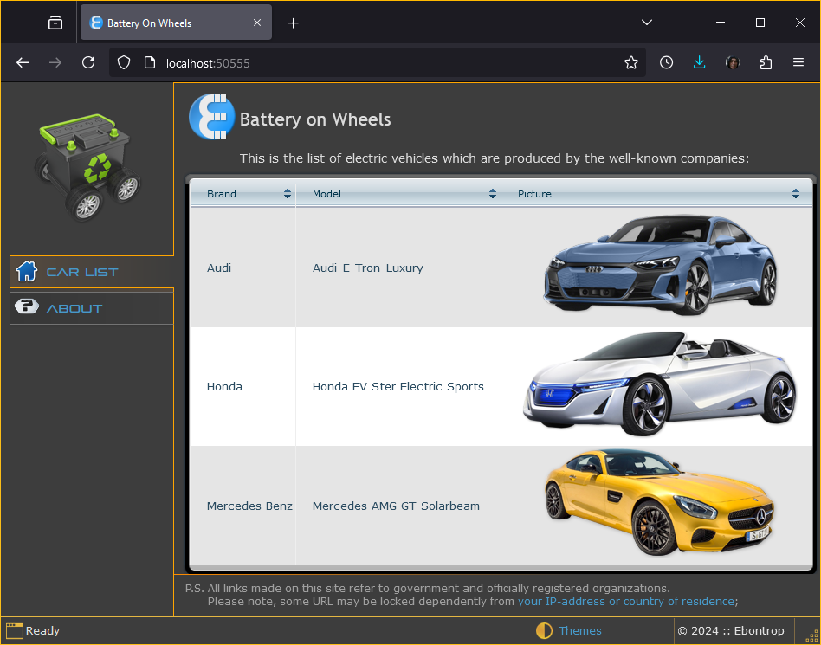
Additional Details
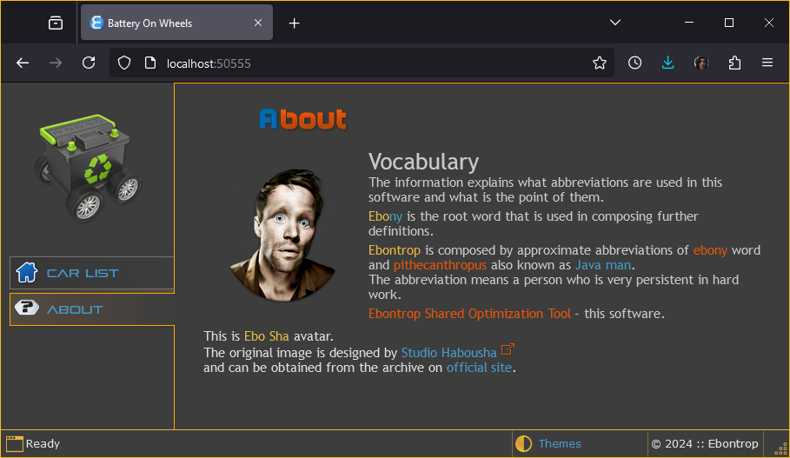
Permanent Storage
The data storage can vary by type dependently from project purposes. Also the format of data that is acceptable by storage may be different: XML, JSON, non-sql, or just RDBMS.

Data Provider
For this test project MS SQL server express is selected for easy development of the project and simpler debugging of the project features. This service is provided within VS setup package.

Data Modeling
This is the model of the database structure:
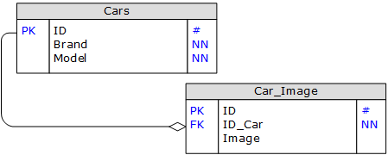
Pic.1 Database structure
Where,
# - auto identity of the key value;
NN – the field cannot have NULL value, that is the value must be set;

