
AMERICAN INTERNATIONAL UNIVERSITY–BANGLADESH (AIUB)
Dept. of Computer Science
Faculty of Science and Technology
CSC2210: OBJECT ORIENTED PROGRAMMING 2
Spring 2023-2024
Section: _______
Project Report On
Krishi Setu – Agricultural Market Management System.
Supervised By
[Dr. Md. Iftekharul Mobin]
Submitted By: Md. Abdur Rafi
Name | ID
1. Md. Abdur Rafi | 24-59241-3
2. Rounukul Islam Raihan | 24-59277-3
3. Md. Tanvir Khan | 24-59275-3
4. Marfin Sarowar Sowad | 24-59221-3
CO2: Display and verify the mean of a real-life Project using the concepts of C# Graphical User Interface based environment with database integration to depict a desktop-based application.
Assessment Criteria | Not Attended/ Incorrect (0) | Inadequate (1-2) | Average (3) | Good (4) | Excellent (5)
Evaluation Criteria | Evaluation Definition |  |  |  | Total =
Requirement fulfillment | Properly demonstrate a real-life scenario-based project with proper functional requirement identification for the Object-Oriented Programming project development activities.
Validation | Ensuring the ability of students' proper demonstration on validation forms in their system in terms of dealing with the data.
Verification | Identifying if the students can verify the system data along with proper functional requirements in terms of data flow.

Table of Contents
Topics | Page No.
1. Case Study | 3
2. Functional Part | 3
3. Normalization & Finalization | 4
4. Database Schema | 7
5. SQL Table Queries | 7
6. UI Navigation Diagram | 9

1. Case Study
In today's agricultural supply chain, connecting farmers directly with buyers while maintaining transparency and fair pricing remains a persistent challenge. Krishi Setu is an agricultural market management system designed to bridge this gap by allowing a Farmer, a Buyer, and a Super Admin to interact seamlessly on a single platform.
Rahim, a rice farmer, registers on Krishi Setu and lists his fresh produce, including quantity, price, and category, through his Farmer Dashboard. Once his account and product listing are approved by the Super Admin, the produce becomes visible in the marketplace.
Karim, a buyer, logs into the platform, browses the product catalog, and finds Rahim's rice at a fair price. He adds it to his cart, applies a promo code issued by the Super Admin for a seasonal discount, and completes the purchase. The transaction is recorded in the system, and Karim can track the status of his order.
Rahim receives a notification of the new order and prepares the produce for delivery. Upon successful completion of the transaction, the system automatically calculates the platform commission, configured by the Super Admin, and credits the remaining amount to Rahim.
Meanwhile, the Super Admin oversees the entire ecosystem — approving farmer and buyer accounts, monitoring product listings, configuring promo codes, and tracking commission revenue through system reports.
Through this coordinated interaction between the Farmer, the Buyer, and the Super Admin, Krishi Setu ensures a transparent, efficient, and fair agricultural marketplace that benefits all stakeholders involved.

2. Functional Part

a) Farmer
- Register and log in to the system
- Manage profile and bank account details
- Add a new product listing
- Edit or remove an existing product listing
- View incoming order requests
- Accept or reject buyer orders
- Track sales, payments, and earnings
- Track delivery / order status

b) Buyer
- Register and log in to the system
- Manage profile and delivery address
- Browse and search the product catalog
- View detailed product information
- Add products to cart
- Apply a promo code at checkout
- Place an order and make payment
- Track order and delivery status

c) Super Admin
- Log in to the admin panel
- Approve or suspend farmer accounts
- Approve or suspend buyer accounts
- Monitor and manage product listings
- Create, update, and deactivate promo codes
- Configure commission rate on transactions
- View commission and revenue reports
- View overall system dashboard and statistics

3. Normalization & Finalization

Creates: one to many relationship (Farmer creates Product).
UNF: farmer_id, farmer_name, farmer_phone, farmer_password, nid_no, district, area, street, bankName, branch_name, accNo, product_id, product_name, category, price, quantity, unit.
1NF: farmer_id, farmer_name, farmer_phone, farmer_password, nid_no, district, area, street, bankName, branch_name, accNo, product_id, product_name, category, price, quantity, unit.
2NF:
1. farmer_id, farmer_name, farmer_phone, farmer_password, nid_no, district, area, street, bankName, branch_name, accNo.
2. product_id, product_name, category, price, quantity, unit, farmer_id (FK).
3NF: Same as 2NF.

Collects: one to many relationship (Buyer purchases Product).
UNF: product_id, product_name, category, price, quantity, unit, buyer_id, buyer_name, buyer_phone, buyer_password, district, area, street.
1NF: product_id, product_name, category, price, quantity, unit, buyer_id, buyer_name, buyer_phone, buyer_password, district, area, street.
2NF:
1. product_id, product_name, category, price, quantity, unit, farmer_id (FK).
2. buyer_id, buyer_name, buyer_phone, buyer_password, district, area, street.
3NF: Same as 2NF.

Transacts: one to many relationship (Buyer places a Transaction on a Product).
UNF: transaction_id, status, quantity, total_amount, trans_date, product_id, buyer_id, promo_id.
1NF: transaction_id, status, quantity, total_amount, trans_date, product_id, buyer_id, promo_id.
2NF:
1. transaction_id, status, quantity, total_amount, trans_date, product_id (FK), buyer_id (FK), promo_id (FK).
2. product_id, product_name, category, price, quantity, unit, farmer_id (FK).
3NF: Same as 2NF.

Issues (Promo Code): one to many relationship (Admin issues Promo Code).
UNF: promo_id, promo_code, discount_percent, expiry_date, admin_id, admin_name, admin_email, admin_password.
1NF: promo_id, promo_code, discount_percent, expiry_date, admin_id, admin_name, admin_email, admin_password.
2NF:
1. promo_id, promo_code, discount_percent, expiry_date, admin_id (FK).
2. admin_id, admin_name, admin_email, admin_password.
3NF: Same as 2NF.

Generates (Commission): one to many relationship (Admin sets Commission on a Transaction).
UNF: commission_id, commission_amount, commission_rate, transaction_id, admin_id.
1NF: commission_id, commission_amount, commission_rate, transaction_id, admin_id.
2NF:
1. commission_id, commission_amount, commission_rate, transaction_id (FK), admin_id (FK).
2. transaction_id, status, quantity, total_amount, trans_date, product_id (FK), buyer_id (FK), promo_id (FK).
3NF: Same as 2NF.

Finalization
- Farmer: farmer_id, farmer_name, farmer_phone, farmer_password, nid_no, district, area, street, bankName, branch_name, accNo.
- Buyer: buyer_id, buyer_name, buyer_phone, buyer_password, district, area, street.
- Admin: admin_id, admin_name, admin_email, admin_password.
- Product: product_id, product_name, category, price, quantity, unit, farmer_id (FK).
- Promo_Code: promo_id, promo_code, discount_percent, expiry_date, admin_id (FK).
- Transaction: transaction_id, status, quantity, total_amount, trans_date, product_id (FK), buyer_id (FK), promo_id (FK).
- Commission: commission_id, commission_amount, commission_rate, transaction_id (FK), admin_id (FK).

4. Database Schema
The schema diagram below presents all tables of the Krishi Setu database, along with their fields, data types, primary keys (PK), and foreign key (FK) relationships, derived from the Farmer, Buyer, Admin, Product, Transaction, Promo Code, and Commission entities.
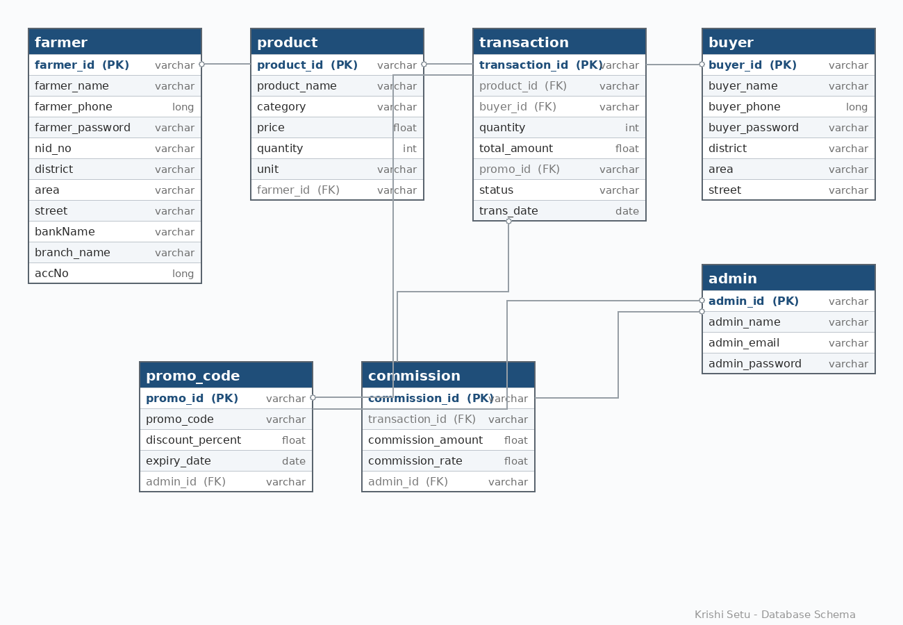
Fig 4.1: Krishi Setu Database Schema Diagram

5. SQL Table Queries

DATABASE
CREATE DATABASE KrishiSetu;
USE KrishiSetu;

Farmer Table
CREATE TABLE farmer (
farmer_id VARCHAR(20) PRIMARY KEY,
farmer_name VARCHAR(100),
farmer_phone BIGINT,
farmer_password VARCHAR(50),
nid_no VARCHAR(30),
district VARCHAR(100),
area VARCHAR(100),
street VARCHAR(100),
bankName VARCHAR(100),
branch_name VARCHAR(100),
accNo BIGINT);

EXEC sp_columns 'farmer'; //to see table structure.

Buyer Table
CREATE TABLE buyer (
buyer_id VARCHAR(20) PRIMARY KEY,
buyer_name VARCHAR(100),
buyer_phone BIGINT,
buyer_password VARCHAR(50),
district VARCHAR(100),
area VARCHAR(100),
street VARCHAR(100));

EXEC sp_columns 'buyer';

Admin Table
CREATE TABLE admin (
admin_id VARCHAR(20) PRIMARY KEY,
admin_name VARCHAR(100),
admin_email VARCHAR(100),
admin_password VARCHAR(50));

EXEC sp_columns 'admin';

Product Table
CREATE TABLE product (
product_id VARCHAR(20) PRIMARY KEY,
product_name VARCHAR(100),
category VARCHAR(100),
price FLOAT,
quantity INT,
unit VARCHAR(20),
farmer_id VARCHAR(20),
FOREIGN KEY (farmer_id) REFERENCES farmer(farmer_id));

EXEC sp_columns 'product';

Promo_Code Table
CREATE TABLE promo_code (
promo_id VARCHAR(20) PRIMARY KEY,
promo_code VARCHAR(30),
discount_percent FLOAT,
expiry_date DATE,
admin_id VARCHAR(20),
FOREIGN KEY (admin_id) REFERENCES admin(admin_id));

EXEC sp_columns 'promo_code';

Transaction Table
CREATE TABLE [transaction] (
transaction_id VARCHAR(20) PRIMARY KEY,
product_id VARCHAR(20),
buyer_id VARCHAR(20),
quantity INT,
total_amount FLOAT,
promo_id VARCHAR(20),
status VARCHAR(50),
trans_date DATE,
FOREIGN KEY (product_id) REFERENCES product(product_id),
FOREIGN KEY (buyer_id) REFERENCES buyer(buyer_id),
FOREIGN KEY (promo_id) REFERENCES promo_code(promo_id));

EXEC sp_columns 'transaction';

Commission Table
CREATE TABLE commission (
commission_id VARCHAR(20) PRIMARY KEY,
transaction_id VARCHAR(20),
commission_amount FLOAT,
commission_rate FLOAT,
admin_id VARCHAR(20),
FOREIGN KEY (transaction_id) REFERENCES [transaction](transaction_id),
FOREIGN KEY (admin_id) REFERENCES admin(admin_id));

EXEC sp_columns 'commission';

6. UI Navigation Diagram
The diagram below illustrates the unified navigation flow of the Krishi Setu system across all three actor interfaces — Farmer, Buyer, and Super Admin — starting from the common Homepage where each actor logs in or creates an account.
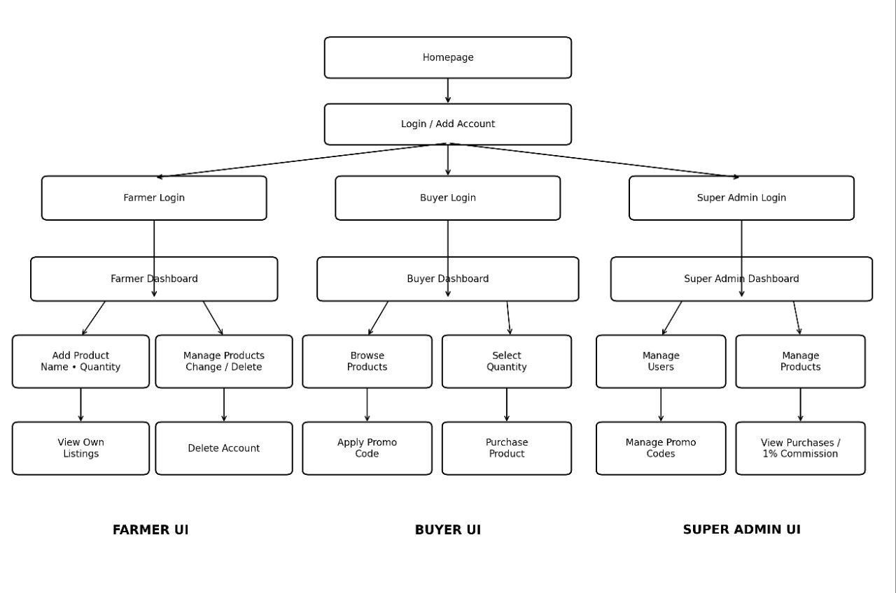
Fig 6.1: Krishi Setu Unified UI Navigation Diagram

Application Screens
The screenshots below show the actual Krishi Setu interface for each actor.
a) Login / Sign In
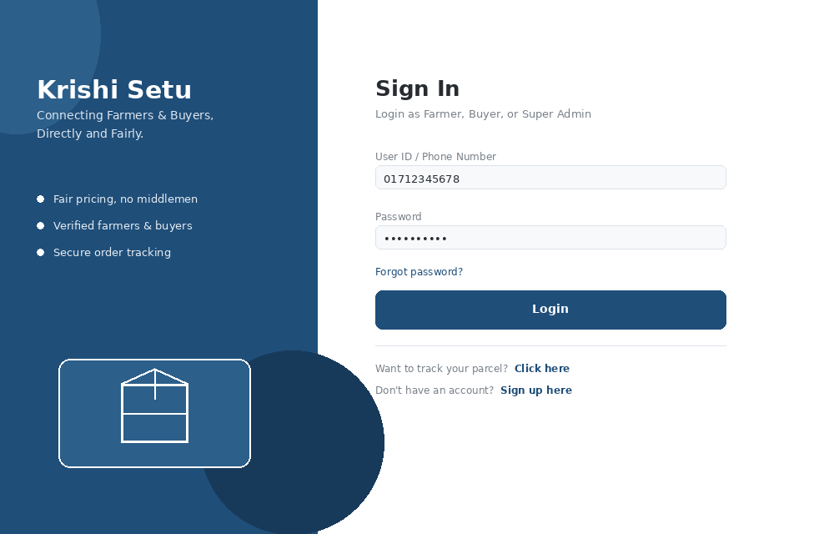
Fig 6.2: Shared Login Screen
b) Farmer Dashboard
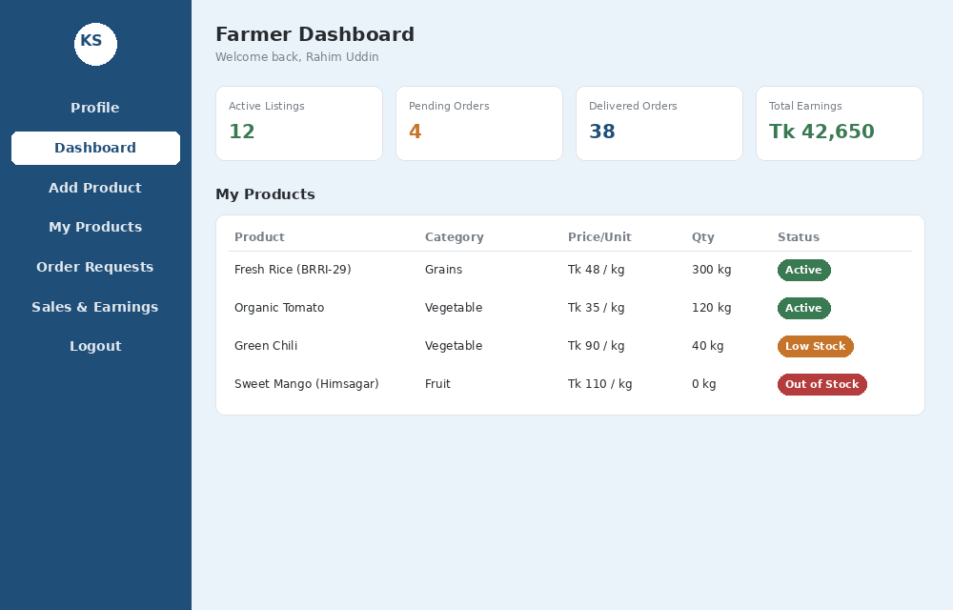
Fig 6.3: Farmer Dashboard
c) Buyer Product Catalog
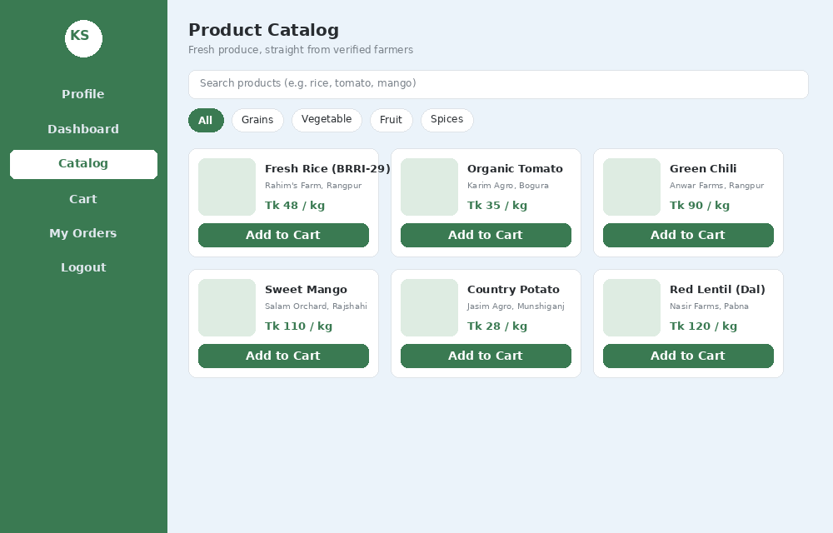
Fig 6.4: Buyer Product Catalog

