****USSD(*117#) Program****

**Program:** Zamtel menu

**Purpose:** To allow the user to select from a variety of Zamtel products and services.

* The **#include <string.h>** statement includes the **string.h** header file, which contains the definition of the **strcmp()** function.
* The program uses the **scanf()** function to read the user input code.
* The program uses the s**trcmp()** function to compare the user input code to the code **\*117#.**
* The **char userCode[5]** declaration creates an array of characters of size **5**. This is enough space for the code **\*117#** and the null terminator **(\0)**.
* The **printf("Enter a code: ")**; statement prints the message "**Enter a code:** " to the console.
* The **scanf("%s", userCode);**statement reads a string from the console and stores it in the userCode array.
* The **if (strcmp(userCode, "*117#") == 0) {**statement compares the **userCode** string to the code \***117#**. If the two codes match, the code block inside the **if** statement is executed.
* The **printf("Code matched!\n")**; statement prints the message "Code matched!" to the console.
* The **else** {statement is executed if the **if** statement is not executed. This means that the userCode string does not match the code **\*117#**.
* The **printf("Code did not match.\n")**;statement prints the message "**Code did not match.**" to the console.

**Input:** The user selects a number from the menu.

**Output:** The program displays information about the selected product or service.

**Example usage:**

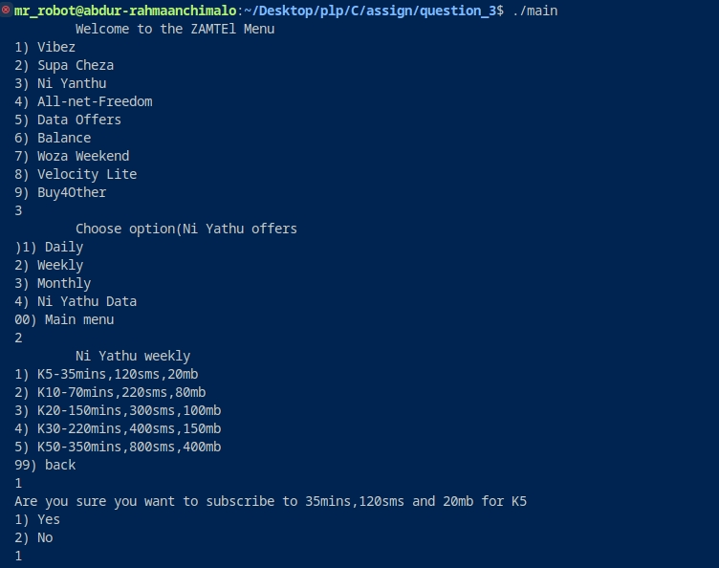

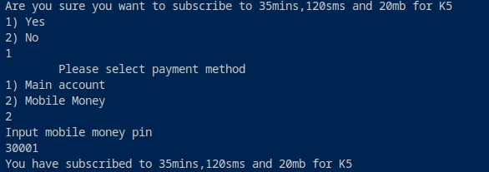

**Notes:**

* The user can press **00** at any time to return to the main menu.
* If the user selects an invalid option, the program will display an error message.
* The program does not currently support all of the Zamtel products and services.

**Additional documentation:**

The following documentation provides additional information about the different options in the Zamtel menu:

**Vibez:**

* Vibez is a prepaid bundle that offers a variety of data, voice, and SMS services.
* Vibez bundles are available in a variety of price points, starting at K5.

**Supa Cheza:**

* Supa Cheza is a postpaid plan that offers unlimited data, voice, and SMS services.
* Supa Cheza plans are available in a variety of price points, starting at K100.

**Ni Yanthu:**

* Ni Yanthu is a prepaid bundle that offers a variety of data, voice, and SMS services, as well as access to Zamtel's social media platforms.
* Ni Yanthu bundles are available in a variety of price points, starting at K10.

**All-net-Freedom:**

* All-net-Freedom is a postpaid plan that offers unlimited data, voice, and SMS services to all Zambian networks.
* All-net-Freedom plans are available in a variety of price points, starting at K200.

**Data Offers:**

* Data Offers is a section of the Zamtel menu that offers a variety of data bundles, starting at K1.

**Balance:**

* The Balance section of the Zamtel menu allows the user to check their account balance.

**Woza Weekend:**

* Woza Weekend is a prepaid bundle that offers a variety of data, voice, and SMS services, as well as access to Zamtel's social media platforms.
* Woza Weekend bundles are only available on weekends and are valid for 24 hours.

**Velocity Lite:**

* Velocity Lite is a postpaid plan that offers a variety of data, voice, and SMS services.
* Velocity Lite plans are available in a variety of price points, starting at K50.

**Buy4Other:**

* Buy4Other allows the user to purchase Zamtel products and services for other people.