بسم ﷲ الرحمان الرحيم
IN THE NAME OF ALLAH, MOST GRACIOUS, EVER MERCIFUL
Mahmud Ahmadiyya College
ABULE-EKO, IJEDE, IKORODU, LAGOS STATE

Website: mahmudcollegeijede.sch.ng

11th April, 2021
NEWS LETTER

Assalamu ‘Alaykum wa Rahmatullah wa Barakatuh.

All praise and adoration belongs to Allah^{(SWT)} Who has been with us since the beginning of the term. We really appreciate His mercies, protection and provisions on each and every one of us. We seek Allah’s continuous blessings on the most perfect of all creation, Hazrat Muhammad Mustapha^{(SWA)}, his family, companions and well wishers from now till the day of resurrection (Amin).

SCHOOL FEES
To those that pay our bill promptly, May Allah always replenish your pockets. And to those that struggle to pay, may Almighty Allah make all your tasks easy. We
appreciate our parents for their love and interest in the college and the sacrifice for the future of their wards. May Allah^{(SWT)} bless all and provide for all your needs.

WASSCE AND NECO
The information getting to us is that NECO is likely to come up earlier than WASSCE. Due to the effect of the COVID – 19 pandemic the Examination bodies of WASSCE have shifted the date to allow other West African Countries catch up.
Parents of our SSS 3 students shall be contacted as situation unfolds.

BECE
The date for the State Terminal Examination for JSS III students has not been determined by the Government.

SECOND TERM HOLIDAY
The second term examination scripts and the school bill for next term are included in the package, while the result shall be sent to the school website (mahmudcollegeijede.sch.ng). Kindly settle the bill during the holiday before resumption. No child will be allowed to stay in the school without paying at least 70% of the bill for the term. Parents that have arrears should endeavour to settle the arrears and pay the new bill. May Allah bless your efforts on the children and increase your sustenance.

Finally, as Ramadan draws near, we wish you all Ramadan Mubarak. May we witness many more on earth. We also implore you to monitor the children at home. They should not be exposed to danger. Remind them of their regular salat and recitation of Qur’an, may Allah protect them for us.

SCHOOL CALENDAR FOR 3RD TERM
1. Closing - Sunday April 11th – Monday 3rd May, 2021
2. Resumption - Tuesday 4th May, 2021 (Boarders 3rd, May)
3. PTA - Saturday 3rd July, 2021
4. Mid – Term Break - 11th and 14th June, 2019
5. Entrance Examination - First – Saturday 29th May, 2021
- Second – Saturday 26th June, 2021
- Third – Saturday 24th July, 2021
6. Price giving Day - Thursday 5th August, 2021
7. Closing - Friday 6th August, 2021
8. Resumption - Monday 20th September, 2021

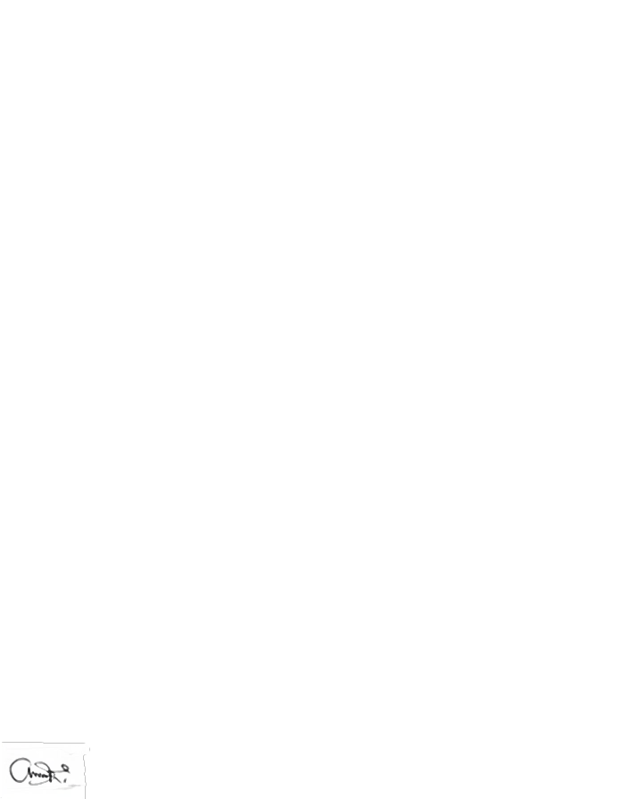
FAGBOLADE T. A. (MRS)
PRINCIPAL

