DBMS Laboratory · Mini project
Reimbursement Management System
Project report: problem, requirements, ER design, relational schema, functional dependencies and normalization
MIS number | Name
612415001 | Abdurrahman Shaikh
612415057 | Dhruv Agarwal
612415044 | Mrudula Dagale
612415093 | Makarand S Kulkarni

October 2026

Contents
1. Problem statement 3
2. Objectives 3
3. Functional requirements 3
3.1 Users and roles 3
3.2 Requirements by role 4
3.3 Data rules the database must enforce 4
3.4 Non-functional requirements 5
4. ER diagram 6
4.1 Notation used 8
4.2 Entity sets 8
4.3 Relationship sets 9
4.4 Specializations and aggregation 10
4.5 Changes from our ER diagram assignment 11
5. Relational schemas 12
5.1 Reduction rules applied 12
5.2 Resulting relation schemas 12
6. Functional dependencies 15
7. Normalization up to 3NF 16
7.1 Definitions 16
7.2 Every relation of the final schema 16
7.3 Walkthrough from an unnormalized claim form 16
8. Implementation 18
8.1 Architecture 18
8.2 Where each rule is enforced 18
8.3 Screens 19
8.4 Running the project 21
9. Conclusion 22

1. Problem statement
Organisations repay employees for money they spend on the organisation's behalf: travel to clients, medical treatment covered by policy, and business expenses such as client meetings. In many offices this still runs on paper forms, e-mailed spreadsheets and bills stapled together. That process has well-known failures:
- Receipts and forms get lost, and nobody can say where a claim is stuck.
- Approval authority is informal: a junior manager can approve a large claim, or a manager can approve their own.
- The same claim can be paid twice, and payments cannot be traced to a bank transfer.
- Totals are retyped by hand, so the approved amount and the paid amount can disagree with the bills.
- Finance cannot answer simple questions (spend by department, by month, by expense type) without re-entering data.

The problem is to design and implement a database application in which employees submit claims made of itemised expenses, managers approve or reject them within their authority, and the finance team pays approved claims to the employee's bank account. The database must be the single source of truth and must itself refuse data that breaks the organisation's rules, whichever program writes to it.

2. Objectives
- Model the reimbursement process with an E-R diagram using the notation of the course textbook (Silberschatz, Korth & Sudarshan, 7th ed.).
- Reduce the E-R diagram to relation schemas with the textbook's rules, identify every functional dependency, and normalize every relation to at least 3NF (all relations reach BCNF).
- Enforce the business rules inside MySQL with keys, foreign keys, CHECK constraints and triggers, so that no client can bypass them.
- Build a role-based web application (React front end, Node.js back end) for applicants, managers and admins.
- Keep a complete trail of who submitted, reviewed and paid each claim, and when.
- Provide reports on spending by department, claim type, expense category and month.

3. Functional requirements

3.1 Users and roles
Every user is an employee. An employee can hold any combination of three roles, which matches the overlapping specialization in the ER diagram:
Role | Who | What they do
Applicant | Employees with a registered payout bank account | File claims and track them
Manager | Employees with an approval limit | Approve or reject other employees' claims up to their limit
Admin | Finance / administration staff | Pay approved claims; maintain employees, roles and departments

3.2 Requirements by role
ID | Requirement
FR1 | All users sign in with their e-mail address and password; the menu shows only the functions of their roles.
FR2 | An applicant submits a claim of exactly one type (travel, medical or business) with the details of that type and one or more expense items (category, description, date, amount, optional receipt file).
FR3 | An applicant sees all their claims with type, date, number of items, total, status and progress (submitted, reviewed by whom and when, paid when and with which bank reference).
FR4 | An applicant can withdraw a claim until a manager has reviewed it.
FR5 | A manager sees a queue of submitted claims that they are allowed to decide: not their own, and with a total within their approval limit. Claims from their direct reports are listed first.
FR6 | A manager approves or rejects a claim; a rejection must state the reason. Each claim is decided once.
FR7 | A manager sees the claims they have reviewed.
FR8 | An admin sees approved claims waiting for payment, with the payee's bank account and IFSC code, and records each payment with its bank transfer reference (UTR).
FR9 | An admin adds and edits employees: personal details, department, supervisor, any number of phone numbers, and roles (applicant with bank details, manager with approval limit, admin).
FR10 | An admin adds, renames and deletes departments.
FR11 | Managers and admins see reports: claims by status, approved spend by department, claim type, expense category and month, the top claimants, and the reporting hierarchy.

3.3 Data rules the database must enforce
ID | Rule
DR1 | Only applicants can file claims, only managers can review them, and only admins can pay them.
DR2 | Nobody reviews or pays their own claim, and the person who approved a claim cannot also pay it.
DR3 | A manager may only decide claims whose total is within their approval limit.
DR4 | A claim moves only SUBMITTED → APPROVED or REJECTED, then APPROVED → PAID. Rejected and paid claims are closed.
DR5 | A rejection carries remarks; an approval or rejection carries the reviewer and date; a payment carries the admin, date and a unique bank reference.
DR6 | A claim has exactly one type, the details of that type only, and at least one expense item. Amounts are positive.
DR7 | Once reviewed, a claim's items and details cannot change, so the approved total is the paid total.
DR8 | Dates are in order (expense ≤ claim ≤ review ≤ payment) and never in the future.
DR9 | E-mail addresses, bank accounts (IFSC + account number) and payment references are unique.
DR10 | The reporting hierarchy has no cycles; an employee cannot supervise themselves.
DR11 | Departments with employees, and employees with claim history, cannot be deleted.

3.4 Non-functional requirements
- Integrity: every rule above is enforced by the database, not only by the user interface.
- Atomicity: a claim, its details and its items are saved together or not at all.
- Security: passwords stored only as bcrypt hashes; parameterised SQL; the application connects with a database account that cannot change the schema.
- Portability: standard SQL (CHECK constraints rather than MySQL ENUMs) wherever MySQL allows it.

4. ER diagram
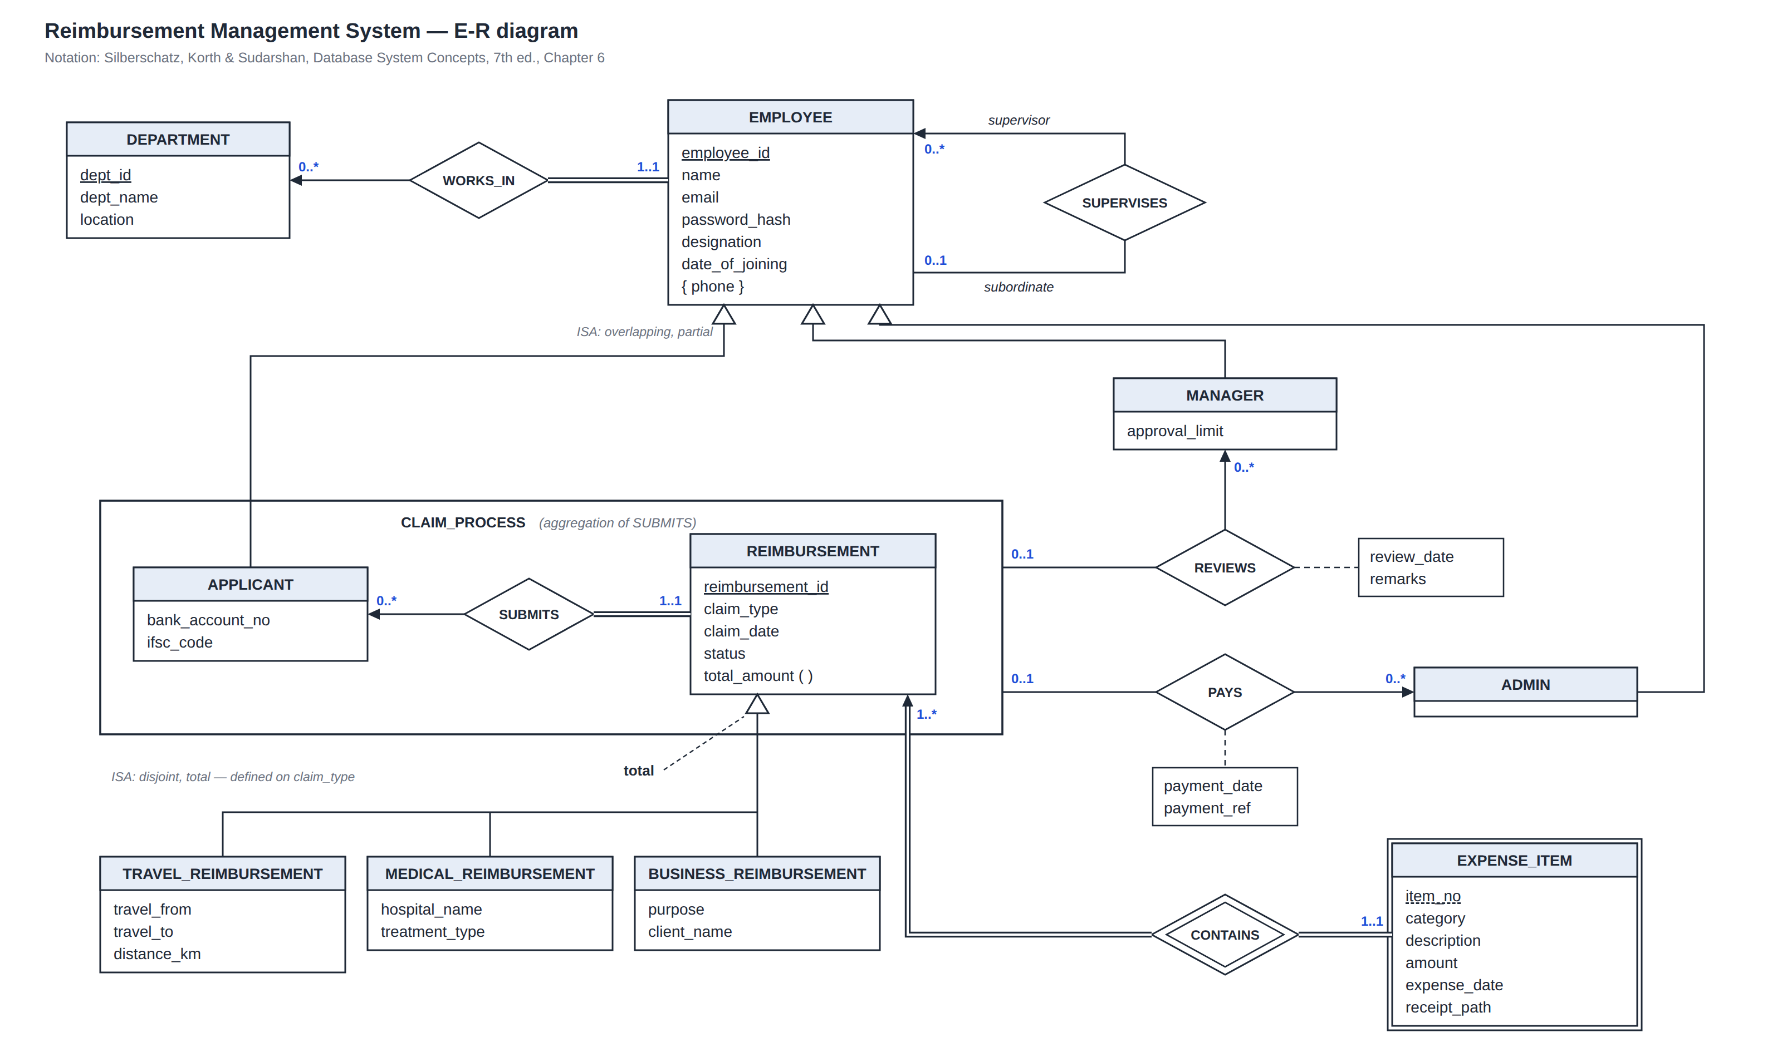
Figure 1. E-R diagram of the Reimbursement Management System (textbook notation; the symbol key is in Section 4.1). A full-resolution copy with the key drawn in is report/er/er_diagram.png.

4.1 Notation used
The diagram uses the notation of the course textbook (Chapter 6), so every symbol has the meaning given there:
Symbol in the diagram | Meaning (Silberschatz Chapter 6)
Rectangle with a shaded header | Entity set; attributes listed below the name; primary key underlined (§6.2)
Double rectangle | Weak entity set; its discriminator has a dashed underline (§6.5.3)
Diamond / double diamond | Relationship set / identifying relationship of a weak entity set
Arrow on a line (→) | The "one" side: each entity at the other end relates to at most one entity here (§6.4)
Plain line | The "many" side
Double line | Total participation: every entity of that set takes part in the relationship
l..h on a line | Minimum and maximum number of relationships each entity of that set takes part in (e.g. 1..1, 0..*)
Role label on a line (supervisor, subordinate) | Role indicator, needed when an entity set relates to itself
Rectangle linked by a dashed line to a diamond | Descriptive attributes of the relationship
{ phone } | Multivalued attribute
total_​amount ( ) | Derived attribute
Hollow arrowhead | Specialization (ISA), pointing to the superclass. Separate arrows = overlapping; one shared arrow = disjoint; the keyword "total" (dashed line to the arrowhead) = total specialization (§6.8)
Box around a relationship and its entity sets | Aggregation: the relationship treated as an entity set (§6.8.5)

4.2 Entity sets
Entity set | Kind | Attributes (key underlined) | Notes
DEPARTMENT | Strong | dept_​id, dept_​name, location | dept_​name is also unique (candidate key).
EMPLOYEE | Strong; superclass | employee_​id, name, email, password_​hash, designation, date_​of_​joining, { phone } | Phone is multivalued. email is a candidate key and the login name.
APPLICANT | Subclass of EMPLOYEE | bank_​account_​no, ifsc_​code (inherits employee_​id) | An employee who may file claims; needs a payout account.
MANAGER | Subclass of EMPLOYEE | approval_​limit (inherits employee_​id) | May review claims up to approval_​limit.
ADMIN | Subclass of EMPLOYEE | none of its own (inherits employee_​id) | Exists because only admins take part in PAYS.
REIMBURSEMENT | Strong; superclass | reimbursement_​id, claim_​type, claim_​date, status, total_​amount ( ) | total_​amount is derived from the items. claim_​type defines the subclass.
TRAVEL_​REIMBURSEMENT | Subclass of REIMBURSEMENT | travel_​from, travel_​to, distance_​km | Details of a travel claim.
MEDICAL_​REIMBURSEMENT | Subclass of REIMBURSEMENT | hospital_​name, treatment_​type | Details of a medical claim.
BUSINESS_​REIMBURSEMENT | Subclass of REIMBURSEMENT | purpose, client_​name | client_​name is optional (internal business).
EXPENSE_​ITEM | Weak (owner: REIMBURSEMENT) | item_​no (discriminator), category, description, amount, expense_​date, receipt_​path | Identified by its claim plus item_​no: "item 2 of claim 17".
CLAIM_​PROCESS | Aggregation | APPLICANT – SUBMITS – REIMBURSEMENT treated as one unit | REVIEWS and PAYS relate to it.

4.3 Relationship sets
Each relationship is described by its mapping cardinality, the participation of each side, and how the diagram shows both. A label l..h sits on the line next to the entity set it describes: on SUBMITS, 1..1 next to REIMBURSEMENT means every claim is submitted by exactly one applicant, and 0..* next to APPLICANT means an applicant submits any number of claims.
Relationship | Connects | Mapping cardinality | Participation | How it is drawn | Becomes in the schema
WORKS_​IN | EMPLOYEE – DEPARTMENT | Many-to-one | EMPLOYEE total; DEPARTMENT partial | Arrow to DEPARTMENT; double line from EMPLOYEE; 1..1 on EMPLOYEE, 0..* on DEPARTMENT | employee.dept_​id NOT NULL, FK → department
SUPERVISES | EMPLOYEE (supervisor) – EMPLOYEE (subordinate) | One-to-many | Both partial | Arrow on the supervisor line; role labels; 0..* (supervisor), 0..1 (subordinate) | employee.supervisor_​id NULL, FK → employee
SUBMITS | APPLICANT – REIMBURSEMENT | One-to-many | REIMBURSEMENT total; APPLICANT partial | Arrow to APPLICANT; double line from REIMBURSEMENT; 0..* on APPLICANT, 1..1 on REIMBURSEMENT | reimbursement.applicant_​id NOT NULL, FK → applicant
REVIEWS | MANAGER – CLAIM_​PROCESS (aggregation) | One-to-many (one decision per claim) | Both partial | Arrow to MANAGER; plain line from the aggregation; 0..* on MANAGER, 0..1 on CLAIM_​PROCESS; descriptive attributes review_​date, remarks | reimbursement.reviewed_​by, review_​date, remarks (NULL until reviewed); reviewed_​by FK → manager
PAYS | ADMIN – CLAIM_​PROCESS (aggregation) | One-to-many (one payment per claim) | Both partial | Arrow to ADMIN; plain line from the aggregation; 0..* on ADMIN, 0..1 on CLAIM_​PROCESS; descriptive attributes payment_​date, payment_​ref | reimbursement.paid_​by, payment_​date, payment_​ref (NULL until paid); paid_​by FK → admin
CONTAINS (identifying) | REIMBURSEMENT – EXPENSE_​ITEM (weak) | One-to-many | Both total | Double diamond; arrow and double line to REIMBURSEMENT; double line to EXPENSE_​ITEM; 1..* on REIMBURSEMENT, 1..1 on EXPENSE_​ITEM | No relation of its own; expense_​item has PK (reimbursement_​id, item_​no) and FK → reimbursement ON DELETE CASCADE

4.4 Specializations and aggregation
Specialization | Subclasses | Constraints | How it is drawn | Becomes in the schema
ISA on EMPLOYEE | APPLICANT, MANAGER, ADMIN | Overlapping, partial | Three separate hollow arrows; no "total" keyword | Tables applicant, manager, admin; each PK is also an FK → employee
ISA on REIMBURSEMENT | TRAVEL_​, MEDICAL_​, BUSINESS_​REIMBURSEMENT | Disjoint, total; attribute-defined on claim_​type | One shared hollow arrow; "total" keyword joined by a dashed line | Tables travel_​/medical_​/business_​reimbursement; each PK is also an FK → reimbursement

Aggregation. CLAIM_PROCESS treats the relationship "applicant submits reimbursement" as one unit. A manager reviews, and an admin pays, a submission: who claimed what. Modelling REVIEWS and PAYS against the aggregation (rather than as ternary relationships with APPLICANT and REIMBURSEMENT) avoids recording the applicant a second time and allowing a review whose applicant differs from the person who submitted the claim (textbook §6.8.5).

4.5 Changes from our ER diagram assignment
The diagram above refines the one submitted for the ER assignment. Every change is justified in the separate Design Decisions document (decision numbers in brackets).
Earlier diagram | Final diagram | Reason
Department was an attribute of EMPLOYEE | DEPARTMENT entity set and WORKS_​IN [E1] | A department has its own attribute (location) and is shared; as an attribute it would cause a transitive dependency.
APPROVES, no attributes | REVIEWS with review_​date, remarks [E8] | A manager may also reject; decisions need a date and a reason.
No way to record payment | ADMIN subclass and PAYS with payment_​date, payment_​ref [E5, E9] | Disbursement is a separate step by a separate person.
Bank_​Account_​No only | bank_​account_​no + ifsc_​code, unique together [E6] | Account numbers are unique only within a bank.
Specialization of REIMBURSEMENT not qualified | Disjoint and total, defined on claim_​type [E10] | Every claim is exactly one type.
Status values not defined | SUBMITTED, APPROVED, REJECTED, PAID with fixed transitions [E11] | Gives the workflow and its constraints.
— | password_​hash on EMPLOYEE; category on EXPENSE_​ITEM [E16, E14] | Sign-in; spend reports by category.
Receipt | receipt_​path [E15] | Files are stored on disk; the database keeps the path.
CONTAINS: REIMBURSEMENT partial | REIMBURSEMENT total (1..*) [E13] | A claim with no items is meaningless.
Ovals and 1/N labels | Attributes inside the rectangles; arrows, double lines and l..h | Matches the course textbook's notation.

5. Relational schemas

5.1 Reduction rules applied
The relations come from the E-R diagram by the reduction rules of textbook §6.7 and §6.8.6:
ER construct | Rule (textbook) | Result
Strong entity sets DEPARTMENT, EMPLOYEE, REIMBURSEMENT | One relation with the same attributes; same primary key (§6.7.1) | department, employee, reimbursement
Multivalued attribute { phone } | New relation: owner's key + the attribute; both form the key (§6.7.2) | employee_​phone (employee_​id, phone)
Derived attribute total_​amount ( ) | Not stored; computed when needed (§6.7.2) | Function claim_​total() and view reimbursement_​summary
Weak entity set EXPENSE_​ITEM | Owner's key + discriminator = primary key; FK to owner (§6.7.3) | expense_​item (reimbursement_​id, item_​no, …)
Identifying relationship CONTAINS | Redundant; no relation (§6.7.5) | Represented by expense_​item's foreign key
Many-to-one with total participation: WORKS_​IN, SUBMITS | Merge into the "many" side (§6.7.6) | employee.dept_​id, reimbursement.applicant_​id (NOT NULL)
Many-to-one with partial participation: SUPERVISES, REVIEWS, PAYS | Merge into the "many" side, using NULLs (§6.7.6) | supervisor_​id; reviewed_​by, review_​date, remarks; paid_​by, payment_​date, payment_​ref
Specializations of EMPLOYEE and REIMBURSEMENT | Method 1: superclass relation plus one relation per subclass holding the superclass key (§6.8.6.1) | applicant, manager, admin; travel_​/medical_​/business_​reimbursement
Aggregation CLAIM_​PROCESS | No relation of its own; its key is the key of SUBMITS (§6.8.6.2) | Key reimbursement_​id, so REVIEWS and PAYS merge into reimbursement

5.2 Resulting relation schemas
Primary keys are underlined. Foreign keys and other keys are listed under each schema. All 11 relations are implemented in db/01_schema.sql.
1. department (dept_id, dept_name, location)
UNIQUE (dept_name)
2. employee (employee_id, name, email, password_hash, designation, date_of_joining, dept_id, supervisor_id)
UNIQUE (email); dept_id → department; supervisor_id → employee (NULL allowed)
3. employee_phone (employee_id, phone)
employee_id → employee
4. applicant (employee_id, bank_account_no, ifsc_code)
employee_id → employee; UNIQUE (ifsc_code, bank_account_no)
5. manager (employee_id, approval_limit)
employee_id → employee
6. admin (employee_id)
employee_id → employee
7. reimbursement (reimbursement_id, claim_type, applicant_id, claim_date, status, reviewed_by, review_date, remarks, paid_by, payment_date, payment_ref)
applicant_id → applicant; reviewed_by → manager (NULL allowed); paid_by → admin (NULL allowed); UNIQUE (payment_ref)
8. travel_reimbursement (reimbursement_id, travel_from, travel_to, distance_km)
reimbursement_id → reimbursement
9. medical_reimbursement (reimbursement_id, hospital_name, treatment_type)
reimbursement_id → reimbursement
10. business_reimbursement (reimbursement_id, purpose, client_name)
reimbursement_id → reimbursement
11. expense_item (reimbursement_id, item_no, category, description, amount, expense_date, receipt_path)
reimbursement_id → reimbursement
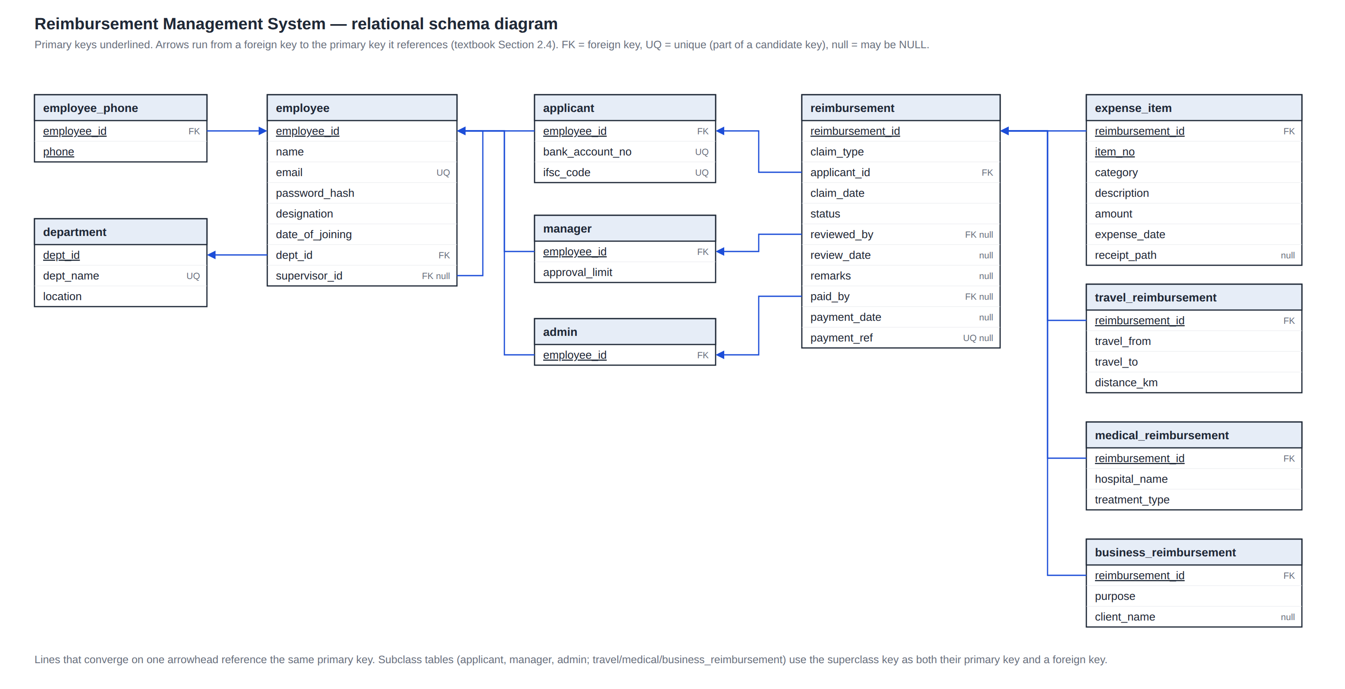
Figure 2. Schema diagram (textbook §2.4): arrows run from each foreign key to the primary key it references.

6. Functional dependencies
The functional dependencies below are the constraints that must hold on each relation; they come from the business rules, not from the sample data. Attribute closures were used to find the candidate keys (textbook §7.4.2).
Relation | Functional dependencies that must hold (F) | Candidate keys | Highest normal form
department | dept_​id → dept_​name, location  dept_​name → dept_​id | {dept_​id}, {dept_​name} | BCNF (so also 3NF)
employee | employee_​id → name, email, password_​hash, designation, date_​of_​joining, dept_​id, supervisor_​id  email → employee_​id | {employee_​id}, {email} | BCNF (so also 3NF)
employee_​phone | Only trivial FDs (both attributes form the key) | {employee_​id, phone} | BCNF (so also 3NF)
applicant | employee_​id → bank_​account_​no, ifsc_​code  ifsc_​code, bank_​account_​no → employee_​id | {employee_​id}, {ifsc_​code, bank_​account_​no} | BCNF (so also 3NF)
manager | employee_​id → approval_​limit | {employee_​id} | BCNF (so also 3NF)
admin | Only trivial FDs | {employee_​id} | BCNF (so also 3NF)
reimbursement | reimbursement_​id → claim_​type, applicant_​id, claim_​date, status, reviewed_​by, review_​date, remarks, paid_​by, payment_​date, payment_​ref  payment_​ref → reimbursement_​id (for paid claims; UNIQUE, NULL until paid) | {reimbursement_​id} | BCNF (so also 3NF)
travel_​reimbursement | reimbursement_​id → travel_​from, travel_​to, distance_​km | {reimbursement_​id} | BCNF (so also 3NF)
medical_​reimbursement | reimbursement_​id → hospital_​name, treatment_​type | {reimbursement_​id} | BCNF (so also 3NF)
business_​reimbursement | reimbursement_​id → purpose, client_​name | {reimbursement_​id} | BCNF (so also 3NF)
expense_​item | reimbursement_​id, item_​no → category, description, amount, expense_​date, receipt_​path | {reimbursement_​id, item_​no} | BCNF (so also 3NF)

Equally important are the dependencies that do not hold. Each was checked against the real-world meaning of the data, because assuming one by mistake would change the keys and the normal forms:
Dependency that does NOT hold | Reason (real-world fact) | Consequence for the design
name → employee_​id | Two employees can share a name. | name is not a key; login uses email.
location → dept_​id | Several departments are in Pune. | location is an ordinary attribute of department.
applicant_​id → reimbursement_​id | An applicant files many claims. | SUBMITS is one-to-many.
applicant_​id, claim_​date → reimbursement_​id | Two claims may be filed on the same day. | No unique constraint on that pair.
reviewed_​by → review_​date | A manager reviews claims on many days. | review_​date belongs to the review, i.e. the claim.
travel_​from, travel_​to → distance_​km | Distance is what was actually travelled on this trip (detours, return legs). | travel_​reimbursement stays in BCNF; see decision E18.
designation → approval_​limit | Limits are set per manager, not per job title. | manager stays in BCNF; see decision E17.
hospital_​name → treatment_​type | A hospital offers many treatments. | Both are attributes of the medical claim.

7. Normalization up to 3NF

7.1 Definitions
Normal form | Condition (Silberschatz §7.3, §7.8, Exercise 7.19)
1NF | Every attribute domain is atomic: no lists or sets inside a cell.
2NF | In 1NF, and no non-prime attribute depends on a proper subset of a candidate key (no partial dependency). The textbook covers 2NF only in Exercise 7.19, calling it "of historical significance"; we show it because the assignment asks for every step up to 3NF.
3NF | For every FD α → β in F⁺: it is trivial, or α is a superkey, or every attribute in β − α belongs to some candidate key. Equivalently for our purposes: no non-prime attribute depends transitively on a key.
BCNF | For every non-trivial FD α → β in F⁺, α is a superkey. BCNF implies 3NF.

7.2 Every relation of the final schema
Applying the definitions to every final relation:
- 1NF holds everywhere: every column is a single atomic value. The one multivalued attribute (phone) has its own relation.
- 2NF only matters for relations with a composite key: employee_phone and expense_item. employee_phone has no non-prime attributes. In expense_item no attribute depends on reimbursement_id alone (claim-level facts live in reimbursement) or on item_no alone (item numbers repeat across claims).
- 3NF and BCNF. In every relation, the left side of every non-trivial FD in the table above is a candidate key (dept_name, email, (ifsc_code, bank_account_no) and payment_ref are keys too). Every relation is therefore in BCNF, which implies 3NF.

7.3 Walkthrough from an unnormalized claim form
To show that the schema is normalized (and not merely normal by luck), we start from the single flat relation a paper claim form or a spreadsheet would produce, and normalize it step by step.
claim_form (reimbursement_id, claim_type, claim_date, status,
applicant_id, applicant_name, email, dept_id, dept_name, location,
bank_account_no, ifsc_code, phones,
reviewed_by, approval_limit, review_date, remarks,
item_no, category, description, amount, expense_date)

Functional dependencies (F)
F1 reimbursement_id -> claim_type, claim_date, status, applicant_id,
reviewed_by, review_date, remarks
F2 applicant_id -> applicant_name, email, dept_id, bank_account_no, ifsc_code
F3 email -> applicant_id
F4 ifsc_code, bank_account_no -> applicant_id
F5 dept_id -> dept_name, location
F6 dept_name -> dept_id
F7 reviewed_by -> approval_limit
F8 reimbursement_id, item_no -> category, description, amount, expense_date

Candidate key. (reimbursement_id, item_no)⁺ = all attributes: F8 gives the item columns, F1 the claim columns, then F2, F5 and F7 the rest. Neither attribute appears on the right of any FD, so every key must contain both: it is the only candidate key. Prime attributes: reimbursement_id, item_no.
Step 1: 1NF. phones holds a list (e.g. "+9198…, 020…"), which is not atomic. Move it to its own relation. (Repeating each row once per phone would instead create the multivalued dependency applicant_id ↠ phone and multiply every item row.)
employee_phone (applicant_id, phone) key: (applicant_id, phone)

Step 2: 2NF. F1 is a partial dependency: claim_type, claim_date, status, applicant_id, … depend on reimbursement_id alone, a proper part of the key (and the applicant, department and reviewer columns follow from them). Split the item-level and claim-level facts:
expense_item (reimbursement_id, item_no, category, description, amount, expense_date)
claim (reimbursement_id, claim_type, claim_date, status, applicant_id, applicant_name,
email, dept_id, dept_name, location, bank_account_no, ifsc_code,
reviewed_by, approval_limit, review_date, remarks)

Lossless: expense_item ∩ claim = {reimbursement_id}, which is a key of claim (§7.2.3 test). expense_item is now in BCNF: its only non-trivial FD is F8, whose left side is its key.
Step 3: 3NF. claim (key reimbursement_id) still has transitive dependencies: reimbursement_id → applicant_id → applicant_name, email, …; applicant_id → dept_id → dept_name, location; and reimbursement_id → reviewed_by → approval_limit. Each makes a non-prime attribute depend on a non-key attribute. Decompose on F2, F5 and F7:
reimbursement (reimbursement_id, claim_type, claim_date, status, applicant_id,
reviewed_by, review_date, remarks)
applicant_details (applicant_id, applicant_name, email, dept_id, bank_account_no, ifsc_code)
department (dept_id, dept_name, location)
manager (reviewed_by -> employee_id, approval_limit)

Lossless: each split shares an attribute that is a key of one side (applicant_id of applicant_details, dept_id of department, reviewed_by of manager).
Dependency preservation. Every FD lies inside one final relation: F1 in reimbursement; F2, F3, F4 in applicant_details; F5, F6 in department; F7 in manager; F8 in expense_item. So each can be checked without a join (§7.4.4).
Cross-check with the 3NF synthesis algorithm (§7.5.2). F is already a canonical cover (no extraneous attributes, one FD per left side). One schema per FD gives the relations above (F3, F4 and F6 fall inside F2's and F5's schemas and are dropped), and the candidate key (reimbursement_id, item_no) is contained in expense_item, so no extra key schema is needed. The algorithm produces the same result.
Result
The final relations are exactly the schema we derived from the ER diagram, with one difference: normalization alone keeps applicant_details as one relation. Our design splits it into employee and applicant because of the partial specialization: employees who are not applicants (an intern, a finance clerk) would otherwise need NULL bank details. Both parts are in BCNF.
The payment columns (paid_by, payment_date, payment_ref) and the claim-type details were left out above to keep it short. They behave the same way: payment columns depend on reimbursement_id only, and the type-specific details move to the subclass relations to avoid NULLs, not because of any normal form.

8. Implementation

8.1 Architecture
Layer | Technology | Responsibility
Front end | React 19, React Router, Tailwind CSS (Vite) | Forms and screens for the three roles; shows database errors as messages.
Back end | Node.js, Express 5, mysql2 | Authentication (bcrypt, JWT), role checks, transactions, file uploads; every query parameterised.
Database | MySQL 8.0 (InnoDB) | 11 tables, 13 foreign keys, 4 unique keys, 18 CHECK constraints, 17 triggers, 2 views, 1 function, 2 procedures.

8.2 Where each rule is enforced
Mechanism | Rules (Section 3.3) | Examples
Primary and unique keys | DR9, one decision per claim, item numbers per claim | uq_​employee_​email, uq_​applicant_​bank, uq_​reimbursement_​payment_​ref
Foreign keys (RESTRICT / CASCADE) | DR1, DR11, weak entity existence | fk_​reimbursement_​reviewer → manager; fk_​item_​reimbursement ON DELETE CASCADE
CHECK constraints | DR2, DR5, DR6 (amount > 0), DR8 (order of dates), domains | chk_​reimbursement_​lifecycle, chk_​reimbursement_​no_​self_​review
Triggers | DR3, DR4, DR6 (one type, at least one item), DR7, DR8 (not in future), DR10 | trg_​reimbursement_​bu, trg_​expense_​item_​bd, trg_​employee_​bu
Transactions (server) | Claim, details and items saved atomically | POST /api/claims

Rules need a trigger when a CHECK cannot express them: they read other rows or tables, compare old and new values, or need today's date. MySQL, like most systems, does not support SQL assertions (textbook §4.4.8). db/06_constraint_tests.sql runs 50 tests that try to break each rule and confirms the database rejects every one.

8.3 Screens
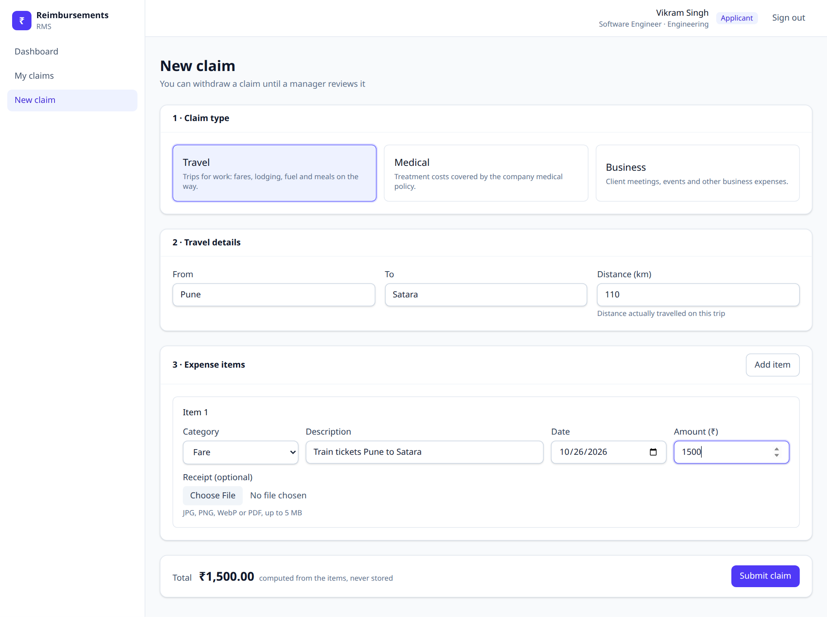
Figure 3. New claim: one claim type with its details, then any number of expense items.
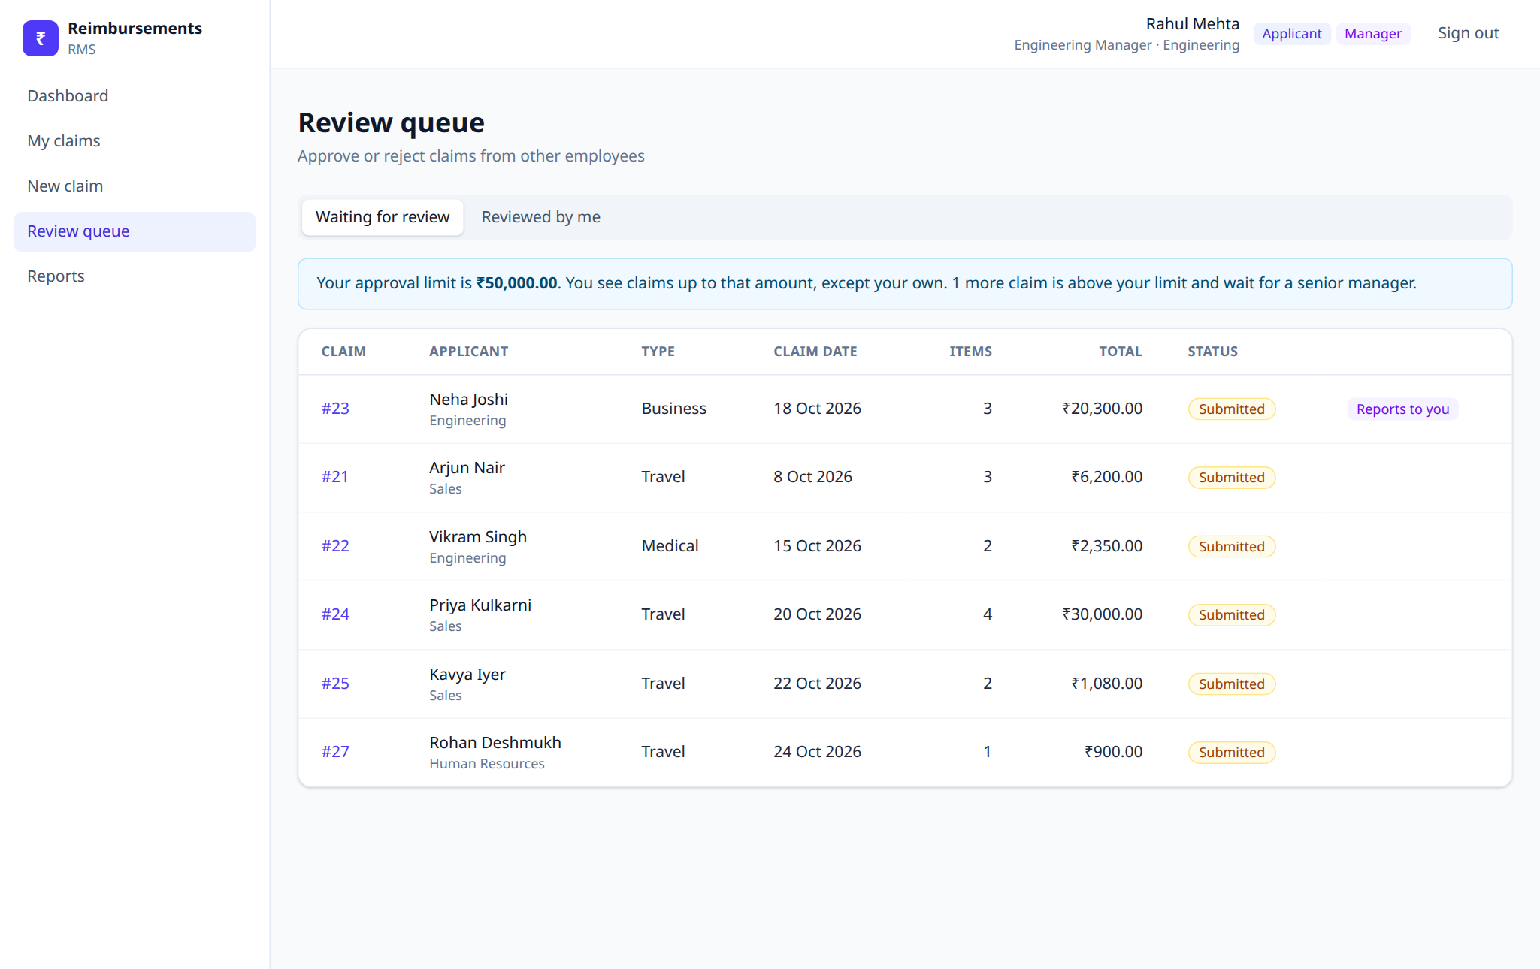
Figure 4. Review queue: only claims the manager is allowed to decide.
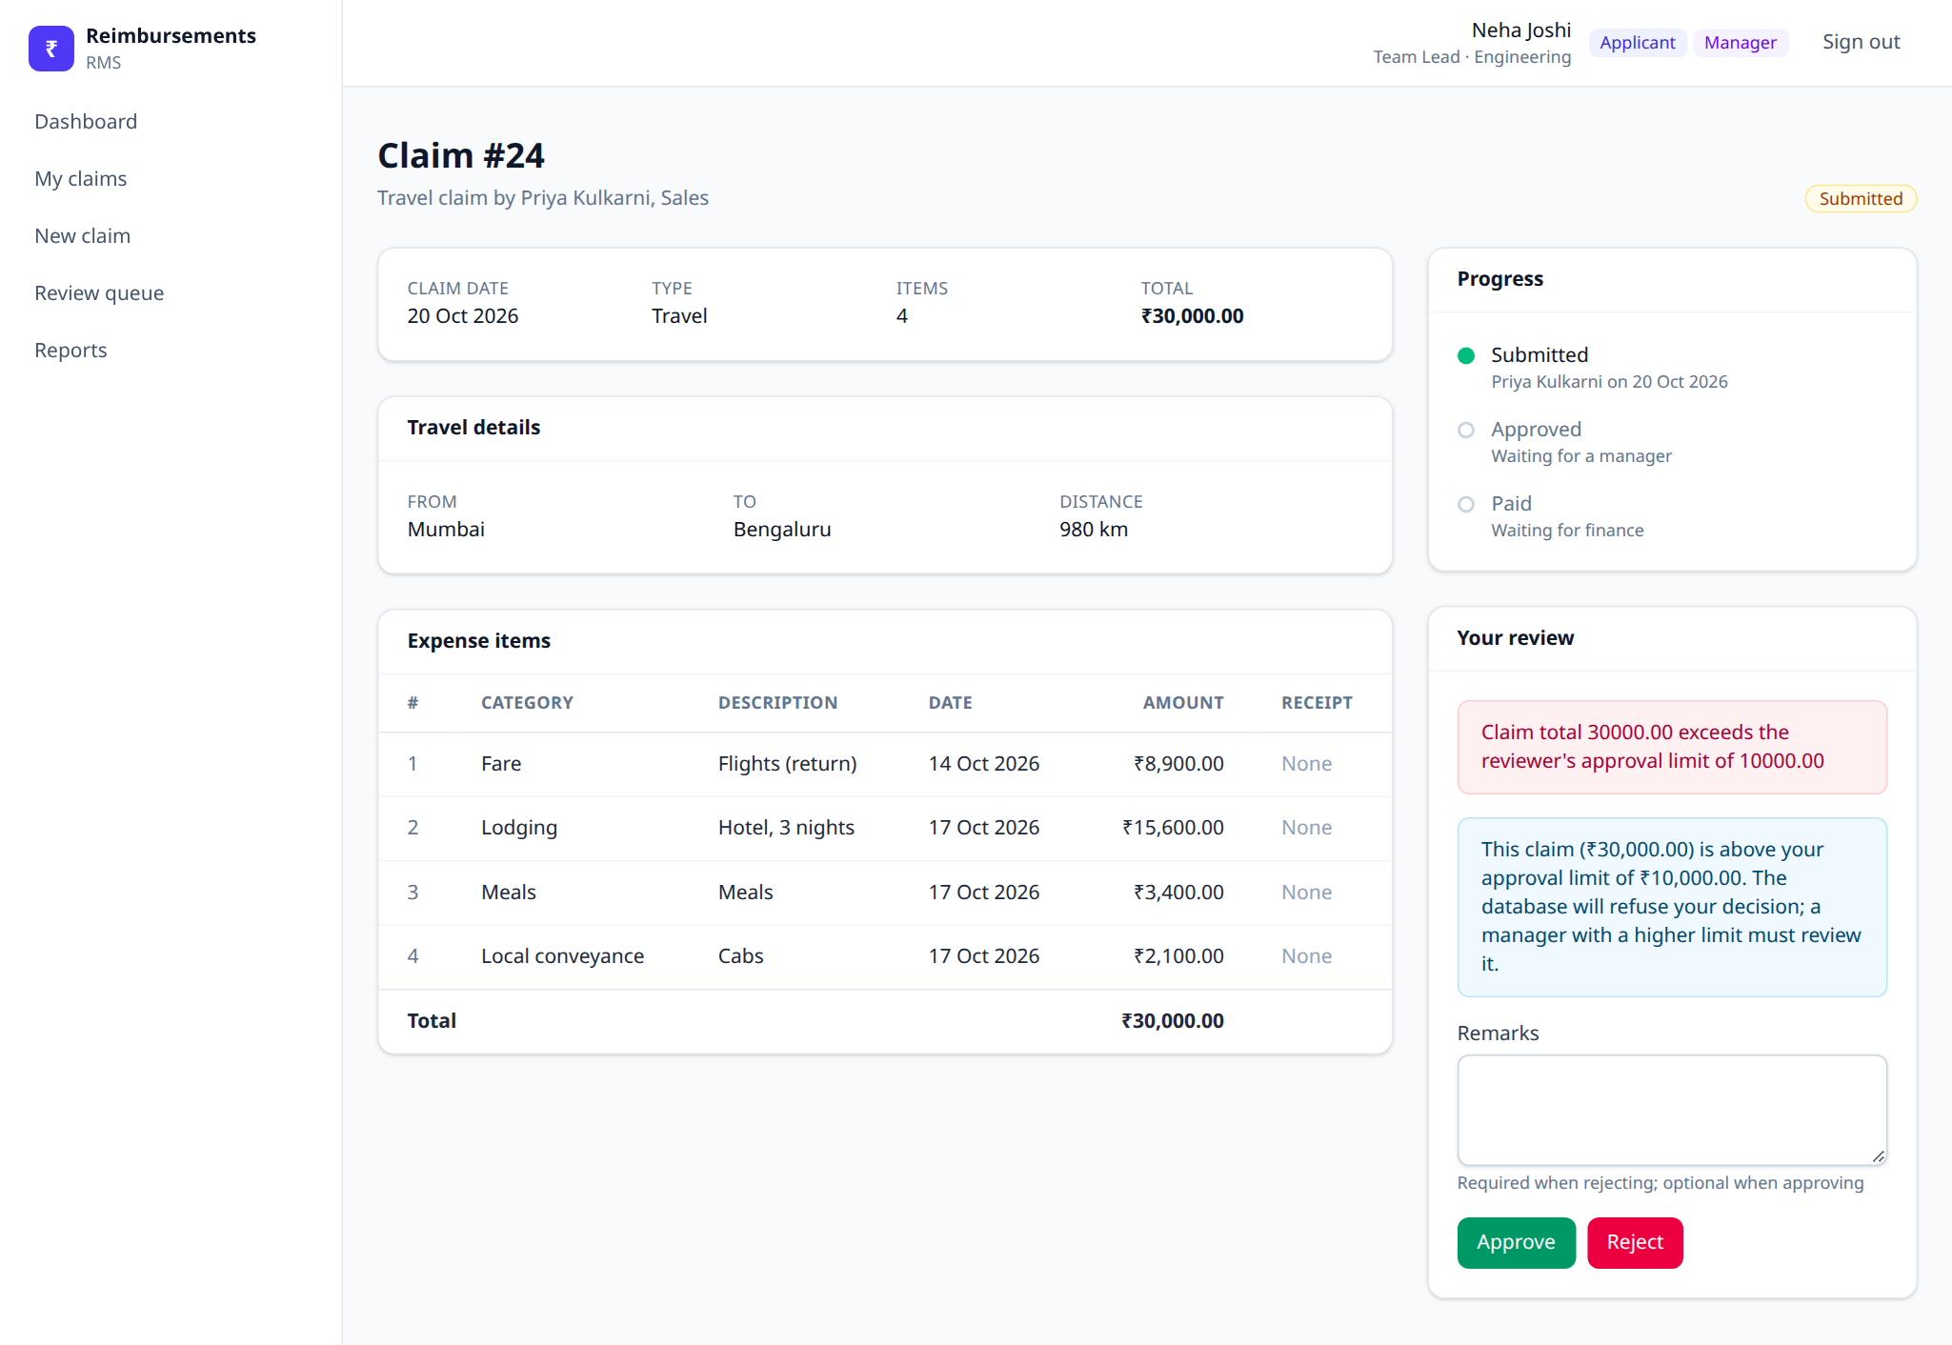
Figure 5. A manager with a ₹10,000 limit tries to approve a ₹30,000 claim; the trigger's message is shown.
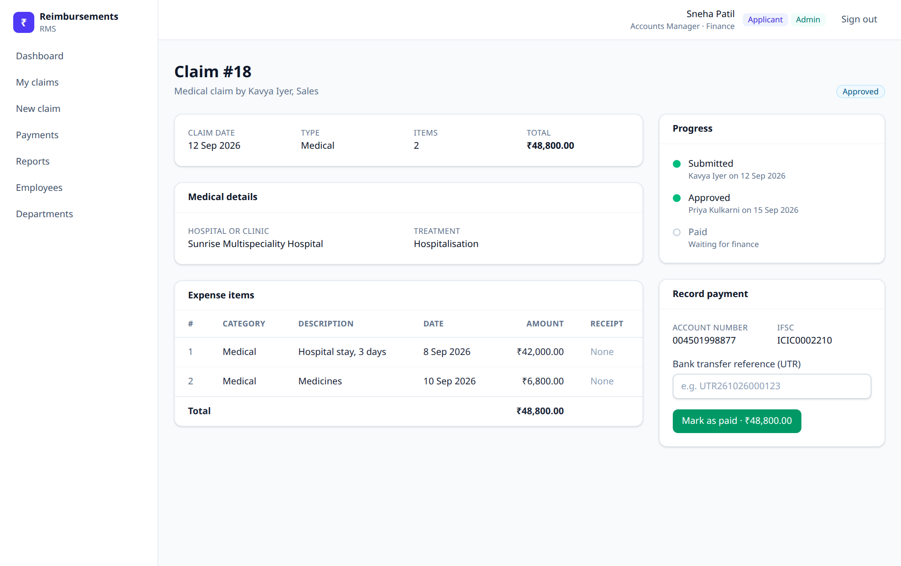
Figure 6. Recording a payment against an approved claim.
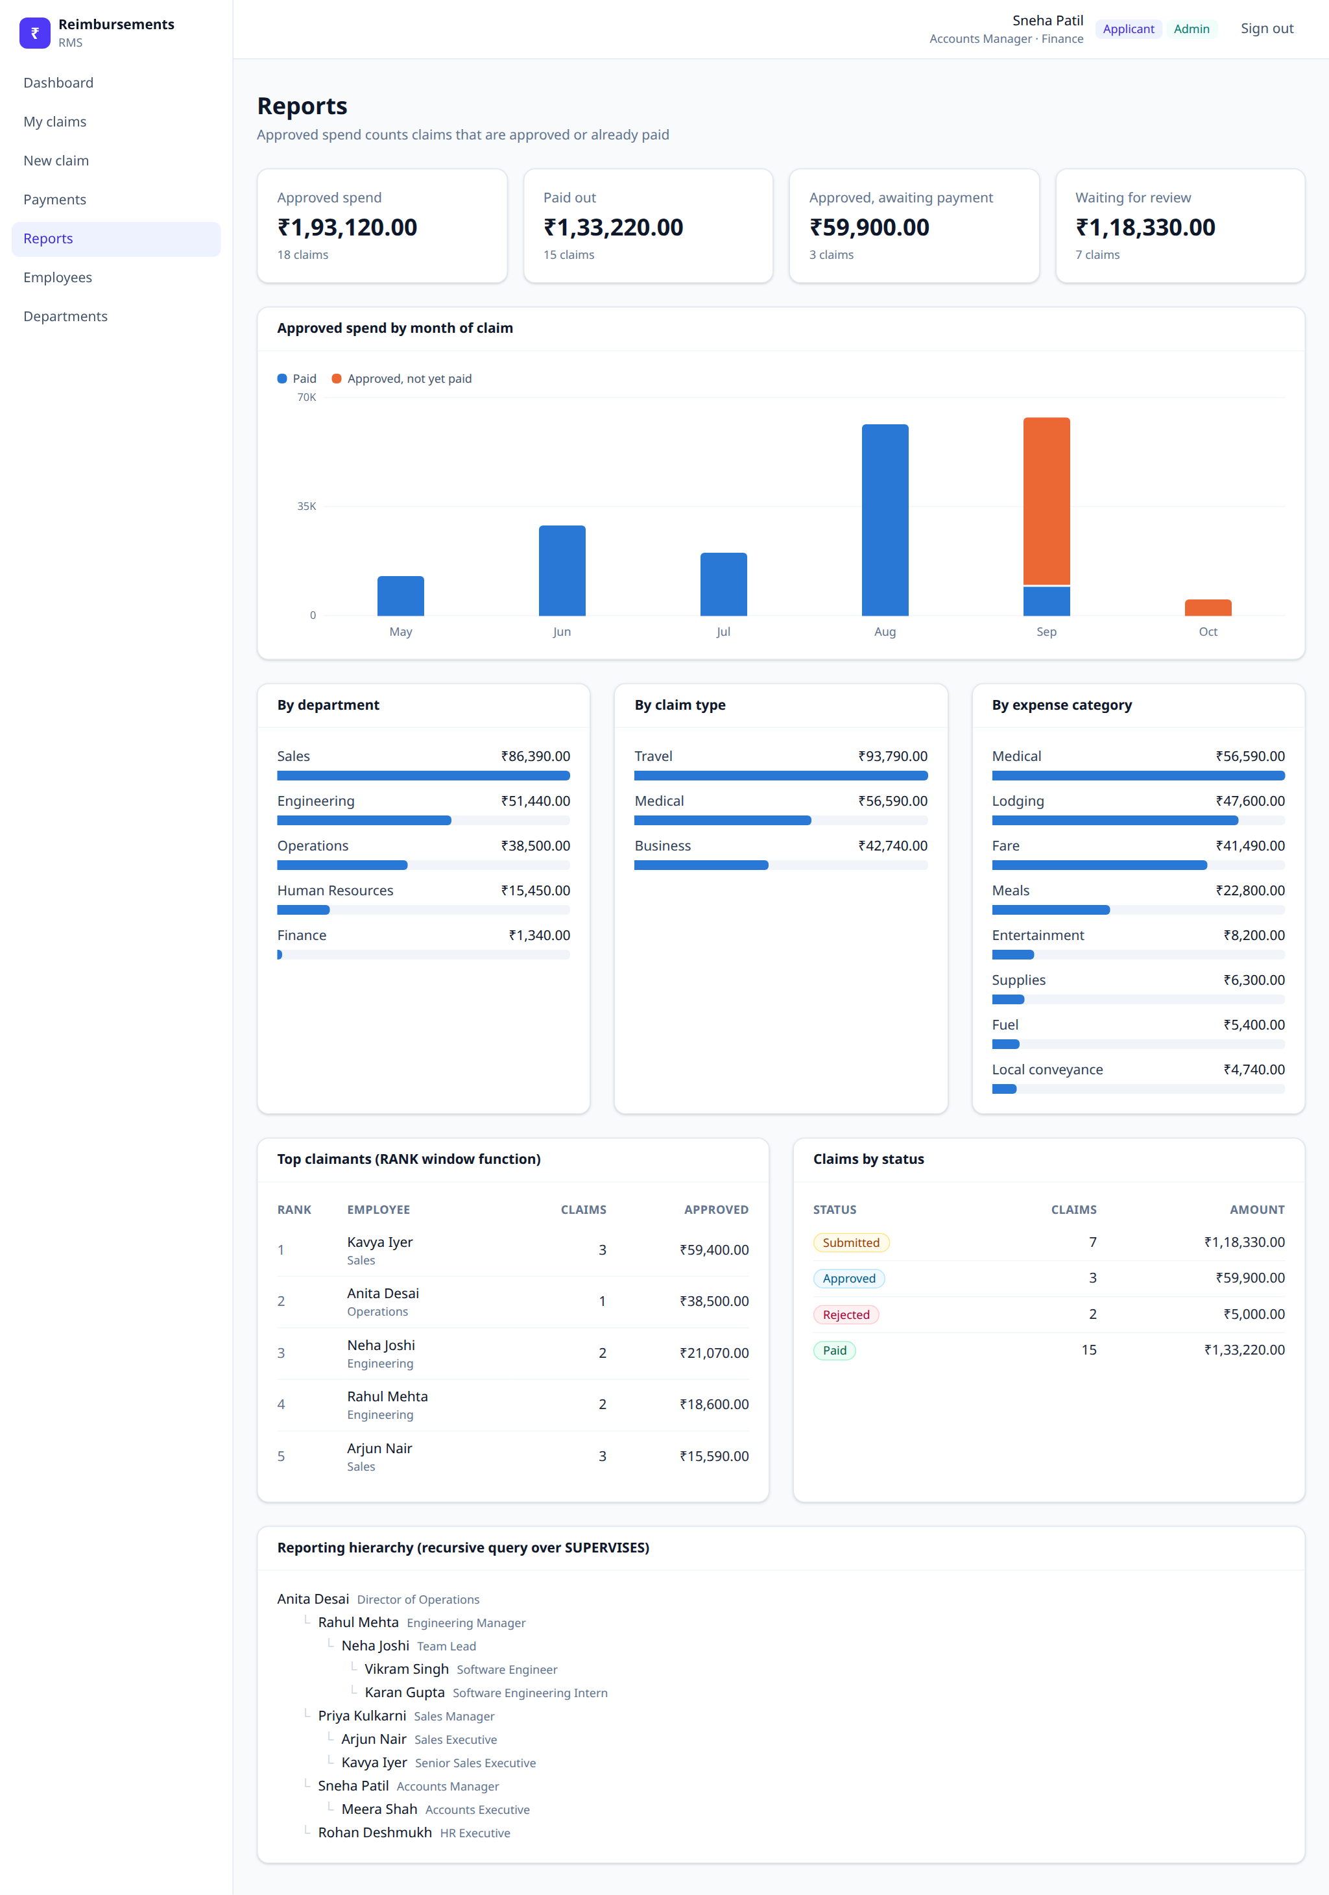
Figure 7. Reports: grouping, a window function (RANK) and a recursive query over SUPERVISES.

8.4 Running the project
docker compose up -d # MySQL 8.0 on port 3307 (or use a local MySQL)
./db/setup.sh # schema, views, triggers, app user, sample data
mysql -h127.0.0.1 -P3307 -uroot -p --protocol=TCP < db/06_constraint_tests.sql # 50 tests
cd server && cp .env.example .env && npm install && npm start # API on :4000
cd client && npm install && npm run dev # UI on :5173

Sample accounts all use the password password123 (for example vikram.singh@rms.example as an applicant, rahul.mehta@rms.example as a manager, sneha.patil@rms.example as an admin). The repository README lists all of them.

9. Conclusion
The database was designed top-down from an E-R model in the textbook's notation, reduced to 11 relation schemas with the standard rules, and checked against its functional dependencies: every relation is in BCNF, and therefore in 3NF. A walkthrough from a flat claim form reaches the same schema through 1NF, 2NF and 3NF, with lossless and dependency-preserving decompositions. Business rules are enforced in the database by keys, CHECK constraints and triggers, and a web application for all three roles runs on top of it.
Further detail
The reasoning behind every design decision, the alternatives we rejected and the trade-offs we accepted are in the companion document, RMS_Design_Decisions.pdf.

