# Overall Circuit

As determined project description, our converter type is fly-back converter. Aim of our circuit is converting 48 V DC to 24 V DC at 100W output. In addition, minimizing loss and controlling output voltage are also our aims of the circuit.

Some information of the circuit are given as follows;

* Input voltage= 48 V DC (%25 changeable for controller)
* Output Voltage= 24 V DC (has to be constant)
* Output Power=100 W
* Output Current at Full Load= 4.16 A
* Switch Frequency = 20kHz
* Duty Cycle=0.4 at 48 V input
* N1/N2= 48/36

The overall circuit and output current and voltage simulation results are given as follows;

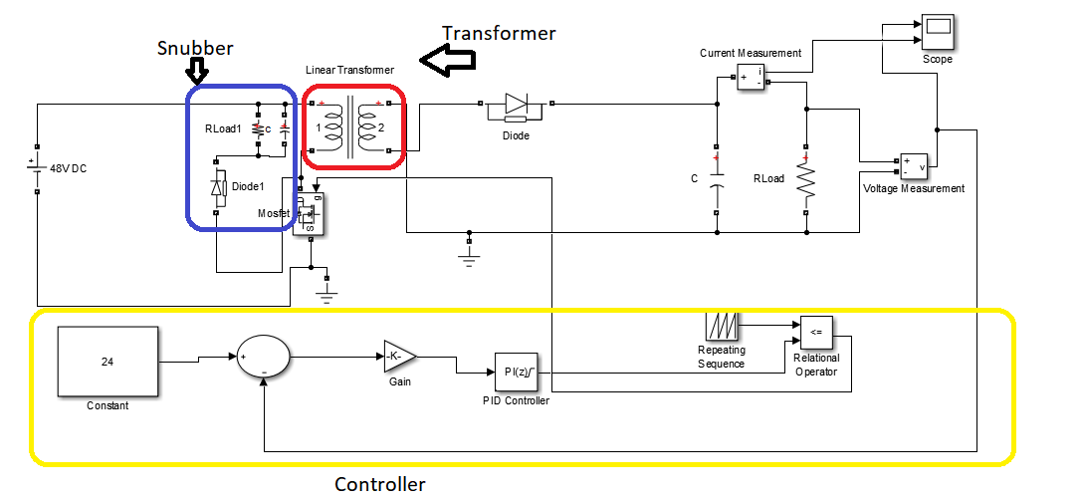

Figure 1. Overall Circuit of Flyback Converter

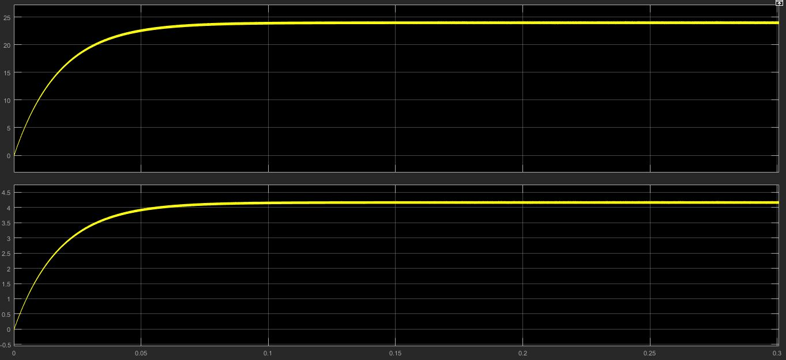

Figure 2.Simulation Result of Flyback Converter Vin=48V and Vout=24V at P=100W

The fly-back converter designed by us consist of 3 main parts.

* Transformer
* Snubber
* Controller

First part is transformer part. Transformer is using for isolation and increasing or decreasing coming voltage and current primary side. Second part is snubber. Snubber is used for decreasing voltage on MOSFET. Effects of snubber on circuit will be determined at snubber part. Last part is controller part. Controller is used for working on load types or different input voltages.

The sub-parts are given as follows;

## Transformer

Transformer parameter was determined simulation project 2 for 250 kHz. However, 250 kHz is very high for our circuit. Therefore, we did some experiment with different frequency. As a result of these experiment, we decided to use 20 kHz. Since the most efficient results was taken at 20 kHz. It was around %80.

We chose AWG 18 wire for using transformer. Since wire current capacity is around 5A according to our system. AWG 18 current capacity is equal to 7 A.

The AWG cable current capacities are given as follows;

Table 1. AWG Cable Features Table

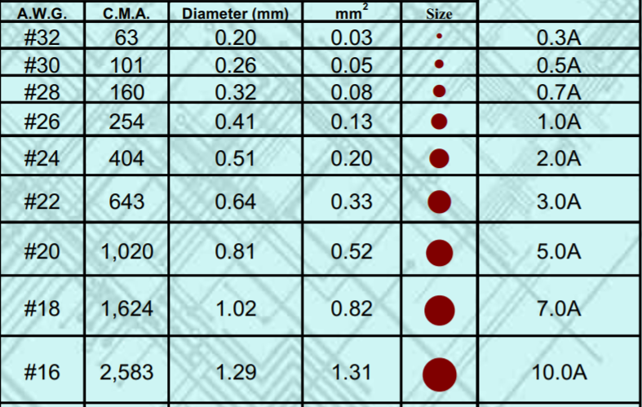

We can choose below number of AWG 19 cable. However, winding difficulty and cost are increasing with increasing diameter of wire. Therefore, we chose AWG 18.

We use ETD core as determined simulation project 2. ETD 29 core is using core in our transformer. Calculations are same with project-2 question 1 transformer design.

Primary winding number is equal to 48 and secondary winding number is equal to 36.

The leakage inductance and magnetizing inductance changed according to winding shape and snubber voltage.

The leakage inductance and magnetizing inductance are given as follows;

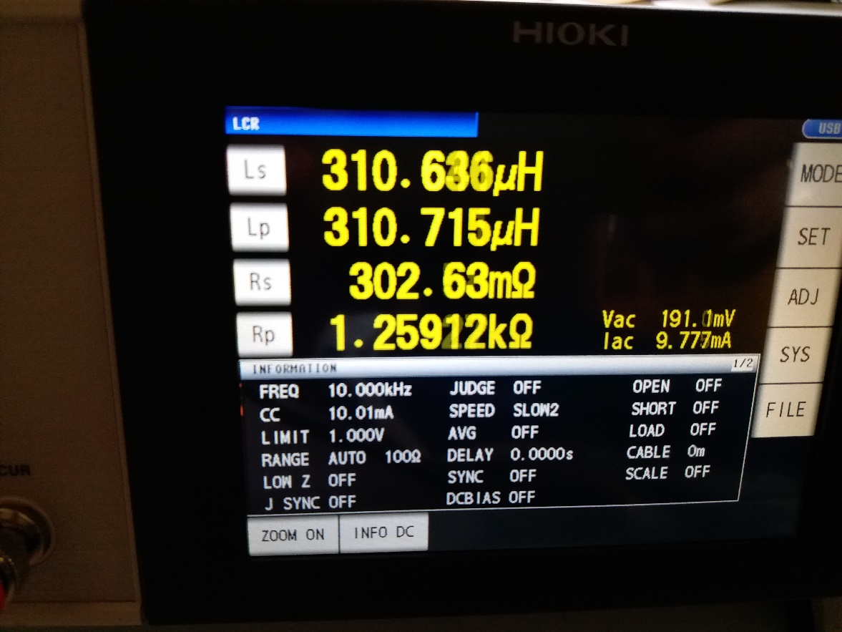

Figure 3. Magnetizing Inductance of Transformer

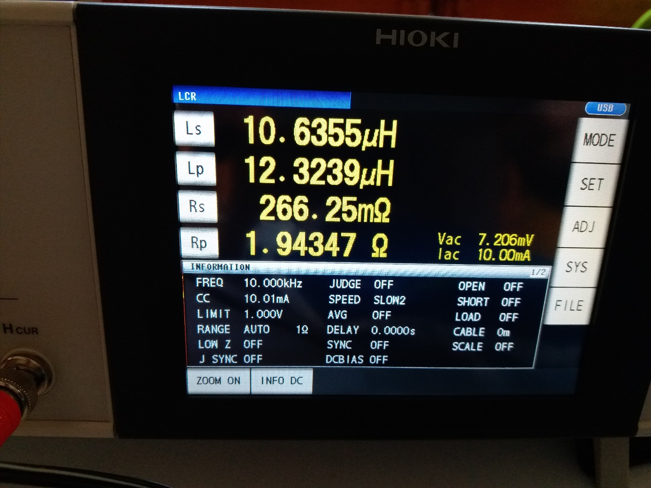

Figure 4. Leakage Inductance of Transformer at Primary Side

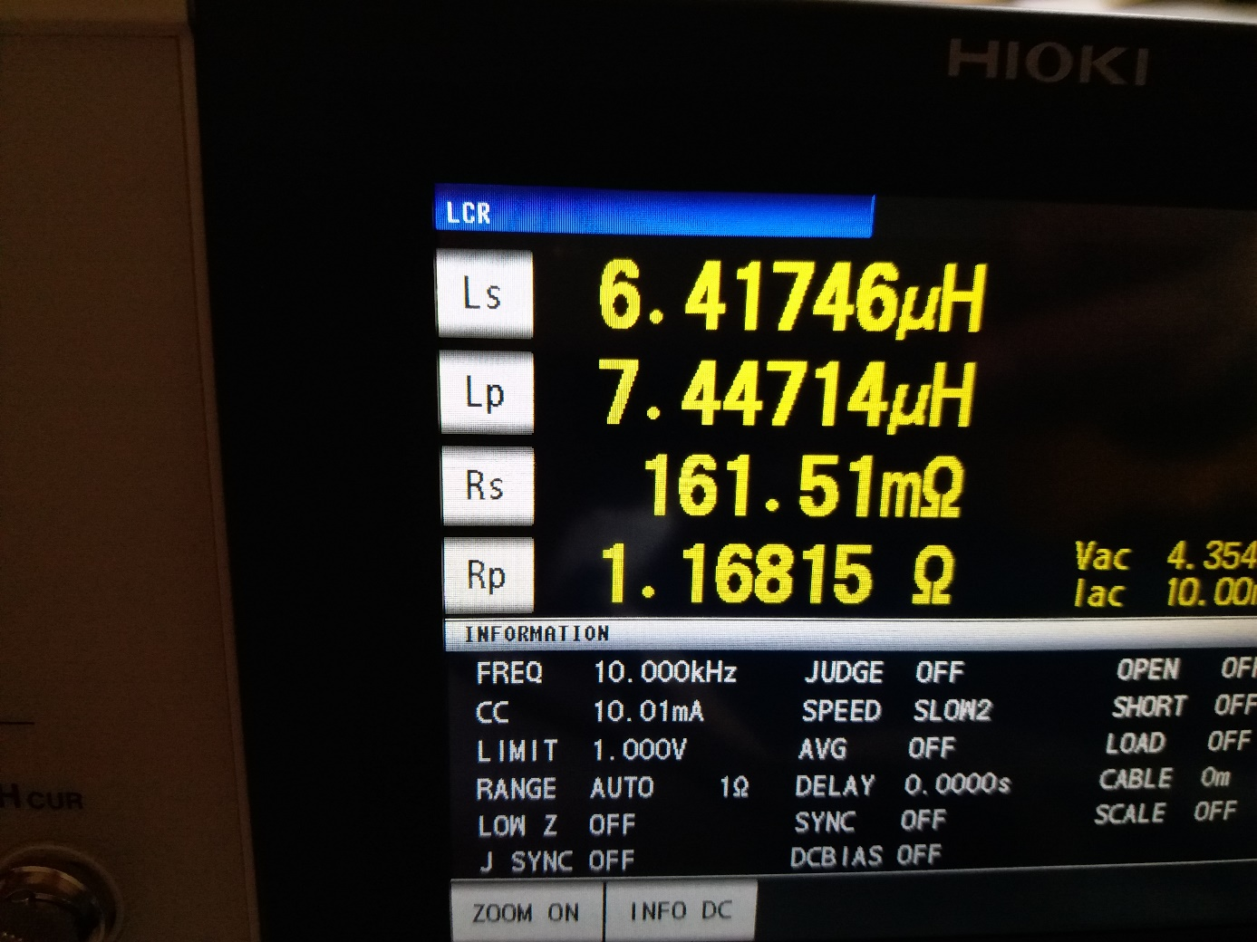

Figure 5. Leakage Inductance of Transformer at Secondary Side

As seen from figure 4 and 5 leakage inductance increases with square of winding number as expected.

As said before snubber voltage changes leakage inductance. When we tested different snubber voltage, we observed that increasing snubber voltage cause to increase leakage inductance.

Also we observed that bigger leakage inductance on transformer cause to much loss. Output voltage of system change with this loss at constant duty circle. The simulation results of low inductance and high inductance are given as follows;

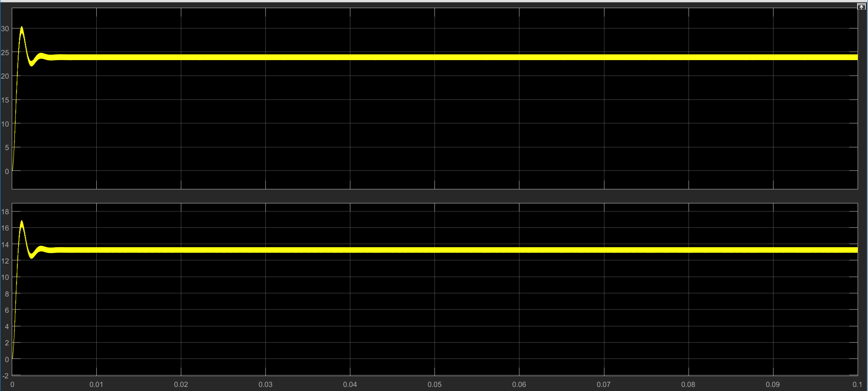

Figure 6. Output Current and Voltage at Low Leakage Inductance at %40 Duty Cycle

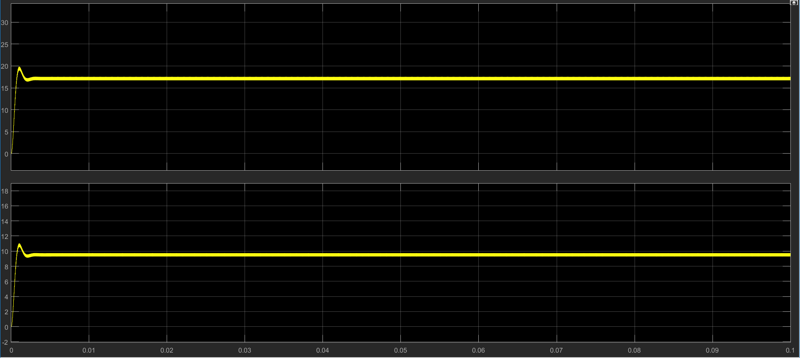

Figure 7.Output Current and Voltage at Normal Leakage Inductance at %40 Duty Cycle

As seen from figure 6 and 7 voltage and current decreased with increasing leakage inductance. For decreasing leakage inductance, we have to consider winding type.