## Snubber Design

In the project, switching device is mosfet. In the real life, used transformer is not ideal. This situation causes leakage inductance on the transformer. This can be called inductive load as well. When inductive load is used and switching is made, inductive current is cut suddenly. This sudden cut causes sharp voltage drop on Mosfet.

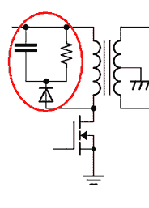

Figure:Schematic of snubber circuit

To prevent this sharp voltage drop, snubber circuits are used. Snubber circuit occur path for inductive current and prevent to sudden cut on the inductive load. This implies that sudden voltage drop on mosfet does not occur. When we determine the resistance and capacitance values of snubber circuit, some simulations have been made and then chosen. Now some simulation results will be given. Before simulation with snubber circuit, the simulation will be shared without snubber circuit to show how large voltage drop occurs on the Mosfet.

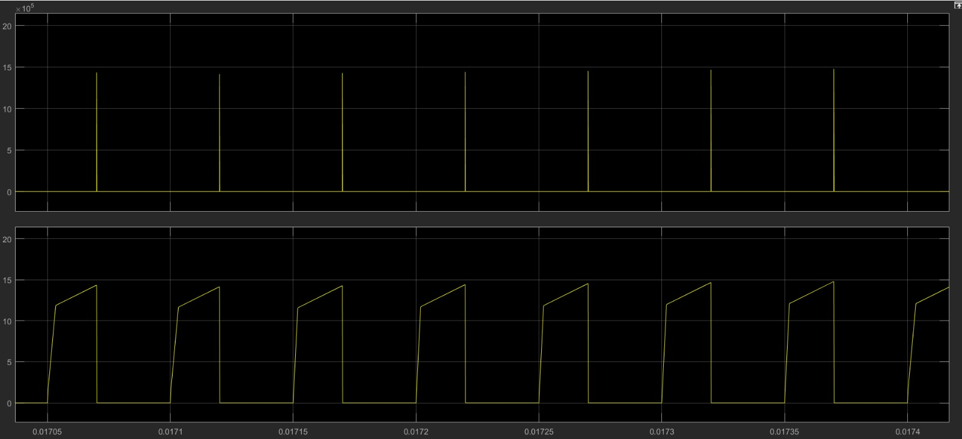

Figure: Voltage and current wabeforms of Mosfet without snubber

As can be seen Figure given above, instantaneous values of voltage drop on Mosfet reaches up to 15000 V. It is hard to handle with this voltage drop and snubber circuit should be used as seen.

Simulation results will be given with 100 ohm and 4.7 mikroFarad, then 250 ohm and 4.7 mikroFarad and finally 560 ohm and 4.7 mikroFarad. By doing this, effect of resistance value will be shown and 560 ohm will be chosen.

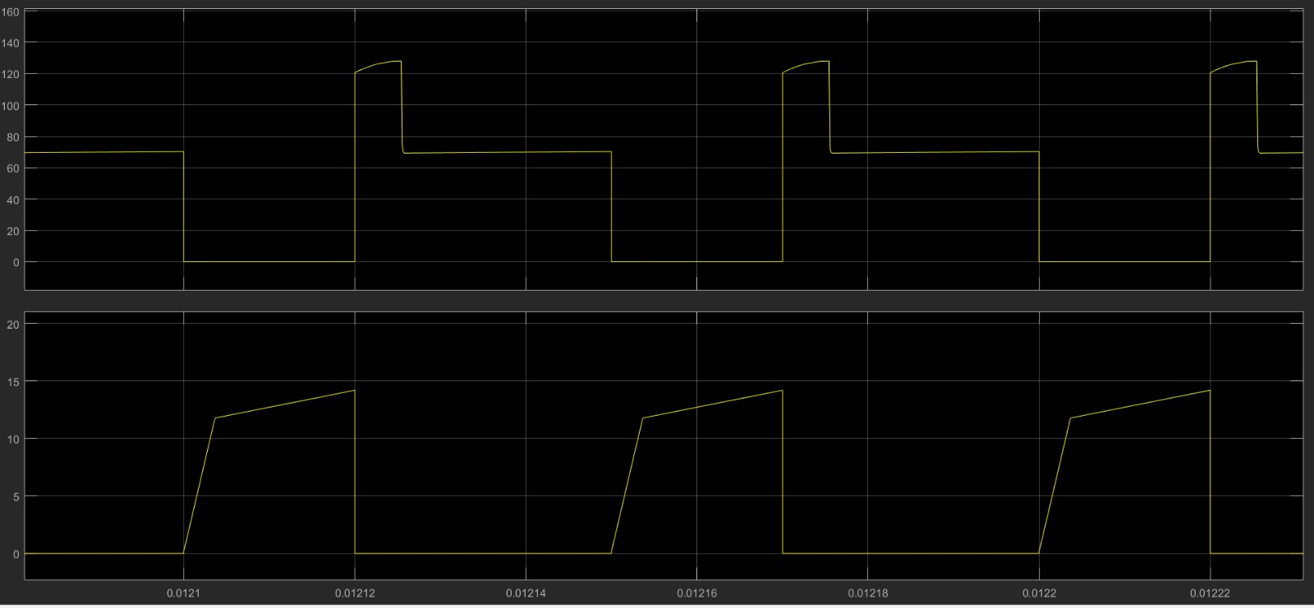

Figure: Voltage and current waveform of mosfet with 100 ohm on snubber

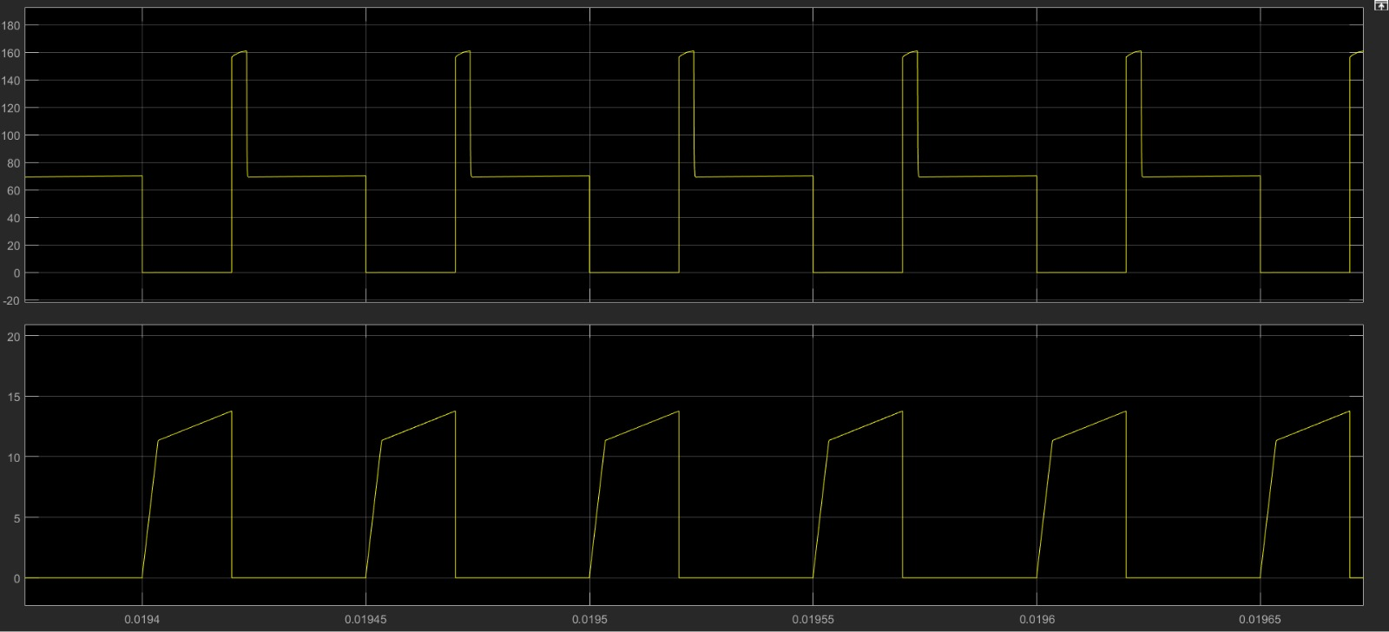

Figure: Voltage and current waveform of mosfet with 250 ohm on snubber

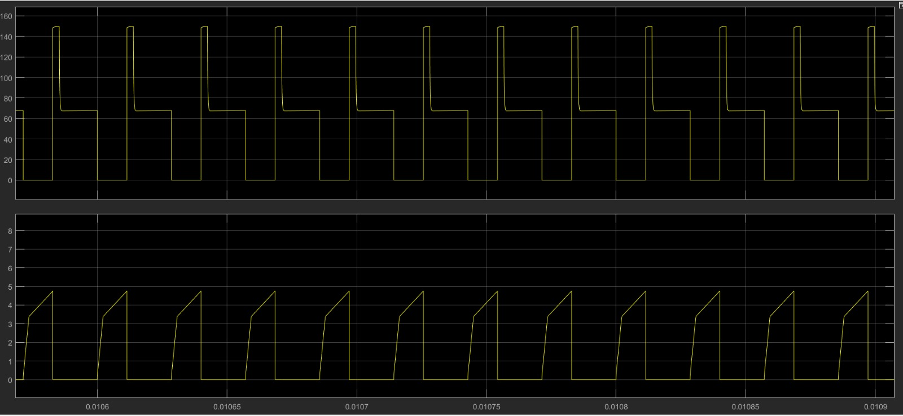

Figure: Voltage and current waveform of mosfet with 560 ohm on snubber

The reason why 560 ohm is chosen is that power loss is at least when 560 ohm is used.

## Component Determination:

Before starting to implement the converter, the most important issue is to choose components which will be used. This process is critical in design procedure. Firstly, choosing secondary side diode. For this purpose, simulation results are important to decide rated voltage and current values.

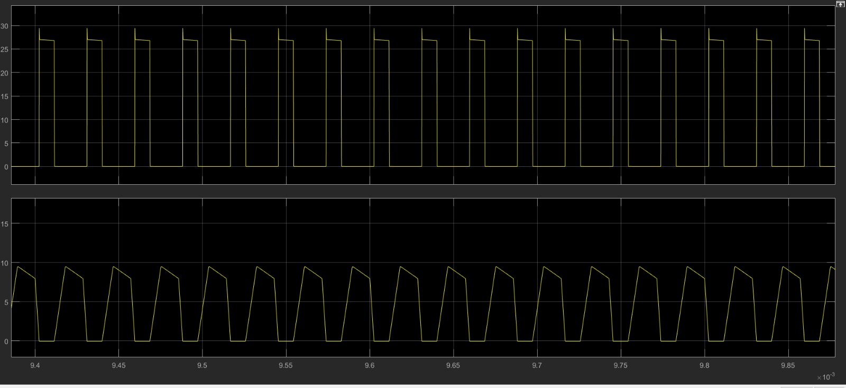

Figure:Voltage and current waveform of secondary side diode

Peak values of voltage and current values of diode can be seen in the Figure given above. By inspiring this result, the rated voltage value will be chosen 100V and current value will be chosen 10 A. Beside this, schotthy diode. Since open voltage od these kind of diodes is lower. This aproaches us to ideal value.

Then choosing of snubber diode will be explained. Its simulation result should be given as well.

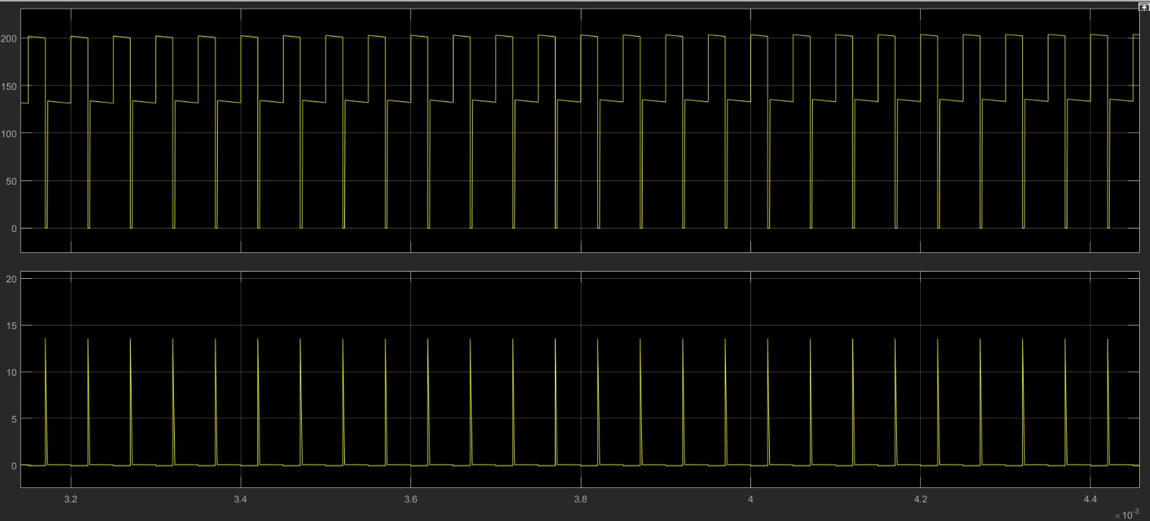

Figure: Current and voltage waveform of snubber diode

As seen from the Figure given above, it can be seen the peak values of voltage and current values of snubber diode. According to these values, we choose the specification of diode we use.

Now, choosing the mosfet will be clarified. Its simulation results also will be given.



Figure: Current and voltage waveform of mosfet

Its peak values can be seen from Figure given above. The mosfet is chosen with rated voltage is 250V and current 10 Ampere. Its open voltage is measured as 0.36V.

Other important component is snubber resistance. Its resistance value is chosen 560 ohm and it is mentioned previous part. Its power rating is 25 Watt.

Rated voltage of output capacitor is chosen according to output voltage and it is determined 100 V.

## Test Results

In this part of report, test results will be given. This results are obtained for four load conditions wich are 25%, 50%, 75% and 100% load. The results will be tabulated and then experimental waveforms will be given.

|  |  |  |  |  |  |  |  |  |  |
| --- | --- | --- | --- | --- | --- | --- | --- | --- | --- |
| Load/result | İnput voltage(V) | İnput current(A) | Output voltage(V) | Output current(A) | P_out(W) | Tmos(C) | Tdiode(C) | Tcap(C) | Snubber voltage(V) |
| 25% | 50.1 | 0.651 | 24 | 1.14 | 27.36 | 27 | 27 | 27.6 | 44.3 |
| 50% | 50.3 | 1.34 | 27.3 | 2.06 | 56.238 | 29 | 30 | 31 | 46.5 |
| 75% | 50.3 | 1.83 | 25.2 | 3.01 | 75.852 | 32 | 33 | 36 | 52.8 |
| 100% | 51 | 2.71 | 26.3 | 4.17 | 109.67 | 40 | 35 | 42 | 60.9 |

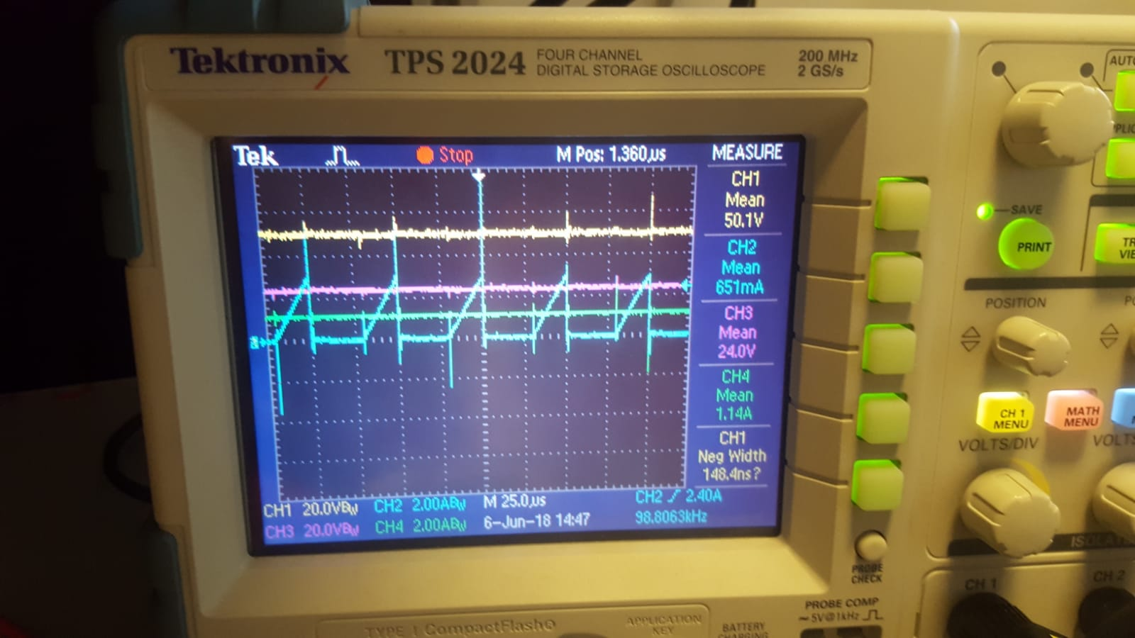

Figure: Output voltage&current, input voltage and current waveforms for 25%load

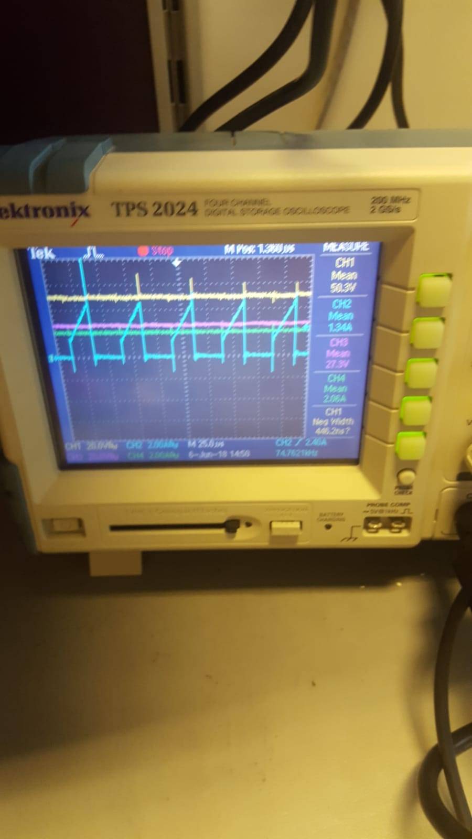

Figure: Output voltage&current, input voltage and current waveforms for 50%load

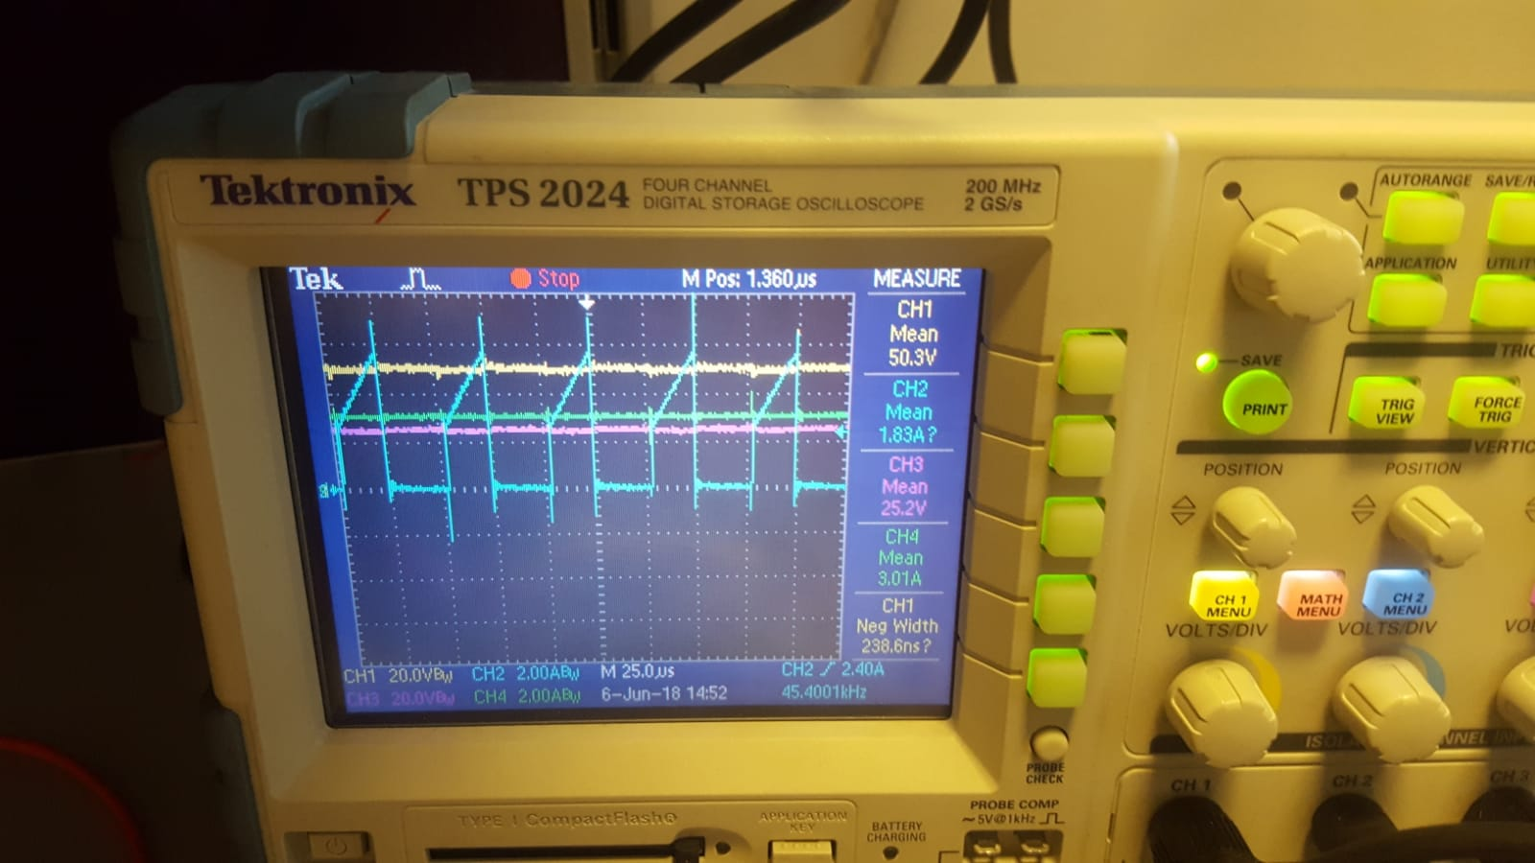

Figure: Output voltage&current, input voltage and current waveforms for 75%load

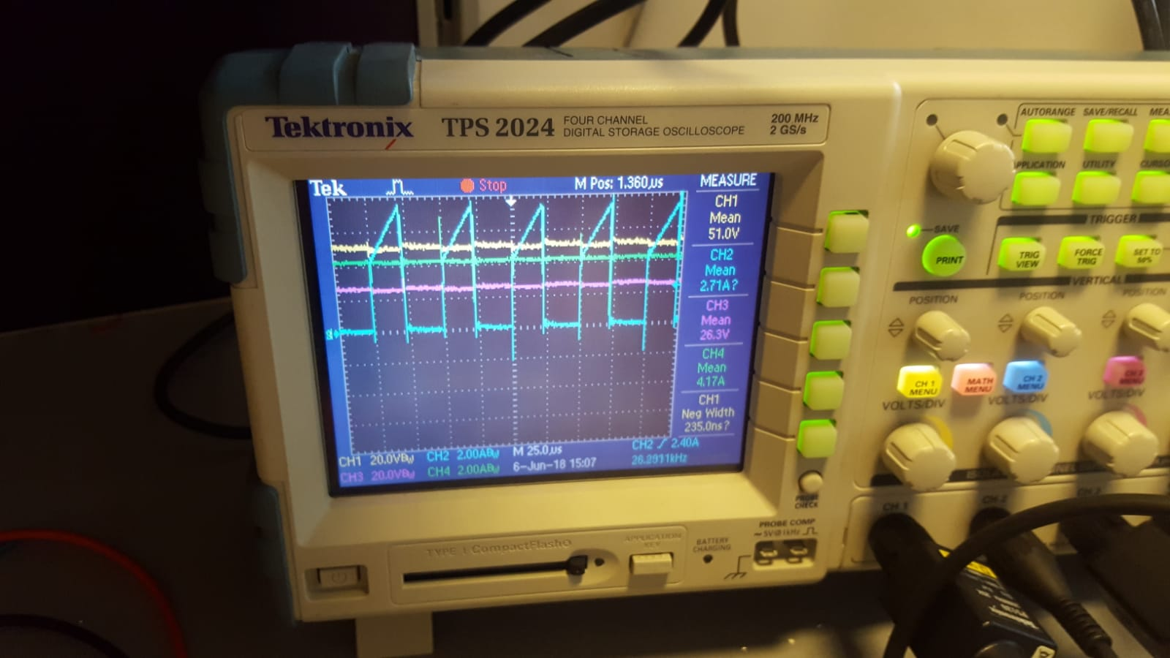

Figure: Output voltage&current, input voltage and current waveforms for 100%load

As can be seen from Figures given above, for four different load, measurements are made.As expected, powers and output currents are different whilee output voltage stays constant. The important difference is the temperature of devices. When higher load is used, temperature of devices increases. The temperature of capacitor is the fastest. On the other hand, yellow waveform is input voltage and blue one is input current. Pink one is output voltage and green one is output current. As can be seen from figure, input current of flyback converter is not continuous due to switching. At the output side, almost DC voltage is obtained with some ripple. Other experimental result is snubber resistor's voltage. Its graph will be given for four loads.

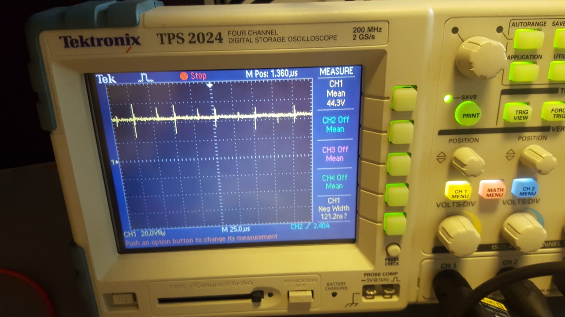

Figure:Snubber resistor's voltage for 25% load

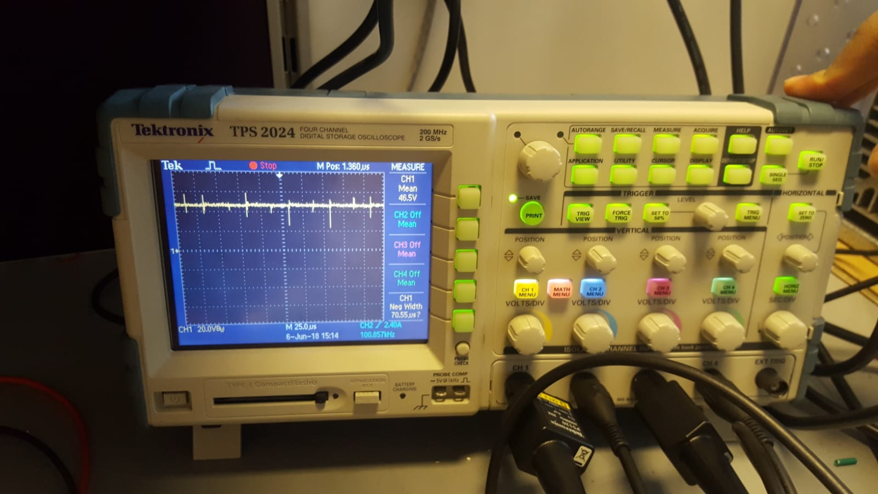

Figure:Snubber resistor's voltage for 50% load

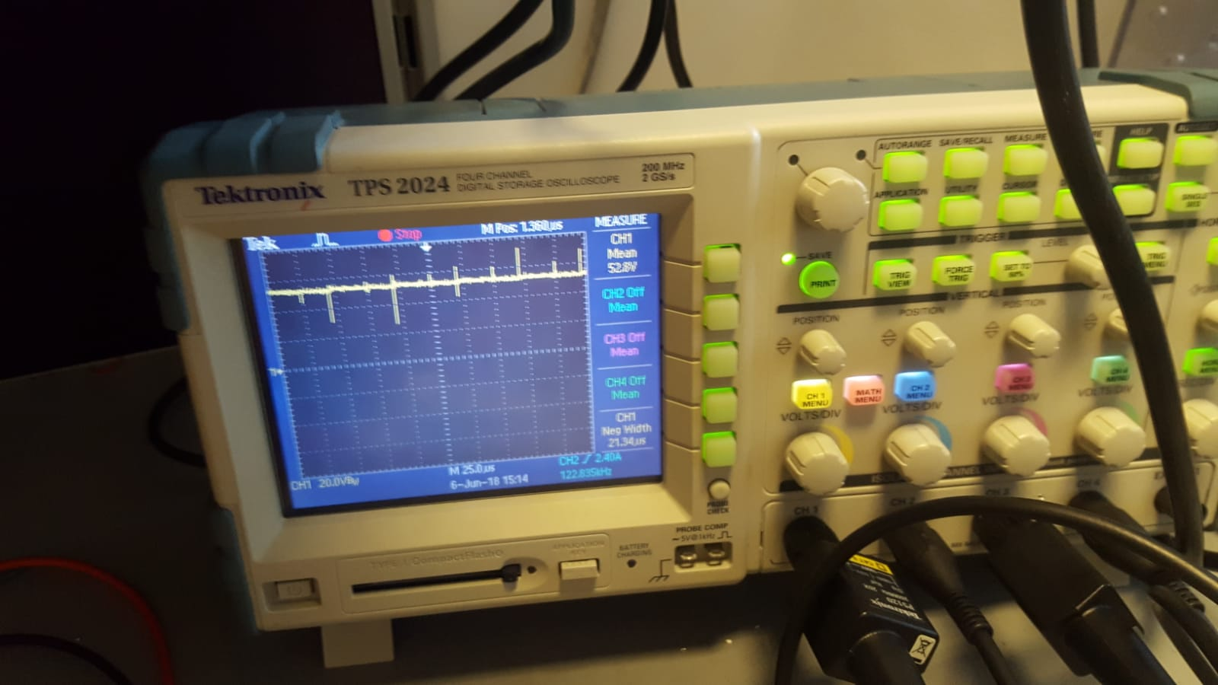

Figure:Snubber resistor's voltage for75% load

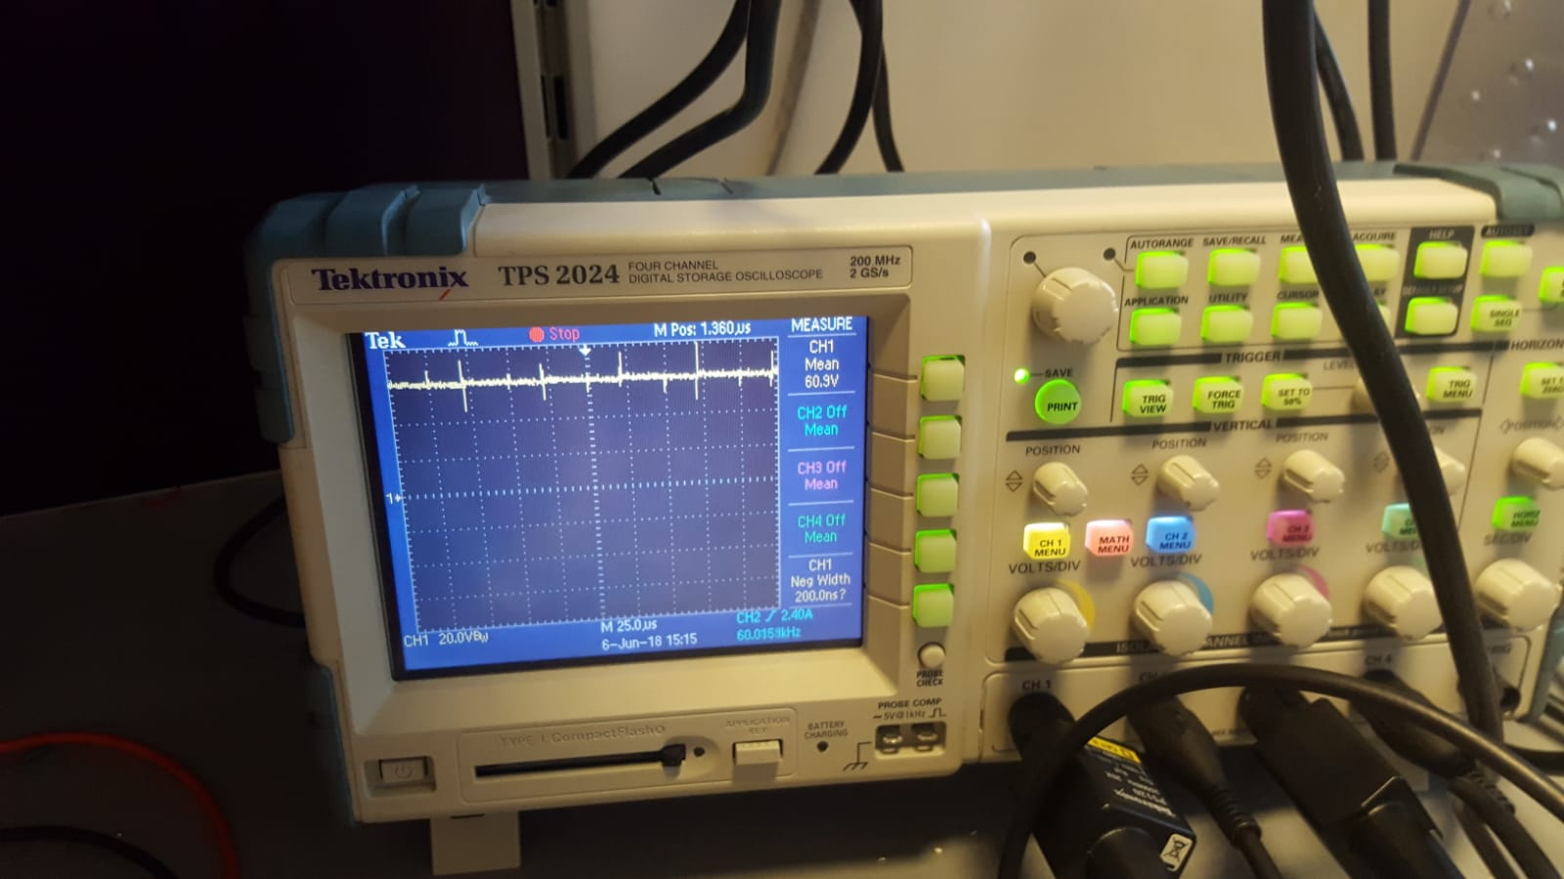

Figure:Snubber resistor's voltage for 100% load

As can be seen from Figures given above, snubber voltage increases with increasing load. This increasement implies increasement on power loss on snubber as well.

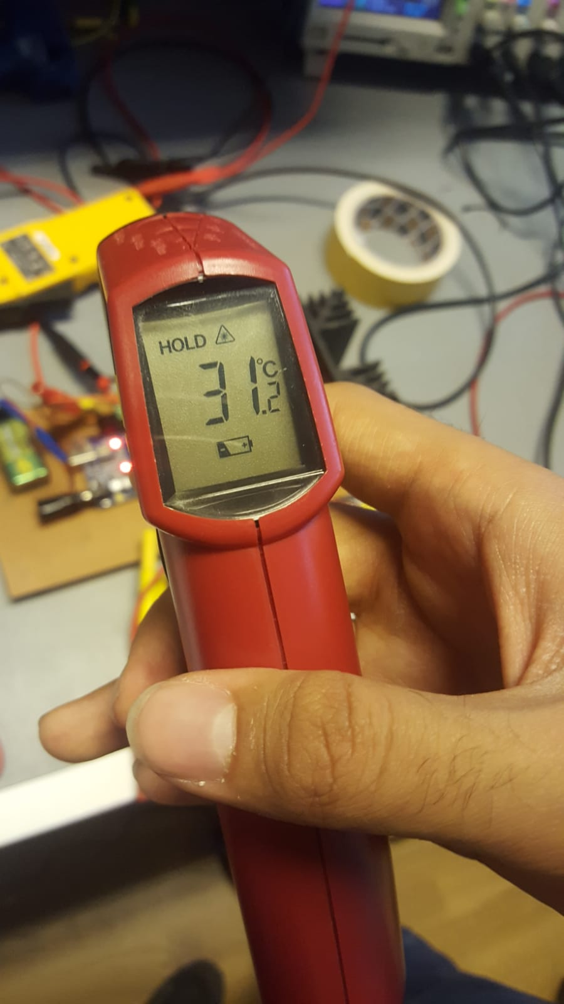

Figure-A view from test measurements (temperature measurement)