**Sachin Pal TY-IT**

**DevOps | Experiment No 9**

**Output:**

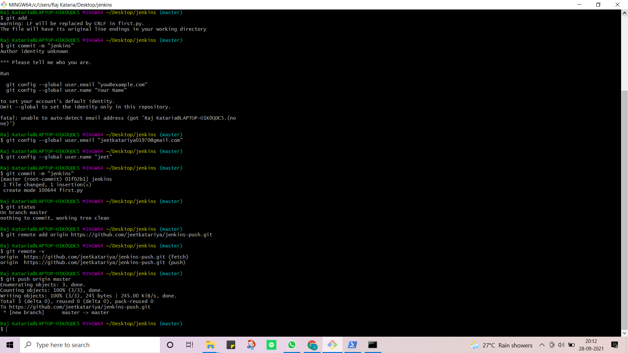

Fig 1: pushing python Code to GitHub

Fig 2: GitHub Repository

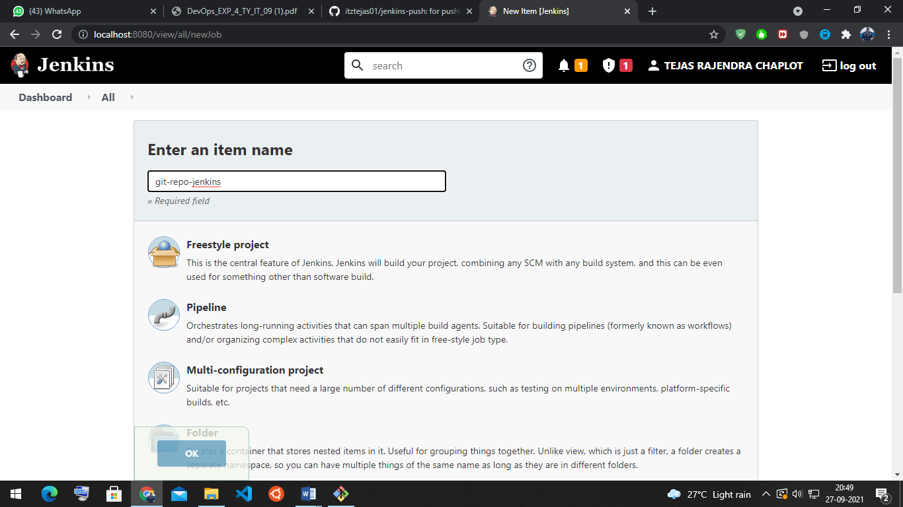

Fig 3: Jenkins Pipeline

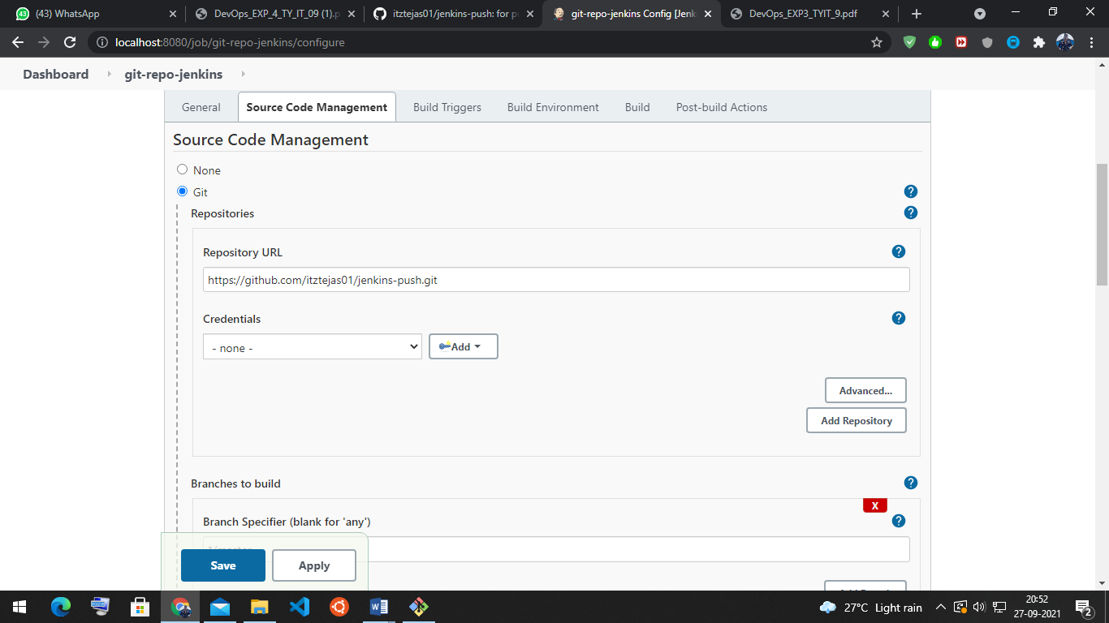

Fig 4: Adding the GitHub Repo

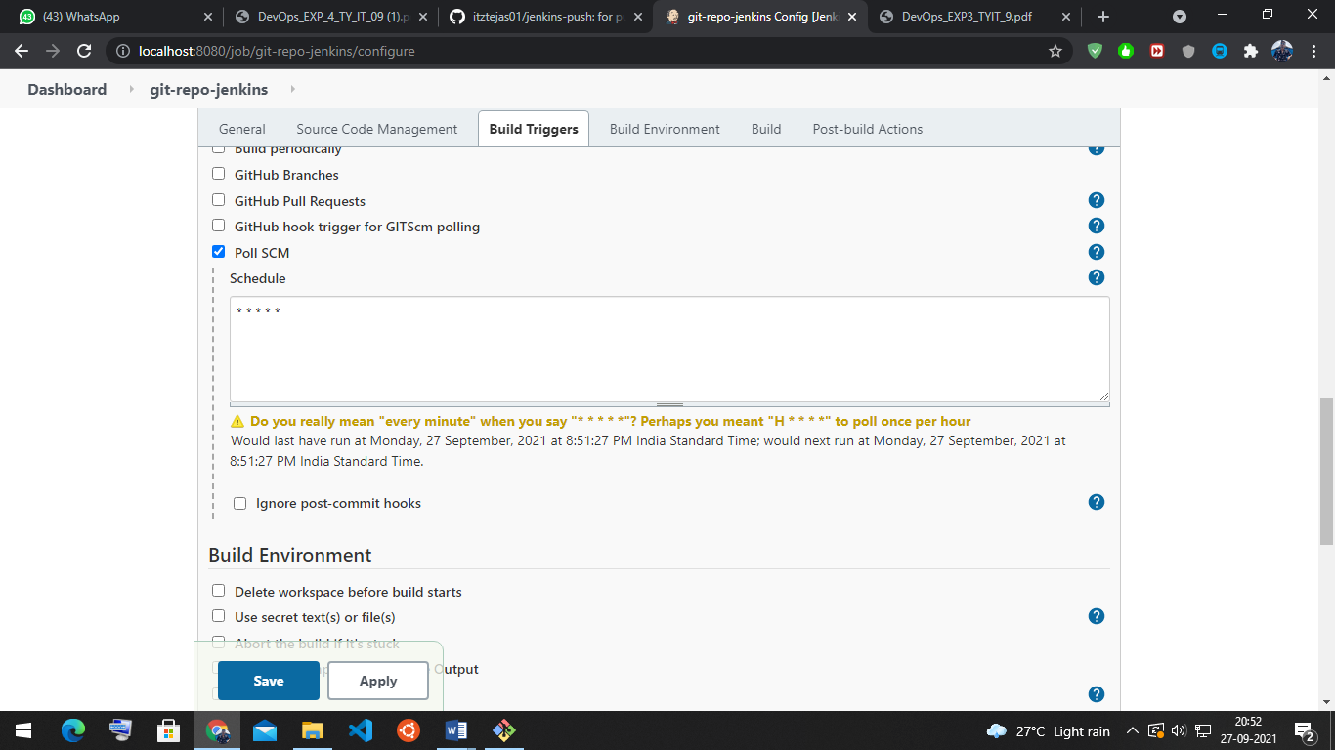

Fig 5: Creating Cronjobs for the repository

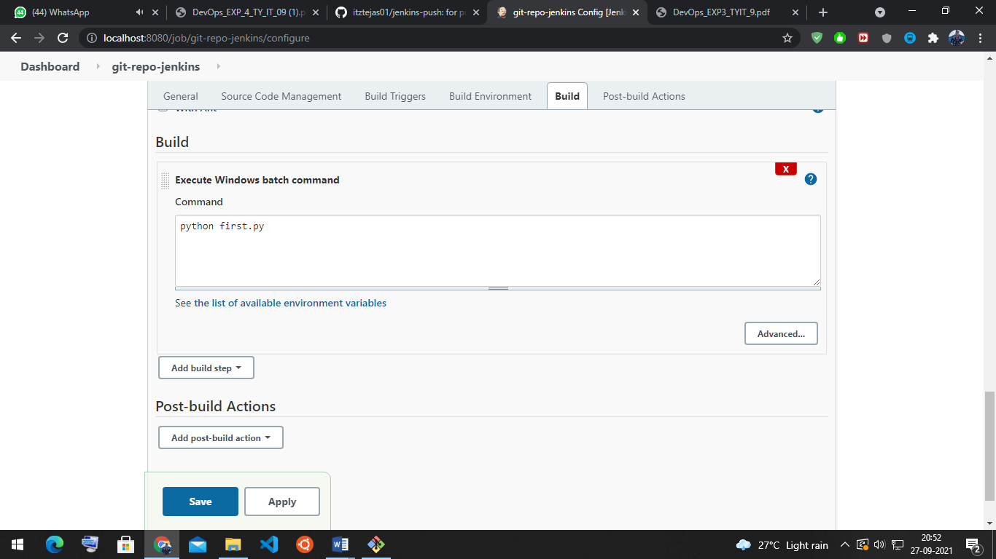

Fig 6: Executing python code

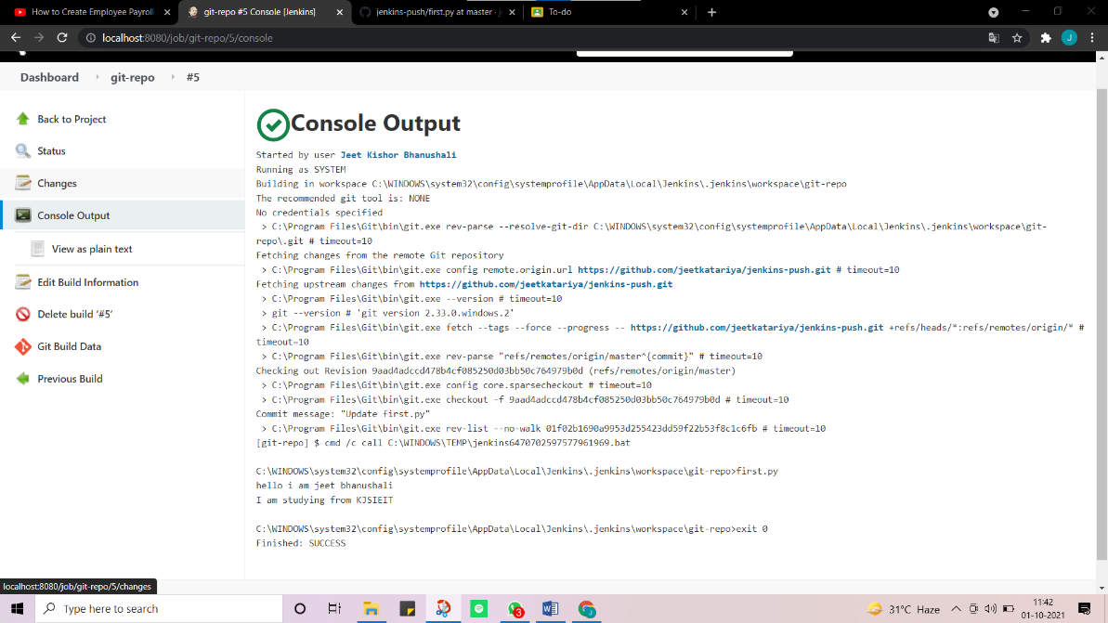

Fig 7: Console output of the code