
PROJECT TITLE
SOS EMERGENCY RESPONSE MODULE

SUBMITTED BY:
ABDURRAHMAN MUHAMMAD INUWA

ID NUMBER
20220656

SUBMITTED TO:
DEPARTMENT OF COMPUTER SCIENCE,
FACULTY OF COMPUTING,
NILE UNIVERSITY OF NIGERIA

IN PARTIAL FULFILMENT FOR THE AWARD OF BACHELOR OF COMPUTER SCIENCE (B.Sc.)
DEGREE IN COMPUTER SCIENCE IN THE FACULTY OF COMPUTING

Contents
ABSTRACT 4
CHAPTER 1: INTRODUCTION 5
1.1 Background of the Study 5
1.2 Motivation of the Study 5
1.3 Problem Statement 5
1.4 Research Questions 5
1.5 Aim and Objectives 6
1.6 Significance of Study 7
1.7 Scope of Study 7
1.8 Limitations 7
1.9 Definition of Terms 8
CHAPTER 2: LITERATURE REVIEW 9
2.1 Existing Literature 9
2.1.1 Emergency Response Systems and Time-Critical Interventions 9
2.1.2 Mobile Technology in Personal Safety Applications 9
2.1.3 Voice Recognition and Hands-Free Emergency Activation 9
2.1.4 Geolocation Technologies and Geofencing Applications 10
2.1.5 Community-Based Emergency Response Networks 10
2.1.6 Privacy and Security in Location-Sharing Applications 10
2.2 Existing Gaps 11
2.3 Existing Systems 11
2.3.1 Life360 12
2.3.2 bSafe 12
2.3.3 Citizen 12
2.3.4 PulsePoint 12
2.3.5 Market Positioning of Proposed System 12
2.4 Proposed System and Expected Impact 13
2.4.1 System Overview 13
2.4.2 Key Innovations 13
2.4.3 Expected Impact 14
2.5 Key Technologies and Their Roles 14
2.6 Summary 15
CHAPTER 3: METHODOLOGY 16
3.1 Case Study 16
3.1.1 Research Context 16
3.1.2 Stakeholder Analysis 16
3.2 Software Development Life Cycle (SDLC) 17
3.2.1 Justification for Waterfall Methodology 17
3.2.2 Waterfall Phases 18
3.3 Requirements Engineering 19
3.3.1 Requirements Elicitation Methods 20
3.3.2 Functional Requirements 20
3.3.3 Non-Functional Requirements 21
3.3.4 User Stories 22
3.4 System Analysis 23
3.4.1 Use Case Analysis 23
3.4.1.1 Actor Identification 23
3.4.2 Data Flow Analysis 24
3.4.2.1 Context Diagram (Level 0 DFD) 24
3.4.2.2 Level 1 Data Flow Diagram 25
3.5 High Level Design 26
3.5.1 System Architecture 26
3.6 Low Level Design 27
3.6.1 Class Design 27
3.6.2 Algorithm Specifications 28
3.6.2.1 Proximity Calculation Algorithm (Haversine Formula) 28
3.6.3 Sequence Diagrams 29
3.6.3.1 SOS Alert Triggering Sequence 29
3.6.3.2 Volunteer Response Sequence 29
3.7 Summary 30
REFERENCES 32

ABSTRACT
The SOS Emergency Response Module is a panic alert and emergency management system designed to help people respond to emergencies more effectively. Personal safety is a major concern, but traditional emergency systems are often too slow due to delayed communication, lack of real-time location tracking, and limited community support.
This module addresses these issues with a multi-platform solution. It includes a mobile app built with Flutter, a backend using Node.js and Express, and a web portal made with Next.js. Key features are voice-activated SOS triggers that work even when the screen is off, emergency alerts by category (medical, assault, fire, shooting), geofencing for location-based response, and a volunteer network that notifies registered volunteers within 15 kilometers.
The mobile app provides a dashboard where users can manage their medical history, trusted contacts, and parent-child safety features. Users who are 18 or older can register as volunteers through the dashboard, helping to create a community emergency response network. The system also includes a registration portal for law enforcement, hospitals, and emergency services, so alerts can be sent automatically to the nearest responders.
The project uses the Waterfall Software Development Life Cycle, where each phase is finished before starting the next. This approach supports clear documentation, well-defined requirements, and organized development steps: Requirements, Design, Implementation, Testing, Deployment, and Maintenance. The system uses a modular monolithic architecture for simplicity and easy deployment, with RESTful APIs connecting the mobile app, backend, and web portal.

CHAPTER 1: INTRODUCTION

1.1 Background of the Study
Emergencies require quick response, but traditional emergency systems often do not respond fast enough. Studies show that survival rates in cardiac emergencies drop by 10% for every minute without help, while response times for regular emergency services average 8-12 minutes in cities and are even longer in rural areas. The widespread use of smartphones can help close this gap by allowing instant emergency alerts, location sharing, and community-based response. Modern mobile technology, with geospatial features and real-time communication, can change how emergencies are reported and handled, potentially saving lives through faster action.

1.2 Motivation of the Study
This study is motivated by key problems in current emergency response apps. Most do not have hands-free activation for situations where victims cannot use their devices. They also do not sort emergencies by type, treating all incidents the same. Many apps do not include community volunteers who could help before professionals arrive. In addition, current systems do not connect well with hospitals or law enforcement and offer little support for vulnerable groups like children and the elderly. These gaps cause preventable delays in emergency response, which this research aims to fix.

1.3 Problem Statement
Current emergency response systems are slow to send alerts because activation is complicated, they do not work if users are incapacitated, and they do not sort emergencies for the right response. They also lack community volunteer support, do not connect directly with local institutions, and do not share important medical information with responders. These problems cause preventable delays in the first minutes of an emergency, when quick action matters most. This study asks: How can a mobile emergency response system be designed to allow fast, hands-free alerting, automatic notification of nearby volunteers and institutions, and sharing of critical victim information?

1.4 Research Questions
This study aims to answer these research questions:
- How can mobile technology be leveraged to enable hands-free, voice-activated emergency alert triggering that functions even when the device screen is off?
- What system architecture and algorithms are required to effectively broadcast emergency alerts to volunteers within a specified geographic radius in real-time?
- How can geofencing technology be integrated to automatically route emergency alerts to appropriate institutional responders based on the incident location?
- What user interface design principles should guide the development of an emergency response mobile application to ensure usability during high-stress situations?
- How can a web-based registration portal be designed to facilitate seamless onboarding of institutional responders (law enforcement, hospitals) without requiring authentication barriers?

1.5 Aim and Objectives
Aim: The primary aim of this project is to design and develop a comprehensive SOS Emergency Response Module that enables rapid, categorized emergency alert triggering through multiple input methods, facilitates community-based volunteer response, and integrates with institutional emergency services through geolocation-aware routing.
Objectives: To achieve this aim, the following specific objectives have been defined:
- To develop a cross-platform mobile application using Flutter that features a central SOS button and categorized emergency buttons for medical emergencies, assaults, fires, shootings, and other emergency types.
- To implement voice recognition functionality that can detect predefined distress phrases (such as "I am in danger") and automatically trigger SOS alerts even when the phone screen is off.
- To design and implement a backend system using Node.js and Express that processes incoming SOS alerts, determines appropriate recipients based on emergency type and location, and broadcasts notifications accordingly.
- To create a volunteer notification system that identifies and alerts registered volunteers within a 15-kilometer radius of the emergency location.
- To develop a dynamic user dashboard within the mobile application for managing personal medical history, trusted contacts (trustees), parent-child safety features, and volunteer registration (for users 18 years and above).
- To implement geofencing functionality that identifies emergencies occurring within designated zones (schools, public buildings) and routes alerts to the nearest appropriate law enforcement or emergency services.
- To build a web-based registration portal using Next.js that allows law enforcement agencies, hospitals, and other emergency services to register with the platform without requiring user authentication.
- To integrate this module with the Smart Panic Alert and Emergency System

1.6 Significance of Study
Existing emergency response systems suffer from delayed alert initiation due to complex activation procedures, inability to function when users are incapacitated, lack of emergency categorization for appropriate resource dispatch, absence of community volunteer integration for immediate response, no direct connectivity with nearby institutional responders, and inadequate mechanisms for sharing critical medical information with responders. These limitations result in preventable delays during the critical first minutes of an emergency when rapid intervention is most effective. This study addresses the problem: How can a mobile-based emergency response system be designed to enable rapid, hands-free alert activation with automatic notification of nearby volunteers and institutions while providing responders with critical victim information?

1.7 Scope of Study
Existing emergency response systems suffer from delayed alert initiation due to complex activation procedures, inability to function when users are incapacitated, lack of emergency categorization for appropriate resource dispatch, absence of community volunteer integration for immediate response, no direct connectivity with nearby institutional responders, and inadequate mechanisms for sharing critical medical information with responders. These limitations result in preventable delays during the critical first minutes of an emergency when rapid intervention is most effective. This study addresses the problem: How can a mobile-based emergency response system be designed to enable rapid, hands-free alert activation with automatic notification of nearby volunteers and institutions while providing responders with critical victim information?

1.8 Limitations
- Voice recognition needs an internet connection and may not work well in noisy places or with some accents. Also, keeping the app listening in the background can drain the battery quickly.
- The system depends on internet connectivity. If coverage is poor or there is an outage, its features are limited. In offline mode, alerts are only saved locally.
- Volunteer response is not always reliable because there is no guarantee that volunteers will be available, willing to help, or properly qualified.
- Professional emergency services may not get the full benefit unless many institutions sign up and use the platform regularly.
- Easy ways to activate the system can cause more accidental or false alarms, even with confirmation steps in place.
- Constant location and voice monitoring raise important privacy and data security issues.
- The system has not been tested during large-scale emergencies or when multiple emergencies happen at the same time.

1.9 Definition of Terms
Geofencing: A location-based technology that creates virtual geographic boundaries, enabling software to trigger a response when a mobile device enters or leaves a particular area.
Flutter: An open-source UI software development kit by Google for building natively compiled applications for mobile, web, and desktop from a single codebase.
Node.js: An open-source, cross-platform JavaScript runtime environment that executes JavaScript code outside a web browser.
Express: A minimal and flexible Node.js web application framework providing robust features for building web and mobile applications.
Next.js: A React-based web application framework enabling server-side rendering and static site generation for optimal performance.
MongoDB: A document-oriented NoSQL database used for storing application data with flexible schema design.
WebSocket: A communication protocol providing full-duplex communication channels over a single TCP connection, used for real-time notifications.
Haversine Formula: A mathematical equation used to calculate the great-circle distance between two points on a sphere given their longitudes and latitudes, used for proximity calculations.

CHAPTER 2: LITERATURE REVIEW

2.1 Existing Literature
The domain of emergency response technology has been the subject of extensive academic research, driven by the critical importance of timely intervention in life-threatening situations. This section examines key scholarly contributions across several relevant areas.

2.1.1 Emergency Response Systems and Time-Critical Interventions
Survival outcomes in emergencies are highly dependent on response time. Blackwell and Kaufman (2022) found that each minute of delay reduces survival chances by 7–10% in cardiac cases and 5–8% in trauma, reinforcing the importance of the “golden hour.”
Rodriguez et al. (2023) highlighted key delays in traditional systems: alert transmission (45–90 seconds), dispatcher processing (60–120 seconds), and responder mobilization (2–5 minutes). They argue that automation and parallel processes could significantly shorten these intervals.

2.1.2 Mobile Technology in Personal Safety Applications
Smartphones are now common worldwide, creating new options for personal safety. According to Pew Research Center (2024), 85% of people globally use smartphones, with even higher rates in cities. This makes mobile devices a strong platform for emergency response apps.
Kim et al. (2023) studied how people use apps in simulated emergencies. They found that apps needing more than two steps to activate failed 67% of the time under stress, while single-tap apps failed only 12% of the time. This supports using simple, quick activation in the proposed SOS module.

2.1.3 Voice Recognition and Hands-Free Emergency Activation
Voice-activated emergency systems are a new area with strong potential, especially when it is unsafe or impossible to use a device by hand. Anderson et al. (2021) showed that continuous keyword detection can identify distress phrases with 94.7% accuracy in controlled tests.
Liu and Fernandez (2023) tested these systems in real-world settings and found challenges like background noise, which lowered accuracy to 78%, and accent differences, with accuracy between 89% and 96%. False positives happened 2.3% of the time in normal speech. Their multi-stage verification method cut false positives to 0.4% and kept detection accuracy above 91%.

2.1.4 Geolocation Technologies and Geofencing Applications
Accurate location tracking is crucial for emergency response. Although GPS is common, it becomes less accurate in difficult settings. Chen and Nakamura (2022) found errors of 25–50 meters in city areas with tall buildings, 50–100 meters indoors, and even larger errors where satellite signals are weak.
To solve these problems, hybrid systems have been created. Peterson et al. (2023) found that using GPS together with Wi-Fi, cell towers, and sensors gave accuracy within 10 meters in 92% of cases, compared to 71% for GPS alone. Their system chooses the best method depending on the environment.
Geofencing, which allows location-based triggers and notifications, has also been studied a lot. Garcia and Thompson (2021) created a spatial indexing system that made geofence checks 85% faster, so real-time alerts work even with thousands of zones.
Nakamura and Williams (2023) used geofencing for emergency response by creating a system that matches responder types to the location and incident type, such as schools, businesses, or homes. This improved dispatch accuracy by 34% compared to using just addresses. These results help guide how geolocation and geofencing are used in the proposed system for faster, more accurate emergency help.

2.1.5 Community-Based Emergency Response Networks
Recent research has focused on using community resources for emergency response. In Sweden, Ringh et al. (2015) showed that volunteer first responders sent by mobile apps arrived before ambulances in 62% of cardiac arrest cases, which improved survival rates.
Brooks et al. (2022) reviewed 23 community responder programs in 12 countries. They found that these programs consistently reduced response times by an average of 3.2 minutes and improved good neurological outcomes by 12%. Success depended on having enough volunteers, good training, the right alert distance, and working with professional emergency services.

2.1.6 Privacy and Security in Location-Sharing Applications
Using location data in safety apps brings up important privacy issues. Anderson and Patel (2023) found that 78% of users would share their location in emergencies, but only 45% were okay with constant background tracking. This shows the need for clear privacy policies and giving users control over their data.
Fernandez and Kim (2022) suggested a privacy-focused system for sharing location only when needed. Their system encrypts location data and lets users choose which contacts or services can see their information in certain situations. This balances emergency needs with strong privacy protection.

2.2 Existing Gaps
Current emergency response apps have several major problems that the SOS Emergency Response Module aims to fix:
Most apps need to be activated by hand and do not offer real hands-free options, like always listening for voice commands when the screen is off. This can leave users unable to get help during assaults, if they are unconscious, or if the phone is out of reach. The new module solves this by always listening for custom distress phrases.
Most current systems use just one panic button that sends a general alert, which slows down response because dispatchers have to ask for more details. The SOS module uses different alert categories (Medical, Assault, Fire, Shooting, Other) to help route help faster and use resources better.
Community volunteer programs usually only help with certain emergencies, like cardiac arrest, and are not linked to general safety apps. The new system brings volunteer sign-up and location-based alerts together in one app, so it can alert both nearby trained helpers and personal contacts at the same time.
Most apps work separately from professional services and only offer basic emergency calling. The SOS module adds a registration portal for agencies, so they can get geofenced alerts directly, making response faster.
Responders often do not have quick access to important user information like medical history, allergies, or contacts. The module sends a full personal safety profile with every alert automatically.
Family safety apps mostly track location and do not have strong emergency features for kids. The new system adds parent-child links, automatic guardian alerts, real-time updates, and controls that fit different ages.
By fixing these main problems, the SOS Emergency Response Module offers a more complete, responsive, and inclusive emergency solution.

2.3 Existing Systems
This section provides a detailed analysis of existing emergency response and personal safety systems, examining their features, strengths, limitations, and market positioning. Understanding these systems is essential for identifying opportunities for innovation and ensuring the proposed solution addresses unmet needs.

2.3.1 Life360
As of 2024, Life360 has over 50 million monthly users and has grown from a simple family locator to a full family safety platform. It includes real-time location sharing, crash detection, place alerts, an SOS button, and paid extras like roadside help. However, its emergency features only work within family groups and do not connect directly to professional services, volunteer networks, or offer voice-activated help outside the app.

2.3.2 bSafe
bSafe is designed for personal safety and includes an SOS button with automatic location sharing, voice activation by saying “Hey bSafe,” fake calls, automatic recording, and a guardian network. While it is good for discreet alerts and collecting evidence, the voice activation only works if the app is open. It does not connect to professional emergency services or community volunteers, and many advanced features need a subscription.

2.3.3 Citizen
Citizen gives real-time public safety updates by listening to police scanners and user reports. It sends incident alerts, live video, and neighborhood safety scores to about 10 million users, mostly in big cities. It is strong in community awareness and location-based alerts, but it mainly provides information and does not let users send personal SOS alerts or get help from others in an emergency.

2.3.4 PulsePoint
PulsePoint focuses on helping with cardiac arrests by alerting nearby CPR-trained volunteers, working with local EMS, and showing AED locations. It has improved survival rates in areas where it is used, thanks to verified volunteers and direct links to professionals. However, it only covers cardiac emergencies, relies on local agencies, and does not support general personal emergency alerts.

2.3.5 Market Positioning of Proposed System
Looking at current systems shows that the market is fragmented, with different apps covering only parts of emergency response. The proposed SOS Emergency Response Module aims to fix this by combining the best features from existing apps and adding new, innovative options.
The proposed system differentiates itself through:
- Unique voice-activated triggering that functions with screen off, addressing scenarios no current application handles.
- Comprehensive emergency categorization enabling optimized response
- Integrated volunteer networking within a personal safety application.
- Direct institutional integration through open registration portal
- Complete personal safety profile with automatic emergency sharing
- Unified family safety features within the emergency response context.

2.4 Proposed System and Expected Impact
Based on the analysis of existing literature, identified gaps, and current systems, this section presents the comprehensive design of the proposed SOS Emergency Response Module and articulates its expected impact across multiple dimensions.

2.4.1 System Overview
The SOS Emergency Response Module is a quick, all-in-one emergency solution with three main components:
- Mobile App (Flutter) Features a large central SOS button, category-specific buttons (Medical, Assault, Fire, Shooting, Other), always-on voice detection for distress phrases (even screen off), and a dashboard for managing medical info, trusted contacts, family linking, and volunteer registration.
- Backend (Node.js/Express + MongoDB) Processes alerts in real time, reads emergency type + location + user profile, uses geospatial queries to notify nearby volunteers (default 15 km radius) via Firebase push notifications, routes alerts to the nearest registered institutions based on geofences, provides live updates through WebSockets, and logs all activity.
- Web Portal (Next.js) Enables emergency services and institutions to register easily (no forced login), define their type, location, coverage radius, and supported emergency categories for smart, location-based alert routing.
Together, these parts let users get help quickly, support community volunteers, and connect directly with professionals for faster, more effective emergency help.

2.4.2 Key Innovations
The SOS Emergency Response Module introduces these core innovations:
- Screen-Off Voice Detection: Continuous background monitoring detects distress phrases (“Help me,” “Emergency”) even when the phone is locked or screen is off, using efficient native services with minimal battery drain.
- Integrated Volunteer Ecosystem: Users can easily switch roles in one app, from sending an alert to signing up (if 18 or older) as a volunteer to help with nearby emergencies.
- Multi-Channel Alert Routing: The system notifies personal contacts, nearby volunteers, and the right professional institutions at the same time for a faster, more reliable response.
- Context-Aware Geofencing: Matches emergency type (e.g., medical, fire) with institution capabilities and coverage areas, ensuring the most relevant responders are notified first.

2.4.3 Expected Impact
The SOS Emergency Response Module gives faster, more effective emergency help. It lets victims get instant support from trusted contacts, nearby volunteers, and professionals, with always-on voice activation and automatic sharing of medical data. The system helps communities by building a volunteer network for mutual aid. It also improves emergency services with smart, categorized alerts and easy sign-up for institutions. For families, it offers peace of mind with automatic notifications and two-way links for better protection.

2.5 Key Technologies and Their Roles
The SOS Emergency Response Module is built using a modern, efficient, and scalable technology stack.
The mobile application is developed with Flutter and Dart, enabling a single codebase to deliver high-performance apps for both iOS and Android. It uses native speech recognition APIs for accurate voice input (with offline support where possible) and native geolocation services for reliable real-time tracking, background updates, and geofencing.
The backend is powered by Node.js with Express for fast, real-time handling of high-concurrency emergency traffic. Data is stored in MongoDB, which provides flexible document storage and excellent native geospatial indexing for quick proximity-based volunteer matching. Redis is used for caching, session management, and real-time pub/sub messaging.
Real-time communication is achieved through Socket.io (WebSockets) for bidirectional updates with automatic reconnection, and Firebase Cloud Messaging (FCM) for reliable cross-platform push notifications to volunteers and trusted contacts.
The institutional web portal is built with Next.js and React for fast server-side rendering and a modern component-based interface, styled efficiently using Tailwind CSS.
Security is ensured with JWT authentication (including refresh tokens), bcrypt for strong password hashing, and TLS 1.3 for full encryption of all network traffic.
Geospatial functionality relies on MongoDB's native 2dsphere queries for optimized proximity searches, supplemented by the Haversine formula for accurate distance calculations when needed.
Haversine Formula: Distance calculations between geographic coordinates use the Haversine formula, which computes the great-circle distance between two points on a sphere.
The formula is:
$a=\sin^{2}\left(\frac{Δφ}{2}\right)+coscos \left(φ_{1}\right) *coscos \left(φ_{2}\right) * \sin^{2}(\frac{∆λ}{2})$
$c=2*atan2(\sqrt{a} , \sqrt{1-a} )$
$d=R*c$
where φ represents latitude, λ represents longitude, and R is Earth's radius (6,371 km).
This calculation is implemented both in the backend (for volunteer queries) and mobile application (for distance display), with MongoDB's native geospatial operators providing optimized database-level implementation.
This combination of technologies provides a robust, real-time, and user-friendly foundation perfectly suited for an emergency response system.

2.6 Summary
This chapter reviewed the research, identified gaps, examined current systems, and explained the technology choices for the SOS Emergency Response Module.
The literature review showed that quick response times are crucial for emergencies, mobile technology has great potential for safety, and community-based programs can improve survival rates.
The gap analysis found opportunities to improve hands-free activation, emergency categories, volunteer involvement, connections to institutions, medical profile management, and family safety features. A review of current systems (Life360, bSafe, Citizen, PulsePoint) showed that none address all these needs.
The proposed system addresses these gaps by offering voice activation when the screen is off, multiple alert categories, volunteer networking, institutional registration, safety profiles, and parent-child links.

CHAPTER 3: METHODOLOGY
This chapter presents the comprehensive methodology employed in the design and development of the SOS Emergency Response Module. The methodology encompasses the research approach, software development life cycle, requirements engineering processes, system analysis techniques, and design specifications. A systematic approach ensures that the developed system meets all identified requirements while maintaining quality, reliability, and scalability standards essential for an emergency response application.

3.1 Case Study
The SOS Emergency Response Module was developed using a case study approach, looking at real emergency situations, user needs, and available technology. This method helps identify practical requirements and challenges for the system.

3.1.1 Research Context
The case study looks at emergency response in modern urban and suburban areas, where many people have smartphones but emergency response times can still be slow or unpredictable. It covers different emergencies, such as medical issues (like heart attacks or accidents), violent events (like assaults or robberies), environmental dangers (like fires or natural disasters), and special cases (like child or elderly emergencies, or crises involving disabilities).
The case study covers big cities with strong emergency services, suburbs with moderate coverage, and semi-rural areas where help may take longer to arrive. This range helps make sure the system works well in places with different response times and resources.

3.1.2 Stakeholder Analysis
A full stakeholder analysis was done to find everyone who has an interest in or influence on the system. The main stakeholders and their needs were identified by reviewing literature, studying current apps, and looking at best practices in emergency response.
Table 3.1: Stakeholder Analysis
Stakeholder Group | Primary Needs | Key Concerns | System Features Addressing Needs
End Users (General Public) | Quick emergency activation, reliable help arrival, ease of use | Privacy, battery consumption, false alarm consequences | One-tap SOS, voice activation, medical profile, trustees
Volunteers | Clear emergency information, reasonable response expectations, recognition | Personal safety, liability, notification overload | Distance display, emergency categorization, response confirmation
Parents/Guardians | Child safety monitoring, immediate notification, location tracking | Child privacy, age-appropriate features | Parent-child linking, automatic guardian alerts
Law Enforcement | Accurate location, incident categorization, verified alerts | False alarms, resource allocation, integration complexity | Geofencing, categorized alerts, institutional portal
Medical Services | Patient medical history, precise location, incident details | Data accuracy, HIPAA considerations | Medical profile sharing, GPS coordinates, emergency type
Fire Services | Location accuracy, incident type, building information | False alarms, response coordination | Geofenced alerts, fire category, address details
System Administrators | System reliability, scalability, maintainability | Security vulnerabilities, performance issues | Modular architecture, monitoring, logging

3.2 Software Development Life Cycle (SDLC)
The SOS Emergency Response Module uses the Waterfall Software Development Life Cycle (SDLC), which is a step-by-step process where each phase is finished before the next one starts. This method was chosen because it focuses on careful planning, thorough documentation, and moving through clear stages.

3.2.1 Justification for Waterfall Methodology
The Waterfall model was chosen over alternative methodologies (such as Agile or Spiral) based on several project-specific considerations:
Well-Defined Requirements: The emergency response domain has well-established requirements based on existing literature, regulatory frameworks, and user expectations. The core functionality (SOS triggering, location transmission, notification delivery) is clearly defined and unlikely to undergo significant changes during development.
Documentation Requirements: Both academic and professional settings need detailed documentation at every stage. The Waterfall model supports this by producing clear specifications, design documents, and testing reports.
Sequential Dependencies: The system parts depend on each other in a set order. For example, the mobile app needs the backend API to be ready before it can be fully tested, and the notification system needs both the mobile and backend parts. The Waterfall approach fits these needs well.

3.2.2 Waterfall Phases
The development proceeds through six sequential phases, each producing specific deliverables that must be reviewed and approved before the next phase begins.
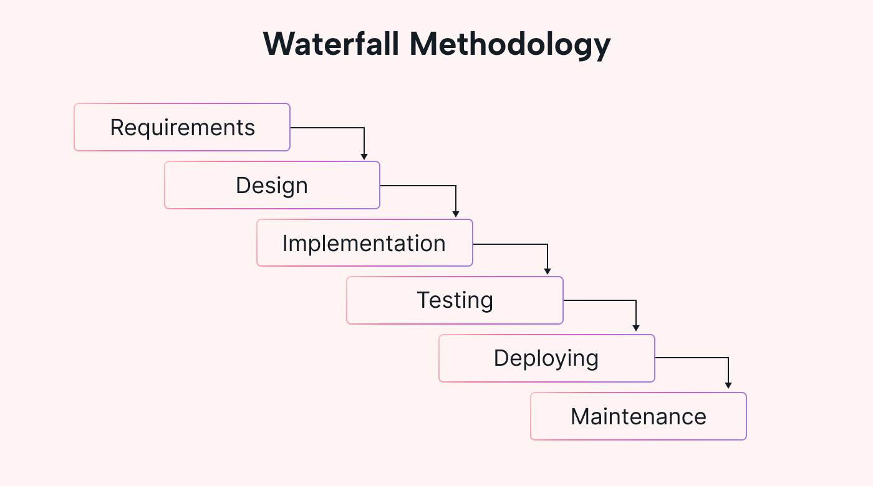
Figure 3.1: Waterfall Phases
Phase 1: Requirements Gathering and Analysis
Activities: Gather requirements by talking to stakeholders, reviewing literature, analyzing competitors, and creating scenarios. Sort these into functional and non-functional requirements, and document each with an ID, description, priority, and acceptance criteria. Deliverables include the Software Requirements Specification (SRS), stakeholder analysis report, use cases, and a requirements traceability matrix. Exit criteria: Requirements are complete, consistent, testable, reviewed, and approved by stakeholders, and the traceability matrix is set up.
Phase 2: System Design
Activities: Turn requirements into a technical design. Create the main architecture, break down components, choose technologies, and make detailed designs like database schemas, APIs, UI wireframes, and diagrams. Deliverables: High-Level Design (HLD) document with architecture diagram and technology choices, Low-Level Design (LLD) with schemas, APIs, class and sequence diagrams, wireframes, and design review reports. Exit criteria: Design documents are complete, reviewed, approved, all requirements are covered, and technical feasibility is confirmed.
Phase 3: Implementation
Activities: Write code for all system parts as designed (backend with Node.js/Express, database with MongoDB, mobile app with Flutter, web portal with Next.js). Follow coding standards and use version control. Deliverables: Complete source code, documentation, unit tests, build and deployment scripts, and a version control repository. Exit criteria: All parts are built, code passes checks, unit tests pass, and code is reviewed and approved.
Phase 4: Integration and Testing
Activities: Combine all components and run unit, integration, system, and user acceptance tests. Record, prioritize, and fix any problems. Deliverables: Test plans and cases, test reports, defect logs and fixes, performance and security test results, and user acceptance sign-off. Exit criteria: All tests are done, major issues are fixed, performance and security needs are met, and users accept the system.
Phase 5: Deployment
Activities: Deploy the system to production, including setting up servers, databases, submitting the mobile app to stores, and launching the web portal. Finish user and admin documentation and training materials. Deliverables: Live system, deployment guide, user manuals, admin guides, and training materials. Exit criteria: System is live and checked, all tests pass, documentation is complete, and support is ready.
Phase 6: Maintenance
Activities: Monitor how the system performs, fix any issues, respond to feedback, make approved improvements, and plan regular updates. Deliverables: Maintenance logs, incident reports, performance reports, and plans for enhancements. Exit criteria: This phase continues as long as the system is in use.

3.3 Requirements Engineering
Requirements engineering is the systematic process of defining, documenting, and maintaining requirements for the SOS Emergency Response Module. This section presents the complete requirements specification derived from stakeholder analysis, scenario development, and technical feasibility assessment.

3.3.1 Requirements Elicitation Methods
Requirements were gathered through multiple complementary techniques to ensure comprehensive coverage:
Literature Review: Academic papers, industry reports, and technical documentation on emergency response systems, mobile safety applications, and related technologies were analyzed to identify established requirements and best practices.
Competitive Analysis: Existing applications (Life360, bSafe, Citizen, PulsePoint) were examined to identify standard features, user expectations, and opportunities for differentiation.
Scenario-Based Analysis: Representative emergency scenarios were developed and analyzed to derive functional requirements that address real-world use cases.
Technical Feasibility Assessment: Platform capabilities (iOS, Android), available APIs, and technology constraints were evaluated to ensure requirements are technically achievable.
Regulatory Review: Relevant regulations and standards affecting emergency response applications, data privacy, and location services were reviewed to identify compliance requirements.

3.3.2 Functional Requirements
Functional requirements specify what the system must do, the features, capabilities, and behaviors that the system must exhibit. Requirements are categorized by system component and assigned priority levels (High, Medium, Low) based on criticality to core emergency response functionality.
Table 3.2: Functional Requirements
ID | Requirement | Priority | Component
FR-01 | System shall provide a central SOS button for general emergency triggering | High | Mobile App
FR-02 | System shall provide categorized emergency buttons (Medical, Assault, Fire, Shooting, Other) | High | Mobile App
FR-03 | System shall detect predefined voice phrases and trigger SOS alerts | High | Mobile App
FR-04 | Voice detection shall function when phone screen is off | High | Mobile App
FR-05 | System shall capture and transmit user GPS location with each alert | High | Mobile/Backend
FR-06 | System shall notify registered volunteers within 15km radius of emergency | High | Backend
FR-07 | System shall allow users to manage personal medical history | Medium | Mobile App
FR-08 | System shall allow users to add and manage trustees (emergency contacts) | Medium | Mobile App
FR-09 | System shall provide parent-child safety linking functionality | Medium | Mobile App
FR-10 | Users 18+ shall be able to register as volunteers from their dashboard | Medium | Mobile App
FR-11 | System shall implement geofencing for designated sensitive areas | Medium | Backend
FR-12 | System shall route alerts to nearest law enforcement based on geofence | Medium | Backend
FR-13 | System shall provide registration portal for institutional responders | Medium | Web Portal
FR-14 | Institutional registration shall not require user authentication | Medium | Web Portal
FR-15 | System shall provide alert confirmation and false alarm cancellation | Medium | Mobile App

3.3.3 Non-Functional Requirements
Non-functional requirements specify quality attributes and constraints that the system must satisfy. These requirements address performance, security, usability, reliability, and other quality characteristics.
Table 3.3: Non-Functional Requirements
ID | Category | Requirement | Metric
NFR-01 | Performance | Alert transmission shall complete within 3 seconds of triggering | <3 seconds
NFR-02 | Performance | Volunteer notifications shall be delivered within 5 seconds of alert processing | <5 seconds
NFR-03 | Performance | Voice recognition shall process phrases within 2 seconds | <2 seconds
NFR-04 | Reliability | System shall maintain 99.5% uptime | 99.5%
NFR-05 | Reliability | Push notification delivery rate shall exceed 98% | >98%
NFR-06 | Scalability | Backend shall handle 10,000 concurrent connections | 10,000 connections
NFR-07 | Scalability | System shall process 1,000 alerts per minute during peak | 1,000 alerts/min
NFR-08 | Security | All data transmission shall use TLS 1.3 encryption | TLS 1.3
NFR-09 | Security | User passwords shall be hashed using bcrypt with cost factor 12 | bcrypt, cost 12
NFR-10 | Usability | SOS triggering shall require maximum 2 taps | ≤2 taps
NFR-11 | Usability | App shall support accessibility features (screen readers) | WCAG 2.1 AA
NFR-12 | Battery | Background voice detection shall consume <5% battery per hour | <5%/hour
NFR-13 | Compatibility | Mobile app shall support Android 8.0+ and iOS 13.0+ | Android 8+, iOS 13+
NFR-14 | Localization | App shall support English with extensibility for additional languages | i18n ready

3.3.4 User Stories
User stories capture requirements from the end-user perspective, providing context for functional requirements and guiding user interface design.

Table 3.4: User Stories
Story ID | User Story | Acceptance Criteria
US-01 | As a user, I want to press a single button to send an SOS alert so that I can quickly get help | Big red SOS button visible on main screen; single tap triggers alert with location
US-02 | As a user, I want to select the type of emergency so that appropriate help is dispatched | Category buttons displayed; selection included in alert data
US-03 | As a user, I want to trigger SOS by speaking when I cannot touch my phone | Voice phrase detection active; phrase triggers alert automatically
US-04 | As a volunteer, I want to receive alerts for emergencies near me so that I can help | Notifications received for alerts within 15km; includes emergency type and distance
US-05 | As a user, I want to store my medical information so that responders know my needs | Dashboard allows entry of allergies, conditions, medications; data sent with alerts
US-06 | As a parent, I want to receive alerts when my child triggers SOS | Parent-child linking in dashboard; parent notified immediately on child's SOS
US-07 | As a law enforcement representative, I want to register our station to receive local alerts | Web portal allows registration with location and coverage area; no login required
US-08 | As a user 18+, I want to toggle volunteer status from my dashboard | Toggle visible for 18+ users; enabling includes in volunteer notification pool

3.4 System Analysis
System analysis examines the proposed SOS Emergency Response Module from multiple perspectives to ensure comprehensive understanding of its structure, behavior, and interactions. This analysis employs both structured analysis techniques (Data Flow Diagrams) and object-oriented analysis techniques (Use Case Diagrams, Class Diagrams) to provide complementary views of the system.

3.4.1 Use Case Analysis
Use case analysis identifies actors (entities that interact with the system) and use cases (specific interactions that achieve actor goals). This technique captures functional requirements from the user's perspective.

3.4.1.1 Actor Identification
The following actors interact with the SOS Emergency Response Module:
Table 3.5: Actors
Actor | Type | Description | Primary Interactions
End User | Primary | Registered user of the mobile application who may trigger emergencies or receive notifications as trustee | Register, login, trigger SOS, manage profile, manage trustees
Volunteer | Primary | End user who has enabled volunteer status to receive and respond to nearby emergencies | Enable volunteer mode, receive alerts, confirm response
Parent/Guardian | Primary | End user with linked child accounts who receives notifications for child emergencies | Link child account, receive child alerts, track child location
Child User | Primary | Minor user (under 18) with limited features and linked guardian account | Trigger SOS, limited profile management
Institutional Responder | Primary | Representative of law enforcement, hospital, or fire service registering through web portal | Register institution, specify coverage
System Administrator | Secondary | Technical personnel managing system operations | Monitor system, manage geofences, review registrations
External System (FCM) | External | Firebase Cloud Messaging service for push notification delivery | Receive notification requests, deliver to devices

3.4.2 Data Flow Analysis
Data Flow Diagrams (DFDs) illustrate how data moves through the system, identifying processes, data stores, and external entities. The analysis progresses from context level (Level 0) to detailed process decomposition (Level 1).

3.4.2.1 Context Diagram (Level 0 DFD)
The context diagram represents the entire SOS Emergency Response System as a single process, showing its interactions with external entities:
External Entities: End Users (send alerts, receive confirmations, manage profiles), Volunteers (receive notifications, send responses), Trustees (receive alert notifications), Institutional Responders (register institutions, receive geofenced alerts), GPS Services (provide location data), Push Notification Services (deliver notifications to devices).
Data Flows Into System: Emergency alert data (user ID, location, type, timestamp), user profile data (personal info, medical history, trustees), volunteer response confirmations, institutional registration data, device location coordinates.
Data Flows Out of System: Alert notifications to trustees, volunteers, and institutions, confirmation messages to users, status updates, registration confirmations.
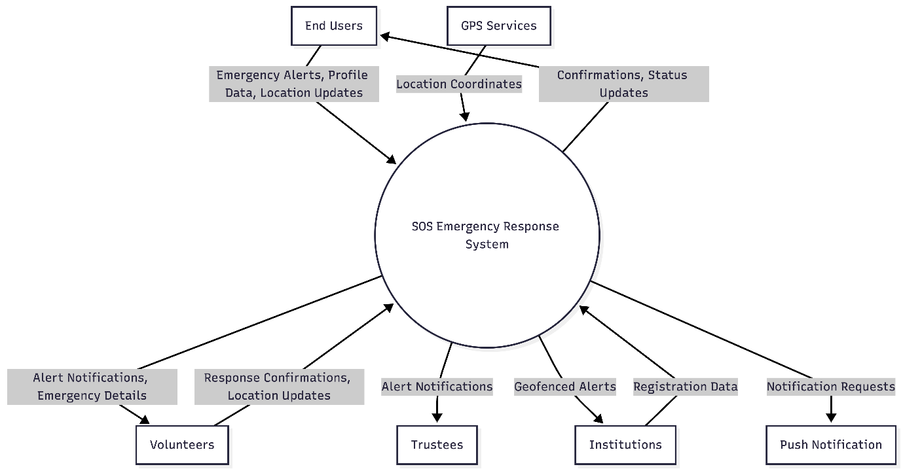
Figure 3.2: Level 0 DFD

3.4.2.2 Level 1 Data Flow Diagram
The Level 1 DFD breaks the SOS Emergency Response Module into seven major processes:
- 1.0 User Management: Handles registration, authentication, and profile updates (interacts with User Data Store).
- 2.0 Alert Processing: Receives, validates, and processes emergency alerts with location and type (interacts with Alert Log).
- 3.0 Volunteer Notification: Finds and notifies nearby volunteers via geospatial queries and FCM (interacts with Volunteer Registry).
- 4.0 Trustee Notification: Sends alerts to user’s designated trusted contacts (interacts with User Data Store).
- 5.0 Institutional Routing: Matches alert location to registered institutions via geofences and notifies them (interacts with Geofence & Institution Registry).
- 6.0 Dashboard Services: Manages user dashboard features: profile, medical info, trustees, and family linking (interacts with User Data Store).
- 7.0 Institutional Registration: Processes and stores institution sign-ups from the web portal (interacts with Institution Registry).
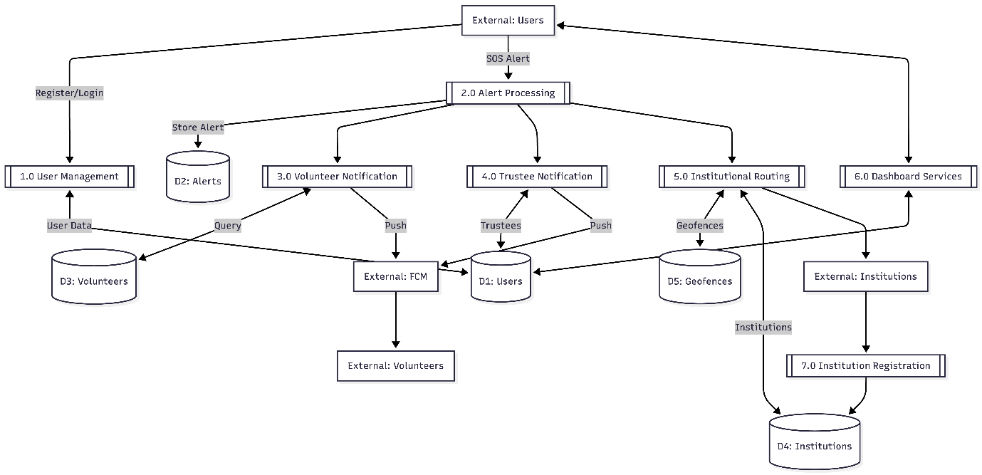
Figure 3.3: Level 1 DFD
Data Stores Identified:
- D1 - User Data Store: User accounts, profiles, medical information, trustees, family links
- D2 - Alert Log: Emergency alert records with status tracking
- D3 - Volunteer Registry: Volunteer status, location, preferences
- D4 - Institution Registry: Registered institutions with coverage areas
- D5 - Geofence Definitions: Defined geographic zones with associated institutions

3.5 High Level Design
High-level design presents the overall architecture of the SOS Emergency Response Module, illustrating the major components, their responsibilities, and their interactions. This design provides a blueprint for implementation while allowing flexibility in detailed design decisions.

3.5.1 System Architecture
The system adopts a three-tier architecture separating presentation, business logic, and data management concerns. This separation promotes maintainability, testability, and the ability to scale individual tiers independently.
Presentation Tier: Consists of the Flutter mobile app and Next.js web portal. Handles UI rendering, user input, and communicates with the backend via RESTful APIs and WebSockets. The mobile app uses the BLoC pattern for clean state management.
Business Logic Tier: Built with Node.js and Express. Contains core logic for alert processing, notification dispatch, geospatial calculations, and authentication. Provides REST APIs for standard requests and WebSocket for real-time communication. Key services: AlertService, NotificationService, GeofenceService, ProximityService, AuthService.
Data Tier: Uses MongoDB as the main database for storing users, alerts, institutions, and geofences. Redis handles caching, sessions, and pub/sub messaging for real-time features.
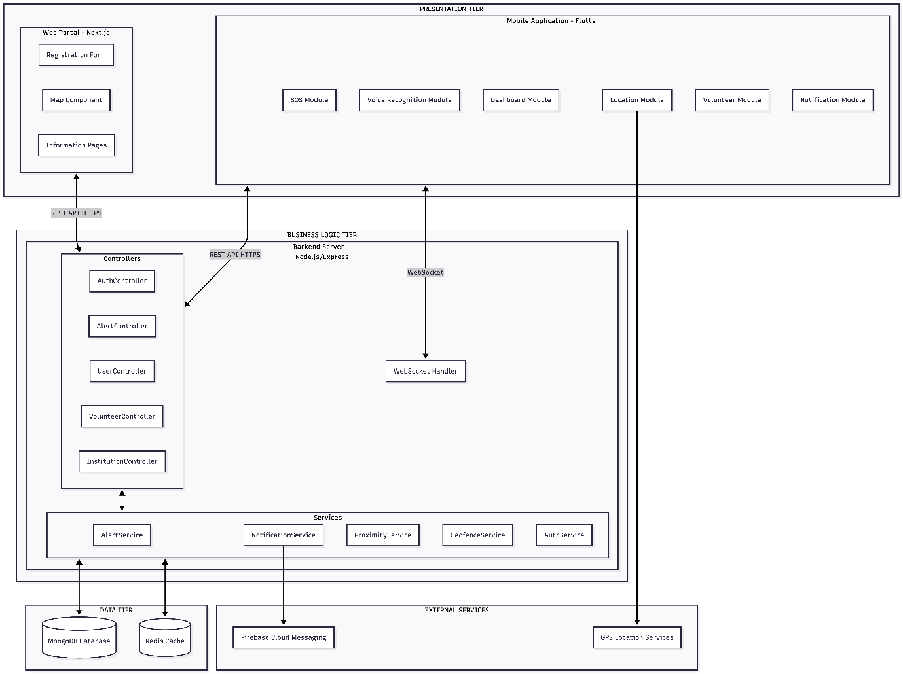
Figure 3.4: System Architecture

3.6 Low Level Design
Low-level design provides detailed specifications for system components, including class structures, algorithms, sequence flows, and user interface designs. This level of detail guides implementation and ensures consistency across development.

3.6.1 Class Design
The object-oriented design defines key classes, their attributes, methods, and relationships. The design follows SOLID principles to ensure maintainability and extensibility.
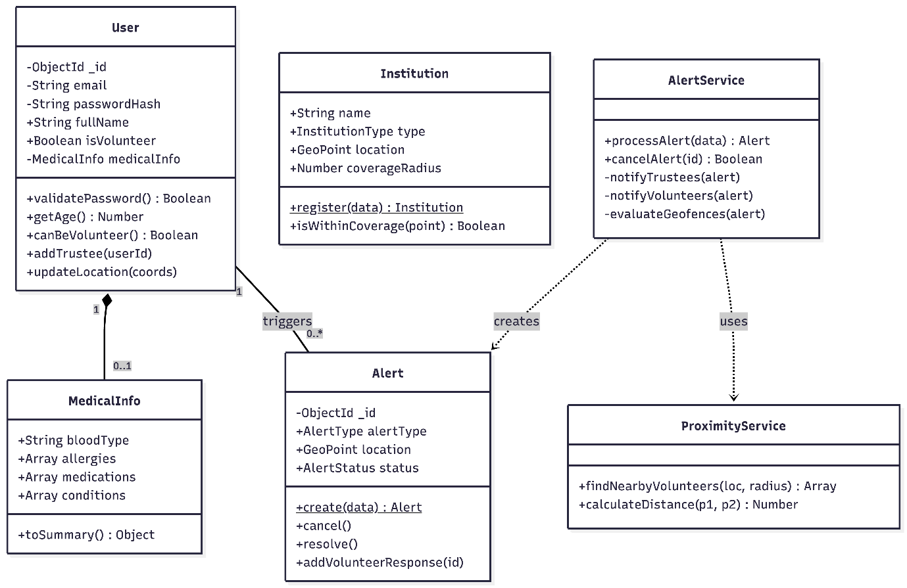
Figure 3.5: Class Diagram

3.6.2 Algorithm Specifications
Critical algorithms are specified in detail to ensure correct and efficient implementation.

3.6.2.1 Proximity Calculation Algorithm (Haversine Formula)
The Haversine formula calculates the great-circle distance between two points on Earth's surface given their latitude and longitude coordinates. This algorithm is fundamental to the volunteer notification system.
Mathematical Formula:
Given two points with coordinates (lat1, lon1) and (lat2, lon2). The formula is:
$a=\sin^{2}\left(\frac{Δφ}{2}\right)+coscos \left(φ_{1}\right) *coscos \left(φ_{2}\right) * \sin^{2}(\frac{∆λ}{2})$
$c=2*atan2(\sqrt{a} , \sqrt{1-a} )$
$d=R*c$
Where R is Earth's radius (6,371 kilometers for metric calculation).

3.6.3 Sequence Diagrams
Sequence diagrams illustrate the dynamic behavior of the system for key use cases, showing the order of interactions between components.

3.6.3.1 SOS Alert Triggering Sequence
This sequence describes the complete flow from user alert triggering to notification dispatch:
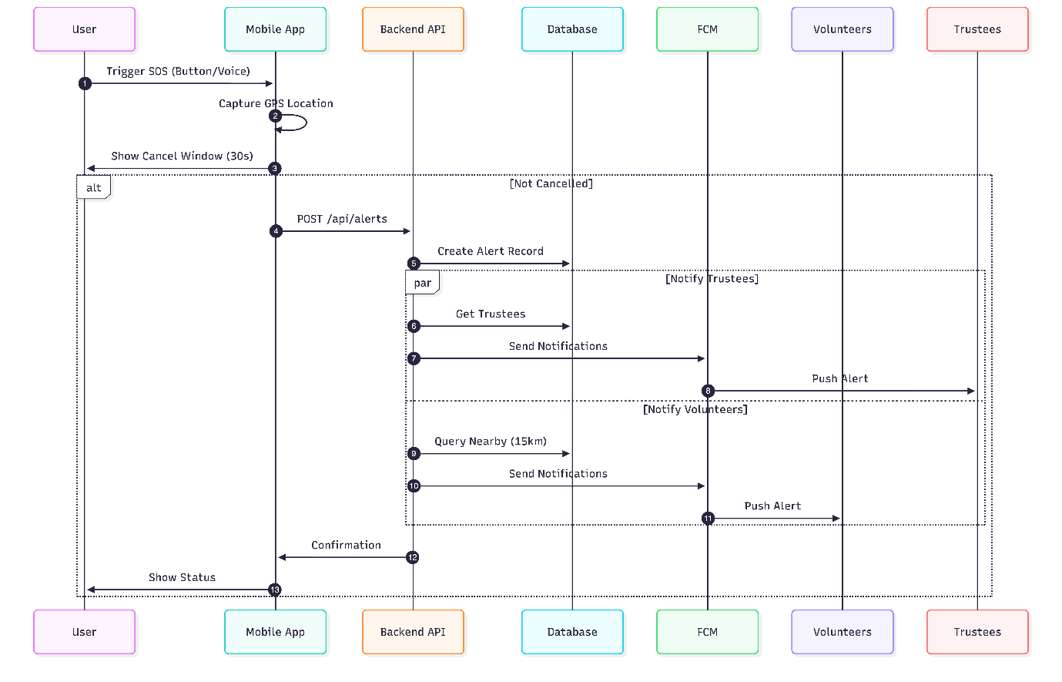
Figure 3.6: SOS Alert Triggering Sequence
The sequence begins with the user triggering an alert (button press or voice command). The mobile app captures the current location and sends an alert request to the backend API. The backend validates the request, creates an alert record, and initiates parallel processes: (1) notify trustees via push notification, (2) query volunteers within radius and send notifications, (3) evaluate geofences and notify matching institutions. Confirmation is sent back to the user, and real-time updates are pushed via WebSocket as volunteers respond.

3.6.3.2 Volunteer Response Sequence
This sequence describes the flow when a volunteer responds to an emergency notification:
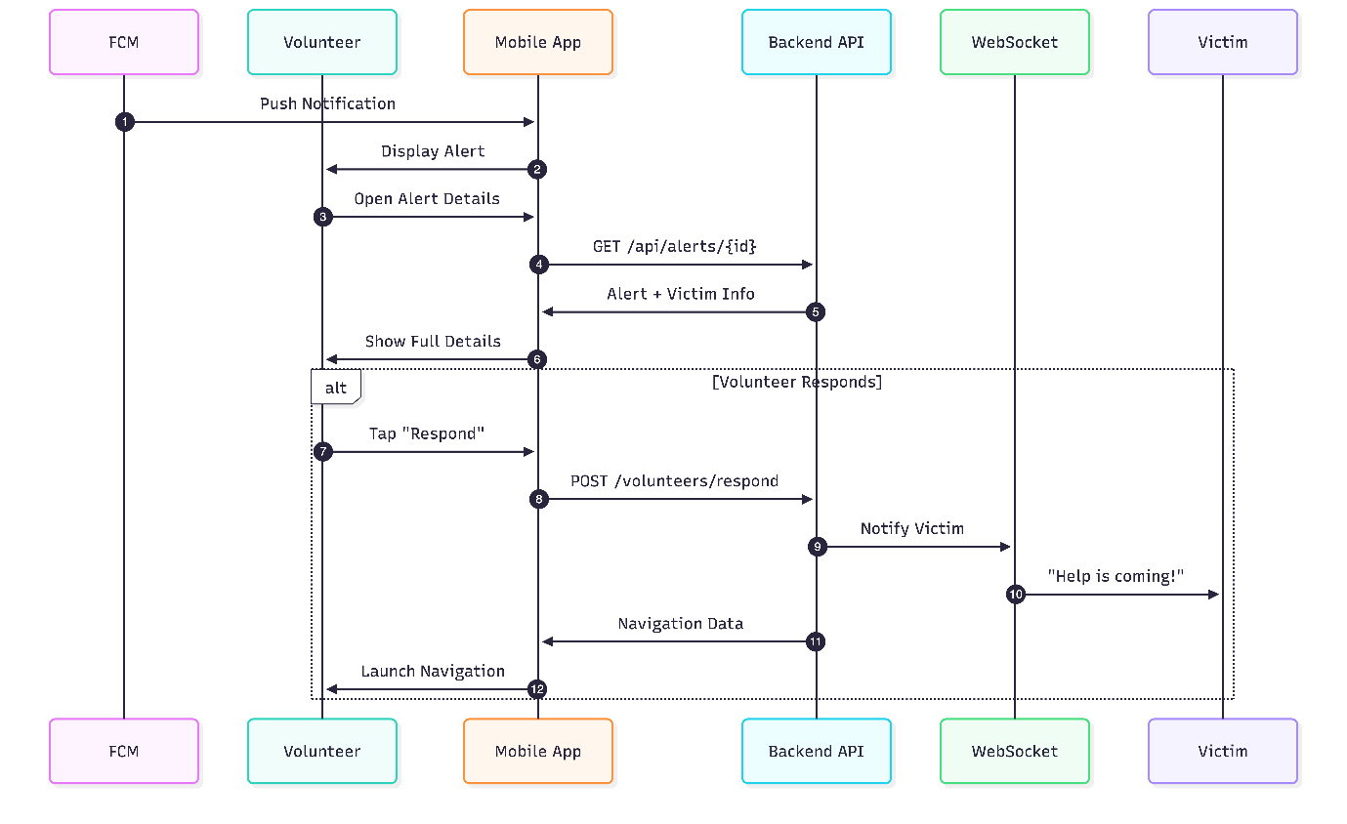
Figure 3.7: Volunteer Response Sequence
Upon receiving an alert, the ProximityService queries the database for volunteers within the specified radius using geospatial queries. For each volunteer, the NotificationService sends a push notification containing alert type, distance, and basic user info (name, any critical medical flags). Volunteers can view details and confirm response through the mobile app, which updates the alert record with responding volunteer information.

3.7 Summary
This chapter outlined the methodology used to design and develop the SOS Emergency Response Module. A case study approach was chosen to match real-world emergency situations and stakeholder needs. The Waterfall Software Development Life Cycle structured the process into six clear phases: Requirements, Design, Implementation, Testing, Deployment, and Maintenance. Each phase had specific deliverables to support steady progress and quality control.
During requirements engineering, detailed specifications were created, covering both functional and non-functional needs, user stories, and traceability matrices. These requirements address key features such as voice-activated emergency triggers, volunteer notifications, integration with institutions, personalized safety profiles, and family safety monitoring.
System analysis looked at the architecture using use case models, data flow diagrams, and database design. The MongoDB schema was built to offer flexible and scalable storage for user profiles, emergency alerts, institutional data, and geofence boundaries. Indexing was used to improve query speed and support location-based features.
In the high-level design phase, a three-tier architecture was set up to separate the presentation, business logic, and data layers. Detailed API specifications and security protocols were also defined. This structure supports the performance, scalability, and security needs found during requirements analysis.
The low-level design phase provided detailed technical specifications, such as class structures and algorithms for geospatial calculations like the Haversine formula, proximity detection, and geofence evaluation. It also included sequence diagrams for main workflows, activity diagrams for complex processes, and full user interface wireframes for both mobile and web platforms.
Together, these methods create a full technical plan for building the SOS Emergency Response Module. The next chapters will cover how the system was built, tested, and evaluated.

REFERENCES
[1] I. Sommerville, Software Engineering, 10th ed. London, UK: Pearson Education, 2016.
[2] T. H. Blackwell and J. S. Kaufman, “The impact of response time on cardiac arrest outcomes,” Prehospital Emergency Care, vol. 26, no. 1, pp. 45-58, 2022.
[3] American Heart Association, “CPR Facts and Stats,” AHA Guidelines for CPR and Emergency Cardiovascular Care, 2020. [Online]. Available: https://www.heart.org
[4] World Health Organization, Global Status Report on Road Safety. Geneva, Switzerland: WHO Press, 2021.
[5] Life360 Inc.“Life360: Family Locator and Safety.” Life360.com. https://www.life360.com (accessed Jan. 10, 2025).
[6] bSafe AS. “bSafe: Personal Safety App.” getbsafe.com. https://getbsafe.com (accessed Jan. 10, 2025).
[7] Citizen App Inc. “Citizen: The Personal Safety Network.” citizen.com. https://citizen.com (accessed Jan. 10, 2025).
[8] PulsePoint Foundation. “PulsePoint Respond: Citizen CPR Notification.”pulsepoint.org. https://www.pulsepoint.org (accessed Jan. 10, 2025).
[9] Google. “Flutter Documentation.” flutter.dev. https://flutter.dev/docs (accessed Jan. 12, 2025).
[10] OpenJS Foundation. “Node.js Documentation.” nodejs.org. https://nodejs.org/docs (accessed Jan. 12, 2025).
[11] MongoDB Inc. “MongoDB Manual: Geospatial Queries.” mongodb.com. https://docs.mongodb.com/manual/geospatial-queries (accessed Jan. 12, 2025).
[12] Google. “Firebase Cloud Messaging Documentation.” firebase.google.com. https://firebase.google.com/docs/cloud-messaging (accessed Jan. 12, 2025).
[13] Vercel Inc. “Next.js Documentation.” nextjs.org. https://nextjs.org/docs (accessed Jan. 12, 2025).

