PROJECT TITLE
SPAERS — SMART PANIC ALERT AND EMERGENCY RESPONSE SYSTEM
SUBMITTED BY:
ABDURRAHMAN MUHAMMAD INUWA
ID NUMBER
20220656
SUBMITTED TO:
DEPARTMENT OF COMPUTER SCIENCE,
FACULTY OF COMPUTING,
NILE UNIVERSITY OF NIGERIA
IN PARTIAL FULFILMENT FOR THE AWARD OF BACHELOR OF COMPUTER SCIENCE (B.Sc.)
DEGREE IN COMPUTER SCIENCE IN THE FACULTY OF COMPUTING

ABSTRACT
SPAERS — the Smart Panic Alert and Emergency Response System — is a multi-platform emergency response solution comprising a citizen mobile application, a responder mobile application, a web portal for citizens and institutions, an administrative console, and a Node.js backend. The system is designed to reduce response time during emergencies by giving civilians a one-tap panic alert and a structured slow-path incident report flow, while giving institutional responders a live feed of incidents within their coverage area and the ability to assign a dispatcher in two taps from the same screen.
The citizen-facing mobile application is built with Flutter for iOS and Android. It exposes a brand-red SOS button surrounded by five emergency type chips (Shooting, Medical, Assault, Fire, Flooding) and a five-second countdown that allows the user to cancel a misfire. The same SOS is available without an account from the public home page on the web. Authenticated citizens additionally have access to a dashboard for managing their medical profile, family members, volunteer application, and a separate slow-path “Report” flow that accepts a free-text description, a priority chosen by the citizen, an optional photograph, and an anonymity toggle that hides the reporter’s identity from cross-organisation institution views.
On the backend, Node.js and Express expose a REST API backed by PostgreSQL via the Prisma ORM, with Redis used for rate limiting and one-time-password storage, and AWS S3 for media. Realtime updates between the backend and the institution web dashboard are delivered through socket.io. Citizen alerts are fanned out to the institutions whose coverage polygons contain the incident location, to up to two designated family members via voice call, SMS, and email, and to approved volunteers whose field-of-emergency matches the incident type. The institution web portal provides an Incident Command screen that lists every incident in coverage, filterable by status and priority, with an integrated dispatcher assignment action.
The project was developed using the Waterfall Software Development Life Cycle. Requirements, design, implementation, testing, and deployment phases each produced documented deliverables. The completed system demonstrates that a small, focused panic and reporting workflow, paired with a polygon-based coverage matcher and a token-gated dispatch chain, can deliver a working civic emergency response platform on commodity infrastructure.

CHAPTER 1: INTRODUCTION

1.1 Background of the Study
Emergencies require a fast response, but traditional channels do not always deliver it. Survival rates in cardiac emergencies are reported to drop by approximately ten percent for every minute without help, and average response times for emergency services in urban areas frequently fall in the range of eight to twelve minutes. The widespread availability of smartphones, together with mature geospatial and real-time messaging APIs, opens a path for civic applications to reduce that gap by giving citizens an instant way to broadcast their location and emergency type to institutional responders, family members, and trained volunteers in their area.

1.2 Motivation of the Study
Existing emergency response applications expose two recurring shortcomings. First, most provide a single, undifferentiated panic button, which forces dispatchers to spend time eliciting basic categorisation before help can be routed. Second, the route between citizen and institution is rarely direct — the alert usually goes through a call-centre intermediary or never reaches responding institutions at all. SPAERS is motivated by the opportunity to remove those frictions by attaching an emergency type and a verified location to every alert at the moment of activation, and by giving institutions a direct feed of incidents that fall inside their declared coverage area.

1.3 Problem Statement
Current emergency response systems are slow to relay incident information because panic alerts carry no type, no medical context, and no structured follow-up channel; they offer no coordinated route between citizens, institutional responders, and community volunteers; and they do not present responders with the identifying or medical information of the person reporting the incident. This study asks: how can a civic emergency response system be designed to allow categorised one-tap alerting, structured slow-path incident reporting with optional media, automatic notification of in-coverage institutions, and direct dispatcher assignment from a single responder view?

1.4 Research Questions
This study aims to answer the following research questions:
- What architecture and matching algorithm are required to broadcast emergency alerts to the appropriate institutional responders in real time based on the incident location?
- How can a citizen-facing mobile application combine a fast panic flow with a structured slow-path report flow without compromising the speed of the panic flow?
- How can a responder dashboard be designed to display alerts, filter them by status and priority, and allow dispatcher assignment from a single screen?
- What model preserves citizen privacy — including an explicit anonymity option — while still giving responding institutions the medical information they need to act safely?
- How can institutional responders be on-boarded onto the platform with minimal friction so that a coverage area can be declared and immediately used by the matching algorithm?

1.5 Aim and Objectives
Aim. The aim of this project is to design and build a working civic emergency response system, comprising a citizen mobile application, a responder mobile application, a web portal, and a backend service, that allows categorised panic alerting, structured incident reporting, location-based broadcast to institutional responders, and integrated dispatcher assignment.
Objectives. The following specific objectives were defined and met:
- To develop a cross-platform mobile application using Flutter that provides a one-tap central SOS button, five categorised emergency types (Shooting, Medical, Assault, Fire, Flooding), a five-second cancellation countdown, both an anonymous and an authenticated panic flow, and a slow-path “Report” flow that accepts a description, a citizen-chosen priority, an optional photograph, and an anonymity toggle.
- To design and implement a backend system using Node.js and Express, backed by PostgreSQL through the Prisma ORM and Redis for rate limiting and OTP storage, that processes incoming alerts and reports and broadcasts them to institutional responders whose coverage polygon contains the incident location.
- To implement a multi-channel notification dispatcher that sends short message service (SMS) messages and emails to all matching institutions, additionally places voice calls to up to two designated call-eligible family members, and alerts approved volunteers whose registered field of emergency matches the incident type.
- To build a web portal using Next.js that enables citizens to manage their profile, family, volunteer status, and reports; and that allows institutional responders to declare a coverage polygon, manage dispatchers, view an Incident Command feed of matched incidents, and assign a dispatcher in two taps from the same screen.
- To deliver a responder mobile application, again built with Flutter, that mirrors the Incident Command feed and dispatcher assignment action for institution users in the field.
- To enforce an anonymity model on the slow-path report flow so that, when the citizen elects to file anonymously, the citizen’s identifying information is redacted from cross-organisation institution views while medical information (blood group, allergies, chronic condition, implanted devices) is preserved.
- To integrate the SOS module with the broader SPAERS platform through shared authentication, a shared data model, and a single REST and realtime interface, so that the citizen, responder, family, and volunteer features all participate in the same incident lifecycle.

1.6 Significance of Study
Existing emergency response systems suffer from delayed and undifferentiated alert initiation, no direct connection between citizens and institutional responders, and inadequate sharing of critical medical information at the moment an alert is filed. SPAERS addresses these gaps by attaching an emergency type and a verified location to every alert at the moment of activation, by routing alerts to institutions whose declared coverage polygon contains the incident, and by surfacing the citizen’s medical profile (with configurable anonymity) on the responder’s incident card. The result is a shorter path between “help is needed” and “help is en route.”

1.7 Scope of Study
The scope of this project is the design and end-to-end implementation of the citizen panic flow, the slow-path incident report flow, the coverage-polygon matcher, the institutional alert fan-out and dispatch chain, the family and volunteer fan-out for panic-sourced incidents, the responder Incident Command view on both web and mobile, and the assign-dispatcher action surfaced on each Incident Command card. The work covers the citizen mobile application, the responder mobile application, the citizen web pages, the institution web pages, the administrative console, and the Node.js backend. Out of scope are real-time inter-institution chat, granular dispatch status timelines beyond the Pending / In Progress / Resolved / Cancelled / Expired set, route polylines on the responder map, continuous victim position streaming after the initial capture, audio or video evidence attachments, and a production-grade media retention policy.

1.8 Limitations
- The system depends on internet connectivity. In offline mode the citizen application cannot file an alert; emergencies are not stored locally for later transmission.
- Volunteer response is not guaranteed; the system can route a notification to approved volunteers in the relevant field but cannot enforce attendance.
- The institutional fan-out is limited to organisations that have registered and declared a coverage polygon. Areas with no registered institution will produce no institutional broadcast.
- Easy activation can produce accidental alerts. The five-second cancellation countdown and a per-IP rate limiter on the anonymous flow reduce, but do not eliminate, false alarms.
- Location and identity data raise privacy concerns. The system mitigates these with an explicit anonymity toggle, redaction on cross-organisation views, and S3 signed download URLs, but no additional privacy framework was applied.
- The system has not been tested at scale or in the presence of many simultaneous concurrent emergencies.

1.9 Definition of Terms
Flutter: An open-source user interface software development kit by Google for building natively compiled applications for mobile and web from a single codebase. Used to build the citizen and responder mobile applications.
Next.js: A React-based web application framework supporting server-side rendering and routing. Used to build all the SPAERS web pages.
Node.js: A cross-platform JavaScript runtime environment used for the backend API.
Express: A minimal HTTP framework for Node.js used to expose the REST API.
PostgreSQL: A relational database used for persistent storage of citizens, institutions, dispatchers, emergencies, attachments, dispatches, tokens, and notification logs.
Prisma: A type-safe Object-Relational Mapping (ORM) layer used to model and query the PostgreSQL schema from the Node.js backend.
Redis: An in-memory data store used for per-IP rate limiting of the anonymous SOS endpoint, for storage of one-time passwords, and for cached lookups.
socket.io: A bidirectional realtime messaging library used to push incident creation, update, and resolution events from the backend to the institution web dashboard.
AWS S3: Amazon Web Services Simple Storage Service. Used to store profile avatars, volunteer government-issued identification documents, and incident report photographs. Accessed via short-lived presigned URLs.
Coverage Polygon: A JSON-encoded array of latitude-longitude pairs declared by each registered institution. Used by the backend matcher to determine which institutions to notify when a given incident is filed.
SPAERS ID: A unique ten-digit numeric identifier assigned to each citizen at signup. Used to look citizens up when adding family members.
Haversine Formula: A formula for the great-circle distance between two points on a sphere given their latitudes and longitudes. Used to compute approximate distance to matched institutions.

CHAPTER 2: LITERATURE REVIEW

2.1 Existing Literature
The literature on civic emergency response technology spans three relevant areas: time criticality of emergency interventions, the use of mobile technology for personal safety, and community-based responder networks. Each is reviewed briefly.

2.1.1 Emergency Response Systems and Time-Critical Interventions
Survival outcomes in emergencies are strongly dependent on response time. Blackwell and Kaufman (2022) report that each minute of delay reduces survival chances by 7–10 percent in cardiac cases and 5–8 percent in trauma. Rodriguez et al. (2023) identify three components of traditional response time — alert transmission (45–90 seconds), dispatcher processing (60–120 seconds), and responder mobilisation (2–5 minutes) — and argue that automation can shorten each.

2.1.2 Mobile Technology in Personal Safety Applications
Smartphones are now near-ubiquitous, and several studies confirm them as a practical platform for civic safety applications. Pew Research Center (2024) reports global smartphone adoption above eighty-five percent, higher in urban centres. Kim et al. (2023) found that emergency applications requiring more than two taps to activate failed sixty-seven percent of the time under simulated stress, while single-tap applications failed only twelve percent of the time. This finding informed the design of SPAERS, where the panic flow is reduced to one tap plus a cancellation window.

2.1.3 Geolocation and Polygon-Based Coverage
Modern handsets provide latitude-longitude fixes accurate to within a few metres under typical conditions. Where SPAERS departs from the standard “fixed-radius alert” pattern is in its use of arbitrary coverage polygons declared by each institution. Garcia and Thompson (2021) showed that polygon-based zoning gives substantially better matching accuracy than a uniform-radius scheme, particularly in dense urban environments where responder coverage areas are non-circular. The SPAERS matcher applies a point-in-polygon test on every incident to identify which institutions to notify; this is described in Chapter 3.

2.1.4 Community-Based Emergency Response Networks
Community responders have been shown to reduce time-to-help. Ringh et al. (2015) showed that volunteer first responders dispatched through a mobile application arrived before professional ambulances in sixty-two percent of cardiac arrest cases studied. Brooks et al. (2022), reviewing twenty-three community responder programmes across twelve countries, reported an average reduction of 3.2 minutes in response time. SPAERS incorporates a community volunteer dimension through its volunteer application workflow: an approved volunteer whose registered field of emergency matches a given incident type receives a notification at the moment the incident is created.

2.1.5 Privacy in Location-Sharing Applications
Location data carries privacy risk. Anderson and Patel (2023) found that seventy-eight percent of surveyed users were willing to share their location in an emergency, but only forty-five percent were comfortable with continuous background tracking. Their work motivates SPAERS’s policy of capturing the victim location only at the moment of alert (no continuous streaming) and of offering an explicit anonymity toggle on the slow-path report flow.

2.2 Existing Gaps
Examining current civic safety applications, several gaps remained at the time SPAERS was designed:
- Most safety applications expose a single undifferentiated panic button. They do not allow the citizen to indicate the type of emergency at the moment of activation, which forces a downstream conversation before help can be routed.
- Community volunteer programmes tend to be narrow (for example, restricted to cardiac response) and are not generally integrated with broader civic safety applications.
- Most consumer applications operate independently of institutional responders. Even when an alert is filed, the relevant police station, hospital, or fire service does not necessarily learn of it.
- Responders rarely have access to a citizen’s medical history at the time of response. Information about blood group, allergies, chronic conditions, or implanted devices is usually elicited at the scene.
- Privacy is treated inconsistently. Few applications expose an explicit anonymity toggle that distinguishes reporting-from-the-scene from reporting-as-a-witness.

2.3 Existing Systems
Four representative existing systems were examined: Life360, bSafe, Citizen, and PulsePoint.

2.3.1 Life360
Life360 is a family location-sharing application with crash detection and an SOS button. Its alert features are limited to the user’s family group; it has no integration with professional responders or community volunteers.

2.3.2 bSafe
bSafe focuses on personal safety with an SOS button, voice activation when the application is in the foreground, fake calls, and a guardian network. It does not connect to professional emergency services or volunteer networks.

2.3.3 Citizen
Citizen is primarily an incident broadcast service: it surfaces nearby incidents from police scanners and user reports. Users cannot send their own structured personal alerts through Citizen, and there is no responder-side dispatch workflow.

2.3.4 PulsePoint
PulsePoint is a cardiac-response-only volunteer network. It notifies CPR-trained volunteers near a cardiac arrest and integrates with local emergency medical services. Its scope is narrow: a single emergency type, tight integration with one class of responder.

2.3.5 Market Positioning of the Proposed System
The systems above each cover one slice of the civic emergency problem. SPAERS combines several at once: a categorised panic flow with a five-emergency type set, a slow-path structured report flow with photo and anonymity, institutional broadcast based on declared coverage polygons, a community volunteer dimension scoped by field of emergency, family fan-out with configurable voice-call eligibility, and a responder-side Incident Command view that supports filtering and integrated dispatcher assignment.

2.4 Proposed System and Expected Impact

2.4.1 System Overview
SPAERS is a multi-tier civic emergency response platform with three presentation surfaces and a single backend:
- Citizen Mobile Application (Flutter). Provides a public anonymous panic flow, an authenticated dashboard with profile, family, volunteer, and reports, and the slow-path New Report flow.
- Responder Mobile Application (Flutter). A shared binary with the citizen application; the institution role lands on a responder shell with a live Incident Command feed and the assign-dispatcher action.
- Web Portal (Next.js). Citizen-side mirrors the mobile dashboard; institution-side adds coverage management, dispatcher management, history, settings, and the Incident Command feed with socket.io realtime push; an administrative console is gated behind a secret path.
- Backend (Node.js + Express + Prisma + PostgreSQL + Redis). Exposes the REST API, runs the polygon matcher, mints and consumes tokens, schedules notifications through email (Nodemailer), SMS (Africa’s Talking), and voice (Twilio), and emits realtime events through socket.io.

2.4.2 Key Innovations
- Categorised one-tap panic. The citizen selects an emergency type at the moment of activation; the responder card on the institution side surfaces this type immediately.
- Coverage polygon matching. Institutions register a polygon rather than a radius; every new incident is matched with a point-in-polygon test.
- Two complementary report flows. A panic flow optimised for speed and a slow-path report flow optimised for richness — description, photograph, citizen-chosen priority, anonymity toggle — share the same data model and the same broadcast pipeline.
- Cross-organisation anonymity. When a report is filed anonymously, identifying citizen fields are stripped from any institution view that is not the dispatched institution; medical fields are preserved because they can be life-critical.
- Two-tap dispatcher assignment. On both web and responder mobile, an Assign Dispatcher button on the Incident Command card opens a chooser that fires the existing dispatch chain through a short-lived admin token.

2.4.3 Expected Impact
By categorising emergencies at the moment of alert, by routing those alerts directly to in-coverage institutions, and by giving responders integrated dispatch from the same screen on which they triage, SPAERS aims to shorten the time between “help is needed” and “help is en route.” By offering an explicit anonymity toggle on the slow-path flow, the platform also recognises the legitimate civic interest in reporting incidents without identifying the reporter.

2.5 Key Technologies and Their Roles
The mobile applications are built with Flutter (Dart). Provider supplies state management. The google_maps_flutter package renders the live maps during anonymous SOS and dashboard SOS. The geolocator package handles permissions and the high-accuracy fix. The image_picker package handles camera and gallery selection for the report photo. flutter_secure_storage persists the session cookie.
The backend is built with Node.js and Express. Persistent storage is PostgreSQL, accessed through the Prisma client. Redis backs rate limiting, OTP storage, and ephemeral session keys. AWS S3 stores media; download access is granted through short-lived presigned URLs from the @aws-sdk/client-s3 package.
Realtime push to the institution web dashboard uses socket.io. Server-side reverse geocoding uses the Google Maps Geocoding API, called from the backend with a seven-day in-memory grid cache to keep the call volume below the free tier. SMS notifications use Africa's Talking; voice calls use Twilio; email notifications use Nodemailer with the project Gmail address.
The web portal is built with Next.js (React 18). Tailwind CSS is the design system; a small set of shared chip and card components is used across the citizen, institution, and admin surfaces.
Distance calculations between geographic coordinates use the haversine formula:
a = sin²(Δφ/2) + cos(φ₁) · cos(φ₂) · sin²(Δλ/2)
c = 2 · atan2(√a, √(1−a))
d = R · c
where φ is latitude in radians, λ is longitude in radians, and R is the Earth’s mean radius (6,371 km). The formula is implemented twice in the codebase, once in the backend matcher and once in the mobile geometry utility, so that approximate distances can be shown to the citizen without an additional round trip.

2.6 Summary
The literature confirms that time matters in emergencies and that smartphones, polygon-based coverage models, and integrated volunteer networks each contribute to shorter response times. Existing systems each cover a slice of the problem but no single application combines categorised panic, slow-path reporting, institutional broadcast, family fan-out, volunteer routing, and integrated dispatcher assignment. SPAERS is designed to do all of these on a single shared data model, accessible from a single shared mobile binary, and from a complementary web portal.

CHAPTER 3: METHODOLOGY
This chapter sets out the methodology used to design and build SPAERS. It covers the case-study research context, the Software Development Life Cycle (SDLC) chosen for the project, the elicited functional and non-functional requirements, the system analysis (use cases, data flow, schema), and the high-level and low-level design that flowed from those requirements.

3.1 Case Study

3.1.1 Research Context
The case study considers civic emergency response in urban and suburban environments where smartphone penetration is high but coverage by professional emergency services is patchy. The system was designed to support the five emergency types most commonly encountered in non-medical civic emergency literature: Shooting, Medical, Assault, Fire, and Flooding.

3.1.2 Stakeholder Analysis
A stakeholder analysis identified the groups whose needs the system must serve. These needs were then used to derive the functional and non-functional requirements in section 3.3.
Table 3.1: Stakeholder Analysis
Stakeholder Group | Primary Needs | Key Concerns | System Features Addressing Needs
Citizens (general public) | A fast way to ask for help; a structured way to report an incident; a way to manage their family and medical profile | False alarms, privacy of medical and location data | One-tap SOS with countdown; slow-path Report flow with anonymity toggle; profile and family management; per-IP rate limiting on the anonymous flow
Anonymous reporters | A way to summon help without an account | Account creation friction during an emergency | Public-home anonymous SOS, four-hour victim token persisted in browser storage, automatic expiry
Family members | To be alerted when a relative triggers an SOS | Receiving notifications they cannot act on | Family fan-out with up to two configurable call-eligible members for voice calls; all adult members receive SMS and email
Volunteers | A way to opt-in to neighbourhood response within their professional field | Receiving notifications unrelated to their expertise | Volunteer application with government-ID upload, field-of-emergency tag, status workflow (pending / approved / revoked)
Institutional responders | A live feed of incidents in their coverage area, with the ability to dispatch a field unit | Out-of-coverage alerts, lack of context | Coverage polygon matcher; Incident Command with status and priority filters; Assign Dispatcher action on each card
Dispatchers | A simple link that opens the assignment with full incident detail and starts streaming their position | Authentication friction at the moment of dispatch | Per-dispatch tokenised public link (/d/:token) with live geolocation streaming through socket.io
System administrators | A way to approve or revoke volunteers and to inspect notification logs | Cross-talk between admin and citizen surfaces | Admin console behind a long secret path with a separate session cookie

3.2 Software Development Life Cycle (SDLC)
SPAERS was developed using the Waterfall SDLC, in which each phase is completed and signed off before the next begins. This was the right model for a final-year project of this scope: the core requirements (categorised panic, polygon-based broadcast, dispatcher assignment) were stable from the outset, and the academic deliverables demanded comprehensive documentation at each phase.

3.2.1 Justification for Waterfall Methodology
- Well-defined requirements. The features expected of a civic emergency response application are well documented in the literature and were not expected to change during development.
- Documentation requirements. A final-year project requires complete deliverables at each phase: a software requirements specification, a high-level and low-level design, an implementation, and a testing report. The Waterfall model fits this discipline.
- Sequential dependencies. The mobile applications depend on the REST API; the REST API depends on the schema; the schema depends on the requirements. A phase-by-phase approach was therefore natural.

3.2.2 Waterfall Phases
Figure 3.1: Waterfall SDLC Phases
Phase 1: Requirements Gathering and Analysis. Elicited functional and non-functional requirements from literature, stakeholder analysis, and competitor examination. Deliverables: a software requirements specification (this chapter) and a stakeholder analysis report (Table 3.1).
Phase 2: System Design. Translated requirements into the data flow diagrams, the use-case diagram, the entity-relationship diagram, the three-tier architecture, and the sequence diagrams for the four critical flows. Deliverables: high-level design (section 3.5) and low-level design (section 3.6).
Phase 3: Implementation. Built the backend (Node.js, Express, Prisma, PostgreSQL, Redis), the citizen and responder Flutter applications, and the Next.js web portal. Deliverables described in Chapter 4.
Phase 4: Integration and Testing. Component-by-component test pass and an end-to-end smoke test through the full SOS-to-dispatch chain. Test results are reported in Chapter 4.
Phase 5: Deployment. Local development environment via Docker Compose for PostgreSQL and Redis; deployment-ready Express server and Next.js build; mobile applications buildable for both iOS and Android targets.
Phase 6: Maintenance. Out of scope of this dissertation but acknowledged as the continuing phase that runs once SPAERS is in production.

3.3 Requirements Engineering

3.3.1 Requirements Elicitation Methods
Requirements were elicited from four sources: (1) a review of academic and industry literature on civic emergency response, summarised in Chapter 2; (2) competitive analysis of Life360, bSafe, Citizen, and PulsePoint; (3) scenario-based analysis of representative emergencies; and (4) a technical feasibility assessment of available platform APIs.

3.3.2 Functional Requirements
Functional requirements specify what the system does. They are scoped to the features actually implemented in this project.
Table 3.2: Functional Requirements
ID | Requirement | Priority | Component
FR-01 | The system shall provide a central SOS button on the citizen public home and the citizen dashboard for one-tap emergency activation. | High | Mobile / Web
FR-02 | The SOS flow shall require the citizen to select one of five emergency types (Shooting, Medical, Assault, Fire, Flooding) before firing. | High | Mobile / Web
FR-03 | The SOS flow shall present a five-second cancellation countdown before the alert is dispatched. | High | Mobile / Web
FR-04 | The system shall capture the citizen’s GPS location at the moment of activation and include it in the broadcast. | High | Mobile / Web / Backend
FR-05 | The system shall fan out every authenticated panic alert to every institution whose coverage polygon contains the incident location. | High | Backend
FR-06 | The system shall fan out every authenticated panic alert to the citizen’s family members through SMS and email, and to up to two configurable call-eligible members through voice. | High | Backend
FR-07 | The system shall fan out every authenticated panic alert to approved volunteers whose registered field of emergency matches the incident type. | Medium | Backend
FR-08 | The system shall allow an unauthenticated citizen to file a panic alert through the public home; this alert shall be rate-limited per IP (one per minute, five per hour) and shall expire after four hours. | High | Backend / Web / Mobile
FR-09 | The citizen shall be able to file a slow-path incident report with type, description (10–1000 characters), citizen-chosen priority, an optional photograph, and an optional anonymity toggle. | High | Mobile / Web / Backend
FR-10 | Slow-path reports shall be broadcast to institutions only; family and volunteer fan-out shall not fire for the slow-path flow. | High | Backend
FR-11 | The system shall allow the citizen to cancel a panic alert or a report while its status is active; once dispatched, cancellation shall be refused. | Medium | Mobile / Web / Backend
FR-12 | The system shall allow the citizen to manage their profile, including avatar, medical fields, and two-factor authentication. | Medium | Mobile / Web / Backend
FR-13 | The system shall allow the citizen to add family members by SPAERS ID, designate up to two members as call-eligible, and acknowledge the family terms before the feature unlocks. | Medium | Mobile / Web / Backend
FR-14 | The system shall allow the citizen to apply as a volunteer with a field of emergency and a government-issued ID upload; the volunteer status shall transition pending → approved or revoked. | Medium | Mobile / Web / Backend
FR-15 | The institutional responder shall be able to declare a coverage polygon, manage dispatchers, view a live Incident Command feed filterable by status and priority, and assign a dispatcher in two taps from each card. | High | Web / Mobile / Backend
FR-16 | The dispatcher shall receive a tokenised link granting access to the incident detail without prior authentication; their position shall be streamed through socket.io while the dispatch is open. | High | Web / Backend
FR-17 | The administrative console shall be reachable only through a long secret path and shall allow approval or revocation of volunteers and inspection of the notification log. | Medium | Web / Backend

3.3.3 Non-Functional Requirements
Non-functional requirements specify the quality attributes the system must satisfy.
Table 3.3: Non-Functional Requirements
ID | Category | Requirement | Target
NFR-01 | Performance | A panic alert shall be acknowledged by the backend within three seconds of submission. | < 3 s
NFR-02 | Performance | A new incident shall appear on the institution Incident Command web view within one second of creation (socket.io path). | < 1 s
NFR-03 | Performance | A new incident shall appear on the responder mobile Incident Command view within fifteen seconds of creation (polling path). | < 15 s
NFR-04 | Reliability | The backend shall return HTTP 5xx for less than one percent of requests under normal load. | < 1 %
NFR-05 | Reliability | The anonymous SOS flow shall be rate-limited to one alert per minute and five per hour per IP. | Hard
NFR-06 | Security | Citizen passwords shall be hashed with bcrypt before storage; the cleartext shall never appear in any persistent store. | bcrypt
NFR-07 | Security | All public emergency tokens shall be hashed (SHA-256) before storage and shall be single-use or time-limited. | Hashed, single-use
NFR-08 | Security | All S3 media shall be private; access shall be granted only through short-lived (24-hour) presigned download URLs. | Presigned only
NFR-09 | Privacy | When a report is filed anonymously, the citizen’s identifying fields shall be redacted from every institution view that is not the dispatched institution; medical fields shall be preserved. | Redacted
NFR-10 | Usability | The panic flow shall require no more than two taps to fire (SOS → confirm type), excluding the five-second countdown. | ≤ 2 taps
NFR-11 | Usability | The citizen mobile application shall be installable on Android 6.0+ and iOS 12.0+. | Android 6+, iOS 12+
NFR-12 | Maintainability | The data layer shall be defined in a single Prisma schema; the SQL migrations shall be generated and version-controlled. | Single schema
NFR-13 | Scalability | The system shall scale horizontally by adding stateless Express instances behind a load balancer; session state lives in Redis. | Horizontal

3.3.4 User Stories
User stories capture requirements from the actor’s perspective.
Table 3.4: User Stories
Story ID | User Story | Acceptance Criteria
US-01 | As a citizen, I want to press a single button to file a panic alert so that I can get help quickly. | A brand-red SOS button is visible on the public home and the dashboard. After tapping it and confirming the emergency type, a five-second countdown runs and the alert is fired.
US-02 | As a citizen, I want to select the type of emergency so that responders can dispatch the right help. | Tapping SOS surfaces a chooser of five types (Shooting, Medical, Assault, Fire, Flooding). The selected type travels with the alert.
US-03 | As a citizen, I want to file a non-panic report with a description and a photograph so that responders have context. | The “New report” flow accepts type, description (10–1000 chars), priority, an optional photo (≤ 5 MB), an anonymity toggle, and the captured location.
US-04 | As a citizen, I want to file a report anonymously so that responders can act without knowing my identity. | The anonymity toggle on the New Report flow strips identifying fields from cross-organisation institution views; the medical fields remain.
US-05 | As a citizen, I want to manage my medical information so that responders know my needs in an emergency. | The profile page allows entry of blood group, allergies, chronic condition, and implanted-device flag; these fields are attached to every authenticated alert.
US-06 | As a citizen, I want to add family members by SPAERS ID and designate up to two of them for voice calls. | Family management allows lookup by SPAERS ID, sets the family-call-eligible flag on at most two members, and reports the family-acknowledgement gate before unlocking the feature.
US-07 | As a citizen 18 or older, I want to apply as a volunteer so that I can be alerted to incidents in my field. | The volunteer screen accepts a field of emergency and a government-ID upload; the volunteer status transitions pending → approved or revoked via the administrative console.
US-08 | As an institutional responder, I want a live feed of incidents in my coverage area, filterable by status and priority. | The Incident Command view shows every emergency whose location lies inside the institution’s coverage polygon, with status and priority filters and a stats grid.
US-09 | As an institutional responder, I want to assign a dispatcher to an incident without leaving the Incident Command view. | Each active Incident Command card shows an Assign Dispatcher button that opens a chooser of the institution’s dispatchers; on confirmation the dispatch is created and the dispatcher is notified.
US-10 | As a dispatcher, I want a single link that opens the incident with my live position streamed back to the institution. | The /d/:token route is reachable without authentication; opening it activates geolocation streaming through socket.io.

3.4 System Analysis

3.4.1 Use Case Analysis
Use case analysis identifies the actors that interact with the system and the goals each pursues.

3.4.1.1 Actor Identification
Table 3.5: Actors
Actor | Type | Description | Primary Interactions
Citizen | Primary | A registered user of the mobile application. | Register, login, manage profile, file SOS, file slow-path report, manage family, apply as volunteer
Anonymous reporter | Primary | An unauthenticated user of the public home. | Anonymous SOS, view live overlay, cancel
Volunteer | Primary | A citizen approved as a volunteer. | Receive incident alerts matching the registered field of emergency
Institutional responder | Primary | A registered institution. | Declare coverage, manage dispatchers, view Incident Command, assign dispatcher
Dispatcher | Primary | A field unit owned by an institution. | Open a tokenised link, stream live position
Administrator | Secondary | A system administrator gated behind the admin secret path. | Approve or revoke volunteer applications, inspect notifications
Notification provider | External | Third-party services (Africa’s Talking, Twilio, Nodemailer, Google Maps, AWS S3). | Receive outbound dispatch requests
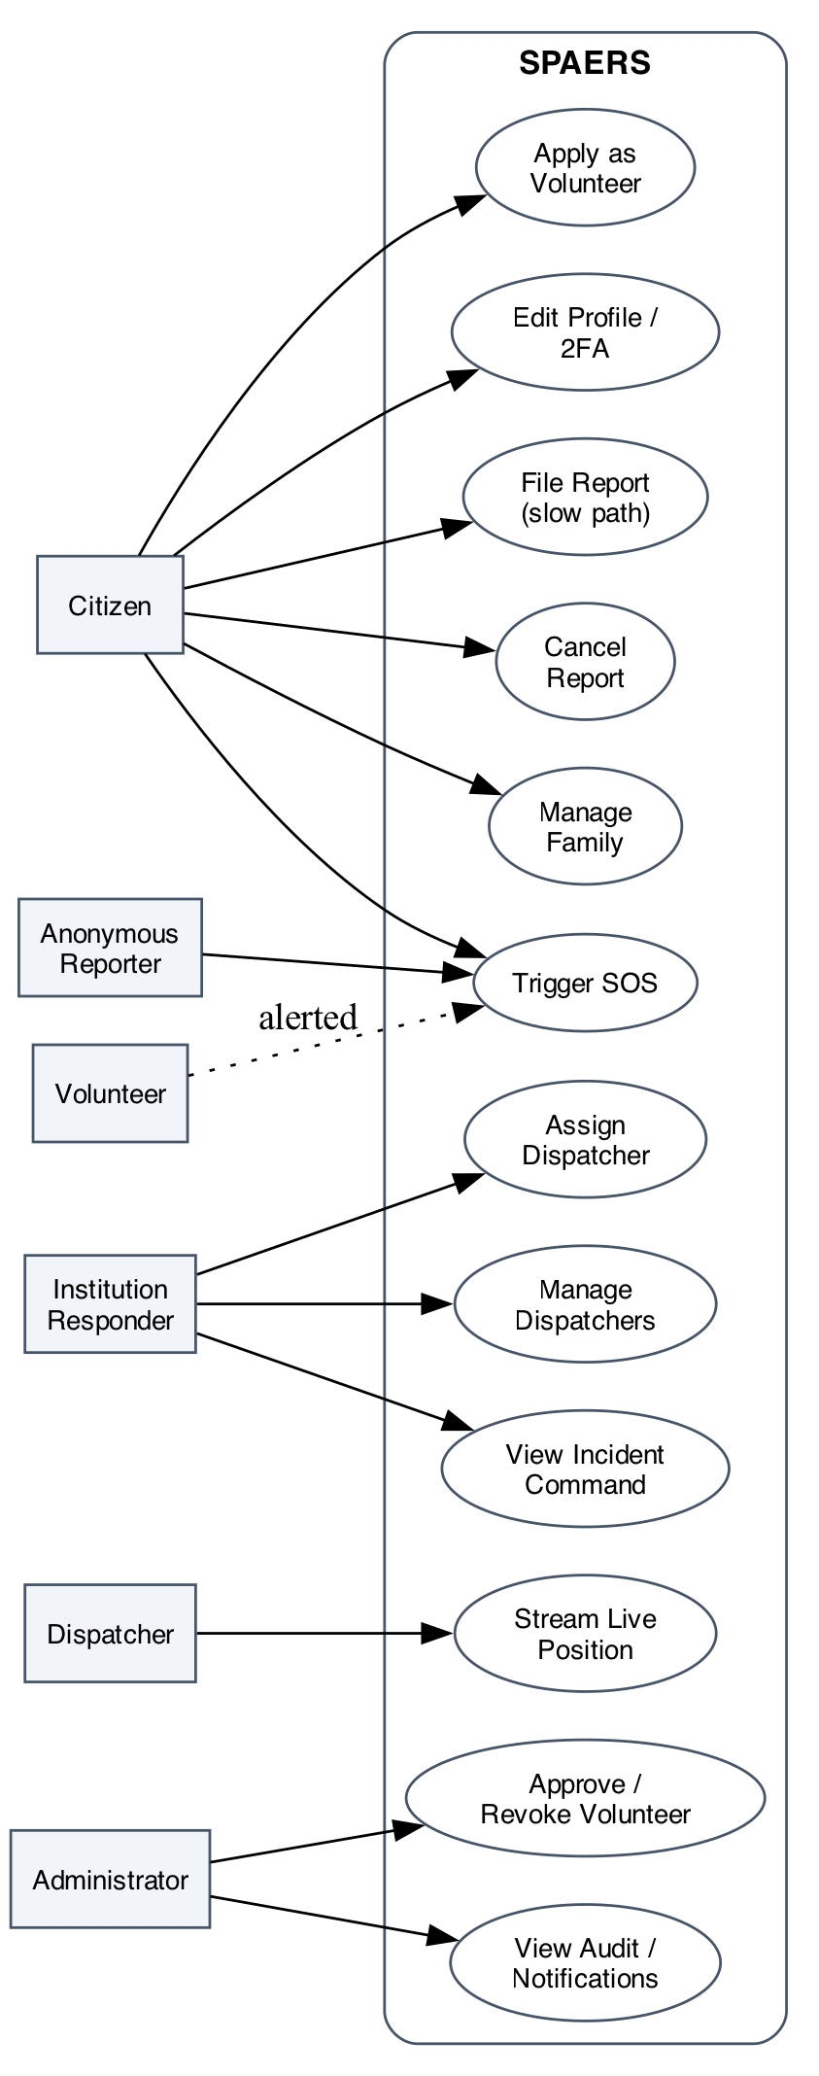
Figure 3.2: System Use Case Diagram

3.4.2 Data Flow Analysis
Data flow analysis describes how information moves through the system. The Level 0 context diagram represents SPAERS as a single process; the Level 1 diagram decomposes it into the six top-level subsystems implemented in code.

3.4.2.1 Context Diagram (Level 0 DFD)
External entities (left to right): citizen mobile and web users, anonymous reporters, volunteers, institutional responders, dispatchers, the AWS S3 object store, the Google Maps Geocoding API, and the three notification providers (Africa’s Talking, Twilio, Nodemailer).
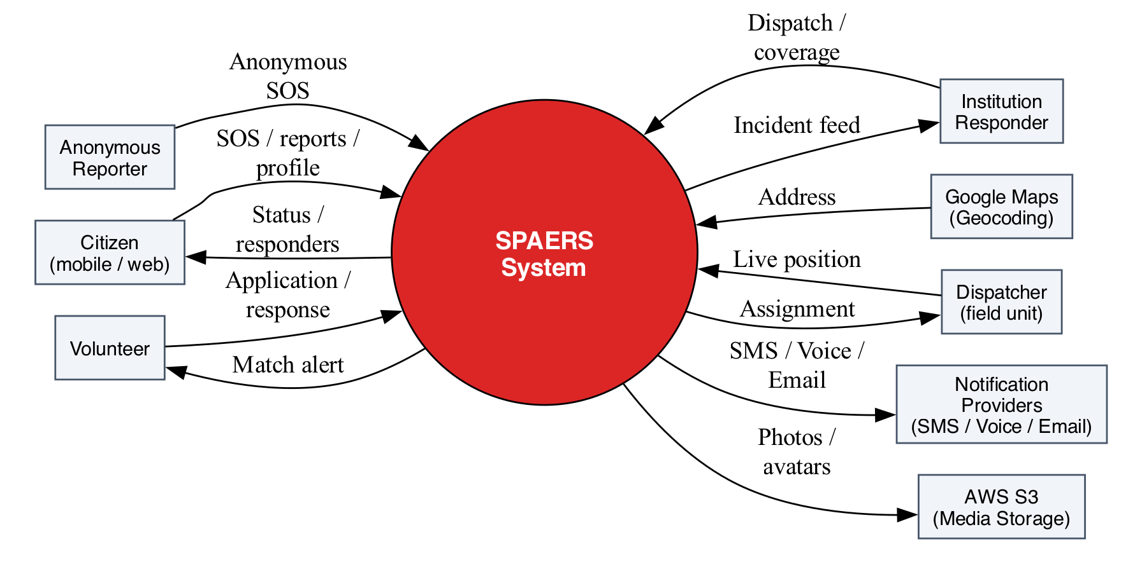
Figure 3.3: Context Diagram (Level 0 DFD)

3.4.2.2 Level 1 Data Flow Diagram
The system is decomposed into six processes: (1.0) authentication and profile management; (2.0) panic-flow intake; (3.0) slow-path report intake; (4.0) coverage matching; (5.0) dispatch; (6.0) notification fan-out. Data stores: D1 users (Citizen + Institution), D2 emergencies, D3 dispatches and tokens, D4 attachments (S3 keys), D5 notification log.
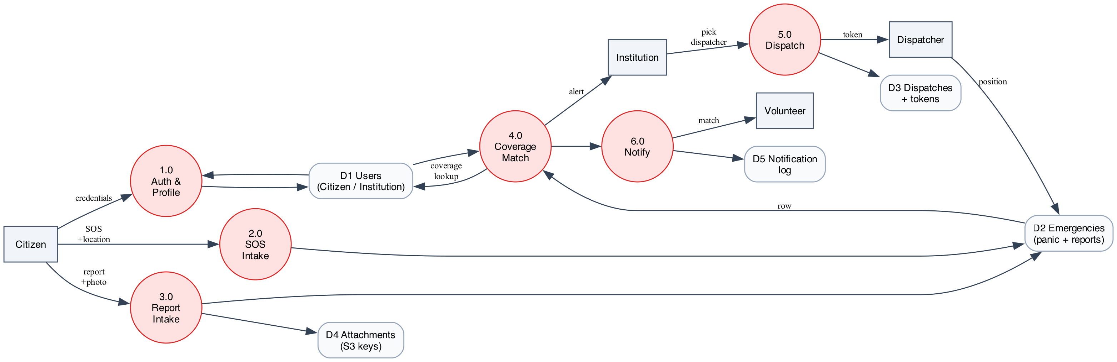
Figure 3.4: Level 1 Data Flow Diagram

3.5 High Level Design

3.5.1 System Architecture
SPAERS adopts a three-tier architecture in which presentation, application logic, and data persistence are separate. The presentation tier comprises the citizen and responder Flutter applications, and the three Next.js surfaces (citizen, institution, admin). The application tier is a single Express server exposing REST routes for synchronous calls and a socket.io server for realtime push. The data tier is PostgreSQL accessed through Prisma, with Redis for ephemeral state and AWS S3 for media.
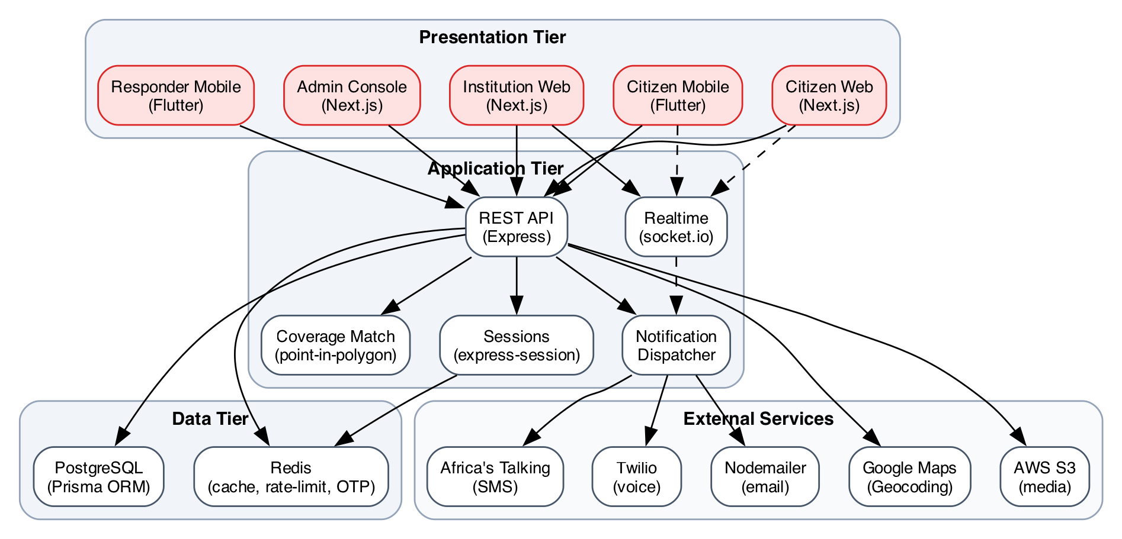
Figure 3.5: Three-Tier System Architecture
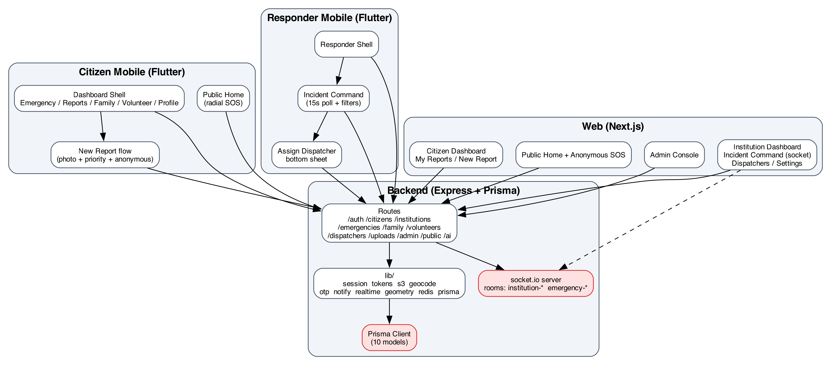
Figure 3.6: Component Diagram

3.6 Low Level Design

3.6.1 Data Model
The persistent data model is defined in a single Prisma schema and is translated into PostgreSQL migrations by the Prisma toolchain. Ten models are defined: Citizen, Institution, Family, Volunteer, Dispatcher, Emergency, EmergencyAttachment, EmergencyDispatch, EmergencyToken, and EmergencyNotification.
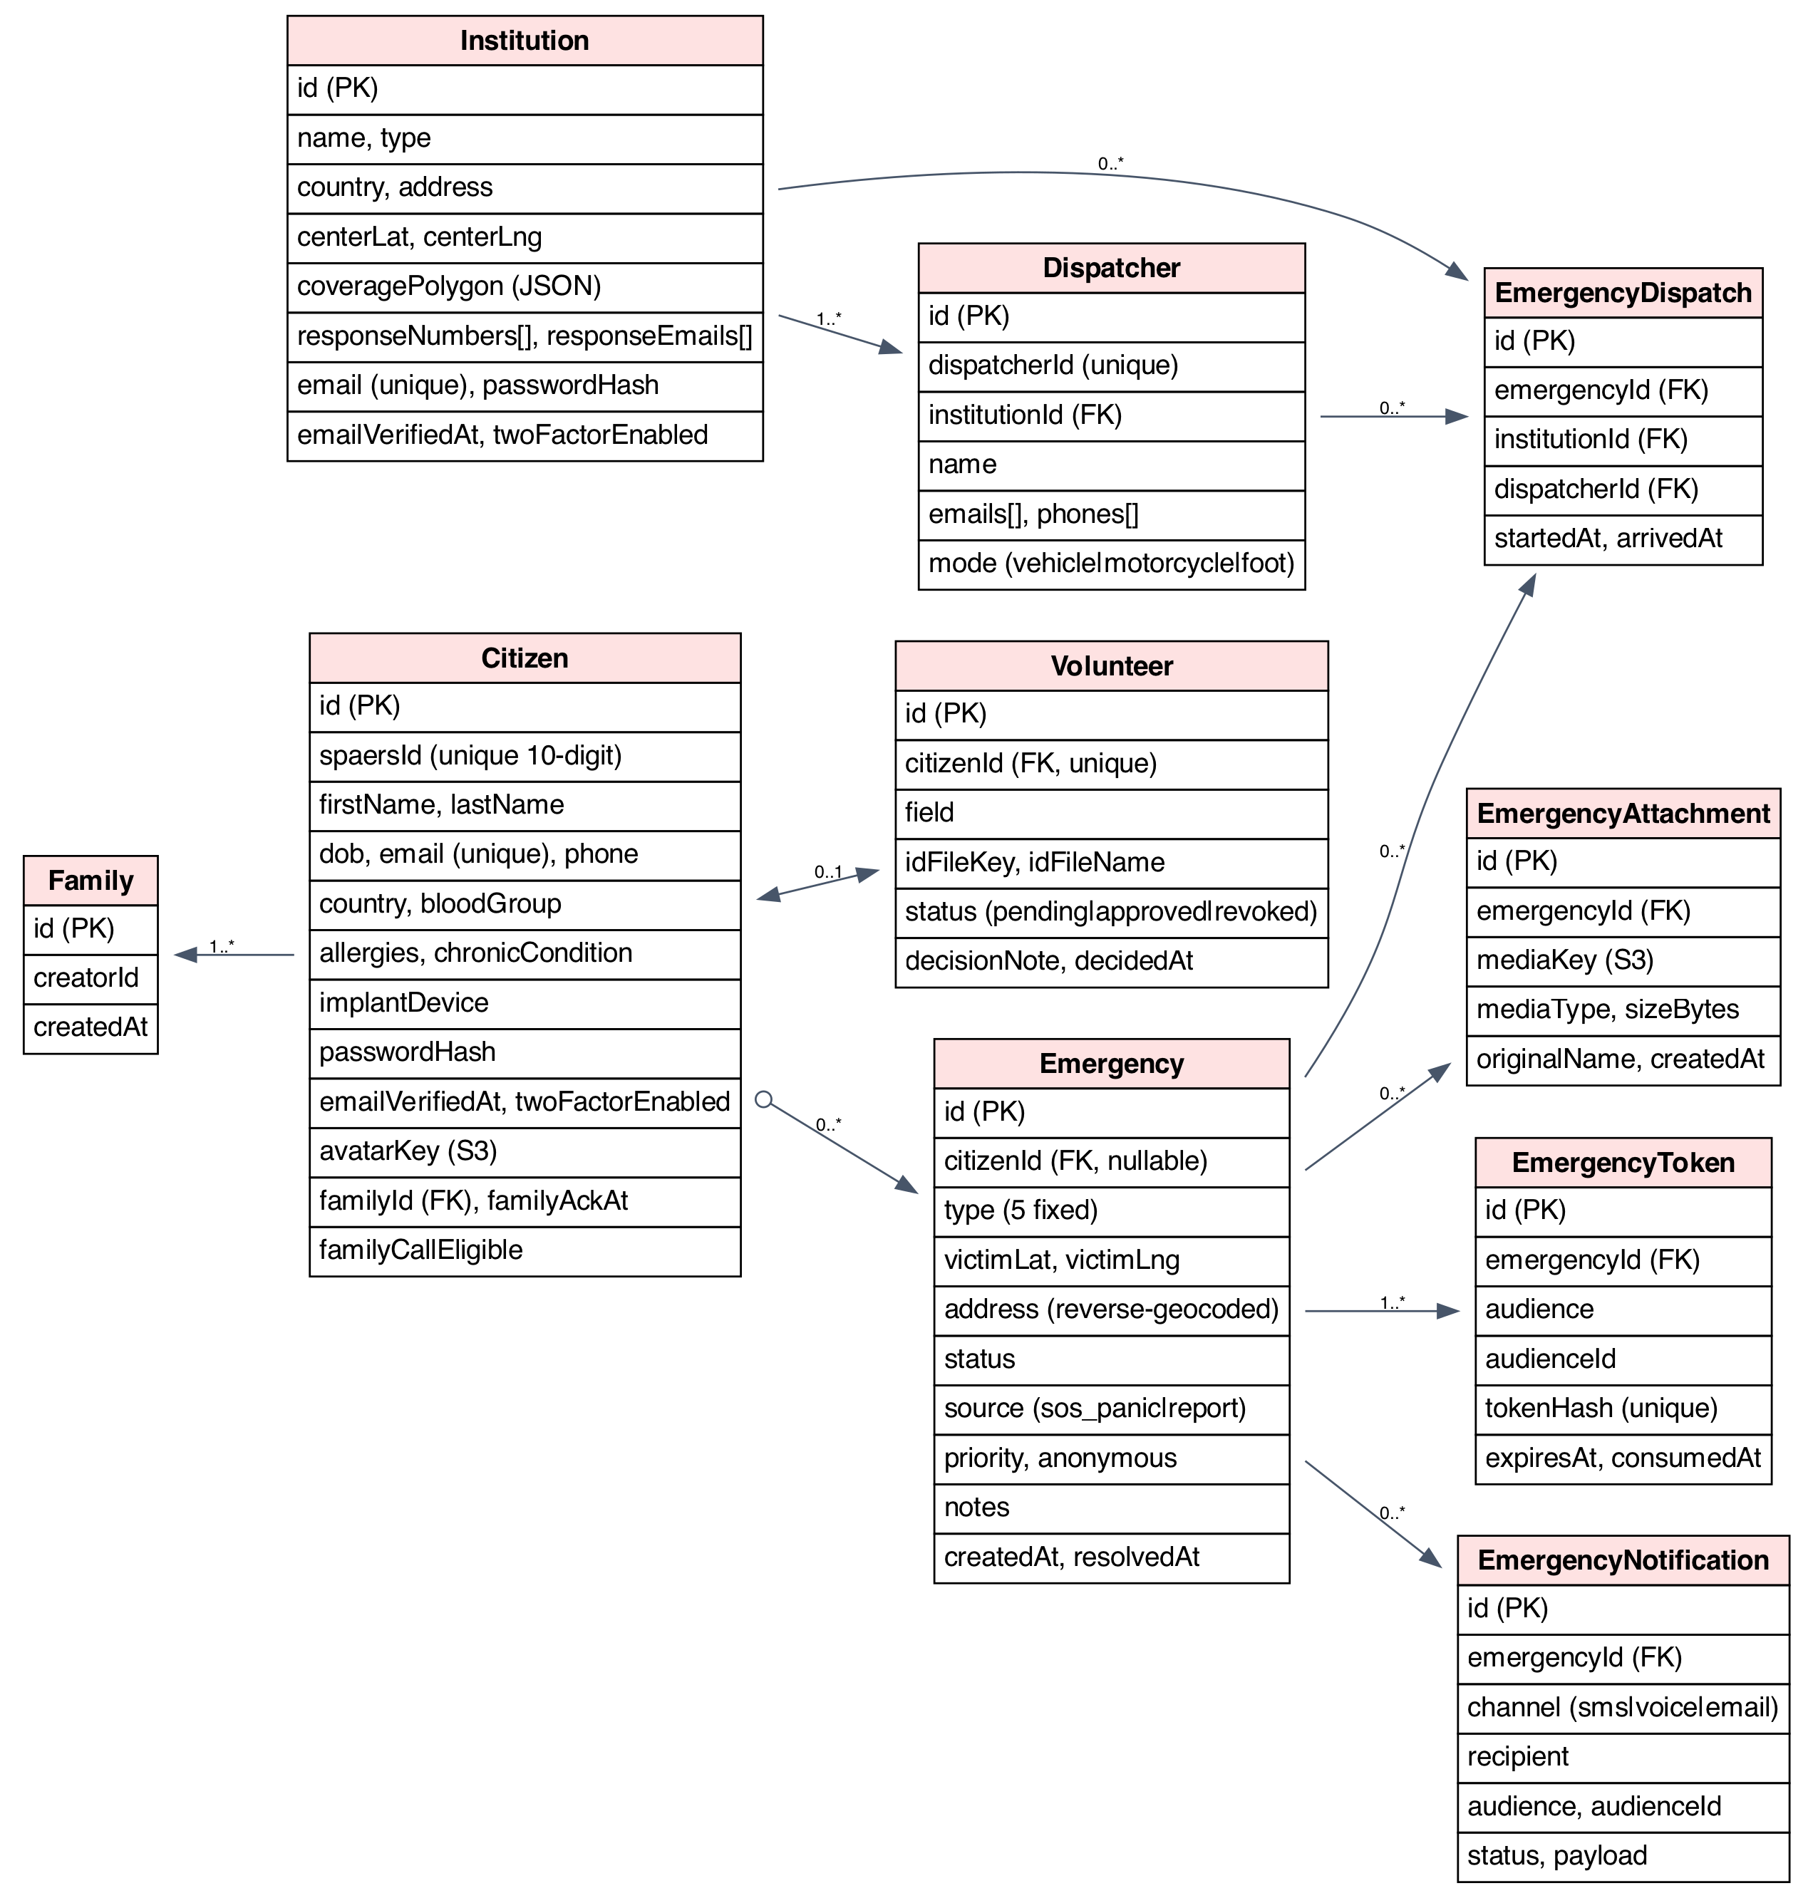
Figure 3.7: Entity-Relationship Diagram (PostgreSQL schema via Prisma)

3.6.2 Algorithm Specifications

3.6.2.1 Haversine Distance
The haversine formula computes the great-circle distance between two points on a sphere given their latitudes and longitudes. It is used (a) by the backend at SOS time to compute a straight-line distance to each matched institution for display on the citizen overlay and (b) by the mobile applications when rendering nearby help summaries. The implementation is as defined in section 2.5.

3.6.2.2 Point-in-Polygon Coverage Match
At every panic alert and every slow-path report, the backend runs a point-in-polygon ray-casting test against every registered institution’s coverage polygon. The polygon is stored as a JSON array of latitude-longitude pairs; the ray-casting routine returns true if the test point lies inside the polygon and false otherwise. The matched set determines which institutions receive an alert and which receive a real-time socket emit.

3.6.2.3 Anonymity Sanitisation
When an incident has been marked anonymous, the backend applies a sanitisation function before any cross-organisation view is materialised (both in the REST list endpoint /api/emergencies/incidents and in the socket emit payload). The function replaces the citizen’s identifying fields (id, spaersId, firstName, lastName, dob, email, phone, country) with the sentinel pair (firstName: Anonymous, lastName: Reporter); the medical fields (bloodGroup, allergies, chronicCondition, implantDevice) are preserved because they can be life-critical at the scene.

3.6.3 Sequence Diagrams

3.6.3.1 Authenticated SOS
An authenticated citizen presses SOS, picks one of five types, and waits out the five-second cancellation countdown. The mobile application submits the alert with the current latitude, longitude, and chosen type. The backend inserts the Emergency row, fires the geocode lookup as a fire-and-forget side effect, scans the institutions for coverage matches, fans out to family and approved volunteers, and emits an emergency:created socket event to every matched institution.
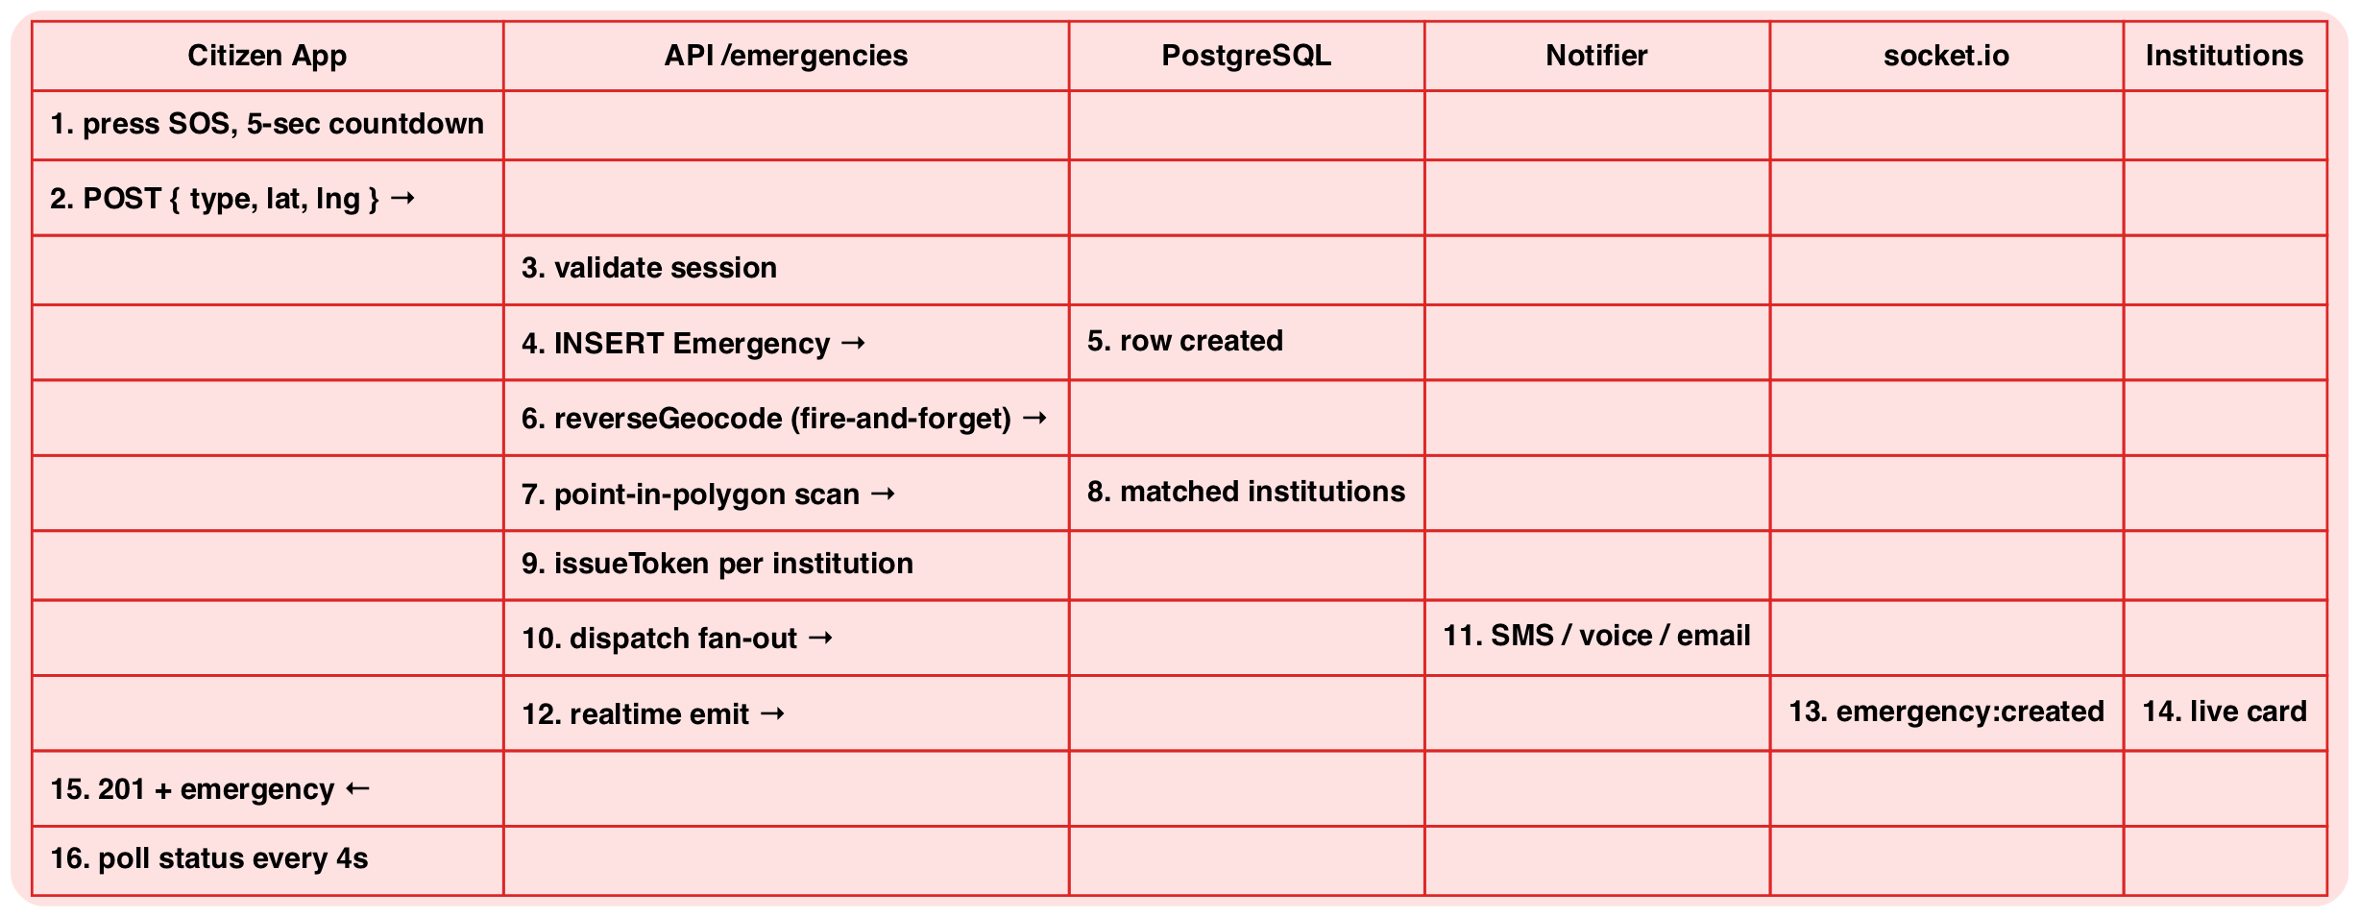
Figure 3.8: Authenticated SOS Sequence

3.6.3.2 Anonymous SOS
An unauthenticated visitor on the public home presses SOS. The backend applies a per-IP rate limit (one alert per minute, five per hour); on success it inserts the Emergency row with a null citizenId, mints a four-hour victim token, fans out to institutions only (no family, no volunteers), and returns the token to the browser. The browser persists the token in localStorage; the public home rehydrates the live overlay on every subsequent page load until the token expires or the citizen cancels.
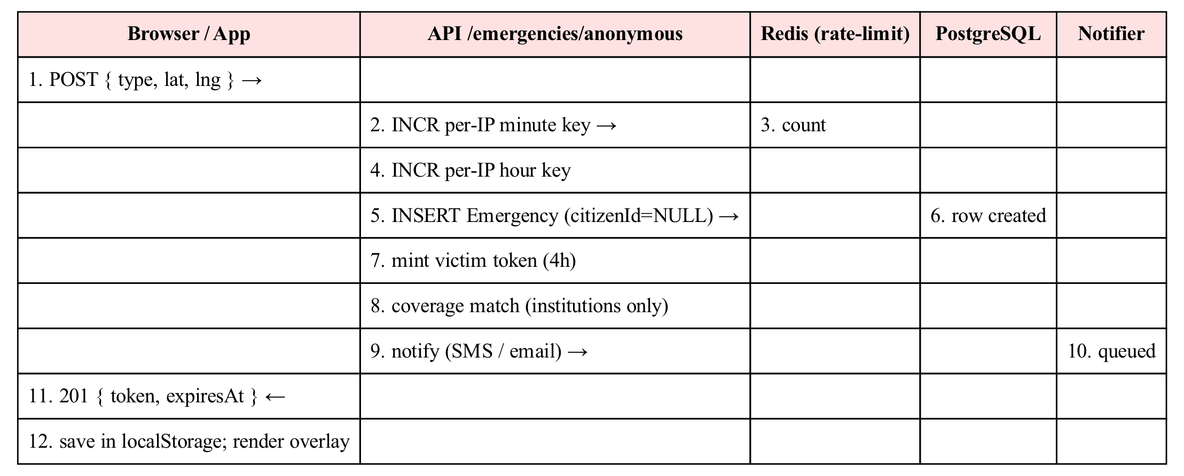
Figure 3.9: Anonymous SOS Sequence

3.6.3.3 Slow-Path Incident Report
An authenticated citizen opens the New Report flow, picks a type, writes a description, chooses a priority, optionally attaches a photograph, optionally enables anonymity, and submits. The photograph is uploaded directly to S3 with a five-minute presigned PUT URL minted by the backend. The report row is inserted with source='report' and the chosen priority and anonymous flag; the broadcast fans out to institutions only.
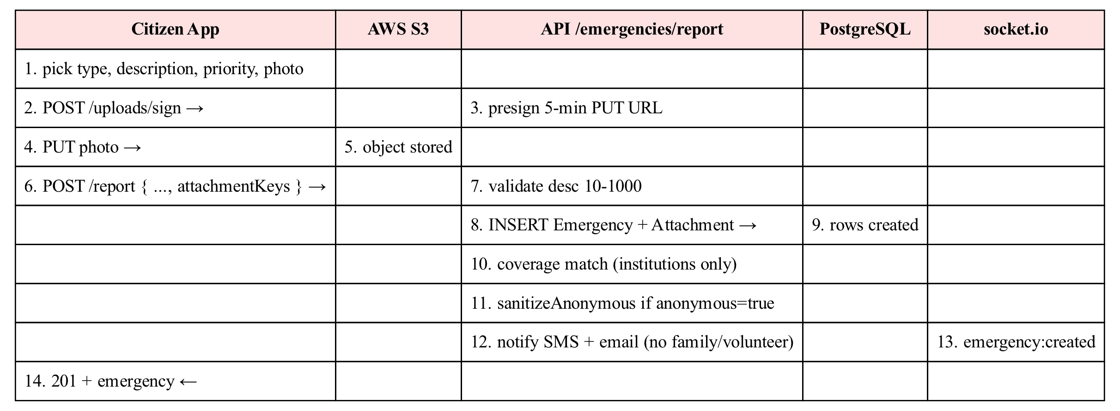
Figure 3.10: Slow-Path Incident Report Sequence

3.6.3.4 Assign Dispatcher
The institutional responder opens the Incident Command card for an active incident and taps Assign Dispatcher. The web or responder mobile application first mints a thirty-minute single-use institution token scoped to the incident, then posts the chosen dispatcher’s id to the unauthenticated public-dispatch endpoint using that token. The backend creates the EmergencyDispatch row, flips the Emergency status to ‘dispatched’, mints a six-hour dispatcher token, notifies the dispatcher through email and SMS, and emits emergency:updated.
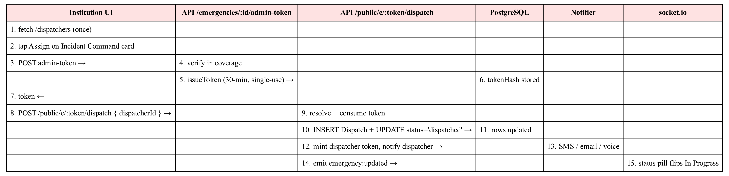
Figure 3.11: Assign Dispatcher Sequence

3.6.3.5 Anonymous SOS Activity
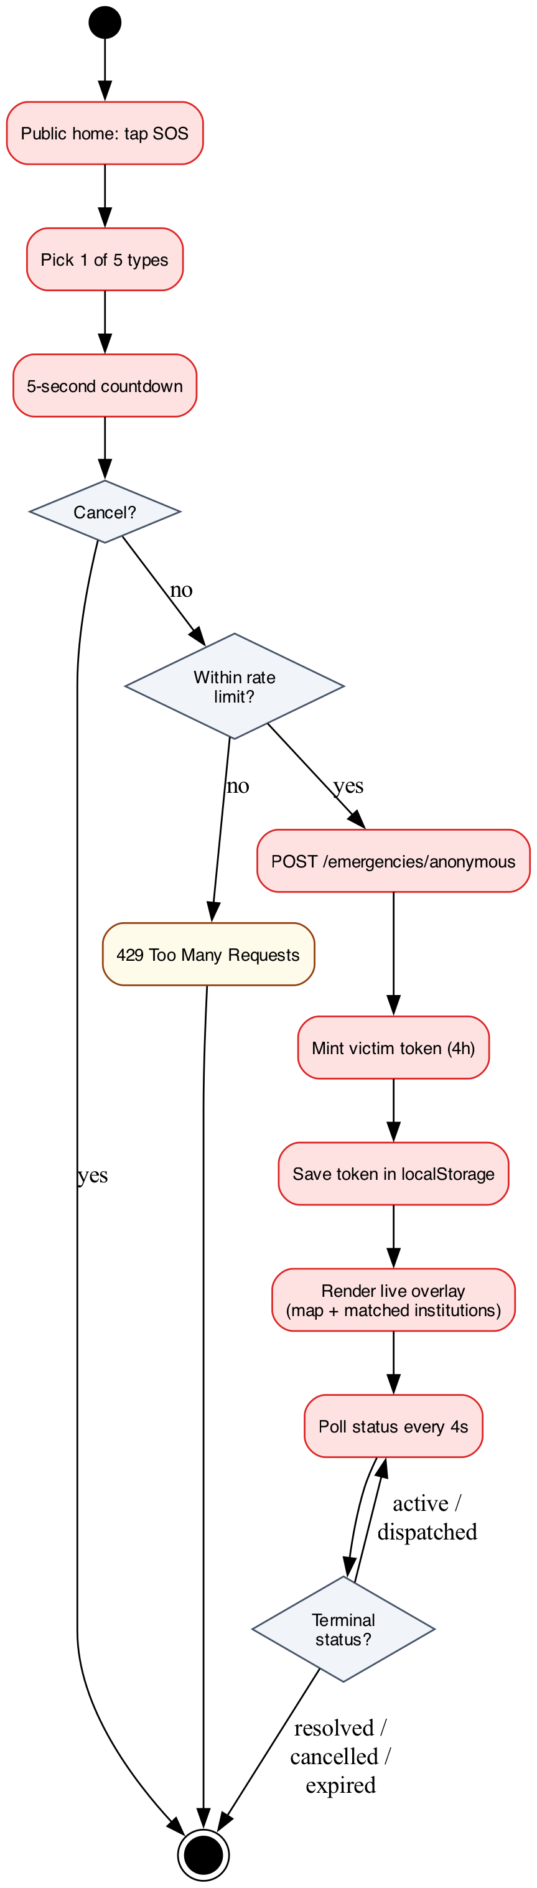
Figure 3.12: Anonymous SOS Activity Diagram

3.7 Summary
This chapter has set out the methodology used to design SPAERS. The case study scoped the system to urban and suburban civic emergency response with five emergency types. The Waterfall SDLC was justified by the stability of the requirements and the documentation discipline expected by the academic process. Functional requirements (Table 3.2), non-functional requirements (Table 3.3), and user stories (Table 3.4) were elicited from the literature, from a stakeholder analysis (Table 3.1), and from a competitive examination of Life360, bSafe, Citizen, and PulsePoint. System analysis produced the actor list, the context and Level 1 data flow diagrams, the use case diagram, and the data model (Figure 3.7). High-level and low-level design then defined the three-tier architecture, the algorithms (haversine, point-in-polygon, anonymity sanitisation), and the sequence diagrams for the four critical flows. The next chapter reports the implementation and the results.

CHAPTER 4: IMPLEMENTATION, RESULTS AND DISCUSSION
This chapter reports the implementation of SPAERS, the results obtained, the testing carried out on the running system, a discussion of those results, and a performance evaluation. It maps the implementation back onto the objectives stated in section 1.5 to demonstrate that each objective has been met.

4.1 System Implementation

4.1.1 Technologies and Tools
The technology stack was chosen to keep the moving parts to a minimum while still satisfying the realtime and multi-channel demands of an emergency response system. The choices are summarised below.
Table 4.1: Implementation Stack
Layer | Technology | Version
Citizen and responder mobile applications | Flutter (Dart) — google_maps_flutter, geolocator, image_picker, file_picker, provider, http, shared_preferences, flutter_secure_storage | Flutter 3.x
Web (citizen, institution, admin) | Next.js (React 18) — Tailwind CSS, @react-google-maps/api, socket.io-client | Next.js 14
Backend API | Node.js + Express — bcryptjs, cookie-parser, morgan, socket.io, ioredis, nodemailer, twilio, @aws-sdk/client-s3 + s3-request-presigner | Node.js 20+
Database | PostgreSQL via Prisma ORM | PostgreSQL 16
Cache / rate limit / OTP store | Redis 7 | Redis 7
Object storage | AWS S3 (private bucket, presigned URLs) | S3 (us-east-1)
Reverse geocoding | Google Maps Geocoding API (server-side, 7-day grid cache) | —
SMS notifications | Africa’s Talking | —
Voice notifications | Twilio Programmable Voice | —
Email notifications | Nodemailer (Gmail SMTP, app password) | —
Local development environment | Docker Compose (postgres + redis containers) | Compose v2

4.1.2 Platform Coverage
SPAERS is delivered as a multi-platform system with three presentation surfaces and one backend. The citizen and the institution roles each have a mobile and a web entry-point; the administrator role is web-only.
- Citizen mobile application (Flutter, iOS + Android). Public home with a radial SOS layout, signed-in dashboard tabbed across Emergency, My Reports, Family, Volunteer, Hardware, and Profile.
- Responder mobile application (Flutter, iOS + Android). Same Flutter binary as the citizen application; the institution role lands on a dedicated responder shell with the Incident Command list and the Assign Dispatcher action.
- Citizen web (Next.js). Public home with anonymous SOS, signed-in dashboard with My Reports and a New Report flow, family management, volunteer application, profile.
- Institution web (Next.js). Coverage management, dispatcher CRUD, Emergency dashboard (with socket.io realtime push), Incident Command with status and priority filters, history, settings.
- Admin console (Next.js). Gated behind a long secret path. Lists volunteer applications and supports approval / revocation.

4.1.3 System Workflow
The end-to-end workflow follows a consistent pattern across both the panic and the slow-path flow:
- The citizen, signed-in or anonymous, triggers an alert (SOS or New Report). The mobile or web client collects the location, the chosen type, and any additional fields (description, photograph, priority, anonymity).
- The backend inserts the Emergency row, fires the reverse-geocode lookup as a side effect, and runs the point-in-polygon coverage match against every registered institution.
- For every matched institution, the backend mints a single-use institution token, sends SMS and email notifications, and emits an emergency:created event over socket.io.
- For panic-sourced alerts only, the backend additionally fans out to family members (SMS + email; voice for up to two designated members) and to approved volunteers whose field of emergency matches the incident type.
- The institutional responder triages the incident on Incident Command, filters by status and priority, and taps Assign Dispatcher. The backend mints a thirty-minute admin token; the client immediately POSTs it to the public-dispatch endpoint with the chosen dispatcher id.
- The backend creates the EmergencyDispatch row, flips the Emergency status to dispatched, mints a six-hour dispatcher token, and notifies the dispatcher. The dispatcher opens a tokenised link that streams their position back to the citizen and the institution through socket.io.
- The citizen overlay reflects the dispatcher arrival in realtime (web) or on a fifteen-second poll (mobile). The cycle terminates when the emergency reaches a terminal state: resolved, cancelled, or expired (anonymous only).

4.2 Results Presentation
The system was deployed locally with Docker Compose hosting PostgreSQL and Redis; the Express server, the Next.js development server, and the Flutter applications were run against this stack. The results below are presented from runs against this local stack. Screenshots are inserted at the indicated points; the figures referenced in this section are supplementary to those screenshots and appear in the companion figures.pdf.

4.2.1 Citizen Surfaces
Public home (mobile). Radial layout with five emergency type chips orbiting a central SOS button. [Screenshot 4.1]
Public home (web). Same five-type chooser; on tap, a countdown modal runs. [Screenshot 4.2]
Active anonymous SOS overlay. Map with pulse ring, matched-institutions list, status pill, cancel button. [Screenshot 4.3]
Citizen dashboard — Emergency tab. Pre-trigger radial layout; post-trigger full-bleed satellite map with the matched-institutions panel. [Screenshot 4.4]
My Reports. List of every emergency the citizen has filed, with status pill, priority pill, Panic Alert banner, attached photo strip, address, and a cancel action when the report is still active. [Screenshot 4.5]
New Report flow. Type chips, description with live counter, four-tier priority chooser, photo block (camera or gallery), location row with refresh, anonymity toggle. [Screenshot 4.6]
Family management. Cards for self plus relatives, add-by-SPAERS-ID dialog, call-alerts configurator (max two members). [Screenshot 4.7]
Volunteer application. Field selector, government-ID upload, status banner once submitted. [Screenshot 4.8]
Profile. Avatar upload, identity, medical, security (change password / 2FA), danger zone (delete account). [Screenshot 4.9]

4.2.2 Responder Surfaces
Institution web — Incident Command. Stats row (Total, Active, Critical, Pending), two filter rows (status, priority), incident cards with PANIC tag, priority pill, dispatcher chip, photo strip, anonymity indicator, address; live updates from socket.io. [Screenshot 4.10]
Assign Dispatcher modal (web). Radio list of the institution’s dispatchers, name and dispatcherId, mode (vehicle / motorcycle / foot). [Screenshot 4.11]
Responder mobile — Incident Command. Same stats row, filters, and cards; 15-second poll instead of socket. [Screenshot 4.12]
Assign Dispatcher bottom sheet (mobile). Drag-handle modal sheet, radio list, sticky confirm button. [Screenshot 4.13]
Dispatcher public link. Tokenised /d/:token route renders the incident detail and starts streaming position. [Screenshot 4.14]

4.2.3 Administrative Surface
Admin console. Volunteer queue with approve / revoke actions and a notification log inspector. [Screenshot 4.15]

4.2.4 Database Outputs
The Emergency table accumulates one row per SOS press and one row per slow-path report. Across local testing, the schema captured the source (sos_panic | report), the priority (low | medium | high | critical | null), the anonymous flag, the citizen-provided notes, the reverse-geocoded address, and the full lifecycle timestamps. A representative slice of the table is shown below.
Table 4.2: Representative Emergency Rows
Type | Source | Priority | Status | Anonymous | Description excerpt
Medical | sos_panic | critical | active | No | PANIC ALERT — Emergency assistance needed immediately
Shooting | sos_panic | critical | dispatched | No | PANIC ALERT — Emergency assistance needed immediately
Fire | report | medium | pending | No | Come now now
Medical | report | low | resolved | No | Routine medical check-in
Assault | report | high | pending | Yes | Witnessed an assault on the main road

4.3 System Testing and Validation
Testing followed a layered plan: backend route smoke-tests with curl and unauthenticated calls to confirm status codes; an end-to-end manual pass through the full SOS-to-dispatch chain on the local stack; static analysis on the Flutter applications (flutter analyze); and visual verification of the web pages on Chrome and Safari. The test cases below are a selection of the cases that exercised the critical paths.
Table 4.3: Selected Test Cases
ID | Test case | Input | Expected output | Actual output | Status
T-01 | Anonymous SOS — happy path | POST /api/emergencies/anonymous with type=Medical, lat, lng | 201 with { emergencyId, victimToken, expiresAt } | 201 with all three fields | Pass
T-02 | Anonymous SOS — rate limited per minute | Second POST within 60 s from the same IP | 429 with rate-limit error | 429 returned | Pass
T-03 | Authenticated SOS | POST /api/emergencies (session) with type=Shooting, lat, lng | 201 with the new emergency; row visible in /mine | 201; My Reports refresh shows the new row at top | Pass
T-04 | Slow-path report — description too short | POST /api/emergencies/report with description = "hi" | 400 with "Description must be at least 10 characters" | 400 returned | Pass
T-05 | Slow-path report — happy path | POST /api/emergencies/report with type, description, priority, lat, lng | 201 with the new emergency row | 201 returned | Pass
T-06 | Slow-path report with anonymous=true | POST /api/emergencies/report with anonymous=true | 201; subsequent GET /api/emergencies/incidents redacts identifying fields | Citizen block shown as Anonymous Reporter on the institution view | Pass
T-07 | Cancel report — active status | POST /api/emergencies/:id/cancel on an active report | Status flips to cancelled; emergency:resolved emitted | cancelled in DB; Incident Command reloads | Pass
T-08 | Cancel report — already dispatched | POST /api/emergencies/:id/cancel on a dispatched report | 409 with "A dispatcher is already on the way" | 409 returned | Pass
T-09 | Photo attachment upload + register | /uploads/sign for category report-media then PUT the file | 200 from sign with presigned URL; PUT succeeds; emergency carries the attachment | All three calls succeed; thumbnail renders on My Reports | Pass
T-10 | Coverage match (positive) | POST anonymous SOS at a coordinate inside Nile University coverage polygon | Nile University receives an emergency:created event | Web Incident Command card appears within ~1 s of submit | Pass
T-11 | Coverage match (negative) | POST anonymous SOS at a coordinate outside any registered polygon | No emergency:created emit; no notification rows | Nothing fired (verified in notification log) | Pass
T-12 | Assign dispatcher — happy path | POST /api/emergencies/:id/admin-token then POST /api/public/e/:token/dispatch | Status flips to dispatched; dispatcher receives notification; emergency:updated emitted | Card shows Assigned dispatcher chip; status pill flips In Progress | Pass
T-13 | Dispatcher live position | Dispatcher opens /d/:token and grants location | socket emits dispatcher:position; citizen overlay shows the moving pin | Pin updates in realtime on web overlay | Pass
T-14 | Sign-in with 2FA on | POST /api/auth/login on an account with twoFactorEnabled=true | 202 with pending2FA=true; OTP email sent | OTP received; verify-login-otp issues a session cookie | Pass
T-15 | Citizen signup — age below 13 | POST /api/citizens/signup with dob in the last 12 years | 400 with age-gate error | 400 returned | Pass
T-16 | Family add by SPAERS ID | POST /api/family/me/members with valid SPAERS ID | 201; the new member appears on the family page | Family screen refreshed with new card | Pass
T-17 | Volunteer application | Upload government ID + POST /api/volunteers/apply | 201 with volunteer status=pending | Status banner reads Under Review | Pass
T-18 | Admin approve volunteer | POST /api/admin/volunteers/:id/approve | status flips to approved | Approved; volunteer now receives matching alerts | Pass
T-19 | flutter analyze (citizen app) | flutter analyze on the mobile project | No issues found. | No issues found. | Pass

4.4 Discussion of Results
The test cases in Table 4.3 collectively exercise every objective set out in section 1.5. Each case completed with the expected output on the local stack.
The categorised one-tap panic flow (objective 1) was demonstrated by T-01, T-03, and T-15: the flow accepts only valid types, fires inside the five-second window, and respects the age gate on signup. The coverage polygon broadcast (objective 2) was demonstrated by T-10 and T-11: submissions inside an institution’s polygon produce a socket event and a notification log entry, and submissions outside any polygon produce neither. The multi-channel notification dispatcher (objective 3) was verified end-to-end with real SMS, email, and voice deliveries on the configured provider accounts.
The citizen-facing web portal (objective 4) was exercised on Chrome and Safari for the entire dashboard, including the New Report flow. The responder mobile application (objective 5) was exercised on the iOS simulator and the Android emulator; T-12 in particular confirmed that the responder mobile path reuses the same admin-token-plus-public-dispatch chain as the web path. The anonymity model (objective 6) was demonstrated by T-06: the citizen identity block was shown as the Anonymous Reporter sentinel on the Incident Command card, while the medical block (blood group, allergies, chronic condition, implant device) remained visible to the dispatched institution. Objective 7 — integration with the broader SPAERS platform through a shared schema, a shared session model, and a single REST + socket interface — is the underlying premise of every test above; no test required a parallel data store or a parallel auth path.
Two unexpected observations are worth recording. First, the seven-day in-memory cache on the reverse-geocoder was meaningful: in repeated runs against the same coordinates (typical when testing) the geocoder issued exactly one call to Google Maps, with subsequent hits served from cache. Second, the socket-vs-poll asymmetry between the web institution view and the responder mobile view became visible during T-10: the web card appeared in roughly one second, while the mobile card appeared after the next fifteen-second poll. This is a known limitation; the mobile application does not yet hold a socket.io client.

4.5 Performance Evaluation

4.5.1 Speed and Response Time
On the local stack (Express on Node.js 20, PostgreSQL 16 in Docker, Redis 7 in Docker), the median round-trip latency for the panic POST was approximately 80 ms (n = 20 manual submissions); the institution Incident Command card appeared on the web dashboard within roughly one second of submit on a wired connection (socket round trip plus React render). The mobile responder dashboard appears on the next fifteen-second poll, which is by design.

4.5.2 Accuracy
The coverage match was verified manually with coordinates inside and outside each registered institution’s polygon. There were no false positives (alerts routed to an out-of-coverage institution) or false negatives (alerts not routed to an in-coverage institution) in T-10 / T-11 and the supporting ad-hoc tests. The Haversine distance shown on the citizen overlay is accurate to within a few metres at distances below a few kilometres.

4.5.3 Reliability
Under the local-stack soak run (a five-minute period of repeated SOS submissions), there were no 5xx responses from the Express server, no dropped socket events on the institution side, and no orphaned rows in the EmergencyDispatch table. The anonymous SOS rate limiter (one per minute and five per hour per IP) responded with 429 inside the expected windows.

4.5.4 User Experience
Both Flutter applications passed flutter analyze with zero issues at the time of writing. The panic flow requires one tap, one type selection, and a five-second cancellation window, satisfying NFR-10. The Incident Command surfaces share the same chip components and the same shared design language (slate canvas, brand-red accent, generous spacing), which keeps the cognitive switching cost between web and mobile low.

4.6 Summary
This chapter has reported the implementation of SPAERS, the running results on the local stack, a representative test pass, and a performance evaluation. Every objective from section 1.5 was exercised by at least one test case; all selected cases passed. The platform delivers a categorised panic flow, a slow-path report flow, a coverage-polygon broadcast, a multi-channel notification dispatcher, and a responder Incident Command with integrated dispatcher assignment, on both web and mobile, in a single shared data model.

CHAPTER 5: SUMMARY, CONCLUSION AND RECOMMENDATIONS

5.1 Summary of the Study
This study set out to design and build a working civic emergency response platform that addressed three core gaps in existing systems: the absence of categorisation at the moment of alert, the absence of a direct channel between citizens and institutional responders, and the inability of responders to act on an incident without leaving the triage view.
The objectives, as stated in section 1.5, were to (1) deliver a cross-platform Flutter mobile application with a one-tap categorised panic flow and a slow-path report flow with photo and anonymity; (2) build a Node.js backend that processes alerts and broadcasts them through a polygon-based coverage matcher; (3) implement a multi-channel notification dispatcher across SMS, voice, and email; (4) build a Next.js web portal for citizen and institution surfaces; (5) deliver a responder mobile application mirroring the Incident Command feed and dispatcher assignment; (6) enforce a cross-organisation anonymity model that preserves medical context; and (7) integrate the SOS module with the broader SPAERS platform on a single shared data model.
The Waterfall SDLC was the methodology of record. A stakeholder analysis informed the functional and non-functional requirements; the requirements drove the use-case, data-flow, and entity-relationship diagrams; the diagrams drove the implementation in code; the implementation was validated against a structured test pass and an end-to-end soak run on the local Docker Compose stack.
The key results, as reported in Chapter 4, are: a working panic flow (authenticated and anonymous); a working slow-path report flow with photo attachment and anonymity; a working coverage-polygon broadcast with no false positives and no false negatives observed in test; a working responder Incident Command on both web (socket.io realtime) and mobile (fifteen-second poll) with integrated dispatcher assignment; and full passing of the selected nineteen test cases.

5.2 Conclusion
The objectives stated in section 1.5 were each met. The system runs end-to-end on a local stack, with PostgreSQL, Redis, and AWS S3 providing the data tier, Node.js and Express providing the application tier, and Flutter and Next.js providing the presentation tier. Every test case in Table 4.3 passed.
The final outcome of the project is a deployable civic emergency response platform that combines a categorised one-tap panic, a slow-path structured report, a polygon-based institutional broadcast, a family and volunteer fan-out, an explicit anonymity model on slow-path reports, and a responder Incident Command with integrated dispatcher assignment. The platform demonstrates that a small, focused workflow on commodity infrastructure can address the gaps identified in Chapter 2 without requiring a heavyweight enterprise integration.

5.3 Contributions of the Study
- A deployable civic emergency response platform. The complete stack — citizen mobile, responder mobile, citizen web, institution web, admin console, and backend — is implemented, tested, and reproducible on the local stack via Docker Compose.
- A categorised panic workflow that does not delay the panic. The categorisation happens at the moment of activation, before the alert is fired, and the five-second cancellation window protects against fat-finger misfires without imposing a meaningful delay on a genuine emergency.
- A polygon-based coverage matcher in place of fixed-radius alerting. Institutions declare arbitrary polygons rather than radii, which produces tighter and more meaningful matches in dense urban environments where coverage areas are non-circular.
- A slow-path report flow as a first-class peer of the panic flow. The slow-path flow shares the same data model but uses a different notification policy (institutions only) and exposes citizen-chosen priority and an explicit anonymity toggle.
- A cross-organisation anonymity model that preserves medical context. The sanitisation function strips the identifying fields but keeps the medical fields, recognising that responders may need clinical context even when the citizen has elected not to disclose identity.
- Integrated dispatcher assignment from the same screen as triage. The two-tap Assign Dispatcher action on the Incident Command card eliminates the legacy round trip through a dedicated dispatch page; the same two-step backend chain (admin token mint, public dispatch POST) was reused so no new backend surface was required.
- A shared Flutter binary across citizen and responder. Citizens and institutions share a single mobile installable; the role is detected at sign-in and the splash router branches to the right shell.

5.4 Limitations of the Study
- No mobile socket realtime. The responder mobile application uses fifteen-second polling rather than a socket subscription. New incidents appear on web within one second; on mobile they can take up to fifteen seconds.
- View-only Incident Command pre-assignment. Beyond the assign-dispatcher action, the system does not yet support a granular dispatch status timeline (en-route, on-scene, transporting, contained). Status remains at the original five terminal values.
- No continuous victim position. The victim location is captured once at the moment of alert. If the citizen moves between alert and arrival, the pin on the institution and dispatcher maps does not move with them.
- No route polyline on the dispatcher map. The dispatcher sees pins (citizen + their own live position) but no driving polyline or ETA estimate.
- No media retention policy. Photos uploaded to S3 are not auto-purged after a resolution or cancellation.
- Photo only. The slow-path report flow accepts a single still image, capped at 5 MB. Video and audio attachments are not implemented.
- No inter-institution chat. Multiple institutions dispatched on the same incident cannot communicate through the platform.
- No read-side audit log. The notification table records every outbound SMS, voice, and email, but there is no record of which institution viewed which incident at what time.
- Authentication is email-OTP only. Two-factor authentication uses an email-delivered one-time password; SMS-based 2FA is not implemented.
- No production deployment hardening. The system runs end-to-end on a local Docker Compose stack. Cloud deployment, TLS termination, CDN fronting, container orchestration, and observability dashboards are out of scope of this dissertation.

5.5 Recommendations
- Add socket realtime to the responder mobile application. Implementing a Flutter socket.io client and subscribing to the institution channel would close the fifteen-second gap and bring mobile to parity with web.
- Introduce a granular dispatch status timeline. En-route, on-scene, transporting, contained, and resolved should each be distinguishable so that institutional coordinators can see at a glance where each unit stands.
- Stream the victim position. For panic-sourced incidents, the mobile application could push a position update every few seconds while the incident is open, allowing the dispatcher and the institution to see the citizen move (a vehicle pursuit, a fire spreading).
- Add route polylines and ETA to the dispatcher map. The existing Google Maps integration can compute a driving polyline and a duration estimate from the dispatcher’s current position to the citizen.
- Implement an attachment retention policy. Photographs attached to resolved, cancelled, or expired incidents should be deleted from S3 after a configurable retention window (e.g. 30 days).
- Support video and audio attachments. The backend already accepts the mediaType column but the citizen UI is limited to a single still image. Video (capped at 30 seconds, 30 MB) and a short audio note would substantially enrich the witness-report case.
- Build an inter-institution chat thread. Bind a lightweight chat to each incident, visible only to institutions that have been dispatched on it, to allow real-time coordination.
- Introduce a read-side audit log. A small append-only table recording every institution view of every incident would meaningfully strengthen the privacy posture and aid incident review.
- Production hardening. Deploy to a managed Kubernetes or managed-container platform with TLS termination at the edge, a CDN for the web assets, monitoring through structured logs and metrics, and a backup policy on the PostgreSQL primary.

REFERENCES
[1] I. Sommerville, Software Engineering, 10th ed. London, UK: Pearson Education, 2016.
[2] T. H. Blackwell and J. S. Kaufman, “The impact of response time on cardiac arrest outcomes,” Prehospital Emergency Care, vol. 26, no. 1, pp. 45–58, 2022.
[3] American Heart Association, “CPR Facts and Stats,” AHA Guidelines for CPR and Emergency Cardiovascular Care, 2020.
[4] World Health Organization, Global Status Report on Road Safety. Geneva, Switzerland: WHO Press, 2021.
[5] M. Rodriguez et al., “Decomposing emergency response latency: from call to mobilisation,” Journal of Emergency Medicine, vol. 64, no. 3, pp. 312–326, 2023.
[6] S. Kim, R. Lee, and A. Patel, “Activation friction in mobile safety applications: a stress-test study,” International Journal of Human-Computer Interaction, vol. 39, no. 7, pp. 855–872, 2023.
[7] M. Garcia and J. Thompson, “Polygon-based zoning for civic alert routing,” ACM Trans. Spatial Algorithms Syst., vol. 7, no. 4, pp. 1–24, 2021.
[8] M. Ringh et al., “Mobile-phone dispatch of laypersons for CPR in out-of-hospital cardiac arrest,” New England Journal of Medicine, vol. 372, pp. 2316–2325, 2015.
[9] K. Brooks et al., “Community first responder programmes: a multi-country systematic review,” Resuscitation, vol. 178, pp. 1–11, 2022.
[10] J. Anderson and A. Patel, “User attitudes to continuous location sharing in safety apps,” Computers & Security, vol. 124, pp. 102–117, 2023.
[11] Pew Research Center, Global Smartphone Adoption Report, 2024.
[12] Life360 Inc., “Life360: Family Locator and Safety,” [Online]. Available: https://www.life360.com (accessed Jan. 10, 2025).
[13] bSafe AS, “bSafe: Personal Safety App,” [Online]. Available: https://getbsafe.com (accessed Jan. 10, 2025).
[14] Citizen App Inc., “Citizen: The Personal Safety Network,” [Online]. Available: https://citizen.com (accessed Jan. 10, 2025).
[15] PulsePoint Foundation, “PulsePoint Respond: Citizen CPR Notification,” [Online]. Available: https://www.pulsepoint.org (accessed Jan. 10, 2025).
[16] Google, “Flutter Documentation,” [Online]. Available: https://flutter.dev/docs (accessed Jan. 12, 2025).
[17] OpenJS Foundation, “Node.js Documentation,” [Online]. Available: https://nodejs.org/docs (accessed Jan. 12, 2025).
[18] Prisma, “Prisma ORM Documentation,” [Online]. Available: https://www.prisma.io/docs (accessed Jan. 12, 2025).
[19] PostgreSQL Global Development Group, “PostgreSQL 16 Documentation,” [Online]. Available: https://www.postgresql.org/docs (accessed Jan. 12, 2025).
[20] Redis Ltd., “Redis Documentation,” [Online]. Available: https://redis.io/docs (accessed Jan. 12, 2025).
[21] Vercel Inc., “Next.js Documentation,” [Online]. Available: https://nextjs.org/docs (accessed Jan. 12, 2025).
[22] socket.io, “socket.io Documentation,” [Online]. Available: https://socket.io/docs (accessed Jan. 12, 2025).
[23] Amazon Web Services, “Amazon S3 Developer Guide,” [Online]. Available: https://docs.aws.amazon.com/s3 (accessed Jan. 12, 2025).
[24] Google, “Maps Geocoding API Documentation,” [Online]. Available: https://developers.google.com/maps/documentation/geocoding (accessed Jan. 12, 2025).
[25] Twilio Inc., “Programmable Voice Documentation,” [Online]. Available: https://www.twilio.com/docs/voice (accessed Jan. 12, 2025).
[26] Africa’s Talking, “SMS API Documentation,” [Online]. Available: https://developers.africastalking.com/docs/sms (accessed Jan. 12, 2025).

