
Variant Edge

Reproducible GRCh38 Rare & Genetic Disease
SNV and CNV Annotation Pipeline

Diseases Covered
Fabry disease
Monilethrix
Androgen Insensitivity Syndrome
Neurofibromatosis Type 1

Name | Abd ur Rehman
Course / Lab | BIOMISA
Department | SINES
Instructor | Dr. Tanveer Ahmad
Submission Date | 16-07-2026

All variant files are synthetic educational data and do not represent real patients.

1. Introduction
This assignment records the complete development, validation, automation, and interpretation workflow used for a reproducible GRCh38 rare-disease & genetic-disease annotation project.
The project was designed to process small sequence variants and copy-number variants as two separate branches. The small-variant branch accepts an unannotated VCF and produces a final VCF containing VEP, SnpEff, ClinVar, and SpliceAI annotations. The CNV branch accepts a four-column BED file and produces AnnotSV, ClassifyCNV, ISV-CNV, and combined-summary outputs.
Every tool was first tested manually in an Apptainer environment. The confirmed commands were then assembled into a disease-specific Bash pipeline and a batch runner for four diseases. The datasets are synthetic educational files and must not be presented as real patient results or used for diagnosis.
The documentation focuses on reproducibility: tool purpose, input, command, output, validation, errors, solutions, final file organization, meaningful screenshots, and GitHub links.
Important interpretation boundary: The sequence and CNV findings described here are synthetic educational targets. The report documents the pipeline and its outputs; it is not a clinical laboratory report.

2. Selected Diseases, Genes, Mechanisms, and Synthetic Targets
The four active diseases and their main disease-focused variants are summarized below. Disease mechanisms are included only to explain why the selected gene and variant are biologically relevant to the workflow.
Disease | Primary gene / locus | Inheritance | Mechanism | Synthetic SNV target | Synthetic CNV target
Fabry disease | GLA; chrX | X-linked | Deficient alpha-galactosidase A causes lysosomal accumulation of globotriaosylceramide and related substrates. | rs104894828; GLA c.902G>A, p.Arg301Gln; pathogenic missense | chrX:101393272-101408012 DEL; includes GLA; pathogenic by AnnotSV and ClassifyCNV
Monilethrix | KRT86 (target SNV); DSG4 (target CNV) | Usually autosomal dominant for keratin genes; autosomal recessive for DSG4 | Hair keratin or desmosomal disruption weakens the hair-shaft cortex, producing fragile, beaded hair. | rs121909130; KRT86 c.1239G>T, p.Glu413Asp; pathogenic missense | chr18:31376776-31414979 DEL; includes DSG4; AnnotSV pathogenic, ClassifyCNV uncertain
Androgen Insensitivity Syndrome | AR; chrX | X-linked | Loss of androgen-receptor function causes reduced cellular response to androgens across a spectrum of complete, partial, or mild AIS. | rs1555997580; AR c.2359C>T, p.Arg787Ter; pathogenic stop-gained | chrX:67543352-67730619 DEL; includes AR; pathogenic by AnnotSV and ClassifyCNV
Neurofibromatosis Type 1 | NF1; chr17q11.2 | Autosomal dominant | Loss of neurofibromin removes negative regulation of RAS signaling and supports abnormal cellular proliferation. | rs267606599; NF1 c.3113+1G>A; pathogenic splice-donor variant; SpliceAI donor-loss 1.00 | chr17:31094882-31382116 DEL; includes NF1 and neighboring genes; pathogenic by all three CNV tools

3. Project Objective and Final Workflow
The objective was to build a portable, reproducible, container-based workflow that can be run with a single meaningful disease name such as fabry, monilethrix, ais, or nf1.
bash pipeline/run_disease_pipeline.sh fabry
bash pipeline/run_all_diseases.sh

3.1 Small-variant branch
Unannotated SNV/indel VCF
-> bcftools norm
-> VEP 115 (offline cache 115)
-> SnpEff
-> ClinVar annotation
-> SpliceAI
-> final annotated VCF.gz

3.2 CNV branch
Unannotated CNV VCF
-> bcftools query conversion to 4-column BED
-> AnnotSV
-> ClassifyCNV
-> ISV-CNV with SHAP values
-> combined CNV summary TSV

4. Project Structure and Naming Convention
~/rare_disease_project/
├── containers/ # Apptainer .sif files and .def recipes
├── resources/ # FASTA, VEP cache, SnpEff, ClinVar, AnnotSV resources
├── tools/ # ClassifyCNV and supporting software
├── input/
│ ├── small_variants/ # unannotated disease VCF files
│ └── cnv/ # CNV VCF and converted BED files
├── pipeline/
│ ├── run_disease_pipeline.sh
│ └── run_all_diseases.sh
└── results/
├── fabry/
├── monilethrix/
├── ais/
└── nf1/

Meaningful base names were used consistently so the pipeline can discover paired inputs automatically:
Disease base name | SNV input | CNV BED input
fabry | fabry.small_variants.vcf | fabry.cnvs.bed
monilethrix | monilethrix.small_variants.vcf | monilethrix.cnvs.bed
ais | ais.small_variants.vcf | ais.cnvs.bed
nf1 | nf1.small_variants.vcf | nf1.cnvs.bed

Figure 1. Project folder structure
(base) abdurrehman000@DESKTOP-OA9I4RJ:~/rare_disease_project$ cd ~/rare_disease_project
tree -d -L 1 \
-I '__pycache__|*_ClassifyCNV|sample_ClassifyCNV'
.
├── containers
├── input
├── pipeline
├── resources
├── results
└── tools
7 directories

5. Step 1 - Prepare the Project Folders
he project folders separate executable containers, reference resources, unannotated inputs, intermediate results, final outputs, and documentation.
mkdir -p ~/rare_disease_project/{containers,resources,input,pipeline,results,tools}
mkdir -p ~/rare_disease_project/resources/{reference,vep_cache,snpeff_data,clinvar,clingen,annovar_humandb,annotsv_annotations}
mkdir -p ~/rare_disease_project/input/{small_variants,cnv}

The -p option creates parent folders when needed and does not fail if a folder already exists. The ~ symbol represents the current user home directory.

6. Step 2 - Confirm Apptainer, Containers, and Resources
Apptainer was selected because the workflow must be portable to systems that provide Apptainer or Singularity. The project binds the host project root to /project inside each container.
apptainer --version
ls -lh ~/rare_disease_project/containers
apptainer exec --bind ~/rare_disease_project:/project ~/rare_disease_project/containers/core_tools.sif bash -lc 'bcftools --version | head -n 1; samtools --version | head -n 1; python3 --version'

Container | Purpose | Important content
core_tools.sif | General command-line utilities | bcftools, samtools, bgzip, tabix, Python and supporting tools
vep.sif | Sequence consequence annotation | VEP 115; must match cache 115
snpeff.sif | Independent functional consequence annotation | SnpEff and GRCh38 MANE database
spliceai.sif | Splice-effect prediction | SpliceAI command-line program
annotsv.sif | CNV annotation | AnnotSV 3.5.10
isv.sif | CNV machine-learning prediction | ISV 0.3.16 with pinned compatible scientific stack

Figure 2. Tool and container confirmation
/home/abdurrehman000/rare_disease_project/containers/annotsv.sif
/home/abdurrehman000/rare_disease_project/containers/core_tools.sif
/home/abdurrehman000/rare_disease_project/containers/isv.sif
/home/abdurrehman000/rare_disease_project/containers/snpeff.sif
/home/abdurrehman000/rare_disease_project/containers/spliceai.sif
/home/abdurrehman000/rare_disease_project/containers/vep.sif
/home/abdurrehman000/rare_disease_project/containers/vep_release116.sif

7. Step 3 - Prepare the GRCh38 Reference Genome
The reference FASTA is required by normalization, VEP, and SpliceAI. The .fai index allows rapid chromosome access.
cd ~/rare_disease_project/resources/reference
gunzip -c hg38.fa.gz > hg38.fa
apptainer exec --bind ~/rare_disease_project:/project ~/rare_disease_project/containers/core_tools.sif samtools faidx /project/resources/reference/hg38.fa
ls -lh hg38.fa hg38.fa.fai

Do not upload to GitHub: The full GRCh38 FASTA and index are external resources, not project source files. Document their source and expected paths instead.

8. Step 4 - Arrange and Validate the Unannotated Inputs
Each disease requires one unannotated small-variant VCF and one CNV file. CNV VCFs were converted into four-column BED files because AnnotSV, ClassifyCNV, and ISV-CNV were run from the same standardized CNV representation.

8.1 Convert CNV VCF to BED
cd ~/rare_disease_project/input/cnv
for vcf in *.cnvs.vcf
do
bed="${vcf%.vcf}.bed"
apptainer exec --bind ~/rare_disease_project:/project ~/rare_disease_project/containers/core_tools.sif bcftools query -f '%CHROM\t%POS0\t%END\t%INFO/SVTYPE\n' "/project/input/cnv/$vcf" | awk 'BEGIN{OFS="\t"}
{
if ($1 !~ /^chr/) $1="chr"$1
if ($4=="DEL" || $4=="DUP")
print $1,$2,$3,$4
}' > "$bed"
done

The BED columns are chromosome, zero-based start, end, and CNV type. Only DEL and DUP records are retained.

8.2 Validate SNV and CNV inputs
for disease in fabry monilethrix ais nf1
do
test -s "input/small_variants/${disease}.small_variants.vcf" || echo "Missing SNV: $disease"
test -s "input/cnv/${disease}.cnvs.bed" || echo "Missing CNV: $disease"
done

Windows metadata: Files ending in :Zone.Identifier are Windows metadata and were removed with rm -f -- *:Zone.Identifier. They are not biological inputs.
Figure 3. Validated disease input pairs
(base) abdurrehman000@DESKTOP-OA9I4RJ:~/rare_disease_project$ for d in fabry monilethrix ais nf1; do printf '%-14s ' "$d"; test -s input/small_varia
nts/$d.small_variants.vcf && test -s input/cnv/$d.cnvs.bed && echo PASS || echo FAIL; done
fabry PASS
monilethrix PASS
ais PASS
nf1 PASS

9. Step 5 - Create the Disease-Specific Automated Script
The main script accepts one lowercase disease base name, validates the paired inputs, creates disease-specific result folders, and runs the SNV and CNV branches.
bash pipeline/run_disease_pipeline.sh fabry

#!/usr/bin/env bash
set -Eeuo pipefail
IFS=$'\n\t'
SCRIPT_DIR="$(cd -- "$(dirname -- "${BASH_SOURCE[0]}")" && pwd)"
PROJECT_ROOT="$(dirname "$SCRIPT_DIR")"
DISEASE="${1:-}"
SNV_INPUT="$PROJECT_ROOT/input/small_variants/${DISEASE}.small_variants.vcf"
CNV_INPUT="$PROJECT_ROOT/input/cnv/${DISEASE}.cnvs.bed"
OUTDIR="$PROJECT_ROOT/results/${DISEASE}"
mkdir -p "$OUTDIR"/{snv,cnv,work,logs,final}

set -Eeuo pipefail makes the pipeline stop on errors, undefined variables, and failures inside pipelines. This prevents a failed annotation stage from being hidden.

10. Step 6 - Normalize Small Variants with bcftools
Item | Description
Input | <disease>.small_variants.vcf
Purpose | Split multiallelic records, left-align variants, verify REF bases against GRCh38, and produce a standardized compressed VCF.
Key field/output | Normalized VCF.gz plus optional .tbi index
Output | results/<disease>/work/<disease>.normalized.vcf.gz

bcftools norm -f /project/resources/reference/hg38.fa -m -any -c x -Oz -o /project/results/${DISEASE}/work/${DISEASE}.normalized.vcf.gz /project/input/small_variants/${DISEASE}.small_variants.vcf

The -c x option excludes records whose REF allele does not match the GRCh38 reference. In the synthetic datasets, some placeholder background variants were removed for this reason. The disease-focused variants remained present. This behavior must be disclosed rather than hidden.

11. Step 7 - Annotate with VEP 115
Item | Description
Input | Normalized VCF.gz
Purpose | Predict gene, transcript, coding, protein, canonical/MANE, HGVS, biotype, and variant-class consequences.
Important field | INFO/CSQ
Output | results/<disease>/snv/<disease>.vep.annotated.vcf

vep --input_file /project/results/${DISEASE}/work/${DISEASE}.normalized.vcf.gz --output_file /project/results/${DISEASE}/snv/${DISEASE}.vep.annotated.vcf --format vcf --vcf --offline --cache --dir_cache /project/resources/vep_cache --species homo_sapiens --assembly GRCh38 --fasta /project/resources/reference/hg38.fa --symbol --canonical --mane --hgvs --variant_class --biotype --numbers --force_overwrite --no_stats --fork 4

12. Step 8 - Add SnpEff Consequences
Item | Description
Input | VEP-annotated VCF
Purpose | Add an independent transcript consequence annotation for comparison with VEP.
Important fields | INFO/ANN; optional LOF and NMD
Output | results/<disease>/snv/<disease>.vep.snpeff.annotated.vcf.gz

apptainer exec --bind "$PROJECT_ROOT:/project" "$SNPEFF_SIF" /opt/snpEff/exec/snpeff ann -noStats -canon -hgvs -dataDir /project/resources/snpeff_data/data GRCh38.mane.1.2.ensembl "$CONTAINER_VEP_OUTPUT" | apptainer exec --bind "$PROJECT_ROOT:/project" "$CORE_SIF" bgzip -c > "$SNPEFF_OUTPUT"

13. Step 9 - Add ClinVar Clinical Annotations
Item | Description
Input | VEP + SnpEff VCF.gz
Purpose | Add known clinical significance, disease names, review status, HGVS, variant type, and gene identifiers for exact ClinVar matches.
Important fields | CLNSIG, CLNREVSTAT, CLNDN, CLNDISDB, CLNHGVS, CLNVC, GENEINFO
Output | results/<disease>/snv/<disease>.vep.snpeff.clinvar.annotated.vcf.gz

bcftools annotate -a /project/resources/clinvar/clinvar.chr.vcf.gz -c INFO/CLNSIG,INFO/CLNREVSTAT,INFO/CLNDN,INFO/CLNDISDB,INFO/CLNHGVS,INFO/CLNVC,INFO/CLNVCSO,INFO/GENEINFO -Oz -o "$CONTAINER_CLINVAR_OUTPUT" "$CONTAINER_SNPEFF_OUTPUT"

A variant with no ClinVar match is not automatically benign. It only means that the exact allele was not annotated by the selected ClinVar resource.

14. Step 10 - Predict Splice Effects with SpliceAI
Item | Description
Input | VEP + SnpEff + ClinVar VCF.gz
Purpose | Predict acceptor gain/loss and donor gain/loss effects and their relative positions.
Important field | INFO/SpliceAI: DS_AG, DS_AL, DS_DG, DS_DL and positions
Output | results/<disease>/snv/<disease>.vep.snpeff.clinvar.spliceai.vcf.gz

spliceai -I "$CONTAINER_CLINVAR_OUTPUT" -O "$CONTAINER_SPLICEAI_RAW" -R /project/resources/reference/hg38.fa -A grch38

The SpliceAI output is compressed and copied to the final folder as <disease>.final.small_variants.annotated.vcf.gz. A .tbi index is optional for submission but useful for fast regional queries.
Figure 4. Compact disease SNV evidence
(base) abdurrehman000@DESKTOP-OA9I4RJ:~/rare_disease_project$ apptainer exec --bind ~/rare_disease_project:/project ~/rare_disease_project/container
s/core_tools.sif bcftools query -f '%CHROM\t%POS\t%ID\t%REF\t%ALT\t%INFO/CLNSIG\t%INFO/CLNREVSTAT\t%INFO/CLNDN\t%INFO/SpliceAI\n' /project/results/a
is/final/ais.final.small_variants.annotated.vcf.gz | grep rs1555997580
chrX 67721873 rs1555997580 C T Pathogenic criteria_provided,_multiple_submitters,_no_conflicts Androgen_resistance_
syndrome|not_provided|Kennedy_disease T|AR|0.00|0.00|0.00|0.00|22|-40|-41|-30

15. Step 11 - Annotate CNVs with AnnotSV
Item | Description
Input | Four-column CNV BED
Purpose | Annotate genes, transcripts, cytobands, dosage-sensitive regions, pathogenic/benign overlaps, known disease associations, ranking criteria, and an AnnotSV ACMG class.
Output | results/<disease>/cnv/<disease>.AnnotSV.tsv

AnnotSV -SVinputFile /project/input/cnv/${DISEASE}.cnvs.bed -outputFile /project/results/${DISEASE}/cnv/${DISEASE}.AnnotSV.tsv -annotationsDir /project/resources/annotsv_annotations/AnnotSV_annotations -genomeBuild GRCh38 -svtBEDcol 4 -annotationMode both -overwrite 1

16. Step 12 - Classify CNVs with ClassifyCNV
Item | Description
Input | The same four-column CNV BED used by AnnotSV
Purpose | Apply ACMG/ClinGen CNV evidence scoring and report the total score, classification, dosage-sensitive genes, and section-level evidence.
Output | results/<disease>/cnv/<disease>.ClassifyCNV.Scoresheet.txt

python3 ClassifyCNV.py --infile /project/input/cnv/${DISEASE}.cnvs.bed --GenomeBuild hg38 --cores 4 --precise --outdir ${DISEASE}_ClassifyCNV

Parallel interpretation: AnnotSV output is not used as ClassifyCNV input. Both tools independently analyze the same CNV BED and are compared afterward.

17. Step 13 - Run ISV-CNV and SHAP Analysis
Item | Description
Input | Header-containing CNV BED: chromosome, start, end, cnv_type
Purpose | Generate an independent machine-learning pathogenicity probability and SHAP contributions showing which feature groups influenced the prediction.
Output | results/<disease>/cnv/<disease>.ISV_with_SHAP.tsv

{
printf "chromosome\tstart\tend\tcnv_type\n"
cat "$CNV_INPUT"
} > "$ISV_INPUT"
results = isv.isv(cnvs, proba=True, shap=True, threshold=0.95)
results.to_csv(output_file, sep="\t", index=False)

The ISV package was run through its Python API because the installed package did not create an isv executable in PATH. The probability is supporting computational evidence and does not replace curated evidence.

18. Step 14 - Combine the Three CNV Outputs
A pandas script inside isv.sif retains one full AnnotSV row per CNV, restores the original zero-based BED start, and merges AnnotSV, ClassifyCNV, and ISV by chromosome, start, end, and type.
Combined column | Meaning
Gene_count | Number of genes reported in the full AnnotSV row
AnnotSV_ranking_score | AnnotSV evidence-based ranking value
AnnotSV_ACMG_class / classification | AnnotSV class 1-5 and corresponding label
ClassifyCNV_classification / total_score | Independent ACMG/ClinGen classification and score
ISV_probability | Independent machine-learning pathogenicity probability
ISV_threshold_0.95 | Whether the probability met the selected 0.95 threshold

Final output: results/<disease>/final/<disease>.final.cnv.summary.tsv
Figure 5. Compact combined CNV summary
(base) abdurrehman000@DESKTOP-OA9I4RJ:~/rare_disease_project$ awk -F '\t' 'NR==1 || ($1=="chr17" && $2==31094882)' ~/rare_disease_project/results/n
f1/final/nf1.final.cnv.summary.tsv | column -t -s $'\t'
Chromosome Start End Type Gene_count AnnotSV_ranking_score AnnotSV_ACMG_class AnnotSV_classification ClassifyCNV_cla
ssifyCNV_total_score ISV_probability ISV_threshold_0.95
chr17 31094882 31382116 DEL 1 1.0 5 Pathogenic Pathogenic 1.0
0 0.990364134311676 Above threshold

19. Step 15 - Final Outputs, Manifest, Logs, and Batch Execution
Final file | Purpose
<disease>.final.small_variants.annotated.vcf.gz | Final VEP + SnpEff + ClinVar + SpliceAI small-variant result
<disease>.final.small_variants.annotated.vcf.gz.tbi | Optional VCF index for rapid queries
<disease>.final.cnv.summary.tsv | Combined AnnotSV + ClassifyCNV + ISV-CNV summary
<disease>.pipeline_outputs.txt | Manifest listing inputs, outputs, record counts, tools, and log path
<disease>.pipeline.log | Detailed run log for troubleshooting and reproducibility

DISEASES=(fabry monilethrix ais nf1)
for disease in "${DISEASES[@]}"
do
bash "$PIPELINE" "$disease"
done

Figure 6. Successful batch completion
============================================================
PIPELINE COMPLETED SUCCESSFULLY
============================================================
Disease: nf1
Final SNV: /home/abdurrehman000/rare_disease_project/results/nf1/final/nf1.final.small_variants.annotated.vcf.gz
Final CNV: /home/abdurrehman000/rare_disease_project/results/nf1/final/nf1.final.cnv.summary.tsv
Manifest: /home/abdurrehman000/rare_disease_project/results/nf1/final/nf1.pipeline_outputs.txt
Log: /home/abdurrehman000/rare_disease_project/results/nf1/logs/nf1.pipeline.log
PASS: nf1 completed successfully

20. Disease-Specific Evidence and Screenshot Plan
Use only two core evidence screenshots per disease: one compact SNV record and one compact CNV summary row. This produces eight understandable disease screenshots. Additional screenshots are optional only when they explain a specific error or tool disagreement.

20.1 Fabry disease
Evidence branch | Meaningful result
SNV | GLA c.902G>A (p.Arg301Gln), pathogenic missense
CNV | GLA-containing deletion; AnnotSV pathogenic; ClassifyCNV pathogenic; ISV 0.897, below 0.95

Figure 7. Fabry disease - disease-focused SNV
abdurrehman000@DESKTOP-OA9I4RJ:~$ apptainer exec --bind ~/rare_disease_project:/project ~/rare_disease_project/container
s/core_tools.sif bcftools query -f '%CHROM\t%POS\t%ID\t%REF\t%ALT\t%INFO/CLNSIG\t%INFO/CLNREVSTAT\t%INFO/CLNDN\t%INFO/SpliceAI\n' /project/results/fabry/final/fabry.final.small_variants.annotated.vcf.gz | grep rs104894828
chrX 101398467 rs104894828 C T Pathogenic criteria_provided,_multiple_submitters,_no_confl
icts Cardiovascular_phenotype|not_provided|Fabry_disease|Fabry_disease,_cardiac_variant|Primary_familial_hypertrophic
_cardiomyopathy T|RPL36A-HNRNPH2|0.00|0.00|0.00|0.00|13|-28|0|4,T|GLA|0.00|0.00|0.00|0.00|-35|-10|-35|-43

Figure 8. Fabry disease - disease-focused CNV
abdurrehman000@DESKTOP-OA9I4RJ:~$ awk -F '\t' 'NR==1 || ($1=="chrX" && $2==101393272)' ~/rare_disease_project/results/fabry/final/fab
ry.final.cnv.summary.tsv | column -t -s $'\t'
Chromosome Start End Type Gene_count AnnotSV_ranking_score AnnotSV_ACMG_class AnnotSV_classification ClassifyCNV_cl
assification ClassifyCNV_total_score ISV_probability ISV_threshold_0.95
chrX 101393272 101408012 DEL 3 1.0 5 Pathogenic Pathogenic
1.00 0.8970537781715393 Below threshold

GitHub links for this disease:
Unannotated SNV VCF: Link
GPT-annotated educational SNV VCF (if retained): Link
Pipeline-annotated final SNV VCF: Link
Unannotated CNV VCF: Link
Converted CNV BED: Link
Combined CNV summary: Link

20.2 Monilethrix
Evidence branch | Meaningful result
SNV | KRT86 c.1239G>T (p.Glu413Asp), pathogenic missense
CNV | DSG4-containing deletion; AnnotSV pathogenic; ClassifyCNV uncertain; ISV 0.651

Figure 9. Monilethrix - disease-focused SNV
abdurrehman000@DESKTOP-OA9I4RJ:~$ apptainer exec --bind ~/rare_disease_project:/project ~/rare_disease_project/containers/core_tools.
sif bcftools query -f '%CHROM\t%POS\t%ID\t%REF\t%ALT\t%INFO/CLNSIG\t%INFO/CLNREVSTAT\t%INFO/CLNDN\t%INFO/SpliceAI\n' /project/results
/monilethrix/final/monilethrix.final.small_variants.annotated.vcf.gz | grep rs121909130
chr12 52306272 rs121909130 G T Pathogenic no_assertion_criteria_provided Monilethrix|not_provided T
|KRT86|0.00|0.00|0.00|0.00|-30|-50|-2|-5

Figure 10. Monilethrix - disease-focused CNV
abdurrehman000@DESKTOP-OA9I4RJ:~$ awk -F '\t' 'NR==1 || ($1=="chr18" && $2==31376776)' ~/rare_disease_project/results/monilethrix/fin
al/monilethrix.final.cnv.summary.tsv | column -t -s $'\t'
Chromosome Start End Type Gene_count AnnotSV_ranking_score AnnotSV_ACMG_class AnnotSV_clas
sification ClassifyCNV_classification ClassifyCNV_total_score ISV_probability ISV_threshold_0.95
chr18 31376776 31414979 DEL 2 1.0 5 Pathogenic Uncertain signif
icance 0.00 0.6507948040962219 Below threshold

GitHub links for this disease:
Unannotated SNV VCF: Link
GPT-annotated educational SNV VCF: Link
Pipeline-annotated final SNV VCF: Link
Unannotated CNV VCF: Link
Converted CNV BED: Link
Combined CNV summary: Link

20.3 Androgen Insensitivity Syndrome
Evidence branch | Meaningful result
SNV | AR c.2359C>T (p.Arg787Ter), pathogenic stop-gained
CNV | AR deletion; AnnotSV pathogenic; ClassifyCNV pathogenic; ISV 0.541

Figure 11. Androgen Insensitivity Syndrome - disease-focused SNV
abdurrehman000@DESKTOP-OA9I4RJ:~$ apptainer exec --bind ~/rare_disease_project:/project ~/rare_disease_project/containers
/core_tools.sif bcftools query -f '%CHROM\t%POS\t%ID\t%REF\t%ALT\t%INFO/CLNSIG\t%INFO/CLNREVSTAT\t%INFO/CLNDN\t%INFO/Spli
ceAI\n' /project/results/ais/final/ais.final.small_variants.annotated.vcf.gz | grep rs1555997580
chrX 67721873 rs1555997580 C T Pathogenic criteria_provided,_multiple_submitters,_no_confli
cts Androgen_resistance_syndrome|not_provided|Kennedy_disease T|AR|0.00|0.00|0.00|0.00|22|-40|-41|-30

Figure 12. Androgen Insensitivity Syndrome - disease-focused CNV
abdurrehman000@DESKTOP-OA9I4RJ:~$ awk -F '\t' 'NR==1 || ($1=="chrX" && $2==67543352)' ~/rare_disease_project/results/ais/
final/ais.final.cnv.summary.tsv | column -t -s $'\t'
Chromosome Start End Type Gene_count AnnotSV_ranking_score AnnotSV_ACMG_class AnnotSV_classification Clas
sifyCNV_classification ClassifyCNV_total_score ISV_probability ISV_threshold_0.95
chrX 67543352 67730619 DEL 1 1.0 5 Pathogenic Path
ogenic 1.00 0.5410510897636414 Below threshold

GitHub links for this disease:
Unannotated SNV VCF: Link
GPT-annotated educational SNV VCF: Link
Pipeline-annotated final SNV VCF: Link
Unannotated CNV VCF: Link
Converted CNV BED: Link
Combined CNV summary: Link

20.4 Neurofibromatosis Type 1
Evidence branch | Meaningful result
SNV | NF1 c.3113+1G>A, pathogenic splice-donor; SpliceAI donor loss 1.00
CNV | NF1-containing deletion; AnnotSV pathogenic; ClassifyCNV pathogenic; ISV 0.990, above threshold

Figure 13. Neurofibromatosis Type 1 - disease-focused SNV
abdurrehman000@DESKTOP-OA9I4RJ:~$ apptainer exec --bind ~/rare_disease_project:/project ~/rare_disease_project/containers
/core_tools.sif bcftools query -f '%CHROM\t%POS\t%ID\t%REF\t%ALT\t%INFO/CLNSIG\t%INFO/CLNREVSTAT\t%INFO/CLNDN\t%INFO/Spli
ceAI\n' /project/results/nf1/final/nf1.final.small_variants.annotated.vcf.gz | grep rs267606599
chr17 31230383 rs267606599 G A Pathogenic criteria_provided,_multiple_submitters,_no_confli
cts Cardiovascular_phenotype|Hereditary_cancer-predisposing_syndrome|Tibial_pseudarthrosis|Neurofibromatosis,_type_1|
NF1-related_disorder|not_provided A|NF1|0.00|0.00|0.06|1.00|20|-13|20|-1

Figure 14. Neurofibromatosis Type 1 - disease-focused CNV
abdurrehman000@DESKTOP-OA9I4RJ:~$ awk -F '\t' 'NR==1 || ($1=="chr17" && $2==31094882)' ~/rare_disease_project/results/nf1
/final/nf1.final.cnv.summary.tsv | column -t -s $'\t'
Chromosome Start End Type Gene_count AnnotSV_ranking_score AnnotSV_ACMG_class AnnotSV_classification Clas
sifyCNV_classification ClassifyCNV_total_score ISV_probability ISV_threshold_0.95
chr17 31094882 31382116 DEL 1 1.0 5 Pathogenic Path
ogenic 1.00 0.990364134311676 Above threshold

GitHub links for this disease:
Unannotated SNV VCF: Link
GPT-annotated educational SNV VCF: Link
Pipeline-annotated final SNV VCF: Link
Unannotated CNV VCF: Link
Converted CNV BED: Link
Combined CNV summary: Link

22. WinterVar Results:
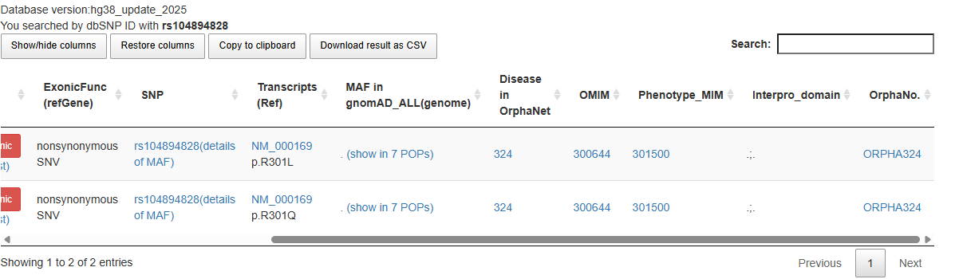
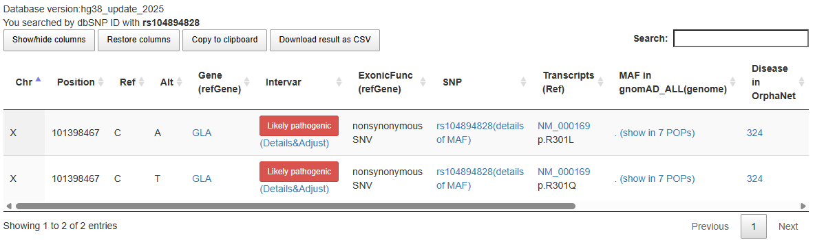
Figure 14. Fabry

Figure 14. Monilethrix
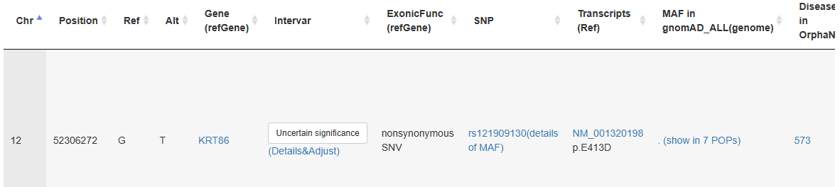
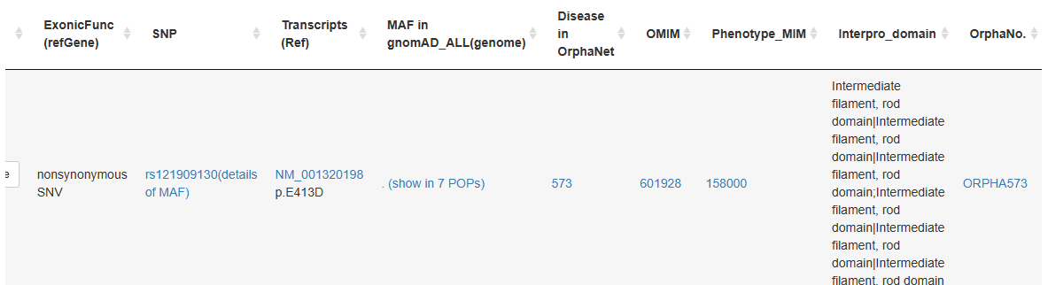

WinterVar does not have the data of variants of AIS and NF1 related diseases selected in this pipeline.

24. Interpretation and Reporting Limitations
- All files are synthetic educational datasets and do not represent real patients.
- The pipeline records computational and database annotations; it does not independently establish a clinical diagnosis.
- Some background variants were removed because their REF bases did not match GRCh38 during bcftools norm -c x.
- A ClinVar match is useful supporting evidence, but classifications require date-stamped review in real clinical work.
- A low or zero SpliceAI score does not make a non-splicing variant benign.
- ISV probability is supporting computational evidence and should not override curated evidence.
- CNV breakpoint accuracy, zygosity, phase, phenotype matching, segregation, and orthogonal confirmation were not available.
- The report should distinguish disease-focused synthetic targets from background variants and from real clinical conclusions.

25. Conclusion
The completed workflow demonstrates a reproducible GRCh38 annotation system with separate sequence-variant and CNV branches. The manual validation phase identified software-version, executable-path, dependency, input-format, and coordinate-consistency issues before automation. The final pipeline now accepts a disease base name, runs the confirmed tools, validates each stage, writes disease-specific outputs, and supports batch execution across Fabry disease, Monilethrix, AIS, and NF1. The GitHub repository should preserve the scripts, recipes, synthetic inputs, selected outputs, meaningful screenshots, and documentation while excluding large databases, container images, secrets, licensed resources, and real patient information.

