Final Year Project Proposal



**Efficient Automated Service Provider**

**(EASP)**

**Supervisor**

**Sir Uzair Saeed**

**Submitted by**

**Abdur Rehman** BSCS-FA19-050

**Muhammad Kabeer Khan** BSCS-FA19-061

**Ahmad Jilani** BSCS-FA19-035

**Department of Computer Science**

**The University of Faisalabad, Engineering Wing**

**Faisalabad, Pakistan**

**(**Date of Submission: 05-12-2022)

**Declaration**

This report has been prepared on the basis of my own work. Where other published and unpublished source materials have been used, these have been acknowledged.

Word Count: ___________________________

|  |  |  |  |
| --- | --- | --- | --- |
| Students Name: | Abdur Rehman | Muhammad Kabeer Khan | Ahmad Jilani |
| Student Registration No: | BSCS-FA19-050 | BSCS-FA19-061 | BSCS-FA19-035 |
| Signatures: |  |  |  |

Date of Submission:

Supervisor Name:

Supervisor Signature:

**CERTIFICATE**

We accept the work contained in the proposal titled “**Efficient Automated Service Provider**”, written by Mr. Abdur Rehman, Mr. Kabeer Khan and Mr. Ahmad Jilani as a confirmation of the required standard for the partial fulfillment of the degree of Bachelor of Science in Computer Science.

Approved by:

Supervisor: Mr. Uzair Saeed

Project Coordinator: Mr. Rehman Shahid

Head of the Department: Dr. Prof Majid Hussain

December 1, 2022**ACKNOWLEDGMENT**

First and foremost, praise Allah the Almighty, the Most Merciful, the Most Gracious, for His showers of blessings throughout our project work to complete the SPEP proposal successfully. Before we begin developing the Proposed System and describing the comprehensive chapters, we want to thank everyone who assisted us at various phases of our project. We boldly state that the project's success is contingent on our parents' unending prayers and support. We would like to express our appreciation to our teachers, who assisted us much in obtaining various information, collecting statistics, and mentoring us from time - to - time in the creation of this project. We would want to express our special thanks to our respected faculty members who offered to assist us in many sections of the problem area. We are grateful to our esteemed teacher, Sir Muhammad Rehman Shahid, for always lending a helping hand in all aspects of the project's development, and especially for enabling us to move forward during the field of developing software products/projects in accordance with internationally recognized standards. We are grateful to Dr. Majid Hussain, HOD and our supervisor Sir Uzair Saeed, for their continued support and for inspiring us to create something unique and new.

**Table of Contents**

Chapter 1: Introduction 4

* 1. Background 4
  2. Project Vision 4
  3. Problem Statement 4
  4. Objectives 5
  5. Project Scope 5
     1. Market Competitors 6
     2. Business significance 6
     3. Business Plan 6
     4. Constraints 6

Chapter 2: Software Requirement Specification 7

* 1. List of Features 7
  2. Quality Attributes 7
  3. Non-Functional Requirements 7

Chapter 3: Logical Design and Architecture 8

* 1. Expanded Use Cases 8
  2. Activity Diagram 9
  3. Domain Model 10

Chapter 4: Conclusion 11

Bibliography 12

**List of Figures**

Figure 1 Minimum Wages in Pakistan 6

Figure 2 Use Case Diagram 12

Figure 3 Activity Diagram 13

Figure 4 Domain Model 14

Figure 5 Architecture Diagram 15

Figure 6 Sequence Diagram 16

**List of Tables**

Table 1 Market Competitors vs EASP 9

Table 2 Gantt Chart 10

Chapter 1: **Introduction**

As technology evolves and the world moves with it, in Pakistan we don’t see such evolution in this space, as we are not giving chances to the skillful laborers with low wages to express their skill set for better income. This app will help them to become common or become known to the public. Through our app service seekers will we be able to connect with these people. Our vision is to facilitate people and businesses in outsourcing their work; whether you're seeking employment or want a worker to carry out a specific task, we can assist you in finding the best match. As a Pakistani who understands people that are service providers and service seekers, I think this app will perform well for middle-class people. And I can sense a bright future in this domain because in middle-class families there’s always been an issue to find a person who can do their chores and daily routine household tasks. As a lazy person, I can present all lazy people and can assure you that one will prefer to find a service provider online rather than going out and wasting his time and money. So, this project is a step in this direction that can impact multiple lives and can have better outcomes.

## Background

Being extremely lazy in every aspect of life I have always preferred some convenience of some sort. But one day the idea came to my mind that there are many convenience apps nowadays that are very helpful to my type of audience, so I did some research and found some apps that I thought can help me with my chores. Still, I was disappointed that I found none of them that have diverse options of services. So as a developer, I gave myself a challenge for myself and other people like me, and I think through my effort I can provide a platform to the people who still have no privilege of giving their services online. Following is the list of monthly income of Pakistani’s.

(Wage Indicator, 2019)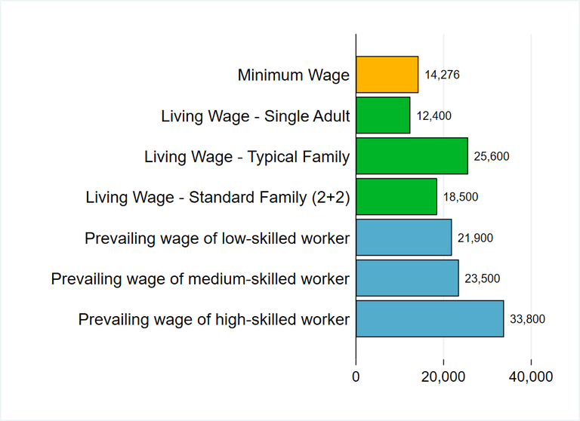

Figure Minimum Wages in Pakistan

## 1.2 Project Vision

The vision of this project is to have a better relationship between service provider and service seeker. And our main goal will be to close the gap between these two entities. And we want a far better outcome as we want our skilled laborer community to have some exposure to a broader audience that will add some additional value to his income and will improve our poverty rate that is going fast as time is passing.

## 1.3 Problem Statement

In Pakistan, more than two million individuals have slipped into poverty. Using the lower-middle-income poverty rate ($3.2 per day), the World Bank calculated that Pakistan's poverty rate was 39.3 per cent in 2020-21, 39.2 per cent in 2021-22, and 37.9 per cent in 2022-23. (Word Bank, 2022) And most of them are some sort of service providers like motor mechanics, gardeners, plumbers, maids, servants, etc. and there is no platform for them to list their offerings. That is why we will provide a platform for service providers and the one who seeks, where every type of service provider can list his offerings without any restrictions.

## Objectives

Our vision is to facilitate people and businesses in outsourcing their work; whether you're seeking employment or want a worker to carry out a specific task, we can assist you in finding the best match. Skilled people may make extra money using our website or mobile app.

The key features of our project are:

* There will be no constraint on the type of service that can be found in the platform.
* The user can be both an employer and an employee simultaneously.
* Rank and update service providers with users' new tasks that are located within a 5-kilometer distance around them.
* Users and service providers can negotiate a price.
* Service provider lists his specialty along with prices.
* There may or might not be a delivery charge (totally depends on the service provider).
* Both the website and the app will allow you to communicate with the service provider.
* Users will receive a message by hiring a service provider.
* We will ensure that this platform uses the internet as little as possible.
* Our assessment officer will assess the service provider's profile.
* A person's profile will be raised if he accomplishes a set of objectives and tasks within a predetermined window of time.

## Project Scope

As technology evolves and the world moves with it, in Pakistan we don’t see such evolution in this space, as we are not giving chances to the skillful laborers with low wages to express their skill set for better income. This app will help them to become common or become known to the public. Through our app service seekers will we be able to connect with these people. We are making this application based on our culture, but I am very hopeful to see this application working in all parts of the world. As the main theme of this application is to minimize the gap between seekers and service providers, this application will act as a bridge between these entities. In the future, as the world is evolving this application will surely be a part of that evolution. If not, the best it will at least be among the ones that are pioneers of this idea.

### Market Competitors

### Comparison of EASP with other market competitors.

Table Market Competitors vs EASP

|  |  |  |  |  |
| --- | --- | --- | --- | --- |
| **Features** | (Maher, 2020) | (SuperTasker.pk, 2019) | (Services Finder, 2018) | **EASP** |
| For Freelancers |  | ✔ |  | ✔ |
| Services Category |  |  | ✔ | ✔ |
| Backend Support |  | ✔ |  | ✔ |
| Chat Support |  |  |  | ✔ |
| User can Post Service | ✔ | ✔ |  | ✔ |
| Client can Post Task |  | ✔ |  | ✔ |

### Business significance

Other Applications have some limitations in aspect of technology, almost all of them lack a proper map integration. We will pin the real time location of service providers and service seekers. And in our app, there will be a list of all service providers so one can choose any person he wants from the list.

### Business Plan

As a service providing platform, we will take 10 percent of every transaction made with our app. But this will be our 80 percent users and 20 percent revenue that we are generating through them. We are taking the approach of 80-20 business model. Our primary focus will be our 20 percent customer that will be providing us 80 percent revenue, that will be business corporates that need service providers for their tasks or let’s say for their building, that is one need a person to clean the building, HVAC Installation and maintenance, flooring, piping, all sort of stuff that an organization need. We will directly made contracts with them, and we will secure that 20 percent of our market providing us 80 percent revenue. And these customers can be factory, an office, an organization, a government’s place, or all sort of things that can get benefits through our app. So initially this is our simple plan and in future it can be evolved if needed.

Table Gantt Chart

|  |  |  |  |  |  |  |  |  |  |  |
| --- | --- | --- | --- | --- | --- | --- | --- | --- | --- | --- |
| *TASK* | *SEP* | *OCT* | *NOV* | *DEC* | *JAN* | *FEB* | *MAR* | *APR* | *MAY* | *JUNE* |
| Project Planning | 29 | 24 |  |  |  |  |  |  |  |  |
| Requirements Gathering |  |  |  | 01 | 30 |  |  |  |  |  |
| Document Phase 1 |  |  | 14 | 30 |  |  |  |  |  |  |
| Design |  |  | 01 | 30 |  |  |  |  |  |  |
| Coding |  |  |  |  |  | 01 |  | 30 |  |  |
| Implementation |  |  |  |  |  |  |  |  | 30 |  |
| Testing |  |  |  |  |  |  |  |  | 30 |  |
| Verification |  |  |  |  |  |  |  |  |  | 30 |

### Constraints

We didn’t find any major constraints to our application as there are very minimal requirements that we need. And we also didn’t find any government policies and regulations related to our app, But I think our main issue can be:

* Person’s verification

Chapter 2: **Software Requirement Specification**

In this chapter, first describe the existing system, its limitations or drawbacks and then explain how the new or proposed system will overcome these problems. This should then be followed by complete requirements specification for the proposed system. Describe the behavior of the system to be developed and include a set of use cases that describe interactions the users will have with the system. In addition, it also describes non-functional requirements. Non-functional requirements impose constraints on the design or implementation (such as performance engineering requirements, quality standards, or design constraints). Should have the following headings:

## List of features

* No Constraints on type of service.
* One can be a service provider or service seeker or both.
* There will be a rank system to prioritize good service providers.
* Task will be visible to only people in a 5Km radius.
* Prices will be negotiable.
* There will be a list of service providers with their respective skills and prices.
* There will be a message feature between users.
* There will be message verifications on services.
* There will be a minimum need to use the internet on the service seeker side.
* There will be a person or in the long term there will be an automated system to filter the profiles to avoid controversial content.
* There will be awards on some set of goals and objectives.

## Quality Attributes

* No Constraints on type of service.
* Negotiable Prices.
* SMS verifications.
* Efficient use of the internet.

## Non-Functional Requirements

* Cross platform compatibility, i.e., iOS, Android and PC.
* Minimal Loading and fetching time.
* Well Optimized for every device.
* Responsive view to all displays.
* Confidentiality is a priority.

Chapter 3: **Logical Design and Architecture**

Systems design is the process of defining the architecture, components, modules, interfaces, and data for a system to satisfy specified requirements. System architecture describes the system in narrative form using non-technical terms. It should provide a high-level system architecture diagram showing a subsystem breakout of the system, if applicable. The high-level system architecture or subsystem diagrams should, if applicable, show interfaces to external systems. Supply a high-level context diagram for the system and subsystems, if applicable.

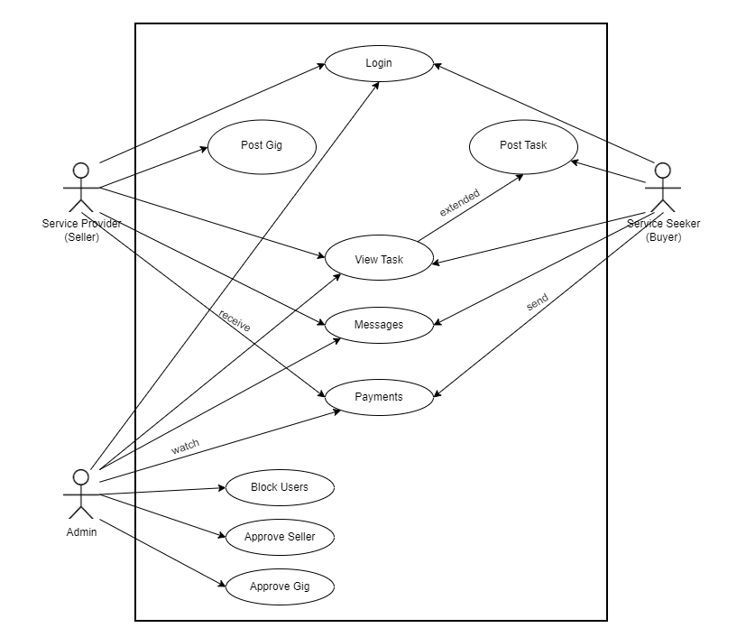**3.1 Expanded Use Case**

Figure Use Case Diagram

**3.2 Activity Diagram**

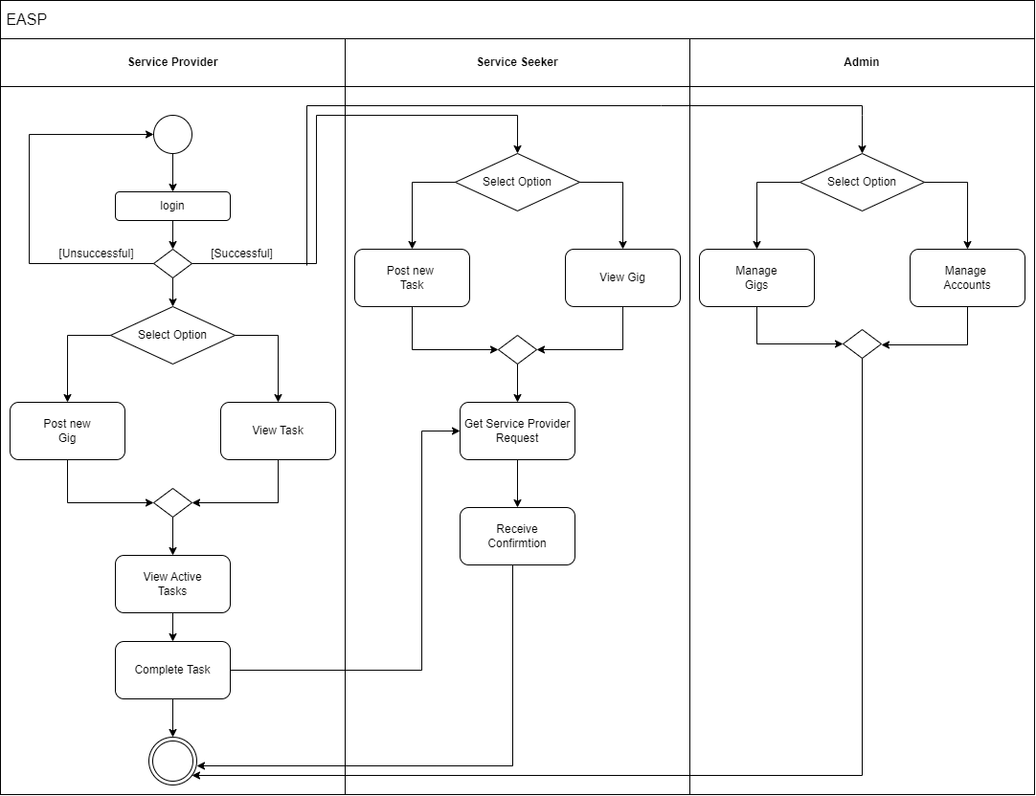

Figure Activity Diagram

**3.3 Domain Model**

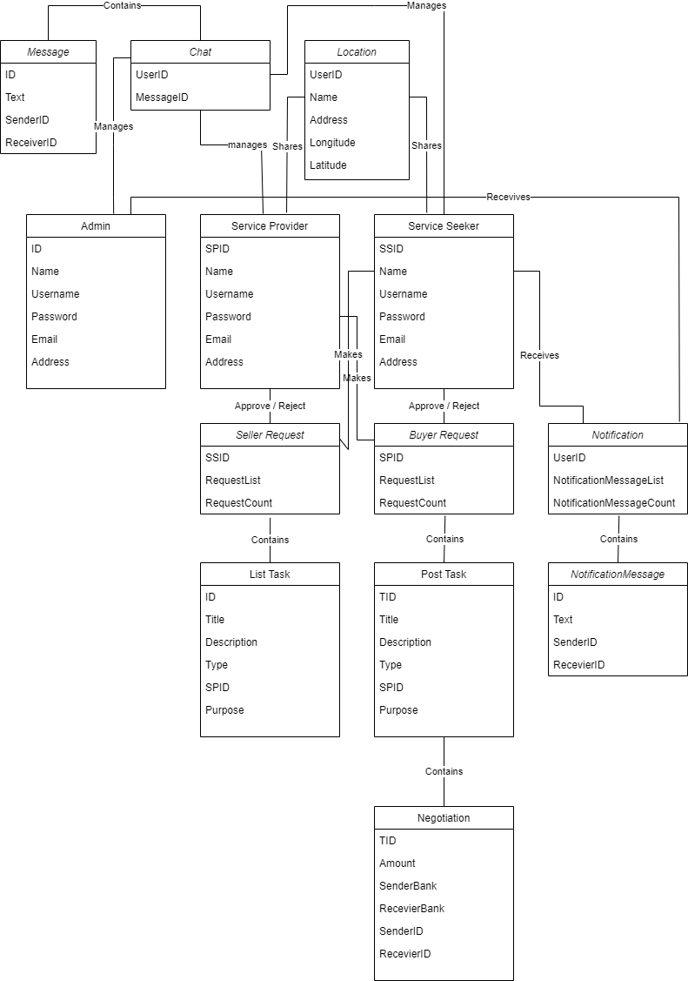

Figure Domain Model

**3.4 Architecture Diagram**

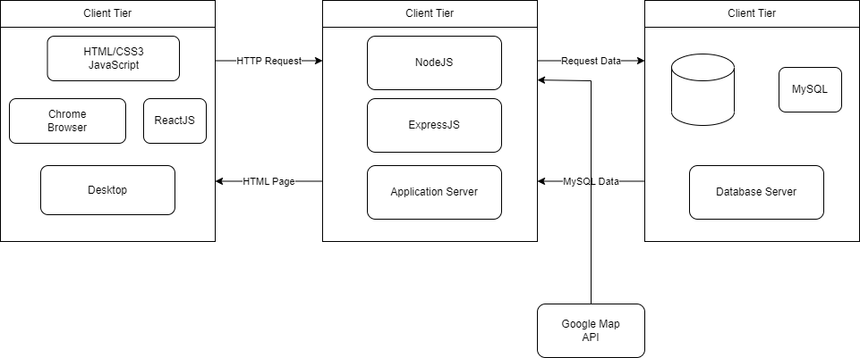

Figure Architecture Diagram

**3.5 Sequence Diagram**

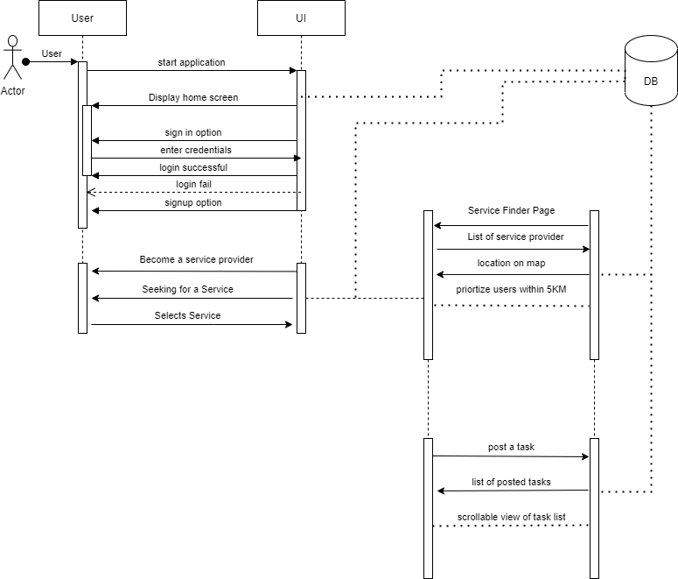

Figure Sequence Diagram

Chapter 4: **Conclusion**

Our vision is to facilitate people and businesses in outsourcing their work; whether you're seeking employment or want a worker to carry out a specific task, we can assist you in finding the best match. As the main theme of this application is to minimize the gap between seekers and service providers, this application will act as a bridge between these entities. This application will act as a bridge between these entities. In the future, as the world is evolving this application will surely be a part of that evolution. And we want a far better outcome as we want our skilled laborer community to have some exposure to a broader audience that will add some additional value to his income and will improve our poverty rate that is going fast as time is passing. Our main theme will be to impact the lives of people who are struggling in life and want to earn some extra, we are a source to them for their betterment. We are hopeful to see this application changing the lives of many people and helping strengthen the economy of our country.

# Bibliography

1. Maher, 2020. *Google Play Store.* [Online]   
   Available at: https://play.google.com/store/apps/details?id=com.maharah.vander&hl=en&gl=US  
   [Accessed 15 October 2022].

2. Services Finder, 2018. *Google Play Store.* [Online]   
Available at: https://play.google.com/store/apps/details?id=com.arfatechdevelopers.servicesfinder&hl=en&gl=US  
[Accessed 16 October 2022].

3. SuperTasker.pk, 2019. *Google Play Store.* [Online]   
Available at: https://play.google.com/store/apps/details?id=com.maharah.vander&hl=en&gl=US  
[Accessed 16 October 2022].

4. Wage Indicator, 2019. *Living Wages.* [Online]   
Available at: https://wageindicator.org/salary/living-wage/archive-no-index/pakistan-living-wage-series-september-2019

5. Word Bank, 2022. *Poverty in Pakistan.* [Online]   
Available at: https://www.wionews.com/south-asia/poverty-in-pakistan-up-from-44-to-54-world-bank-393089  
[Accessed 15 November 2022].