* Install VirtualBox
* Install CentOS 7
* Create a user as your first letter in the first name and last name.

Ex: Kranthi kavuri = kkavuri

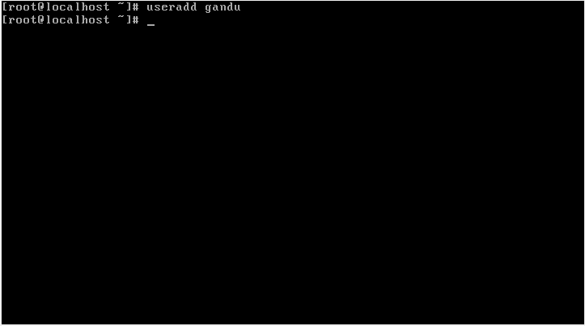

* Go to your home directory.

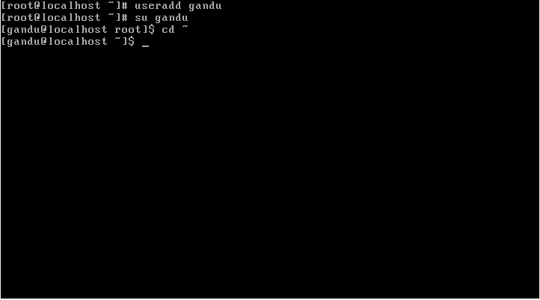

* Create subdirectories in your home directory with your username + 1 & 2.

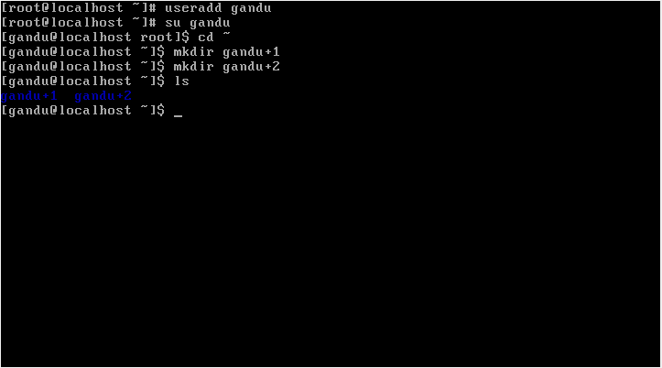

* Create a file with your username.

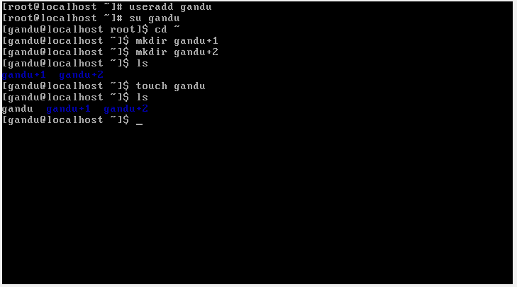

* Change the permissions for the file to read and write but not execute.

Before Changing the file looks like as below

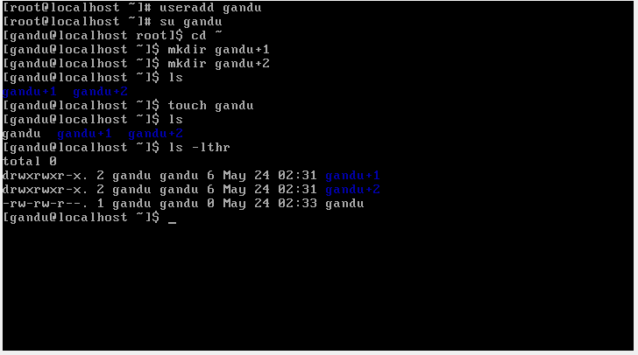

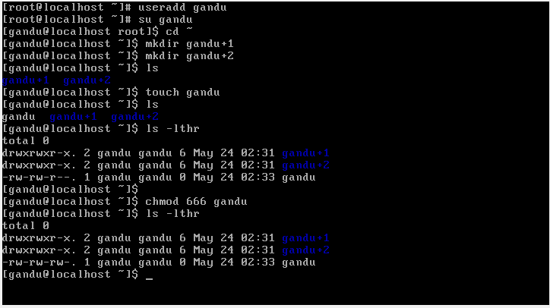

* Change the permission for the file to read and execute but not write.

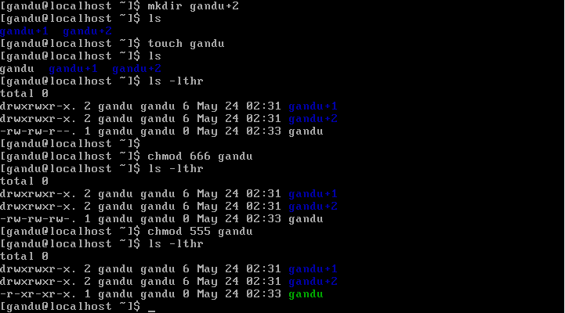

* Write two lines in a file and display it to the screen.

