**Installing GIT on Ubuntu:**

1. **Sudo apt-get install git**

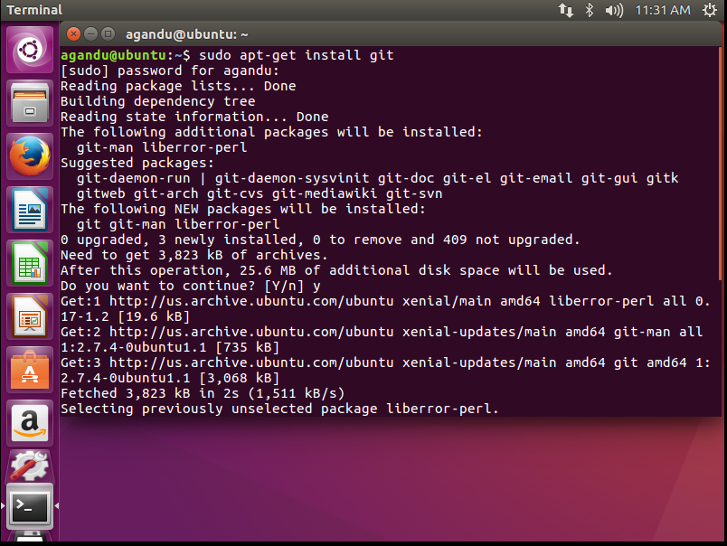

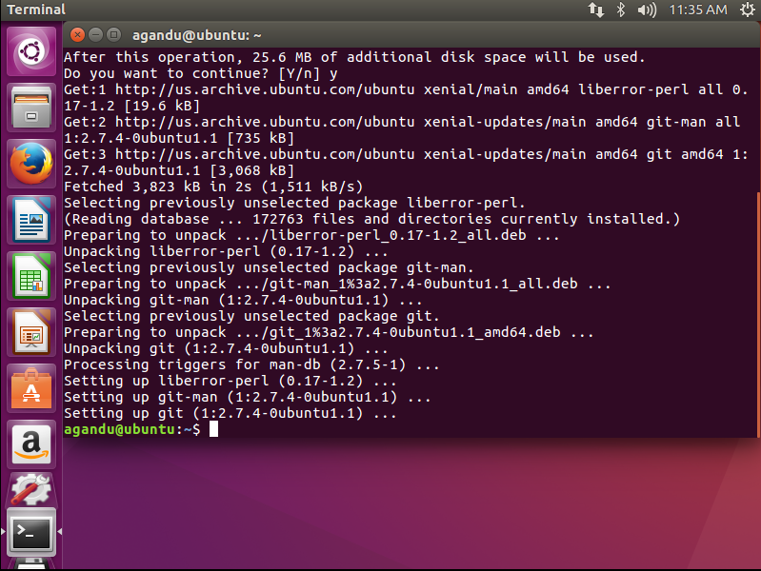

1. **Git config –global user.name “anithareddyk” (my github user name is anithareddyk)**

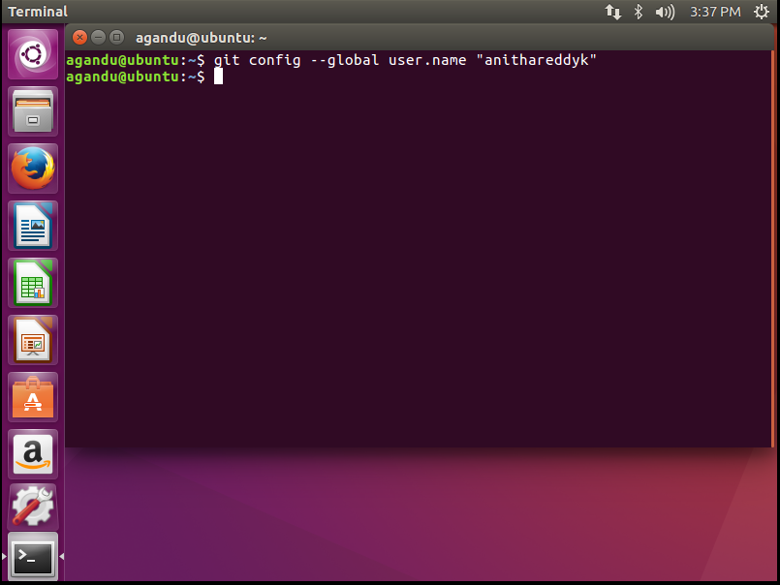

1. g**it config --global user.email** [**anithareddy41@gmail.com**](mailto:anithareddy41@gmail.com)

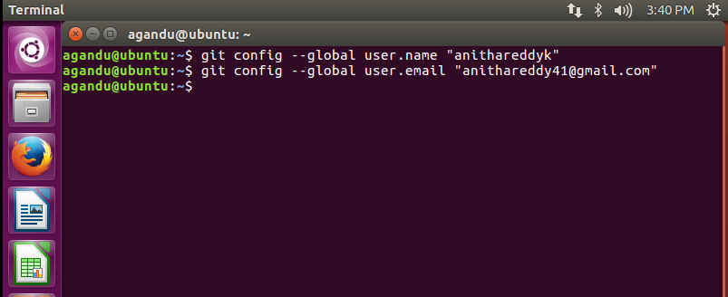

1. **Open github.com in browser and login using github credentials**
2. **Create a new repository ,here I am creating a repository named “gittest”**
3. **Mkdir called “gittest” in your local machine( you can give any name)**
4. **Go to directory “gittest”**

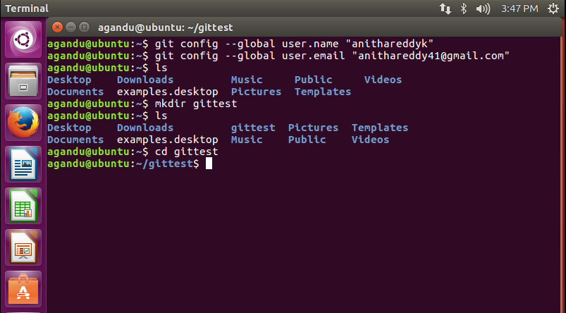

1. **echo "# gittest" >> README.md**

Creating README file in gittest using echo

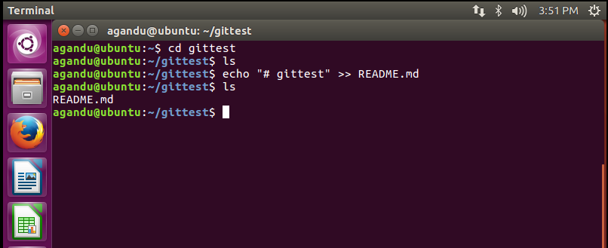

1. **git init**

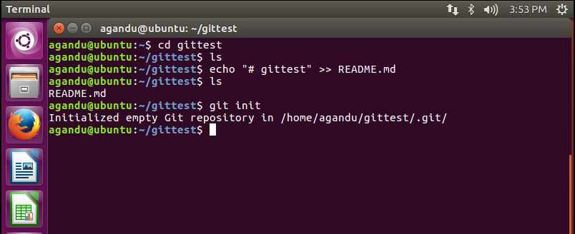

**10. git add README.md**

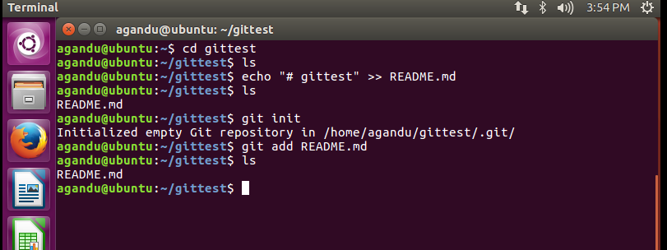

**11. git commit -m "first commit"**

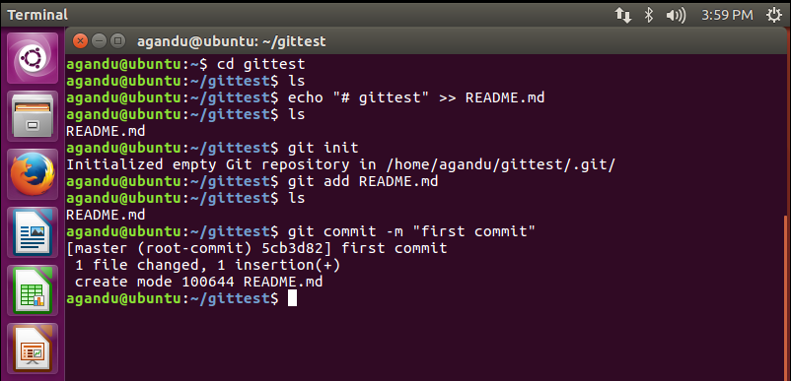

**12. git remote add origin https://github.com/anithareddyk/gittest.git**

It links up local directory and git repository.

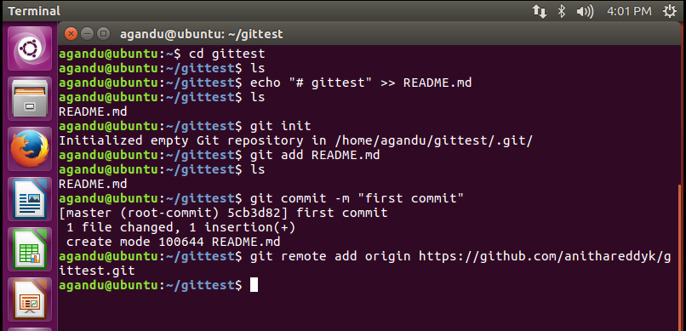

**13. git push -u origin master( for this step to be executed you need to provide github credentials as shown in the screenshot)**

**This pushes the file README to github**

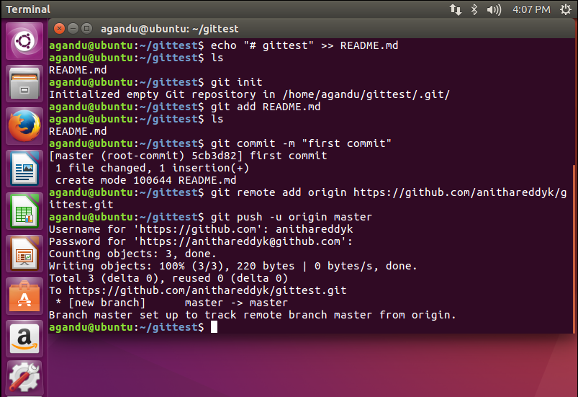

**Now look at the github gittest you see README file**

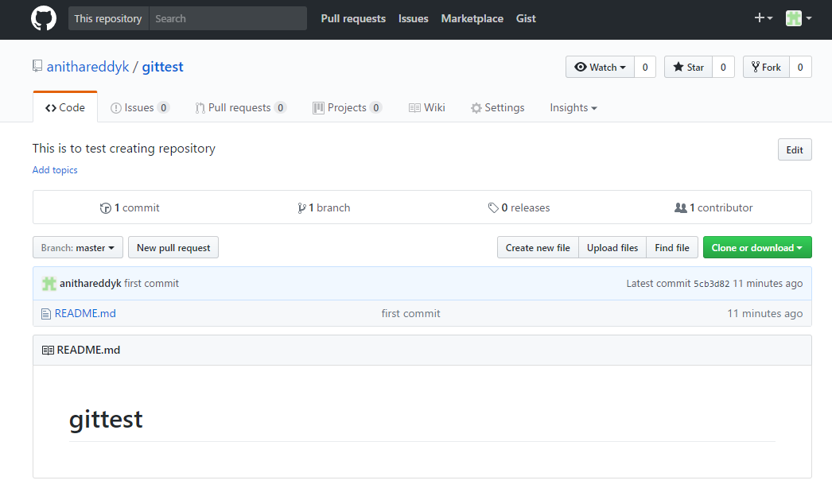

**Now will go and create new file named test.txt**

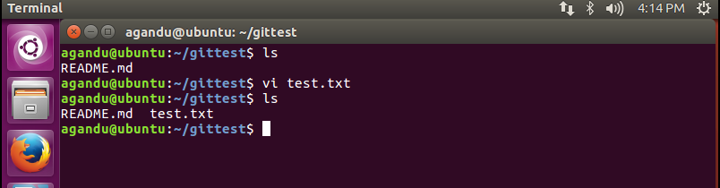

**git add test.txt**

**git status**

**git commit –m “This is test.txt file”**

**git status**

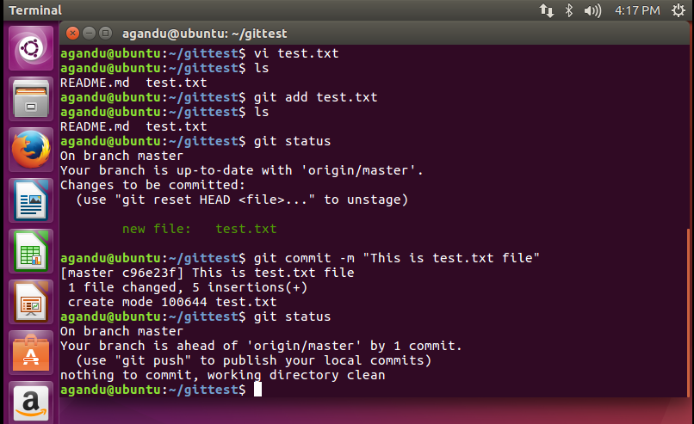

**Now go ahead and push the txt file to github**

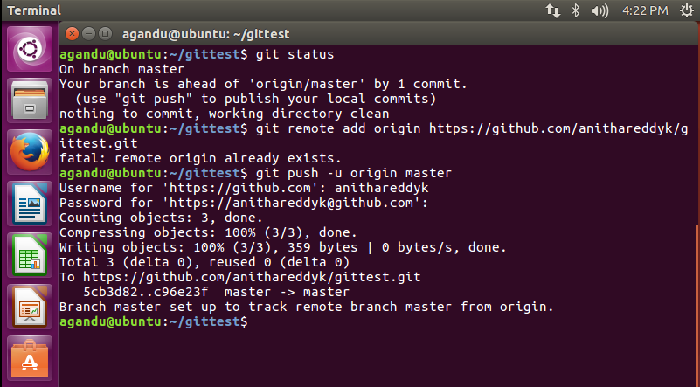

**Now go and referesh the gittest repository, you can see test.txt file**

