* Update the apt package index:

$ sudo apt-get update

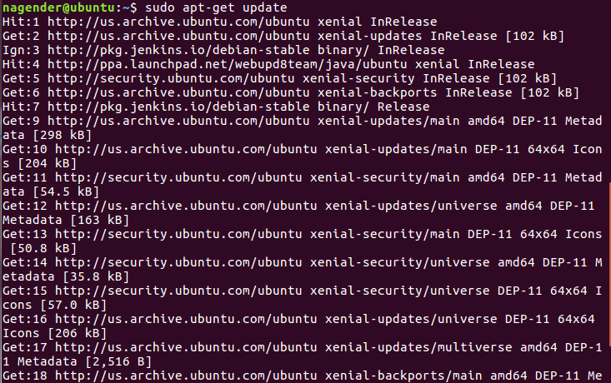

* Install packages to allow apt to use a repository over HTTPS:

$ sudo apt-get install \

apt-transport-https \

ca-certificates \

curl \

software-properties-common

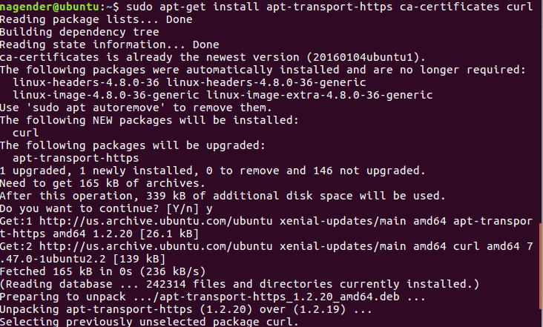

* Add Docker’s official GPG key:

$ curl -fsSL https://download.docker.com/linux/ubuntu/gpg | sudo apt-key add

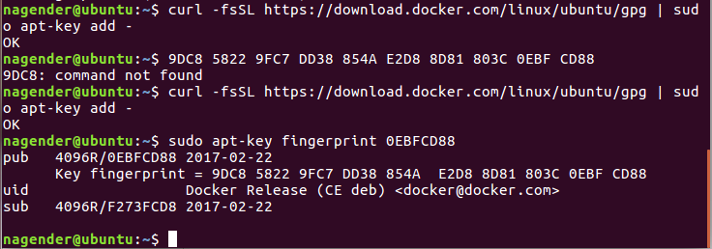

**amd64**:

$ sudo add-apt-repository \

"deb [arch=amd64] https://download.docker.com/linux/ubuntu \

$(lsb_release -cs) \

stable"

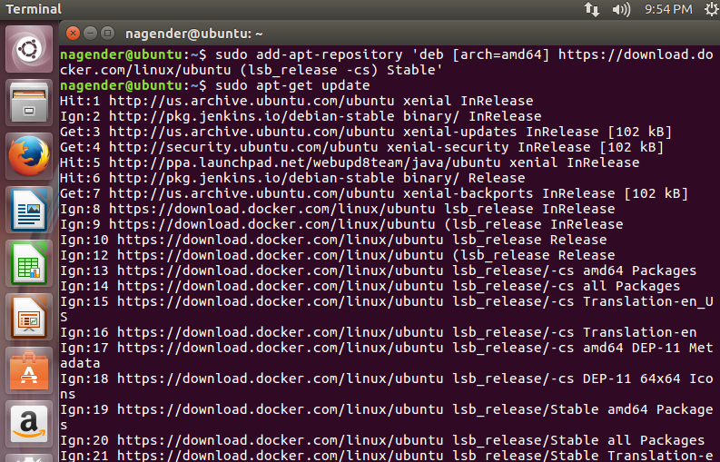

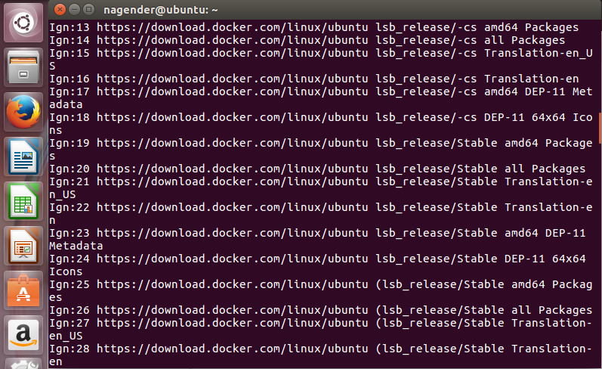

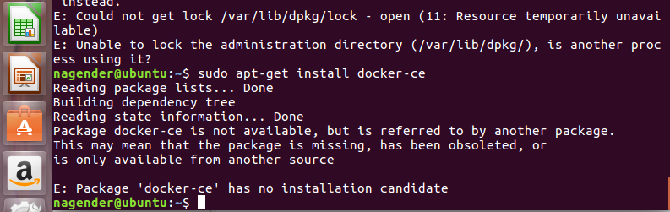

* Install the latest version of Docker CE, or go to the next step to install a specific version. Any existing installation of Docker is replaced.

$ sudo apt-get install docker-ce

