ASSIGNMENT 02
DAV
MUHAMMAD ABDURREHMAN
22I-1963
DS-A

Data Preprocessing

IMDb Top 1000 Dataset

Overview
The IMDb Top 1000 dataset underwent several preprocessing steps to clean and standardize the data, enabling accurate analysis. This report summarizes each step taken in the preprocessing workflow.

Steps
- Data Import and Initial Examination
  - Imported the dataset using pandas.
  - Removed unnecessary columns, specifically Overview and Poster_Link, to focus on key attributes for analysis.
- Handling Duplicate Rows
  - Identified duplicate rows in the dataset.
  - The code checked for duplicates, and a count of the duplicate rows was displayed, though no specific action was taken to remove duplicates in this script. If duplicates were found, they should ideally be removed.
- Handling Missing Values
  - Certificate: Replaced missing values in the Certificate column with "NA".
  - Meta_score: Filled missing values in the Meta_score column with its mode (the most frequently occurring score).
  - Gross: Filled missing values in the Gross column with its mode. Since Gross typically represents revenue, using the mode provides a reasonable estimate for missing entries.
- Data Cleaning
  - Released Year: Removed rows where Released_Year had a value of "PG". This step ensures that only numerical year values are retained.
  - Runtime: Removed the string "min" from each entry in the Runtime column, leaving only numerical values.
  - Gross: Removed commas from Gross values, allowing conversion to numeric format.
- Data Type Conversion
  - Released Year: Converted Released_Year to integer format for consistency.
  - Runtime: Converted Runtime to integer, facilitating runtime analysis.
  - Gross: Converted Gross to int64 to handle large numerical values representing gross revenue.
  - Meta_score: Converted Meta_score to integer format.
- Exporting the Cleaned Data
  - Saved the cleaned dataset to a new CSV file (MoviesData.csv) for subsequent analysis and reporting.

Tableau Visualization

I made 3 dashboards and A story with 3 story points comprising of 11 different visualizations.

DASHBOARD 1

1. Top 10 Directors (IMDB) by Gross (Bar Chart)
- This horizontal bar chart displays the top 10 directors ranked by the total gross earnings of their films.
- Steven Spielberg leads with the highest gross, followed by Christopher Nolan and Peter Jackson.
- Each director's bar represents their cumulative earnings, with the x-axis showing the gross in millions (M) or billions (B).

2. Directors with Most Votes (Pie Chart)
- The pie chart illustrates the directors who have garnered the most votes for their films on IMDB.
- Christopher Nolan holds the largest segment with 28.49% of total votes, indicating his popularity among audiences.
- Other directors, such as Quentin Tarantino (19.99%) and Steven Spielberg (19.24%), also have significant portions, reflecting high audience engagement.

3. Directors with Most Meta Scores (Heat Map)
- This heat map ranks directors by their cumulative Meta Scores (a measure of critical acclaim).
- Alfred Hitchcock has the highest Meta Score total, with a score of 1,270, indicating widespread critical acclaim.
- Directors like Steven Spielberg and Hayao Miyazaki also have high Meta Scores, reflecting consistent quality across their work.
- The color gradient highlights the score range, with darker shades representing higher scores.

Summary :
- Gross Earnings: Steven Spielberg dominates in gross earnings, reflecting the commercial success of his films.
- Audience Engagement: Christopher Nolan is the most popular director based on votes, indicating strong audience approval.
- Critical Acclaim: Alfred Hitchcock has the highest cumulative Meta Score, showcasing his influence and recognition among critics.

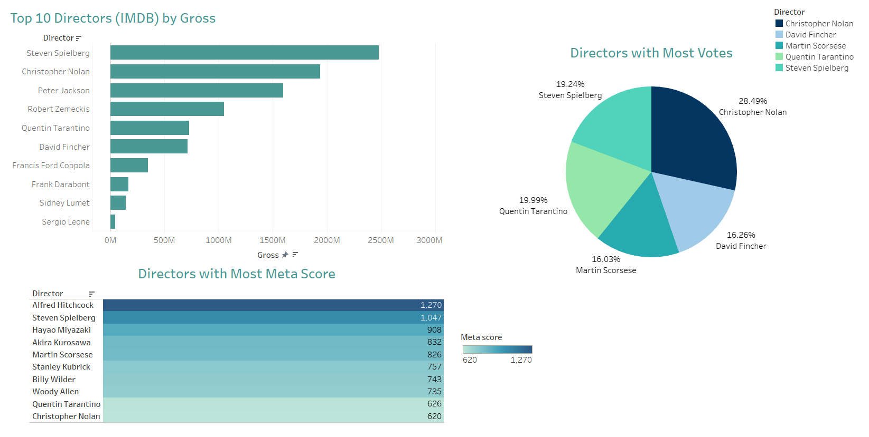

DASHBOARD 2

1. IMDB Ratings of Genres (2000-2015) (Line Chart)
- This line chart shows the trend of IMDB ratings across various genres from 1934 to 2014.
- Different genres, such as Action, Adventure, Animation, and Drama, are represented by distinct colors, with peaks and troughs indicating changes in ratings over time.
- The chart suggests fluctuating popularity and critical reception for genres over the years, with certain genres experiencing spikes in specific periods.

2. Gross of Leading Stars in Top 5 Genres (Scatter Plot)
- This scatter plot visualizes the gross earnings of leading stars across the top 5 genres.
- The x-axis represents major actors like Tom Hanks, Leonardo DiCaprio, Clint Eastwood, Al Pacino, and Robert De Niro, while the y-axis shows their film grosses.
- Each dot represents a genre, color-coded (e.g., Action, Adventure, Animation, Biography, Drama).
- Tom Hanks has the highest-grossing films, with earnings close to 1 billion, indicating his significant box office draw.

3. Runtime of Top 3 Genres (2000-2005) (Bar Chart)
- This grouped bar chart displays the runtime of the top 3 genres (Action, Comedy, Drama) from 2000 to 2005.
- Each bar represents a year and shows the runtime in minutes for each genre.
- Drama tends to have longer runtimes, particularly in 2004, indicating a trend toward more in-depth storytelling in this genre.
- The bar colors reflect different years, making it easy to track changes in runtime over time.

Summary:
- Genre Popularity Over Time: The line chart highlights the fluctuating ratings of different genres, showing trends and shifts in audience preferences and critical reception.
- Box Office Success by Star: Tom Hanks stands out in the scatter plot, demonstrating his high earnings in the top genres.
- Genre Runtime Trends: Drama films generally have longer runtimes, while Action and Comedy vary more, reflecting differences in storytelling style and format.

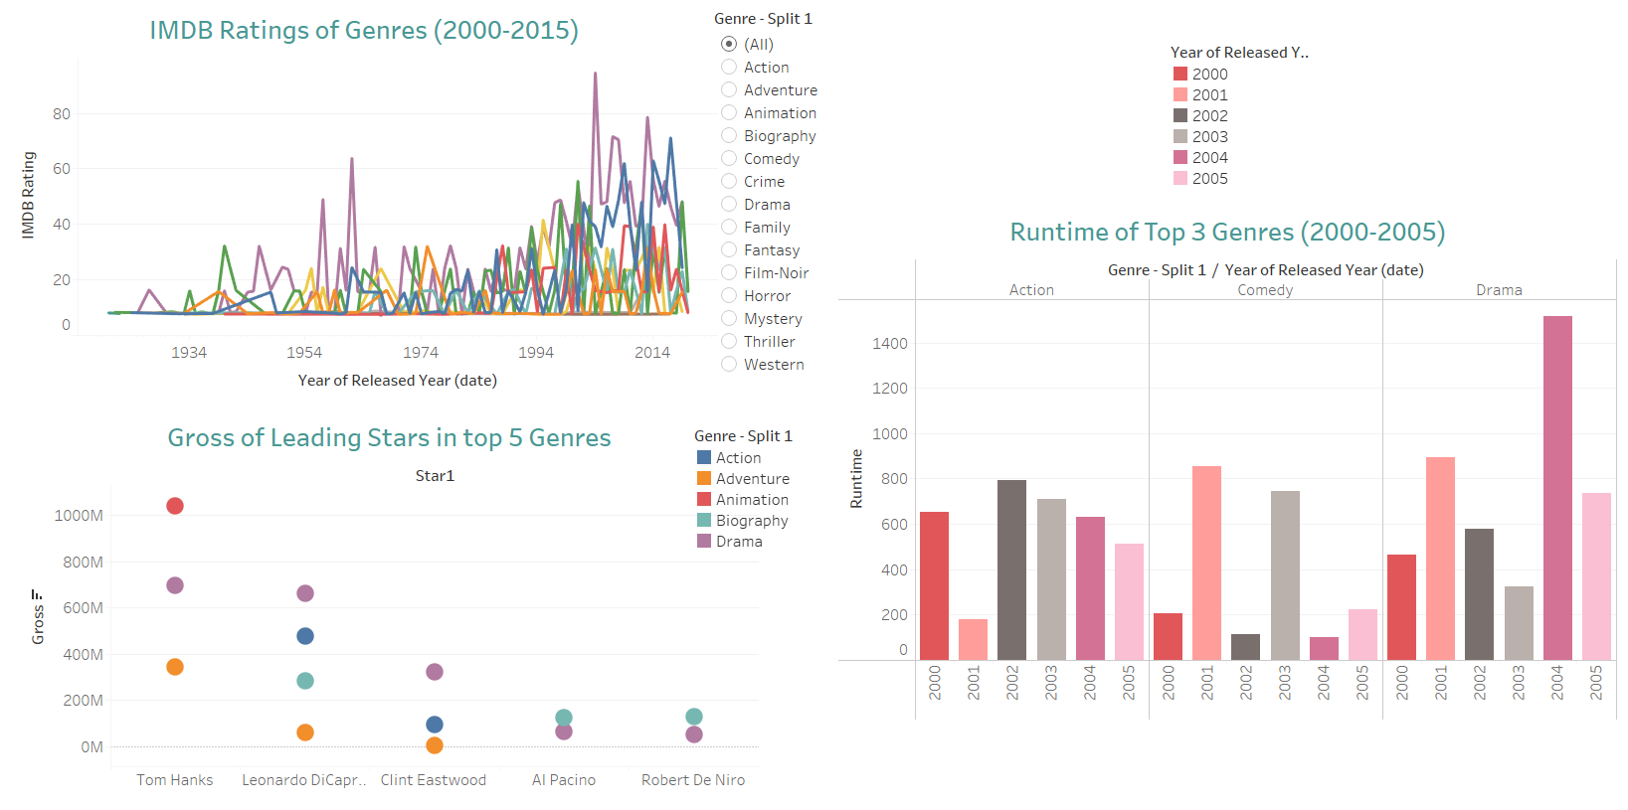

DASHBOARD 3
- Top 10 Series by IMDB Rating (Bar Chart)
  - This bar chart showcases the IMDB ratings of the top 10 TV series.
  - Series such as The Shawshank Redemption, The Godfather, and The Dark Knight dominate the top ratings, with scores over 8.6.
  - The chart highlights the popularity of these series, with The Shawshank Redemption achieving the highest rating among them.
- Change in Gross over the Years (Line Chart)
  - This line chart illustrates the trend in gross revenue over the years.
  - Starting from the early 1990s, there’s a gradual increase in gross revenue, with notable spikes in the 2000s and early 2010s.
  - The chart suggests a general upward trend in box office revenue, reflecting growing audience sizes and possibly increased ticket prices.
- Certificate vs. Gross over the Years (Line Chart)
  - This chart displays gross earnings based on film certification over time.
  - Certificates such as PG, R, and Approved are represented, showing varying earnings trends over the decades.
  - From around 1970 onwards, we see a significant rise in revenue across certifications, with specific certifications like R and PG-13 having notable peaks.
- Comparison wrt No. of Votes (Bubble Chart)
  - This bubble chart compares the number of votes received by leading stars like Tom Hanks, Christian Bale, Johnny Depp, and Leonardo DiCaprio.
  - Leonardo DiCaprio has the highest number of votes, with over 9 million, indicating strong audience engagement.
  - The size of each bubble corresponds to the vote count, making it easy to visualize each actor’s popularity.
Summary:
- IMDB Ratings of Top Series: The bar chart effectively ranks the top-rated series, showcasing viewer preferences.
- Trends in Gross Revenue: The line chart shows a growth in box office gross over the years, with peaks indicating blockbuster releases.
- Certification Impact on Revenue: Revenue appears to vary by certification, with R and PG-13 films showing strong earnings in recent decades.
- Audience Engagement with Leading Stars: The bubble chart highlights Leonardo DiCaprio's lead in terms of audience votes, indicating his high popularity among viewers.

STORY(DASHBOARD 3)

