DESIGN AND ANALYSIS OF ALGORITHMS
ASSIGNMENT 03

Muhammad Abdurrehman 22I-1963
Ahmad Akhtar 21I-1655
Bilal Fayyaz 22I-1992
DS-A

REPORT

1. Application Functionalities
The Word Search Application is designed to facilitate users in searching for specific terms within multiple text files. Its key functionalities include:
- Search Functionality: Users can input a search term to initiate a search across multiple selected text files. The application will return:
  - File Name: The name of the file where the search term is found.
  - Row Number: The line number within the file where the term is located.
  - Column Number: The position of the search term within the specified row.
- Advanced Matching Options:
  - Whole Word Match:
    - Unchecked: Returns all instances of the search term, including substrings within larger words.
    - Checked: Only returns results that match the search term as a whole word.
  - Case Sensitivity:
    - Unchecked: Performs a case-insensitive search, treating variations in upper and lower case as equivalent.
    - Checked: Conducts a case-sensitive search, only returning results that match the exact case of the search term.
- Performance Evaluation:
The application implements both the Brute Force and Knuth-Morris-Pratt (KMP) algorithms for searching. After completing the search, the application records and displays the time taken by each algorithm, including:
Time Taken by Brute Force: Displays the time required to execute the Brute Force search.
Time Taken by KMP: Displays the time required to execute the KMP search.
Comparison : Brute Force and KMP search time was almost the same when there was no occurrence of the searched text. But with the increase in number of occurrences, the KMP Algorithm search time increased. This means that Brute Force matches the string faster than KMP Algorithms.

2. Language Used
The application is developed using Python, specifically leveraging the Tkinter library for GUI creation. Python was chosen due to its:
- Ease of Use: Python's syntax is clear and straightforward, making it accessible for both beginners and experienced developers.
- Rich Libraries: The Tkinter library provides a simple way to create graphical user interfaces, allowing for rapid development.
tkinter as tk: Provides the core components for building the graphical user interface (GUI) of the application.
from tkinter import filedialog: Allows users to open file selection dialogs to choose text files for searching.
from tkinter import messagebox: Displays informational and error messages to users for notifications and alerts.
from tkinter import scrolledtext: Creates a scrollable text area to display the search results and any relevant output.
import tkinter.font as tkFont: Enables customization of font styles and sizes for text elements within the GUI.
import os: Facilitates file and directory operations, such as retrieving the names of selected files.
import time: Measures the execution time of search algorithms to evaluate their performance in the application.

3. User Guide

Navigating the Application
- Launching the Application:
  - Execute the script in a Python environment with Tkinter installed.
- Selecting Files:
  - Click the "Select Files" button to open a file dialog.
  - Choose one or more .txt files you wish to search.
- Entering the Search Term:
  - Type your search term in the input box labeled "Enter Search Term."
- Setting Search Options:
  - Check the "Whole Word Match" box to restrict results to whole words.
  - Check the "Case Sensitive" box to enforce case sensitivity in the search.
- Initiating the Search:
  - Click the "Search" button to perform the search across the selected files.
  - Results, including positions and time taken for each algorithm, will be displayed in the results area.
- Viewing Results:
  - The results area will show the search outcomes and processing times, formatted as follows :

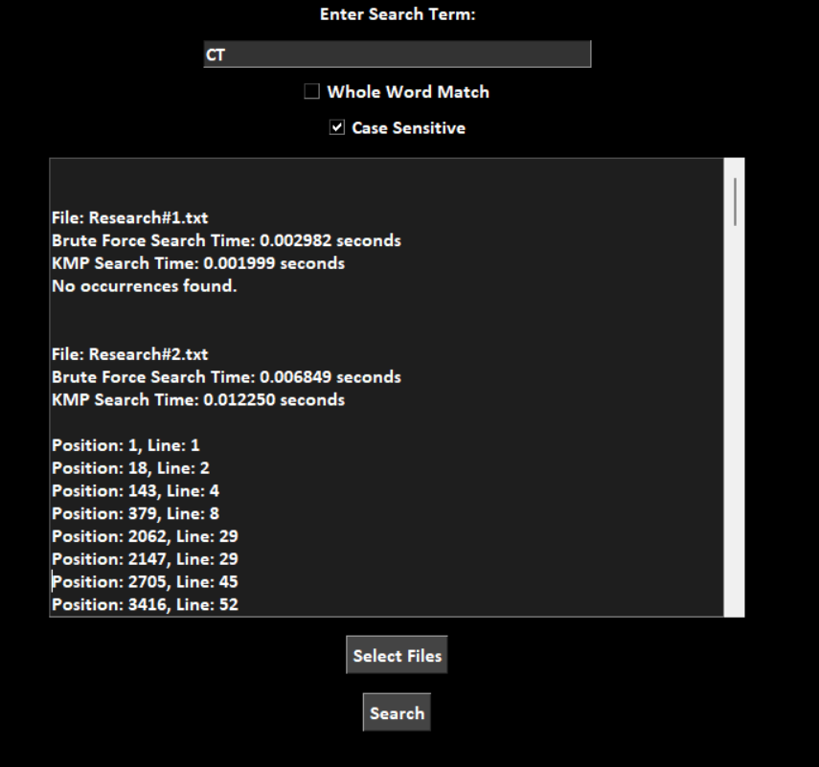

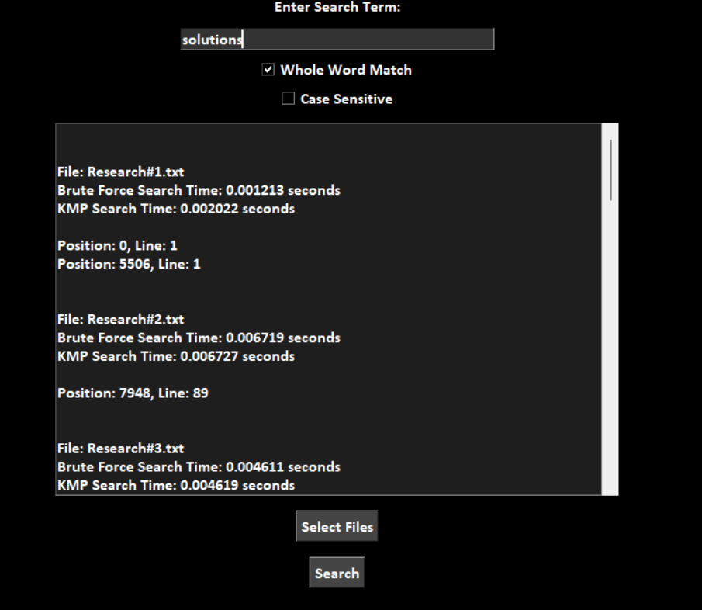

Any errors encountered during file reading will be presented in a message box.

Searching without Emtering an Item:

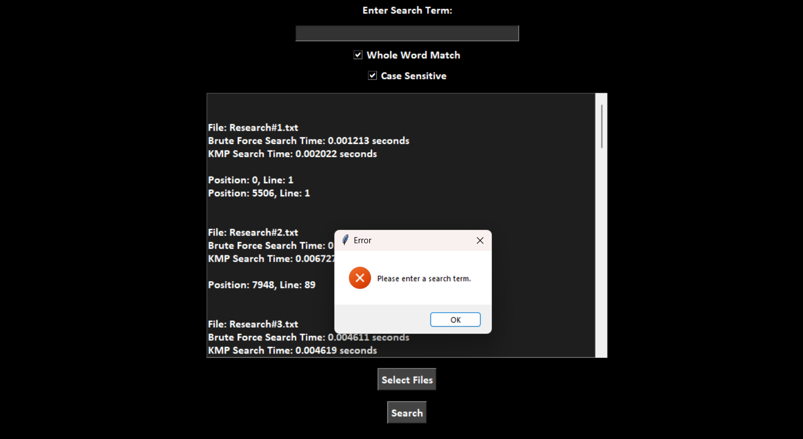

No format except Txt Files:

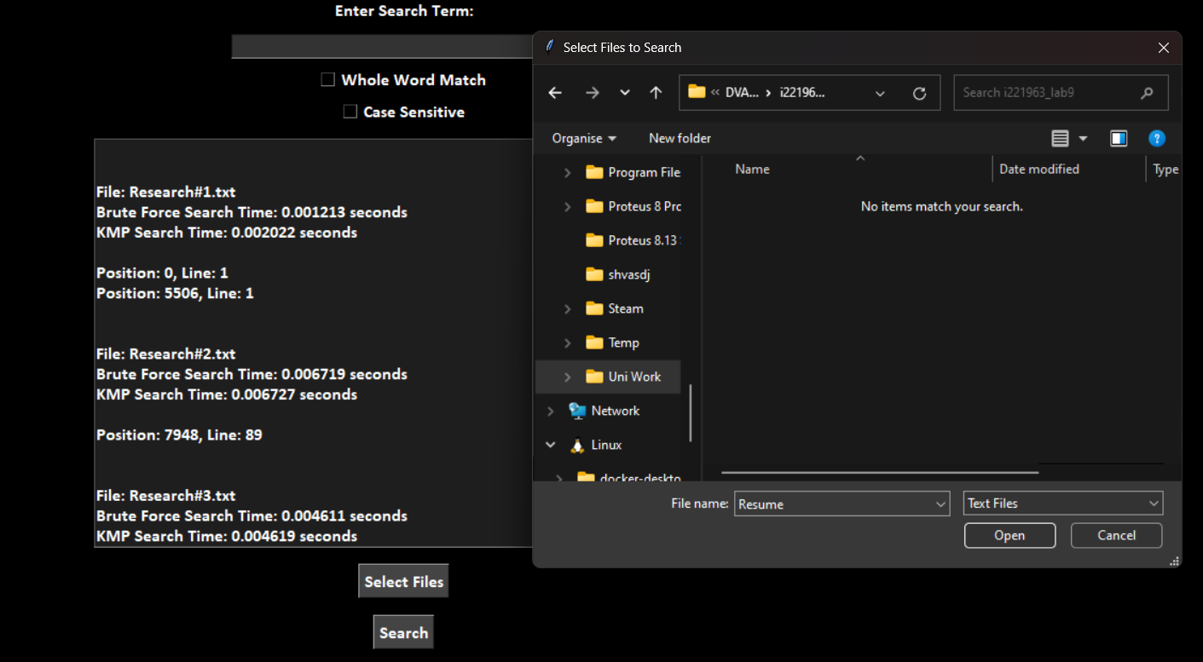

4. References
The following external resources and references were utilized for the implementation of this application:
- https://www.geeksforgeeks.org/kmp-algorithm-for-pattern-searching/
- https://www.youtube.com/watch?v=yMJLpdKV0BQ
- https://www.geeksforgeeks.org/python-gui-tkinter/
- https://www.geeksforgeeks.org/python-os-path-basename-method/

