Pressure Controlling System

Abdulrahman Mahmoud Abutalib
Learn-In-Depth

System Requirements :

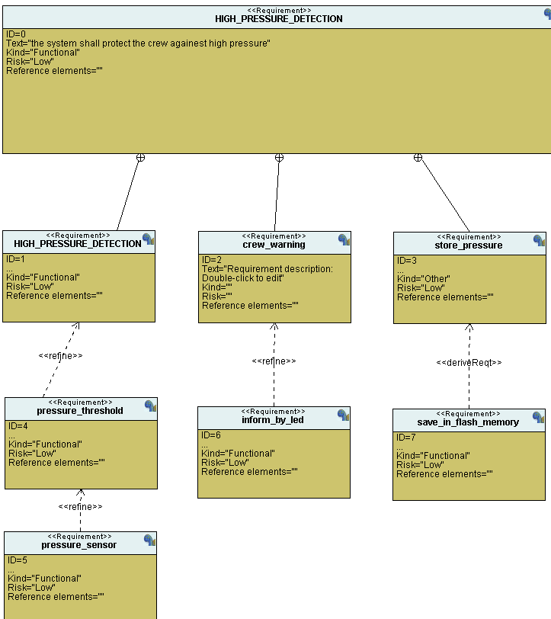

System hardware partitioning :

Stm32f103c6 (cortex-m3)

System Analysis :

- use case study

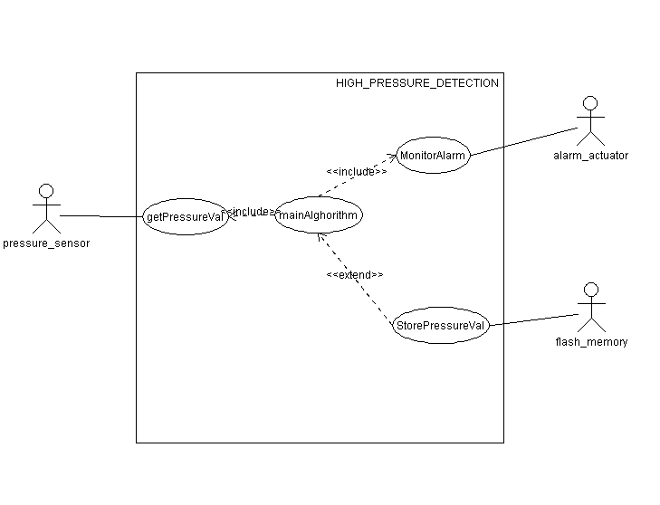

Activity diagram :

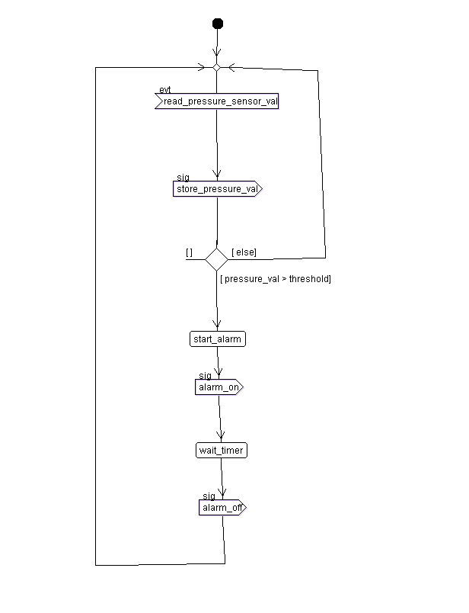

- Sequence diagram :

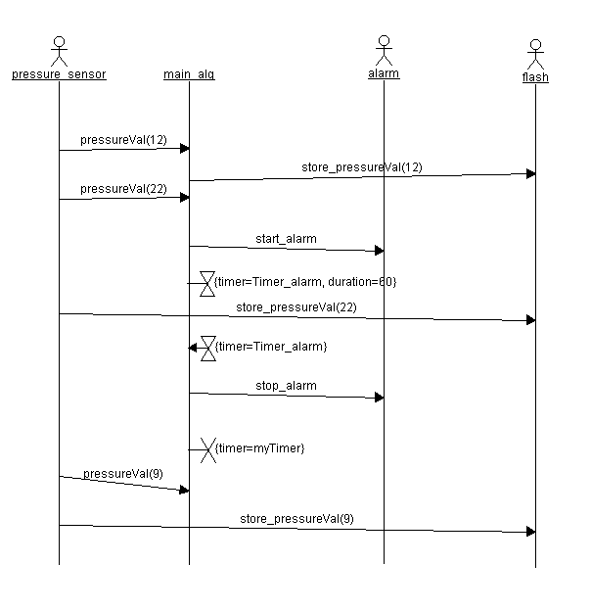

System design :

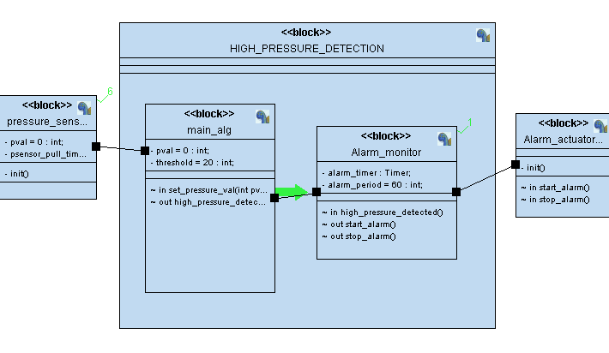

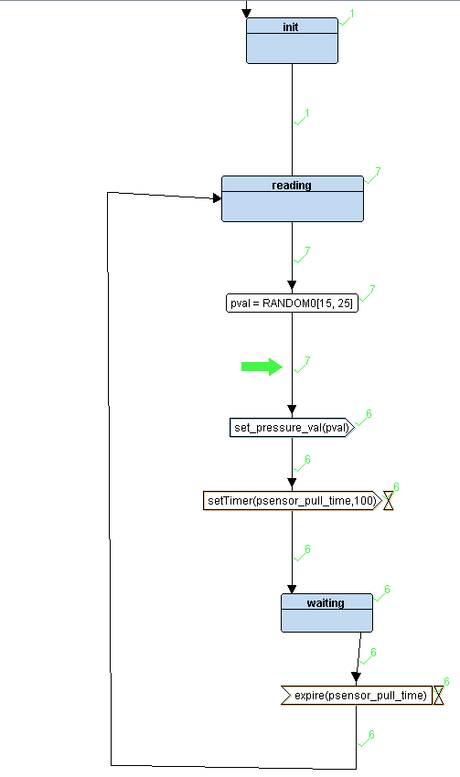
- pressure sensor diagram :

- Alghorithm :
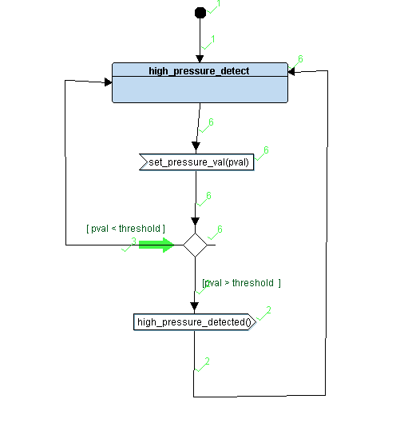

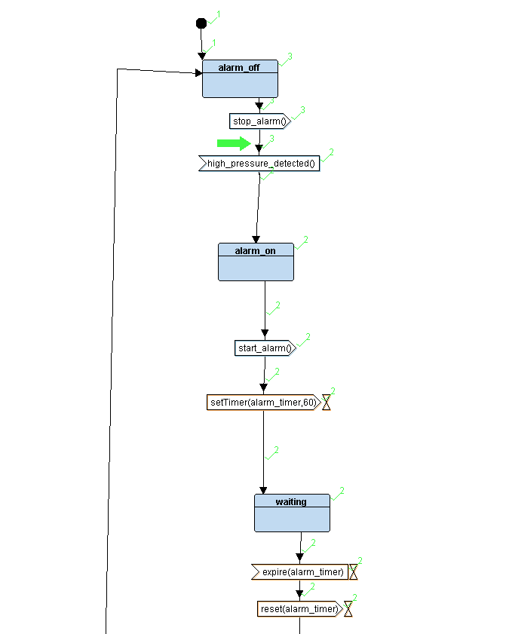
- Alarm monitor :

- Alarm actuator :
