PROJECT FRAMING / 01
SMART FRIDGE
Project Framing Document
Before anyone builds a smart fridge, someone should check it is worth building. That is the job here.
PROJECT | Smart Fridge | VERSION | 1.1 (revised)
PURPOSE | Pre-development feasibility assessment | STATUS | Baseline for the project plan
AUTHOR | Abdo | DATE | 12 November 2026
1. A company with a margin problem
The company behind this project makes home appliances. It is mid-sized: big enough to run a real product range, but not so big that investing millions in the wrong idea would go unnoticed. Traditional refrigerators still sell, but margins are shrinking, competition is intense and innovation has slowed down.
The executive board thinks a smart, connected fridge could be the next growth lever. Thinks, not knows. That gap is what this project is about.
2. The idea: a fridge that does more than stay cold
Smart homes already include thermostats, lights, door locks and vacuum cleaners. A connected fridge would bring that logic into the kitchen. It could, for example, help people keep track of what they have, cut food waste, or fit into the rest of their connected home.
Those are ideas to test, not findings. No customer research has been done yet, and nothing in this document claims otherwise.
3. What we do not know yet
Do customers actually need it? Finding a feature interesting is not the same as paying extra for it.
Can it be built and supported? A connected fridge adds sensors, software, security and after-sales service on top of ordinary refrigerator engineering.
Do the economics work? The price customers accept has to cover what it costs to design, make, sell and support the product.
4. Our mission, and the decision we are supporting
Our mission is to structure the investigation: frame the project, plan the research, work out the resources, budget and risks, and then give the board a recommendation it can act on. We do not build the fridge, and we do not pretend to have answers we have not earned.
Is a smart refrigerator worth the company's investment? Does it meet a real customer need, can it realistically be built and supported, and does it make business sense?
The recommendation will be one of three outcomes:
GO | The evidence supports moving to a more detailed development phase.
PIVOT | There may be something here, but the target users, features, technical approach or business model need rethinking.
NO-GO | The evidence does not justify further investment in this concept.
We recommend. The board decides.
5. Starting assumptions (to be tested, not trusted)
Everything below is a hypothesis. Each one gets tested during the investigation, and this document gets updated if the evidence disagrees.
Assumption | Hypothesis
A1 Customer value | Some households would value connected features such as tracking food or reducing waste.
A2 Market opportunity | A clearly differentiated product could stand out from competitors.
A3 Technical feasibility | The needed technologies exist, but integration, reliability, security and cost are open questions.
A4 Commercial viability | There is a price that customers accept and that covers the costs.
A5 Organizational capability | The company may lack some skills and need outside experts, suppliers or partners.
A6 Investment discipline | No full development spending until the major market, technical, operational and financial uncertainties have been assessed.
6. What is in, and what is out
The scope is deliberately narrow. This is a planning and feasibility project, not a build.
Concept work, such as a brand idea, a mockup or a launch visual, may appear when it helps the story land. It will always be labeled as a concept, never presented as a finished or validated result.
In scope
- Framing the project: problem, scope, assumptions, stakeholders, constraints and success criteria.
- Planning the market, customer and competitor research. The plan, not its results.
- A high-level, desk-based assessment of technical and operational feasibility.
- A project management plan: schedule (Gantt chart), human and material resources, budget, risk register and communications.
- A final recommendation to the board: GO, PIVOT or NO-GO.
Out of scope
- Manufacturing a refrigerator, in any quantity.
- Detailed industrial design, hardware engineering, and any prototype, working demo or production-ready software.
- Commercial distribution, a real product launch or paid advertising.
- Securing investment, signing supplier agreements or committing company money.
7. Where this phase sits in the bigger picture
This project covers the first stretch of a longer lifecycle: framing and feasibility, planned at about 37 working days. Its output is the board's decision.
Design, prototyping, certification, production preparation and launch come afterwards, and only if the board says GO once it has seen the feasibility results. We will still plan them in the Gantt chart, so the board can see the whole journey and what it would be committing to.
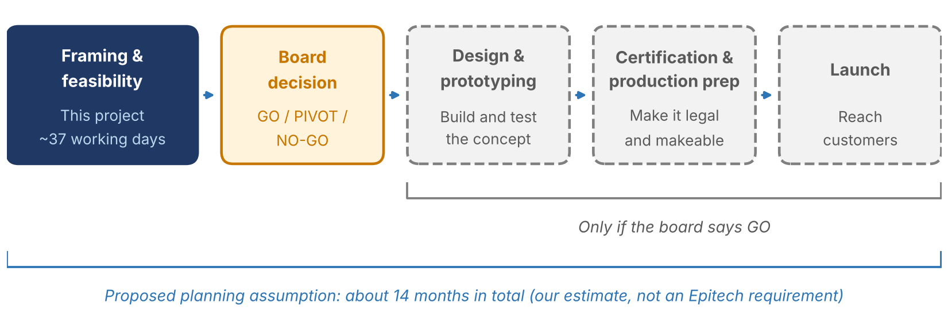
The 14-month total is our own planning assumption, not a duration imposed by Epitech. It will be revised as we learn more.
8. Who is involved
Stakeholder | Interest / contribution
Executive board / sponsor | Reviews the opportunity, budget request, risks and recommendation, and makes the investment decision.
Project team | Plans the investigation, maintains the project documents and prepares the recommendation.
Potential customers | Hold the evidence about needs, expectations, adoption barriers and willingness to pay.
Marketing and sales | Positioning, competitors, distribution and customer acquisition.
Technical and operations specialists | Technology options, architecture, components, manufacturing, logistics and after-sales.
Finance | Cost assumptions, pricing, margins and profitability scenarios.
Suppliers and service providers | Possible sources of indicative information on components, manufacturing, connectivity and support.
Listing a stakeholder does not mean they have been contacted or have agreed to take part.
9. What success looks like, and what limits us
Success
- A clear problem, scope and set of assumptions that everyone reads the same way.
- A research plan that could realistically produce the evidence the decision needs.
- A schedule, resource plan, budget and risk register (at least five major risks) that agree with each other.
- Two communications: one for the project team and one for a board member, each written for its audience.
- A recommendation that follows from the evidence and says plainly what we still do not know.
Limits
- No approved budget, validated customer segment or confirmed feature set.
- No real supplier quotations. Costs will be estimates and labeled as such.
- Demand, competitor positioning and willingness to pay are untested.
- The schedule, including the 14-month lifecycle, is an initial baseline and will change.
10. Version history
Version | Date | Change
1.0 | 12 Nov 2026 | First framing baseline.
1.1 | 12 Nov 2026 | Rewritten shorter and in a more natural voice. Added the story (situation, idea, unknowns, mission, decision), the lifecycle and the conditional later phases. Scope kept to plan and define.

