z

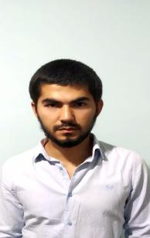

My fullname is Mirzamahmudov Abduvohid O’ktamjon og’li.

I am 24 years old. I was born in1996.

Now I am study of Napa Edu Hub IT Academy.

ABOUT ME**:**

Mirzamahmudov

Abduvohid

Full stack

developer

ACADEMICEDUCATION:

CONTACT ME

+998 94 671 77 76

*abduvohid.mizamahmudov@gmail.com*

Region Andijon

District Baliqchi

Town Chinobod

**FULL STACK DEVELOPER**

**2019-2020**

Napa Edu Hub IT Academy.

PROFESSIONAL

QUALIFICATION:

**FULL STACK DEVELOPER**

**HTML**

**CSS BOOTSTRAP**

**JAVASCRIPT JQUERY**

**PHP YII2**

PERSONAL SKILLS:

**Creativity:**

**Organisation:**

**Team Work:**

**Communucation:**

LANGUAGES

English

PROFFESSIONAL SKILLS:

**Core Java**

**HTML**

**CSS**

**JAVA SCRIPT**

**PHP**

Uzbek

Call: +998 94 671 77 76 mail: [abduvoxid.mirzamaxmudov@mail.](mailto:yourmailid@gmail.com)ru