Using the WebCrawler, I found 10 important words to base the knowledge base on. (film, game, theatre, horror, horrorbuzz, events, services, date, view, news) The knowledge base I made from these words is a simple SQL script. There are two tables, basic_ask which stores info related to basic keywords, and article_ask whish stores a bit more information related to certain articles.

Here are some example

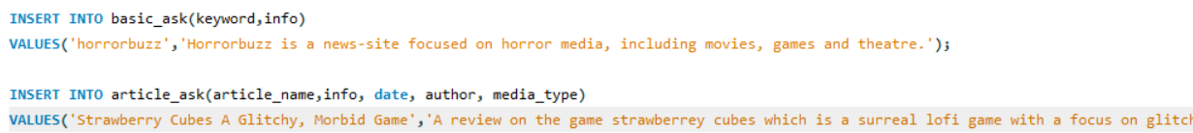

Q: Could you tell me about Horrorbuzz?  
A (Detecting horrorbuzz keyword): Horrorbuzz is a news site focused on horror media including movies, games, and theatre.

Q: Do they have any articles on strawberry cubes?  
A (detecting word “articles” and searching for “strawberry cubes” in the articles): There is an article called “Strawberry Cubes A Glitchy, Morbid Game”

Q: Who wrote it?  
A (Assuming it refers to last mentioned ask.): Wes Conan