Instructions

In this task, you will read reddit posts about ebikes and extract information about the   
specific bikes and bike manufacturers on the thread. Specifically you should do the following:

* Open the url
* Click to reveal all of the comments on the post (see example below)

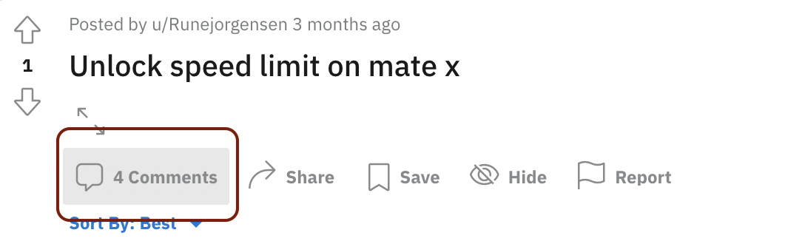

* Read all of the comments and look for any time a specific ebike manufacturer or ebike make/model is mentioned
* Copy and paste the exact text that references the ebike make/model or manufacturer
* Search for the make/model (or manufacturer) on the web and include a link to the specific make/model page from the manufacturer's website.
* **Be sure to find the page from the manufacturer. There are lots of pages listing ebikes for sale online. The goal is the find the page from the manufacturer.**
* In many cases, there will be many mentions of different ebikes on the same reddit thread. You should identify every single mention of an ebike make/model or manufacturer on the thread.
* **If a make/model or manufacturer is listed twice, please include every single reference of the make/model or manufacturer.**
* The example below should help clarify this task. But please ask questions if you more confused. If you are not sure what to do in a certain circumstance, leave a comment in the doc.

# Example

<https://www.reddit.com/r/ebikes/comments/yaz4wv/need_an_e_bike_that_i_can_throw_2_kids_on_the/>

* Start by clicking the URL for the reddit thread. The first comment references the Riese & Muller Multicharger.

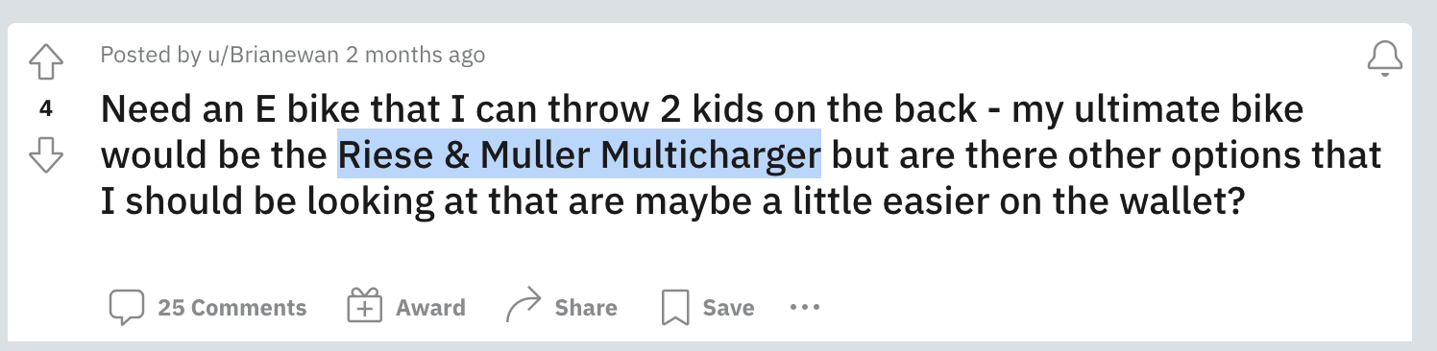

* If you search for this online, you can find the manufacturer website for this make/model.
* <https://www.r-m.de/en-us/bikes/multicharger/>
* Add the following link by copying and pasting the **exact** text from the reddit thread and linking to the manufacturer.
* [Riese & Muller Multicharger](https://www.r-m.de/en-us/bikes/multicharger/)
* Now proceed to the next comment

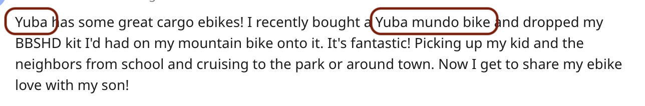

* There is one mention of a manufacturer ('Yuba'), and one mention of a make/model ('Yuba mundo bike'). You should add them both by copying and pasting the **exact** text from the thread, like this:
* [Yuba](https://yubabikes.com/)
* [Yuba mundo bike](https://yubabikes.com/cargobikestore/mundo-electric/)
* Notice that the first link goes go to the manufacturer, because the text ('Yuba') just references a manufacturer.
* Notice that the second link should goes to the page for the specific make/model 'Yuba mondo bike'.
* Notice also that the reddit commenter does not describe the bike using the exact same string as the manufacturer, who calls the bike a 'Mundo EP8'. This is very common. You may have to use your judgment and do a little searching around online to figure out which bike you think the commenter is talking about.
* The actual page you submit should look like this:

# Example<https://www.reddit.com/r/ebikes/comments/yaz4wv/need_an_e_bike_that_i_can_throw_2_kids_on_the/>

* [Riese & Muller Multicharger](https://www.r-m.de/en-us/bikes/multicharger/)
* [Yuba](https://yubabikes.com/cargobikestore/mundo-electric/)
* [Yuba mundo bike](https://yubabikes.com/cargobikestore/mundo-electric/)
* ... plus many more examples from the remaining comments ...

# 0

<https://www.reddit.com/r/ebikes/comments/xu7ox9/lectric_xp_lite_suspension_fork_upgrade/iqv72fx/>

# 1

<https://www.reddit.com/r/ebikes/comments/xvv0pa/out_in_the_wild_at_last_i_need_a_new_front_wheel/ir38dyd/>

# 2

<https://www.reddit.com/r/ebikes/comments/yg8cke/winter_biking_goods_for_all_whos_stubborn_like_me/iu9b4cr/>

# 3

<https://www.reddit.com/r/ebikes/comments/y5ay9y/looking_for_some_opinions_on_this_kit/isiq32r/>

# 4

<https://www.reddit.com/r/ebikes/comments/y0p6tv/long_commute_recommendation/iru2mdg/>

# 5

<https://www.reddit.com/r/ebikes/comments/y4laq4/ebike_repairs_more_on_1_comment/isrqywg/>

# 6

<https://www.reddit.com/r/ebikes/comments/ybc6tc/lights_for_bbs02/itgk7hb/>

# 7

<https://www.reddit.com/r/ebikes/comments/y9saad/fiido_t1_electric_bike_appears_to_be_breaking_in/it8z5u7/>

# 8

<https://www.reddit.com/r/ebikes/comments/y260m1/anyone_else_have_cold_weather_problems_with_bbs02/is1i6dc/>

# 9

<https://www.reddit.com/r/ebikes/comments/ycgus4/well_apparently_only_class_1_ebikes_are_legal_in/itmcqos/>