Instructions

In this task, you will read reddit posts about ebikes and extract information about the   
specific bikes and bike manufacturers on the thread. Specifically you should do the following:

* Open the url
* Click to reveal all of the comments on the post (see example below)

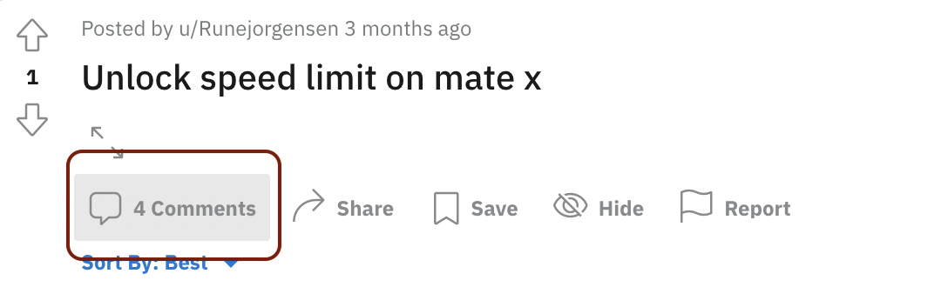

* Read all of the comments and look for any time a specific ebike manufacturer or ebike make/model is mentioned
* Copy and paste the exact text that references the ebike make/model or manufacturer
* Search for the make/model (or manufacturer) on the web and include a link to the specific make/model page from the manufacturer's website.
* **Be sure to find the page from the manufacturer. There are lots of pages listing ebikes for sale online. The goal is the find the page from the manufacturer.**
* In many cases, there will be many mentions of different ebikes on the same reddit thread. You should identify every single mention of an ebike make/model or manufacturer on the thread.
* **If a make/model or manufacturer is listed twice, please include every single reference of the make/model or manufacturer.**
* The example below should help clarify this task. But please ask questions if you more confused. If you are not sure what to do in a certain circumstance, leave a comment in the doc.

# Example (detailed)

<https://www.reddit.com/r/ebikes/comments/yaz4wv/need_an_e_bike_that_i_can_throw_2_kids_on_the/>

* Start by clicking the URL for the reddit thread. The first comment references the Riese & Muller Multicharger.

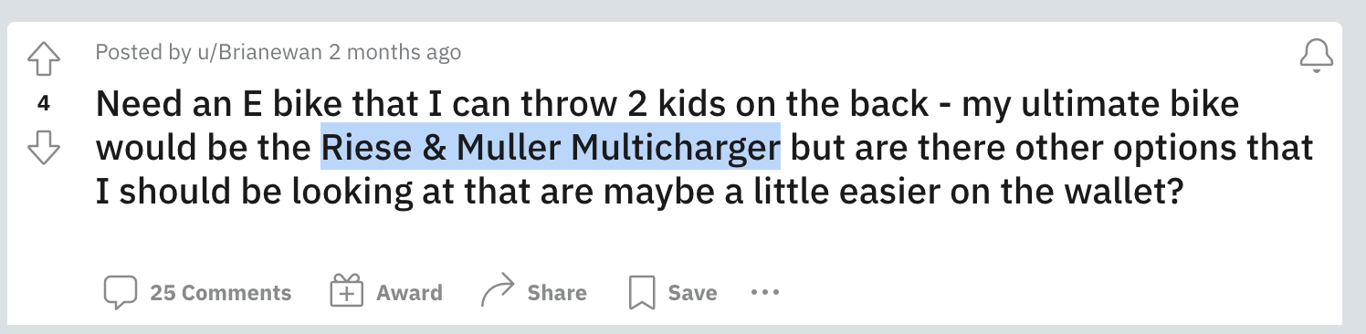

* If you search for this online, you can find the manufacturer website for this make/model.
* <https://www.r-m.de/en-us/bikes/multicharger/>
* Add the following link by copying and pasting the **exact** text from the reddit thread and linking to the manufacturer, like this:
* [Riese & Muller Multicharger](https://www.r-m.de/en-us/bikes/multicharger/)
* Now proceed to the next comment

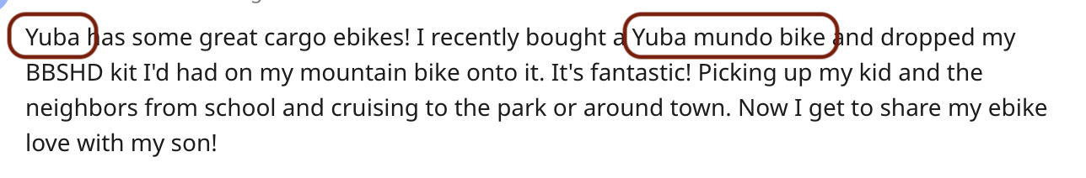

* There is one mention of a manufacturer ('Yuba'), and one mention of a make/model ('Yuba mundo bike'). You should add them both by copying and pasting the **exact** text from the thread, like this:
* [Yuba](https://yubabikes.com/)
* [Yuba mundo bike](https://yubabikes.com/cargobikestore/mundo-electric/)
* Notice that the first link goes to the manufacturer, because the text ('Yuba') just references a manufacturer.
* Notice that the second link should goes to the page for the specific make/model, the 'Yuba mondo bike'.
* Notice also that the reddit commenter does not describe the bike using the exact same string as the manufacturer, who calls the bike a 'Mundo EP8'. This is very common. You may have to use your judgment and do a little searching around online to figure out which bike you think the commenter is talking about.
* The actual page you submit should look like this:

# Example

<https://www.reddit.com/r/ebikes/comments/yaz4wv/need_an_e_bike_that_i_can_throw_2_kids_on_the/>

* [Riese & Muller Multicharger](https://www.r-m.de/en-us/bikes/multicharger/)
* [Yuba](https://yubabikes.com/)
* [Yuba mundo bike](https://yubabikes.com/cargobikestore/mundo-electric/)
* ... plus many more examples from the remaining comments ...

# 0

<https://www.reddit.com/r/ebikes/comments/ygtim1/i_see_your_bridge_picture_and_raise_you_a/iuc0koz/>

# 1

<https://www.reddit.com/r/ebikes/comments/y31ec2/question_about_bms_wiring_the_diagram_points/is6ykj8/>

# 2

<https://www.reddit.com/r/ebikes/comments/xumzji/charging_ebike_batteries_off_the_grid/iqw9bv7/>

# 3

<https://www.reddit.com/r/ebikes/comments/y9ssp5/torque_arms_wont_properly_fit_secured_with_ziptie/it7hmdz/>

# 4

<https://www.reddit.com/r/ebikes/comments/y86734/bosch_makes_the_best_motor/it0rgag/>

# 5

<https://www.reddit.com/r/ebikes/comments/y4ybc8/full_suspension_fat_tire_ebike/ish0tcn/>

# 6

<https://www.reddit.com/r/ebikes/comments/y7cjzc/i_hacked_my_bike_to_go_40_mph_but_it_keeps/iswb5b2/>

# 7

<https://www.reddit.com/r/ebikes/comments/y3zuc2/what_ebike_size_do_i_need/isbdwof/>

# 8

<https://www.reddit.com/r/ebikes/comments/xsfhfm/when_does_an_ebike_stop_being_an_ebike_as_far_as/iql2600/>

# 9

<https://www.reddit.com/r/ebikes/comments/y1df6p/radmission_high_step_or_mid_step/irye7t8/>