"Community Development" Website Wireframe Description”  
  
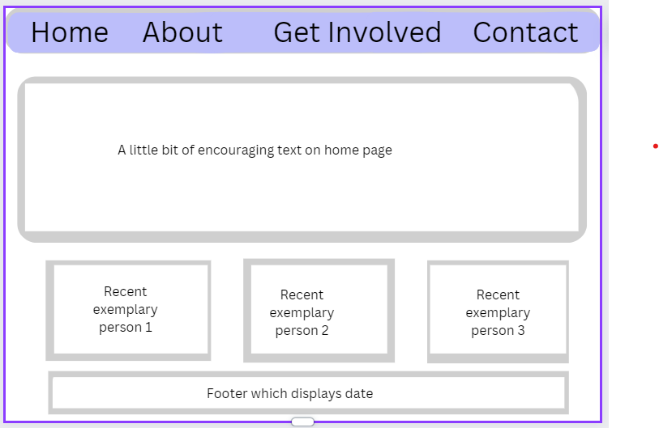

The wireframe presents a straightforward and user-centric layout for a "Community Development" website, designed to facilitate ease of navigation and highlight key information. The top section features a clean, bold navigation bar with four main options: 'Home', 'About', 'Get Involved', and 'Contact', each with a distinct clickable area for intuitive user interaction.

Below the navigation bar lies a prominent content box that spans a significant width of the page, serving as a dynamic space intended for motivational or introductory text. This area draws the visitor’s attention first, setting the tone of the website with an inspiring message that encapsulates the essence of community development.

Subsequent to the main content box are three secondary content areas, equally spaced and aligned horizontally across the page. These are designated for showcasing profiles of individuals who exemplify the spirit of community involvement—labelled 'Recent exemplary person 1', 'Recent exemplary person 2', and 'Recent exemplary person 3'. These sections can be utilized to share stories, achievements, or spotlight community members, acting as a motivational tool and demonstrating the impact of the organization.

The footer of the wireframe extends across the full width of the page, purposed for ancillary information such as the current date, and features an interactive element—potentially a slider—that allows users to engage with the content dynamically.

Overall, the wireframe suggests a site that's not only informative but also interactive and community-focused, aiming to foster engagement and spotlight individual contributions to community development.

***As I progress through the web development course, there may be a need to enhance the navigation bar by adding more elements or refining existing ones to improve the website's functionality and user experience.***