Install WP+ Tools

# Step 1: Install recommended programs

The programs recommended for running WA+ Tools (developed with Python 2.7) are:

* Anaconda (4.3.1 Python 2.7)
* Git (2.22.0)

The installers are provided in folder.

# Step 2: Install required python packages

The *watools* and *WA_Hyperloop* packages are dependent on several module packages:

* gdal
* pyshp

If some modules are missing, start the Command prompt (or Anaconda prompt in new Anaconda versions) and install the package with missing modules using the command line

*conda install [package_name]*

For example:

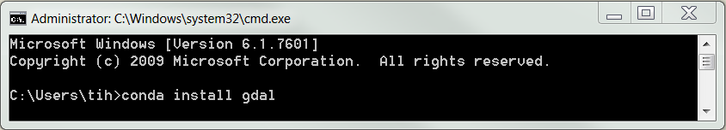

# Step 3: Install WaPOR and Water Accounting toolbox packages

* Find Anaconda home directory and navigate to *site-packages* folder

%HOME%\Continuum\Anaconda2\Lib\site-packages

(For example: C:\Users\username\AppData\Local\Continuum\Anaconda2\Lib\site-packages)

* Right-click and select **Git GUI Here**
* Select **Clone Existing Repository**

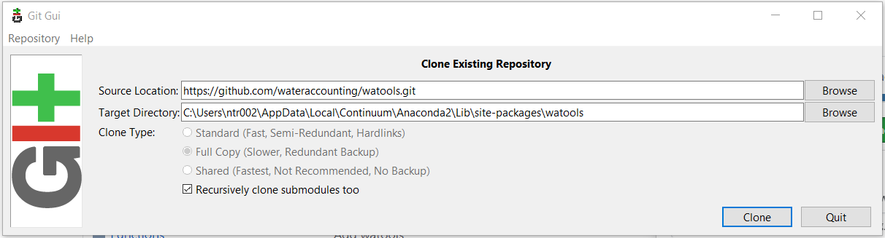

* + In the *Source Location* field, copy and paste repository URL from GitHub

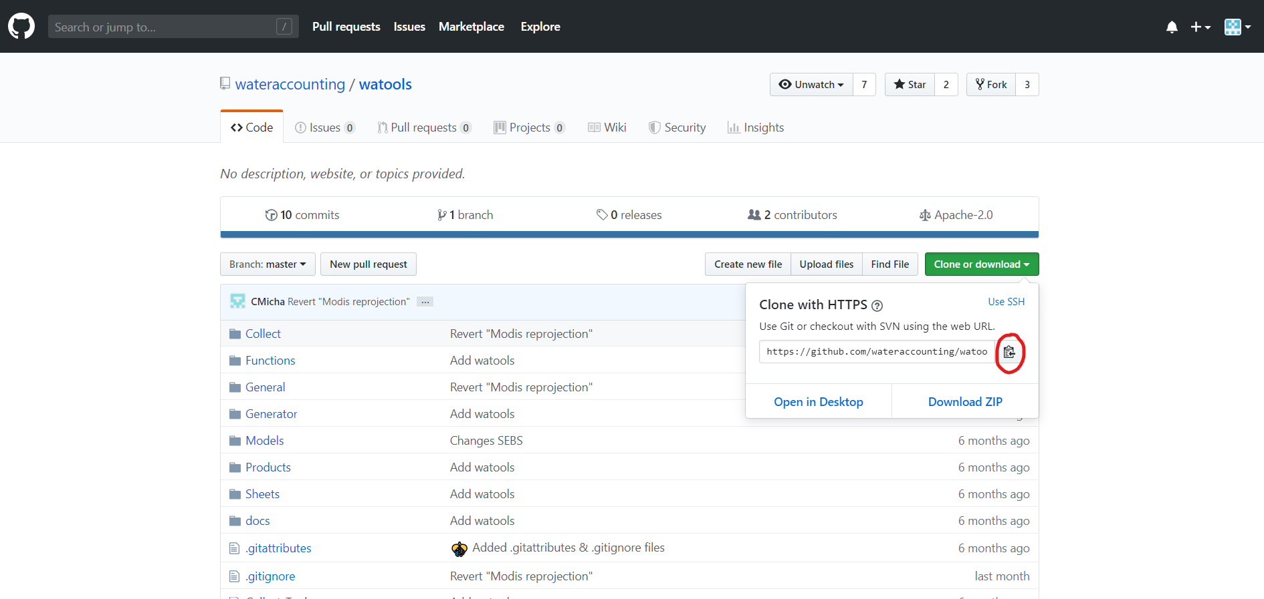

The URLs of WP+ Tool packages are

* hkvwaporpy: <https://github.com/trngb/hkvwaporpy.git>
  + In the *Target Directory* field, fill in a new path in site-packages folder as following:

%HOME%\Continuum\Anaconda2\Lib\site-packages\watools

%HOME%\Continuum\Anaconda2\Lib\site-packages\hkvwaporpy

* + Click *Clone*
  + Clone all mentioned packages

# Step 4: Use WP+ tool packages in python console

* Start **Spyder** from Start menu
* In the IPython console window, type in

*import hkvwaporpy*

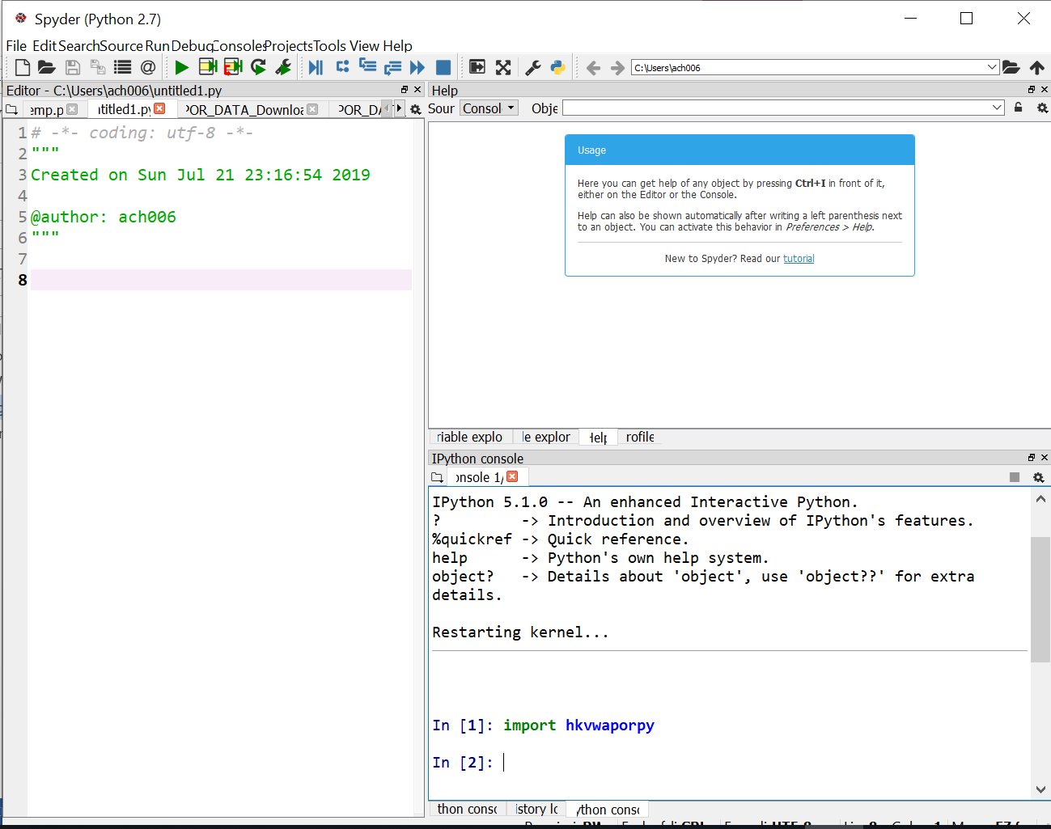

If no message pops up, the packages are successfully installed. If some modules are not found, install the module using method in Step 2.

# Step 5: Add Environment Variables

To run GDAL and pyshp program from python command, the path of the executables need to be added in environment variables.

To add an environment variable, go to the environment variables manager of the computer. For a Windows 7 system go to: **Control panel > System and security > System > Advanced system settings > Advanced > Environment variables**. This will pops up the window as shown below.

[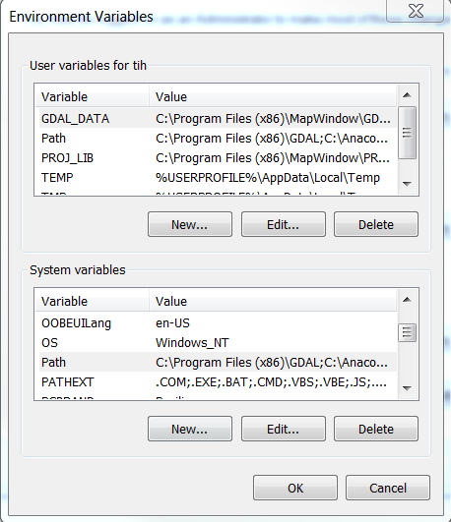](https://github.com/wateraccounting/wa/blob/master/docs/figs/environment_variables.png)

Under the **User variables** box, click on **New** to create new variable. Edit the variable name and value as following:

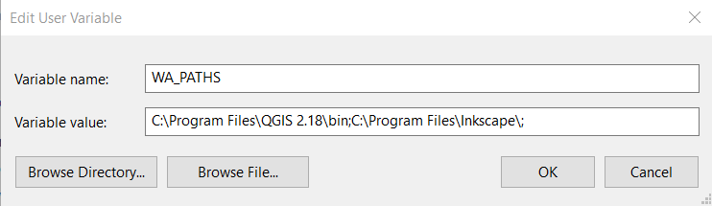

Where **C:\Program Files\QGIS 2.18\bin** and **C:\Program Files\Inkscape\** might be different paths to QGIS and Inkscape program on your computer.

Also, some calculations of the Water Accounting Toolbox are performed in the WA Home folder. Within this location all the output will be stored and also the input must be stored in this folder. So create a folder somewhere on your computer and define this folder here as follows:

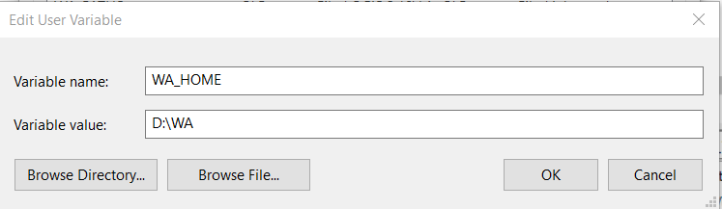

Where variable value is the path to a folder of your selection. Make sure that there is enough space available to store all the water accounting outputs.