FACE RECOGNITION BASED HOME SURVEILLANCE AND SECURITY SYSTEM

signature date

1. -------------------------------------- ----------------- ----------------------

2. ------------------------------------- ----------------- ----------------------

3. -------------------------------------- ----------------- ----------------------

# Declaration

We the undersigned, declare that this thesis project submitted in fulfillment of the requirement of the final thesis project in Electrical and Computer Engineering department in Gondar university (Institute of Technology), is recorded of our Own work carried out by the academic year 2020 under the supervision and guidance of Mr. Agmuasie B.

The extent and source of information are derived from the existing literature and have been indicated through the project at the appropriate places. The matter embodied in this work is original and has not been submitted for the award of any other final thesis project, either in this or any other University.

Declared by:

Student signature date

1. Betelihem Yosef ________________ _______________

2. Henok Moges ________________ _______________

3. Nahom G/Eyesus ________________ _______________

4. Nega Habtamu ________________ _______________

Project Advisor: Agmuasie B.

Signature_________________

##### ACKNOWLEDGEMENT

First of all, we would like to thank God for guiding us throughout our academic journey and also to our family, we appreciate the support they have given us throughout our academic journey. This quest has not been easy but you have always solemnly stood by our side. we say thank you. Moreover, we extend our sincere gratitude to all the lecturers and non-teaching staff of the Department of Electrical and Computer Engineering for their contribution towards the success of this work.

Then we would like to express our gratitude and sincere thanks to our respected advisor, Mr. Agmuasie B. for his professional guidance, advice, motivation, endurance, and encouragements. And also, we would like to say thanks to our friend for their effort of knowledge which we have got them valuable. The guidance and support received from all the members who contributed and who are contributing to this project. We are grateful for their constant support and help.

**ABSTRACT**

The ability to automatically recognize human faces based on dynamic facial images is important in security, surveillance and health/independent living domains. This project aims to identify a person through face recognition for home surveillance and security. Face recognition is very complex and multidimensional problem. This system will serve as smart security module for monitoring. Traditional surveillance systems only record the activities based on motion, but this system serves the purpose of facial recognition so as to reduce the error caused due to motion detection. This approach exploits the Viola- Jones method for face detection, the Kanade- Lucas-Tomasi algorithm as a feature tracker and PCA for face recognition. The platforms that we used for this process are MATLAB and Arduino. The communication established between the MATLAB and Arduino is serial type of communication. The system which converts facial images to feature characteristics of initial training database images is designed in MATLAB. Facial features are extracted from the face. Eigenvalues are calculated and represented as an Eigen vector. Using Euclidian distance method, an unknown face image and database image are compared. The recognized facial image has minimum Euclidian distance with the database images. When face is recognized it sends SMS to the authorized person using GSM module and an alarm will be running. Security system using MATLAB and embedded system design is cost effective, reliable and highly accurate.

Key Words: face detection, face tracking, face recognition, real time, video surveillance, Viola and Jones, principal component analysis, Facial features, Eigenvectors, Euclidian distance, GSM module, Alarm

**Table of Contents**

Approval Page i

Declaration ii

ABSTRACT iv

List of Figures viii

List of Abbreviations ix

CHAPTER ONE 1

INTRODUCTION 1

1.1 Background 1

1.2 Problem Statement 2

1.3 Significance of The Project 3

1.4 Objectives 3

**1.4.1 General Objective** 3

**1.4.2 Specific Objective** 3

1.5 Methodology 3

1.6 Scope of The Project 5

CHAPTER TWO 6

LITERATURE REVIEW 6

CHAPTER THREE 10

3.1 Arduino 10

3.2 PIR Sensor 12

**3.2.1 Principle of Operation of A PIR Sensor** 12

**3.2.2 Applications of The PIR Sensor** 13

3.4 Buzzer 13

3.8 Web Camera 14

CHAPTER FOUR 15

SYSTEM DESIGN 15

4.1 Hardware Design 15

4.2 Software Design 15

**4.2.1 Face Detection** 16

**4.2.2 Face Tracking** 19

**4.2.3 Face Recognition** 19

CHAPTER FIVE 23

RESULT AND DISCUSSION 23

5.1 Result 23

5.2 Discussion 24

CHAPTER SIX 25

CONCLUSION AND RECOMMENDATION 25

6.1 Conclusion 25

6.2 Recommendation 25

REFERENCES 26

Appendices 27

# List of Figures

Figure 1.1 Steps of Face Recognition System Applications 2

Figure 1.2 Methodology of the Project 4

Figure 3.1 Arduino Uno 11

Figure 3.2 PIR Sensor 12

Figure 3.3 Operation of a PIR Sensor 13

Figure 3.4 Buzzer 14

Figure 3.5 Web Camera 14

Figure 4.1 General Block Diagram of Face Recognition Based Surveillance and Security system 15

Figure 4.2 Plot Showing Time Taken by Each Method 17

Figure 4.3 Basic Haar Wavelets 18

Figure 4.4 Haar Wavelets Extracting Features 18

Figure 4.5 Cascaded Classifier 18

Figure 4.6 Specimen’s Images Taken From AT&T Database and Its Resultant Eigenface 20

Figure 4.7 Face Recognition Flowchart 21

Figure 4.8 Flowchart of Face Recognition Based Surveillance and Security System 22

# List of Abbreviations

|  |  |
| --- | --- |
| AC | Alternative current |
| AG | PC |
| ATM | Automated Teller Machine |
| AT&T | PIR |
| CCTV | closed-circuit television |
| DC | Direct current |
| GSM | Global System for Mobile Communication |
| GSS | TCP/IP |
| HMI | Human Machine Interface |
| ICSP | In-circuit serial programming Identification |
| ID | Identification |
| IP | Internet protocol |
| IR | infrared |
| KLT | Kanade-Lucas-Tomasi |
| PC | Personal computer |
| PCA | Principal Component Analysis |
| PIR | Passive infrared |
| PWM | Pulse width modulation |
| RF | Radio frequency |
| SIM | subscriber identity module |
| SMS | short message service |
| TCP | Transmission Control Protocol |
| UK | United Kingdom |
| US | United state |
| USB | Universal Serial Bus |
| VCR | Video cassette recorder |

# CHAPTER ONE

# INTRODUCTION

## 1.1 Background

Security is the big deal in today’s world, the diversity and characteristics of crimes have become very different. With the development of technology in the modern world, the quality of the crimes has increased. Every day, many incidents such as burglary, extortion, terrorist incidents and kidnapping occurred.

Video surveillance began with simple closed-circuit television monitoring (CCTV). As early as 1942, there were press reports in various countries across the world suggesting police use of surveillance cameras in public places. When video cassette recorders hit the market, video surveillance became really popular. Analog technology using taped video-cassette recordings meant surveillance could be preserved on tape as evidence. A complete analog video-surveillance system consisted of a camera, monitor, and VCR. The old tube camera was only useful in daylight, and the VCR could only store eight hours of footage at best.[1]

Security is one of the at most requirements of homes and business. In today high technology environment, organizations are becoming more and more dependent on their information systems. Many organizations will identify information as an area of their operation that needs to be highly secured as part of their system of internal control. This project aims to identify a person through face recognition and provide alert when the security is at risk. Face recognition is one of the applications of image processing. Image processing method is that it will convert an image into digital form and perform some operations on the image, in order to get an enhanced image or to excerpt some useful information from it. It is a type of signal dispensation in which input is image, like video frame or photograph and output may be image or attribute associated with that image. Usually, image processing system includes treating images as two-dimensional signals while applying already set signal processing methods to them.[2]

We can make advantage of image processing and face recognition in our CCTV cameras. Video surveillance and the analysis of the obtained footage is a process which needs a huge memory. Video surveillance using CCTV is now being used everywhere. But the effective video surveillance is not implemented anywhere. The current practice of video surveillance is installing a camera and analyzing the footages which are stored. But with the same cost we can do something better. That is rather than analyzing the footages after the incident occurred, notify the authority of organization at the time of incident so that higher authority can take necessary action without any delay. In our system a camera is installed in the room which is to be secured. Along with the camera a PIR sensor is used so that there is no need of keeping camera turned on. So, when human presence is detected by PIR sensor, camera turns on and start capturing the video. From the frames obtained from the captured video human face is detected and facial features are extracted using Viola Jones algorithm. The image is compared with the image stored in the database as the reference image using PCA algorithm. When face is not recognized an alarm will be played to notify the security guard about the unauthorized entry attempt. Also, a message is sent to higher authority regarding the entry time and date.

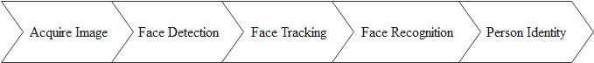

Figure 1.1 Steps of Face Recognition System Applications

## 1.2 Problem Statement

In the recent years, as more and more items such as art are gaining importance, the prices of such things are also going through the roof. Therefore, technology has come in the forefront for protection and surveillance of such goods and items.

In the advent of the current insecurity and the rise in inflation in the world, people have opted to take their own security measures instead of totally depending on the police. This has seen the rise of security companies being formed which have taken various security measures and methods to ensure safety for the public. While this is a good thing it has come with its demerits the main ones being that the cost of hiring the required security is out of range for most Ethiopians and when a security breach takes place, unless the owner is within the premise, they are the last to be contacted which more often than not happens to be too late for any action.

The need to develop surveillance system through innovative technology immensely influenced the development of this project. The system should be able to detect motion (intruder), activate a camera to take frames of video after motion is sensed and then send an alert to the facility owner through SMS and electronic mail plus an image attachment.

## 1.3 Significance of The Project

To do user friendly home security system. And also, to make reliable system by using face recognition of a person.

## 1.4 Objectives

### **1.4.1 General Objective**

The general objective of this project is to design and make the simulation of face recognition-based home surveillance and security system.

### **1.4.2 Specific Objective**

The specific objectives are:

* To study and describe how Arduino can be interfaced with a motion detector and web camera.
* To study how MATLAB can be programmed so as to be able to send an email to a prescribed mail hub.
* To study how Arduino can be programmed so as to be able to send an SMS to a mobile phone.
* To develop and build a simulation of the surveillance system based on face detection, tracking and recognition.
* To design and simulate a motion detecting and tracking system for real time video analysis.

## 1.5 Methodology

The methods used when conducting this research consists of five phases which are the preliminary work phase, design phase, simulation phase, testing phase, and lastly the analysis phase. These five phases have been executed many times to produce the best solution at the end of the research.

Figure 1.2 Methodology of the Project

The first phase is the preliminary work phase. At this phase, the problem was identified by collecting the review research papers which are related to face recognition-based home surveillance and security system, and how to overcome this problem. This phase also determines the conceptual design requirement through hardware and software specification. The second phase is the design phase. At this phase, face recognition-based home surveillance and security system is designed based on proposed home architecture. The topology design will be used in many scenarios to focus on the problem/issue that needs to be solved. The design of the topology has been conducted and then forwarded to the simulation phase where the topology has been created. In the simulation phase, the topology has been designed using MATLAB. At the end of this phase, the result obtained from the former phase is analyzed in the final step. The last phase has been the testing phase. At this phase, after obtaining the preliminary simulation test result from the previous phase, the result has been compared with analysis phase. The collected data will be documented after finding the best solution.

## 1.6 Scope of The Project

The scope of this project is to make the simulation of face detection and recognize of a person and by comparing with stored face images in the database and perform a response for the intruder by sending email and SMS also buzzer is activated.

**1.7 Outline of The Paper**

This project consists of six chapters.

* Chapter 1, is an introduction to the project that consists of project background, problem statement, significance of the project, objective, methodology and also scope of the project.
* Chapter 2, covers on the literatures on the project that include the related work or study on the previous project.
* Chapter 3, discuss conceptual framework of study.
* Chapter 4, explains the software development and hardware analysis of the system.
* Chapter 5, discuss about test result and discussion of this project.
* Chapter 6, explain overall conclusion and recommendation.

# CHAPTER TWO

# LITERATURE REVIEW

In the last few years, the state-of-the-art algorithms put significant contributions to theory and practice of face detection for the security system. Due to the need for online surveillance, particular attention has been focused on high-speed real-time detection and tracking methods. State-of-the-art research on face detection is summarized in the following sections. Among huge literature content on these subjects, we focused on real-time methods that require fast computational procedures to be applied online. Even though there are a lot of different algorithms for face detection, most of the publications have focused on face detection of individual images. The history about image processing and remote monitoring and we will see the past few years, significant research carried out for developing intelligent human machine interaction (HMI). Natural language understanding, knowledge databases, sophisticated tools for reasoning have all contributed towards the goal of designing machines that behave more human like. A truly intelligent machine should be able to extract information from the environment that it is embedded in, without the need for any external agent to supply this information. The key aspect to interact in a human inhabited environment is the ability of a machine to recognize humans and their activities.

CCTV was first utilized by the US Military in the 1940s for the testing of the V2 missile in order to safely monitor the tests. Siemens AG at Test Stand VII in Peenemunde, Germany (1942), for observing the launch of V-2 rockets first Video Surveillance System was installed. Outside government special facilities, it was developed initially as a means of increasing security in banks. In 1960s, officials in the UK began installing CCTV systems in public places. In 1970s and 1980s led to several larger trial programs later that decade. In 1996, government spending on CCTV technology accounted for three quarters of the crime prevention budget in the UK. In 1969 the first CCTV system set up in a public building was in the New York City Municipal building and spread to other cities and was soon widely implemented. In the 1970s and 80s, CCTV use became more common in establishments prone to security threats, like banks, stores, gas stations. In 1993 after the terrorist attack Security cameras were installed in the World Trade Center as a preventative. By mid-90s, ATMs across the country were commonly equipped with CCTV cameras, and many retail stores. Today in Britain, CCTV cameras monitor road, sidewalk, squares in city centers, rail stations and buses, as well as in other businesses

[1] Ms. Naga Jyoti and Mr. K. Vijaya Vardhan have proposed a system which captures the images and upload it to cloud server whenever a motion is detected. They also propose to send SMS alerts to users using GSM module. The limitations in this project are because of all the images are upload to the cloud the storage to be big size, because of there is no sensor to check the presence of a person in the area the system take high electric power.

[2] M. Surya Deekshith Gupta, Vamsikrishna Patchava, and Virginia Menezes have implemented a system which continuously captures the surroundings and if there is any moment, it turns on the light and captures the screenshots that results in sending of those to authorized person as an alert. The limitations in this project are take high amount of power because of capture the surrounding continuously, and also the system capture not only a person it captures any moment including animals so the screenshot of any moment send to the authorized person this makes tedious for use, and also because of the light is on to capture the screenshot the intruder can be hide himself from the camera.

[3] Aruni Singh, Sanjay Kumar Singh, Shrikant Tiwari have implemented comparison of various face recognition algorithms including eigenfaces, fisher faces, Principle Component Analysis. The limitations in this project are as the images compress to use minimum space in the storage there is loss of some its important features and therefore in higher level of compression accuracy decreases, and also these projects use different algorithms to facial recognition the system is too complex.

[4] Aamir Nizam Ansari, Mohamed Sedky, Neelam Sharma, Anurag Tyagi have implemented a system in which Raspberry Pi executes the processing of all the data and after the data is analyzed then the set actions are triggered for example sending an email on detection of motion and uploading images and videos to the ftp server. The limitations in this project are when cloud is not available then the data is not stored locally on the system to send when the connection resumes.

[5] R.Chandana, Dr.S.A.K.Jilani, Mr.S.Javeed Hussain have proposed a system using Raspberry Pi and Gyroscope sensor. When a movement is detected, the Pi captures the image and then sends an alert email with the captured image. The sensor data is visualized in the form of charts on Thing Speak.

[6] The 1GSS, (1960-1980) were based on analog sub systems for image acquisition, transmission and processing. The drawbacks like requiring high bandwidth and retrieval of events due to large number of video tape requirements and difficult online event detection which only depended on human operators with limited attention span. The 2GSS, (19802000) were used both analog and digital sub systems to resolve some drawbacks of its predecessors. Most of the work during 2GSS is focused on real-time event detection. Third generation surveillance systems (3GSS), (2000-till now) provide end-to-end digital systems in which the Image acquisition and processing at the sensor level and communication through mobile and fixed heterogeneous broadband networks and image storage at the central server’s benefit from low cost digital infrastructure. The ultimate goal of 3GSS is to allow video data to be used for online alarm generation to assist human operators and for offline inspection effectively. [6-7]

[7] Sneha Singhd and his team described IP Camera Video Surveillance system using Raspberry Pi technology. The Researchers aimed at developing a system which captures real time images and displays them in the browser using TCP/IP. The algorithm for face detection is being implemented on Raspberry Pi, which enables live video streaming along with detection of human faces. The research did not include any of surveillance reactions.

[8] B. Udaya Kumar and et al. presents the implementation of a low-cost Arduino based home security system This security system project deals with the design and development of a theft control system for home, which is being used to prevent/control any theft attempt. The developed system makes use of an embedded system comprising of an open hardware microcontroller (Arduino) and a modem based on Global System for Mobile communication (GSM) technology. The designed and developed system can be installed in the home. An interfacing intrusion detector unit is also connected to the microcontroller-based security system. The system thus incorporates a passive infrared sensor (PIR) for motion detection. In case of an intrusion attempt, a warning message is being transmitted by the system (as an SMS) to the owner’s mobile phone, or to any pre-configured mobile phone number for further processing. The security system comprises of an Arduino Uno microcontroller, a standard SIM900A based GSM/GPRS modem and PIR sensor. The whole system can be powered from any 12VDC/2A power supply unit/battery. The preprogrammed warning message is automatically transmitted to the concerned mobile number. Alerts are sent through only SMS. This system however does not transmit the image of the intruder. It only conveys a notification message.

[9] Hteik Htar Lwin and et al. Have proposed a door lock access system which comprised mainly of three subsystems: namely face detection, face recognition and automatic door access control. Face recognition is implemented by using the Principal Component Analysis (PCA). The door will open automatically for the known person due to the command of the microcontroller. On the other hand, alarm will ring for the unknown person. Drawback of this system is input images are taken through a web camera continuously until the ‘stop camera’ button is pressed. Someone is required at the location to check unauthorized person’s images or status of the system and take further action. Personal computer (PC) is connected with the microcontroller, the whole system will not work if PC is crashed or Non-Function.

[10] J. Shankar Kartik and et al. Have proposed two systems are proposed, one is based on GSM technology and other uses web camera to detect the intruder. The first security system uses a web camera, installed in house premises, which is operated by software installed on the PC and it uses Internet for communication. The camera detects motion of any intruder in front of the camera dimensions or camera range. The software communicates to the intended user via Internet network and at the same time it gives sound alert. The second security system is SMS based and uses GSM technology to send the SMS to the owner. Our system monitors everything by moving cameras to the center of the face, this can increase the efficiency of monitoring and can eliminate the blind spots of fixed cameras.

N.B Title, year

# CHAPTER THREE

**CONCEPTUAL FRAMEWORK**

The system consists of an embedded side and a software side.

In embedded side we use

* A microcontroller (atmega328)
* PIR sensor
* GSM module
* Buzzer
* Web camera

Software used

* MATLAB 2019b
* Proteus
* Arduino IDE

The software side and embedded sides communicate serially.

## 3.1 Arduino

The Arduino Uno is a microcontroller board based on the ATmega328. It has 14 digital input/output pins (of which 6 can be used as PWM outputs), 6 analog inputs, a 16 MHz crystal oscillator, a USB connection, a power jack, an ICSP header, and a reset button. It contains everything needed to support the microcontroller; simply connect it to a computer with a USB cable or power it with an AC to DC adapter or battery to get started.

In this project, Arduino UnoR3 with the ATMega328P micro controller is used to control the tracking motion for the camera on two servo motors (pan-motion & tilt-motion). We used Arduino platform for this model because of its simple interfacing and working with the MATLAB. Adding the hardware support package to the MATLAB through the add-ons is extremely convenient. As the process of face detection happens, serial input at the Arduino receives the distances from the center to that of the bounding box. With this input from the serial port, Arduino code is written such that it compares the input co-ordinates to the conditions in the program and operates the servo motors accordingly. This continuously runs to put the center of the bounding box on the center of the video frame.

The major components of Arduino UNO board are as follows:

* USB connector.
* Power port.
* Microcontroller.
* Analog input pins.
* Digital pins.
* Reset switch.
* Crystal oscillator.
* USB interface chip.

Advantages of Arduino Uno

1. Open source and extensible hardware.
2. Cross-platform.
3. Easy to learn for beginners
4. Simple, clear programming environment
5. Open source and extensible hardware Servo motor



Figure 3.1 Arduino Uno

## 3.2 PIR Sensor

The PIR sensor itself has 2 slots in it, each one is made by a special material that is sensitive to Infrared rays. The lens used here is not really doing much and so we see that the two slots can see out past some distance, basically the sensitivity range of the sensor. Both slots detect the same amount of IR, the medium amount radiated from the rooms and walls or outdoors, when the sensor is idle. When a warm body’s like a humans and animal passes by, it first intercepts one half of the PIR sensor, which causes a positive differential change between the two halves. When the body leaves the sensing area, the reverse happens; the sensor will generate a negative differential change. These change pulses are what is detected.

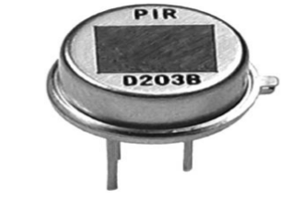

Figure 3.2 PIR Sensor

### **3.2.1 Principle of Operation of A PIR Sensor**

An individual PIR sensor detects changes in the amount of infrared radiation impinging upon it, which varies depending on the temperature and surface characteristics of the objects in front of the sensor. When an object, such as a human, passes in front of the background, such as a wall, the temperature at that point in the sensor's field of view will rise from room temperature to body temperature, and then back again [28].

The sensor converts the resulting change in the incoming infrared radiation into a change in the output voltage, and this triggers the detection. Objects of similar temperature but different surface characteristics may also have a different infrared emission pattern, and thus moving them with respect to the background may trigger the detector as well [28].

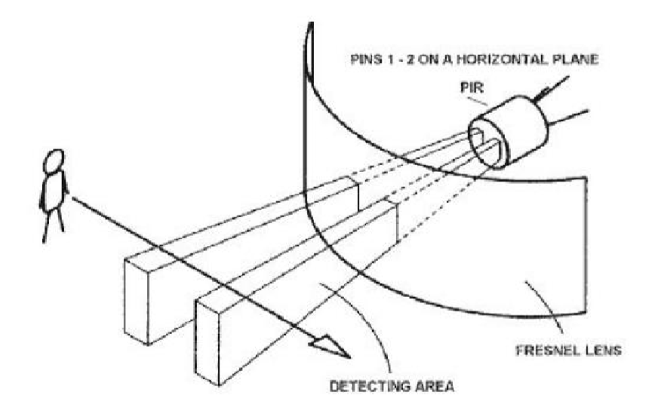

Figure 3.3 Operation of a PIR Sensor

### **3.2.2 Applications of The PIR Sensor**

* Remote camera trigger.
* A home-made security system using PIR sensors (which is built into a Start Trek panel!) PIR sensor + Arduino + Servo = automatic cat door!
* Motion detection in home surveillance/security systems.

**3.3 GSM module**

GSM module 300 is used in this work. SIM 300 is a widely used GSM modem around the globe, and more popular among students. SIM300 is a triband GSM modem being able to operate only in 900, 1800, 1900MHz band. It operates from 3.4V to 4.5V supply range. It consists of a DB9 port in order to communicate with the computer or with the micro-controller, a power jack, an integrated module, a connector and a micro strip antenna, an interface circuit of Max 232.

## 3.4 Buzzer

Buzzer is the alarming device, which sound the alarm if any intruders are detected. It works the vibrating disk in a magnetic buzzer is attracted to the pole by the magnetic field. When an oscillating signal is moved through the coil, it produces a fluctuating magnetic field which vibrates the disk at a frequency equal to that of the drive signal.

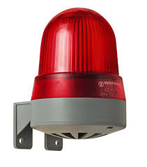

Figure 3.4 Buzzer

## 3.8 Web Camera

A webcam – short for ‘web camera’ is a digital camera that’s connected to a computer. It can send live pictures from wherever it’s sited to another location by means of the internet. They are commonly used for surveillance but unlike analog closed-circuit television (CCTV) cameras, they require no local recording device, only a local area network.

Webcam characteristics include:

* Compared to other models of camera, webcams are considerably lower in cost, especially from a video telephony perspective.
* Compared to most handheld cameras, the maximum resolution of a webcam is low.

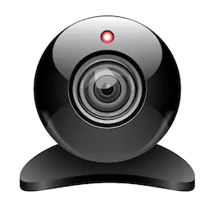

Figure 3.5 Web Camera

# 

# CHAPTER FOUR

# SYSTEM DESIGN

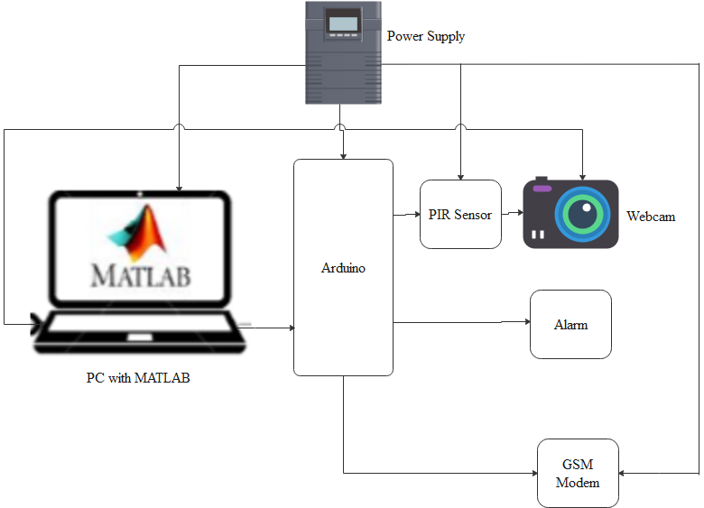

Figure 4.1 General Block Diagram of Face Recognition Based Surveillance and Security system

## 4.1 Hardware Design

## 4.2 Software Design

Algorithm of the system is applied in MATLAB R2019b software. MATLAB is a production of MathWorks Co. can be performed many algorithms such as data analysis, numeric computation, signal processing, image processing, mathematical computation, etc. MATLAB supplies facility environment for implementing scientific works by reposing toolboxes for any goals which is generation of algorithms are more powerfully. Image acquisition toolbox, and image processing toolbox are used while generation of the algorithm of face detection and tracking system. Image acquisition toolbox provides image achieving from camera system that MATLAB supports. This toolbox will bridge between output incoming data and MATLAB environment. Image processing toolbox enables many source algorithms, graphical tools, analysis, etc. Filters, transforms, enhancements, etc. are ready to apply functions which simplify to code generation. This toolbox is used in face detection and tracking system.

### **4.2.1 Face Detection**

**4.2.1.1 Different Types of Algorithms**

There are three main approaches considered for implementing face detection. They are ‘Neural network-based face detection’, ‘Image pyramid statistical method’ and ‘Voila & Jones’. Each implementation is discussed below:

**1. Neural network-based face detection**

Faces are detected at multiple scales by calculating an image pyramid. Each image in that pyramid is then scanned by using a fixed size sub-window and its content is corrected. The correction is to make sure that the lighting is non uniform. The histogram is also equalized. This corrected sub window is then passed through many parallel neural networks. The networks decide if there are any faces in the window. All of these multiple outputs are passed through an AND gate to give the final result. As it’s an AND gate the number of false detections is reduced.

**2. Image pyramid statistical method**

The basic mechanics of this algorithm is also to calculate an image pyramid and scan a fixed size sub-window through each layer of this pyramid. The content of the sub window is subjected to a wavelet analysis and histograms are made for the different wavelet coefficients. The orientation of the object is determined by differently trained parallel detectors. These detectors are trained so that they are sensitive to the different orientations and one which received the highest hit is considered as the best estimate of the actual orientation.

**3.Voila and Jones method**

The main focus of this method was to achieve a reasonably high face detection rate in the smallest amount of time possible. The detector uses features which are calculated using ‘Integral Image’. This is a new type of image representation which is introduced in this method’s paper. Also, a new type of learning algorithm was introduced in this paper which inherits Adaptive Boosting (AdaBoost) algorithm features. This learning algorithm is then applied which selects the critical visual features and generates classifiers. Background or in other words the fewer interesting regions are discarded by a cascade classifier.

**4.2.1.2 Comparison of algorithms**

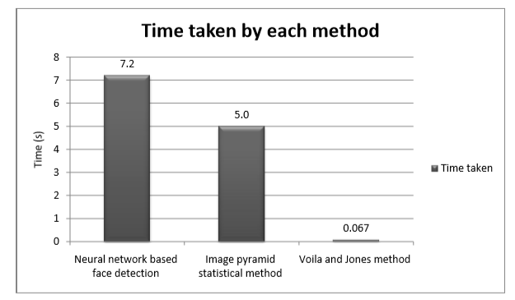

Figure 4.2 Plot Showing Time Taken by Each Method

The plot above shows the time taken for each method to process an image. we can clearly see that ‘Voila and Jones’ method work significantly faster when compared with others. It is also considered as one of the breakthroughs in the face detection industry.

**4.2.1.3 Voila and Jones method theory**

This method uses ‘Haar’ wavelets for feature extraction from the images. These wavelets also allow feature evaluation.

A & B – Edge features

C – Line features

D – Four rectangle Features

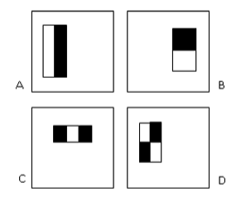

Figure 4.3 Basic Haar Wavelets

They are formed of one low interval and high interval or in other words are single wavelength

square waves. A square wave is a pair of one light and one dark adjacent rectangle. The calculation of these wavelets is relatively easy as the white areas are just subtracted from the black ones. Figure 4.4 shows the four basic types of Haar wavelets in 2D.

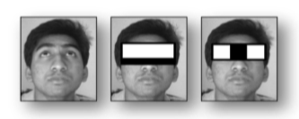

Figure 4.4 Haar Wavelets Extracting Features

The feature extraction is made faster by integral image which is a special representation of the image. A machine learning method, called ‘AdaBoost’ enables classifier training and feature selection. All of the detected features are then combined efficiently by using a cascaded classifier. This is shown in figure 4.5.



Figure 4.5 Cascaded Classifier

Viola-Jones algorithm for face detection using MATLAB program works in following steps:

1.Creates a detector object using [Viola-Jones algorithm](https://www.cs.ubc.ca/~lowe/425/slides/13-ViolaJones.pdf)  
2. Takes the image from the video  
3. Detects features  
4. Annotates the detected features

### **4.2.2 Face Tracking**

We are using Kanade-Lucas-Tomasi KLT algorithm to do face tracking. This algorithm is basically based on feature point tracking on the first face, and keeps on tracking it until there is no feature point available. For the first feature points set on tracking, we used eigenvalue algorithm to find corner points. Basically, this is Shi–Tomasi corner detection algorithm which detects the corner. It directly computes the value of eigenvalues to determine whether it is a point of interest or not. After detecting those points, we will be able to track each of the points we found from Shi-Tomasi corner detection. For each consecutive frame we will try to match the points from the step above. There might be points missing, and if it is the case, we will rule them out. As long as there are at least 2 points exist in the videoframe, we will be able to continue tracking the face by finding out the affine transformation of those points. Then because we are running in real-time, we will want the corner detection algorithm to run again once all corner points are gone.

### **4.2.3 Face Recognition**

**4.2.3.1 Eigenfaces Method**

This method is based upon PCA. An initial set of images of faces are used to create a training set. The number of face shots of each person stored in the database depends on how much processing time they will take. These faces are then broken down into individual vectors. The magnitude of each vector represents the brightness of individual sectors of the gray scale image. A covariance matrix is formed by normalizing these vectors. After this eigenvector are derived from this covariance matrix and a set of eigenvectors of an image forms an eigenface as shown in Figure 4.6. Eigenface helps in just focusing at the main face features rather than the whole face data. In other words, it enables us to find the weight of each face.

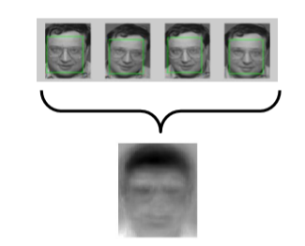

Figure 4.6 Specimen’s Images Taken From AT&T Database and Its Resultant Eigenface

When a new face image is acquired the weight of that face is calculated and then subtracted from the each of the weights of other images in the database. Those difference numbers represent how much different each image is from the original image. The lower the number the closer is the match. This difference is also known as the max Euclidean distance.

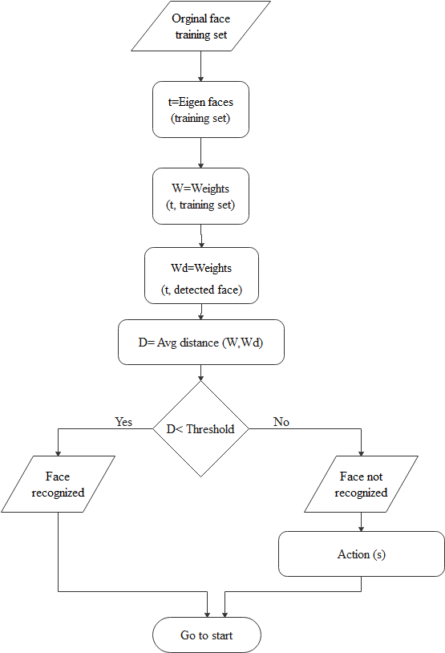

Figure 4.7 Face Recognition Flowchart

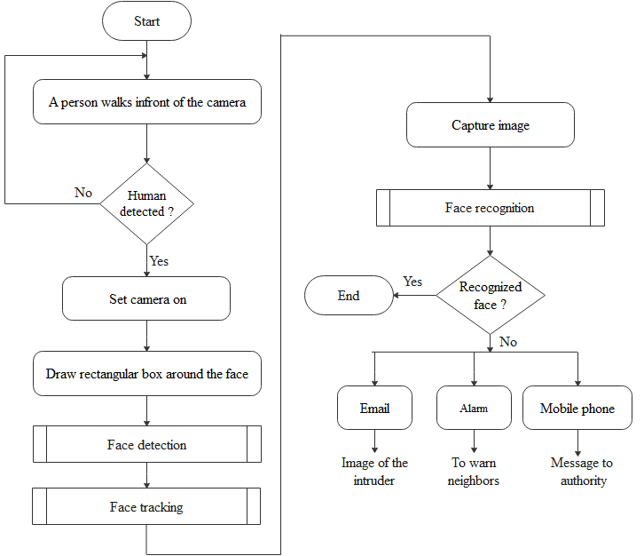

Figure 4.8 Flowchart of Face Recognition Based Surveillance and Security System

**CHAPTER FIVE**

**RESULT AND DISCUSSION**

**5.1 Result**

Human presence is detected by PIR sensor. If there is a person, camera turns on and start capturing the image from the video.

Fig. 1

To capture the training images and store in the database there are commands need to run on the MATLAB code. If the face is detected it captures and stored in folder as shown in the figure below.

Fig. 2

The faces which weren’t detected were those who either were looking sideways at 30-40° or didn’t have enough contrast between the features for the Haar wavelet to identify them.

Here we have taken 10 face images of three different person with different expressions as shown in figure below.

Fig. 3

The following images converted to grayscale format as shown in figure below.

Fig 5.

The face recognition is done on the testing images by using Principal Component Analysis Algorithm.

Whenever an unknown face has detected via web camera, it has started capturing intruder images, attaching these images to the mail and sending it to the owner as we can see in the screenshot.

The GSM module sends SMS alert to the owner and the buzzer activated to announce for nearby person as shown in figure below.

**5.2 Discussion**

In order to test and validate the proposed face recognition security system, implementation of the algorithm was applied using MATLAB interface with proteus software. The database was created and accessed by the MATLAB software during the processing of the input image. This system is a real-time face recognition system that reads a real-time video from the camera connected to the computer running the software, takes an image from this video, processes it to detect any human face presented in front of the camera, and then recognizes the face using a set of face images in a database. The faces which weren’t recognized correctly were mostly those with severe variation in the lighting condition. Also, in some of the false negative cases the difference in the face expression was large enough to confuse the algorithm. This system was tested on several cases, and it achieved a face detection accuracy of 90% and a face recognition accuracy of 80%. Also, signal has been sent from MATLAB to Arduino and the Arduino send a signal for both GSM module and buzzer. The GSM module sends SMS alert to the owner and the buzzer activated to announce for nearby person.

**CHAPTER SIX**

**CONCLUSION AND RECOMMENDATION**

**6.1 Conclusion**

Face recognition systems are going to be used more and more in the future for security reasons because they provide better performance over other security systems. Face recognition is the technology adopted here. Since face recognition can be done using Viola jones algorithm and PCA algorithm system is efficient. Use of MATLAB environment for the software side ensures the simplicity of system. Although its accuracy is below 80%, this system may be improved by utilization of additional features.

**6.2 Recommendation**

uture work may include improvement of the Face

recognition using specific characters in the face (distance

between eyes) and also analyze the face in 3-D by using the

combination of two cameras and by using these two methods,

the probability of error will decrease and the system will be

more accurate and with a very low cost.

uture work may include improvement of the Face

recognition using specific characters in the face (distance

between eyes) and also analyze the face in 3-D by using the

combination of two cameras and by using these two methods,

the probability of error will decrease and the system will be

more accurate and with a very low cost.

uture work may include improvement of the Face

recognition using specific characters in the face (distance

between eyes) and also analyze the face in 3-D by using the

combination of two cameras and by using these two methods,

the probability of error will decrease and the system will be

more accurate and with a very low cost.

Future work may include improvement of the face recognition using specific characters in the face (distance between eyes) and also analyze the face in 3-D by using the combination of two cameras and by using these two methods, the probability of error will decrease and the system will be more accurate and with a very low cost.

# REFERENCES

[1]. https://kintronics.com/the-history-of-video-surveillance/

[2] https://en.wikipedia.org/wiki/Image_processing

[3] Ms. Naga Jyoti and Mr. K. Vijaya Vardhan, “Design and Implementation Of Real Time Security Surveillance System Using IoT”, Communication and Electronics Systems (ICCES), International Conference: IEEE, 2016.

[4] M. Surya Deekshith Gupta, Vamsikrishna Patchava, and Virginia Menezes: “Surveillance and Monitoring System Using Raspberry Pi and SimpleCV”: Green Computing and Internet of Things (ICGCIoT), IEEE, 2016.

[5] Aruni Singh, Sanjay Kumar Singh, Shrikant Tiwari, “Comparison of Face Recognition Algorithms on Dummy Faces”, The International Journal of Multimedia & Its Applications (IJMA) Vol.4, No.4, August 2012.

[6] Aamir Nizam Ansari, Mohamed Sedky, Neelam Sharma, Anurag Tyagi, “An Internet of Things Approach for Motion Detection using Raspberry Pi”, International Conference on Intelligent Computing and Internet of Things (IC1T), 2015.

[7] R.Chandana, Dr.S.A.K.Jilani, Mr.S.Javeed Hussain, “Smart Surveillance System using Thing Speak and Raspberry Pi”, International Journal of Advanced Research in Computer and Communication Engineering Vol. 4, Issue 7, July 2015.

# Appendices