**COMPUTING SUBJECT:** Restful ASP.Net Core-services

**TYPE:** Assignment

**IDENTIFICATION:** RestCustomerService

**COPYRIGHT:** *Michael Claudius & Peter Levinsky*

**LEVEL:** Medium

**TIME CONSUMPTION:** 3-5 hours

**EXTENT:** 60 lines

**OBJECTIVE:** Restful services based on ASP.Net Core

**PRECONDITIONS:** Exercise RestCalculatorService is a mustRest service theory. Http-concepts  
 Computer Networks Ch. 2.2

**COMMANDS:**

**IDENTIFICATION:** RestCustomer /MICL&PELE

Purpose

The purpose of this assignment is to be able to provide and consume restful ASP.Net Core web services on objects of a specific class.

Precondition

You must have done the RestCalculatorService, as basic information and guidelines are given in this exercise.

Mission

You are to make and use restful web services based on the ASP.Net Core services by setting up a server (provider), test the services by use of Fiddler/Postman and create a client (consumer) using the services provided. On the way you will publish the service to the cloud (Azure) and apply CORS from Azure. The service supports the classic GET, POST, PUT and DELETE requests. This we shall do in the following steps:

1. Create a project with auto generated service: api/values
2. Create a model class Customer for customer data
3. Create a controller CustomerController to provide REST services
4. Extend CustomerController with a list of customers
5. Create and provide a controller oriented service in CustomerController
6. Test the service using Browser/Fiddler/Postman
7. Create a client/consumer utilizing the service
8. More services and testing by Fiddler/Postman and client/consumer
9. Publish to Azure
10. Support simple Cross Origin Resource Sharing (CORS) using Azure
11. Set up a project for Unit test
12. Support dedicated Cross Origin Resource Sharing (CORS) in the project
13. Refactor the consumer code

This assignment holds all step 1-10.

*In the next assignment, RestCustomerService No. 2, holds steps 11-13.*

Domain description

Management and administration of customers utilizing web services for the classic operations:

Create (POST)

Read, i.e. Find one or more. (GET)

Update (PUT)

Delete (DELETE)

Reflecting standard Http requests.

When surfing on the net it is easy to find many descriptions more or less useful, and in more or less updated versions. Here are some:

*Useful links for C#:*

Serializable Class

<https://msdn.microsoft.com/en-us/library/4abbf6k0(v=vs.110).aspx>

CRUD-Operations and routing  
<https://docs.microsoft.com/en-us/aspnet/web-api/overview/web-api-routing-and-actions/attribute-routing-in-web-api-2>

Building ASP web services  
This is for ASP Framework but there are ideas about the programming

<https://docs.microsoft.com/en-us/aspnet/web-api/overview/web-api-routing-and-actions/create-a-rest-api-with-attribute-routing>

Cors – Cross Origin Ressource Sharing

<https://docs.microsoft.com/en-us/aspnet/web-api/overview/security/enabling-cross-origin-requests-in-web-api> (from the middle enable CORS)

<https://en.wikipedia.org/wiki/Cross-origin_resource_sharing>

Test

<https://code.msdn.microsoft.com/Unit-Testing-with-ASPNET-1374bc11/sourcecode?fileId=179451&pathId=1993051352>

<https://docs.microsoft.com/en-us/aspnet/web-api/overview/testing-and-debugging/unit-testing-with-aspnet-web-api>

Assignment 1: Restful ASP.Net Core-service provider

You are to make a Rest Service provider RestCustomerService.

Start Visual Studio:File -> New -> Project.

Choose: Web -> ASP.NET Core Web Application (**not .Net Framework**).

Browse to a convenient location and give the name RestCustomerService.

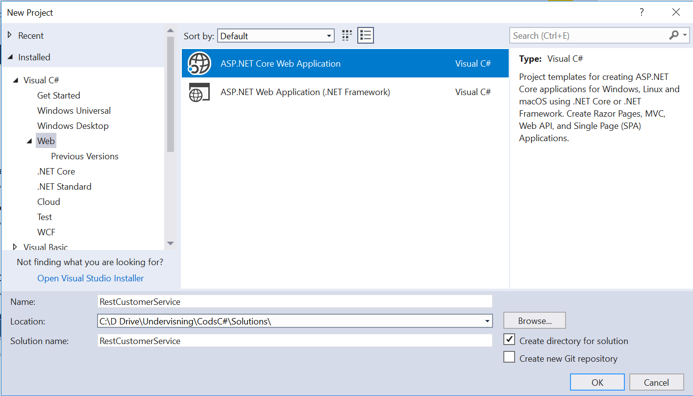

Click OK.  
Now a project template with options are given.

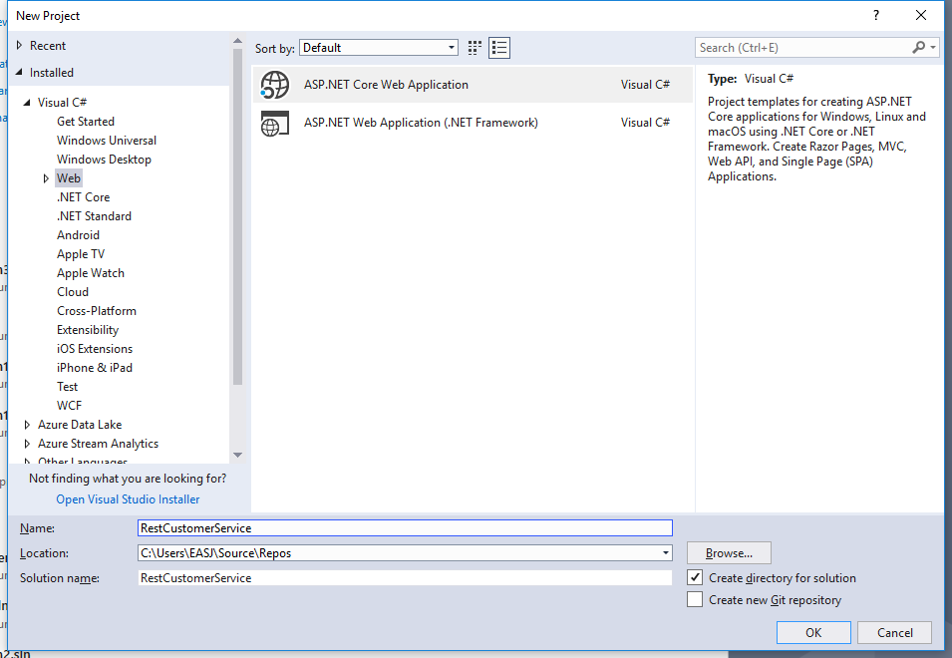

Click on OK.

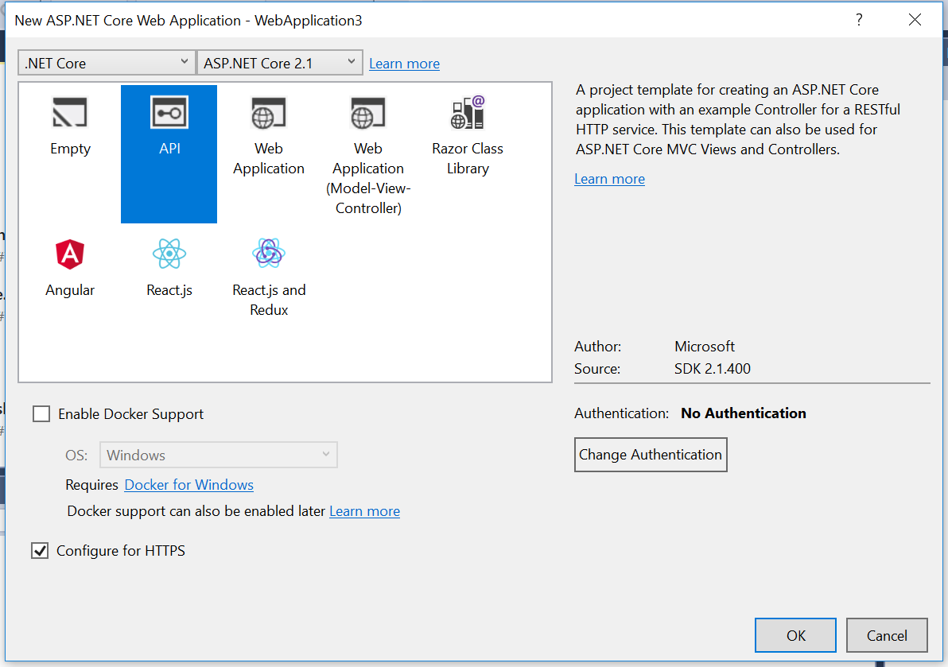

Choose the API.

**DON’T tick Docker support.**

**Tick HTTPS** if you intend to use GoogleChrome or MicrosoftEdge as browser. And Fiddler as a tester-client. This has been tested by me (Michael Claudius) and it all works fine.

**Don’t tick HTTPS,** if you intend to use Firefox as browser.Also if you intend to use Postman, it could (nit sure) have problems using https. But then of course https will **NOT** be supported later on.

Now you have to wait a while…

Execute the Application by viewing it in a local Browser. This will start the Azure emulator.

As you can see it takes the predefined URL:

<http://localhost:49972/api/values>

The port number (49972)will be different on your computer.

*Now we are ready to extend the project with first a model class then a controller class.*

Assignment 2: Model class Customer

We need a class, Customer, for customer objects. Therefore, to the project add (right click project, choose Add -> Folder) a folder named “Model” and in this folder add a public class, “Customer”, with the data fields:

ID, unique identifier

FirstName,

LastName,

Year, year of registration

with get/set method for all the fields; i.e. they are properties.

Make the constructors:

Customer(int id, string first, string last, int year)  
Intializing all the data fields  
  
Customer() {}   
//empty constructor needed for JSON transfer. Serializable objects.

Assignment 3: REST API operation by creating a controller

*You are to create a controller where the operation contracts must be defined as REST API routes and methods similar to ValuesController and CalculatorController.*

In the solution in the controller folder, add (i.e. Right click) a new controller named “CustomerController”.   
Choose ‘Web API Controller **with read/write actions**’.

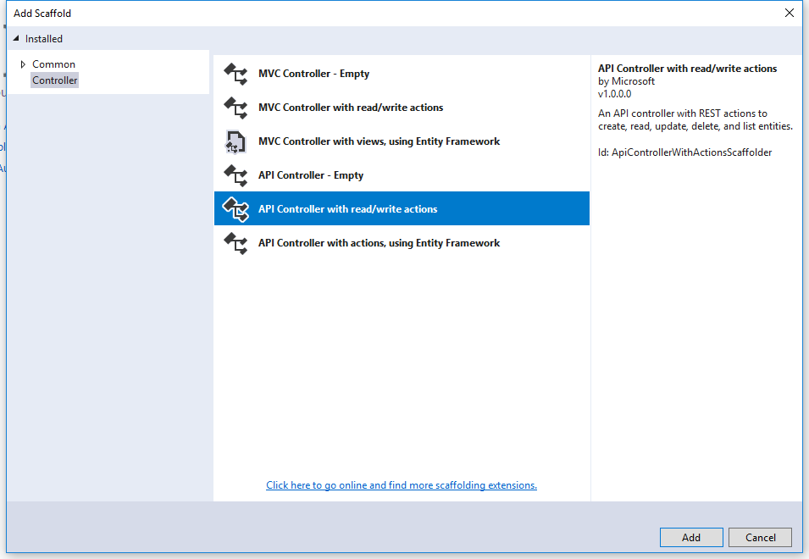

Click Add and you can see the new controller.

*Now we are ready to create customers and add services on them.*

Assignment 4: Extend CustomerController with a list of customers

In *CustomerController* declare a static list holding three customers:

private static List<Customer> cList = new List<Customer>()

How to add customers so the list is always initialized with three customers?

Maybe you also like this:

public static int nextId = 0;

But what should that be used for...?

Assignment 5: Define the GET service GetCustomers

In *CustomerController m*odify the first Get method (it’s the one returning values) to support a Rest API GET request, that returns a list of all customers:

// GET: api/Customer

[HttpGet]

public List<Customer> Get() // or public IEnumerable<string> Get()

{

return *<your list> //cList*

}

And implement the method to let it return your customer-list.

What is the full route to the Get operation?

Why did we choose to change HttpGet?

Assignment 6: Testing application in Browser/ and Fiddler/Postman

Execute the Application by viewing it in a local Browser. This will start the Azure emulator.

From the browser call the customer:

<http://localhost:44343/api/customer>

<http://localhost:44343/api/customer/1>   
  
*All fine?!.*

Not yet but we are close!!

Try also to invoke the method from Fiddler/Postman.

*Before adding more services, you will write a consumer program.*

Assignment 7: Consumer: RestCustomerConsumer

Create a simple Console Application project “RestCustomerConsumer”. Add a Customer class to the project, a class similar to the Customer class you used in the provider.  
In order to serialize/deserialize objects, you must from NuGet install the package Newtonsoft.json.

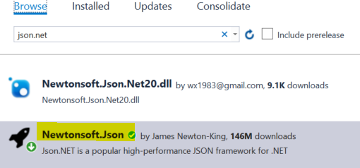

Now to consume the “Get” service, you in Program class (i.e. **Not inside *main***) make a very special method:

public static async Task<IList<Customer>> GetCustomersAsync()

{

using (HttpClient client = new HttpClient())

{

string content = await client.GetStringAsync(CustomersUri);

IList<Customer> cList = JsonConvert.DeserializeObject<IList<Customer>>(content);

return cList;

}

}

Where the CustomerUri is the URI pointing to your service and method (api/customer).

1. In *main* show how to use the method and print the list of customers.  
   Execute the program
2. Carefully explain the code line-by-line what goes on.

Assignment 8: More services and usage by client/consumer

You must now extend the service (i.e. your controller) with more methods.

In *CustomerController* define more operations handling:

* Customer Get(int id)  
  Return the customer information with the specified id.
* DeleteCustomer(int id)   
  Delete (DELETE) the customer with the specified id.
* InsertCustomer(Customer c)  
  Insert (POST) the customer object in the list
* UpdateCustomer(int id, Customer c)  
  Update (PUT) a specified customer. Retrieves a specified customer, replace the old customer information/object in the list, with new customer information/object, c.

1. For each method, show how to use it from Fiddler/Postman.
2. For each method, show how to use it in the consumer RestCustomerClient.  
   Rather similar to the Async-methods (get and post) you already made in this exercise and in RestCalculatorService

**Notice:** Remember for each method you must carefully think about:

* Which HTTP method/verb to use?
* What should the URI (Route) look like? Any parameters to the URI, like {id}?
* Do you want to specify the route explicitly like: [Route("customer/{id:int}")]  
  for each method
* Return type: true/false, customer object, id etc..

And write down your arguments.

Assignment 9: Publish in Azure

1. Publish your service in Microsoft Azure.
2. Use a browser to show the API and the methods.
3. Use Postman or Fiddler to show requests and responses.
4. Show how to use the Azure service instead of the local URI in your consumer program.

Assignment 10: Simple support of Cross Origin Resource Sharing (CORS) in Azure

You must now change the Azure settings to apply CORS to your Rest Service, i.e. your Rest Service (API) can be consumed in scripting frontend pages, like Javascript/Typescript based applications.

1. Login to your Azure portal and click on your WebApp project (miclRestCustomerCore).  
   Scroll down on the left panel and find the CORS button:

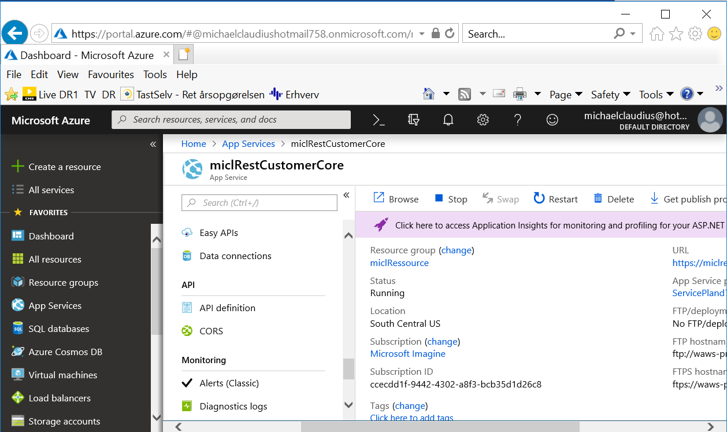

1. Click on the green CORS button and the pop-up window looks like this:

Your web-service should be made available for any external host.

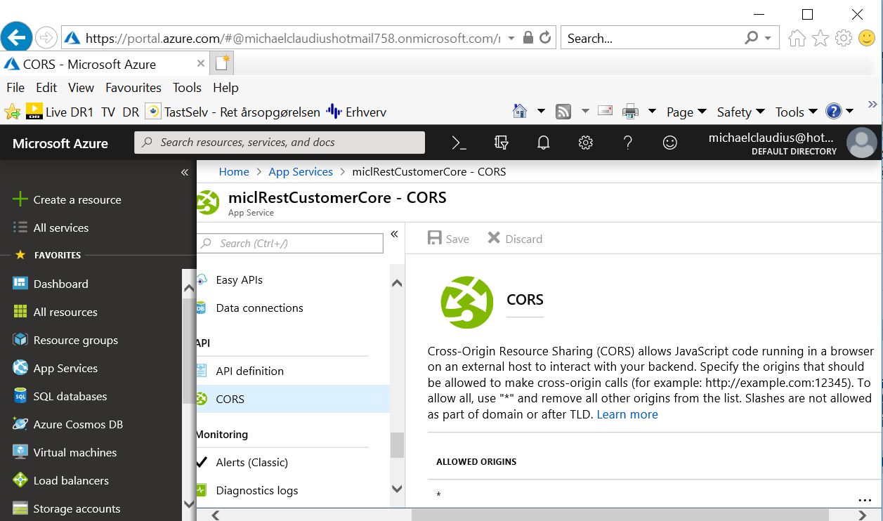

Sp to allow Javascript code -running in a browser on any external host- to access the backend with the rest web service place a “*” in the Text field below “ALLOWED ORIGINS”.

Then click on “Save”.

**CONGRATULATIONS YOU NOW HAVE A NICE RESTFUL WEB SERVICE**

*Now you and others can later utilize your rest service from Typescript/Javascript etc..*

*In the next assignment we will detail the CORS possibility and unit testing ☺*

Appendix A: Running from Fiddler/Postman

*This a is an example for using a service add on two integers. It will be similar for services on customers.*

Try to invoke the method from Fiddler/Postman

Be aware that you must:

1. Click on Composer
2. Choose POST
3. Define the Content-Type: application/json
4. Request body must hold the Customer as a Json-string

It will look something like this:

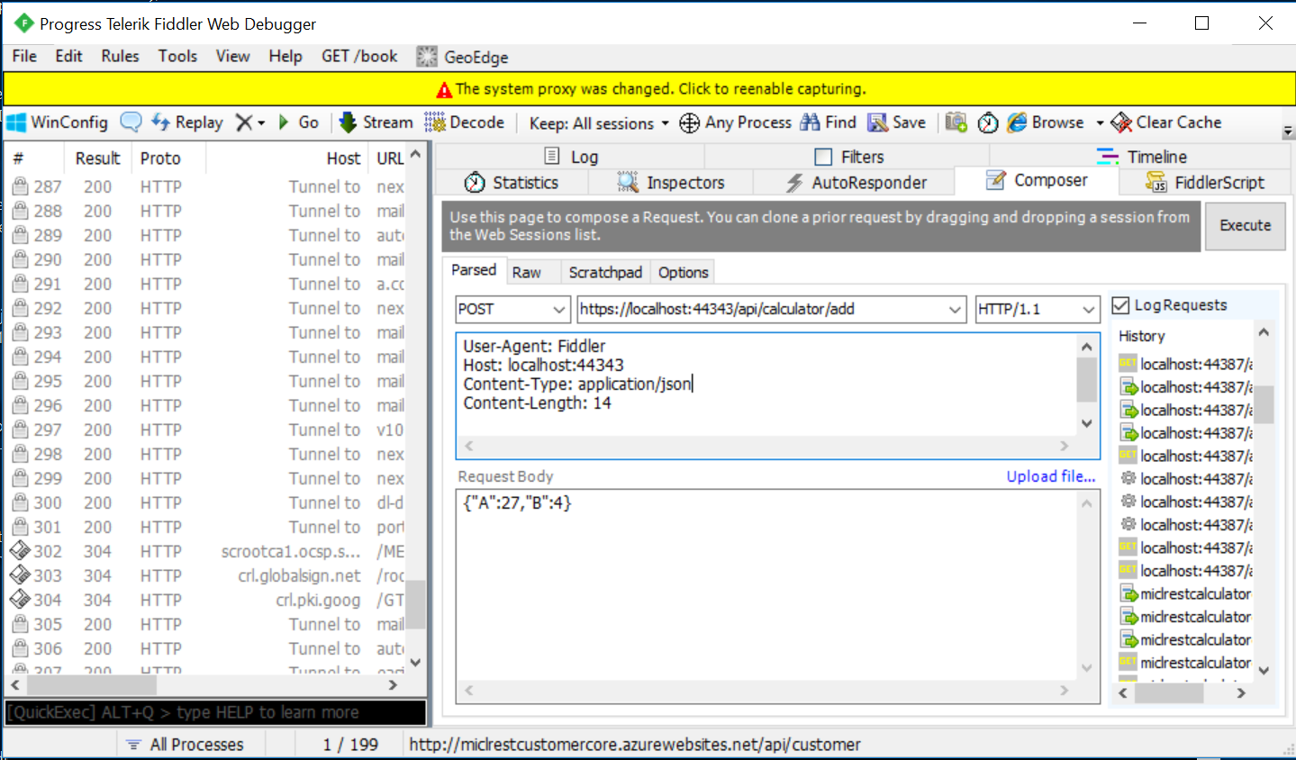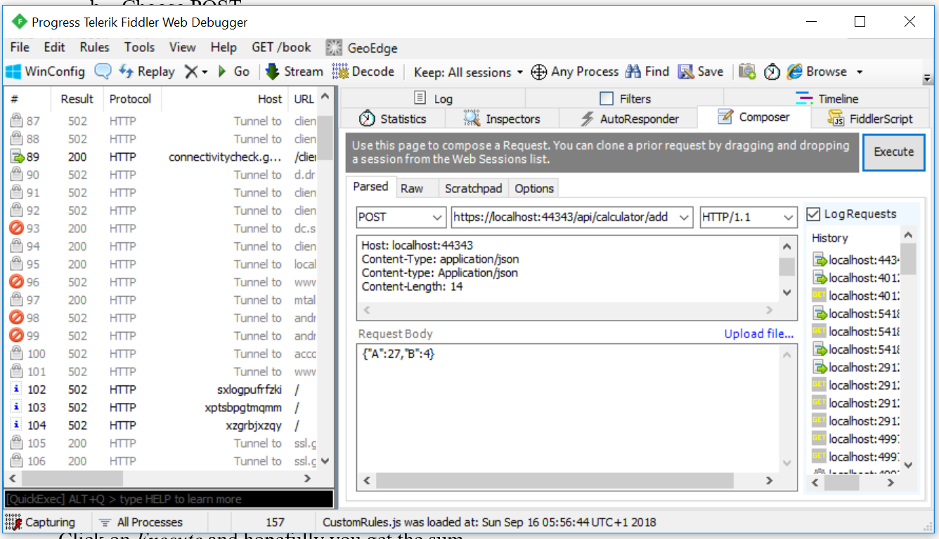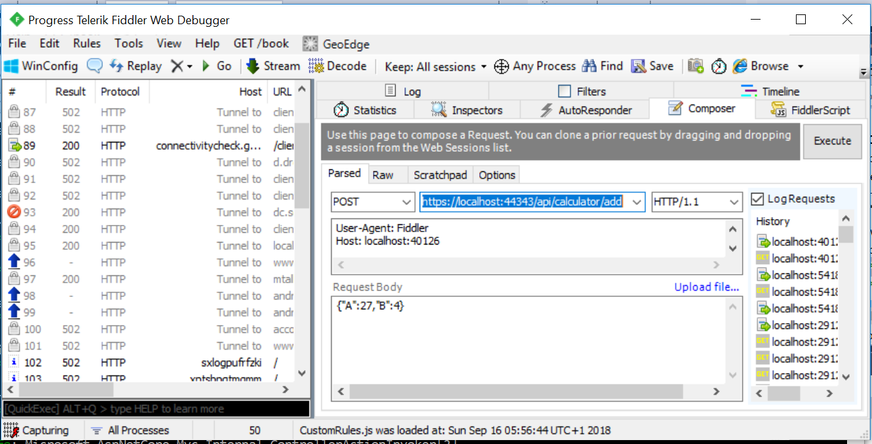

Click on *Execute* and hopefully you get the sum.