Al Azhar University – Gaza

**FACULTY OF ENGINEERING AND INFORMATION TECHNOLOGY**

**DEPARTMENT OF SOFTWARE ENGINEERING**

**Software Design**

**Student's Name:                                        Student's ID:**

Abed Alftah Sameer Alshorafa   20181510

**SUPERVISED BY**

Eng. **Yussuf Abu Shaaban**

|  |  |
| --- | --- |
| |  | | --- | |  | |

November 2021

First Semester 2021/2022

**Index**

**TITLE                                                                        PAGE**

**1-**  **Abstract                                                                                                  1**

**2-**   **Introduction**

**3-**   **Chapter 1: Business Requirements**

1-   Functional Requirements

2-   Non-functional Requirements

3-   Actors

**4-**   **Chapter 2: Use Cases**

1-   Use case diagram

2-   Use case details

**5-**   **Chapter 3: Sequence Diagrams**

**6-**   **Chapter 4: Class Diagrams**

1-   Class diagram

2-   Class entity

3-   Full class diagram

4-   Database schema

**Abstract**

When a patient goes to a doctor and the doctor says : you must take this medicine for 3 weeks as example, the patient doesn't follow instructions and takes the medecin more than the doctor says or at irregular intervals, that leads to wrong results and more pain.

So,we went to automate this process to make sure that the medicine will be eaten in the right time and quantity.

**Introduction**

These days, patients must remember his/her medicine times and names . But if he/she forgets to take his/her medicine at the right time, will have pain and maybe start his/her medecin from the start in some situation. So our system came to solve this big problem to make our patients relaxed and comfortable .

The system is a mobile application that works as follows:

1) A doctor writes a prescription for a patient.

2) The patient goes to the pharmacy to get his treatment.

3) The pharmacist adds a new drug in the patient's account, adds the name, and determines the time periods.

4) Every period the application issues an alarm to alert the patient to take the medication.

5) Patients take the medication and click "Done" to start a new timer and save that action in the database.

6) The next time a patient goes to the doctor, the doctor can export the drug taking dates for that patient and check whether he follows the instructions or not.

System needs some help to work perfected.

patient or one of his/her nabers He has to be committed with system to get best result

**Chapter 1:**

**Business Requirement**

**1.**  **Business Requirement**

**1.1.** **Functional Requirement**

|  |  |  |
| --- | --- | --- |
| **No.** | **FR name** | **FR description** |
| **1** | **Sign Up** | **every user must create an account to be able to login into the system** |
| **2** | **Log In** | **user must Login into the system to save his/her data and be able to do any process** |
| **3** | **Add patient** | **Doctors should add patient to his/her list to monitor his health** |
| **4** | **add medicin** | **pharmacist must add medicine to patient profile from his/her account** |
| **5** | **medicine took** | **when patient took his/her medicine, must click on”Done” to stop alarm and save data** |
| **6** | **Git history** | **Doctor or pharmacist can export history of taking medicine to patient by read QR code to his/her profile** |
| **7** | **Edit medicine** | **Pharmacist can edit medicine information (name,time)** |
| **8** | **Delete medicine** | **Pharmacist can delete medicine .** |
| **9** | **End medicine** | **Doctor can end medicine if patient get well** |
| **10** | **Display medicine** | **patient can show all his/her medicines and its periods** |
| **11** | **Write prescription** | **Doctor should Write a prescription to patient,this prescription contains the medicine.** |
| **12** | **scan QR code** | **Pharmacist read the prescription using QR code and get it from the patient account.** |
| **13** | **Patent Profile** | **Open patient profile to display fill case .** |
| **14** | **View Home** | **Make decision to how display main view according to his/her type.** |
| **15** | **Generate QR code** | **Convert links to QR code to get smoothy work** |
| **16** | **Share Profile** | **Get profile link to share it with other users** |
| **17** | **Share Prescription** | **Get prescription link to share it with other users** |

**1.2.** **Nonfunctional Requirement**

**1-** **Security**: No one can see the personal information of other user only authorized

**2-**  **Usability:** system should be easy to use for all users also to users don't have background knowledge

**3-**  **Availability:** system should provide offline copy of data on user mobile to use it in all cases.

**4-** **Performans**: System should able to read QR code in less than 1 second ,upload new data in less than 20 seconds , create new account and chick if information is correct or duplicated in less than 40 seconds.

**1.3.** **Actors**

|  |  |  |
| --- | --- | --- |
| **No.** | **Name** | **Description** |
| **1** | **Doctor** | He diagnoses the patient and has the authority to write and add the patient's treatment description |
| **2** | **Pharmacist** | He reads the QR code, dispenses the treatment and inserts the doctor's instructions for taking the treatment in the application for the user's account |
| **3** | **Petent** | The person who is the focus of the problem, as he will take the treatment when the system reminds him of it, and confirms to the system that he has taken his treatment |

**Chapter 2:**

**Use case**

**2.**  **Use case**

**2.1.** **Use case diagram**

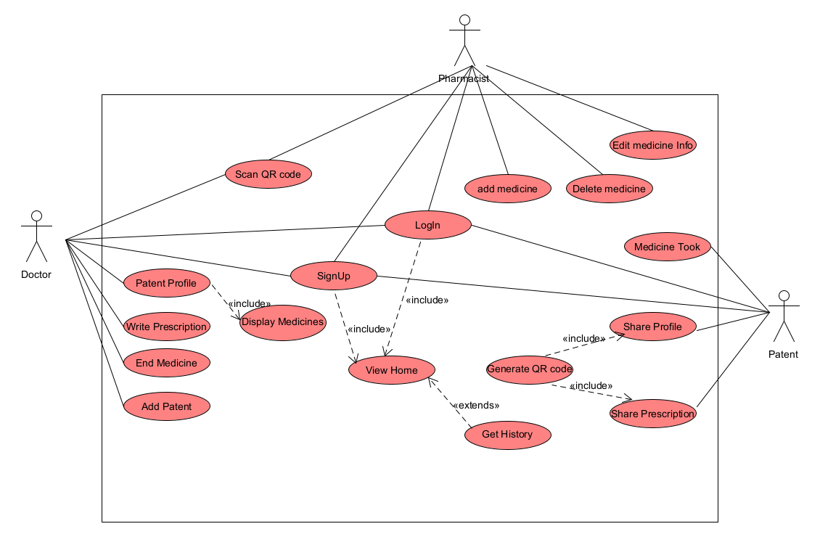

**2.2.** **Use case details**

|  |  |
| --- | --- |
| **Name** | **SingUp** |
| **Actors** | **Doctor , Pharmacist , patient** |
| **Description** | **Summary:**  **This use case as create new account , So if any actor want to use the system to first time,he/she must Sign Up**  **Scenario:**  **user Download the application to first time , system will open signup page to get requered data from user , and ask user if has an account to Login. After that user can use the system using his/her account in the same device or other device.** |
| **Relation** | **its include View Home use case** |
|  |  |

|  |  |
| --- | --- |
| **Name** | **Login** |
| **Actors** | **Doctor , Pharmacist , patient** |
| **Description** | **Summary:**  **Using this use case a user can enter the system and use it , and the system can also check user authorization.**  **Scenario:**  **the user opens the application, if the user doesn't choose “Remember me” ,the system will open the login page, and ask the user to enter his/her username and password . After that system will open Home page** |
| **Relation** | **its include View Home use case** |
|  |  |

|  |  |
| --- | --- |
| **Name** | **Write Prescription** |
| **Actors** | **Doctor** |
| **Description** | **Summary:**  **Using this use case a Doctor will be able to give patient his/her prescription.**  **No actor can use this use case to be sure that doctor write the prescription.**  **Scenario:**  **patient go to doctor because he/she has a pain , doctor will open patient profile and press”add prescription” , thin add medicine name ,caliber,and quantity and press”save”.** |
| **Relation** |  |
|  |  |

|  |  |
| --- | --- |
| **Name** | **Add patient** |
| **Actors** | **Doctor** |
| **Description** | **Summary:**  **Using this use case a Doctor will be able to add new patient to his/her profile.**  **Scenario:**  **patient go to new doctor (patient visit this doctor for first time ) because he/she has a pain , doctor will press(add new patient) and user must open his/her profile and press (Share)to get QR code, system will open camera to read QR code for patient profile.** |
| **Relation** | **include scan QR code user case** |
|  |  |

|  |  |
| --- | --- |
| **Name** | **End Medicine** |
| **Actors** | **Doctor** |
| **Description** | **Summary:**  **Using this use case a Doctor will be able to end the medicine that patient he was taking it before.**  **Scenario:**  **patient go to doctor after end the prescribed treatment period , doctor Renew medicin by Write prescription , or end this medicine if patient is ok,** |
| **Relation** |  |
|  |  |

|  |  |
| --- | --- |
| **Name** | **Scan QR code** |
| **Actors** | **Doctor,Pharmacist** |
| **Description** | **Summary:**  **Using this use case a Doctor can add new patient ,and Pharmacist can read prescription from patient phone,**  **Scenario:**   * **First case: patient go to new doctor , so his/her file is not shone by the doctor , so doctor must scan QR code to patient profile.**      * **Second case:patient has a prescription and go to pharmacy to get medicin, pharmacist must scan QR code to get the prescription information and make it an expense.** |
| **Relation** |  |
|  |  |

|  |  |
| --- | --- |
| **Name** | **add medicine** |
| **Actors** | **Pharmacist** |
| **Description** | **Summary:**  **Using this use case a pharmacist can add new medicin to patient profile to save new medicin info,and make the system notify the patient at the right time to take it .**  **Scenario:After doctor add rescription to patient profile ,patient should go to pharmacy to bay the medicine. in this case and after pharmacist scan the QR code,he/she should add medicin to patient profile and add the period of time that system must remember patient to take medicin .after that system will save new medicin and in the right time system will notify patient to take his/her medicin.** |
| **Relation** |  |
| **Exception** |  |

|  |  |
| --- | --- |
| **Name** | **Edit Medicine** |
| **Actors** | **Pharmacist** |
| **Description** | **Summary:**  **Using this use case a pharmacist can edit old medicin in patient profile to save new information about this medicin**  **Scenario:pharmacist give patient medicin but write wrong name or any other required information and after that watch out the mistake , he/she must delete this information and write the right information**  **rong medicin and patient back to pharmacist to notify he/she about this mistak. in this case pharmacist must getback the rong medicin and give patient the right one also he/she must edit medicin info to get best performance.** |
| **Relation** |  |
| **Exception** |  |

|  |  |
| --- | --- |
| **Name** | **Delete Medicine** |
| **Actors** | **Pharmacist** |
| **Description** | **Summary:**  **Using this use case a pharmacist can delete medicin was added by mistake in patient profile to save new alternative medicin**  **Scenario: Pharmacist  give patient wrong medicin and patient back to pharmacist to notify he/she about this mistake. in this case pharmacist must get back the wrong medicin and give patient the right one. Also he/she must delete old one and add new one.** |
| **Relation** |  |
| **Exception** |  |

|  |  |
| --- | --- |
| **Name** | **Get History** |
| **Actors** | **Doctor,Pharmacist ,patient** |
| **Description** | **Summary: Actors use this use case to show how patent took his/her medicin in the last days.**  **Scenario: some times patient back to doctor or pharmacist  and allegedly that the medicin not remove a pain or illness,in this case doctor or pharmacist open patent history to ensure that the patient is committed to taking the treatment as directed by the doctor.** |
| **Relation** |  |
| **Exception** | **patient don't press “took” when took medicine ,so system don't save history** |

|  |  |
| --- | --- |
| **Name** | **patient Profile** |
| **Actors** | **Doctor, Pharmacist, Patient** |
| **Description** | **Summary: Actors use it to show patient profile and his/her medicine and times.**  **Scenario:patient go to doctor in new case, and doctor want to write new prescription, in this case doctor must show patient medicines and times to avoid conflicting treatments.** |
| **Relation** | **Include Display Medicines use case** |
| **Exception** |  |

|  |  |
| --- | --- |
| **Name** | **Share Profile** |
| **Actors** | **Patient** |
| **Description** | **Summary: To make doctor and pharmacist able to show his/her medicine and history , patient must share his/her profile with them . profile link will display as QR code for easy.**  **Scenario: Patient go to doctor for first time, patient must share his/her profile with doctor to add he/she to his patient list** |
| **Relation** | **Include Generate QR code use case** |
| **Exception** |  |

|  |  |
| --- | --- |
| **Name** | **Share Prescription** |
| **Actors** | **Patient** |
| **Description** | **Summary: To make pharmacist able to show his/her new medicine written in prescription, patient must share his/her prescription with pharmacist . pharmacist link will display as QR code for easy.**  **Scenario: Patient go to pharmacy to bay his/her medicine, patient must share his/her prescription with pharmacist to add new medicine to patient profile** |
| **Relation** | **Include Generate QR code use case** |
| **Exception** |  |

|  |  |
| --- | --- |
| **Name** | **Generate QR** |
| **Actors** | **Patient** |
| **Description** | **Summary: we this use case to make work more easy for all actors.**  **Scenario: when patient want to share his/her profile ,system use this use case to convert profile link from readable form to QR code form to make it more secure and easy to share .** |
| **Relation** |  |
| **Exception** |  |

|  |  |
| --- | --- |
| **Name** | **Medicine Took** |
| **Actors** | **Patient** |
| **Description** | **Summary: this use case tell the system that the patient is took his/her medicine and sent to system the required information are used to work perfectly.**  **Scenario: suppose that pharmacist add new medicine to patient profile and select the period he/she must take medicine in. in this time patient must take his/her medicine and tell system that “I’m took my medicine now” to save this and notify he/she in next time.** |
| **Relation** |  |
| **Exception** |  |

|  |  |
| --- | --- |
| **Name** | **View Home** |
| **Actors** | **Doctor, Pharmacist, Patient** |
| **Description** | **Summary: using this use case system will mange actor and select his/her type to display perfect view and give he/she the ableaty he/she need to work**  **Scenario: patient open the system and login suscsecfoly ,system now should select user type (as patient) and display his/her medicine and all functions that patient can use it.** |
| **Relation** | **Included by Signup use case**  **Included by Login use case**  **Extended by patient profile use case**  **Extended by Get history use case** |
| **Exception** |  |

|  |  |
| --- | --- |
| **Name** | **Display medicine** |
| **Actors** | **Doctor, Pharmacist, Patient** |
| **Description** | **Summary: display all patient medicine and descriptions.**  **Scenario: Patient go to doctor and doctor want to write new medicine ,but before that he/she must be sour that no old medicine conflict with new one .** |
| **Relation** | **Included by patient profile** |
| **Exception** |  |

**Chapter 3:**

**Sequence diagrams**

**3.**  **Sequence diagrams**

**3.1-  Login**

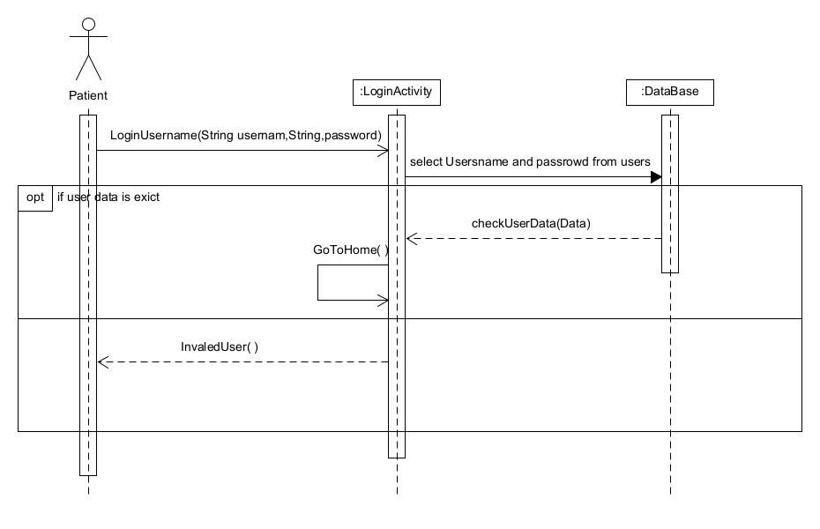

**3.2 SignUp**

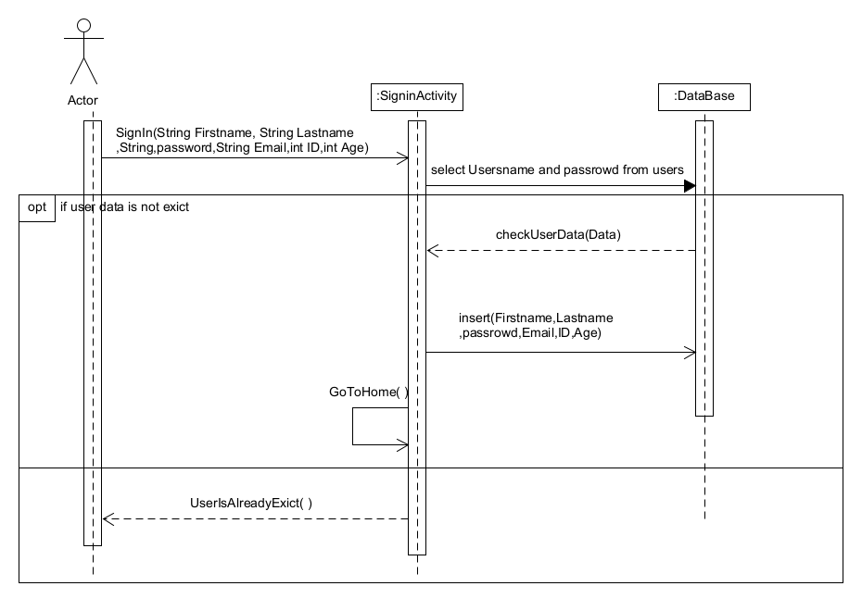

**3.3 View Home**

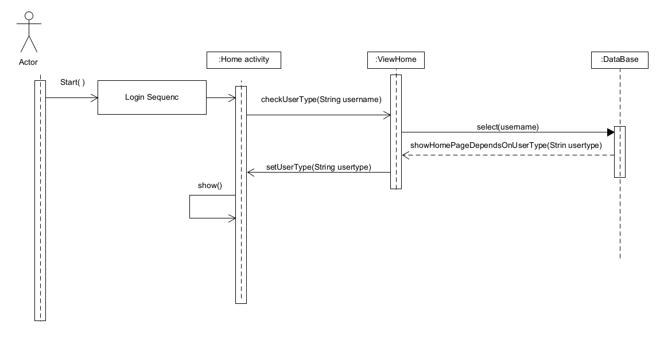

**3.4 Write Prescription**

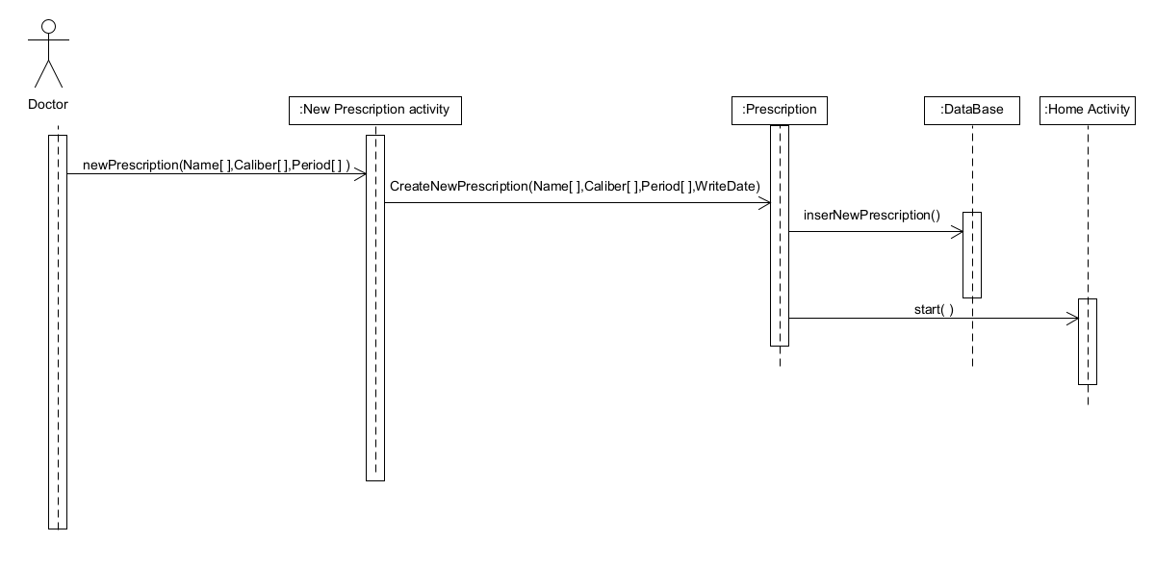

**3.5 Add Medicine**

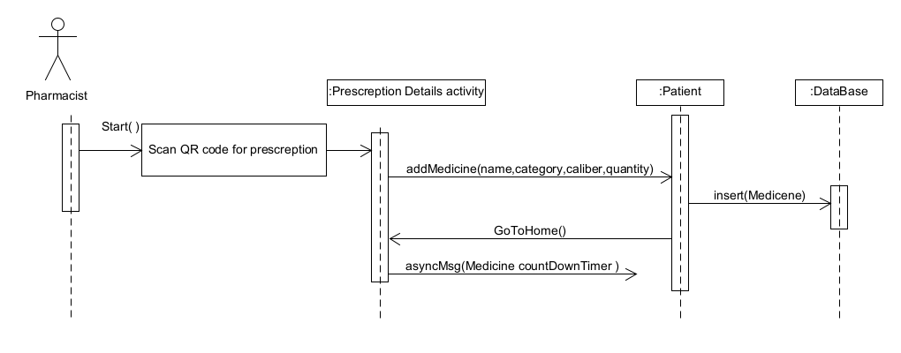

**3.6 Add Patient**

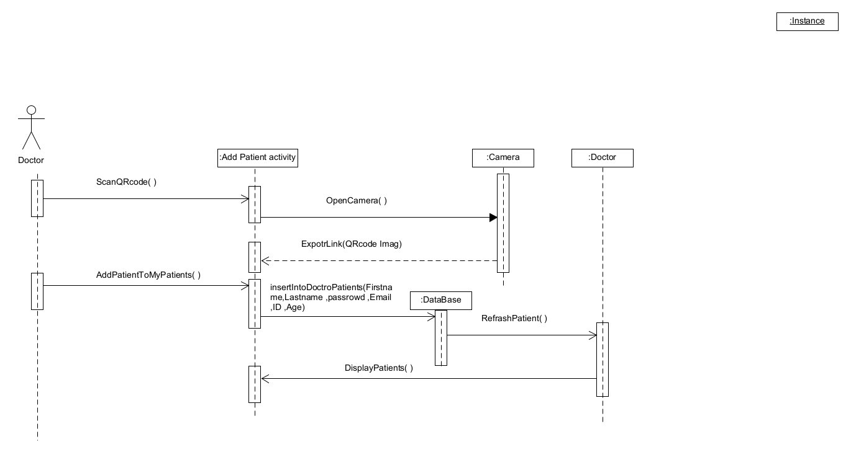

**3.7 Delete Medicine**

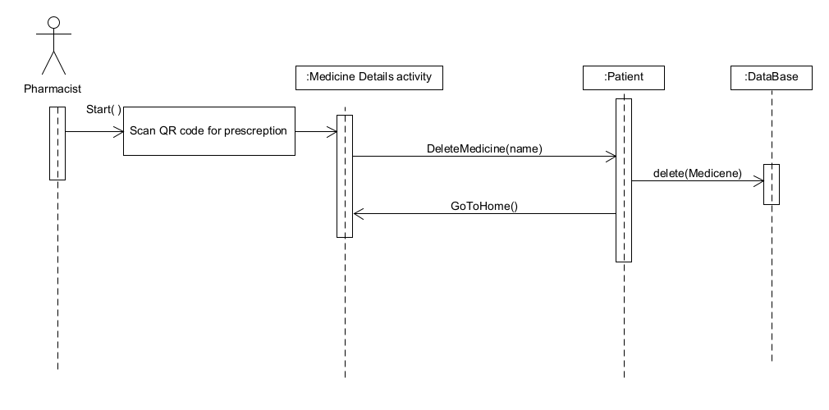

**3.8 Edit Medicine**

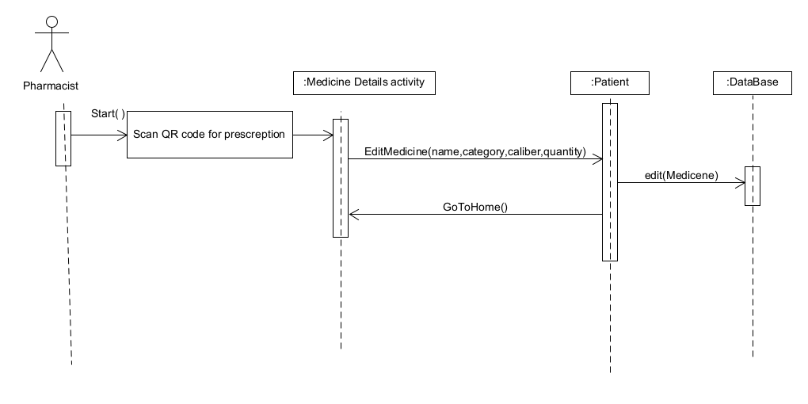

**3.9 End Medicine**

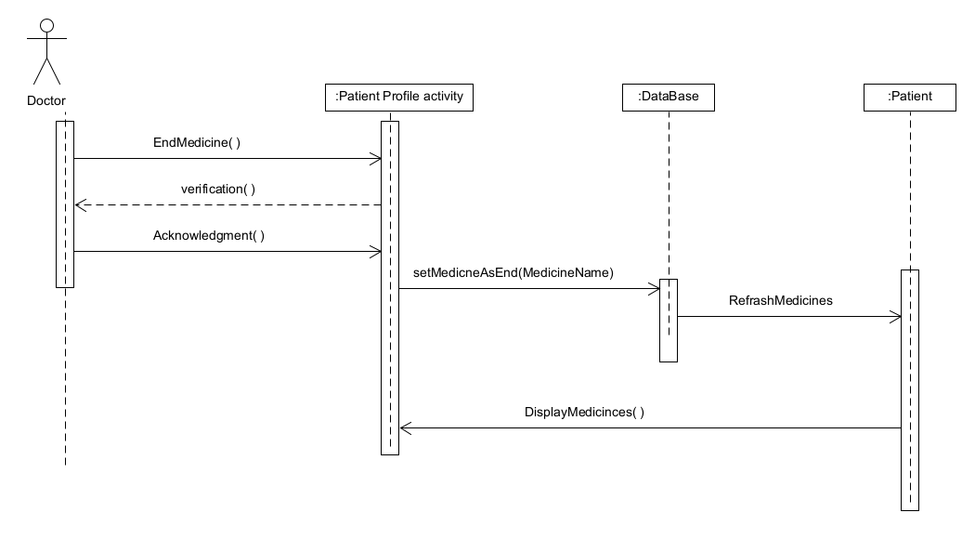

**3.10 Medicine Took**

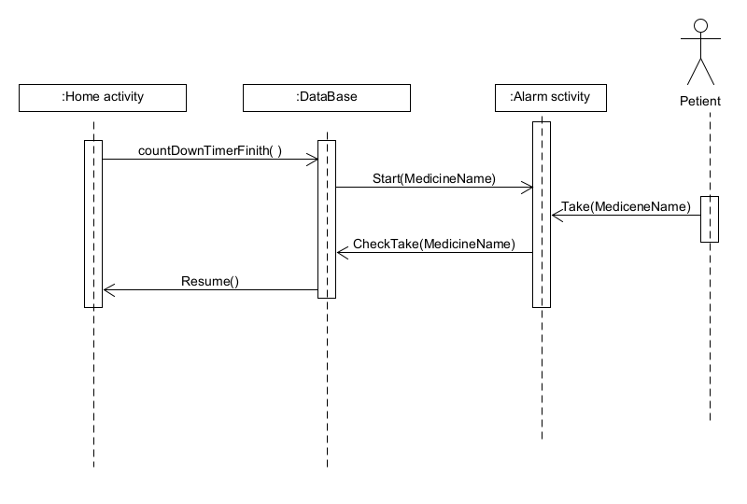

3.11 Patient Profile

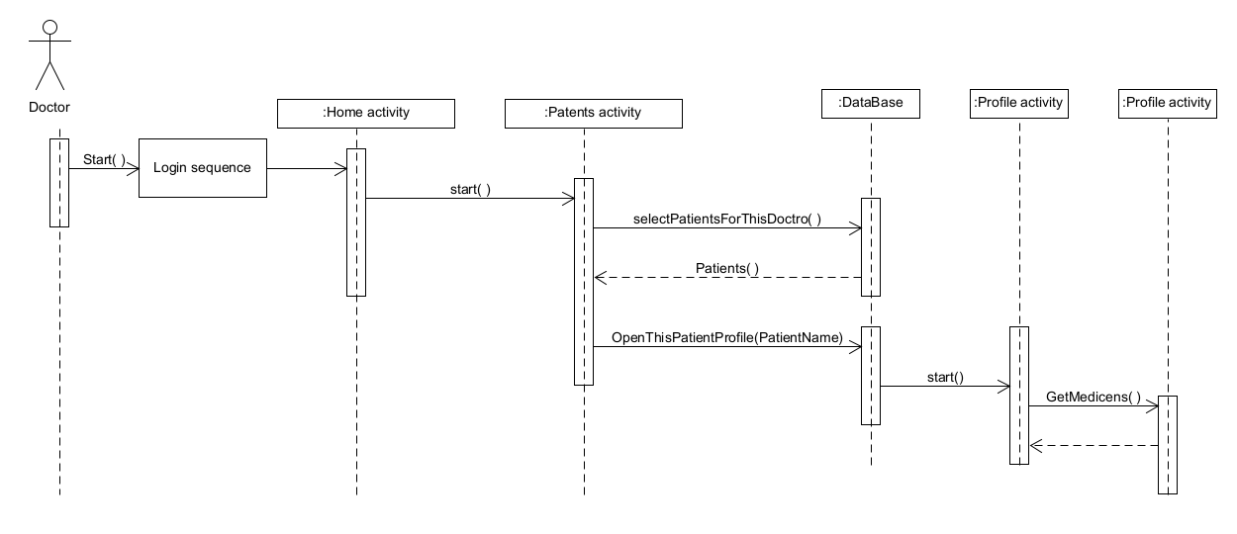

3.12 Scan QRcode

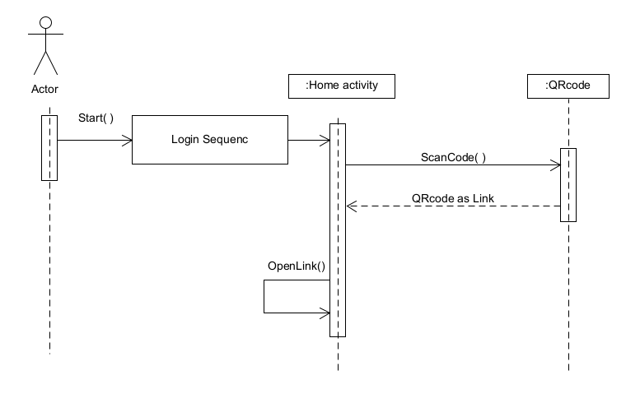

3.13 Share Prescription

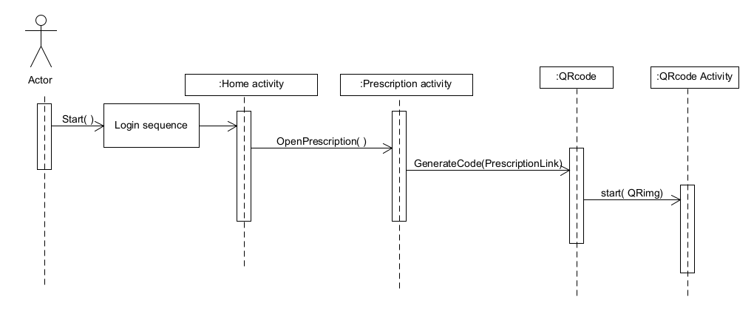

3.14 Share Profile

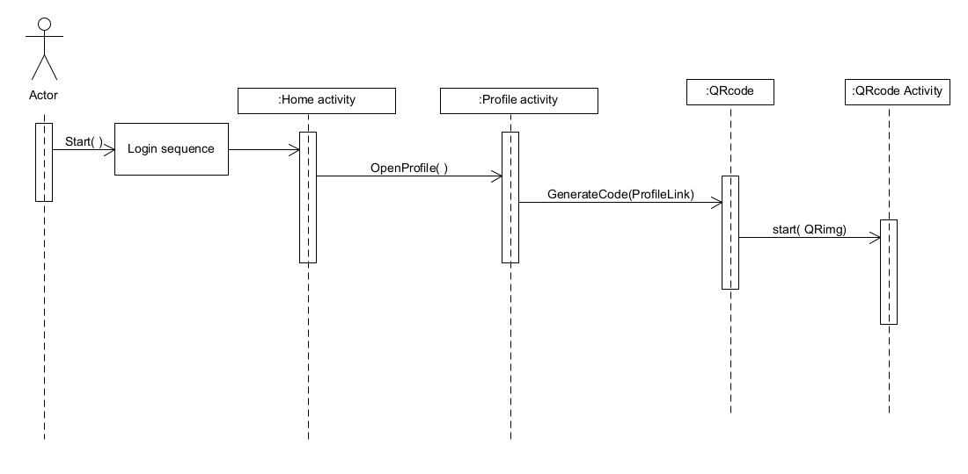

**Chapter 4:**

**Class diagram**

**4.**  **Class diagrams**

**4.1.** **Class diagram**

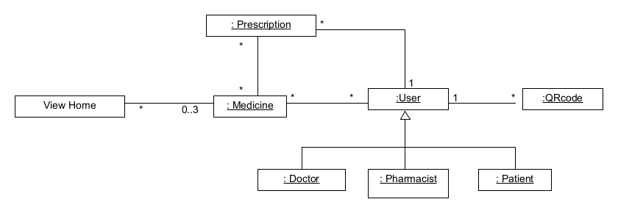

**4.2.** **Class entity**

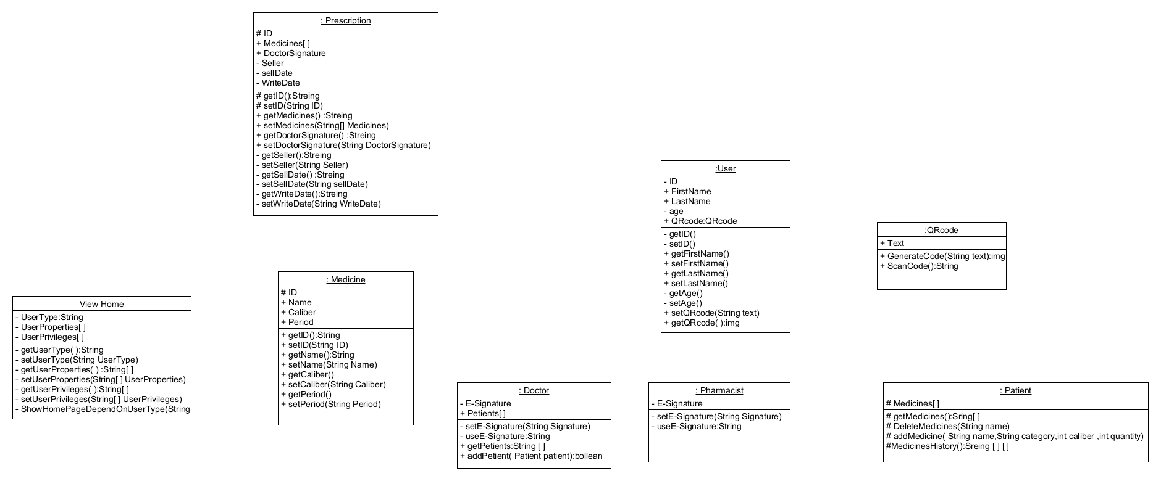

**4.3.** **Full class diagram**

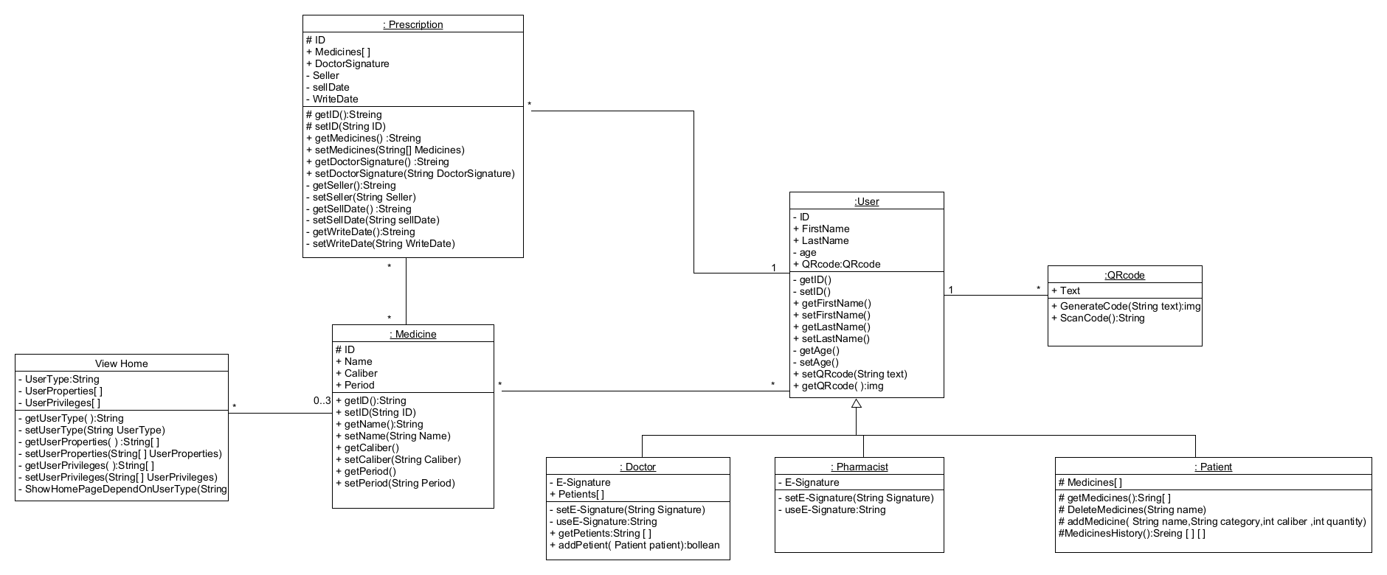

**4.4.** **Database schema**

**Users :**

**(ID:number ,FirstName:text ,LastName:text ,age:number)**

**Medicines:**

**(ID:number ,UserID:number ,name:varchar(20) ,** **Caliber:number ,Period:number)**

**Prescriptions:**

**(ID:number ,medicineID:number ,Username:text ,time:date ,spent:Boolean)**