 | School of Information Systems

Web Programming (Client Side)

Submission Exercise 1 – Project Approval
StudyWith · find your study group, pass together
Academic year 2026–2027
Before you submit – delete this box
- Fill in the blue [brackets]: student IDs, your teammates' details and the submission date.
- Section 1 (design thinking): talk to a few classmates and show them the wireframes, then update the Empathize and Test rows to match what you actually heard.
- Read the whole document together as a team and change anything that doesn't fit your plan.

Project details
Project name | StudyWith
In one sentence | A web app where college students find, join and create study groups for their courses, on campus or online.
GitHub repository | https://github.com/Abedab2/web-project
Submission date | [DD/MM/YYYY]

Team members
# | Full name | Student ID | Email | GitHub username
1 | Abed Abuata | [ID] | abedab2@mta.ac.il | Abedab2
2 | [Full name] | [ID] | [Email] | [Username]
3 | [Full name] | [ID] | [Email] | [Username]

1. Design Thinking Process
We followed the five stages of design thinking. The rest of this document – the system description, persona, scenarios, user flows and wireframes – is the outcome of this process.
Stage | What we did | Main insights
Empathize | We talked with [number] students from our year about how they prepare for exams, and looked at how study partners are found today in course WhatsApp and Facebook groups. | Partners are usually searched for only in the last days before an exam. Requests get lost in busy chats. Students who work need evening or online sessions. Many hesitate to join strangers without knowing the group's level and size.
Define | Problem statement: busy students need a simple way to find a study group for a specific course, at a time and in a format that suit them, because today this information is scattered across chats and gets lost. | The real need is not "more groups" but clear, filterable information: course, time, place, level and free spots.
Ideate | We considered a shared exam calendar per course, one-to-one study-partner matching, a board of private tutors, and a study-group board with filters. | We chose the study-group board: it solves the main pain directly, needs no accounts or payments, and maps naturally to five clear screens.
Prototype | Paper sketches of the main screens, then digital wireframes for desktop and mobile with realistic data (section 6). | The group card (course, time, format, level and free spots) is the core component; it is reused on four of the five screens.
Test | We walked [number] classmates through both scenarios using the wireframes. | [What they said and what we changed, e.g. we added 'spots left' to every card and a filter for groups with free spots]

2. System Description (§3.1)
Project topic
StudyWith – a study-group finder for college students.
Purpose of the system
StudyWith helps students prepare for exams together. Students browse study sessions for their courses, see exactly when, where and at what level each session takes place, join with one click, and open a new group when nothing suitable exists.
The problem it solves
Today, students look for study partners in crowded course WhatsApp groups and Facebook posts. Messages get lost, it is unclear who is studying what, when and where, and students who work or live far from campus find it hard to fit in. As a result, many students study alone even though they would prefer to study with others.
Target audience
Undergraduate students (mostly aged 20–30), especially first- and second-year students in demanding courses such as Data Structures, Databases and Web Programming. Many of them work part time and commute, so the time and format (on campus or online) of a session matter to them.
Main actions the system enables
- Search and filter study groups by course, topic, date, format (on campus / online) and level.
- View a group's details: agenda, time, place or meeting link, organizer and free spots.
- Join a group with one click, and leave it if plans change.
- Create a new study group using a detailed form.
- Track upcoming sessions on the My groups page.

3. Persona (§3.1)
Name | Maya Cohen
Age | 23
Occupation / situation | Second-year Information Systems student. Works 20 hours a week in customer support at a tech company and commutes from Rishon LeZion.
Comfort with technology | High. Uses apps for everything, but has little patience for cluttered interfaces.
In her own words | "I don't need another WhatsApp group with 300 people. I need three people who study Databases on Tuesday evening."

Relevant background
Maya did well in her first year, but studied mostly alone and struggled in Data Structures. This semester she has four exams within three weeks. She is a member of six course WhatsApp groups and misses most study-partner requests because they get buried under hundreds of messages. On Mondays, Wednesdays and Thursdays she works until 18:00, so she can only join sessions in the evening or online.
Needs
- Find people who study the same course, at times that fit her work schedule.
- Know in advance exactly when, where (or on which link) and at what level a session takes place.
- Small, focused groups with a clear agenda.
Goal
Join a focused study group for the Web Programming exam, and open her own group for Databases when she can't find one that fits.
Main challenge in using the system
Limited time and uncertainty. She can't scroll through chats to find groups, and she worries about showing up to a session that is too advanced, too crowded or already cancelled. She needs to understand a group in seconds and get immediate confirmation when she joins.

4. Use-Case Scenarios (§3.2)

4.1 Scenario 1: Maya finds and joins a study group for the Web Programming exam
Description
Maya's Web Programming exam is in two weeks and she wants to practise past exam questions with others. On the Home screen she chooses "Web Programming" in the quick search and clicks "Find groups". The Find Groups screen opens, already filtered by the course. Because she commutes, she adds the filters "Online" and "Exam practice" and compares the results by date and free spots. She opens "React hooks – past exam questions" (Tuesday, 10 November, 19:00). On the Group Details screen she reads the agenda, sees that 4 of 6 spots are taken, and clicks "Join group". The button changes to "You're in", the spots update to 5 of 6, and the counter next to "My groups" in the header goes up by one. She opens My Groups and sees the session with its date, time and Zoom link.
Screens involved
Home → Find Groups → Group Details → My Groups
Main branches
If no group matches her filters, an empty-state message offers to clear the filters or create a group (Scenario 2). If a group is full, its Join button is disabled.

4.2 Scenario 2: Maya creates a study group for the Databases exam
Description
Maya wants to practise normalization and ER diagrams for the Databases exam. From the Home screen she goes to Find Groups and filters by "Databases", but the only group is on Thursday at 17:30, before she finishes work, and it covers a different topic. She clicks "Create a group" and fills in the Create Group form: course, topic, date, start time 18:30, a two-hour duration, up to 5 participants, "On campus" in "Library, group room 3", the "Exam practice" level, a short agenda, and her name and email. When she clicks "Create group", two fields are marked in red: the date she typed has already passed, and she used her private Gmail address instead of her college email. She fixes both and submits again. A success message confirms that the group was saved, and the new group appears in My Groups under "Created by me", where she copies its link to share in the course WhatsApp group.
Screens involved
Home → Find Groups → Create Group → My Groups
Main branches
Invalid fields show error messages and the form is not sent. If saving through the course API fails, an error message appears and the form keeps all the data so she can try again.

4.3 Screen coverage
Together, the two scenarios cover all five screens.
Screen | Scenario 1 | Scenario 2
1. Home | ✓ | ✓
2. Find Groups | ✓ | ✓
3. Group Details | ✓ | –
4. Create Group (form) | – | ✓
5. My Groups | ✓ | ✓

5. User Flow (§3.2)
The diagrams show the screens (blue), the user's actions (arrows), the decision points (diamonds) and the system's feedback (gray), including the main branches: no search results, a full group, validation errors and a failed save.

5.1 User flow – Scenario 1
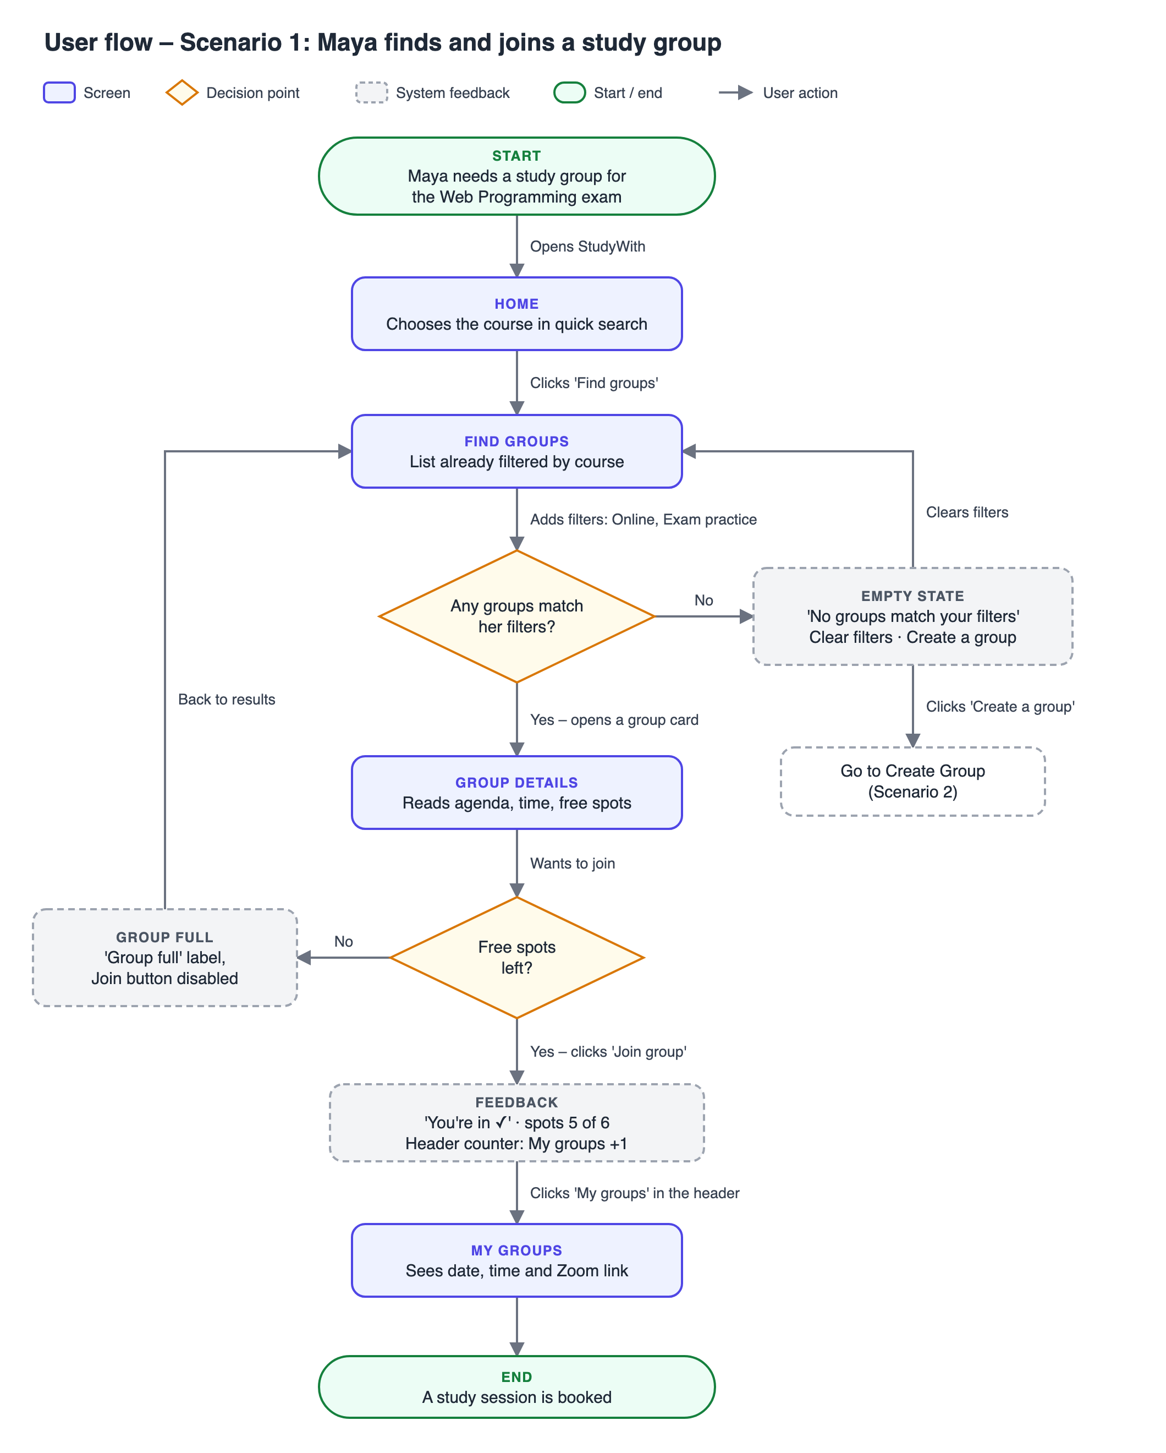

5.2 User flow – Scenario 2
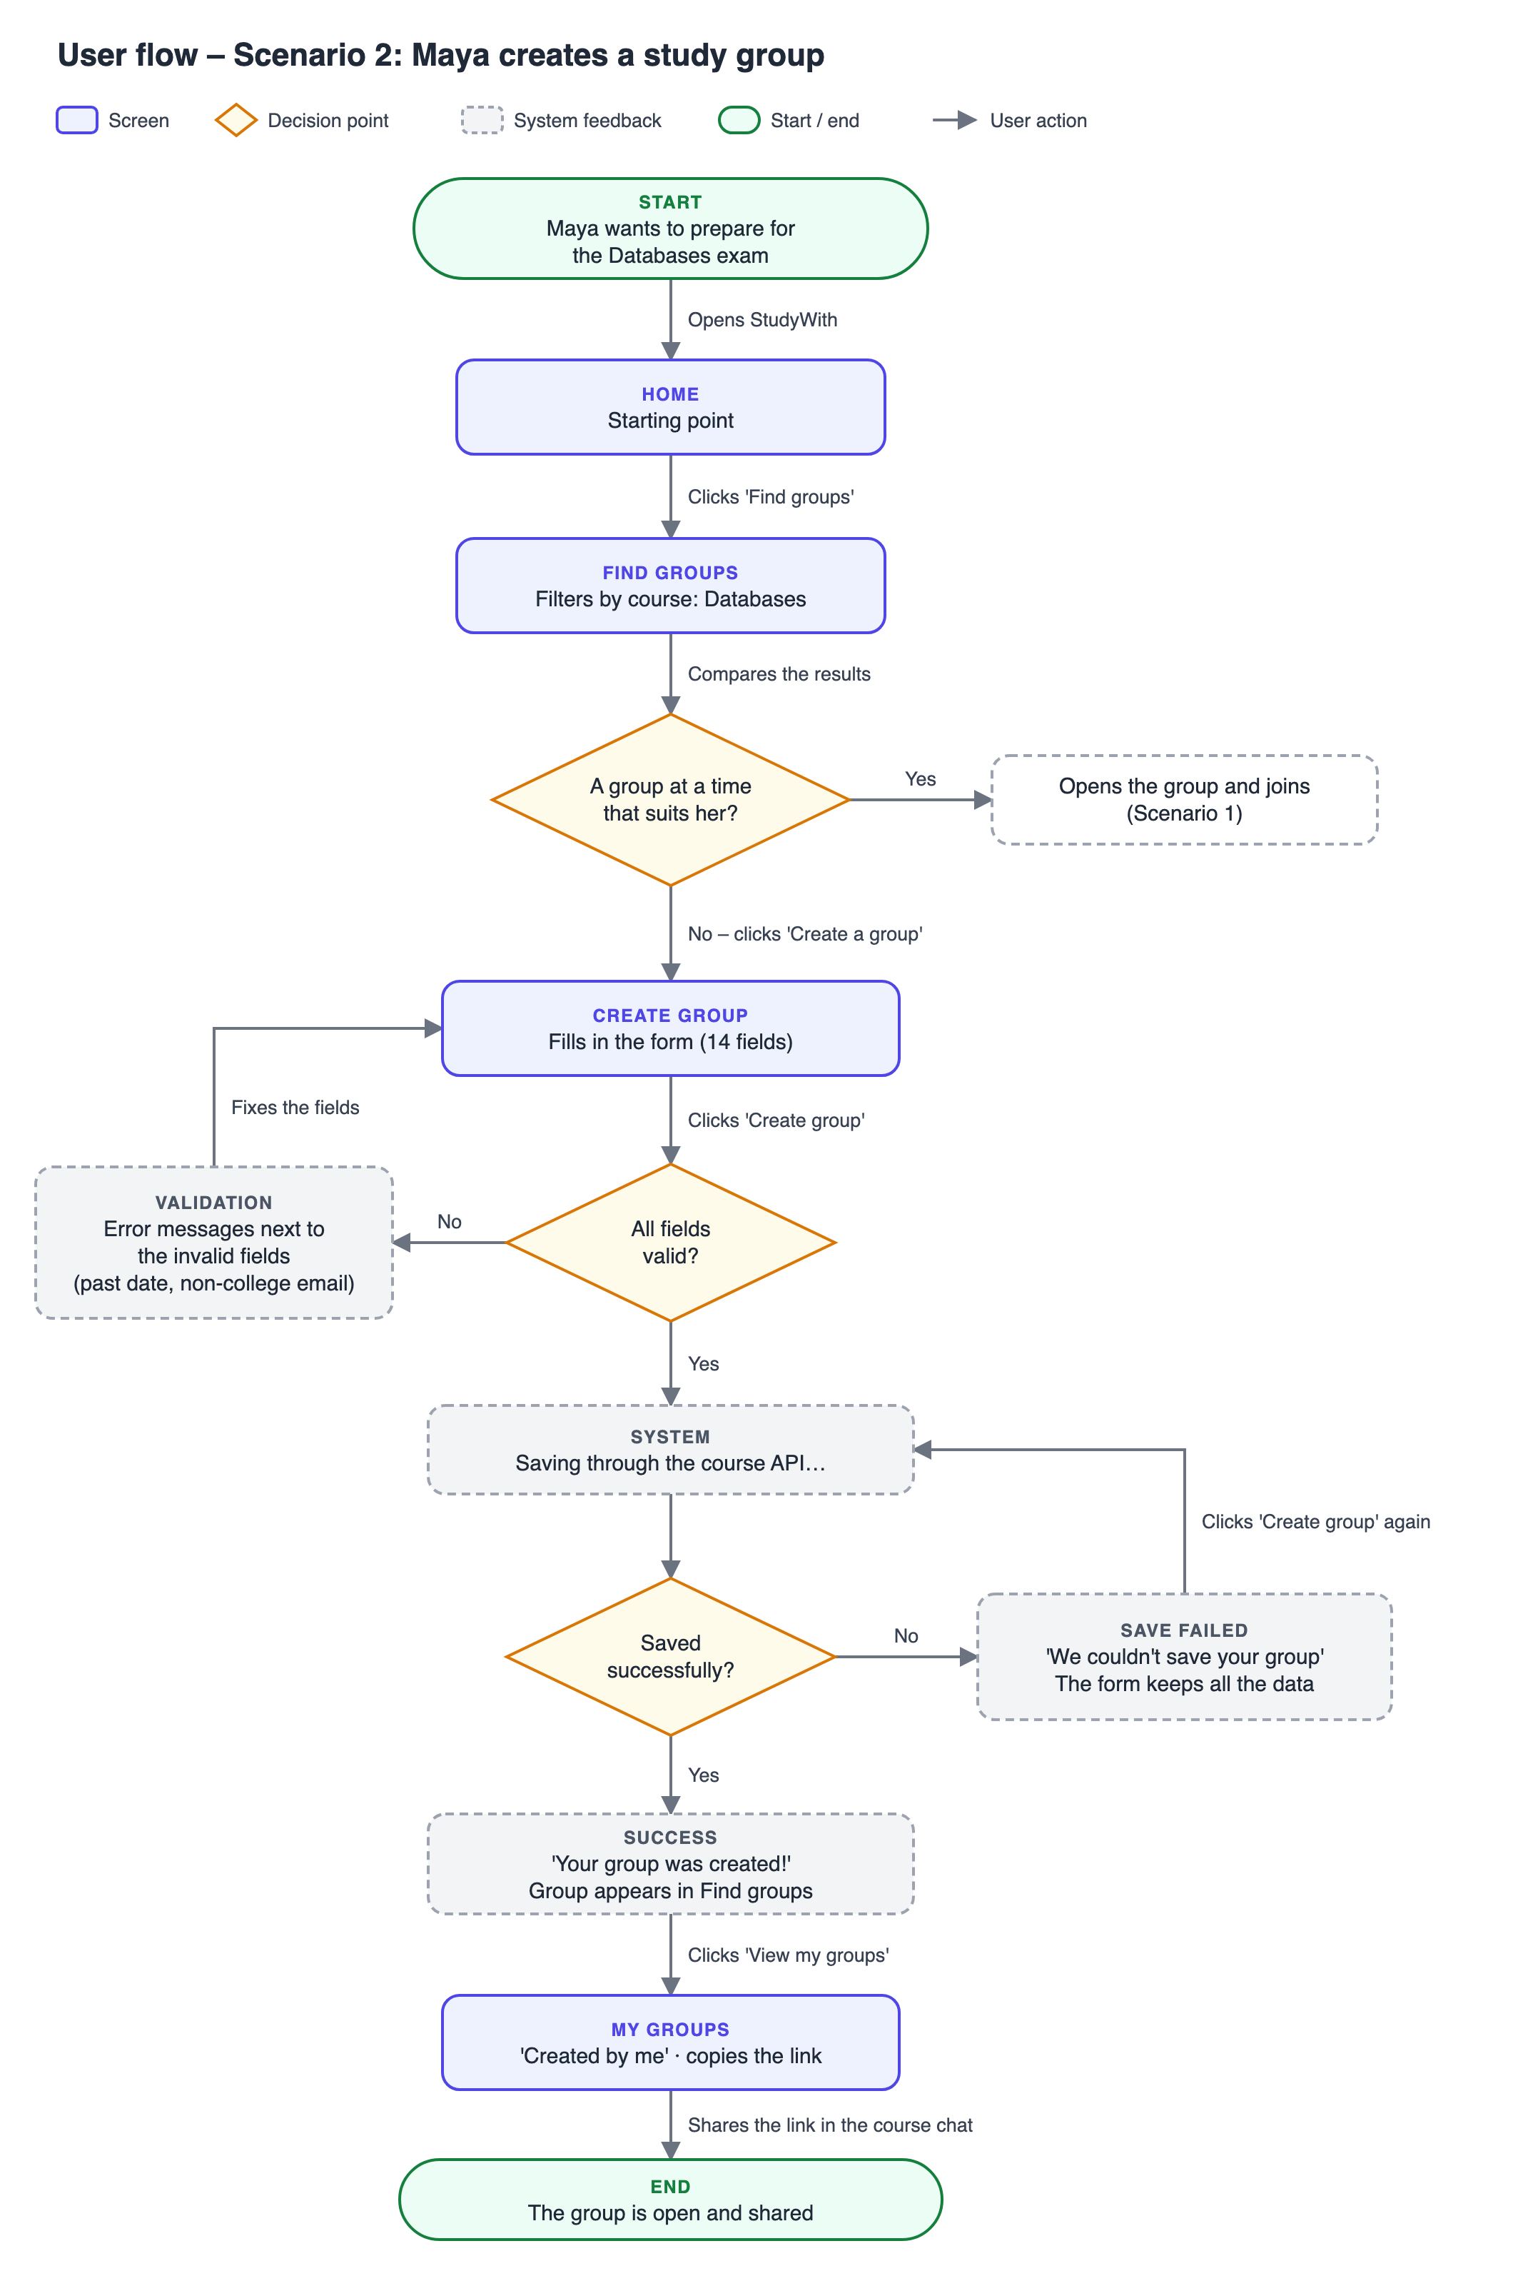

6. Screen Planning – Wireframes (§3.3)
The wireframes show the five screens with realistic, invented data. All screens share the same header, navigation, group card, buttons and messages. Each screen is designed for desktop and adapts to phones (section 6.8).

6.1 Screens overview
# | Screen | Purpose | Scenarios
1 | Home | Entry point: quick search by course, this week's groups, how it works, and a call to create a group. | 1, 2
2 | Find Groups | Browse all groups with filters (course, topic, date, format, level, free spots) and sorting. | 1, 2
3 | Group Details | Full information about one session, and the Join / Leave action. | 1
4 | Create Group | The main form (14 fields) for opening a new study group. | 2
5 | My Groups | Upcoming sessions the user joined and groups they created. | 1, 2

6.2 Design language
Shared design rules, so all five screens look and behave like one system.
Element | Our decision
Header & navigation | Logo on the left; Home, Find groups, Create group and My groups on the right. The active page is underlined. A counter next to My groups shows how many groups the user joined. On phones the links move into a Menu button and the counter stays visible.
Colors | Indigo (#4F46E5) for main actions and the active page; dark gray text on a light gray background; green for success, red for errors and full groups, amber for "almost full".
Typography | One sans-serif font (system font). Headings 32 / 22 / 17 px, body text 15 px, small text 13 px.
Buttons | Primary: filled indigo. Secondary: indigo outline. Disabled: gray. Destructive (Leave group): red outline.
Reusable components | Group card, filter panel, form field with label and error message, success / error message, tabs, date block, header and footer.
Mobile layout | One column; filters open from a Filters button; cards and form fields stack; main buttons span the full width.

6.3 Screen 1 – Home
Purpose
The entry point. Explains what StudyWith is within seconds and gets the student to relevant groups quickly.
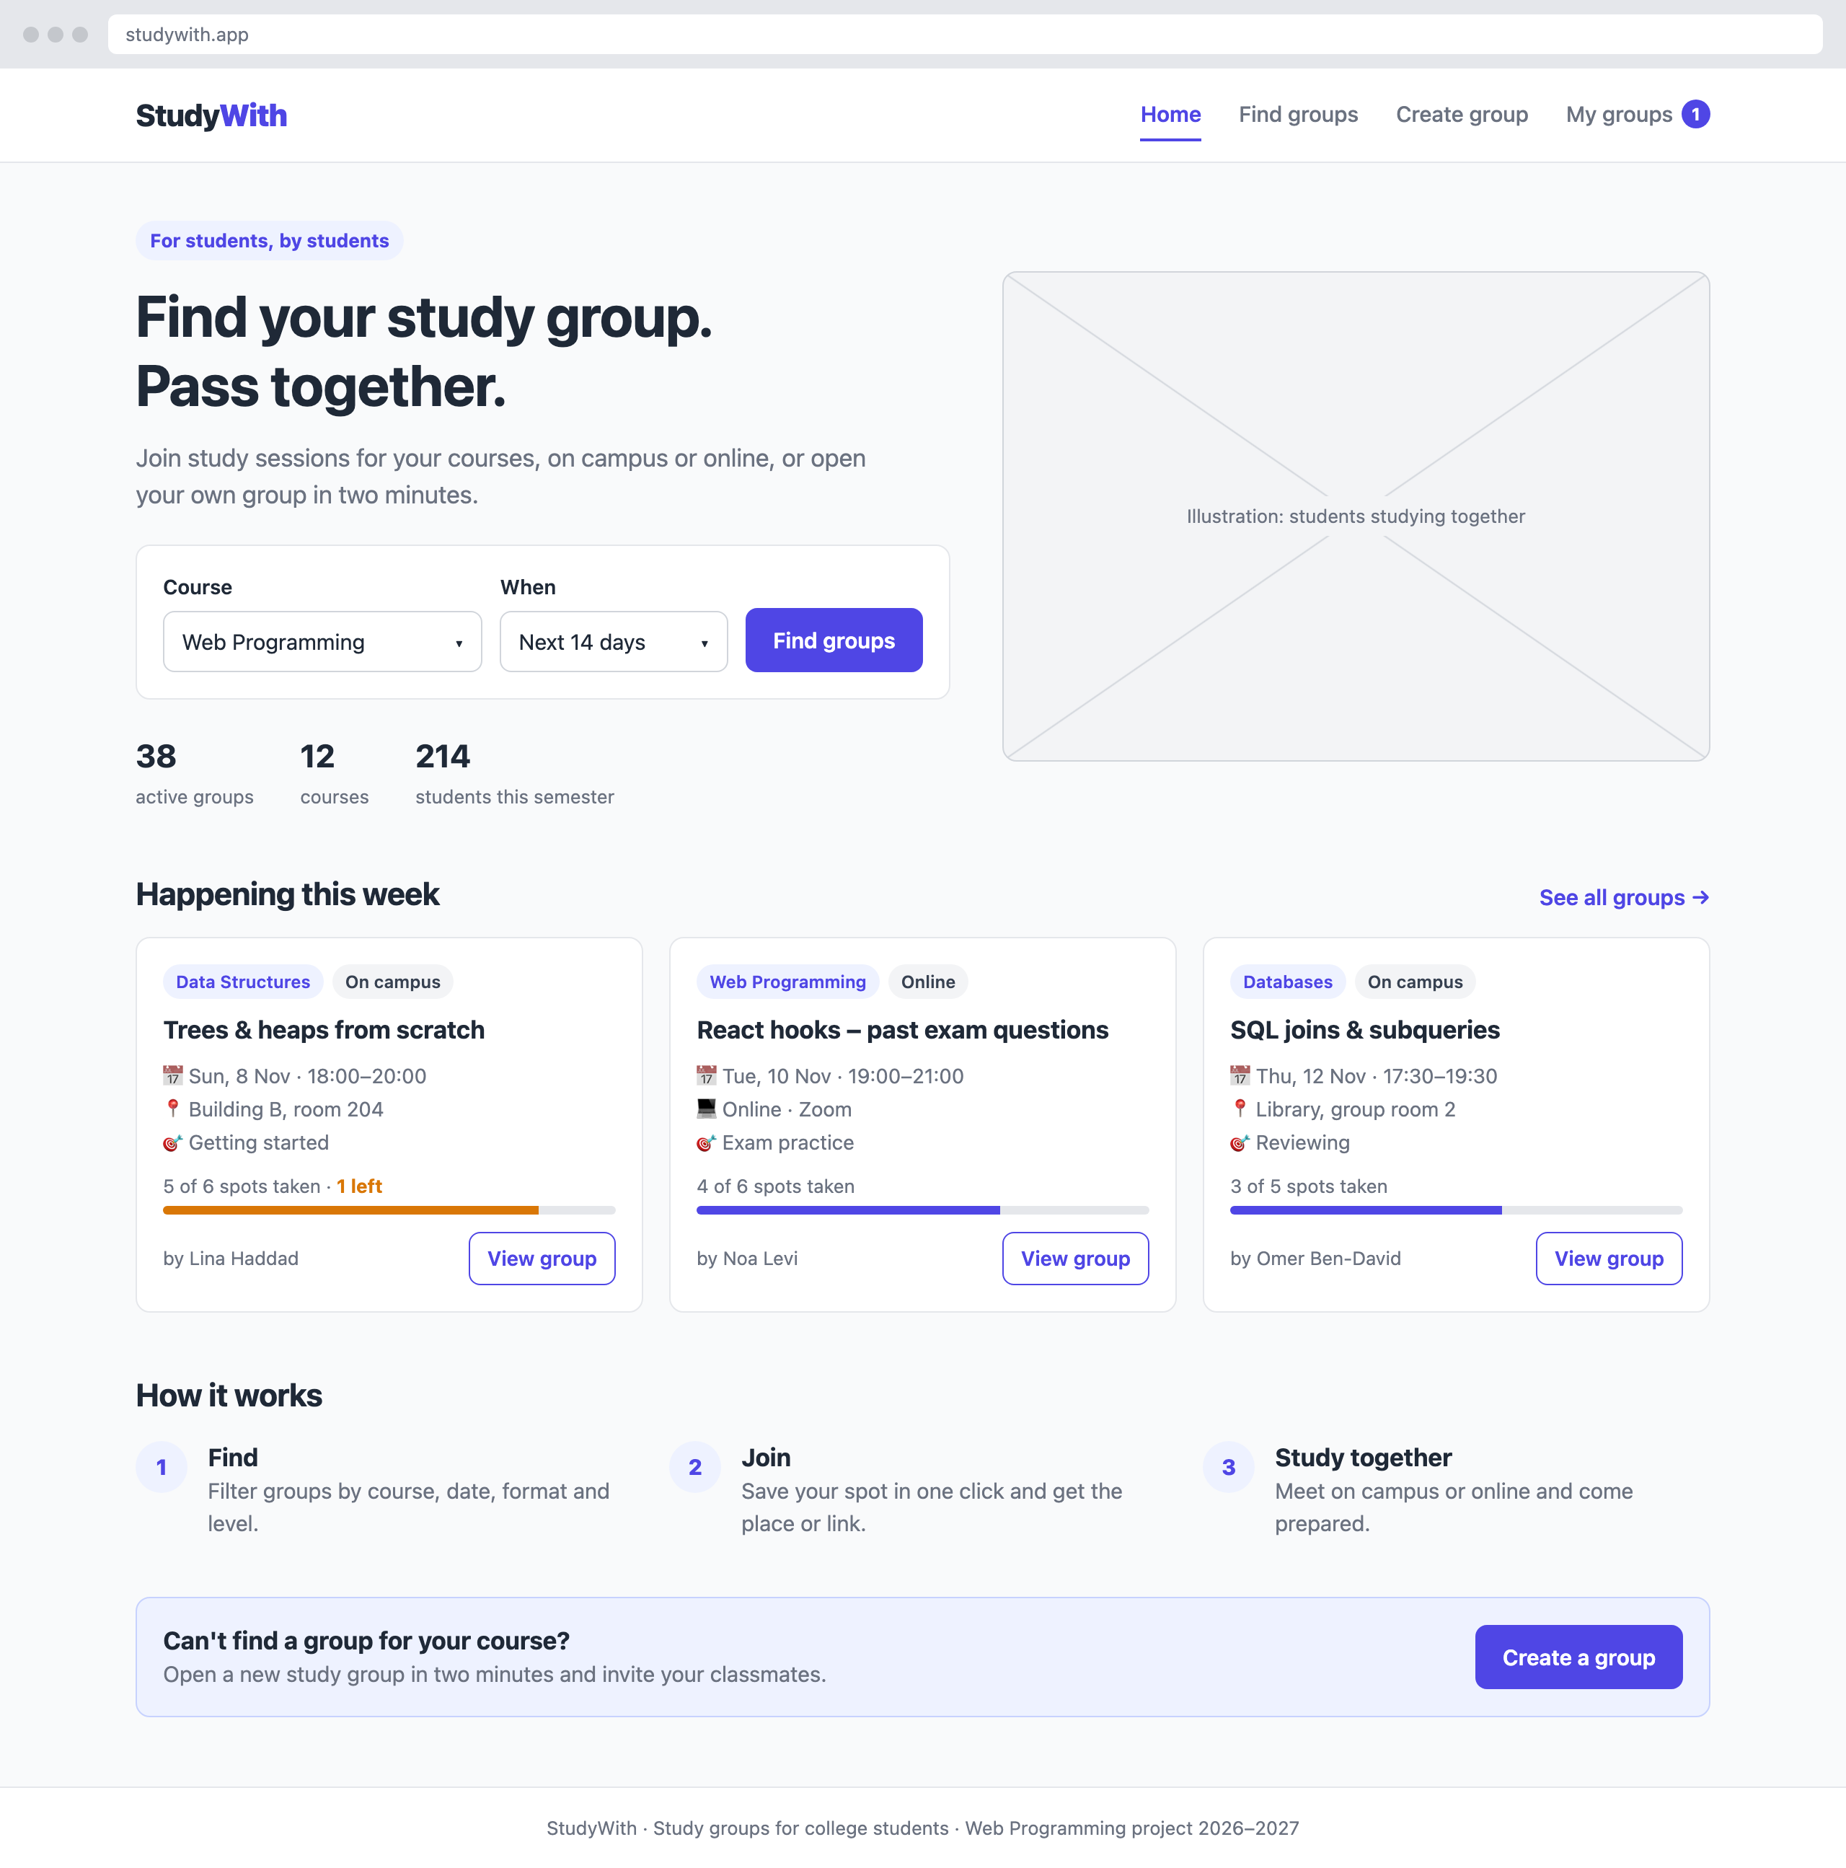
Wireframe – Home (desktop)
Main components
- Header with logo, navigation and the My groups counter.
- Hero with a headline and a quick search (course + time range).
- Stats strip: active groups, courses and students.
- "Happening this week": three group cards.
- "How it works": three steps (Find, Join, Study together).
- Call to action to create a group, and a footer.
Interactions and states
- The quick search opens Find Groups with the chosen course and time range already applied.
- Clicking a group card opens its Group Details screen.
- The My groups counter in the header always shows how many groups the user joined.
Navigation
Arrives from: any screen, through the logo or the Home link.
Leads to: Find Groups (quick search, "See all groups"), Group Details (group card), Create Group (call to action), My Groups (header).
Part of scenario(s)
Scenarios 1 and 2

6.4 Screen 2 – Find Groups
Purpose
Lets the student find the right group quickly by narrowing the list by course, time, format and level.
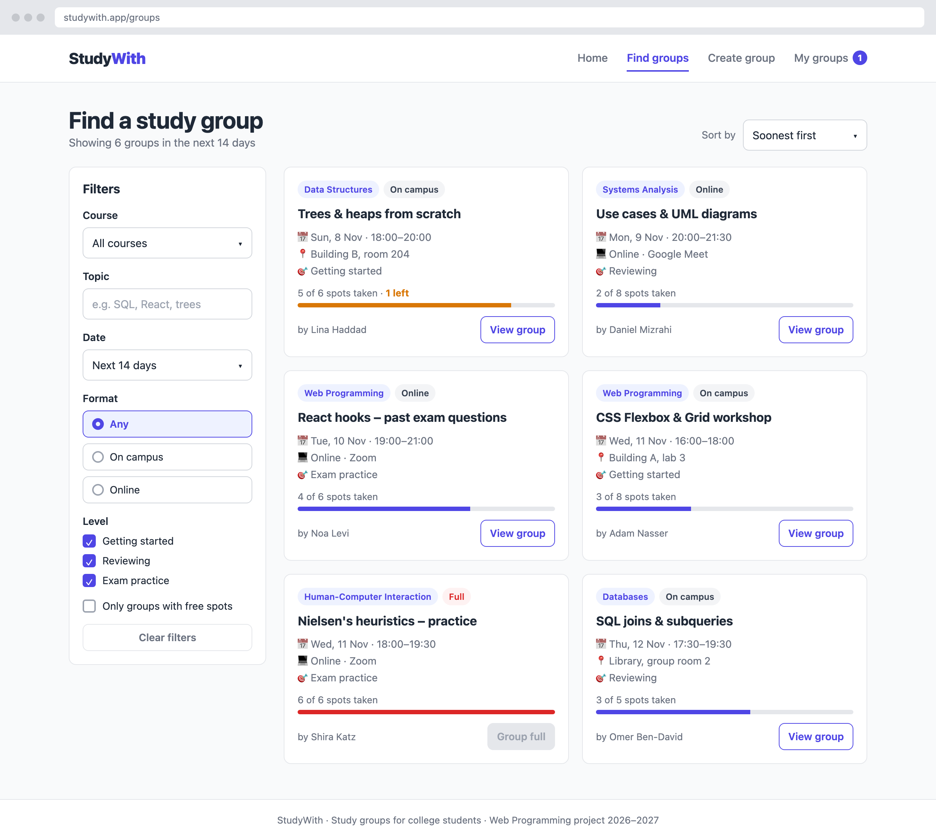
Wireframe – Find Groups (desktop)
Main components
- Filter panel: course, topic search, date range, format, level, "Only groups with free spots" and Clear filters.
- Results count and a sort menu.
- Grid of group cards: course, format, date and time, place, level, spots bar and organizer.
- Card states: available, almost full (amber) and full (disabled button).
Interactions and states
- The list updates immediately when a filter changes; it is built from an array of groups.
- If no group matches, an empty-state message appears with "Clear filters" and "Create a group".
- On phones, the filters open from a Filters button.
Navigation
Arrives from: Home (quick search, "See all groups") or the header.
Leads to: Group Details (View group) and Create Group (empty state or header).
Part of scenario(s)
Scenarios 1 and 2

6.5 Screen 3 – Group Details
Purpose
Gives all the information needed to decide whether to join, and lets the student join with one click.
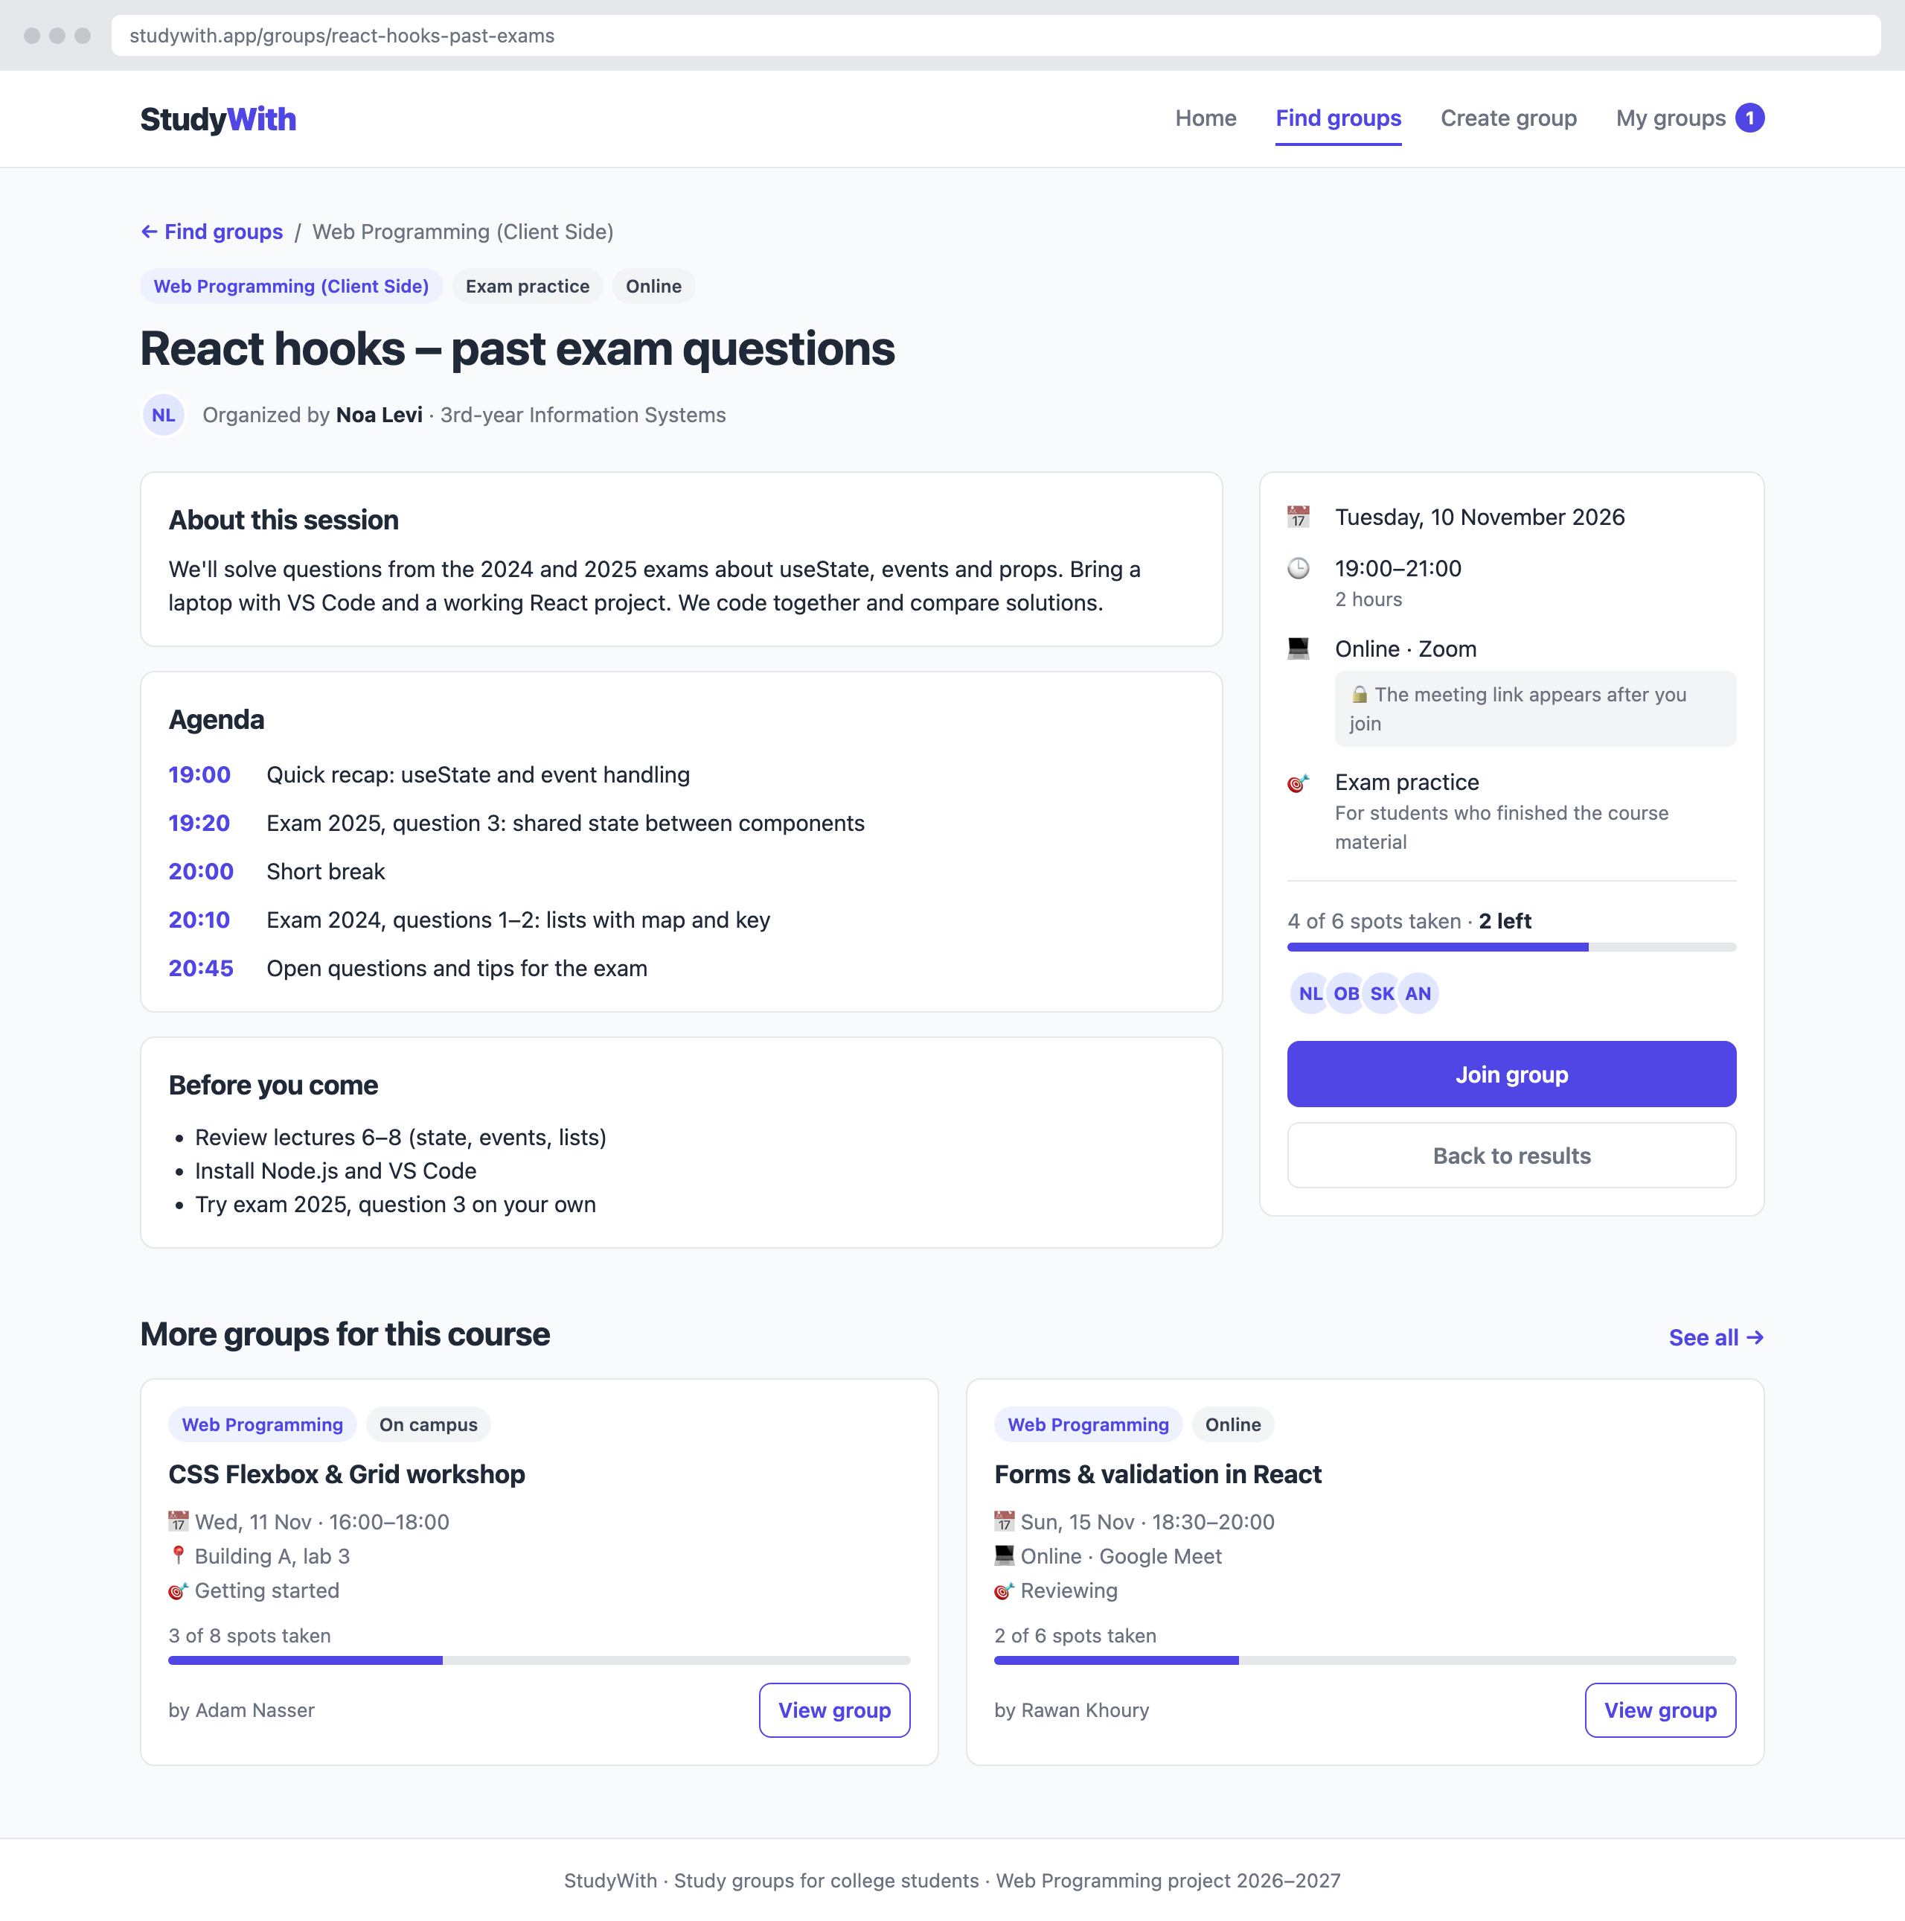
Wireframe – Group Details (desktop)
Main components
- Breadcrumb back to the results.
- Title with course, level and format chips, and the organizer.
- "About this session", "Agenda" and "Before you come".
- Side card: date, time, place or link, level, spots bar, participants and the Join group button.
- "More groups for this course": two group cards.
Interactions and states
- Clicking "Join group" changes the button to "You're in" with a Leave option, updates the free spots and the header counter.
- The meeting link is shown only after the user joins.
- If the group is full, the button is disabled and shows "Group full".
Navigation
Arrives from: Find Groups, Home or My Groups (group card or View group).
Leads to: My Groups (after joining or through the header), Find Groups (breadcrumb) and other groups' details.
Part of scenario(s)
Scenario 1

6.6 Screen 4 – Create Group
Purpose
The main form of the system: lets a student open a new study group that other students can find and join.
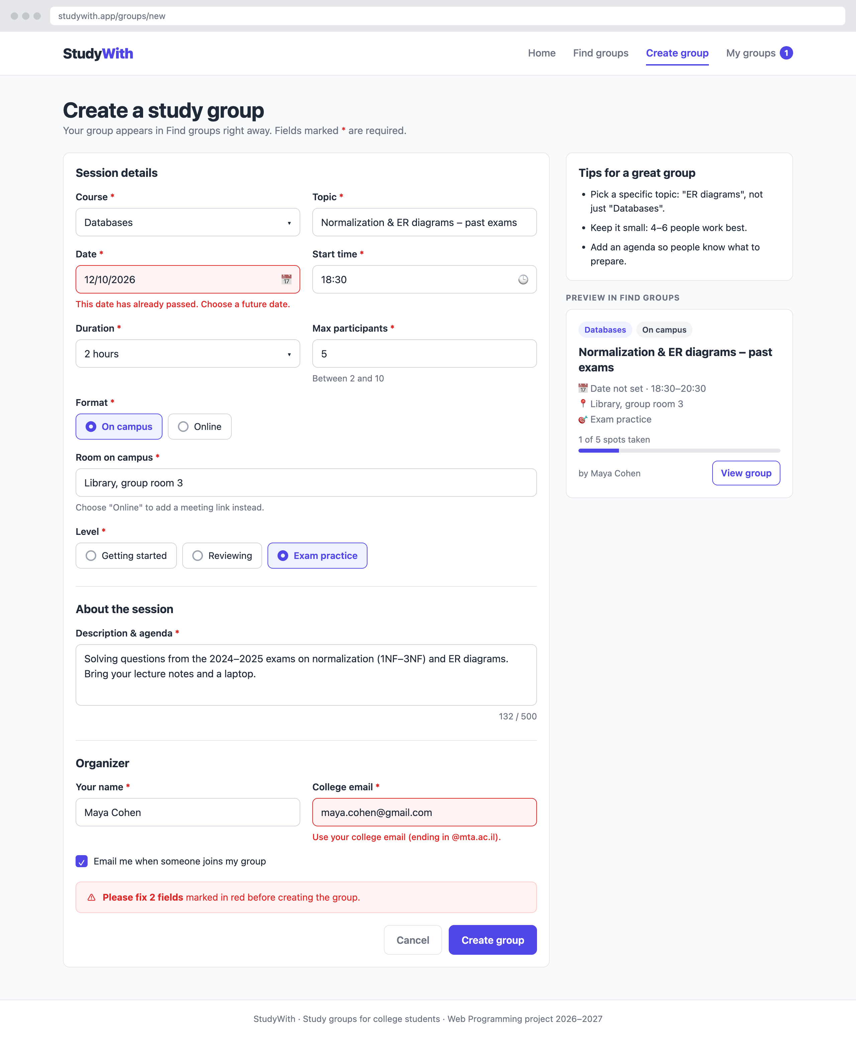
Wireframe – Create Group (desktop)
Main components
- Form in three sections: session details, about the session, and organizer.
- Error messages under invalid fields, plus a summary message above the buttons.
- Tips card and a live preview of the group card.
- Cancel and Create group buttons.
Interactions and states
- The Room field appears for "On campus"; the Meeting link field appears for "Online".
- Fields are checked when the user leaves them and again on submit.
- The data is saved through the course API, with a clear success or failure message.
Navigation
Arrives from: the header, the Home call to action, or the Find Groups empty state.
Leads to: My Groups (after a successful save) and Find Groups (Cancel).
Part of scenario(s)
Scenario 2

Planned form fields
14 fields of 9 different input types. Room and Meeting link replace each other, depending on the format, so 13 fields are visible at a time.
# | Field | Input type | Required | Validation
1 | Course | Select | Yes | One of the listed courses
2 | Topic | Text | Yes | 5–60 characters
3 | Date | Date | Yes | Today or later, up to 60 days ahead
4 | Start time | Time | Yes | Between 08:00 and 21:00
5 | Duration | Select | Yes | 1, 1.5, 2 or 3 hours
6 | Max participants | Number | Yes | Whole number between 2 and 10
7 | Format | Radio | Yes | On campus or Online
8 | Room on campus | Text | If on campus | 3–40 characters, e.g. "Building B, room 204"
9 | Meeting link | URL | If online | Valid link starting with https://
10 | Level | Radio | Yes | Getting started, Reviewing or Exam practice
11 | Description & agenda | Textarea | Yes | 20–500 characters, with a live counter
12 | Your name | Text | Yes | 2–40 letters and spaces
13 | College email | Email | Yes | Valid email ending in @mta.ac.il
14 | Email me when someone joins | Checkbox | No | –

Feedback after submitting
On success: a green message, "Your group was created!", and a move to My Groups → Created by me.
On failure: a red message, "We couldn't save your group. Check your connection and try again." The form keeps everything the user typed.

6.7 Screen 5 – My Groups
Purpose
A personal overview of the sessions the student joined and the groups they created, so they never miss a session.
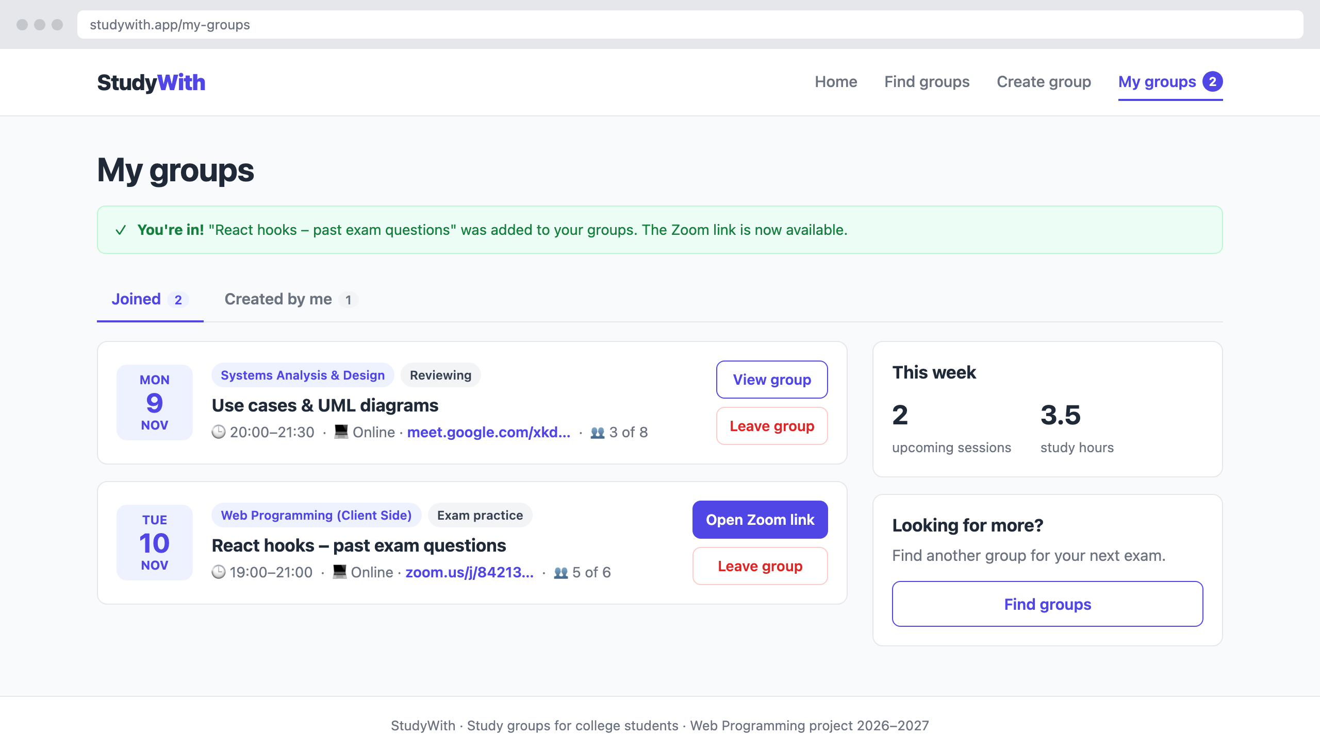
Wireframe – My Groups (desktop)
Main components
- Success message after joining or creating a group.
- Tabs: "Joined" and "Created by me", with counts.
- Session rows: date block, title, course, time, place or link, and actions (Open Zoom link, View group, Leave group).
- "This week" summary card and a shortcut to Find Groups.
Interactions and states
- Leaving a group removes it from the list and updates the header counter.
- If the user hasn't joined any group yet, an empty state shows a "Find groups" button.
- Switching tabs changes the list without leaving the page.
Navigation
Arrives from: the header (any screen), Group Details after joining, or Create Group after saving.
Leads to: Group Details and Find Groups.
Part of scenario(s)
Scenarios 1 and 2

6.8 Mobile views
Every screen is planned for phones as well. These are the first screenful of each screen at a 390 px phone width.
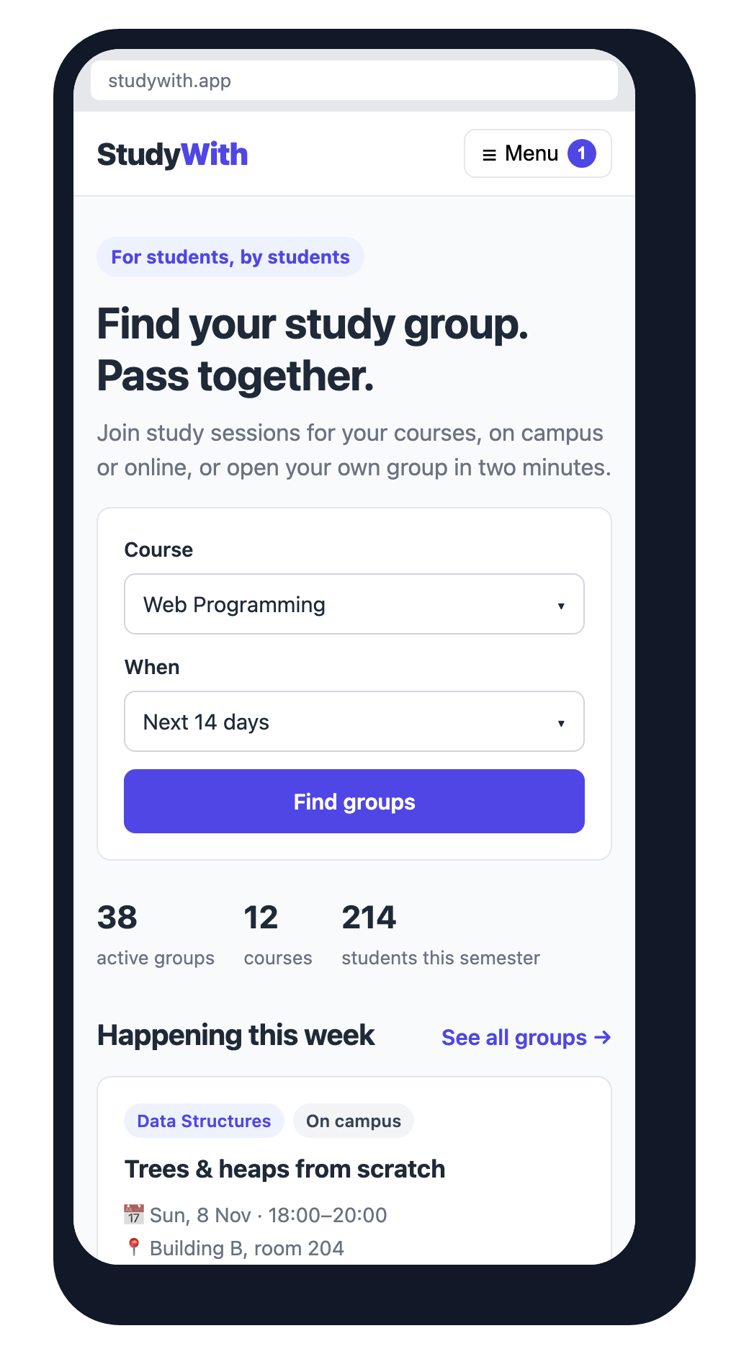  Home | 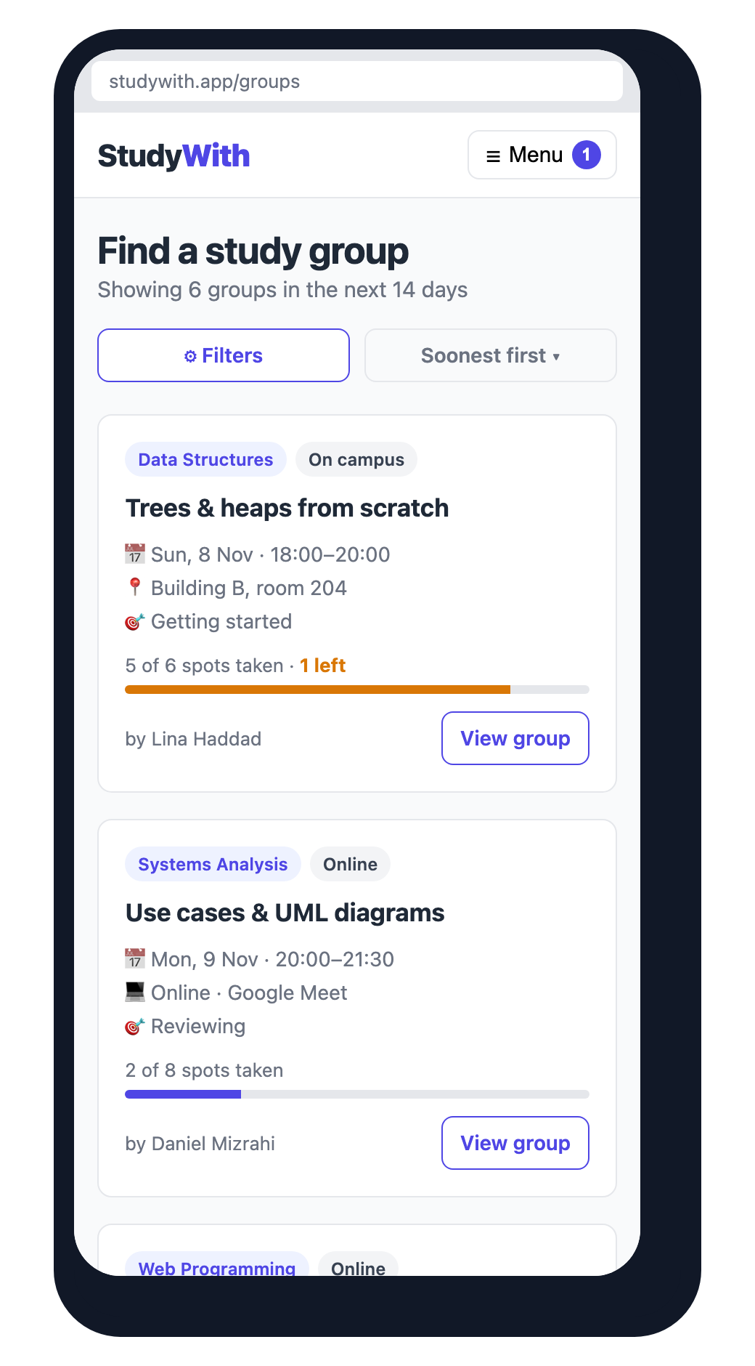  Find Groups | 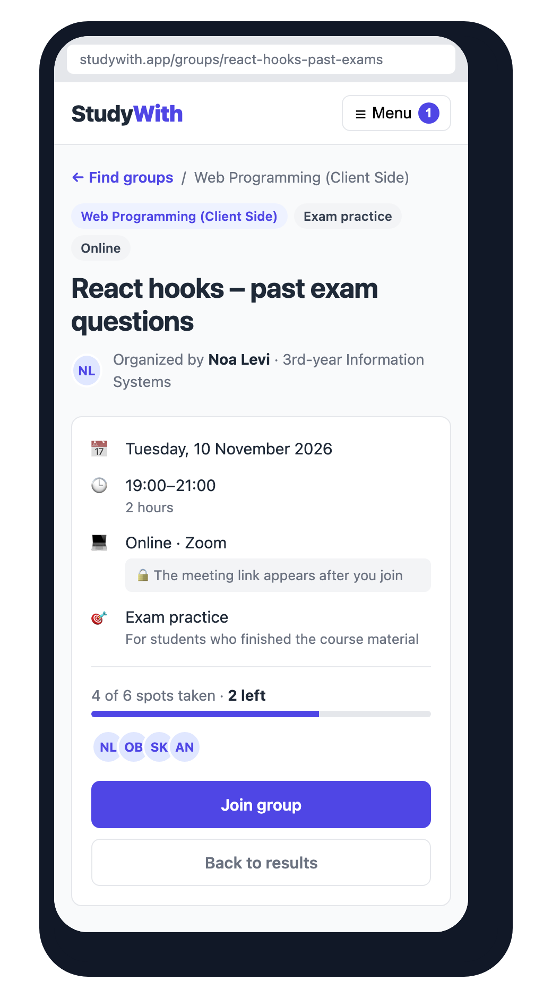  Group Details
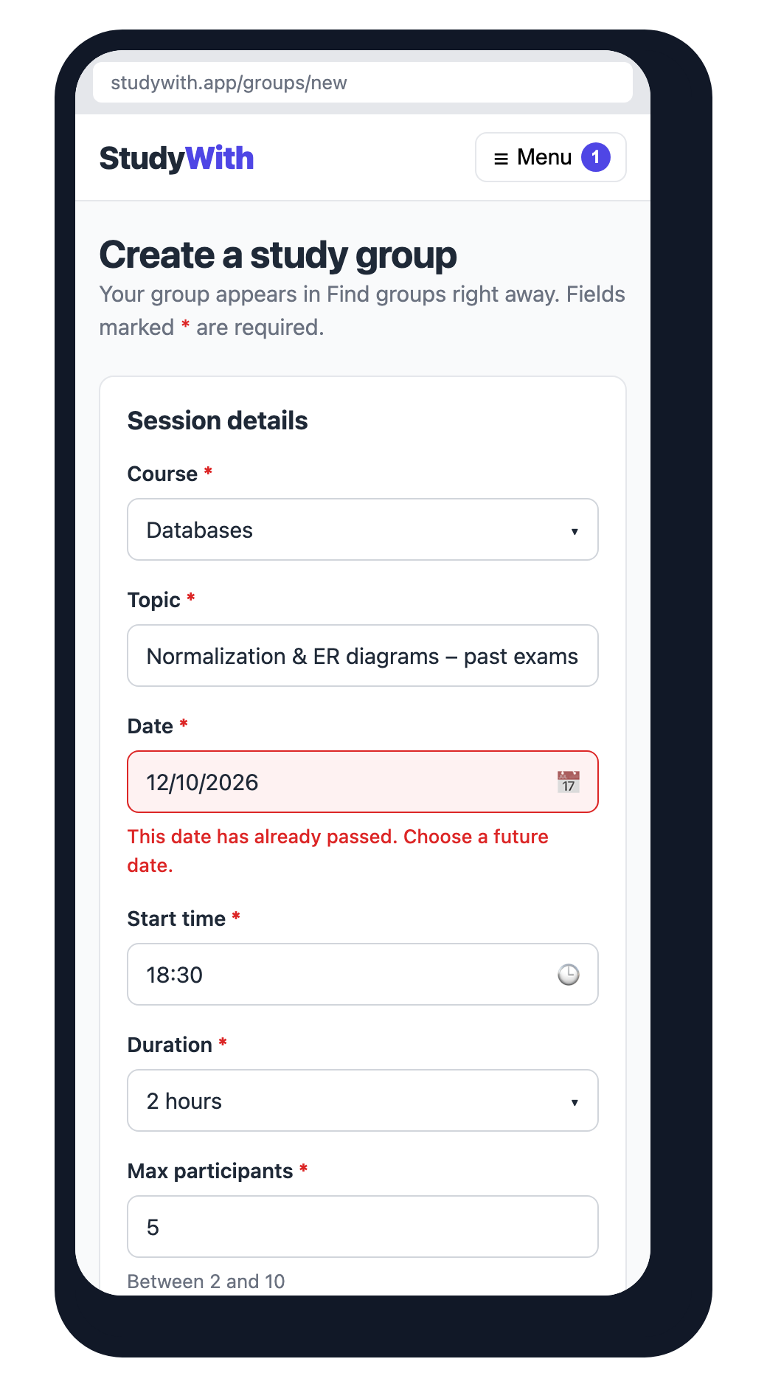  Create Group | 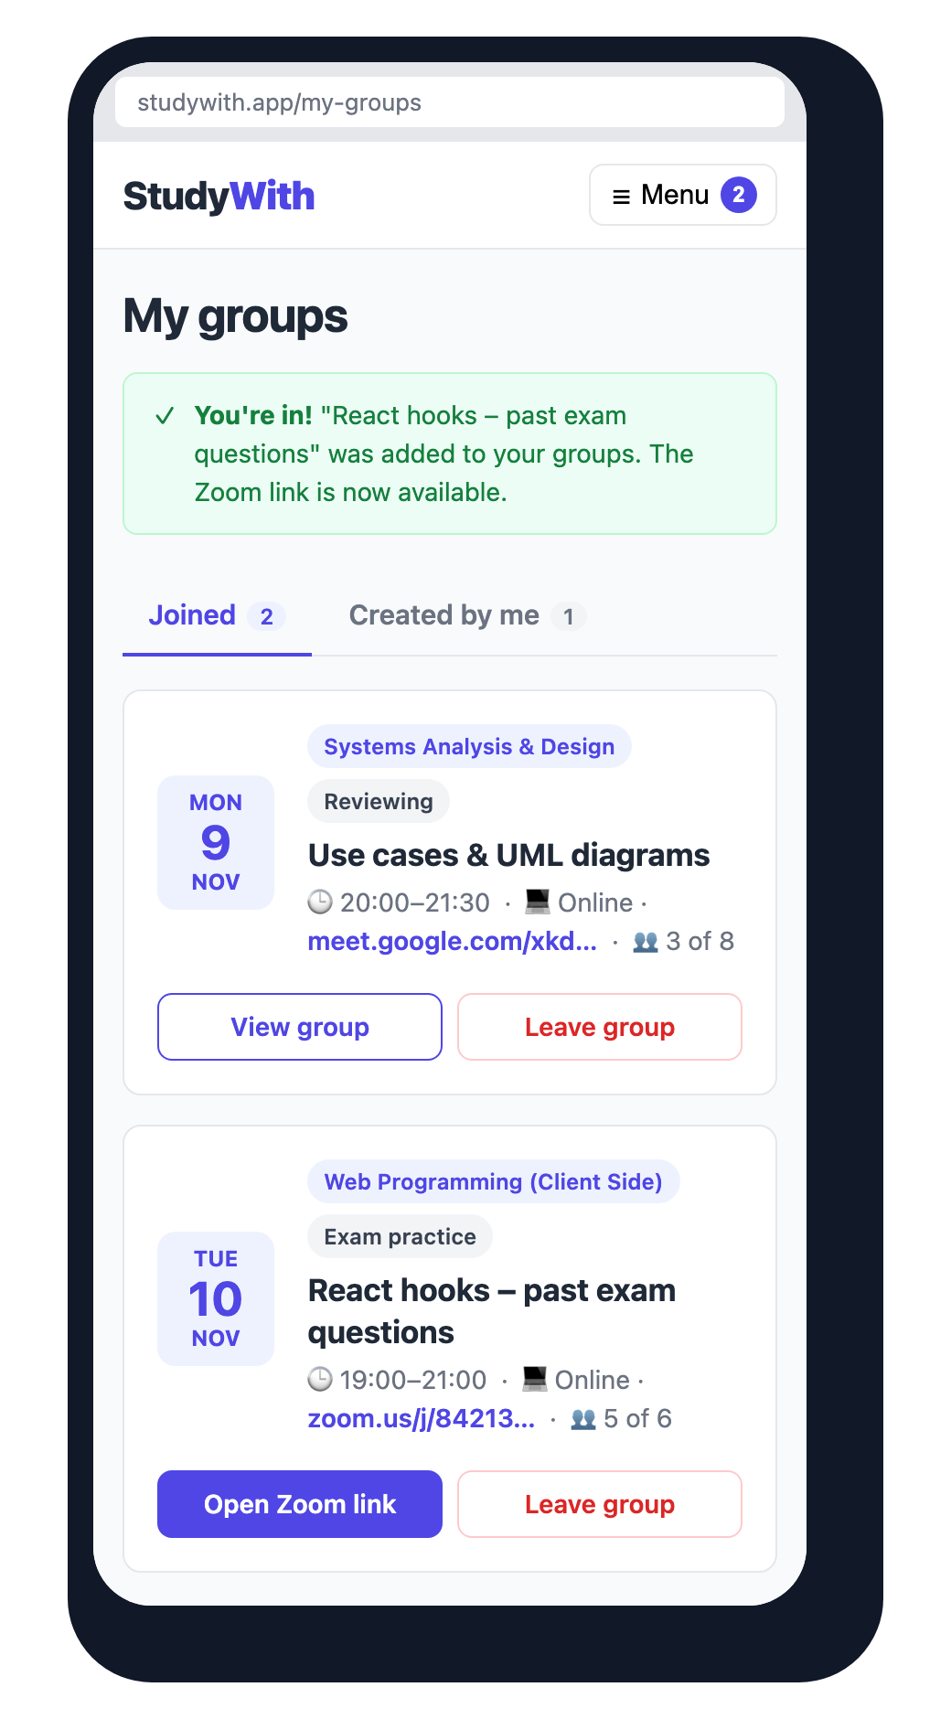  My Groups | On phones  - Navigation collapses into a Menu button; the My groups counter stays visible.  - Filters open from a Filters button.  - Cards, form fields and buttons stack in one column.  - Main buttons span the full width, so they are easy to tap.

